If you go down to the woods today….

Matt Grainger

4 6 2019

## Bear population challenge

Apply your knowledge about population models to this grizzly bear dataset. Answer the questions and show your code (either in a new script file or in a new Rmarkdown file - you can adapt the original). Save the file and send it to me.

# a # sign means that R does not read this as code.   
#install.packages("popbio") #remove the first hash if you do not have popbio installed as a package   
library(popbio)

## Upload and explore the bears dataset

data(grizzly)  
View(grizzly)  
#?grizzly# what is the grizzly data about?  
attach(grizzly) ## You need to attach the data so that   
#you can use it in the functions that follow   
#(otherwise you need to signal to R which data you are using)  
plot(year, N, type='o', pch=16, las=1, xlab="Year",   
 ylab="Adult females", main="Yellowstone grizzly bears")

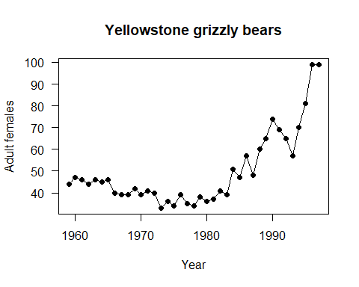

## What is the grizzly data set all about

Look up the grizzly dataset from the R help (see above ?grizzly will search for the dataset in the helpfiles).

Provide a summary of the grizzly dataset

## Calculate the rate of population change

Their are only female bears in this count. What could you do to make this data more representative of the population?

Do we need more data than just female bears?

## Use the population models to assess the population change in bears

Make use of only the first 10 years of the bears dataset to predict the future 17 years. Plot this on the same graph (hint in base R you can add points to a plot using the “points()” fuction)

#Extra credit:: Make the plots look pretty (look at ?ggplot2 for example and search on Google for ggplot2)

grizzly[1:10,]

## year N  
## 1 1959 44  
## 2 1960 47  
## 3 1961 46  
## 4 1962 44  
## 5 1963 46  
## 6 1964 45  
## 7 1965 46  
## 8 1966 40  
## 9 1967 39  
## 10 1968 39

lam<-c(rep("NA",9))  
  
for (i in 2:10){  
 lam[i]<-grizzly$N[i+1]/grizzly$N[i]  
}  
lam

## [1] "NA" "0.978723404255319" "0.956521739130435"  
## [4] "1.04545454545455" "0.978260869565217" "1.02222222222222"   
## [7] "0.869565217391304" "0.975" "1"   
## [10] "1.07692307692308"

mean(as.numeric(lam), na.rm=TRUE)

## Warning in mean(as.numeric(lam), na.rm = TRUE): NAs introduced by coercion

## [1] 0.9891857

sd(as.numeric(lam), na.rm=TRUE)

## Warning in is.data.frame(x): NAs introduced by coercion

## [1] 0.05903223

# 0.9891  
#0.05903223

dim(grizzly)

## [1] 39 2

N=NULL  
  
N[1]=grizzly$N[10]  
  
for (i in 1:16){  
 N[i+1]<-rnorm(1,0.9891, 0.05903223)*N[i]  
}  
  
N

## [1] 39.00000 36.85339 37.21183 37.53756 38.45468 40.13371 42.72634 43.26715  
## [9] 44.31509 48.05821 47.35019 51.32550 49.99261 44.65043 44.50225 45.37927  
## [17] 42.14742

library(tidyverse)  
bears<-data.frame(N=N, years=grizzly$year[10:26])  
bears %>%   
 ggplot(aes(years,N))+  
 geom_point(col="blue")+  
 geom_line(col="blue")+  
 geom_point(data=grizzly, aes(year, N), colour="brown")+  
 geom_line(data=grizzly, aes(year, N), colour="brown")+  
 ggthemes::theme_base()

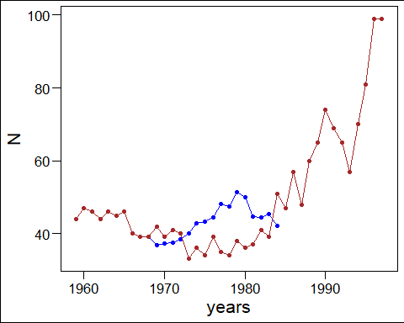

detach(grizzly)# remember to detach the data from the session  
rm(list=ls())# this cleans your environment - is useful but   
#you might want to keep it sometimes - use caution