Research waste in applied ecology and conservation

Matthew J. Grainger1*, Frederike C. Bolam2, Gavin B. Stewart2, Erlend B. Nilsen1

1Norwegian Institute for Nature Research, P.O. Box 5685 Torgarden, 7485, Trondheim, Norway

2Modelling Evidence and Policy Research Group, School of Natural and Environmental Sciences, Ridley Building 2, Claremont Road, Newcastle upon Tyne NE1 7RU, UK

*corresponding author: matthew.grainger@nina.no

“Research waste” is a well established concept in medical research (1). Research is wasted when its outcomes cannot be used for the benefit of society (2). Waste can occur at any of the four stages of research (as defined by 2); question setting; methods; accessibility; and reporting. In recent years there has been an increased focus in ecology on methods (e.g. 3; 4) which have called for methodological improvements in individual studies. Open science is fast becoming mainstream in ecological publishing which is vastly improving accessibility (5). Evidence synthesis approaches such as systematic review and meta-analysis have become stalwarts of ecology and conservation research (6) leading to improved reporting for the benefit of decision-makers. Despite these advances research waste still occurs in ecology and here we focus on a critical area where ecology and conservation can make large steps forward in research waste reduction.

Chalmers & Glasziou (2009) separate what we suggest is part of the same research stage across the reporting and question setting stages. Namely, that new studies do not take in to account the body of evidence that have taken place prior to them (categorised as reporting by 2) and that low priority questions are being asked. A low priority question may be one that is not relevant to stakeholders (and 2 suggest that stakeholders be apart of the research commissioning process). Alternatively a low priority question may be one that has already been sufficeintly addressed in the literature so that any further studies are a waste of resources and should be avoided.

In medicine, one way in which this particular type of research waste has been identified is by looking at cumulative meta-analysis. A cumulative meta-analysis typically describes the accumulation of evidence (e.g., about the effectiveness of an intervention) as the available estimates are added to the analysis in chronological order (7). By carrying out this approach a researcher or funder can show the point at which there is sufficient evidence to be confident that a reported effect is true and thus new trials are no longer required.

As an example of the approach we can look at the potential of autonomous acoustic recorders to replace human observers in wildlife sampling and monitoring, which now has a long history in the ecological literature (starting from at least 8). Technological advances over the last two decades have allowed this potential to be explored fully. Well over 150 field studies have been carried out that address this issue either directly or indirectly and seek to address the question of whether acoustic recorders can replace human observers in wildlife surveys. Darras et al. (2018) explored the pooled effect of these types of studies using a meta-analysis. They concluded that when human observers (using point counts) and sound recorders sample areas of equal size then there is no difference between estimates of bird species richness. Despite this, using their search terms in a Web of Science search identifies another 14 papers that have been published after Darras et al. (2018) was submitted. By using a cumulative meta-analysis we can answer the question “Do we need another study quantifying the difference between acoustic recorders and human observers for bird survey point counts?” In addition, we can show the historical point at which studies into this topic could have been stopped and research waste (in a restricted sense) could have been avoided.

**A worked example of cumulative meta-analysis to identify research waste**

We extracted the data and R code from 9 to recreate their analysis. Building on their random effects meta-analysis we ran a cumulative meta-analysis using the “cumul” function in the “metafor” package (10) in R. The cumulative meta-analysis was ordered by publication year and plotted using the “forest” function. To assess the point at which there is sufficient evidence and no further investigations are required we plotted the z-curve in relation to the cumulative sample size. The thresholds for significance was a z value of 1.96 or -1.96. When the z curve crosses this threshold then the level of evidence is considered sufficient. This approach (known as “trial sequential analysis”) is well developed in medicine (wetterslev2008trial). Plots were produced using ggplot2 in R (11).

The effect size of studies investigating the difference between autonomous acoustic recorders and human observers in terms of bird species richness estimates was consistently close to 0 in each study (Figure 1). Trial sequential analysis shows that an evidence threshold was reached in 2015. This suggests that studies undertaken post 2015 were a waste of research resources.

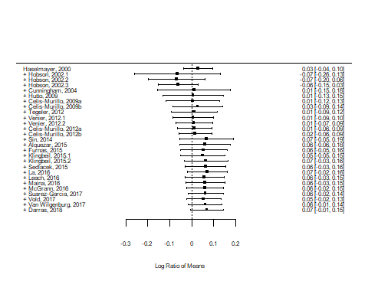

Cumulative forest plot of the meta-analysis of Darras et al. (2018) on the difference between human observers and acoustic recorders in terms of species richness.

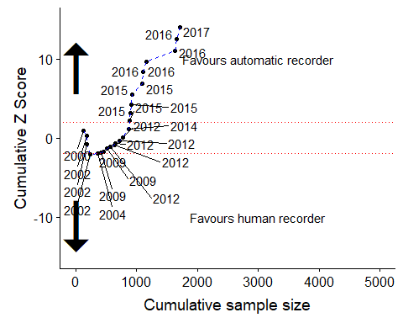

Trial sequential analysis. The red dashed lines indicate the significance threshold (between -1.96 and 1.96). When the z-curve crosses the red line then there is sufficient evidence and no new trials are required.

To reduce research waste we need to be able to first quantify it. One option is to use cumulative meta-analysis. The approach demonstrated here is well established in the medical literature. It is well known and tested. Therefore, it should not be challenging to integrate in to conservation and applied ecology workflows. Ideally, funding decisions would take into account the available evidence before giving grants to well studied topics.

There are at least two important caveats that need to be discussed. The first is that currently, due to heterogeneity in reporting as well as the drive for novelty in publications that meta-analysis is challenging in applied ecology as it is. There might not be sufficient good quality research to quantify the cumulative effect of even some apparently well studied phenomena. In cases such as this one might consider using a systems modelling approach to identify key areas of uncertainty in a topic that could be prioritised for research focus.

It is important to remember that research funding for fieldwork might not only be about answering a research question and could be more targeted to the development of researchers skills (PhD students, etc.) in their field of interest. Funding for training and skill development should be given weight in any funding prioritisation.

“We need less research, better research, and research done for the right reasons” (Altmann, 1994).

# References

1. Glasziou, P. & Chalmers, I. Research waste is still a scandal—an essay by paul glasziou and iain chalmers. *Bmj* **363,** k4645 (2018).

2. Chalmers, I. & Glasziou, P. Avoidable waste in the production and reporting of research evidence. *The Lancet* **374,** 86–89 (2009).

3. Fraser, H., Parker, T., Nakagawa, S., Barnett, A. & Fidler, F. Questionable research practices in ecology and evolution. *PloS one* **13,** e0200303 (2018).

4. Nilsen, E. B., Bowler, D. & Linnell, J. D. C. Exploratory and confirmatory conservation research in the open science era. (2019). doi:[10.32942/osf.io/75a6f](https://doi.org/10.32942/osf.io/75a6f)

5. Powers, S. M. & Hampton, S. E. Open science, reproducibility, and transparency in ecology. *Ecological applications* **29,** e01822 (2019).

6. Gurevitch, J., Koricheva, J., Nakagawa, S. & Stewart, G. Meta-analysis and the science of research synthesis. *Nature* **555,** 175 (2018).

7. Lau, J. *et al.* Cumulative meta-analysis of therapeutic trials for myocardial infarction. *New England Journal of Medicine* **327,** 248–254 (1992).

8. Ralph, C. J., Sauer, J. R. & Droege, S. Monitoring bird populations by point counts. *Gen. Tech. Rep. PSW-GTR-149. Albany, CA: US Department of Agriculture, Forest Service, Pacific Southwest Research Station. 187 p* **149,** (1995).

9. Darras, K. *et al.* Comparing the sampling performance of sound recorders versus point counts in bird surveys: A meta-analysis. *Journal of applied ecology* **55,** 2575–2586 (2018).

10. Viechtbauer, W. Conducting meta-analyses in R with the metafor package. *Journal of Statistical Software* **36,** 1–48 (2010).

11. Wickham, H. *Ggplot2: Elegant graphics for data analysis*. (Springer-Verlag New York, 2016).