|  |  |  |  |
| --- | --- | --- | --- |
| **Statistics** | | | |
|  | | Age | Experience  coaching |
| N | Valid | 252 | 249 |
| Missing | 0 | 3 |
| Mean | | 37.62 | 15.58 |
| Median | | 35.00 | 13.00 |
| Mode | | 25a | 10 |
| Std. Deviation | | 11.673 | 10.015 |
| Variance | | 136.269 | 100.293 |
| Minimum | | 0 | 1 |
| Maximum | | 70 | 43 |
| a. Multiple modes exist. The smallest value is shown | | | |

Note: 0 age is a problem. I’m not sure why this is. Check the data and try to identify this participant. Go on fluid survey and verify this answer.

|  |  |  |  |  |  |
| --- | --- | --- | --- | --- | --- |
| **Which of the following best describes your gender?** | | | | | |
|  | | Frequency | Percent | Valid Percent | Cumulative Percent |
| Valid | Male | 141 | 56.0 | 56.0 | 56.0 |
| Female | 111 | 44.0 | 44.0 | 100.0 |
| Total | 252 | 100.0 | 100.0 |  |

Note: 111 female coaches is an amazing number!!! Your sample is very balanced despite a reported unbalanced population.

|  |  |  |  |  |  |
| --- | --- | --- | --- | --- | --- |
| **Statistics** | | | | | |
|  | | How likely are you to use? | | How likely are you to refer a fellow coach? | |
|  | | Next month | Next season | Personal concern | Performance problems |
| N | Valid | 252 | 252 | 252 | 252 |
| Missing | 0 | 0 | 0 | 0 |
| Mean | | 1.6667 | 2.7500 | 1.9048 | 2.5397 |
| Median | | 1.0000 | 3.0000 | 1.5000 | 3.0000 |
| Mode | | .00 | 5.00 | .00 | .00 |
| Std. Deviation | | 1.85961 | 1.85237 | 1.70038 | 1.77701 |
| Variance | | 3.458 | 3.431 | 2.891 | 3.158 |
| Minimum | | .00 | .00 | .00 | .00 |
| Maximum | | 5.00 | 5.00 | 5.00 | 5.00 |

|  |  |  |  |  |
| --- | --- | --- | --- | --- |
| **How likely are you to use SPS next month?** | | | | |
|  | | Frequency | Percent | Cumulative Percent |
| Valid | Not at all | 111 | 44.0 | 44.0 |
| 1.00 | 37 | 14.7 | 58.7 |
| 2.00 | 17 | 6.7 | 65.5 |
| 3.00 | 31 | 12.3 | 77.8 |
| 4.00 | 24 | 9.5 | 87.3 |
| Very likely | 32 | 12.7 | 100.0 |
| Total | 252 | 100.0 |  |

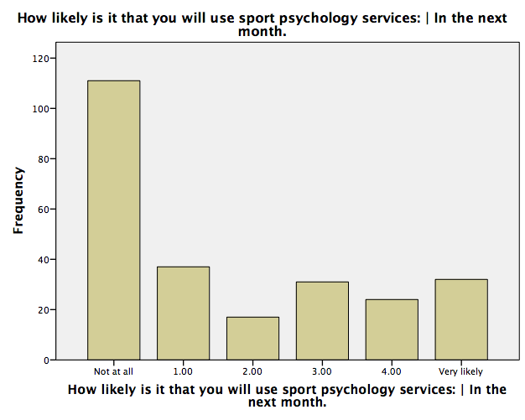

Note: 44% of coaches stated they will not use SPS for themselves next month (may be explained by offseason).

|  |  |  |  |  |
| --- | --- | --- | --- | --- |
| **How likely are you to use SPS next season?** | | | | |
|  | | Frequency | Percent | Cumulative Percent |
| Valid | Not at all | 48 | 19.0 | 19.0 |
| 1.00 | 30 | 11.9 | 31.0 |
| 2.00 | 29 | 11.5 | 42.5 |
| 3.00 | 38 | 15.1 | 57.5 |
| 4.00 | 44 | 17.5 | 75.0 |
| Very likely | 63 | 25.0 | 100.0 |
| Total | 252 | 100.0 |  |

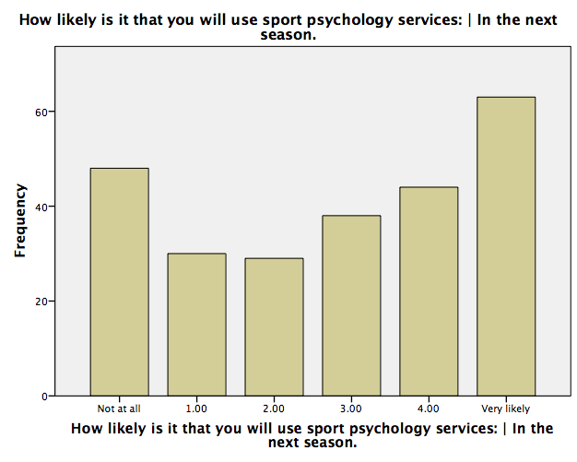

|  |  |  |  |  |
| --- | --- | --- | --- | --- |
| **How likely are you to refer a fellow coach for personal concerns?** | | | | |
|  | | Frequency | Percent | Cumulative Percent |
| Valid | Not at all | 72 | 28.6 | 28.6 |
| 1.00 | 54 | 21.4 | 50.0 |
| 2.00 | 33 | 13.1 | 63.1 |
| 3.00 | 37 | 14.7 | 77.8 |
| 4.00 | 31 | 12.3 | 90.1 |
| Very likely | 25 | 9.9 | 100.0 |
| Total | 252 | 100.0 |  |

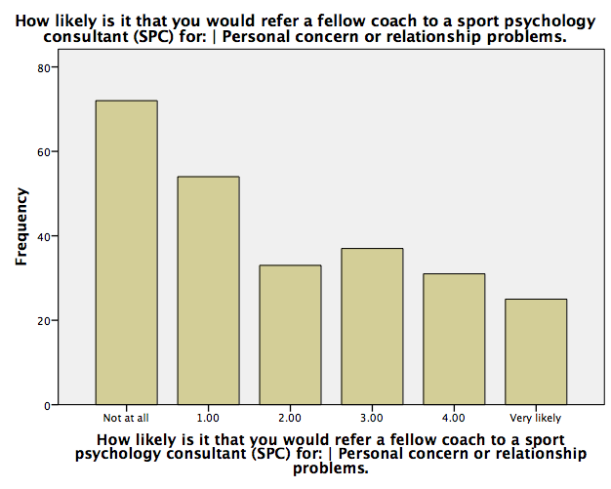

|  |  |  |  |  |
| --- | --- | --- | --- | --- |
| **How likely are you to refer a fellow coach for performance problems?** | | | | |
|  | | Frequency | Percent | Cumulative Percent |
| Valid | Not at all | 51 | 20.2 | 20.2 |
| 1.00 | 36 | 14.3 | 34.5 |
| 2.00 | 25 | 9.9 | 44.4 |
| 3.00 | 48 | 19.0 | 63.5 |
| 4.00 | 50 | 19.8 | 83.3 |
| Very likely | 42 | 16.7 | 100.0 |
| Total | 252 | 100.0 |  |

