10.4
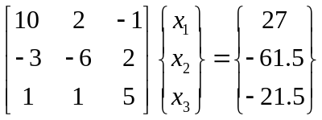
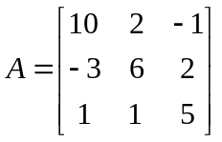; 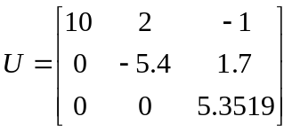; 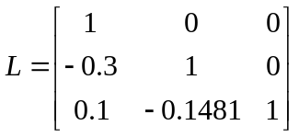;
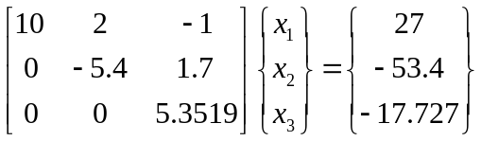;
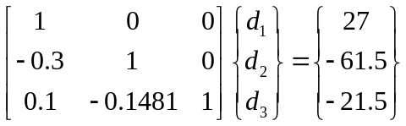
d₁ = 27; d₂ = -53.4; d₃ = -32.1085;
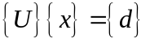
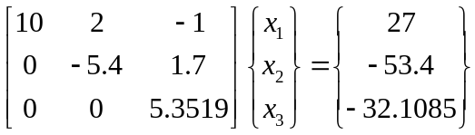
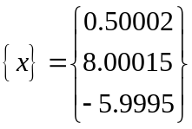
Alternative vector b:
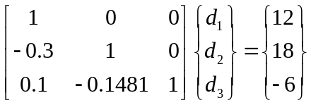
d₁ = 12; d₂ = 21.6; d₃ = -4.00104;
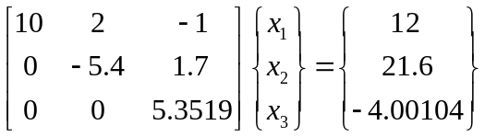
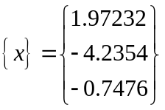
10.5
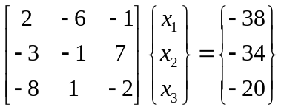
Gauss Elimination with partial pivoting:
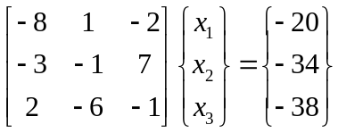
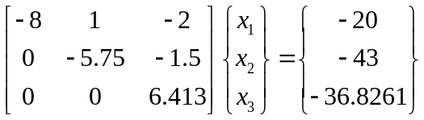
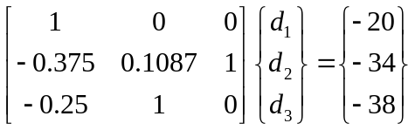
d₁ = -20; d₂ = -43; d₃ = -36.8261;
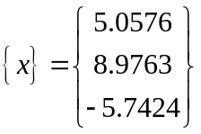

10.6
Please refer to M-file attached in the end.
TEST and Confirmation:
>> A=[10 2 -1; -3 -6 2; 1 1 5];
>> [L,U]=LUfactorize(A)
L =
1.0000 0 0
-0.3000 1.0000 0
0.1000 -0.1481 1.0000

U =
10.0000 2.0000 -1.0000
0 -5.4000 1.7000
0 0 5.3519
>> L*U
ans =
10.0000 2.0000 -1.0000
-3.0000 -6.0000 2.0000
1.0000 1.0000 5.0000
>> b=[27 -61.5 -21.5]';
>> d=L\b
d =
27.0000
-53.4000
-32.1111
>> x=U\d
x =
0.5000
8.0000
-6.0000
Confirm with build-in lu fuction:
>> [L,U]=lu(A)
L =
1.0000 0 0
-0.3000 1.0000 0
0.1000 -0.1481 1.0000
U =
10.0000 2.0000 -1.0000
0 -5.4000 1.7000
0 0 5.3519
12.2
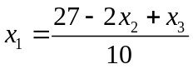
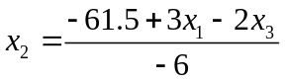
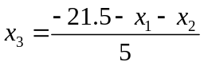
Initial x₂ = 0, x₃ = 0;
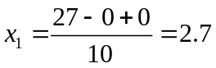
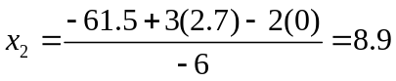
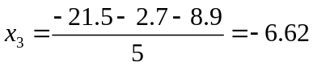
Second iteration:
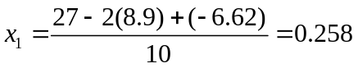
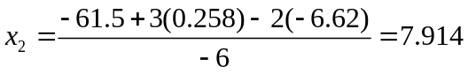
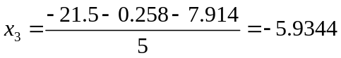
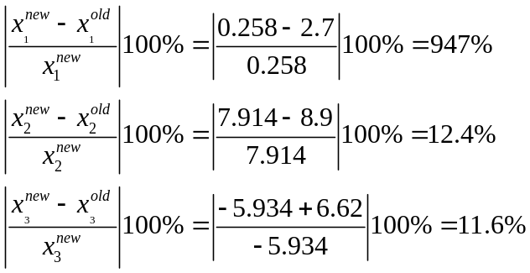
Third Iteration:
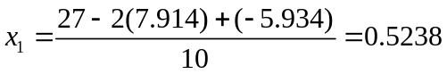
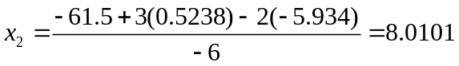
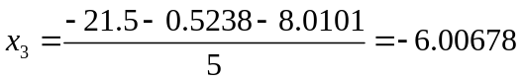
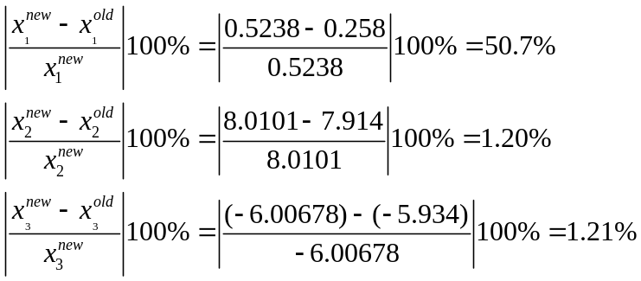
Fourth Iteration:
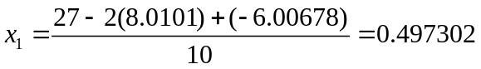
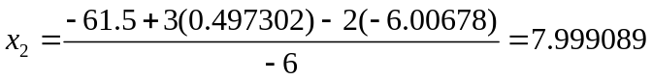
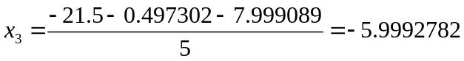
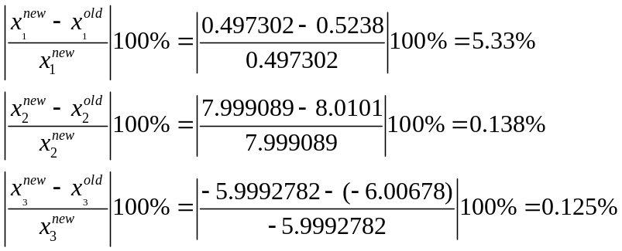
Fifth Iteration:
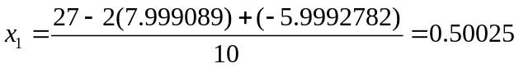
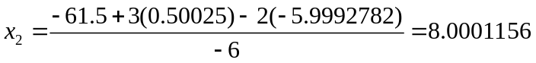
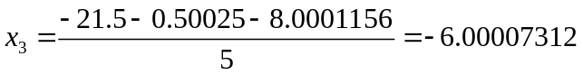
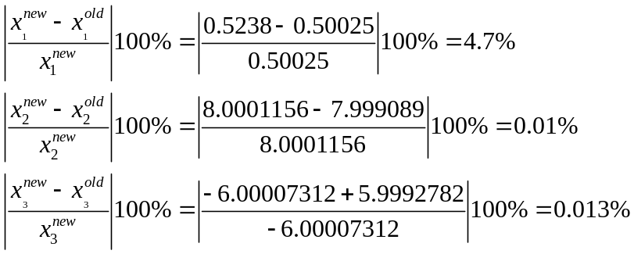
So the final result of x should be:
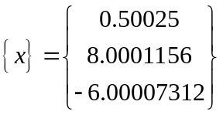

12.5
a) Without Relaxation
According to diagonally dominant principle:
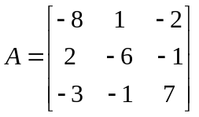
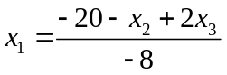
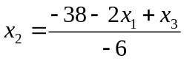
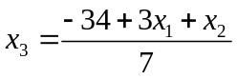
Initial x₂ = 0, x₃ = 0;
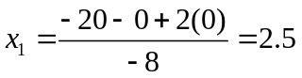
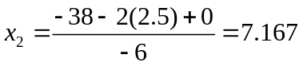
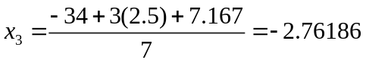
Second Iteration:
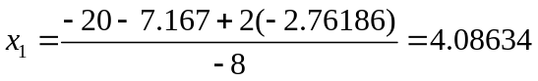
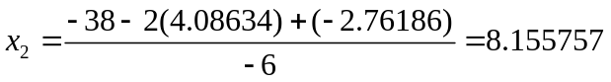
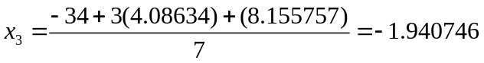
Third Iteration
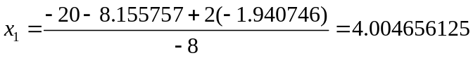
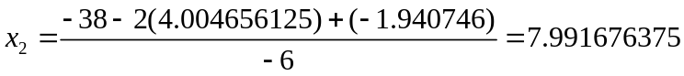

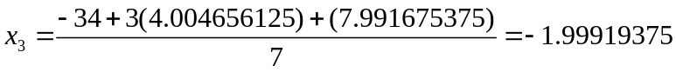
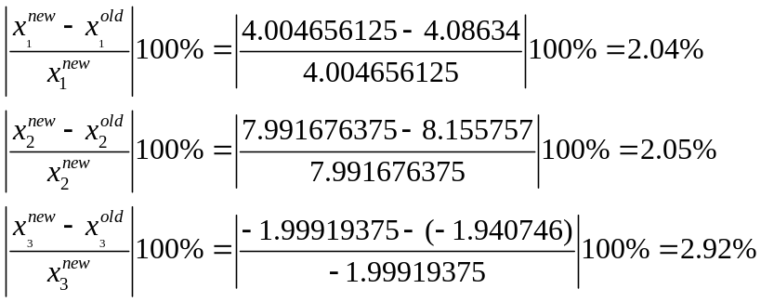
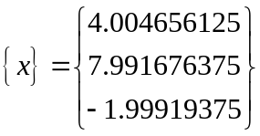
b) With relaxation:
=2.5
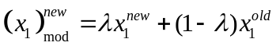
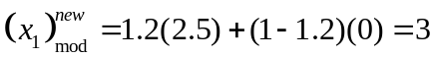

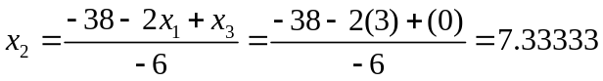
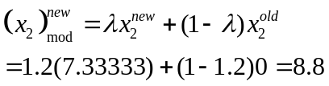

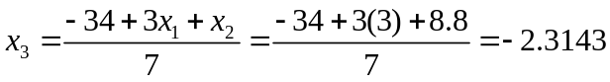
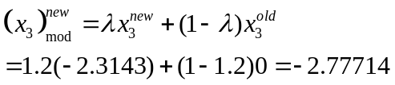

Second Iteration:
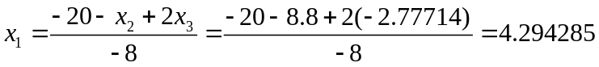
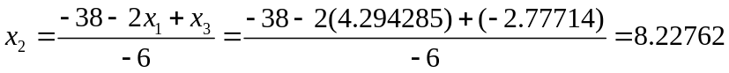
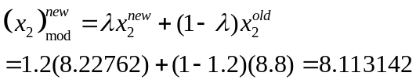
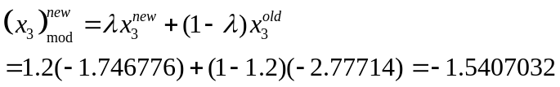

Third iteration:

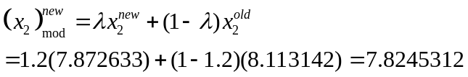

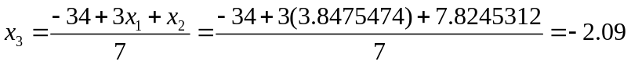
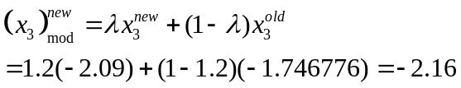

Fourth Iteration:
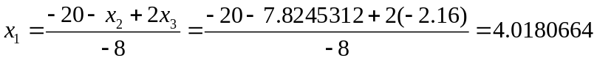

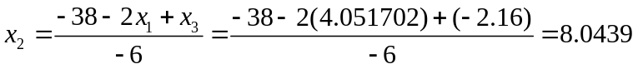
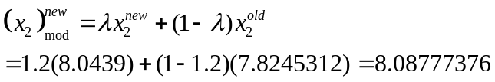

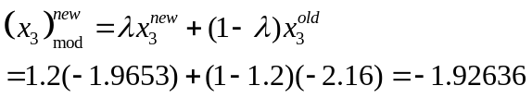
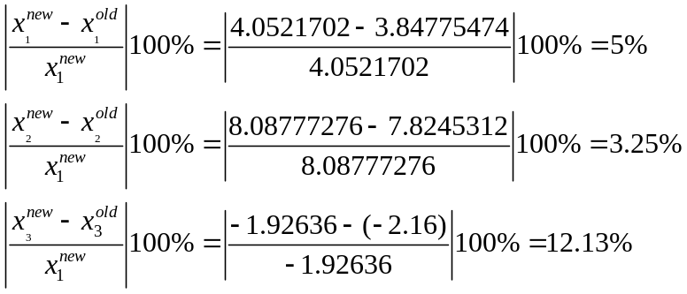
Fifth iteration:

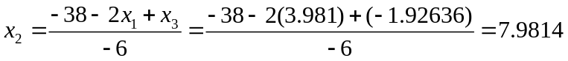
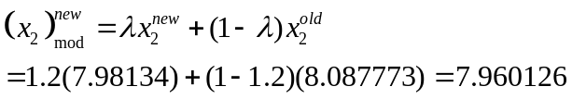

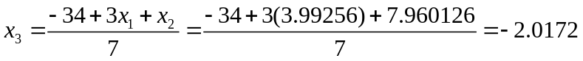
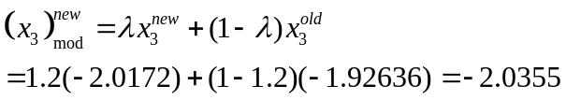

The error is lesser than 5%
So the final result is:
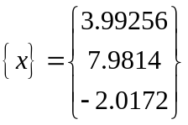
12.8
a) Graphic
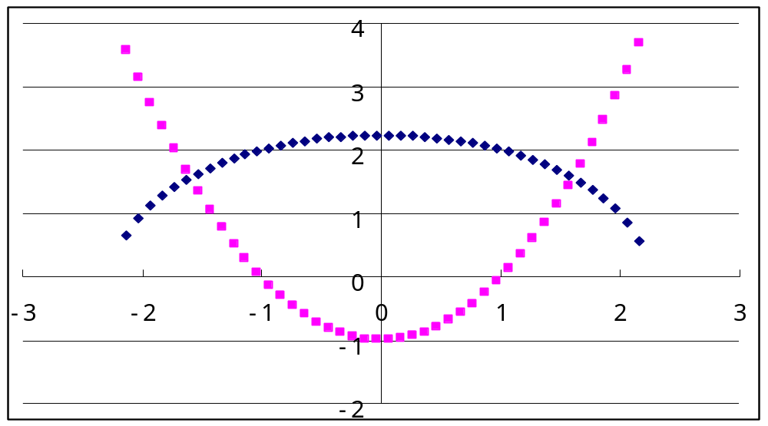
x= 1.6; y= 1.55
b) Substitution
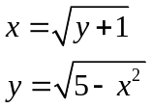
x = 2.5^0.5 = 1.58113
y = (5-1.58113²)^0.5 = 1.58113883
x = (1.58113883+1)^0.5 = 1.6065
y = (5-1.6065²)^0.5 = 1.555269
x = (1.555269 +1)^0.5 = 1.5985
y = (5-1.5985²)^0.5 = 1.562585
x = (1.56285 +1)^0.5 = 1.60089
y = (5-1.60089²)^0.5 = 1.5611
c) Newton-Raphson
MATLAB solution
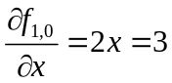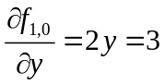
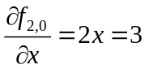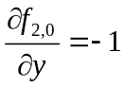
>> x=1.5;
>> y=1.5;
>> J=[2*x 2*y; 2*x -1]
J =
3 3
3 -1
>> f=[x^2+y^2-5; x^2-y-1]
f =
-0.5000
-0.2500
>> A = [x; y]
A =
1.5000
1.5000
>> A = A-J\f
A =
1.6042
1.5625
>> x=1.6042;
>> y=1.5625;
>> J=[2*x 2*y; 2*x -1]
J =
3.2084 3.1250
3.2084 -1.0000
>> f=[x^2+y^2-5; x^2-y-1]
f =
0.0149
0.0110
>> A = [x; y]
A =
1.6042
1.5625
>> A = A-J\f
A =
1.6005
1.5616

After several iterations: x=1.600, y = 1.561

