CEE 691-001 Homework #7
Shibo Wang
16.5: Solution:
x | -1 | -0.6 | -0.2 | 0.2 | 0.6 | 1
f(x) | 0 | 0 | 0 | 1 | 1 | 1
a. Cubic spline with not-a-knot end conditions:
Calculate by hand:
First and last equations
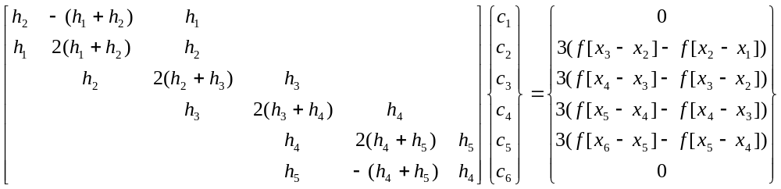
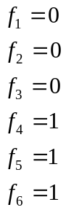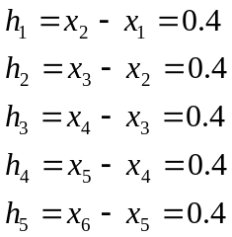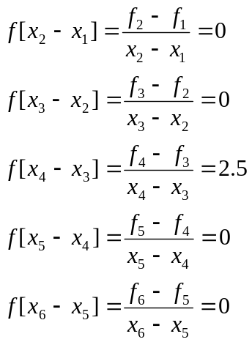
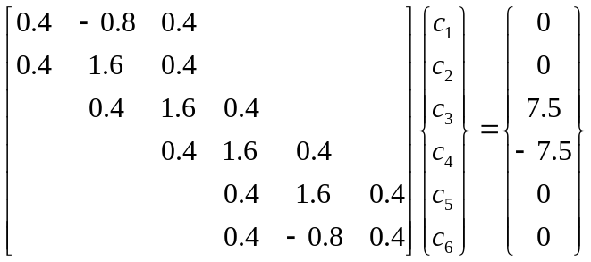
Use Matlab to solve:
>> x=[0.4 -0.8 0.4 0 0 0;0.4 1.6 0.4 0 0 0; 0 0.4 1.6 0.4 0 0; 0 0 0.4 1.6 0.4 0; 0 0 0 0.4 1.6 0.4; 0 0 0 0.4 -0.8 0.4]
x =
0.4000 -0.8000 0.4000 0 0 0
0.4000 1.6000 0.4000 0 0 0
0 0.4000 1.6000 0.4000 0 0
0 0 0.4000 1.6000 0.4000 0
0 0 0 0.4000 1.6000 0.4000
0 0 0 0.4000 -0.8000 0.4000
>> y=[0; 0 ; 7.5; -7.5; 0; 0]
y =
0
0
7.5000
-7.5000
0
0
>> u=y\x
u =
0 0.0267 0.0800 -0.0800 -0.0267 0
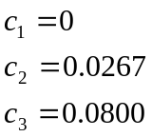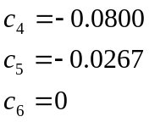
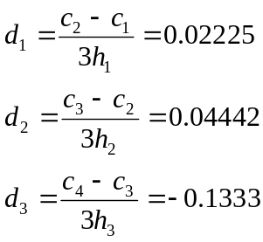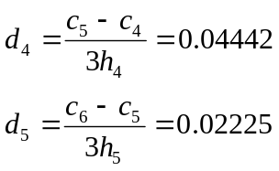
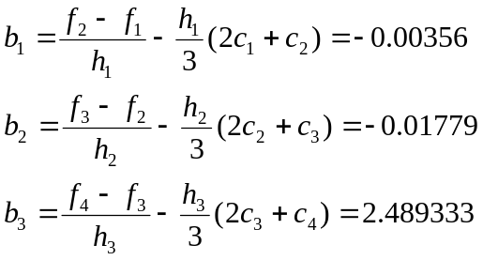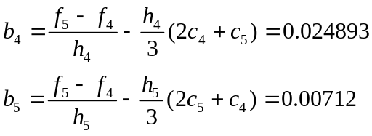
Therefore, the cubic splines for each interval should be:
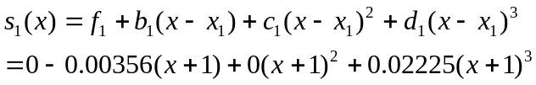
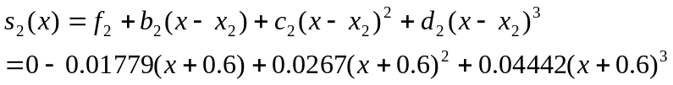
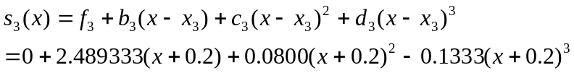
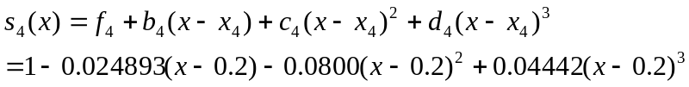
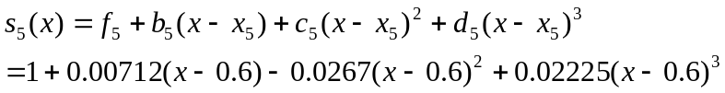
Calculate by Matlab:
>> x=linspace(-1,1,6);
>> y=[0,0,0,1,1,1];
>> xx=linspace(-1,1) ;
>> yy=spline(x,y,xx) ;
>> x1=linspace(-1,0);
>> x2=linspace(0,1);
>> y1=0;
>> y2=1;
>> plot(x,y,'o',xx,yy,x1,y1,'--',x2,y2,'--')
The plot comparing the fit with the step function is shown below.
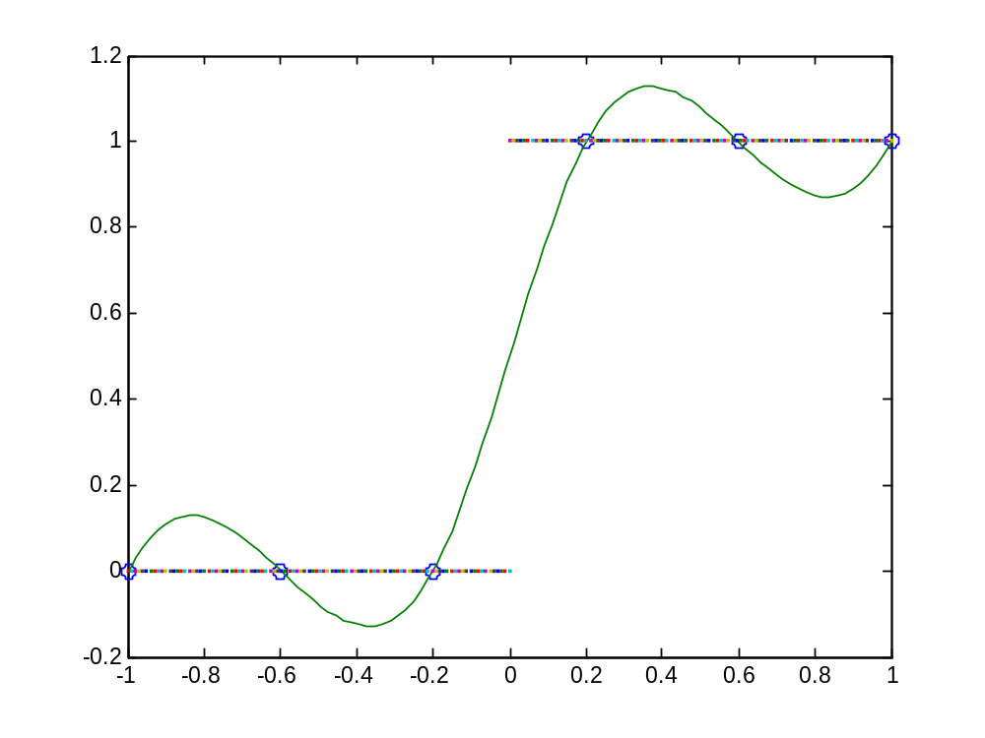

b. Cubic spline with zero-slope clamped end conditions:
Calculate by hand:
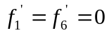
First and last equations:

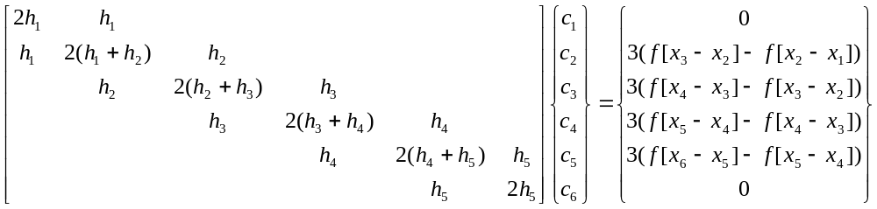
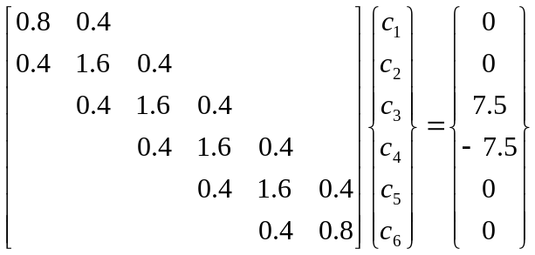
Use Matlab to solve:
>> x=[0.8 0.4 0 0 0 0;0.4 1.6 0.4 0 0 0; 0 0.4 1.6 0.4 0 0; 0 0 0.4 1.6 0.4 0; 0 0 0 0.4 1.6 0.4; 0 0 0 0 0.4 0.8]
x =
0.8000 0.4000 0 0 0 0
0.4000 1.6000 0.4000 0 0 0
0 0.4000 1.6000 0.4000 0 0
0 0 0.4000 1.6000 0.4000 0
0 0 0 0.4000 1.6000 0.4000
0 0 0 0 0.4000 0.8000
>> y=[0; 0 ; 7.5; -7.5; 0; 0]
y =
0
0
7.5000
-7.5000
0
0
>> u=y\x
u =
0 0.0267 0.0800 -0.0800 -0.0267 0
Therefore, the cubic splines for each interval should be:
Calculate by Matlab:
>> yc=[0,0,0,0,1,1,1,0];
>> x=[-1, -0.6,-0.2,0.2,0.6,1];
>> yyc=spline(x,yc,xx);
>> plot(x,y,'o',xx,yyc,x1,y1,'--',x2,y2,'--')
The plot comparing the fit with the step function is shown below.
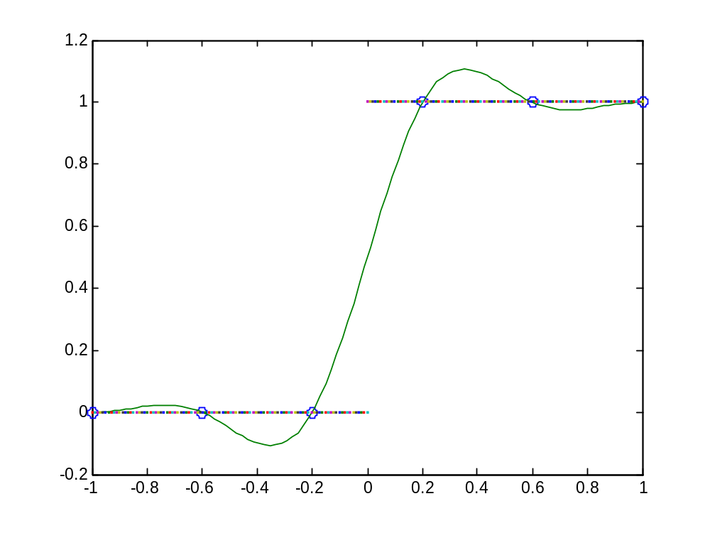
c. piecewise cubic Hermite interpolation:
Calculate by Matlab:
>> x=[-1, -0.6,-0.2,0.2,0.6,1];
>> y=[0,0,0,1,1,1];
>>xx=linspace(-1,1);
>> yh=interp1(x,y,xx,'pchip')
>> plot(x,y,'o',xx,yh,x1,y1,'--',x2,y2,'--')

The plot comparing the fit with the step function is shown below.

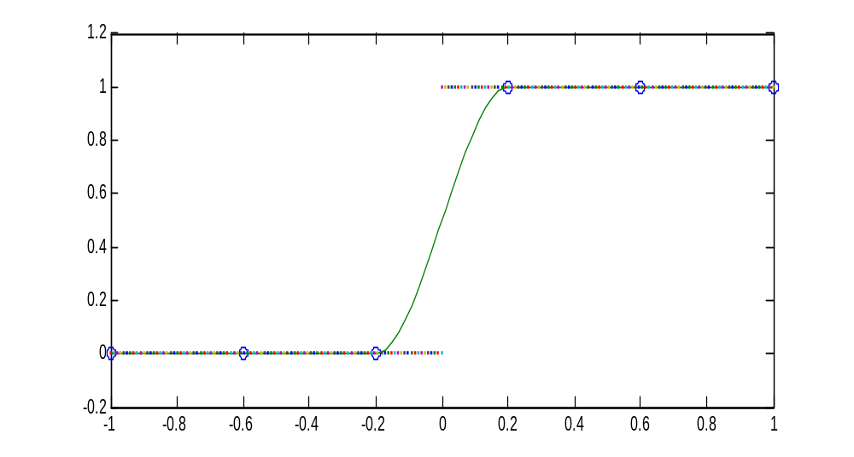
16.7 : Solution :
(a). Cubic spline with not-a-knot end conditions:
Calculate by Matlab:
>> x=[1,3,5,6,7,9];
>> y=[1.000,2.172,4.220,5.430,4.912,9.120];
>> xx=linspace(1,9);
>> yy=spline(x,y,xx);
>> yr=0.0185*xx.^5-0.444*xx.^4+3.9125*xx.^3-15.456*xx.^2+27.069*xx.^1-14.1;
>> plot(x,y,'o',xx,yy,xx,yr,'--')
The plot comparing the fit with the step function is shown below.
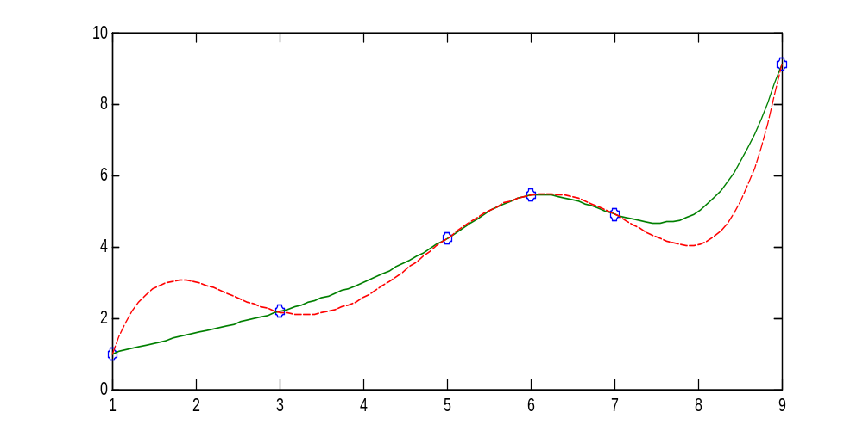
b. Cubic spline with determined slope clamped end conditions:
Differentiating the equation:
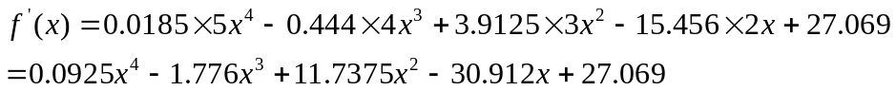
For the first and last node,
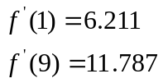
Calculate by Matlab:
>> x=[1,3,5,6,7,9];
>> y=[1.000,2.172,4.220,5.430,4.912,9.120];
>> xx=linspace(1,9);
>> yc=[6.211 y 11.787];
>> yy=spline(x,yc,xx);
>> plot(x,y,'o',xx,yy,xx,yr,'--')
The plot comparing the fit with the step function is shown below.
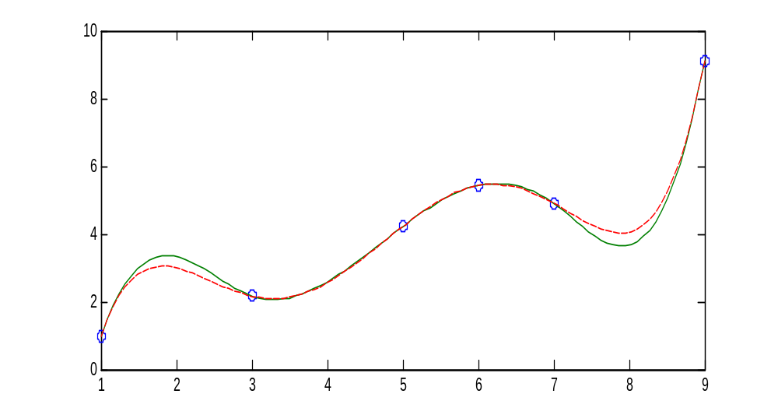

16.8 Solution:
a. Use 4th order polynomial interpolation:
Using Matlab: M-file is in the back of this homework:
Write in the command window:
>> format long
>> >> x=[1.8,2.0,2.2,2.4,2.6]';
>> y=[0.5815,0.5767,0.5560,0.5202,0.4708]';
>> Newtint(x,y,2.1)
ans =
0.568303906250000
Running Matlab, get the true value of 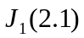
>> J=besselj(1,2.1)
J =
0.5683
b. Using cubic splines : natural ends.
Use Matlab:
>> x=[1.8,2.0,2.2,2.4,2.6]';
>> y=[0.5815,0.5767,0.5560,0.5202,0.4708]';
>> yy=spline(x,y,2.1)
yy =
0.568298437500000

16.9 Solution: Use Matlab to solve:
a. piecewise linear interpolation,
>> x=[0,8,16,24,32,40];
>> o=[14.621,11.843,9.87,8.418,7.305,6.413];
>> xx=linspace(0,40);
>> yy=interp1(x,o,xx);
>> plot(x,o,'o',xx,yy)
The plot showing the results is shown below.
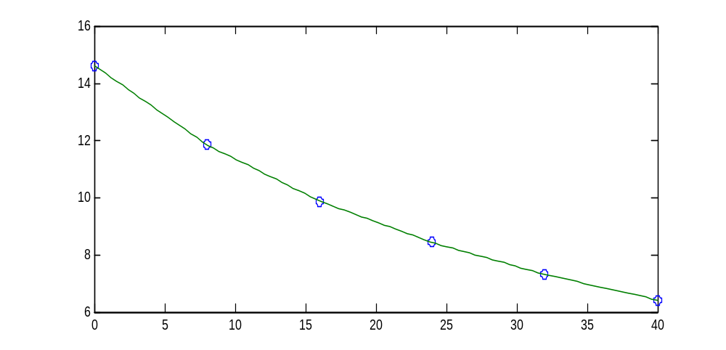
for T=27 °C
>> yy=interp1(x,o,27)
yy =
8.000624999999999
The relative error is:
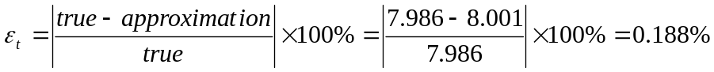
b. 5th order polynomial
>> x=[0,8,16,24,32,40];
>> o=[14.621,11.843,9.87,8.418,7.305,6.413];
>> xx=linspace(0,40);
>> p=polyfit(x,o,5);
>> u=polyval(p,xx);
>> plot(x,o,'o',xx,u)
The plot showing the results is shown below.
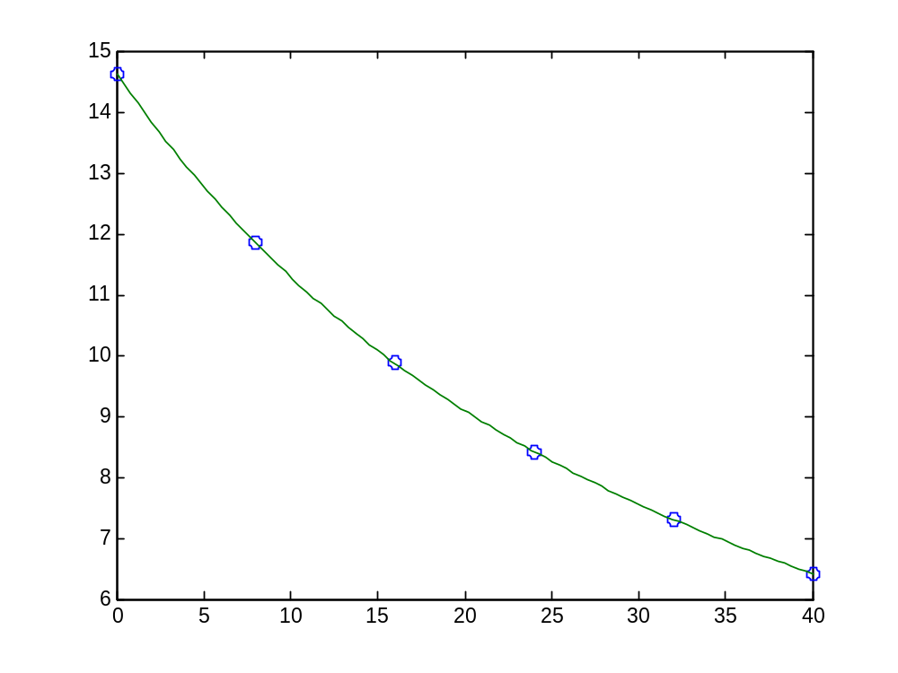
for T=27 °C
>> r=polyval(p,27)
r =
7.968238960266107
The relative error is:

c. spline with natural ends:
>> x=[0,8,16,24,32,40];
>> o=[14.621,11.843,9.87,8.418,7.305,6.413];
>> xx=linspace(0,40);
>> yy=spline(x,o,xx);
>> plot(x,o,'o',xx,yy)
The plot showing the results is shown below.
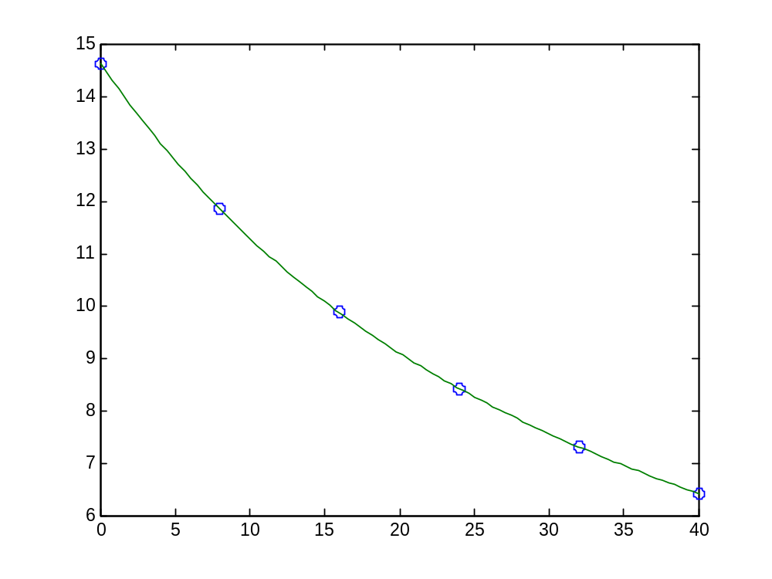
for T=27 °C
>> r=spline(x,o,27)
r =
7.967888020833333
The relative error is:

M-file: Polynomial Interpolation:
function yint=Newtint(x,y,xx)
%yint:use an n-1 order Newton interpolating polynomial based on n data
%points (x,y)
%xx: a given value of the independent variable.
n=length(x);
if length(y)~=n, error(wrong); end
b=zeros(n,n);
%assign dependent variables to the first column of b.
b(:,1)=y(:); %the (:) ensures that y is a column vector.
for j=2:n,
for i=1:n-j+1
b(i,j)=(b(i+1,j-1)-b(i,j-1))/(x(i+j-1)-x(i));
end
end
%use the finite divided differences to interpolate
xt=1;
yint=b(1,1);
for j=1:n-1
xt=xt*(xx-x(j));
yint=yint+b(1,j+1)*xt;
end

