CEE 691-001 Homework set 8
Shibo Wang April 3 2008
17.9 Solution:
According to the proposed problem, closed-end Composite Simpson’s 1/3 rule is applied with 6 segments.
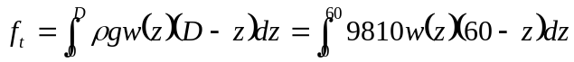
Exact Solution: 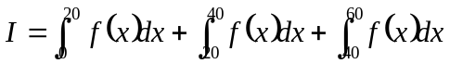
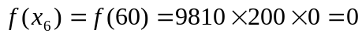
Substituting Simpson’s 1/3 rule:
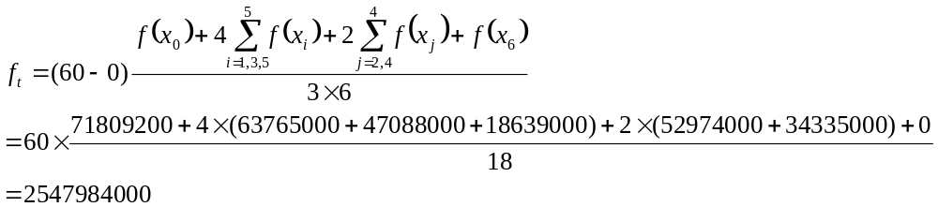For
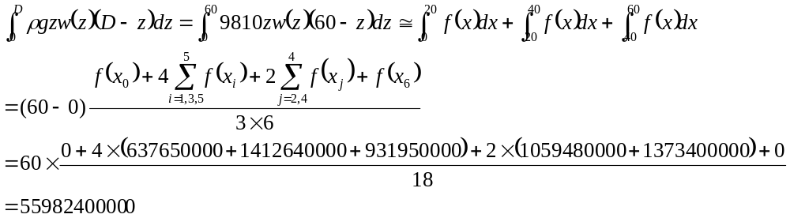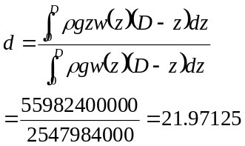
17.12 Solution:
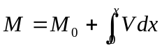
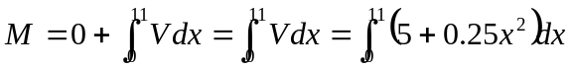
a. analytical solution:
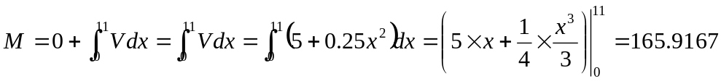
b. multiple-application trapezoidal rule:
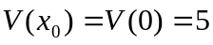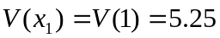
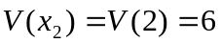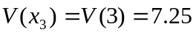
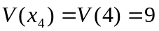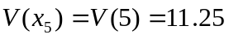
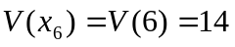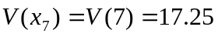
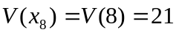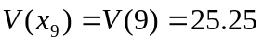
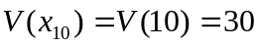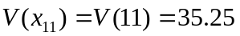
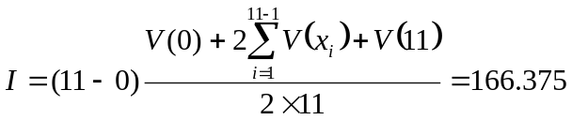
c. multiple-application Simpson’s rule:
Since there are 11 segments, which is odd, both Simpson’s 1/3 and 3/8 rules are used.
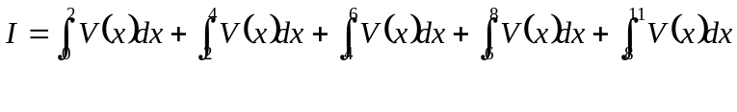
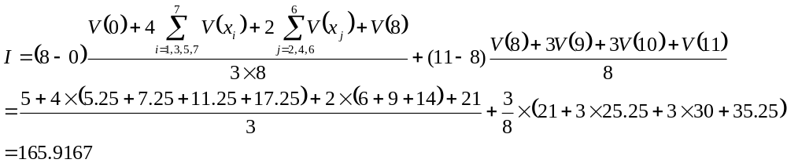
17.14 Solution:
Since the number of segments are odd and unequal, Simpson’s 3/8 rule should be applied for 7:30 to 8:15 and Simpson’s 1/3 rule.
Time,hr | 7:30 | 7:45 | 8:00 | 8:15 | 8:45 | 9:15
Rate,per 4 mins | 18 | 24 | 14 | 24 | 21 | 9
Rate,per min | 4.5 | 6 | 3.5 | 6 | 5.25 | 2.25
a.
b.
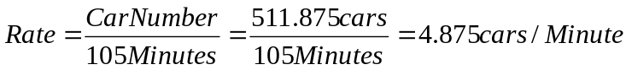

17.15 Solution:
Double integration:
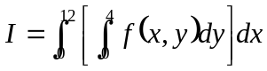
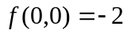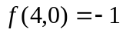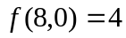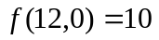
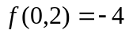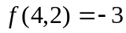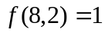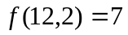
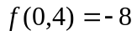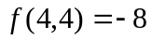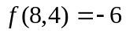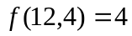
Integrate y direction first using Simpson’s 1/3 rule:
X=0 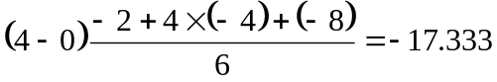
X=4 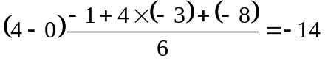
X=8 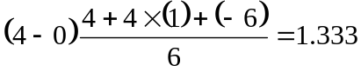
X=12 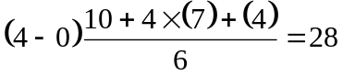
Integrate y direction first using Simpson’s 3/8 rule:
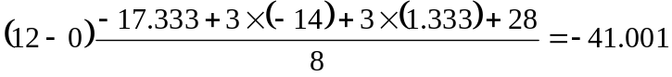
17.17 Solution:
Integration with unequal segments: (trapezoidal rule to each segment)
y,m | 0 | 2 | 4 | 5 | 6 | 9
H,m | 0.5 | 1.3 | 1.25 | 1.7 | 1 | 0.25
U,m/s | 0.03 | 0.06 | 0.05 | 0.12 | 0.11 | 0.02
H*U,m²/s | 0.015 | 0.078 | 0.0625 | 0.204 | 0.11 | 0.005
i. trapezoidal rule to each segment
ii. Use Simpson’s 1/3 rule for 0—4 and 4—6, 6—9 trapezoidal
