1. (b) The concentration at point A:
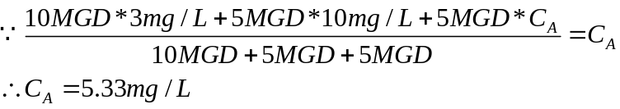
(a) The mass rate of substance of point A (in lb/day):
(c) The mass rate of substance at point B:
The concentration at point B:
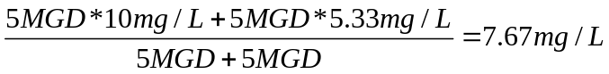
(d) The concentration at point C:
The mass rate of substance at point C:
2. (a) The substance is conservative:
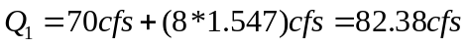
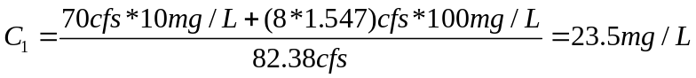
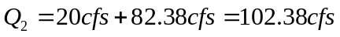
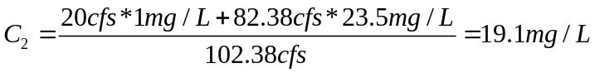
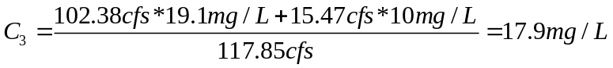
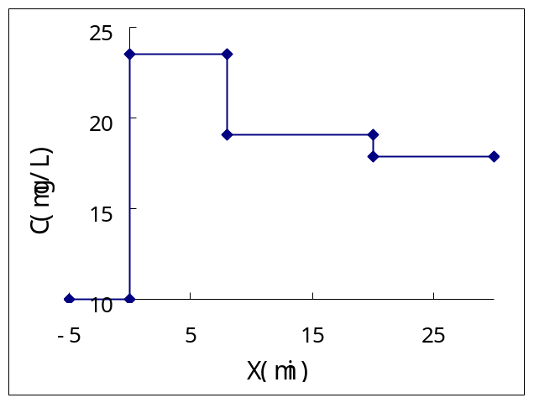

(b) The substance is nonconservative (K=0.25day⁻¹):
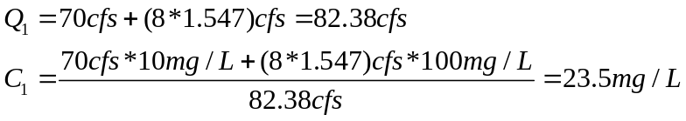
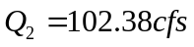
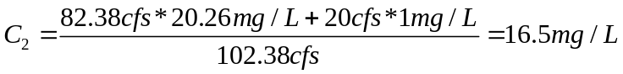
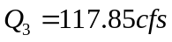
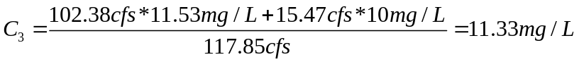
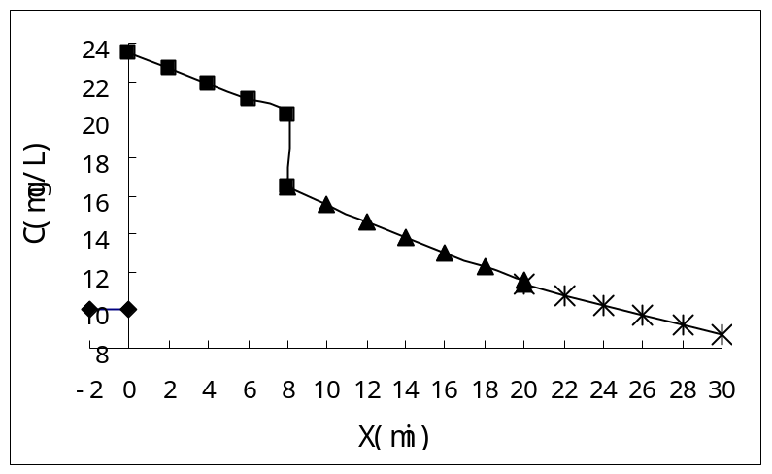
3. (a) Point source reduction:
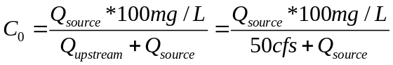
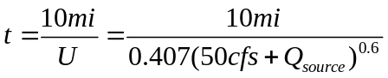
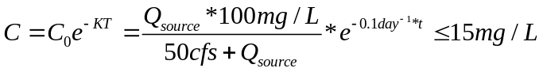

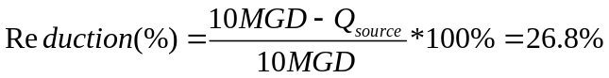
(b) Increase upstream flow:
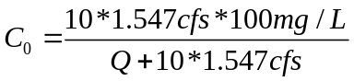
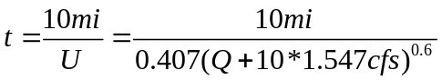
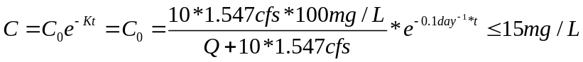
Q=71.69cfs

4. Estimate the discharge concentration:
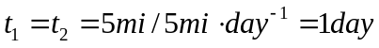
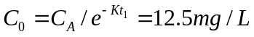
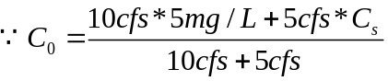
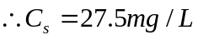
The discharger’s claim isn’t true. The discharge concentration is 27.5mg/L.

