User Interface Demo

Anchoring Components
Get the UIDemo project off R:\Unity Best practice. It has a scene with Ethan able to walk around on a plane, with two coloured boxes
Add a Canvas

Add a few buttons to it, and place them top left, top right and bottom centre as shown (go into 2D mode for this)

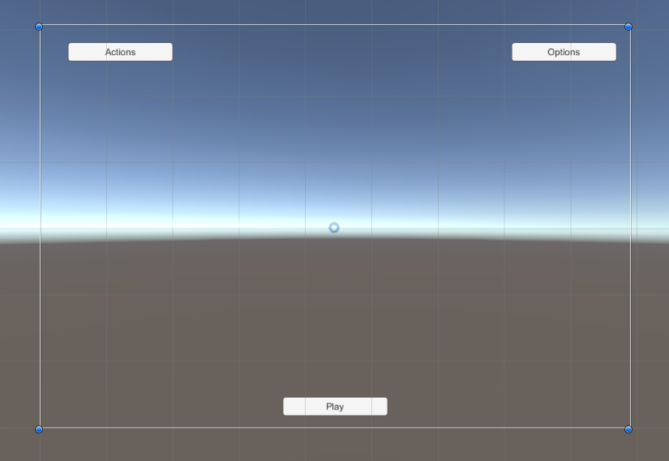
Play, and change the screen size. You'll see the buttons go off the edge of the screen, because they're by default anchored to the centre.

Change this with the anchors widget so that each one is anchored to the correct corner of the screen. Now resize the screen after running and see how they're all anchored to the correct screen points

Button Clicks
Lets make an object below the Actiosn button to hold actions.
For now, create a ScrollView below it, and give it an extra component called UIPanel (which we'll od more with later.
For now, lets give this the one function, Toggle, which turns it on and off.

public void Toggle()
{
gameObject.SetActive(!gameObject.activeSelf);
}

We can hook it up to the Actions button using the OnClick event in the inspector

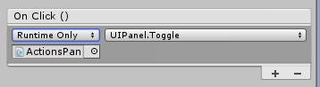
Clicking the Action button should now toggle this panel on and off.

Programmatic UI
That's all well and good, but often we want to set up a UI for a variable list of data.
Lets set up the following classes:

Action – base class Scriptable object that does something to a GameObject.
MaterialAction – derived class that changes the materials on an object

We want to have a List of Actions that we can display in the UI as buttons with info that we can click on.

We need a UIActionList component that manages and updates the list of UI elements to match the List
and a UIAction component to handle the UI for an individual Action.

Let's start with the UIAction and Action classes. An Action can exist without a UIAction (eg through a keyboard interface) but a UIAction needs an action.

Actions have a name (inherited from object) description and a icon, and an abstract fucntion for their action.

public abstract class Action : ScriptableObject {

public Sprite icon;
public string desc;

public abstract void DoAction(GameObject target);
}

So UIActions need an Image and two text fields to represent these, and a reference to their action.

public class UIAction : MonoBehaviour {

public Action action;
public Image icon;
public Text nameTag;
public Text descTag;

We can put together a background image with these on in our ScrollRect (as children of the Content object) and set them up like this.

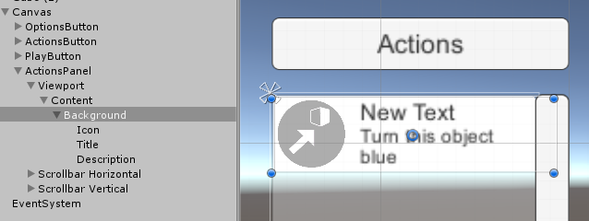
Put a UIAction script on the Background item and link up its fields in the inspector like so.
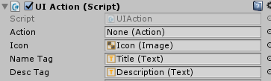
We could set an action in the editor, but our paln is to read a list of actions and create a copy of this for every action, and set the action programatically.
We put a SetAction fucntion into UIAction that uipdates these fields when the action its showing changes.
public void SetAction(Action a)
{
action = a;
if (icon)
icon.sprite = action.icon;
if (nameTag)
nameTag.text = action.name;
if (descTag)
descTag.text = action.desc;
}

Add a Button component to the Icon, and don't do anything with it's OnClick event for now, as we'll hook it up via script later.
Lets set up the list now.
Now, on the Content (parent of the Background item) add a UIActionList component. This will hold a list of actions we can set in the editor (for now) or via script (later).
public class UIActionList : MonoBehaviour {

public List<Action> actions = new List<Action>();
public UIAction uiPrefab;

Dictionary<Action, UIAction> uiActions = new Dictionary<Action, UIAction>();

This holds -
a List of Actions which we use as master data.
A uiPrefab, of which we'll clone one of per action
A dictionary mapping actions to their UIAction to help us remove old actions when the list changes.

In start we turn off the prefab, and update our list of actions (moved to a separate function so we can call it from elsewhere)

In UpdateActions we:
- Go through our existing dictionary of items and remove an UIActions whose Actions are no longer in the list
- Instantiate a new UIAction for every action that doesn't have one, and call SetAction on it.
This means we can load up some actions in the editor and see them all in the panel when we run!

Final step – we've added a button click event to each UIAction's button object via script, this works just as if we'd set it up in the editor.
public Button button;

void Start()
{
// hook up button
button.onClick.AddListener(OnClicked);
}

public void OnClicked()
{
action.DoAction(Action.selectedObject);
}

We've added a little component on the Camera to set the static variable Action.selectedObject with mouseclicks. If you run now, you should get the Actions appearing, and be able to click on obejcts and then on the action buttons to change the colour of things.
(Load Demo2 for this)

One last point – clicking UI elements may cause you to click on the ground plane, and affect it rather than one of the boxes! To fix this, add a check to the Selector script to make sure we're not on top of a UI element when we click.
public class Selector : MonoBehaviour {

public EventSystem eventSystem;

void Update()
{
if (Input.GetMouseButtonDown(0) && eventSystem.IsPointerOverGameObject() == false)
{
RaycastHit hit;
if (Physics.Raycast(Camera.main.ScreenPointToRay(Input.mousePosition), out hit))
{
Action.selectedObject = hit.collider.gameObject;
}
}
}
}

Duplicating our action panel into a hotkey bar
We can use the exact same code to make a hotkey bar down the bottom left of the screen.
- Make a 264 x40 image with the background image on it, and add a UIActionList to it.
- Copy the icon from the action panel, and paste it into the Action Bar as a child. Give it a UIAction component. Hook it up to itself as Icon and Button, leaving the Text entries blank.
- Drag six actions into the list in UI Action List and set the Icon to be the UI Prefab.
This should all work without extra code now. You'll get a little bar with six icons which do their thing on the selected object.
Two criticisms.
- We have the same list of actions specified twice.
- We can't tell which buttons does what on the hot bar. Tooltips would be awesome!

We'll put a Player script on the Ethan character, and store our central Actions list in there.

public class Player : MonoBehaviour {

public List<Action> actions;

We'll then make an event derived class to braodcast to any interested parties when our actions list changes, and we send this event from Start to initialise our bar and panel.

[System.Serializable]
public class PlayerEvent : UnityEvent<Player>
{ }

public PlayerEvent onActionsChanged;

// Use this for initialization
void Start () {
onActionsChanged.Invoke(this);
}

void SetActions(List<Action> acs)
{
actions = acs;
onActionsChanged.Invoke(this);
}

}

In the Player we then hook up the Action Bar and Content of the ActionPanel via the Inspector.

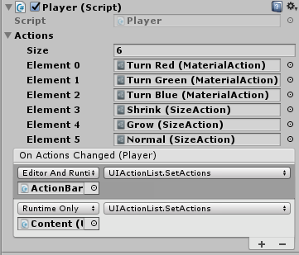
Note that at the top of the function list when you expand it for UIActionList it says Dynamic Player, which means it will pass the Player entry from the Invoke call through as an argument.
Run this and you should get matching arguments in the Panel and Bar.

Now we want to be able to change the Player's powers at runtime.

We can make an Options panel to do this, where we can toggle on or off the color actions or size actions. We get this to call the Player's SetActions function, where it rests its list of actions and then broadcasts it to any interested parties such as the ActionBar and ActionPanel.

Note the coroutine used in UIActionList to size the bars when they adapt.

Tooltips
The approach we take here is to have a single image and text item on a separate canvas, and move it into position when we mouse over an object that requires a tooltip. When we exit we turn the object off.
The new canvas gets a Tooltip component, which has a static instance member in a simple singleton pattern. The one Ive provided automastically finds the gameobject for the tooltip component (for turning on and off), the Image component (for resizing) and the Text item (for setting the message).
When we show it, we determine which quadrant of the screen we're in, and set the pivot of the tooltip accordingly, so it never goes off screen.
When we set the text message, we use a TextGenerator to determine how big to make the tooltip to fit the text nicely.

We have a TooltipUser script we place on any item we want to show a tooltip, like the Icons on the ActionBar.
In the start() we hook up mouse enter and exit events via an EventTrigger, which we add programmatically for ease of setup.
This requires one of its sibling components to implement the IToolTip interface, which returns the messgae to display. Here we've added that to UIAction to show the name in bold and the description on the next line.

And that's it. The actionBar will now display tooltips!
Note that the tooltip canvas and text have Raycast Target turned off, so they don't pop up and obscure the mouse pointer, which leads to tooltips flickering on and off.

World Space canvases
You can set up a UI screen in world space.
Very useful for VR/AR, Health Bars (See separate project in Unity Best Practice folder) and just general coolness!
Demo5 scene has moved the Options Menu to above the second cube.
The canvas is a child of the cube now.
Its been scaled to 1/100th, because world coordinates are much smaller numbers that screen pixel coordinates generally. The canvas is a chile of the cube now, and so shrinks and grows with the cube.

Particles in the UI.

