Empirical Benchmarking Apparatus
Interpretability Score (S) as a Quantitative Metric - standard vs. adversarial training; 7 dataset-model pairings x 2 regimes x 2 runs = 28 runs.
Metrics tracked throughout: Accuracy, PGD Accuracy (robustness), S / Structural Bottleneck Score (interpretability), Integral, Generalization (accuracy-PGD gap)
1. Summary table (mean +/- CI) - accuracy, PGD accuracy, S, integral, per pairing, standard vs. adversarial
2. Best vs. last checkpoint table - same metric set, stability/drift over training
3. Training curves - small multiples: rows = pairings, columns = metrics, standard vs. adversarial with variance bands
4. Stability-across-runs plot - individual-run traces plus bold mean, per metric, per pairing
5. Compute table - wall-clock time per run, per pairing/regime
6. Ablation - on the key hyperparameter for computing S (layer/rank/PCA-truncation choice), reporting effect on all four metrics
7. Significance test - paired test (Wilcoxon/paired t) per pairing, per metric
8. Trade-offs section - 8a Accuracy vs. S; 8b PGD accuracy vs. S; 8c Accuracy vs. PGD accuracy; 8d 3-way scatter matrix
9. Full Observation Visualization - every summary number backed by its raw observations:
9.1 Per-pairing distribution plot (violin/strip) - one panel per metric, raw points overlaid
9.2 Eigenvalue spectrum overlay - the raw covariance spectrum S is derived from, per pairing
9.3 Training-curve panel grid - observation-level version of (3)
9.4 Stability strip - observation-level version of (4)
9.5 Relationship scatter matrix - accuracy x robustness x interpretability, all runs plotted
9.6 Best-vs-last paired dot plot - drift shown as a slope, per metric, per pairing
9.7 Layer-wise score matrix (heatmap) - standard, adversarial, and difference map
9.8 Layer x width x integral relationship - heatmap plus line-slice view by depth bin
9.9 Depth/width marginal plots - score/integral vs. depth and vs. width
9.10 Layer-to-network aggregation check - whole-network S vs. mean/min/max/last-layer aggregations
9.11 Layer importance / contribution ranking - which layers drive the aggregate score
9.12 Cross-layer correlation matrix - modularity vs. shared structure across layers
9.13 Layer-wise training trajectory - one panel per layer, S vs. epoch
9.14 Bottleneck localization plot - where the rank-loss/concentration bottleneck sits
9.15 Per-layer robustness-interpretability scatter - layer-level version of (8b)
10. Leaderboard-style cross-model comparison - answers "which model wins" directly, the way RobustBench leaderboards do:
10.1 Ranked dot plot - all pairings/regimes sorted by S, mean with 95% CI
10.2 Multi-metric parallel coordinates - one line per pairing/regime across accuracy, PGD accuracy, S, integral
10.3 Pareto frontier plot - robustness vs. interpretability, Pareto-optimal pairings highlighted
10.4 Rank-stability plot - leaderboard order, best vs. last checkpoint

Model / Dataset / Method Pairings
Model | Dataset | Regime
ResNet-18 | CIFAR-10 | Standard
ResNet-18 | CIFAR-10 | Adversarial
VGG-16 | CIFAR-10 | Standard
VGG-16 | CIFAR-10 | Adversarial
ResNet-18 | CIFAR-100 | Standard
ResNet-18 | CIFAR-100 | Adversarial
WideResNet-28-10 | CIFAR-100 | Standard
WideResNet-28-10 | CIFAR-100 | Adversarial
ResNet-18 | TinyImageNet-200 | Standard
ResNet-18 | TinyImageNet-200 | Adversarial
ResNet-18 | CUB-200-2011 | Standard
ResNet-18 | CUB-200-2011 | Adversarial
ViT-B/16 | CUB-200-2011 | Standard
ViT-B/16 | CUB-200-2011 | Adversarial
7 pairings, ResNet-18 as the through-line across all four datasets, plus one dataset-specific specialist each (VGG-16, WideResNet-28-10, ViT-B/16). 7 pairings x 2 regimes x 2 replicate runs = 28 runs.

Table 1
Pairing | Regime | Accuracy (%) | PGD Accuracy (%) | S | Integral
ResNet-18/CIFAR-10 | Standard | — ± — | — ± — | — ± — | — ± —
ResNet-18/CIFAR-10 | Adversarial | — ± — | — ± — | — ± — | — ± —
VGG-16/CIFAR-10 | Standard | — ± — | — ± — | — ± — | — ± —
VGG-16/CIFAR-10 | Adversarial | — ± — | — ± — | — ± — | — ± —
ResNet-18/CIFAR-100 | Standard | — ± — | — ± — | — ± — | — ± —
ResNet-18/CIFAR-100 | Adversarial | — ± — | — ± — | — ± — | — ± —
WideResNet-28-10/CIFAR-100 | Standard | — ± — | — ± — | — ± — | — ± —
WideResNet-28-10/CIFAR-100 | Adversarial | — ± — | — ± — | — ± — | — ± —
ResNet-18/TinyImageNet-200 | Standard | — ± — | — ± — | — ± — | — ± —
ResNet-18/TinyImageNet-200 | Adversarial | — ± — | — ± — | — ± — | — ± —
ResNet-18/CUB-200-2011 | Standard | — ± — | — ± — | — ± — | — ± —
ResNet-18/CUB-200-2011 | Adversarial | — ± — | — ± — | — ± — | — ± —
ViT-B/16/CUB-200-2011 | Standard | — ± — | — ± — | — ± — | — ± —
ViT-B/16/CUB-200-2011 | Adversarial | — ± — | — ± — | — ± — | — ± —
Table 1. Summary statistics (mean ± 95% CI) for accuracy, PGD accuracy, S, and integral, by pairing and training regime, averaged across replicate runs.

Table 2
Pairing | Regime | Acc. Best | Acc. Last | PGD Best | PGD Last | S Best | S Last
ResNet-18/CIFAR-10 | Standard | — | — | — | — | — | —
ResNet-18/CIFAR-10 | Adversarial | — | — | — | — | — | —
VGG-16/CIFAR-10 | Standard | — | — | — | — | — | —
VGG-16/CIFAR-10 | Adversarial | — | — | — | — | — | —
ResNet-18/CIFAR-100 | Standard | — | — | — | — | — | —
ResNet-18/CIFAR-100 | Adversarial | — | — | — | — | — | —
WideResNet-28-10/CIFAR-100 | Standard | — | — | — | — | — | —
WideResNet-28-10/CIFAR-100 | Adversarial | — | — | — | — | — | —
ResNet-18/TinyImageNet-200 | Standard | — | — | — | — | — | —
ResNet-18/TinyImageNet-200 | Adversarial | — | — | — | — | — | —
ResNet-18/CUB-200-2011 | Standard | — | — | — | — | — | —
ResNet-18/CUB-200-2011 | Adversarial | — | — | — | — | — | —
ViT-B/16/CUB-200-2011 | Standard | — | — | — | — | — | —
ViT-B/16/CUB-200-2011 | Adversarial | — | — | — | — | — | —
Table 2. Best-checkpoint vs. last-checkpoint values, addressing potential drift/overfitting of the interpretability score over training.

Table 3
Pairing | Regime | Compute (h) | Runs (n)
ResNet-18/CIFAR-10 | Standard | — ± — | 2
ResNet-18/CIFAR-10 | Adversarial | — ± — | 2
VGG-16/CIFAR-10 | Standard | — ± — | 2
VGG-16/CIFAR-10 | Adversarial | — ± — | 2
ResNet-18/CIFAR-100 | Standard | — ± — | 2
ResNet-18/CIFAR-100 | Adversarial | — ± — | 2
WideResNet-28-10/CIFAR-100 | Standard | — ± — | 2
WideResNet-28-10/CIFAR-100 | Adversarial | — ± — | 2
ResNet-18/TinyImageNet-200 | Standard | — ± — | 2
ResNet-18/TinyImageNet-200 | Adversarial | — ± — | 2
ResNet-18/CUB-200-2011 | Standard | — ± — | 2
ResNet-18/CUB-200-2011 | Adversarial | — ± — | 2
ViT-B/16/CUB-200-2011 | Standard | — ± — | 2
ViT-B/16/CUB-200-2011 | Adversarial | — ± — | 2
Table 3. Wall-clock compute time per run, by pairing and regime.

Table 4
Hyperparameter value | Accuracy (%) | PGD Accuracy (%) | S | Integral | Compute (h)
Layer subset A | — ± — | — ± — | — ± — | — ± — | — ± —
Layer subset B | — ± — | — ± — | — ± — | — ± — | — ± —
Layer subset C | — ± — | — ± — | — ± — | — ± — | — ± —
Full rank | — ± — | — ± — | — ± — | — ± — | — ± —
Truncated rank | — ± — | — ± — | — ± — | — ± — | — ± —
Table 4. Ablation on the hyperparameter used to compute S (e.g., layer subset, rank truncation), showing its downstream effect on all tracked metrics.

Table 5
Pairing | Metric | Test statistic | p-value | Significant (α=0.05)
ResNet-18/CIFAR-10 | Accuracy | — | — | —
ResNet-18/CIFAR-10 | PGD Accuracy | — | — | —
ResNet-18/CIFAR-10 | S | — | — | —
ResNet-18/CIFAR-10 | Integral | — | — | —
VGG-16/CIFAR-10 | Accuracy | — | — | —
VGG-16/CIFAR-10 | PGD Accuracy | — | — | —
VGG-16/CIFAR-10 | S | — | — | —
VGG-16/CIFAR-10 | Integral | — | — | —
ResNet-18/CIFAR-100 | Accuracy | — | — | —
ResNet-18/CIFAR-100 | PGD Accuracy | — | — | —
ResNet-18/CIFAR-100 | S | — | — | —
ResNet-18/CIFAR-100 | Integral | — | — | —
WideResNet-28-10/CIFAR-100 | Accuracy | — | — | —
WideResNet-28-10/CIFAR-100 | PGD Accuracy | — | — | —
WideResNet-28-10/CIFAR-100 | S | — | — | —
WideResNet-28-10/CIFAR-100 | Integral | — | — | —
ResNet-18/TinyImageNet-200 | Accuracy | — | — | —
ResNet-18/TinyImageNet-200 | PGD Accuracy | — | — | —
ResNet-18/TinyImageNet-200 | S | — | — | —
ResNet-18/TinyImageNet-200 | Integral | — | — | —
ResNet-18/CUB-200-2011 | Accuracy | — | — | —
ResNet-18/CUB-200-2011 | PGD Accuracy | — | — | —
ResNet-18/CUB-200-2011 | S | — | — | —
ResNet-18/CUB-200-2011 | Integral | — | — | —
ViT-B/16/CUB-200-2011 | Accuracy | — | — | —
ViT-B/16/CUB-200-2011 | PGD Accuracy | — | — | —
ViT-B/16/CUB-200-2011 | S | — | — | —
ViT-B/16/CUB-200-2011 | Integral | — | — | —
Table 5. Paired significance test (Wilcoxon signed-rank / paired t-test) per pairing and metric, testing whether adversarial training changes the metric relative to standard training.

Figure 1
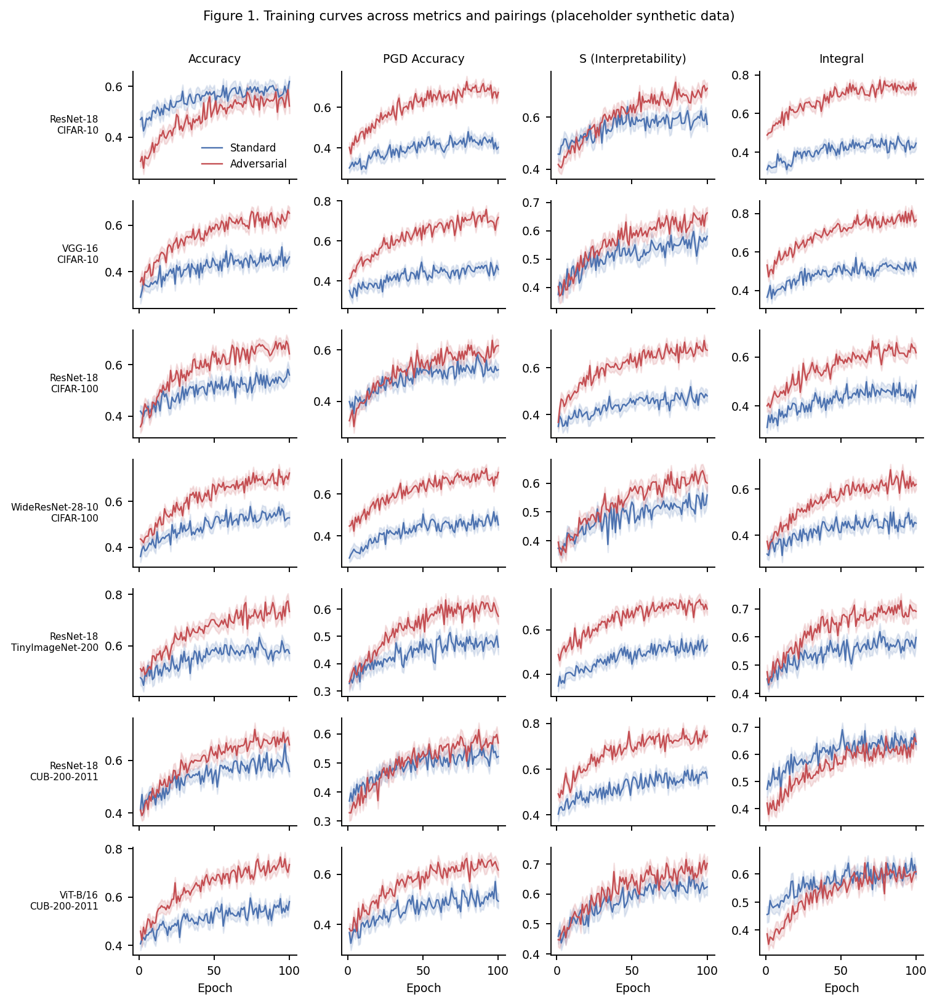
Figure 1. Training curves across metrics (accuracy, PGD accuracy, S, integral) and pairings, standard vs. adversarial. Shaded bands show ±1 s.d. across replicate runs. Placeholder synthetic data.

Figure 2
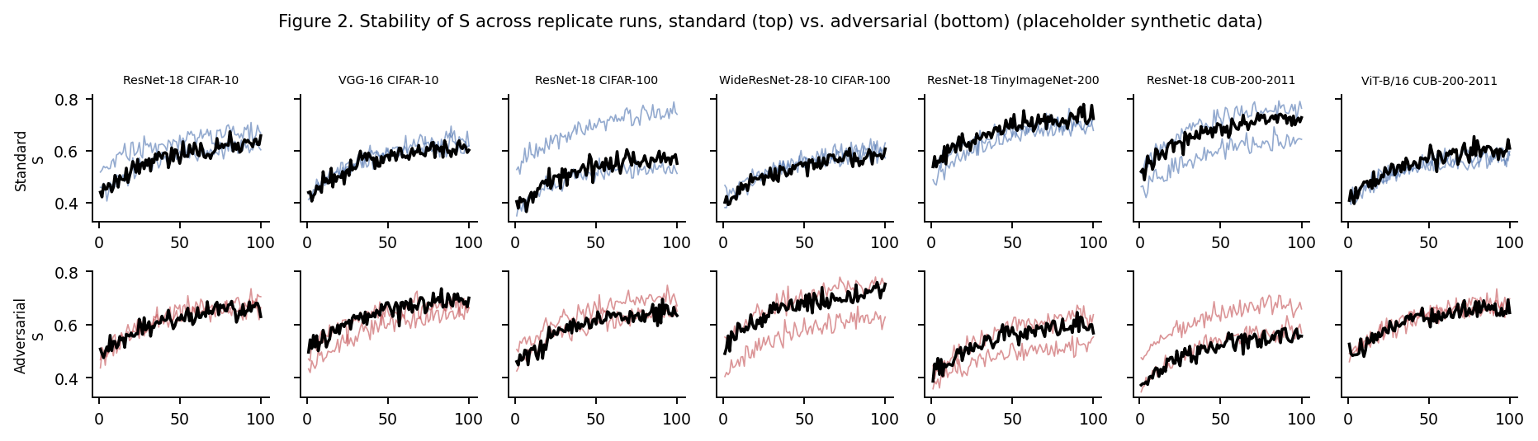
Figure 2. Stability of S across replicate runs, standard (top row) vs. adversarial (bottom row), by pairing. Thin lines: individual runs; thick line: mean. Placeholder synthetic data.

Figure 3
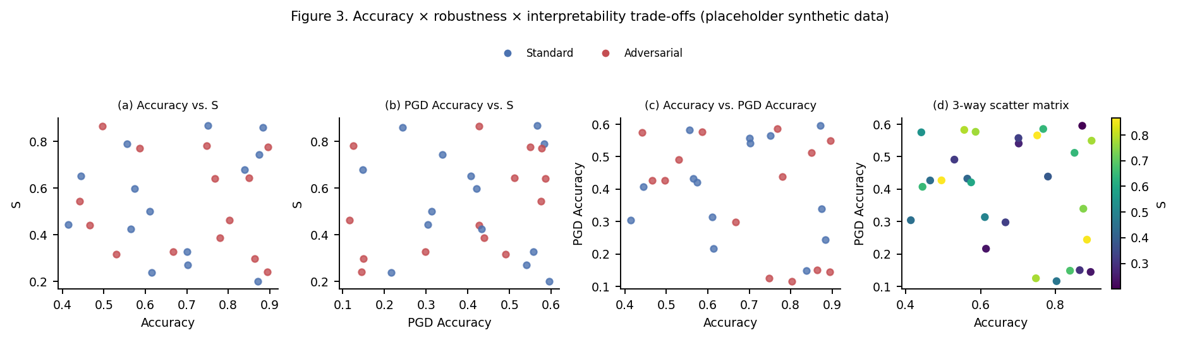
Figure 3. Accuracy × robustness × interpretability trade-offs. (a) Accuracy vs. S. (b) PGD accuracy vs. S. (c) Accuracy vs. PGD accuracy. (d) Joint scatter colored by S. Placeholder synthetic data.

Figure 4
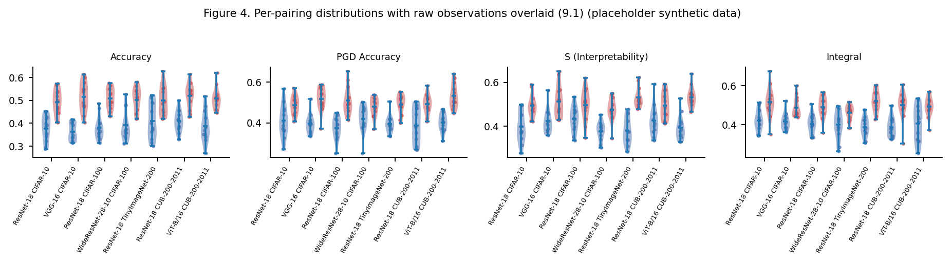
Figure 4 (9.1). Per-pairing distributions of accuracy, PGD accuracy, S, and integral, standard vs. adversarial, with raw observations overlaid on violin plots. Placeholder synthetic data.

Figure 5
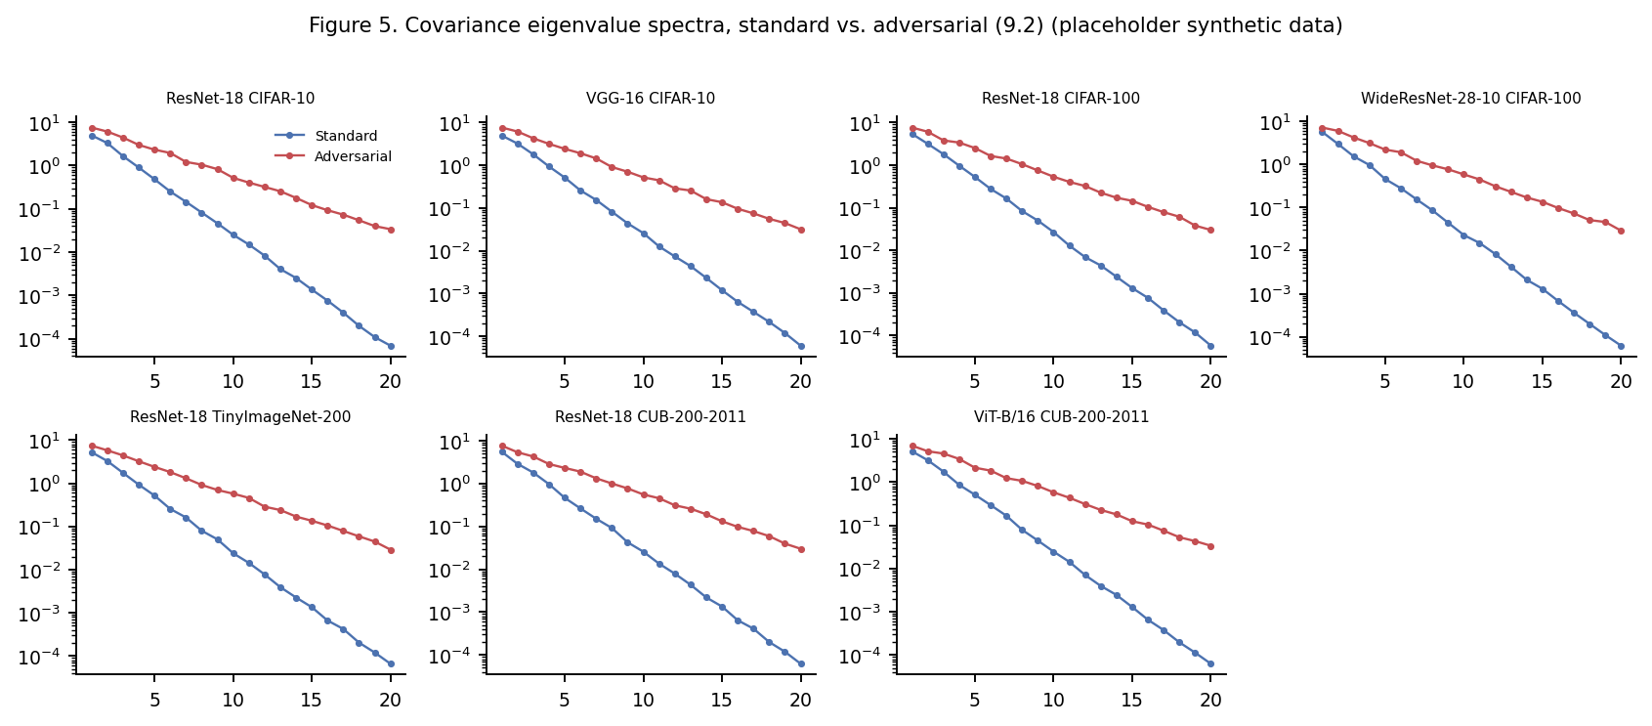
Figure 5 (9.2). Covariance eigenvalue spectra, standard vs. adversarial, by pairing — the raw material from which S is computed. Placeholder synthetic data.

Figure 6
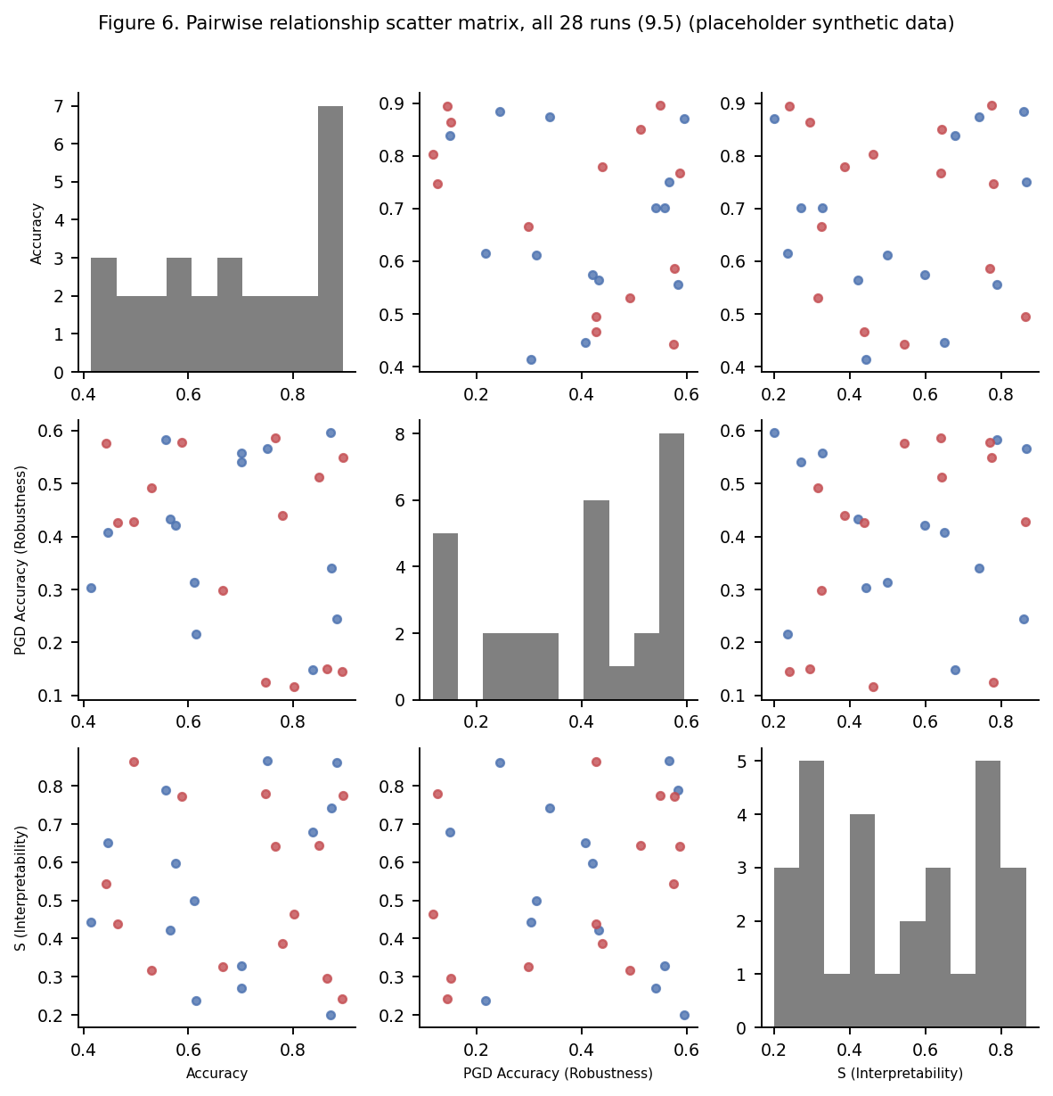
Figure 6 (9.5). Pairwise relationship scatter matrix — accuracy, PGD accuracy (robustness), and S (interpretability) — all individual runs plotted, colored by regime. Diagonal shows marginal histograms. Placeholder synthetic data.

Figure 7
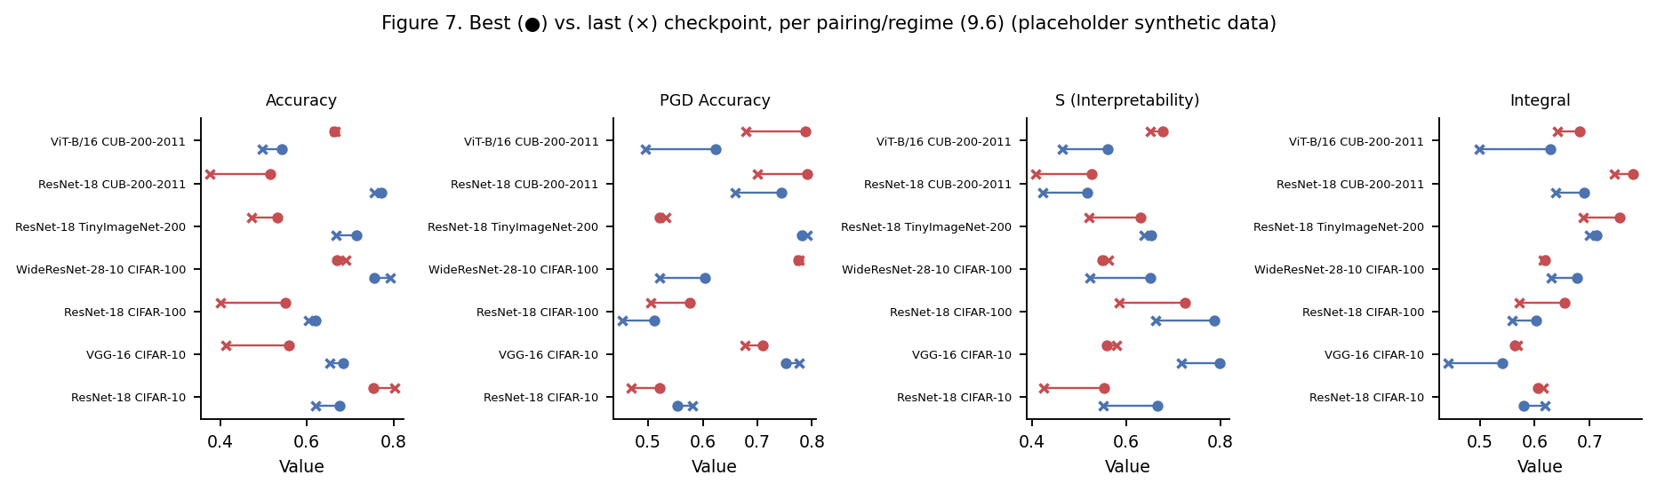
Figure 7 (9.6). Best (●) vs. last (×) checkpoint per pairing and regime, across metrics — drift/overfitting visible as connecting-line slope. Placeholder synthetic data.

Figure 8
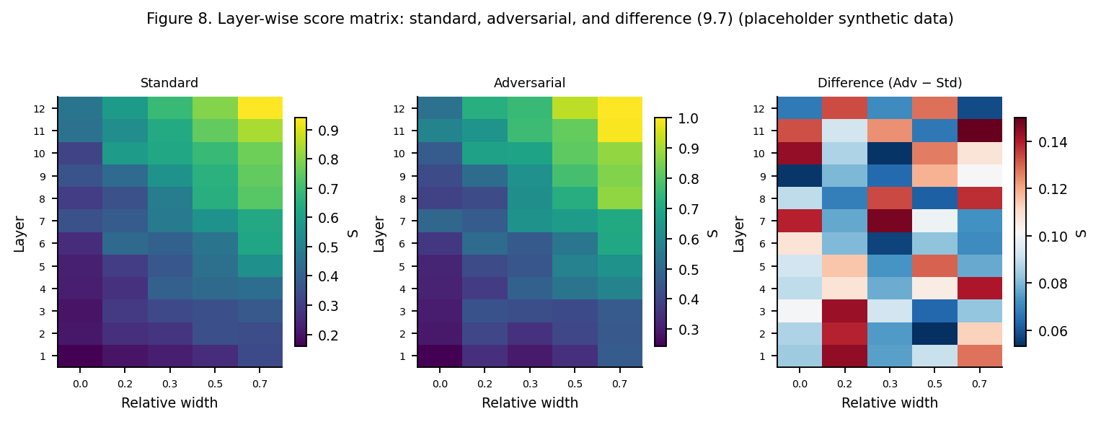
Figure 8 (9.7). Layer-wise S score matrix (layer × relative width): standard, adversarial, and difference (adversarial − standard). Placeholder synthetic data.

Figure 9
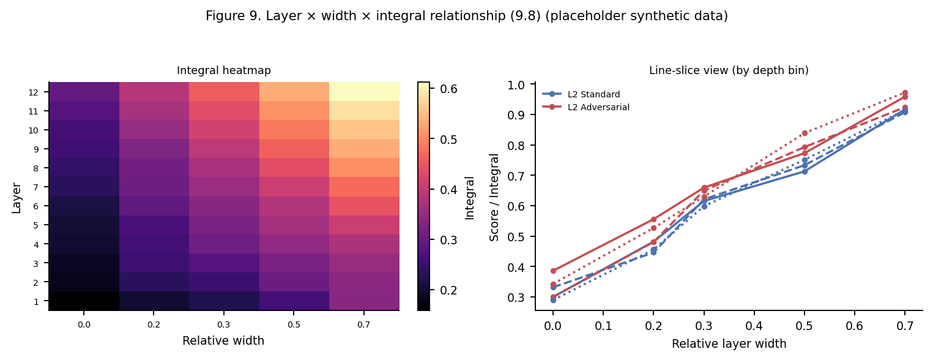
Figure 9 (9.8). Layer × width × integral relationship: heatmap of cumulative integral (left), and line-slice view by depth bin (right). Placeholder synthetic data.

Figure 10
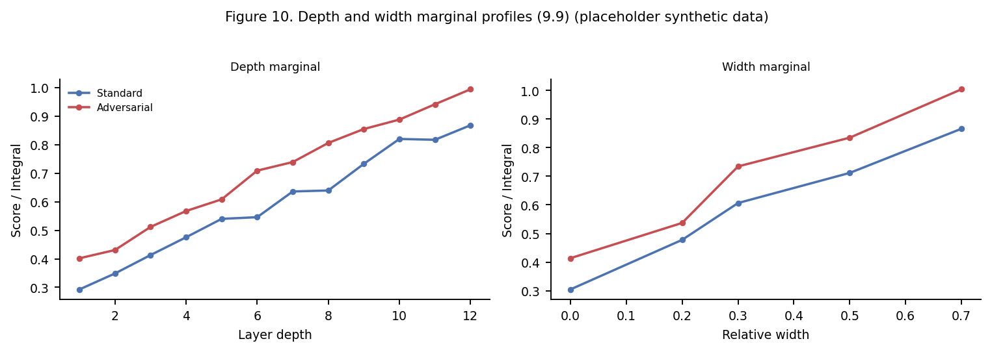
Figure 10 (9.9). Depth marginal (left) and width marginal (right) profiles of score/integral, standard vs. adversarial. Placeholder synthetic data.

Figure 11
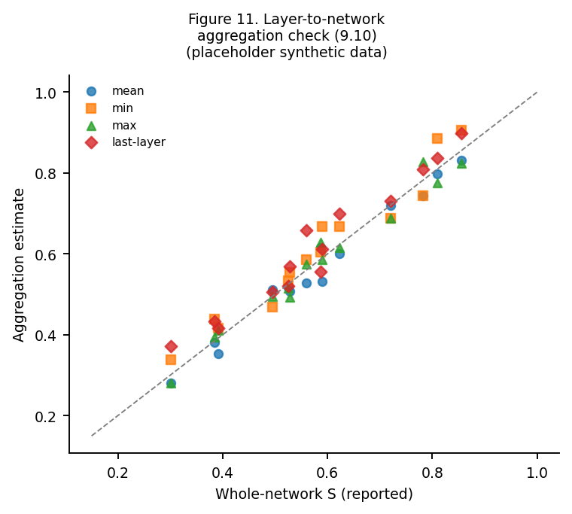
Figure 11 (9.10). Layer-to-network aggregation check: whole-network S (reported) vs. simple aggregations (mean, min, max, last-layer) of the per-layer matrix. Dashed line: identity. Placeholder synthetic data.

Figure 12
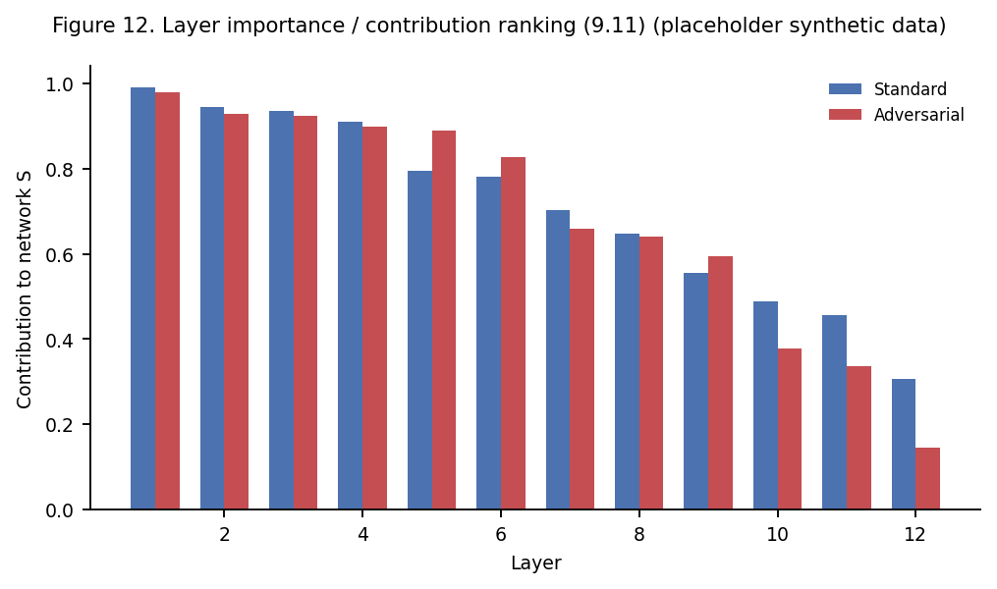
Figure 12 (9.11). Layer importance / contribution ranking to the aggregate network S, standard vs. adversarial. Placeholder synthetic data.

Figure 13
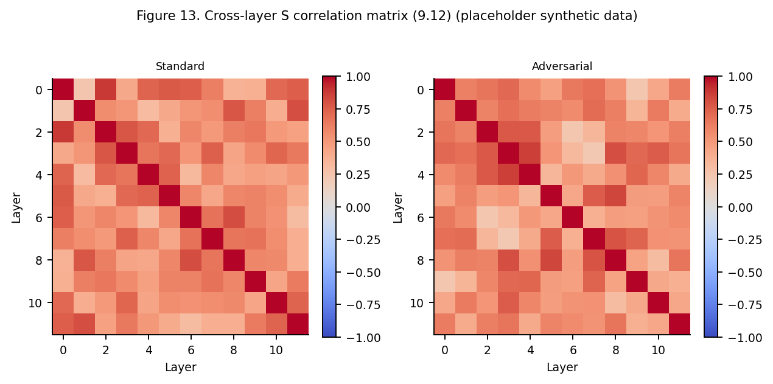
Figure 13 (9.12). Cross-layer correlation matrix of S values across runs/checkpoints, standard vs. adversarial. Placeholder synthetic data.

Figure 14
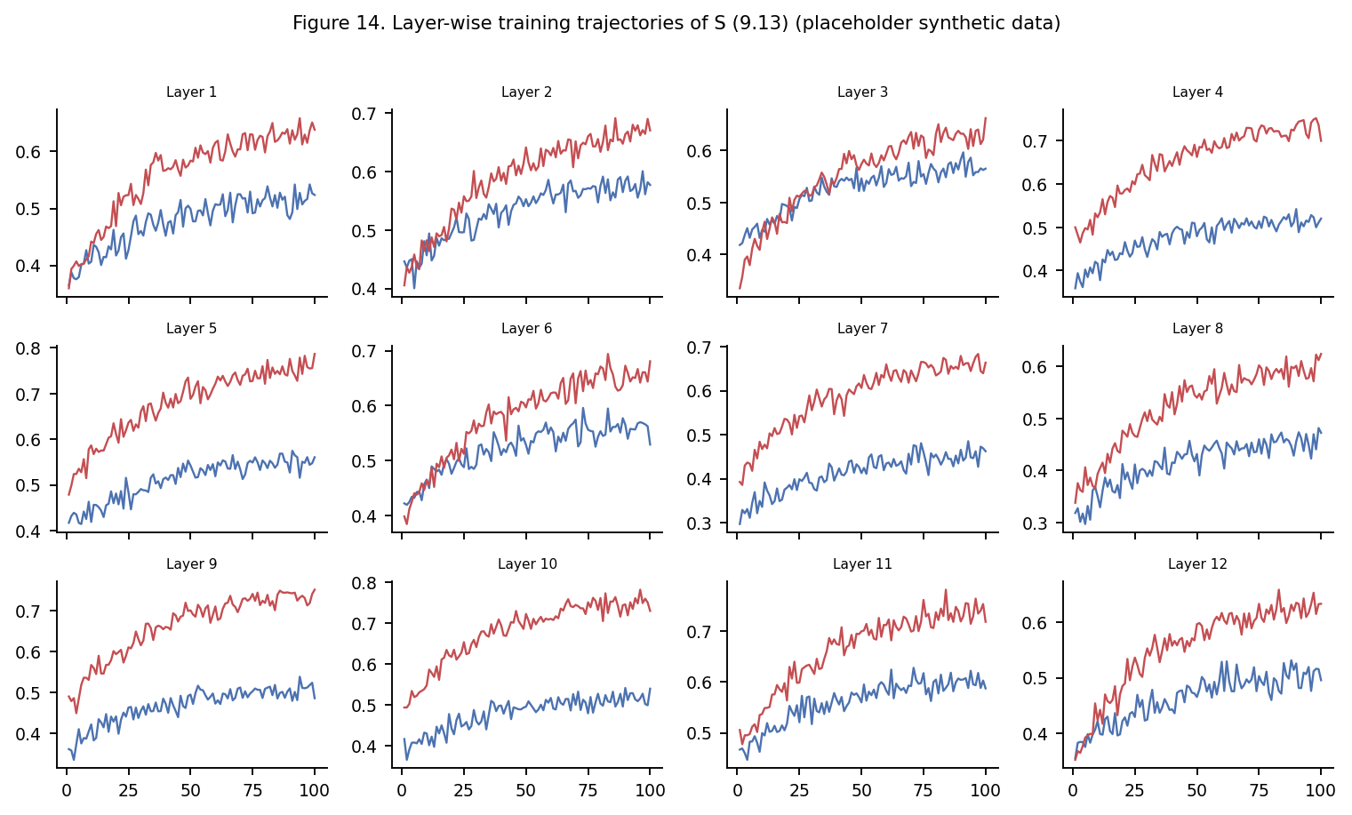
Figure 14 (9.13). Layer-wise training trajectories of S, one panel per layer, standard vs. adversarial. Placeholder synthetic data.

Figure 15
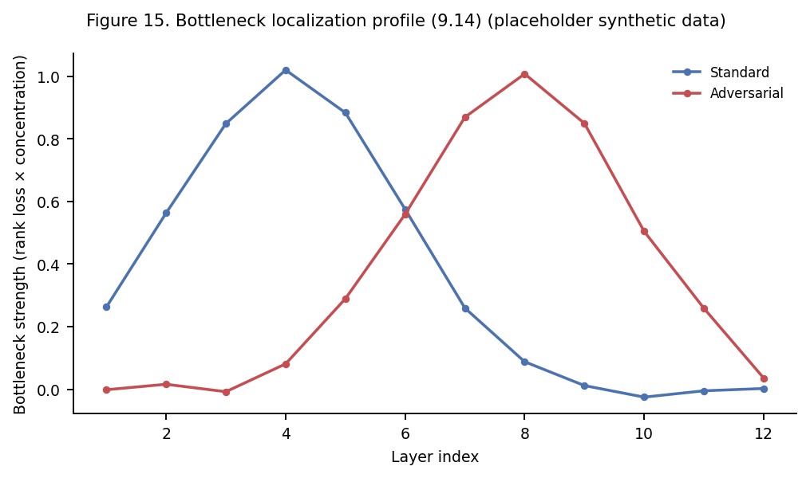
Figure 15 (9.14). Bottleneck localization profile across layer index (rank loss × concentration increase), standard vs. adversarial. Placeholder synthetic data.

Figure 16
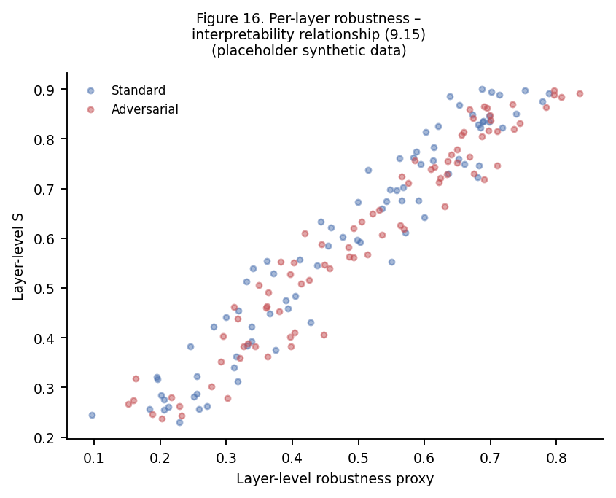
Figure 16 (9.15). Per-layer robustness–interpretability relationship: layer-level S vs. layer-level robustness proxy, standard vs. adversarial. Placeholder synthetic data.

Figure 17
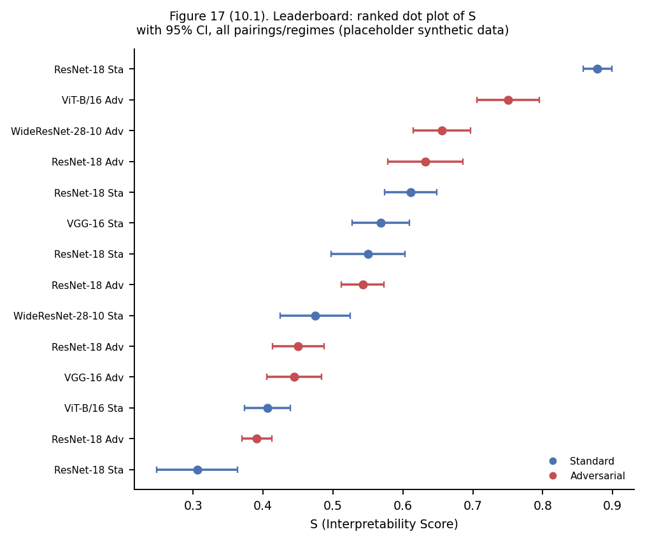
Figure 17 (10.1). Leaderboard: ranked dot plot of S with 95% CI, all pairings and regimes, sorted from highest to lowest. Placeholder synthetic data.

Figure 18
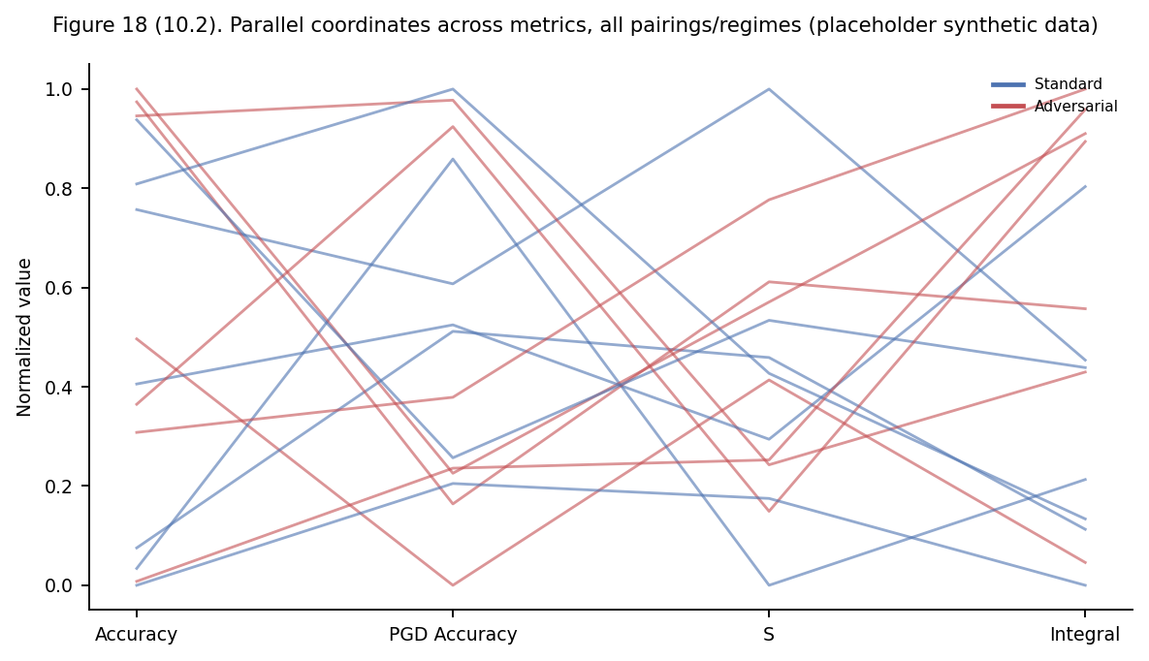
Figure 18 (10.2). Parallel coordinates across accuracy, PGD accuracy, S, and integral, one line per pairing/regime (normalized per axis). Placeholder synthetic data.

Figure 19
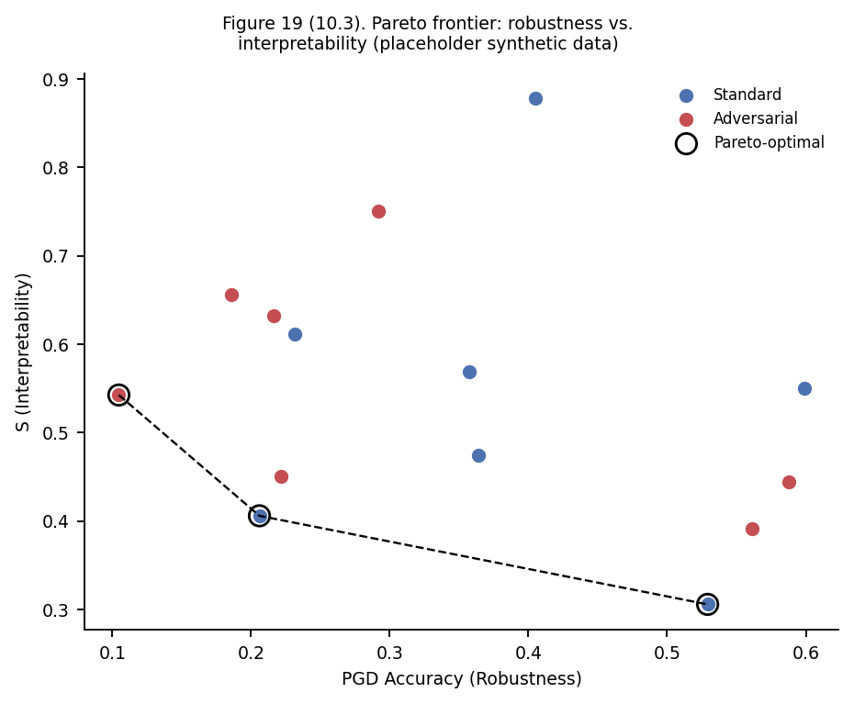
Figure 19 (10.3). Pareto frontier of robustness (PGD accuracy) vs. interpretability (S); open circles mark Pareto-optimal pairings/regimes. Placeholder synthetic data.

Figure 20
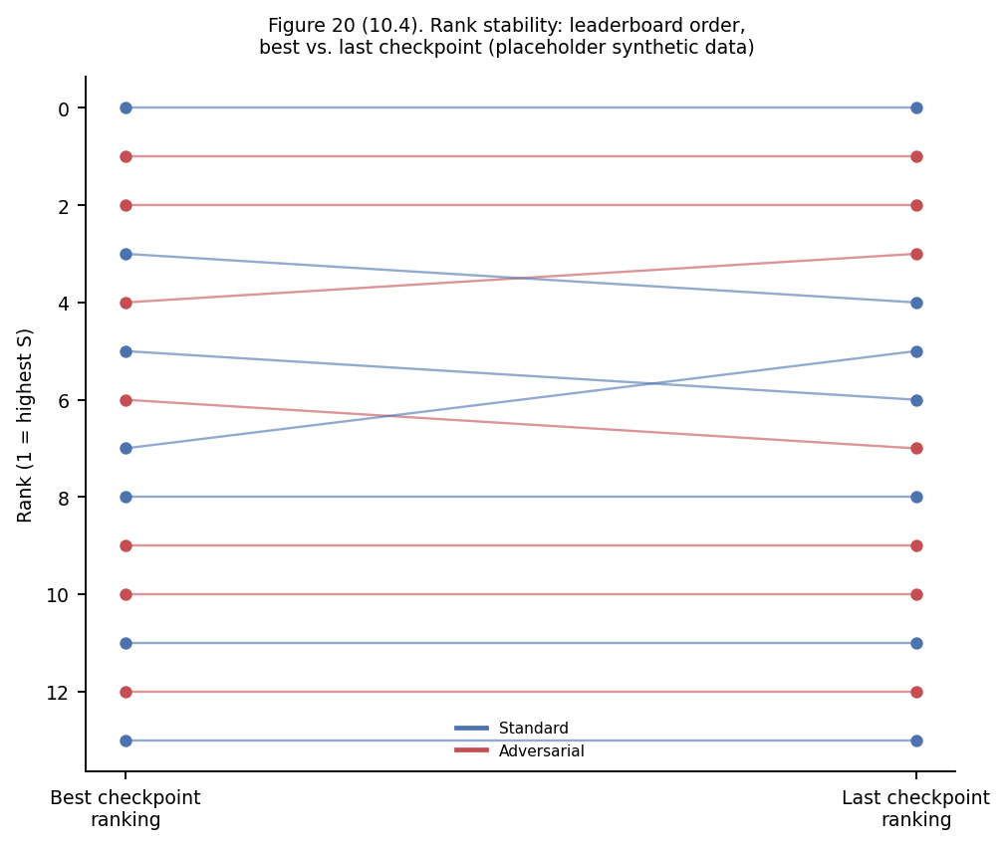
Figure 20 (10.4). Rank stability of the S leaderboard: ranking from best-checkpoint S vs. ranking from last-checkpoint S, per pairing/regime. Placeholder synthetic data.

