

EFFICACY OF ADJUVANT AZITHROMYCIN AND 3RD GENERATION CEPHALOSPORIN TO PREVENT POST CESAREAN SSI: A RANDOMISED CONTROL NON-INFERIORITY TRIAL
THESIS SUBMITTED IN THE PARTIAL FULFILLMENT OF THE REQUIREMENT FOR THE AWARD OF THE DEGREE OF
MS
Obstetrics and Gynecology
Under
ALL INDIA INSTITUTE OF MEDICAL SCIENCES PATNA
(SESSION: January 2024 – January 2027)
By
Dr Purnima Sagar

DEPARTMENT OF OBSTETRICS AND GYNECOLOGY
ALL INDIA INSTITUTE OF MEDICAL SCIENCES,
PATNA
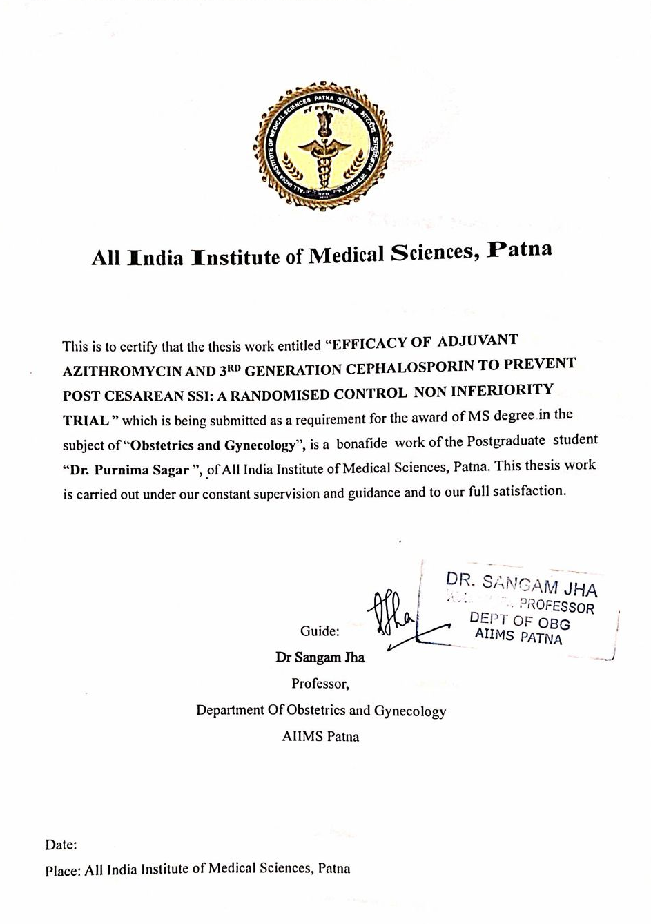
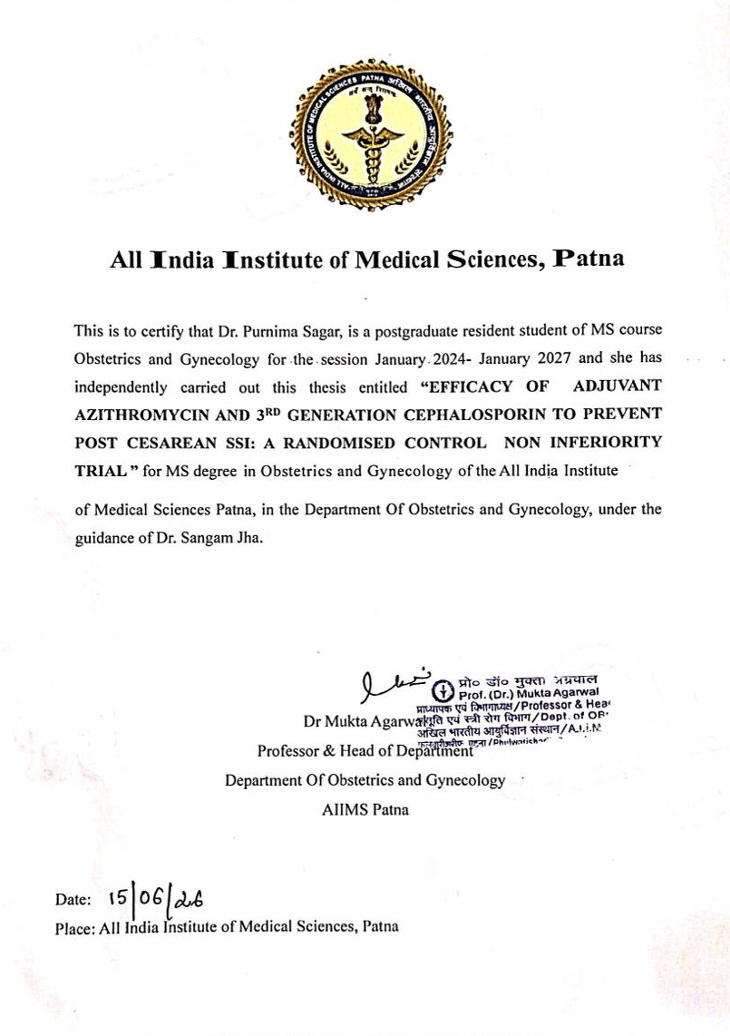

All India Institute of Medical Sciences, Patna
I hereby declare that this thesis work entitled “EFFICACY OF ADJUVANT AZITHROMYCIN AND 3RD GENERATION CEPHALOSPORIN TO PREVENT POST CESAREAN SSI: A RANDOMISED CONTROL NON INFERIORITY TRIAL”, submitted in the partial fulfillment of the requirement for the award of the degree MD/MS/MDS/DM/M.Ch in the subject of “Obstetrics and Gynecology”, All India Institute of Medical Sciences, Patna, is a record of original work done by me under the supervision of Dr. Sangan Jha.
The information and data given in this research work is authenticated to the best of my knowledge. This research is not submitted to any other university or institution for the award of any degree, diploma, fellowship or published any time before.

Dr Purnima Sagar
Junior Resident (Academic)
Department Of Obstetrics and Gynecology
AIIMS Patna

Date: 15/06/2026
Place: All India Institute of Medical Sciences, Patna

IEC Approval Letter
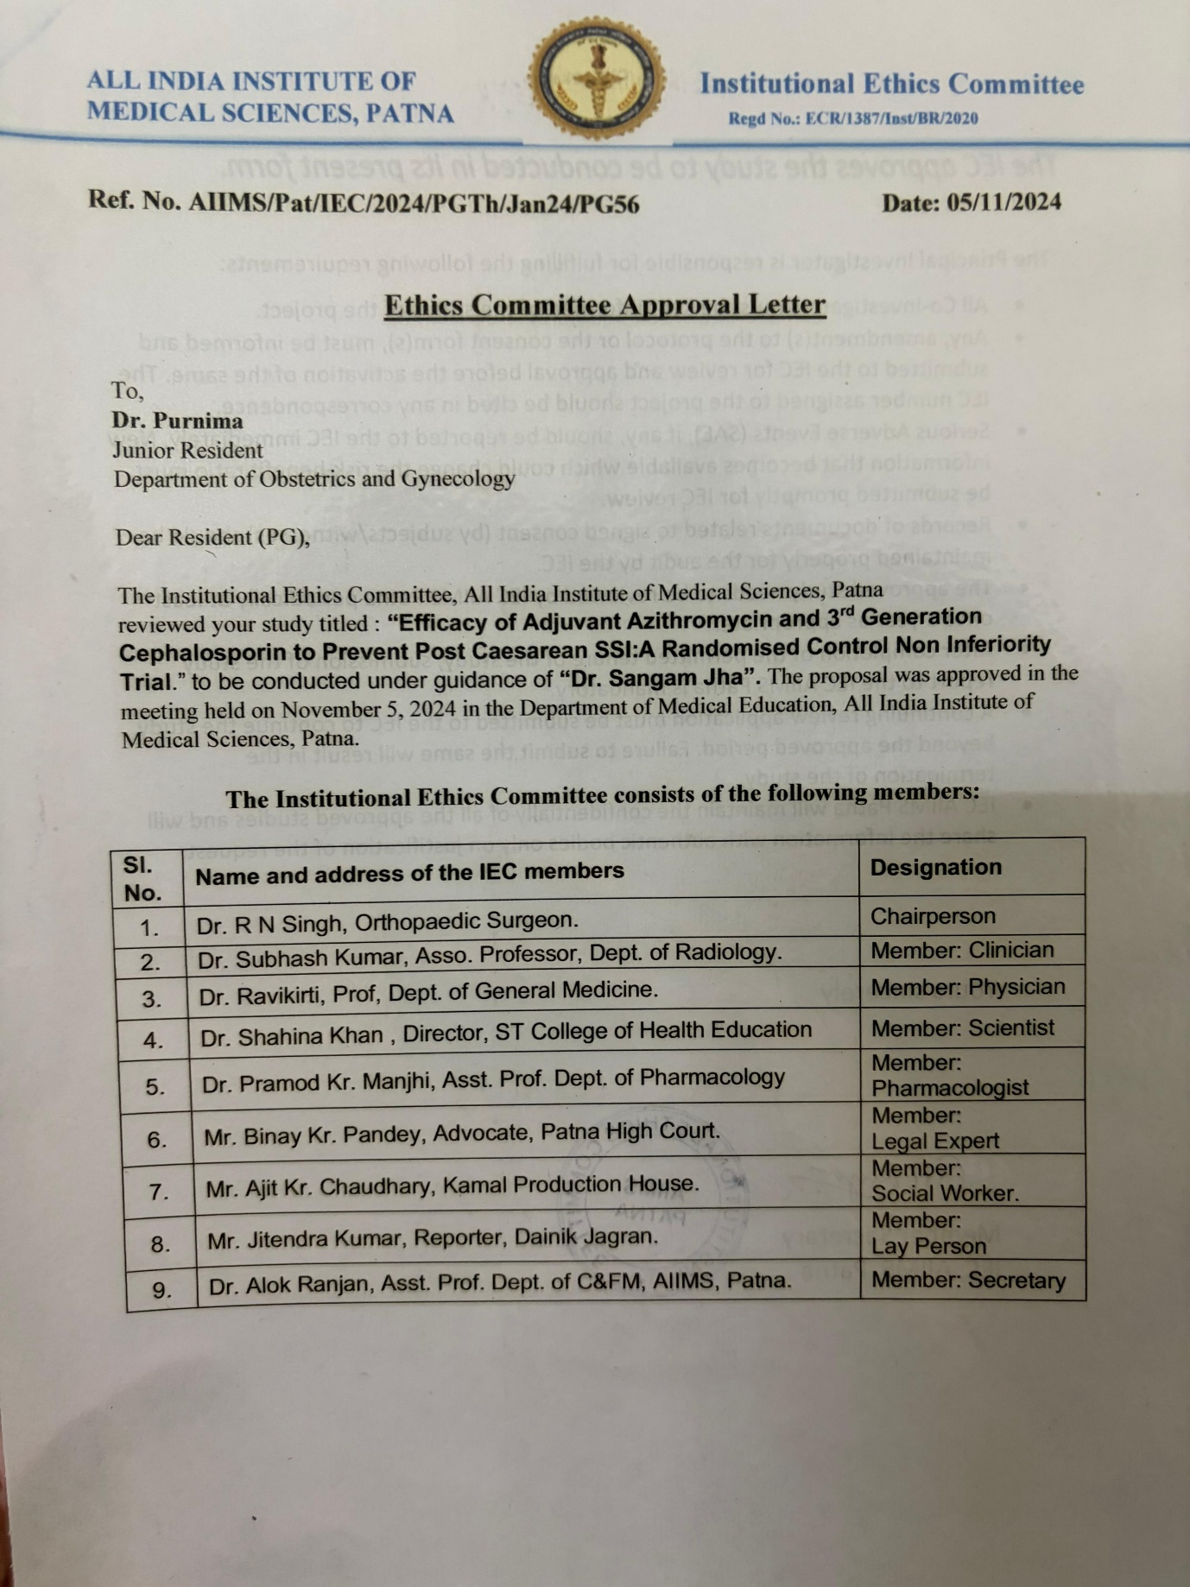

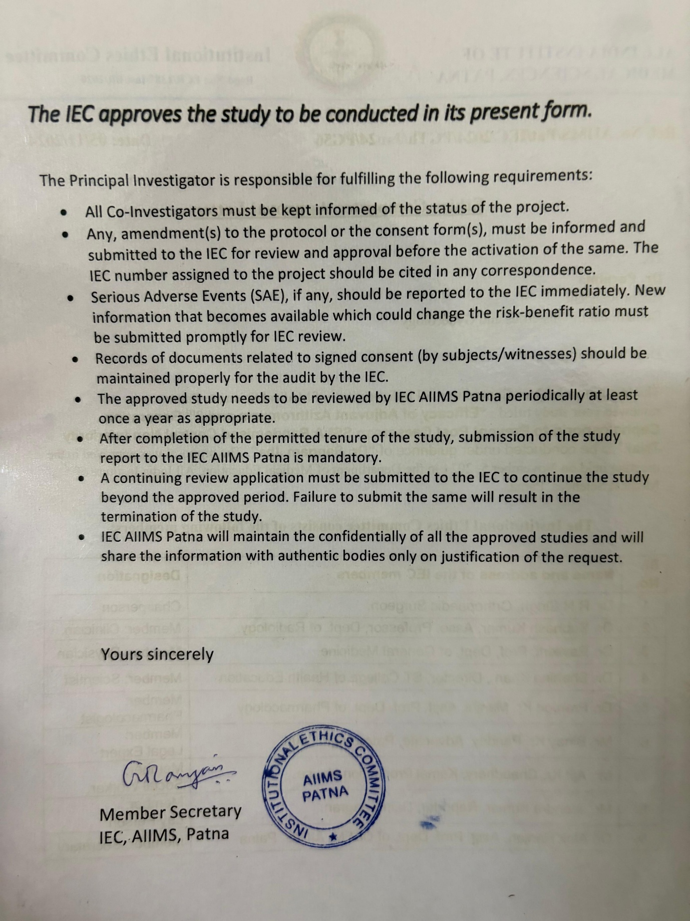

IRC Approval Letter
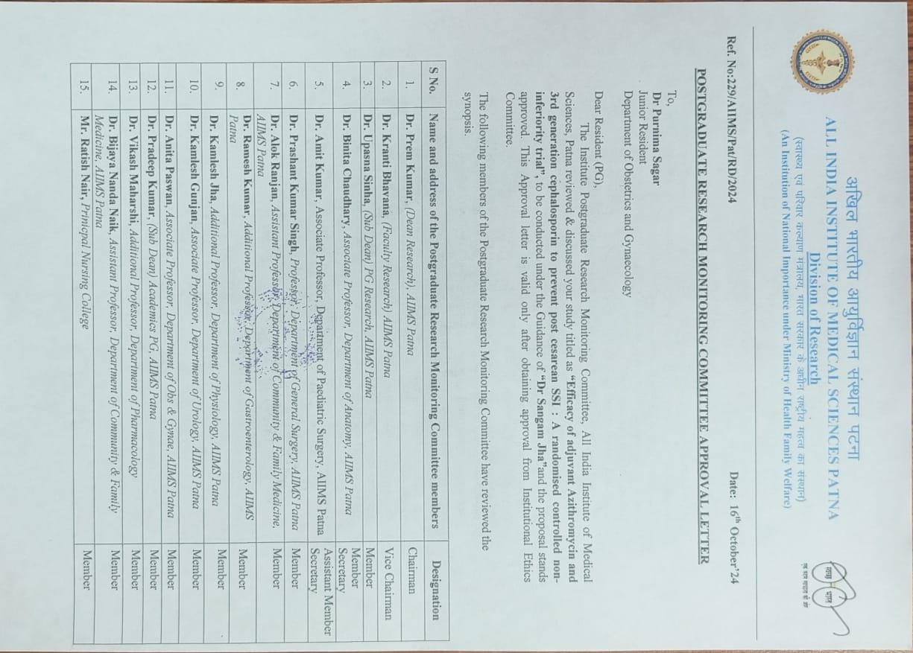



Plagiarism check report
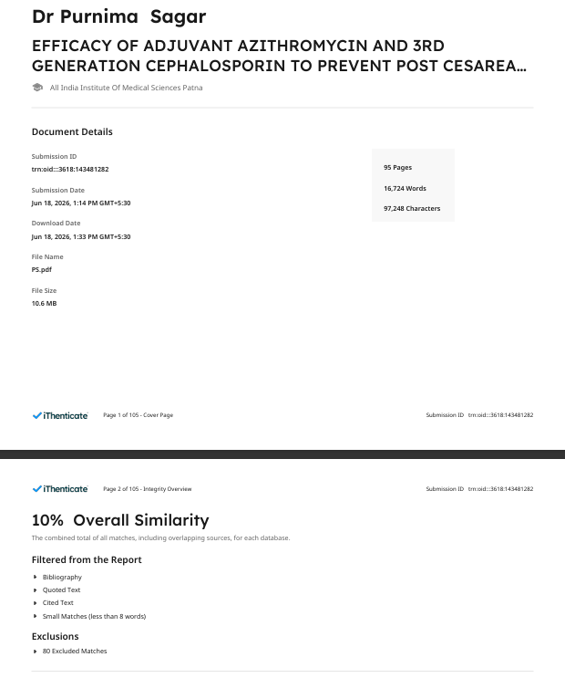

Acknowledgement
I express my sincere gratitude to my guide, Dr. Sangam Jha, Professor, Department of Obstetrics and Gynaecology, AIIMS Patna, for his constant guidance, encouragement, valuable suggestions, and unwavering support throughout the planning, conduct, and completion of this dissertation. His academic insight and mentorship have been instrumental in shaping this work.
I am also thankful to all the faculty members of the Department of Obstetrics and Gynaecology, AIIMS Patna, for their support and encouragement during my postgraduate training and throughout this research work.
I extend my heartfelt appreciation to all the patients who participated in this study. Without their cooperation and trust, this work would not have been possible.
I would like to acknowledge my juniors and colleagues for their assistance in patient follow-up, data collection, and day-to-day support during the conduct of the study. Their cooperation greatly facilitated the successful completion of this research.
I wish to express my deep gratitude to my brother Pulkit Sagar Ph D ,my brother in law Dr Prem Prakash Mch CTVS, my sister Dr Divya Sagar MD anesthesia, my senior Dr. Naveen Suthar MD CFM for their continuous academic support, methodological guidance, critical discussions, and assistance in research planning, data management, and scientific writing..
I owe my deepest gratitude to my mother and father for their unconditional love, patience, sacrifices, and constant encouragement throughout my academic journey. Their faith in me has been my greatest source of strength during the demanding years of postgraduate training and research.
Finally, I thank Almighty God for providing me with the strength, perseverance, and opportunity to complete this work successfully.
Dr. Purnima

Table of Contents

IEC Approval Letter iv
IRC Approval Letter vi
Plagiarism check report viii
Acknowledgement ix
Table of Contents x
List of tables xi
List of figures xiii
Abbreviations xv
1. Introduction 1
2. Aim and Objectives 5
3. Review of Literature 7
4. Methodology 26
5. Results 41
6. Discussion 73
7. Strengths 80
8. Limitations 81
9. Summary 82
10. Conclusion 84
11. Recommendations 85
12. References 86
13. Annexures 91

List of tables
Table 1 Data collection and follow-up schedule of the study participants 38
Table 2 Distribution of study participants based on age in completed years (n = 178) 43
Table 3 Distribution of study participants based on BMI category (n = 178) 44
Table 4 Distribution of study participants based on socioeconomic status (n = 178) 45
Table 5 Distribution of study participants based on period of gestation in days (n = 178) 46
Table 6 Distribution of study participants based on parity (n = 178) 47
Table 7 Distribution of study participants based on number of previous LSCS (n = 178) 48
Table 8 Distribution of study participants based on type of LSCS (n = 178) 49
Table 9 Distribution of study participants based on number of fetuses (n = 178) 50
Table 10 Distribution of study participants based on presentation (n = 178) 51
Table 11 Distribution of study participants based on gestational diabetes mellitus (n = 178) 52
Table 12 Distribution of study participants based on preeclampsia (n = 178) 53
Table 13 Distribution of study participants based on gestational hypothyroidism (n = 178) 54
Table 14 Distribution of study participants based on intraoperative meconium stained liquor (n = 178) 55
Table 15 Distribution of study participants based on number of per-vaginal examinations done (n = 178) 56
Table 16 Distribution of study participants based on duration of latent labor in hours (n = 178) 56
Table 17 Distribution of study participants based on duration of active labor in minutes (n = 178) 56
Table 18 Distribution of study participants based on copper-T insertion done (n = 178) 57
Table 19 Distribution of study participants based on bilateral tubal ligation done (n = 178) 58
Table 20 Distribution of study participants based on blood loss during surgical procedure in ml (n = 178) 59
Table 21 Distribution of study participants based on duration of surgical procedure in minutes (n = 178) 60
Table 22 Distribution of study participants based on dilatation of cervical os in cm (n = 178) 61
Table 23 Distribution of study participants based on presence of SSI (n = 178) 62
Table 24 Distribution of study participants based on presence of SSI in elective lscs group (n = 75) 63
Table 25 Distribution of study participants based on presence of SSI emergency lscs group (n = 96) 63
Table 26 Multivariable logistic regression to predict SSI from drug regimes (N = 178) 64
Table 27 Distribution of study participants based on type of SSI (n = 16) 65
Table 28 Distribution of study participants based on endometritis (n = 178) 66
Table 29 Cox proportional hazard model to estimate hazard ratio for developing SSI 67
Table 30 Distribution of study participants based on secondary suturing done (n = 178) 68
Table 31 Distribution of study participants based on readmission for SSI (n = 16) 69
Table 32 Distribution of study participants based on rDS present (n = 171) 70
Table 33 Distribution of study participants based on neonatal sepsis (n = 171) 71
Table 34 Distribution of study participants based on nICU admission (n = 171) 72

List of figures
Figure 1 Search Strategy Part-1 8
Figure 2 Search Strategy Part-2 9
Figure 3 Chemical structure of azithromycin. 14
Figure 4 Schematic view of azithromycin mechanism inhibiting translation of mRNA Source: Heidary et al., 2022.¹⁵ 15
Figure 5 Time-dependent antibacterial and immunomodulatory mechanisms of azithromycin Source: Parnham et al., 2014.¹⁶ 16
Figure 6 Images of SSI during study 33
Figure 7 Study tool for SSI part-1 35
Figure 8 Study tool for SSI part-2 36
Figure 9 Neonatal sepsis screen criteria. 37
Figure 10 Gantt chart depicting the timeline of major milestones of thesis project 39
Figure 11 Consort chart of the study 42
Figure 12 Box plot showing distribution of age of the participants in study groups (N = 178) 43
Figure 13 Bar plot depicting distribution of study participants based on bmi category (n = 178) 44
Figure 14 Bar plot depicting distribution of study participants based on socioeconomic status (n = 178) 45
Figure 15 Bar plot depicting distribution of study participants based on parity (n = 178) 47
Figure 16 Bar plot depicting distribution of study participants based on number of previous lscs (n = 178) 48
Figure 17 Bar plot depicting distribution of study participants based on type of lscs (n = 178) 49
Figure 18 Bar plot depicting distribution of study participants based on number of fetus (n = 178) 50
Figure 19 Bar plot depicting distribution of study participants based on presentation (n = 178) 51
Figure 20 Bar plot depicting distribution of study participants based on gestational diabetes mellitus (n = 178) 52
Figure 21 Bar plot depicting distribution of study participants based on preeclampsia (n = 178) 53
Figure 22 Bar plot depicting distribution of study participants based on gestational hypothyroidism (n = 178) 54
Figure 23 Bar plot depicting distribution of study participants based on intraoperative meconium stained liquor (n = 178) 55
Figure 24 Bar plot depicting distribution of study participants based on copper-t insertion done (n = 178) 57
Figure 25 Bar plot depicting distribution of study participants based on bilateral tubal ligation done (n = 178) 58
Figure 26 Boxplot depicting distribution of study participants based on blood loss during surgical pocedure (N = 178) 59
Figure 27 Boxplot depicting the distribution of study participants based on duration of surgical procedure (N = 178) 60
Figure 28 Boxplot depicting the distribution of study participants based on dilatation of cervical os (N = 178) 61
Figure 29 Kaplen-Meier curve to estimate time to develop SSI 67
Figure 30 Bar plot depicting distribution of study participants based on note. values are presented as n (%). (n = 171) 70
Figure 31 Bar plot depicting distribution of study participants based on neonatal sepsis (n = 171) 71
Figure 32 Bar plot depicting distribution of study participants based on NICU admission (n = 171) 72

Abbreviations
Abbreviation | Full form
AIIMS | All India Institute of Medical Sciences
ANC | Antenatal Care
BMI | Body Mass Index
BPV | Bleeding Per Vaginum
CS | Caesarean Section
CTG | Cardiotocography
DVT | Deep Vein Thrombosis
EDD | Expected Date of Delivery
GDM | Gestational Diabetes Mellitus
GOPD | Gynaecology Outpatient Department
LSCS | Lower Segment Caesarean Section
LMP | Last Menstrual Period
OBGYN | Obstetrics and Gynaecology
PICF | Participant Informed Consent Form
PIS | Participant Information Sheet
POG | Period of Gestation
RCT | Randomised Controlled Trial
SNOSE | Sequentially Numbered Opaque Sealed Envelope
SSI | Surgical Site Infection
UTI | Urinary Tract Infection

Introduction


Caesarean section is the most common and one of major surgical procedure performed in Obstetrics. It poses risk of variety of postoperative morbidities such as surgical site infection (henceforth SSI), endometritis, wound infection, urinary tract infection (UTI), puerperal sepsis, wound dehiscence, deep vein thrombosis (DVT). Post cesarean wound infection or to say SSI is most common in occurence.¹Furthermore, infection that occurs after delivery may result in substantial emotional and physical distress for the mother, as well as financial burden on the healthcare system.
According to a study conducted in Bhagalpur, Eastern India, even after antimicrobial prophylaxis, with Ceftriaxone and Metronidazole. The overall prevalence of SSIs is 11.1%. This post caesarean SSI is caused by vaginal flora.² Possible reason for this could be the non-coverage of a fastidious organism in addition to the absence of standard care, wound type, and categories of surgery, medical comorbidities along with length of hospital stay³.
The prospective observational study was performed at a 1500 bedded tertiary care teaching hospital in Gujarat state, India at S.S.G. Hospital, Baroda which is a state government-funded hospital⁴. The total cost of illness due to post-caesarean SSI is almost three times higher compared to the non-infected matched control group. Patients with SSI had an average hospital stay 10 days longer than the control group, and the total length of antimicrobial therapy is also significantly higher in the SSI group. This reflects the health burden of not only the patient but many families ⁴. So, a better strategy to combat this situation is not the post operative use of antibiotics to treat SSI but to prevent them using appropriate prophylaxis.
A study conducted at the University Teaching Hospital Kigali in Rwanda found that antimicrobial resistance (AMR) poses a significant global health threat, particularly in developing countries. Among patients with post-partum infections, such as abdominal sepsis after caesarean sections, gram-negative bacterial isolates showed resistance rates ranging from 63% to 88%. This situation could lead to increased morbidity and mortality in this high-risk population. Understanding of culprit florae and resistance patterns is crucial for tailoring initial therapy effectively⁵.
Two major reason to develop SSI are iatrogenic infection during procedure and upper reproductive tract infection caused by vaginal flora.⁶ While many strategies have been implemented to control infections. These are improved operation theatre ventilation, techniques to sterilize surgical instruments, barriers, surgical techniques, along with prophylaxis using antimicrobial agent. While advances made in field described has been strengthened but increasing incidence of SSI remains a concern, and improving the antimicrobial prophylaxis is an effective approach when all other methods has reached their thresholds.
Antibiotics are the mainstay to combat the SSI. Ceftriaxone, a third generation of cephalosporins, offers protection against several bacteria involved in SSI. The most common organisms responsible for SSI are gram positive Staphylococcus aureus, Streptococcus pneumoniae and gram-negative Enterobacter, Escherichia coli, Klebsiella pneumoniae, Proteus mirabilis, and Serratia marcescens.⁷ But prolonged antibiotic exposure increases the risk of antimicrobial resistance (AMR), especially Clostridioides Difficile infection, and acute kidney injury. This most widely use antibiotic for prophylaxis is ceftriaxone which has its own advantages and disadvantage⁸. Ceftriaxone has been detected in the breast milk of humans and has potential negative effects in breastfeeding infants such as disruption of gastrointestinal flora resulting in oral thrush in new-born. Hence prophylactic single dose of antibiotics will give better care and outcome mother and infants⁹. But its minimal role in protection against fastidious vaginal and peritoneal cavity flora, which are proved to be responsible for post caesarean SSI¹⁰. That’s why addition of drug which covers vaginal and peritoneal flora will add on to our favourable outcome.
Azithromycin, classified as a macrolide antibiotic has coverage including to agents of UTI, commonly leads to SSI following c-section. These agents are Haemophilus influenzae, Chlamydia trachomatis, The mycoplasma include: Mycoplasma hominis, Mycoplasma genitalium, Mycoplasma fermentans (incognitus strain),M. pneumoniae. The ureaplasma includes: Ureaplasma parvum, Ureaplasma urealyticum . These mycoplasmas and ureaplasma are considered normal inhabitants of the genital tract ¹¹. It has been implicated in postpartum endometritis (commonly polymicrobial) after CD, wound infection, UTI and serious maternal adverse events^{12.}
Adjunctive Azithromycin, a macrolide has been shown to be effective in caesarean delivery as it has better penetration in myometrial, adipose, and placental tissue¹². Administering azithromycin prior to incision (500 mg IV) alongside a cephalosporin can add on to the better outcome of post caesarean SSI, endometritis, and UTI. Not only for mother Adjunctive Azithromycin has been proven to be protective against neonatal skin infection also, though it has no affect in prevention of neonatal sepsis and other related neonatal morbidities¹².
Adding to this, the undesirable outcome of AMR is combated with pre-operative prophylactic dose administration of antibiotics. This not only prevent the SSI and its sequalae, but also the economic and co morbidity burden on patient. Therefore, avoiding unnecessary postoperative continuation of antibiotic prophylaxis and adding a appropriate antibiotic to our routine prophylactic course is crucial. By far Ceftriaxone is used widely in Eastern India for this purpose.

Aim and Objectives


Aim:
Assessing the efficacy of single dose combination of 3rd generation cephalosporin and azithromycin in preventing SSI following caesarean section among Indian women.
Objectives:
Primary objective:
- To compare the incidence of SSI between prophylactic combination of ceftriaxone and azithromycin to prophylactic combination ceftriaxone and cefuroxime in Indian pregnant women undergoing c-section.

Secondary Objectives
- To compare type of SSI between 2 groups.
- To compare incidence of UTI between two groups.
- To compare incidence of develop Endometritis between two groups.
- To compare Time to development of surgical site infection
- To compare the incidence of the neonatal sepsis between two groups.

Review of Literature


Search Strategy
Search was done using Pubmed search Engine with controlled vocabulary in both MeSh term and Text word in Title/Abstract.
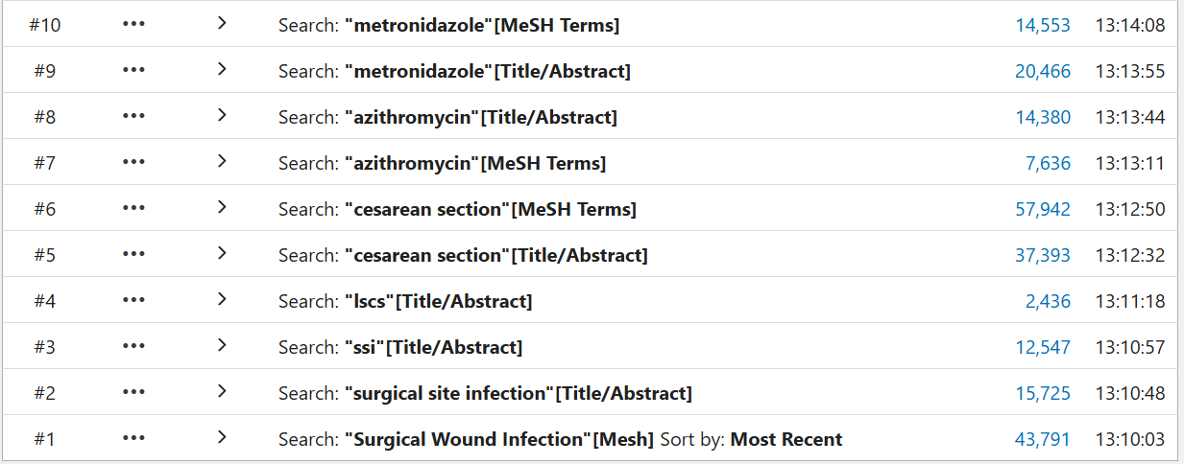
Figure 1 Search Strategy Part-1

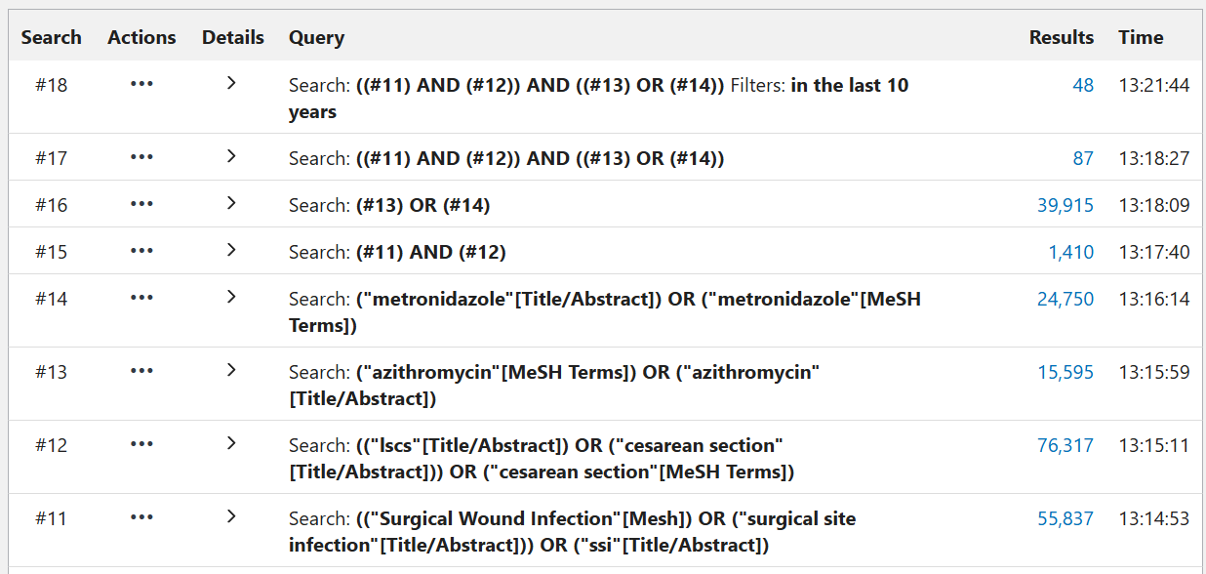
Figure 2 Search Strategy Part-2

Burden of Caesarean Delivery and Post-Caesarean Surgical Site Infection
Caesarean delivery is one of the most frequently performed major obstetric operations worldwide. The rate of caesarean section has increased substantially across several regions during the last few decades.¹ ² Global estimates have shown that the caesarean section rate reached approximately 21.1%, and projections suggest that it may rise further to nearly 28.5% by 2030 if current trends continue.¹ The World Health Organization has highlighted that the rising caesarean section rate is occurring alongside inequities in access to safe obstetric surgery.² This means that some settings continue to experience underuse of caesarean delivery where it is medically required, while other settings experience overuse without clear clinical indication. Irrespective of the reason for the rising rate, an increase in caesarean delivery increases the absolute number of women exposed to postoperative complications. Surgical site infection is one of the most important infectious complications following caesarean delivery. Post-caesarean SSI may include superficial incisional infection, deep incisional infection, organ-space infection, endometritis, wound dehiscence, need for secondary suturing, or readmission due to infection. The reported incidence of post-caesarean SSI varies widely across settings because of differences in case mix, antibiotic prophylaxis, surgical technique, infection-control practices, and post-discharge surveillance.³ ⁴ A narrative review reported that post-caesarean wound infection may occur in approximately 3% to 15% of caesarean deliveries depending on the clinical context.³ A recent systematic review and meta-analysis also confirmed that post-caesarean SSI remains a relevant global complication.⁴ The burden is especially important in low- and middle-income countries because baseline infection risk, delayed presentation, resource limitation, and antimicrobial resistance may be more frequent.⁵ ⁶ Post-caesarean SSI increases maternal morbidity through pain, wound discharge, fever, delayed recovery, prolonged antibiotic therapy, and need for additional wound care. The occurrence of SSI after childbirth can also interfere with breastfeeding, mother–newborn bonding, mobility, and early postnatal recovery. In severe cases, post-caesarean infection can progress to endometritis, pelvic abscess, peritonitis, sepsis, and multi-organ dysfunction. The economic impact of post-caesarean SSI is also substantial. An Indian tertiary-care study reported an incisional SSI incidence of 5.63% among women undergoing caesarean section. ⁵ The same study reported that women with SSI had longer hospital stay and higher treatment costs compared with women without SSI. This finding is important because many patients in Indian public hospitals come from low- and middle-income families where prolonged admission and repeated treatment can increase financial hardship. Evidence from low-resource settings has also shown that post-caesarean SSI can be associated with antimicrobial-resistant organisms.⁶The coexistence of SSI burden and antimicrobial resistance makes prevention of infection more important
than treatment after infection occurs. Therefore, strategies to reduce post-caesarean SSI should be clinically effective, feasible in routine obstetric care, and aligned with antimicrobial stewardship.

Microbiology and Pathogenesis of Post-Caesarean Infection
Post-caesarean infection is generally polymicrobial in origin. The microbial contamination may occur from skin flora, vaginal flora, enteric flora, operating-room environment, and organisms introduced during surgical manipulation.³ ⁶ ⁷ The incisional component of infection is commonly related to contamination by skin organisms and environmental organisms during surgery.³ The uterine and genital tract component is more relevant in caesarean delivery than in many other surgical procedures because the uterine cavity is opened during the operation.⁷ Organisms implicated in post-caesarean infection include Gram-positive cocci, Gram-negative bacilli, anaerobes, and atypical genital tract organisms. Commonly relevant organisms include Staphylococcus aureus, streptococci, Escherichia coli, Klebsiella species, anaerobes, Mycoplasma species, and Ureaplasma species.³ ⁷ ⁶ The genital tract flora becomes especially important when caesarean section is performed during labour or after rupture of membranes. ⁸ During labour, repeated vaginal examinations, cervical dilatation, ruptured membranes, and prolonged exposure of the uterine cavity may increase bacterial ascent. These factors may explain why non-elective caesarean delivery is often associated with higher infectious morbidity than scheduled prelabour caesarean delivery. The risk of infection is also influenced by operative factors such as surgical duration, tissue handling, blood loss, haemostasis, and wound closure. Longer operative duration increases tissue exposure and may increase the probability of bacterial contamination. A secondary analysis of a large randomised trial showed that clinical and operative factors continued to predict maternal infection even when extended-spectrum antibiotic prophylaxis was used.⁸ This suggests that antibiotic regimen is important, but it cannot fully eliminate infection risk created by labour-related and surgery-related exposures. Standard beta-lactam prophylaxis provides useful activity against many skin and enteric organisms. ² ⁷
However, beta-lactam antibiotics do not reliably cover atypical genital organisms such as Mycoplasma and Ureaplasma species.⁷ ⁹This creates a biological rationale for adding a macrolide antibiotic to cephalosporin prophylaxis. Azithromycin is active against atypical genital tract organisms and can broaden the prophylactic spectrum when used with standard cephalosporin prophylaxis. This is particularly relevant in caesarean delivery performed after labour or rupture of membranes, where genital tract organisms may contribute meaningfully to infection. ⁷ ⁸ ⁹
Antimicrobial resistance adds another layer of complexity to post-caesarean infection.
A prospective study from rural Rwanda found that post-caesarean SSI isolates were frequently Gram-negative and showed high resistance to commonly used antibiotics.⁶ Indian surgical prophylaxis audits have shown that ceftriaxone-based regimens are frequently used in local practice.¹⁰ Frequent use of broad-spectrum antibiotics may contribute to selection pressure if antibiotic exposure is prolonged or poorly rationalised. Therefore, the ideal prophylactic regimen should provide adequate coverage at the time of surgical contamination while avoiding unnecessary postoperative antibiotic exposure.

Current Guidelines and Standard Antibiotic Prophylaxis for Caesarean Delivery
Antibiotic prophylaxis is an established intervention for reducing infectious morbidity following caesarean section. The World Health Organization recommends prophylactic antibiotics for women undergoing caesarean section. WHO guidance supports a simple and short antibiotic regimen, preferably a single dose administered before surgery. The recommended timing is 30 to 60 minutes before skin incision so that adequate tissue concentration is present during surgical contamination.² This timing principle is central to surgical prophylaxis because prophylaxis is intended to prevent infection rather than treat established infection. ACOG also supports the use of prophylactic antibiotics in labour and delivery, including caesarean delivery. ¹¹ International guidelines commonly favour cefazolin or other narrow-spectrum cephalosporin-based prophylaxis for routine caesarean delivery.² ¹¹ The advantage of narrow-spectrum prophylaxis is that it provides effective coverage against common organisms while reducing unnecessary broad-spectrum exposure. However, the actual antibiotic used in clinical practice often varies according to institutional policy, drug availability, local prescribing culture, and resistance pattern. In several Indian tertiary-care settings, ceftriaxone is frequently used as a prophylactic antibiotic.¹⁰
Ceftriaxone has broad Gram-negative activity and a longer half-life than cefazolin, which may partly explain its frequent use in Indian practice.¹⁰ However, ceftriaxone is broader-spectrum than cefazolin and may have greater ecological consequences if used widely and repeatedly. International guidance generally does not recommend prolonged postoperative antibiotics after uncomplicated caesarean delivery when effective pre-incision prophylaxis has been administered.² ¹¹ Prolonged postoperative oral antibiotic use increases total antibiotic exposure.Increased antibiotic exposure may increase selection pressure for antimicrobial resistance at both patient and institutional levels.Therefore, a shorter perioperative regimen that is not clinically worse than an extended regimen would be valuable for clinical practice. This is the conceptual basis for a non-inferiority trial comparing a single-dose perioperative regimen with an extended postoperative regimen.

Rationale for Adjunctive Azithromycin
Azithromycin is a macrolide antibiotic with activity against atypical organisms, including Mycoplasma and Ureaplasma species.⁷ ⁹ This property is important because atypical genital tract organisms are not reliably covered by cephalosporins alone. When azithromycin is added to standard cephalosporin prophylaxis, the antimicrobial spectrum expands beyond the usual beta-lactam coverage. This broader spectrum is microbiologically rational in caesarean delivery because infection may arise from both surgical site organisms and genital tract organisms. The rationale is stronger in non-elective caesarean delivery because labour and membrane rupture increase exposure to genital tract organisms. Azithromycin can be administered as a single perioperative dose. Single-dose administration makes it operationally feasible in obstetric theatres and emergency caesarean settings.⁷ ¹² A single-dose adjunctive regimen may also avoid the need for prolonged postoperative oral antibiotics if clinical outcomes are maintained. ² ⁷This is relevant to antimicrobial stewardship because reduced antibiotic exposure is desirable when infection prevention is not compromised. The available randomised evidence has not shown a significant increase in measured short-term neonatal adverse outcomes with single-dose adjunctive azithromycin in caesarean delivery.⁷ The absence of a major short-term neonatal safety signal supports the clinical acceptability of single-dose adjunctive azithromycin when appropriately indicated.⁷ However, safety interpretation should remain balanced because long-term microbiome and resistance effects require ongoing surveillance.¹³Overall, adjunctive azithromycin has microbiological, clinical, operational, and stewardship-related advantages as a perioperative adjunct in caesarean prophylaxis.
Azithromycin
Azithromycin is a semi-synthetic azalide macrolide antibiotic with the molecular formula C₃₈H₇₂N₂O₁₂ and molecular weight of approximately 749.0 g/mol. Structurally, it consists of a 15-membered macrolactone ring with a methyl-substituted nitrogen atom at the 9a position, which distinguishes it from erythromycin and other classical macrolides. It also contains two attached sugar moieties, desosamine and cladinose, which contribute to its ribosomal binding and antibacterial activity. This structural modification improves its acid stability, tissue penetration, intracellular accumulation, and prolonged duration of action, making it suitable for short-course therapy and peri-operative prophylactic use. ¹⁴ ¹⁵
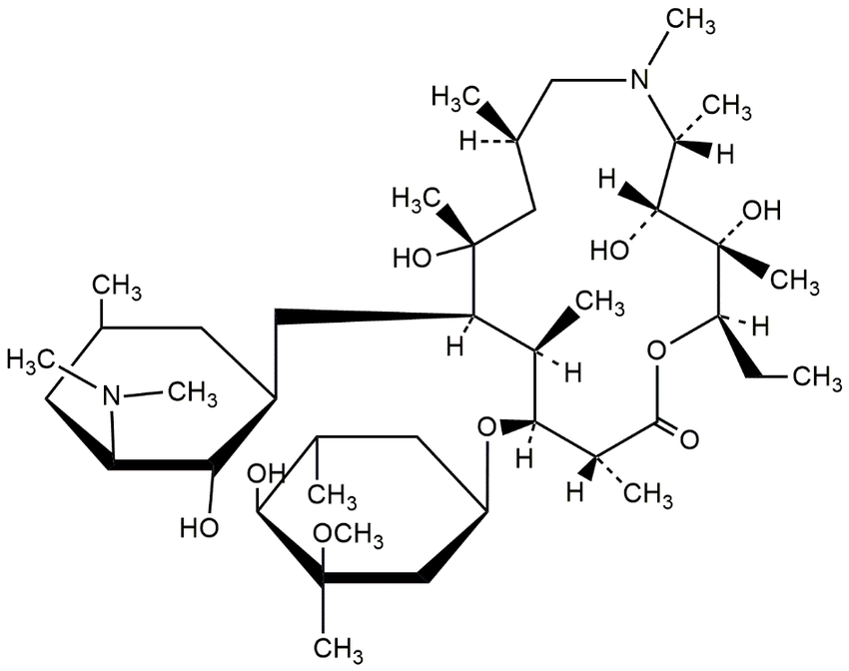
Figure 3 Chemical structure of azithromycin.
Source: Bhimani et al., 2016.¹⁴
Azithromycin has broad clinical relevance because it has been evaluated as an adjunct prophylactic agent for preventing post-caesarean infectious morbidity. It acts primarily by binding to the 50S bacterial ribosomal subunit, particularly near the nascent peptide exit tunnel, thereby inhibiting bacterial protein synthesis and suppressing bacterial growth. It is usually bacteriostatic, although high tissue concentrations may produce bactericidal activity against selected organisms.¹⁵
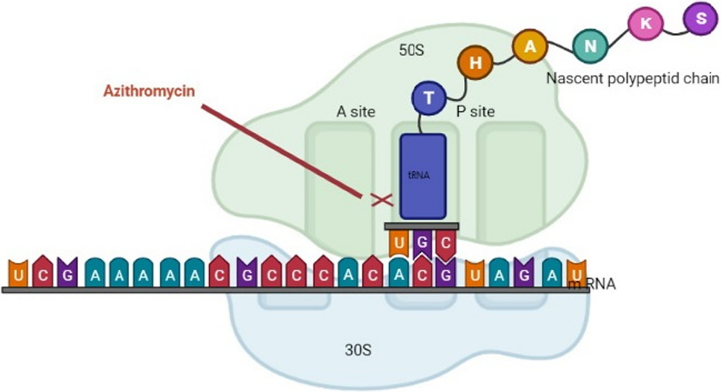
Figure 4 Schematic view of azithromycin mechanism inhibiting translation of mRNA
Source: Heidary et al., 2022.¹⁵
Azithromycin has activity against several respiratory and genital-tract organisms, including Streptococcus pneumoniae, Haemophilus influenzae, Moraxella catarrhalis, Mycoplasma pneumoniae, Chlamydia trachomatis, and other susceptible organisms, although local susceptibility and antimicrobial resistance remain important limitations. ¹⁵ ¹⁶ In general practice, it is used for selected bacterial respiratory infections, sexually transmitted infections such as chlamydial infection, skin and soft-tissue infections, and prevention or treatment of disseminated Mycobacterium avium complex infection in specific immunocompromised patients.¹⁵ In pregnancy, azithromycin is commonly used when clinically indicated, particularly for genital-tract infections, but its use should remain indication-based because unnecessary exposure may contribute to antimicrobial resistance and adverse effects. ⁷
Azithromycin has a long duration of action because it does not remain mainly in plasma; it rapidly distributes into tissues and cells, especially phagocytes, and is then slowly released back from tissues.¹⁶ Its terminal elimination half-life is approximately 68 hours, which permits once-daily dosing and short treatment courses such as 3-day or 5-day regimens. Official prescribing information states that this prolonged terminal half-life is due to extensive tissue uptake and subsequent tissue release.
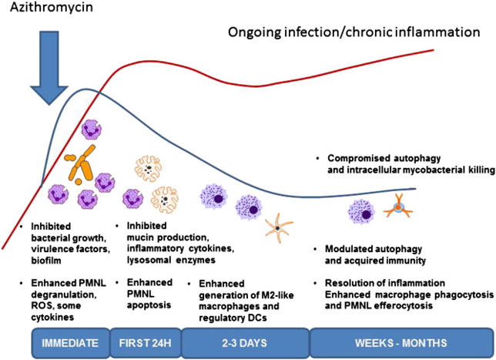
Figure 5 Time-dependent antibacterial and immunomodulatory mechanisms of azithromycin
Source: Parnham et al., 2014.¹⁶
The figure summarizes the time-dependent antibacterial and immunomodulatory actions of azithromycin. Immediately after administration, azithromycin exerts its primary antibacterial action by inhibiting bacterial growth, reducing virulence factor expression, and suppressing biofilm formation. This early effect is accompanied by modulation of polymorphonuclear leukocyte activity, including degranulation and reactive oxygen species generation, which contributes to early microbial clearance. During the first 24 hours, azithromycin reduces mucin production, inflammatory cytokine release, and lysosomal enzyme-mediated inflammatory activity, while also enhancing neutrophil apoptosis. This transition is important because apoptosis of activated neutrophils limits persistent neutrophil-mediated tissue injury and promotes resolution of acute inflammation. Over the next 2–3 days, azithromycin promotes the generation of M2-like macrophages and regulatory dendritic cells, shifting the inflammatory response from an active destructive phase toward a regulatory and reparative phase. During prolonged exposure over weeks to months, azithromycin modulates autophagy and acquired immune responses, enhances macrophage phagocytosis and efferocytosis of apoptotic neutrophils, and supports resolution of chronic inflammation.
Azithromycin has excellent tissue and intracellular penetration. It penetrates several tissues and accumulates inside neutrophils and macrophages. These phagocytic cells migrate to infected or inflamed tissues, allowing azithromycin to be delivered in high concentration at the actual site of infection.[3] In the context of caesarean section, this is important because azithromycin’s high genital-tract and tissue penetration, along with intracellular accumulation, supports its use as an adjunct to routine cephalosporin prophylaxis. After pre-operative administration, it can reach infected or inflamed tissue compartments and provide extended coverage against organisms involved in post-caesarean endometritis, wound infection, and other infective morbidity. Its long half-life also means that antimicrobial activity continues beyond the immediate peri-operative period, which is useful in preventing early post-operative infectious complications.
Azithromycin is considered acceptable for use in pregnancy when clinically indicated. In obstetric practice, azithromycin is relevant to caesarean-section prophylaxis because adjunctive azithromycin added to standard prophylaxis has been shown to reduce post-caesarean infectious morbidity in women undergoing nonelective caesarean delivery.[5] However, it should be used only for clear indications because unnecessary exposure may contribute to antimicrobial resistance and adverse effects such as gastrointestinal intolerance, rare hepatotoxicity, and QT prolongation.¹⁵

Evidence from Randomised Controlled Trials
The strongest randomised evidence for adjunctive azithromycin in caesarean delivery comes from the C/SOAP trial.⁷ This was a multicentre, double-blind, placebo-controlled randomised trial among women undergoing non-elective caesarean delivery. All participants received standard cephalosporin prophylaxis, and the intervention group received adjunctive azithromycin 500 mg intravenously.The control group received placebo in addition to standard prophylaxis. The primary outcome was a composite of endometritis, wound infection, or other infection within six weeks after delivery. The primary composite infection outcome occurred in 6.1% of women in the azithromycin group and 12.0% of women in the placebo group. This corresponded to a relative risk of 0.51, indicating an approximately 49% relative reduction in postoperative infectious morbidity. Endometritis was reduced from 6.1% in the placebo group to 3.8% in the azithromycin group.Wound infection was reduced from 6.6% in the placebo group to 2.4% in the azithromycin group.
The number needed to treat was favourable because prevention of infection avoided downstream antibiotic use, readmission, and surgical intervention. The trial did not detect a significant increase in measured short-term neonatal adverse outcomes.This trial established adjunctive azithromycin as an effective addition to standard prophylaxis in non-elective caesarean delivery.⁷
The C/SOAP trial is directly relevant because it demonstrated that targeting atypical genital tract organisms can reduce post-caesarean infectious morbidity.⁷ ⁹ However, its comparator regimen was based on standard cephalosporin prophylaxis, most commonly cefazolin. This limits direct generalisation to settings where ceftriaxone is commonly used as baseline prophylaxis. The trial also did not directly compare a single-dose azithromycin-containing regimen with an extended postoperative oral cephalosporin regimen.⁷ Therefore, the C/SOAP trial supports the scientific basis of adjunctive azithromycin but does not fully answer the Indian local practice question.¹⁰ A secondary analysis of the C/SOAP data examined risk factors for maternal infection despite extended-spectrum prophylaxis.⁸ This analysis showed that risk was not determined by antibiotic regimen alone. Factors such as prolonged membrane rupture, longer operative duration, and operative characteristics continued to influence infection risk. This is relevant because post-caesarean SSI prevention must address both pharmacological and procedural risk factors.
Another secondary analysis examined the timing of adjunctive azithromycin administration.¹² This analysis found that adjunctive azithromycin retained benefit when administered within 60 minutes before skin incision or shortly after incision. This finding has practical importance because exact pre-incision timing may be difficult in emergency caesarean delivery. The evidence supports a flexible but still perioperative timing window for adjunctive azithromycin.^{[12]}

Evidence from Observational Studies, Additional Clinical Studies, and Meta-Analyses
Observational studies, additional clinical studies, and pooled evidence have examined the role of adjunctive azithromycin in caesarean prophylaxis beyond the original randomised trial setting.¹⁷ ¹⁸ ¹⁹ [10,14,15] These studies are important because the effectiveness of any prophylactic regimen may vary according to baseline infection risk, patient profile, institutional antibiotic policy, and operative practices.
A randomised controlled trial evaluated adjunctive azithromycin prophylaxis among women undergoing non-elective caesarean delivery and assessed its effect on uterine caesarean scar defect. ¹⁷ In that trial, adjunctive azithromycin was given along with single-dose cephalosporin prophylaxis. The study was based on the hypothesis that perioperative infection and inflammation may contribute to impaired uterine scar healing after caesarean delivery. Adjunctive azithromycin prophylaxis was reported to protect women from uterine caesarean scar defect after non-elective caesarean delivery.¹⁷ Although uterine caesarean scar defect is not the same as early postoperative SSI, the finding is relevant because it supports the broader role of adjunctive azithromycin in improving post-caesarean healing-related outcomes. This evidence also strengthens the biological plausibility that reducing perioperative infection or inflammation may influence both early infectious morbidity and later scar-related complications.
sReal-world studies have also evaluated adjunctive azithromycin after implementation into routine caesarean prophylaxis protocols.¹⁸ ¹⁹[14,15] A before-and-after cohort study assessed the clinical effectiveness of adding azithromycin to antimicrobial prophylaxis for caesarean delivery.¹⁸ [14] The study suggested that the effect of adjunctive azithromycin may vary according to institutional setting, baseline infection rate, and population risk profile. This is important because the magnitude of benefit from adjunctive prophylaxis may be greater in settings with higher baseline SSI risk. Evidence has also been reported in women undergoing prelabor caesarean birth.
A retrospective cohort study found that adjunctive azithromycin prophylaxis for prelabor caesarean birth was associated with lower odds of postpartum infection.¹⁹ This suggests that adjunctive azithromycin may have potential benefit beyond non-elective caesarean delivery. However, the evidence for elective or prelabor caesarean delivery remains less definitive than the evidence for non-elective caesarean delivery.⁷ ¹⁹[7,15] The baseline risk of infection is generally lower in prelabor caesarean delivery than in non-elective caesarean delivery. Therefore, larger sample sizes may be needed to demonstrate a statistically significant reduction in infection in lower-risk populations. Observational studies and studies assessing extended outcomes should be interpreted cautiously because confounding, institutional practice, outcome definition, and surveillance method may influence results. Nevertheless, these studies provide useful supportive evidence and help define the broader clinical relevance of adjunctive azithromycin in caesarean delivery.
Systematic reviews and meta-analyses have synthesised the evidence on adjunctive macrolides and broader-spectrum prophylaxis in caesarean delivery.⁹ ²⁰ ²¹ [9,16,17] A systematic review and meta-analysis found that adjunctive macrolides reduced wound infection and endometritis after caesarean section.²⁰ Another meta-analysis reported that pre-incision adjunctive prophylaxis reduced post-caesarean SSI and shortened hospital stay compared with standard cefazolin prophylaxis alone.²¹
A more recent meta-analysis also supported the efficacy of adding azithromycin to antibiotic prophylaxis in reducing endometritis and wound infection after caesarean delivery.⁹ These pooled findings support the principle that adjunctive azithromycin or broader-spectrum pre-incision prophylaxis can reduce post-caesarean infectious morbidity. However, most of the available evidence is based on cefazolin as the background cephalosporin. This limits direct applicability to Indian tertiary-care settings where ceftriaxone is commonly used as the baseline prophylactic antibiotic.¹⁰
Therefore, local evidence is required to determine whether adjunctive azithromycin with ceftriaxone can safely replace extended postoperative cephalosporin regimens without increasing SSI.

Evidence from Broader Peripartum Azithromycin Studies
Azithromycin has also been evaluated for prevention of maternal infection outside caesarean prophylaxis. The A-PLUS trial assessed single-dose oral azithromycin among women planning vaginal delivery in low- and middle-income countries.¹³ The trial reported that maternal sepsis or death was reduced in the azithromycin group compared with placebo. The reduction was mainly driven by reduction in maternal sepsis. Although the A-PLUS trial was not a caesarean prophylaxis trial, it supports the broader concept that peripartum azithromycin can reduce maternal infectious morbidity. This finding is relevant because maternal infection remains an important contributor to morbidity in low- and middle-income settings. However, the mode of delivery, dose, route, and population in A-PLUS differ from caesarean prophylaxis trials. Therefore, A-PLUS should be considered supportive background evidence rather than direct evidence for post-caesarean SSI prevention. The broader maternal infection benefit of azithromycin strengthens biological plausibility but does not replace the need for caesarean-specific evidence.
For the present study, the more directly applicable evidence remains adjunctive azithromycin with cephalosporin prophylaxis in caesarean delivery.⁷ ⁹ ²⁰ ²¹ [7,9,16,17]

Neonatal Safety, Timing, and Operational Considerations
Neonatal safety is an important consideration when antibiotics are administered before delivery. In the C/SOAP trial, adjunctive azithromycin did not increase measured short-term neonatal adverse outcomes.⁷ The neonatal outcomes assessed included neonatal sepsis and neonatal intensive care-related outcomes. This finding supports the short-term safety of single-dose adjunctive azithromycin in the studied caesarean population.
The A-PLUS trial also did not show a major neonatal benefit, but it provided additional safety context for peripartum azithromycin exposure. ¹³[19]Despite reassuring short-term trial data, continued monitoring remains important because antibiotics can theoretically influence neonatal microbiome and resistance patterns. The timing of antibiotic prophylaxis is another operational issue.[2,13] WHO recommends administration of caesarean prophylaxis before surgery, preferably 30 to 60 minutes before incision. The timing analysis of adjunctive azithromycin showed that benefit persisted when azithromycin was given within 60 minutes before incision or shortly after incision.¹² This is practical in emergency obstetric settings where there may be limited time between decision for caesarean and skin incision. A regimen that is easy to administer within routine operating-room workflow is more likely to be implemented successfully. Single-dose azithromycin is operationally simpler than prolonged postoperative antibiotic courses.This simplicity may improve adherence to protocol-based prophylaxis. It may also reduce missed doses, unnecessary prescriptions, and variability in postoperative antibiotic practice.

Indian and Low-Resource Context
Indian obstetric practice has specific contextual features that justify local evidence generation. ⁵ ¹⁰ The caesarean delivery rate is rising, and the absolute burden of women exposed to postoperative infection risk is increasing.Post-caesarean SSI remains clinically important in Indian tertiary-care settings. An Indian prospective observational study reported that SSI after caesarean delivery increased hospital stay and cost.⁵ These findings show that post-caesarean SSI is not only a clinical issue but also a health-system and economic issue. The choice of prophylactic antibiotic in India may differ from international guideline preferences. Ceftriaxone is frequently used in several Indian surgical prophylaxis settings.¹⁰ This creates a mismatch between the international evidence base and local practice. Most high-quality evidence for adjunctive azithromycin was generated using cefazolin-based prophylaxis.⁷ ²⁰ ²¹ [7,16,17] Therefore, evidence from cefazolin-based settings cannot be directly transferred to ceftriaxone-based settings without caution. The use of postoperative oral cephalosporins after caesarean delivery is also common in some Indian institutions. ¹⁰[11] However, extended postoperative antibiotics increase total antibiotic exposure and may conflict with stewardship principles when not clearly necessary. Antimicrobial resistance is particularly relevant in low-resource settings where broad-spectrum antibiotic use is common. Therefore, a shorter antibiotic regimen that is not inferior to extended prophylaxis would be clinically valuable.The present study is positioned within this Indian practice gap.

Antimicrobial Stewardship and the Logic of Non-Inferiority
Antimicrobial stewardship aims to optimise antibiotic use while reducing unnecessary exposure, resistance selection, adverse effects, and cost.In caesarean prophylaxis, stewardship favours appropriate pre-incision prophylaxis rather than routine prolonged postoperative antibiotics. A single-dose regimen is preferred when it provides adequate protection against infection.
However, changing practice from an extended regimen to a shorter regimen requires evidence that the shorter regimen does not compromise patient safety. This is where a non-inferiority design is appropriate.
A non-inferiority trial is useful when the new intervention has advantages such as reduced antibiotic exposure, lower cost, simpler administration, or better stewardship, and the goal is to show that it is not unacceptably worse than the existing regimen.In the present context, ceftriaxone plus azithromycin is a shorter and broader-spectrum perioperative regimen. The comparator regimen, ceftriaxone followed by oral cefuroxime, represents extended postoperative cephalosporin practice. If the shorter regimen is non-inferior, it could reduce total antibiotic exposure while maintaining SSI prevention. Such a finding would support rationalisation of post-caesarean antibiotic prophylaxis in Indian tertiary-care settings. The non-inferiority approach is also ethically appropriate because all participants receive active antibiotic prophylaxis. The aim is not to compare prophylaxis with no prophylaxis, but to compare two active regimens with different stewardship implications. Therefore, the non-inferiority design matches the clinical and programmatic question of this study.

Evidence Gap and Need for the Present Study
The existing literature shows strong evidence that adjunctive azithromycin reduces post-caesarean infectious morbidity when added to standard cephalosporin prophylaxis.⁷ ⁹ ²⁰ ²¹ The strongest randomised evidence is from non-elective caesarean delivery in a high-income setting.⁷ Several meta-analyses support adjunctive macrolides or broader-spectrum pre-incision prophylaxis. However, most of these studies used cefazolin as the background prophylactic antibiotic. This is important because Indian tertiary-care practice often uses ceftriaxone instead of cefazolin. There is limited randomised evidence evaluating adjunctive azithromycin with ceftriaxone as the baseline cephalosporin. There is also limited evidence comparing a single-dose ceftriaxone-plus-azithromycin regimen with an extended postoperative ceftriaxone-plus-cefuroxime regimen.This evidence gap is clinically important because local antibiotic policy should be based on local practice, baseline SSI risk, patient population, and antimicrobial resistance pattern.
The present trial addresses this gap by comparing a shorter dual-spectrum perioperative regimen with an extended cephalosporin-based regimen. The intervention regimen has the potential to provide broader coverage against atypical genital organisms while reducing postoperative antibiotic exposure. The control regimen reflects prevailing extended practice in settings where postoperative cephalosporins are commonly used.
Therefore, the study is justified as a pragmatic randomised controlled non-inferiority trial in an Indian tertiary-care obstetric setting.

Conceptual Framework
Caesarean delivery exposes both the abdominal wound and uterine cavity to microbial contamination. The relevant organisms include skin flora, enteric organisms, anaerobes, and genital tract atypical organisms. Standard cephalosporin prophylaxis reduces the risk of infection by covering many skin and enteric organisms. Residual infection risk may persist because of atypical genital organisms, labour exposure, membrane rupture, repeated vaginal examinations, prolonged surgical duration, and patient-related risk factors. Adjunctive azithromycin broadens coverage against atypical genital organisms.A single perioperative ceftriaxone-plus-azithromycin regimen may therefore provide broad perioperative coverage without requiring prolonged postoperative oral antibiotics.If the shorter regimen is non-inferior to the extended regimen, it may support SSI prevention while reducing total antibiotic exposure.
This conceptual framework links microbiology, clinical risk factors, antibiotic choice, and antimicrobial stewardship in the prevention of post-caesarean SSI.

Summary of Review of Literature
The recent literature shows that caesarean delivery is increasing globally and that post-caesarean SSI remains an important cause of preventable maternal morbidity.¹ ² ³ ⁴ Post-caesarean SSI causes prolonged hospital stay, additional antibiotic use, wound-related intervention, readmission, delayed recovery, and increased treatment cost.³ ⁵ The burden is particularly relevant in Indian and low-resource settings because infection risk, resource constraints, and antimicrobial resistance may be greater. ⁵ ⁶ ¹⁰ The microbiology of post-caesarean infection is polymicrobial and includes organisms not reliably covered by beta-lactam prophylaxis alone.³ ⁷ ⁹ Routine antibiotic prophylaxis is effective and recommended for caesarean delivery, but prolonged postoperative antibiotics are not routinely required when adequate perioperative prophylaxis is used.² ¹¹ Adjunctive azithromycin expands antimicrobial coverage to atypical genital organisms and has been shown to reduce post-caesarean infectious morbidity when added to standard prophylaxis. ⁷ ⁹ ²⁰ ²¹
The strongest randomised evidence demonstrated reduction in composite infection, wound infection, and endometritis with adjunctive azithromycin in non-elective caesarean delivery. Evidence from observational studies and meta-analyses further supports the role of adjunctive azithromycin or broader-spectrum pre-incision prophylaxis.⁹ ¹⁸ ¹⁹ ²¹ However, most high-quality evidence is based on cefazolin-based prophylaxis in high-income settings. Indian practice frequently uses ceftriaxone-based prophylaxis and may include extended postoperative oral cephalosporins.¹⁰ There is limited Indian randomized evidence comparing single-dose ceftriaxone plus azithromycin with extended ceftriaxone-plus-cefuroxime prophylaxis. Therefore, the present study is justified as a randomized controlled non-inferiority trial to determine whether a shorter, broader-spectrum regimen can replace the extended local regimen without compromising prevention of post-caesarean SSI.

Methodology


Ethical Approval
Ethical approval was obtained from AIIMS Patna IEC before commencing starting the study.

CTRI Registration
CTRI registration was after obtaining ethical approval from AIIMS Patna. CTRI registration number is CTRI- /2024/12/077949.

Study Design, Setting and Duration
This study was a two-arm, participant-blinded, randomized controlled trial conducted in the Department of Obstetrics and Gynaecology, All India Institute of Medical Sciences (AIIMS), Patna, Bihar, India. The study was conducted over a period of one year from January 2025 to January 2026.

Study Population
Pregnant women aged 18–45 years with a period of gestation greater than 28 weeks who underwent caesarean section at AIIMS Patna during the study period were screened for eligibility.

Eligibility Criteria
Inclusion Criteria
- Women aged 18 years or above.
- Women undergoing caesarean section.
- Women willing to provide written informed consent.
- No known allergy to ceftriaxone or azithromycin.
Exclusion Criteria
- Use of systemic antibiotics within seven days preceding caesarean section.
- Known hypersensitivity to any study antibiotic.
- Rupture of membranes for more than 24 hours or rupture occurring outside the study hospital.
- Evidence of pre-existing infection or fever before surgery.
- Presence of significant medical comorbidities such as overt diabetes mellitus, tuberculosis, chronic cardiac disease, or other chronic systemic illnesses.
- Pre-operative haemoglobin less than 7 g/dL.

Sampling

Sample Size
The sample size was calculated based on a previous study evaluating adjunctive azithromycin for prevention of post-caesarean infectious morbidity. Assuming an expected surgical site infection rate of 4% in the control group and 2% in the intervention group, with a type I error of 5%, type II error of 10%, non-inferiority margin of 20%, and an anticipated non-response rate of 10%, the minimum required sample size was estimated to be 89 participants per group. Therefore, a total of 178 participants were enrolled in the study.

Sampling Technique
Eligible participants were recruited using a consecutive sampling technique until the required sample size was achieved.

Study Groups
Control Group
Participants allocated to the control group received:
- Injection Ceftriaxone 1 g intravenously as a single pre-operative dose.
- Oral Cefuroxime 500 mg twice daily for five days post-operatively.
Intervention Group
Participants allocated to the intervention group received:
- Injection Ceftriaxone 1 g intravenously as a single pre-operative dose.
- Injection Azithromycin 500 mg intravenously diluted in 250 mL normal saline administered 30–60 minutes before skin incision.
A repeat dose of azithromycin was administered when intraoperative blood loss exceeded 1500 mL.

Randomization and Blinding
After obtaining informed consent and collecting baseline data participants were randomly allocated into either the intervention group or the control group using randomization list. Block randomization of variable block size of 2,4,6 was done. A computer-generated randomization sequence was prepared before commencement of the study.
Allocation concealment was ensured using Sequentially Numbered Opaque Sealed Envelopes (SNOSE). An independent resident not involved in outcome assessment opened the sealed envelope and administered the allocated treatment regimen as per instructions mentioned in the SNOSE.
Participants and outcome assessors were not blinded to treatment allocation throughout the study period.

Surgical Procedure
All participants underwent lower segment caesarean section according to the standard departmental protocol.
Pre-operative skin preparation was performed using 10% povidone-iodine solution. Caesarean delivery was performed through a Pfannenstiel skin incision followed by a lower uterine segment transverse incision. Following delivery of the fetus and placenta, uterine closure was performed in two layers using Vicryl No. 1 sutures. Subcutaneous tissue was approximated using interrupted Vicryl sutures and skin closure was performed using Vicryl Rapide 3-0. Sterile occlusive dressing was applied at the end of the procedure.
Post operative care and follow up
Patient was monitored for fever after 24 hours of operation, excruciating pain at stich line, soakage of dressing, abnormal foul-smelling discharge per vaginum, burning micturition and increase frequency of micturition. Patient was daily counselled regarding high protein diet and perineal hygiene and was asked to take bath on day 3 and limited visit. Dressing was done on post operative day three and suture line was assessed daily for surgical site infection Postoperative care was provided according to institutional protocol.
Patient was usually discharge on postoperative day 4 or after baby discharge and was advice to follow up regularly on postoperative day 7, day 14, day 30, day 42 or if not possible patient was followed up telephonically for any signs and symptoms of surgical site infection. Postoperative care was provided according to institutional protocol.

Outcome Measures
Primary Outcome Measure
The primary outcome was the occurrence of surgical site infection within 42 days following caesarean section, assessed using the CDC criteria for surgical site infection (study tool). Data were collected using a printed data collection proforma. Demographic and obstetric characteristics, clinical history and relevant laboratory investigations were recorded preoperatively, followed by randomization. Intraoperative details were documented during the caesarean section. Postoperative data related to surgical site infection and adverse events were collected during hospitalization and subsequently through scheduled outpatient follow-up visits or telephonically (if not able to show up )on postoperative days 7, 14, 30 and 42 days. Patient were asked to visit hospital or contact telephonically to address any delayed adverse events.

Figure 6 Images of SSI during study
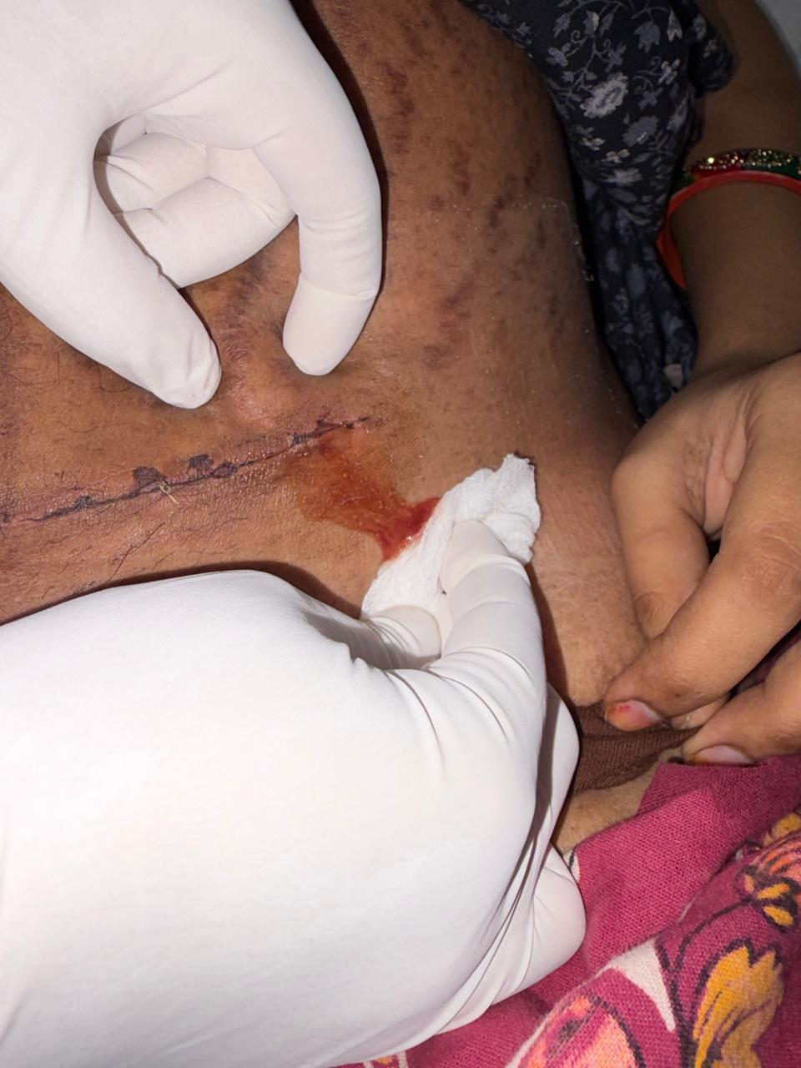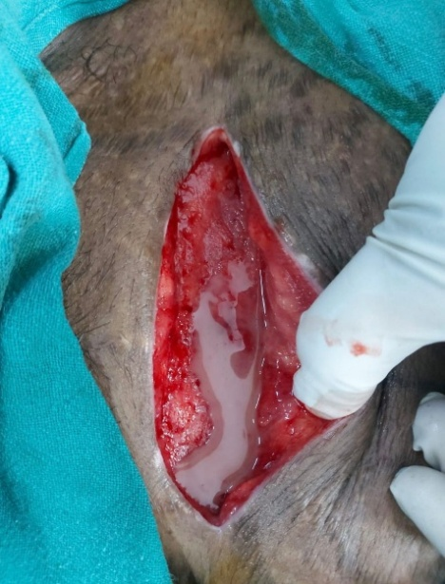
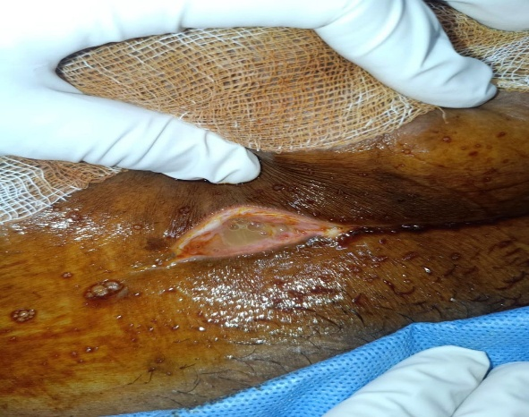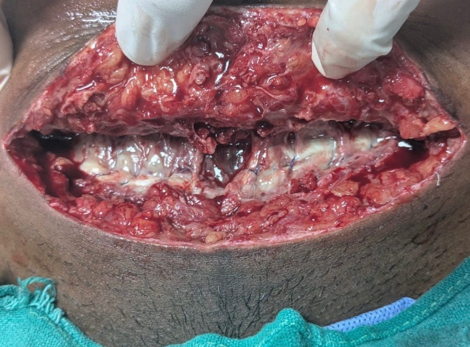

Secondary Outcomes measure
- The type of SSI was assessed using CDC SSI assessment criteria ( )and classified as superficial incisional, deep incisional or organ/space SSI. When multiple tissue levels were involved, the deepest level was recorded. The frequency and proportion of each SSI type were compared between the two study groups.
- The neonatal sepsis was suspected in neonates presenting with lethargy, poor feeding, fever or hypothermia, vomiting, abdominal distension, seizures, poor perfusion or clinical deterioration. In suspected cases, blood samples were sent for total leucocyte count, absolute neutrophil count, micro-erythrocyte sedimentation rate, C-reactive protein, immature-to-total neutrophil ratio and blood culture. A sepsis screen was considered positive when at least two parameters were abnormal.
- The urinary tract infection was diagnosed clinical based on symptoms such as dysuria, urinary urgency and increased frequency during hospitalization.
- Endometritis was diagnosed according to the CDC/NHSN surveillance criteria in women presenting with at least two of the following findings without another recognized cause: fever >38.0°C, uterine or abdominal pain or tenderness, and purulent uterine drainage.38
- Time to development of SSI was calculated from the date of caesarean section to the date of its first diagnosis. Patients were assessed during hospital stay and subsequently followed up on postoperative days 7, 14, 30 and 42. Those who did not attend the scheduled follow-up were contacted telephonically and enquired about symptoms suggestive of SSI. Patients reporting such symptoms were advised to visit the hospital for clinical examination and confirmation of diagnosis. The time to development of SSI was then compared between the two study groups.
- Time to development of surgical site infection.
- Duration of hospital stay.

Study Tool
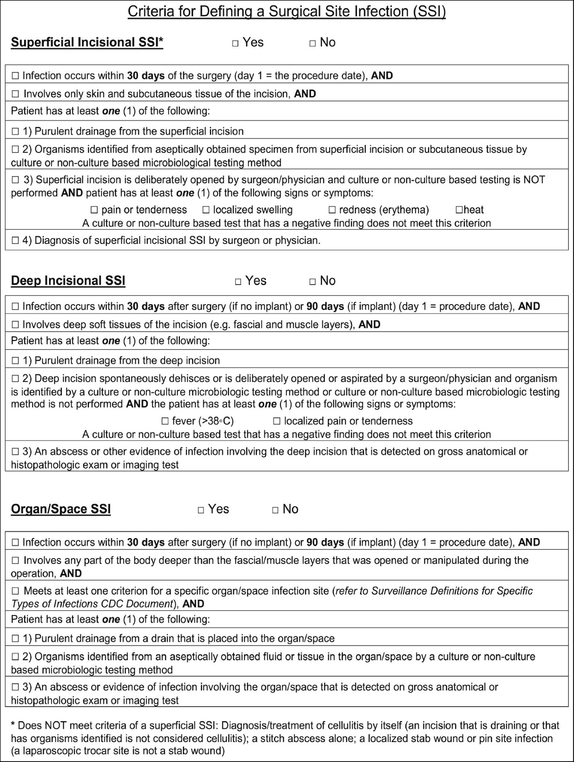
Figure 7 Study tool for SSI part-1

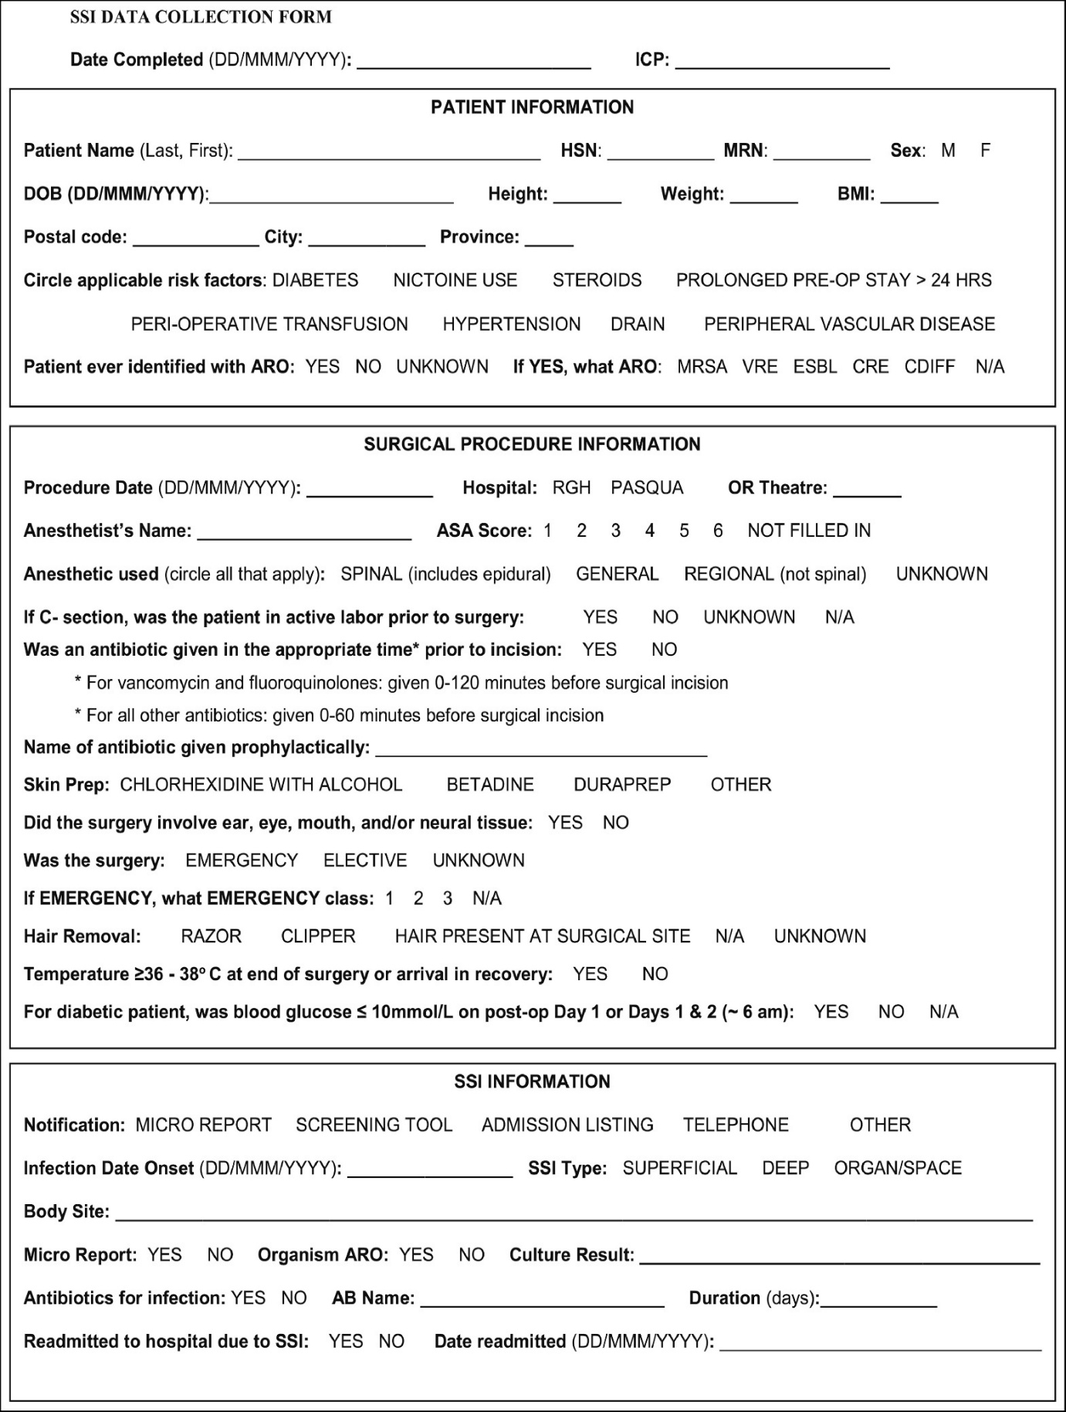
Figure 8 Study tool for SSI part-2

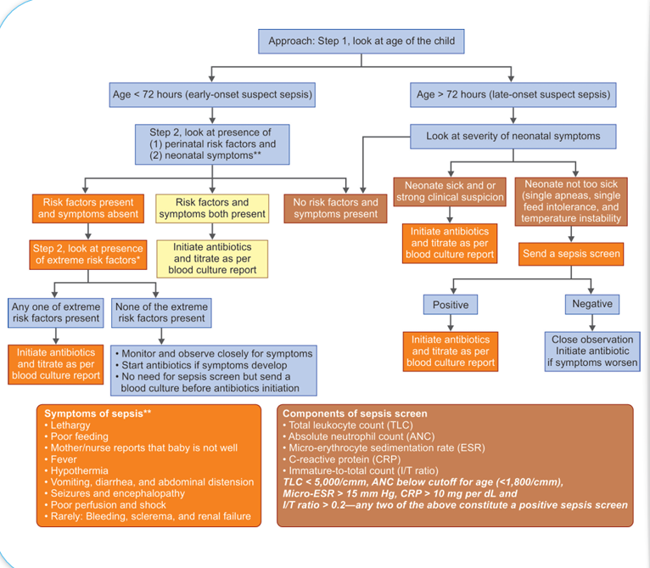
Figure 9 Neonatal sepsis screen criteria.

Data Collection
Data Collection was done using printed data collection proforma. All demographic & Obstetrics data was taken preoperatively along with clinical history and laboratory investigation details. After that randomization was done and surgical details were noted intraoperatively. Postoperatively including hospital stay and thereafter discharge data related SSI and adverse events was collected on routine OPD follow-ups at regular intervals at Day7, 14, 30, 42nd day.

Table 1 Data collection and follow-up schedule of the study participants
Assessment | Preoperative | Intraoperative | 24 h | In-hospital upto 72 hours | Day 7 | Day 14 | Day 30 | Day 42
Demographic & obstetric data | ✓
Clinical & laboratory data | ✓
Surgical details |  | ✓
SSI assessment |  |  | ✓ | ✓ | ✓ | ✓ | ✓ | ✓
Adverse events |  |  | ✓ | ✓ | ✓ | ✓ | ✓ | ✓
Hospital stay duration |  |  |  | ✓

Gantt Chart
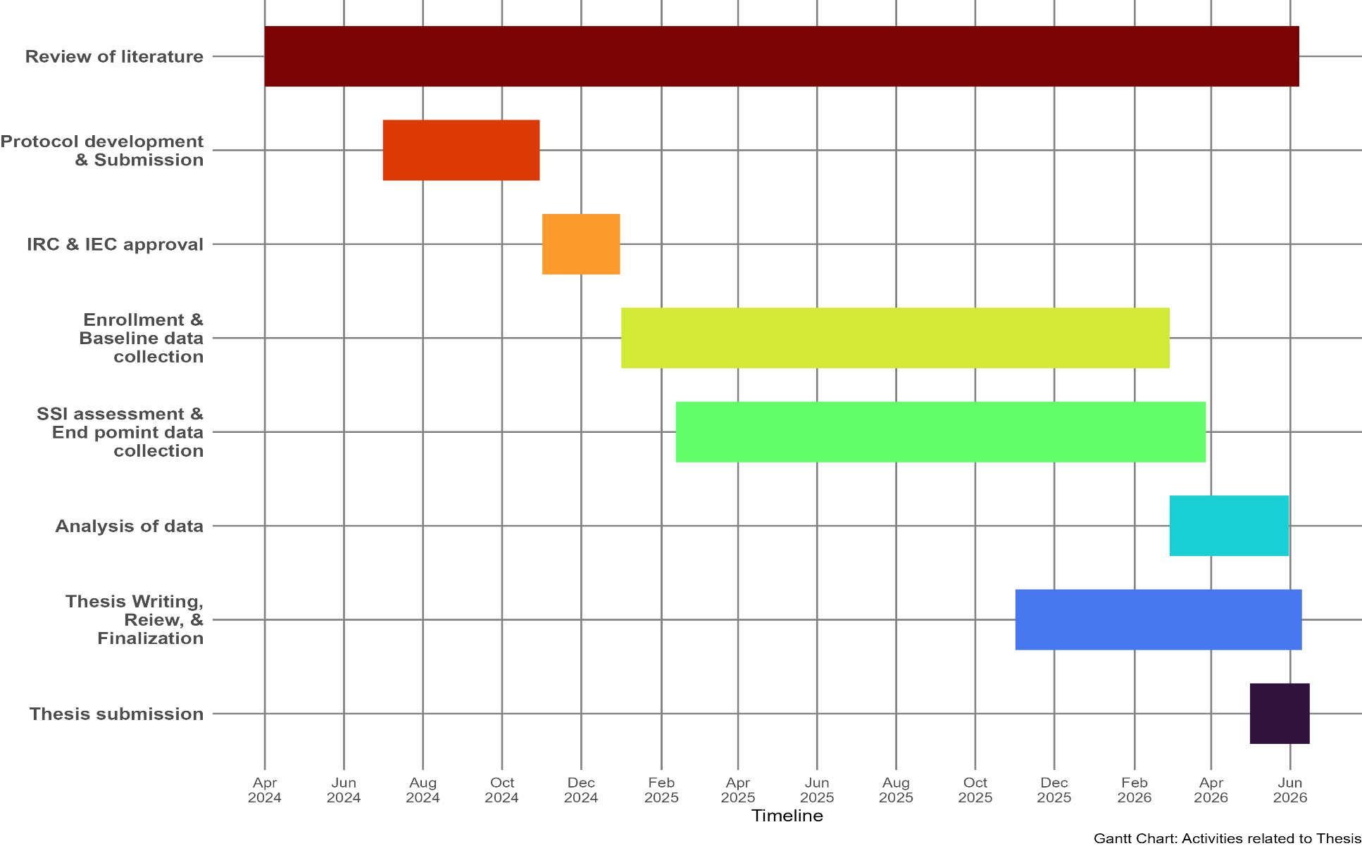
Figure 10 Gantt chart depicting the timeline of major milestones of thesis project

Statistical Analysis
Data were entered into google sheets using google form to minimize the error in data entry. Subsequently data was cleaned and imported into Jamovi statistical environment version2.6.44 for further transformations and analysis
Continuous variables were tested for normality of distribution using visual inspection of Q-Q plots. Normally distributed data was summarized as mean ± standard deviation otherwise median with interquartile range. Categorical variables were expressed as frequencies and percentages.
Association between categorical variables was performed using the Chi-square test or Fisher's exact test and student t test was used to detect the significance of mean difference in two groups.
Per protocol analysis was performed. Odds ratios with 95% confidence intervals were calculated for outcome measures.
Multivariable logistic regression analysis was carried out to identify independent predictors of surgical site infection and adjust for potential confounders. Variables with a p-value less than 0.20 in univariable analysis were entered into the multivariable model using a forward selection approach. A p-value less than 0.05 was considered statistically significant.
Kaplan Meier curve was plotted to estimate the median time to develop SSI. This is the time point where 50% of the events has occurred. Cox proportional hazard model was applied in time to event analysis to estimate groupwise hazard ratio and 95% confidence interval.

Results


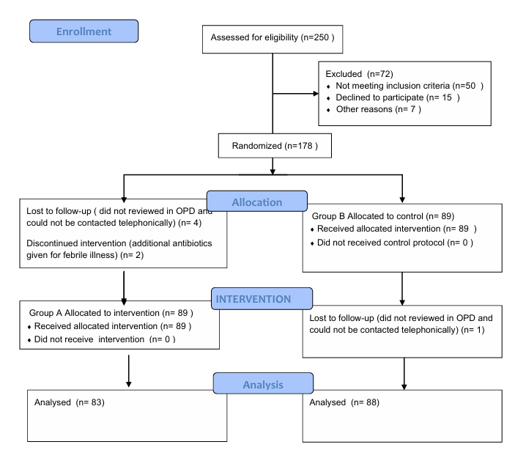
Figure 11 Consort chart of the study

Descriptive analysis
Table 2 Distribution of study participants based on age in completed years (n = 178)
Characteristics | Intervention | Control | p-value
Characteristics | (n = 89) | (n = 89) | p-value
Age in completed years | 27 ± 5 | 27 ± 5 | 0.3
Note. Values are presented as Mean ± SD.

On visual inspection of Q-Q plot age of the participants was distributed normally and summarised as Mean ± SD. Both intervention and control groups are comparable to each other at baseline with average age being 27 years.

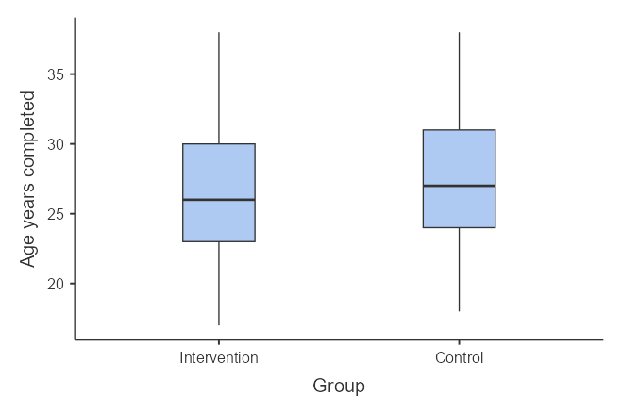
Figure 12 Box plot showing distribution of age of the participants in study groups (N = 178)

Table 3 Distribution of study participants based on BMI category (n = 178)
Characteristics | Intervention | Control | p-value
Characteristics | (n = 89) | (n = 89) | p-value
BMI category |  |  | 0.6
Normal weight | 48 (54%) | 49 (55%)
Obese | 22 (25%) | 18 (20%)
Overweight | 18 (20%) | 18 (20%)
Underweight | 1 (1.1%) | 4 (4.5%)
Note. Values are presented as n (%).

Figure 13 Bar plot depicting distribution of study participants based on bmi category (n = 178)

Interpretation:
Both study groups were comparable in terms of BMI distribution. Approximately half of them were having normal weight, while both obese and overweight were in similar proportion. A very few were underweight.

Table 4 Distribution of study participants based on socioeconomic status (n = 178)
Characteristics | Intervention | Control | p-value
Characteristics | (n = 89) | (n = 89) | p-value
Socioeconomic status |  |  | 0.045
Lower middle class | 20 (22%) | 25 (28%)
Middle class | 67 (75%) | 55 (62%)
Upper middle class | 2 (2.2%) | 9 (10%)
Note. Values are presented as n (%).

Figure 14 Bar plot depicting distribution of study participants based on socioeconomic status (n = 178)

Interpretation:
Majority of the participants belonged to the middle class of socio economic status followed by lower middle class. Very few belonged to the upped middle class. Both groups are comparable in terms of socioeconomic status.

Table 5 Distribution of study participants based on period of gestation in days (n = 178)
Characteristics | Intervention | Control | p-value
Characteristics | (n = 89) | (n = 89) | p-value
Period of gestation in days | 266 ± 12 | 266 ± 13 | >0.9
Note. Values are presented as Mean ± SD.

Interpretation:
Average period of gestation in both groups was 266 days. This corresponds to the POG of 38 weeks. Both groups are comparable in POG.

Table 6 Distribution of study participants based on parity (n = 178)
Characteristics | Intervention | Control | p-value
Characteristics | (n = 89) | (n = 89) | p-value
Parity |  |  | 0.4
Primigravida | 33 (37%) | 25 (28%)
One | 44 (49%) | 50 (56%)
>2 | 12 (13%) | 14 (16%)
Note. Values are presented as n (%).

Figure 15 Bar plot depicting distribution of study participants based on parity (n = 178)

Interpretation:
Half of the participants were primigravida while approximately 1/3rd were were delivering second time. Rest were having parity of more than 2. Bth groups are comparable interms of parity.

Table 7 Distribution of study participants based on number of previous LSCS (n = 178)
Characteristics | Intervention | Control | p-value
Characteristics | (n = 89) | (n = 89) | p-value
Number of previous LSCS |  |  | 0.2
0 | 41 (46%) | 29 (33%)
1 | 39 (44%) | 49 (55%)
≥2 | 9 (10%) | 11 (12%)
Note. Values are presented as n (%).

Figure 16 Bar plot depicting distribution of study participants based on number of previous lscs (n = 178)

Interpretation:
In intervention group slightly higher participants were having no hostiry of previous lscs, while approximately half of them having lscs second time. Both groups were nonetheless comparable in terms of previous LSCS history.

Table 8 Distribution of study participants based on type of LSCS (n = 178)
Characteristics | Intervention | Control | p-value
Characteristics | (n = 89) | (n = 89) | p-value
Type of LSCS |  |  | 0.6
Elective | 40 (45%) | 37 (42%)
Emergency | 49 (55%) | 52 (58%)
Note. Values are presented as n (%).

Figure 17 Bar plot depicting distribution of study participants based on type of lscs (n = 178)

Interpretation:
A little more than half of the participants had emergency caesarean section, but both groups are comparable in type of LSCS.

Table 9 Distribution of study participants based on number of fetuses (n = 178)
Characteristics | Intervention | Control | p-value
Characteristics | (n = 89) | (n = 89) | p-value
Number of fetuses |  |  | 0.7
Singleton | 85 (96%) | 87 (98%)
Twin | 4 (4.5%) | 2 (2.2%)
Note. Values are presented as n (%).

Figure 18 Bar plot depicting distribution of study participants based on number of fetus (n = 178)

Interpretation:
Most of the participants were having singleton pregnancy in both groups. Very few had multiple fetuses. Both groups are comparable in this regard.

Table 10 Distribution of study participants based on presentation (n = 178)
Characteristics | Intervention | Control | p-value
Characteristics | (n = 89) | (n = 89) | p-value
Presentation |  |  | >0.9
Breech | 5 (5.6%) | 4 (4.5%)
Cephalic | 84 (94%) | 84 (94%)
Transverse | 0 (0%) | 1 (1.1%)
Note. Values are presented as n (%).

Figure 19 Bar plot depicting distribution of study participants based on presentation (n = 178)

Interpretation:
Approximately all of the pregnancies were with cephalic presentation a very few being breech or transverse. Both groups are comparable based on presentation of delivery.

Table 11 Distribution of study participants based on gestational diabetes mellitus (n = 178)
Characteristics | Intervention | Control | p-value
Characteristics | (n = 89) | (n = 89) | p-value
Gestational diabetes mellitus |  |  | 0.2
Yes | 19 (21%) | 12 (13%)
No | 70 (79%) | 77 (87%)
Note. Values are presented as n (%).

Figure 20 Bar plot depicting distribution of study participants based on gestational diabetes mellitus (n = 178)

Interpretation:
Less than 1 in 5 participants were having GDM in each group. Both groups are comparable in terms of participants having GDM.

Table 12 Distribution of study participants based on preeclampsia (n = 178)
Characteristics | Intervention | Control | p-value
Characteristics | (n = 89) | (n = 89) | p-value
Preeclampsia |  |  | >0.9
Yes | 3 (3.4%) | 3 (3.4%)
No | 86 (96.6%) | 86 (96.6%)
Note. Values are presented as n (%).

Figure 21 Bar plot depicting distribution of study participants based on preeclampsia (n = 178)

Interpretation:
Most of the participants did not have preeclampsia in both groups. Both groups are comparable.

Table 13 Distribution of study participants based on gestational hypothyroidism (n = 178)
Characteristics | Intervention | Control | p-value
Characteristics | (n = 89) | (n = 89) | p-value
Gestational hypothyroidism |  |  | 0.091
Yes | 29 (33%) | 19 (21%)
No | 60 (67%) | 70 (79%)
Note. Values are presented as n (%).

Figure 22 Bar plot depicting distribution of study participants based on gestational hypothyroidism (n = 178)

Interpretation:
Around 1/3rd of the participants or less in each group were having gestational hypothyroidism. Both groups are comparable in this regards.

Table 14 Distribution of study participants based on intraoperative meconium stained liquor (n = 178)
Characteristics | Intervention | Control | p-value
Characteristics | (n = 89) | (n = 89) | p-value
Intraoperative Meconium-stained liquor |  |  | 0.2
Yes | 18 (20%) | 26 (29%)
No | 71 (80%) | 63 (71%)
Note. Values are presented as n (%).

Figure 23 Bar plot depicting distribution of study participants based on intraoperative meconium stained liquor (n = 178)

Interpretation:
Around 1/4th participants had meconium stained liquor intraoperatively. Both groups were comparable as rates were similar.

Table 15 Distribution of study participants based on number of per-vaginal examinations done (n = 178)
Characteristics | Intervention | Control | p-value
Characteristics | (n = 89) | (n = 89) | p-value
Number of per-vaginal examinations done | 2.7 ± 3.8 | 1.9 ± 2.9 | 0.13
Note. Values are presented as Mean ± SD.

Table 16 Distribution of study participants based on duration of latent labor in hours (n = 178)
Characteristics | Intervention | Control | p-value
Characteristics | (n = 89) | (n = 89) | p-value
Duration of latent labor in hours | 6 ± 10 | 5 ± 8 | 0.5
Note. Values are presented as Mean ± SD.

Table 17 Distribution of study participants based on duration of active labor in minutes (n = 178)
Characteristics | Intervention | Control | p-value
Characteristics | (n = 89) | (n = 89) | p-value
Duration of active labor in minutes | 0.87 ± 2.48 | 0.48 ± 1.79 | 0.3
Note. Values are presented as Mean ± SD.

Interpretation:
In intervention group average number of PV examination was more than 2, while in control group it was slightly less. Both groups had latent labour duration of 6 and 5 hours in both intervention and control groups and active labour duration around 1 min each. In these three parameters both groups were comparable.

Table 18 Distribution of study participants based on copper-T insertion done (n = 178)
Characteristics | Intervention | Control | p-value
Characteristics | (n = 89) | (n = 89) | p-value
Copper-T insertion done |  |  | >0.9
Yes | 17 (19%) | 17 (19%)
No | 72 (81%) | 72 (81%)
Note. Values are presented as n (%).

Figure 24 Bar plot depicting distribution of study participants based on copper-t insertion done (n = 178)

Interpretation:
Around 1 in 5 participants opted for Cu-T insertion post caesarean section. Both groups are comparable since rate is similar.

Table 19 Distribution of study participants based on bilateral tubal ligation done (n = 178)
Characteristics | Intervention | Control | p-value
Characteristics | (n = 89) | (n = 89) | p-value
Bilateral tubal ligation done |  |  | 0.3
Yes | 20 (22%) | 15 (17%)
No | 69 (78%) | 74 (83%)
Note. Values are presented as n (%).

Figure 25 Bar plot depicting distribution of study participants based on bilateral tubal ligation done (n = 178)

Interpretation:
Around 1 in 5 study participants had bilateral tubal ligation done post caesarean section in each group. Both groups are comparable.

Table 20 Distribution of study participants based on blood loss during surgical procedure in ml (n = 178)
Characteristics | Intervention | Control | p-value
Characteristics | (n = 89) | (n = 89) | p-value
Blood loss during surgical procedure in ml | 520 ± 183 | 515 ± 212 | 0.7
Note. Values are presented as Mean ± SD.

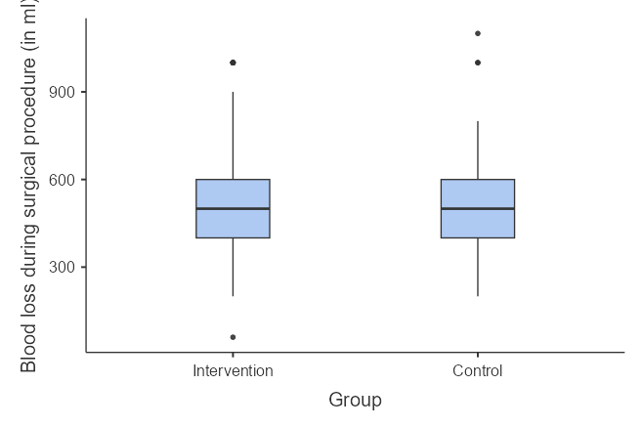
Figure 26 Boxplot depicting distribution of study participants based on blood loss during surgical pocedure (N = 178)

Interpretation:
There are few outliers in both group at both lower and upper end for blood loss during surgical procedure. Nonetheless both groups are comparable in this regard.

Table 21 Distribution of study participants based on duration of surgical procedure in minutes (n = 178)
Characteristics | Intervention | Control | p-value
Characteristics | (n = 89) | (n = 89) | p-value
Duration of surgical procedure in minutes | 72 ± 21 | 70 ± 20 | 0.7
Note. Values are presented as Mean ± SD.

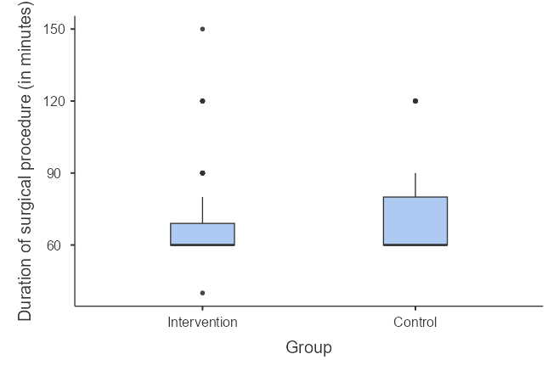
Figure 27 Boxplot depicting the distribution of study participants based on duration of surgical procedure (N = 178)

Interpretation:
Few outliers at upper end were frequently noted in both study groups. But overall both groups were comparable.

Table 22 Distribution of study participants based on dilatation of cervical os in cm (n = 178)
Characteristics | Intervention | Control | p-value
Characteristics | (n = 89) | (n = 89) | p-value
Dilatation of cervical os in cm | 1.37 ± 2.43 | 0.85 ± 1.64 | 0.3
Note. Values are presented as Mean ± SD.

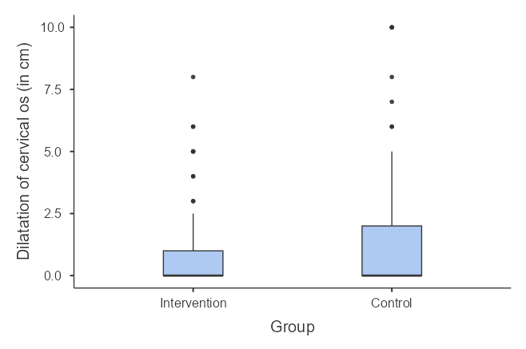
Figure 28 Boxplot depicting the distribution of study participants based on dilatation of cervical os (N = 178)

Interpretation:
Frequent outliers were noted on the upper end of cervical os dilatation, but it did not skewed the distribution from normality. Cervical os dilation was similar in both groups that is being around 1 cm. In this regard both groups are comparable.

Inferential analysis

Table 23 Distribution of study participants based on presence of SSI (n = 178)
Characteristics | Intervention | Control | p-value
Characteristics | (n = 88) | (n = 83) | p-value
Presence of SSI |  |  | 0.2
Yes | 6 (6.8%) | 10 (12%)
No | 82 (93%) | 73 (88%)
Note. Values are presented as n (%).

Interpretation:
SSI rates of 6% and 12% were noted in both intervention and control group respectively. Though SSI rates being numerically double in control group no statistical significance was noted on z test of two proportion test. This infers that both drug regimes are similar in terms of SSI prevention and intervention regime is non inferior to standard of care regime.
Since intervention regime is composed of one time antibiotic administration compares to multiple doses schedule in control group it may be considered a better choice in day to day practice.

Subgroup Analysis
Since both elective and emergency caesarean sections were included in study. A subgroup analysis was done to assess the differential effect of intervention in both stratas.

Table 24 Distribution of study participants based on presence of SSI in elective lscs group (n = 75)
Characteristics | Intervention | Control | p-value
Characteristics | (n = 40) | (n = 37) | p-value
Presence of SSI |  |  | 0.1
Yes | 0 (0%) | 3 (8.1%)
No | 40 (100%) | 34 (91.9%)
Note. Values are presented as n (%).

Table 25 Distribution of study participants based on presence of SSI emergency lscs group (n = 96)
Characteristics | Intervention | Control | p-value
Characteristics | (n = 49) | (n = 52) | p-value
Presence of SSI |  |  | 0.8
Yes | 6 (12.2%) | 7 (13.4%)
No | 43 (87.8%) | 45 (86.6%)
Note. Values are presented as n (%).

Interpretation:
Overall, very less SSI rates were observed in participants undergoing elective caesarean section compared to emergency caesarean section that is 3/82 vs 13/96. But in both strata no statistically significant difference was found in SSI rates.

Logistic Regression
Table 26 Multivariable logistic regression to predict SSI from drug regimes (N = 178)
Characteristics | Adjusted OR | 95% CI | p-value
Drug group
Control | — | —
Intervention | 0.34 | 0.08, 1.24 | 0.12
Intraoperative meconium-stained liquor | 2.47 | 0.68, 9.02 | 0.2
Duration of latent labor in hours | 1.1 | 1.02, 1.20 | 0.018
Number of per-vaginal examinations done | 1.18 | 0.95, 1.45 | 0.12
Bilateral tubal ligation done | 0.1 | 0.00, 0.86 | 0.068
Duration of surgical procedure in minutes | 1.05 | 1.02, 1.09 | 0.001
Dilatation of cervical os in cm | 0.82 | 0.53, 1.17 | 0.3
Note. CI = confidence interval; OR = odds ratio.

Interpretation:
Multivariable logistic regression was done to estimate the odds of developing SSI from intervention regime compared to control regime after controlling for perinatal factors. The odds of developing SSI is 0.34 times in intervention regime compare to that of control regime with 95% CI ranging from 0.08 to 1.24. Since 95% CI includes null value of 1, this effect is statistically non-significant. This is after controlling for intraoperative meconium stained liquor, duration of latent labour, number of per vaginal examinations conducted, bilateral tubal ligation, duration of surgical procedure and dilatation of cervical os. It can also interpretated that using intervention regime results in 66% less odds of developing SSI compared to control, but again this effect is not statistically significant.

Secondary outcomes

Type of SSI
Table 27 Distribution of study participants based on type of SSI (n = 16)
Characteristics | Intervention | Control | p-value
Characteristics | (n = 6) | (n = 10) | p-value
Type of SSI |  |  | 0.4
Deep | 1 (17%) | 0 (0%)
Superficial | 5 (83%) | 10 (100%)
Note. Values are presented as n (%).

Interpretation:
Only 1 participant in intervention group has developed deep SSI out of 6 with SSI. In control group none has developed deep SSI. This is statistically non significant and should be interpretated with caution due to low frequency of SSI observed.

Endometritis

Table 28 Distribution of study participants based on endometritis (n = 178)
Characteristics | Intervention | Control | p-value
Characteristics | (n = 88) | (n = 83) | p-value
Endometritis |  |  | >0.9
Yes | 1 (1.1%) | 0 (0%)
No | 87 (98.9%) | 83 (100%)
Note. Values are presented as n (%).

Interpretation:
In the type of SSI only 1 participant developed endometritis in intervention group compared to none in control group. This is statistically non-significant and should be interpretated with caution due to low frequency observed for SSI.

Time to develop SSI
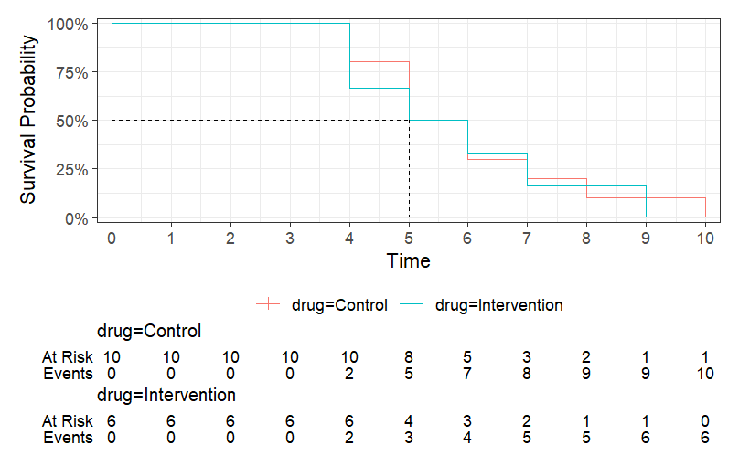
Figure 29 Kaplen-Meier curve to estimate time to develop SSI

Table 29 Cox proportional hazard model to estimate hazard ratio for developing SSI
Characteristic | HR | 95% CI | p-value
Drug
Control | — | —
Intervention | 1.13 | 0.40, 3.17 | 0.8
Abbreviations: CI = Confidence Interval, HR = Hazard Ratio
Note. Values are presented as n (%).

Interpretation:
In both drug all of the SSIs were developed by the 10th day of surgery. By 5th day of surgery around 50% of the SSI events in each group were observed. Since both curves follows closely to each other it can be seen that both drug regime does not differ in time to develop SSI. Though in cox proportional hazard model rate of developing SSI was 13% faster with intervention regime compared to control regime but 95% CI includes null value of 1 effect was statistically non significant.

Secondary suturing
Table 30 Distribution of study participants based on secondary suturing done (n = 178)
Characteristics | Intervention | Control | p-value
Characteristics | (n = 6) | (n = 10) | p-value
Secondary suturing done |  |  | >0.9
Yes | 5 (83%) | 10 (100%)
No | 1 (14%) | 0 (0%)
Note. Values are presented as n (%).

Interpretation:
All of the participants in control group required secondary suturing compared to only 80% in the intervention group. This effect is statistically non significant. But it should be interpretated with caution as very low frequencies of SSI are observed.

Readmission for SSI

Table 31 Distribution of study participants based on readmission for SSI (n = 16)
Characteristics | Intervention | Control | p-value
Characteristics | (n = 6) | (n = 10) | p-value
Readmission for SSI |  |  | 0.2
Yes | 0 (0%) | 3 (30)%)
No | 6 (100%) | 7 (70%)
Note. Values are presented as n (%).

Interpretation:
None of the participants in intervention group required readmission for SSI, but around 1/3rd of the participants in control group required readmission. But this effect is statistically non-significant and should be interpretated with caution due to low frequencies observed for SSI.

Respiratory distress
Table 32 Distribution of study participants based on rDS present (n = 171)
Characteristics | Intervention | Control | p-value
Characteristics | (n = 88) | (n = 83) | p-value
RDS present | 5 (5.7%) | 4 (4.8%) | >0.9
RDS absent | 83 (94.3%) | 79 (95.2%)
Note. Values are presented as n (%).

Figure 30 Bar plot depicting distribution of study participants based on note. values are presented as n (%). (n = 171)

Interpretation
Both group had equal frequency of respiratory distress syndrome and is not associated with intervention or control regimen.

Neonatal sepsis
Table 33 Distribution of study participants based on neonatal sepsis (n = 171)
Characteristics | Intervention | Control | p-value
Characteristics | (n = 89) | (n = 89) | p-value
Neonatal sepsis |  |  | >0.9
Present | 2 (2.3%) | 3 (3.6%)
Absent | 86 (97.7%) | 80 (96.4%)
Note. Values are presented as n (%).

Figure 31 Bar plot depicting distribution of study participants based on neonatal sepsis (n = 171)

Interpretation:
Both groups had similar frequency of neonatal frequency and was not associated with any regimen.

NICU Admission
Table 34 Distribution of study participants based on nICU admission (n = 171)
Characteristics | Intervention | Control | p-value
Characteristics | (n = 88) | (n = 83) | p-value
NICU admission |  |  | 0.52
Present | 8 (9.1%) | 10 (12.0%)
Absent | 80 (90.9%) | 73 (88.0%)
Note. Values are presented as n (%).

Figure 32 Bar plot depicting distribution of study participants based on NICU admission (n = 171)

Interpretation:
A slight higher proportion of NICU admission was noted in control group but it did not reach statistical significance.

Discussion


We conducted a randomized controlled non-inferiority study to compare single-dose perioperative ceftriaxone plus azithromycin with ceftriaxone followed by five days of oral cefuroxime for prevention of post-caesarean surgical site infection. We included 178 women undergoing caesarean section, with 89 participants in each group. Both elective and emergency caesarean sections were included, making our findings relevant to routine obstetric practice. Participants were followed postoperatively and after discharge to assess surgical site infection and other maternal and neonatal outcomes.
The baseline demographic and obstetric characteristics were broadly comparable between the two groups, supporting the validity of outcome comparison. Mean maternal age was similar in both groups, 27 ± 5 years each. Jyothi et al., an Indian randomized controlled trial and the closest study to the present work, also reported comparable mean age between groups, 27.39 ± 3.03 years in the cefazolin-placebo group and 26.42 ± 2.65 years in the cefazolin-azithromycin group.²² Tita et al. reported similar mean age of 28.2 ± 6.1 years and 28.4 ± 6.5 years in the azithromycin and placebo groups, respectively.²³ Huang et al. reported slightly higher age, 30.0 ± 3.1 years and 30.4 ± 3.5 years in the experimental and placebo groups, respectively.²⁴ Ruzic et al. also reported a slightly higher age profile in their prelabor caesarean cohort, 29.2 ± 5.8 years before azithromycin implementation and 30.4 ± 5.9 years after azithromycin implementation.²⁵ Thus, the present study, similar to previous trials, included women in the usual reproductive-age obstetric population.
The present study represents a relatively leaner Indian obstetric population. Normal BMI was the most common category, observed in 48 women (54%) in the intervention group and 49 women (55%) in the control group. Obesity was present in 22 women (25%) and 18 women (20%), respectively. Jyothi et al. also represented an Indian obstetric population with a lower BMI profile, reporting mean BMI of 25.49 ± 3.18 kg/m² and 24.88 ± 2.90 kg/m² in the two groups.²² In contrast, Tita et al. reported a much higher mean BMI of 35.3 ± 7.7 kg/m² and 35.5 ± 7.9 kg/m².²³ Huang et al. reported mean BMI of 27.4 ± 4.0 kg/m² and 27.7 ± 3.6 kg/m², respectively.²⁴ Ruzic et al. also reported a higher BMI profile of 32.6 ± 9.7 kg/m² and 32.4 ± 8.8 kg/m².²⁵ This difference is clinically important because higher BMI is an established risk factor for wound infection and post-caesarean SSI. Therefore, our study adds locally useful evidence from an Indian population whose anthropometric profile differs from many Western cohorts.
Gestational age was also comparable between groups. Mean period of gestation was 266 ± 12 days in the intervention group and 266 ± 13 days in the control group, corresponding approximately to 38 weeks. Jyothi et al. reported period of gestation of 36.75 ± 2.71 weeks and 36.41 ± 2.77 weeks in their two groups.²² Tita et al. reported gestational age of 38.9 ± 2.3 weeks and 39.0 ± 2.3 weeks.²³ Huang et al. reported 39.5 ± 1.1 weeks in both groups.²⁴ Ruzic et al. reported gestational age of 36.8 ± 3.8 weeks and 36.7 ± 3.6 weeks in the pre-AZI and post-AZI groups.²⁵ Thus, the present study mainly included term or near-term caesarean deliveries, similar to the published evidence.
Parity and previous pregnancy distribution were balanced in the present study. Primigravida constituted 33 women (37%) in the intervention group and 25 women (28%) in the control group. Jyothi et al. reported comparable parity, 2.02 ± 1.26 and 2.05 ± 1.19 in their two groups.²² Tita et al. reported previous pregnancy in 552 women (54.2%) and 560 women (56.3%) in the azithromycin and placebo groups, respectively.²³ Huang et al. reported mean pregnancy count of 1.5 ± 1.1 and 1.4 ± 0.7 in the experimental and placebo groups.²⁴ The present study additionally reported previous LSCS status in detail. One previous LSCS was present in 39 women (44%) in the intervention group and 49 women (55%) in the control group. Jyothi et al. also reported previous caesarean delivery, present in 30 women and 27 women in their two groups.²² This detailed documentation is useful because previous caesarean delivery may influence operative complexity, adhesions, duration of surgery and wound-related morbidity.
Both elective and emergency caesarean sections were comparably distributed among both groupos. Emergency LSCS was performed in 49 women (55%) in the intervention group and 52 women (58%) in the control group, while elective LSCS was performed in 40 women (45%) and 37 women (42%), respectively. Jyothi et al. also included both emergency and elective caesarean sections; emergency caesarean section was performed in 73 and 71 women, while elective caesarean section was performed in 27 and 29 women in the two groups.²² In contrast, Tita et al. included only nonelective caesarean deliveries, and Huang et al. also focused on non-elective caesarean delivery.^{23,24} Ruzic et al. specifically evaluated prelabor caesarean births and therefore represented a lower-risk caesarean population.²⁵ Thus, the present study occupies an important practical position by including both elective and emergency procedures, making it more reflective of routine obstetric practice.
Comorbidities were also well balanced. Gestational diabetes mellitus was present in 19 women (21%) in the intervention group and 12 women (13%) in the control group. Jyothi et al. excluded women with diabetes mellitus but reported hypertensive disorders of pregnancy in 27 and 34 women in their two groups.²² Tita et al. reported gestational diabetes in 99 women (9.7%) and 106 women (10.7%) in the azithromycin and placebo groups, respectively.²³ Huang et al. reported gestational diabetes in 16 and 18 women, respectively.²⁴ Ruzic et al. reported pregestational diabetes in 99 women (7.1%) and 104 women (7.0%), while medication-controlled gestational diabetes was present in 63 women (4.5%) and 94 women (6.4%) in the pre-AZI and post-AZI groups, respectively.²⁵ Preeclampsia was present in 3 women (3.4%) in both groups in the present study, whereas Ruzic et al. reported a higher burden of preeclampsia, 19.9% and 26.4% in their two groups.²⁵ Overall, important maternal risk factors were distributed comparably between groups in the present study, further strengthening the internal validity of the comparison.
Labour-related parameters were comparable between groups. Duration of latent labour was 6 ± 10 hours in the intervention group and 5 ± 8 hours in the control group. Jyothi et al. did not report latent labour duration separately but reported duration of rupture of membranes of 4.34 ± 4.01 hours and 4.48 ± 3.87 hours in their two groups. They also identified duration of ROM >12 hours as a significant risk factor for SSI among women who developed infection.²² Tita et al. did not report latent labour duration separately, but membrane rupture before skin incision was almost identical in both groups, 87.8% and 87.7%, respectively.²³ Huang et al. reported comparable labour duration of 5.4 ± 4.9 hours and 5.8 ± 4.9 hours.²⁴ Therefore, the present study appropriately captured labour exposure as an important infection-related variable.
In the present study, the number of per-vaginal examinations was 2.7 ± 3.8 in the intervention group and 1.9 ± 2.9 in the control group. Jyothi et al. also recorded this parameter and reported a comparable number of vaginal examinations in both groups, 1.53 ± 1.70 and 1.51 ± 1.70.²² This parameter was not separately reported by Tita et al. or Huang et al. in their baseline tables.^{23,24} Its inclusion is important because repeated per-vaginal examinations may increase ascending genital-tract contamination and thereby influence post-caesarean SSI risk. By documenting this variable and showing comparable distribution between groups, the present study provides a more detailed assessment of labour-related infection risk and strengthens the validity of comparison between the two antibiotic regimens.
Cervical dilatation was lower in the present study, with mean dilatation of 1.37 ± 2.43 cm in the intervention group and 0.85 ± 1.64 cm in the control group. Huang et al. reported higher cervical dilatation of 3.4 ± 2.4 cm in the experimental group and 3.6 ± 2.4 cm in the placebo group, although it was comparable between groups.²⁴ Jyothi et al. did not separately report cervical dilatation, but reported comparable vaginal examination and ROM duration between groups.²² Tita et al. did not report cervical dilatation separately; however, labour-related indications such as failure to progress (35.3% vs 34.4%) and failed induction (10.3% vs 10.4%) were well balanced between the two groups.²³ The relatively lower cervical dilatation in the present study suggests lesser labour exposure before caesarean section, which may have reduced ascending genital-tract contamination and may partly explain the low frequency of endometritis and deep SSI observed in this study. Importantly, cervical dilatation was comparable between the two groups in the present study, indicating that its effect on SSI risk was balanced and unlikely to confound the comparison between antibiotic regimens.
Operative parameters were similarly distributed. Blood loss was 520 ± 183 ml in the intervention group and 515 ± 212 ml in the control group. Jyothi et al. reported approximate blood loss of 391 ± 120.06 ml and 377 ± 114.45 ml in their two groups.²² Huang et al. reported lower but comparable blood loss of 228.4 ± 63.8 ml and 231.1 ± 193.9 ml.²⁴ Duration of surgery was 72 ± 21 minutes and 70 ± 20 minutes in the intervention and control groups, respectively. Jyothi et al. reported operative duration of 1.095 ± 0.26 hours and 1.06 ± 0.22 hours, while Huang et al. reported shorter but balanced operative duration of 35.3 ± 7.3 minutes and 35.1 ± 7.3 minutes.^{22,24} The longer operative duration in the present study may reflect institutional practice, case complexity, previous LSCS distribution and inclusion of both elective and emergency procedures. Importantly, despite longer operative time, the intervention group did not show increased SSI.
In the present per-protocol analysis, surgical site infection occurred in 6 women (6.8%) in the ceftriaxone–azithromycin group compared with 10 women (12.0%) in the control group. Although this difference was not statistically significant (p = 0.20), the absolute reduction of 5.2 percentage points favoured the intervention regimen. On multivariable logistic regression, the intervention regimen was associated with lower adjusted odds of SSI compared with the control regimen, although this did not reach statistical significance (adjusted OR = 0.34; 95% CI: 0.08–1.24; p = 0.12). This is clinically encouraging because single-dose ceftriaxone–azithromycin avoided five days of postoperative cefuroxime without increasing the observed SSI rate.
The direction of effect is consistent with published evidence, especially the Indian trial by Jyothi et al. They reported significantly lower SSI with cefazolin plus azithromycin compared with cefazolin alone, 3% vs 15% (p = 0.003).²² Tita et al. reported that adjunctive azithromycin reduced post-caesarean infection from 12.0% to 6.1%, endometritis from 6.1% to 3.8%, and wound infection from 6.6% to 2.4%.²³ Ruzic et al. reported that implementation of adjunctive azithromycin in prelabor caesarean birth reduced composite post-caesarean infection from 4.8% to 3.3% (aOR 0.60; 95% CI 0.40–0.89), mainly due to reduced wound infection, 3.5% vs 2.4% (aOR 0.61; 95% CI 0.39–0.98).²⁵ Yang et al., in a systematic review and meta-analysis, reported that addition of azithromycin significantly reduced wound infection in randomized controlled trials (RR 0.40; 95% CI 0.27–0.58; p < 0.00001) and in cohort studies (RR 0.66; 95% CI 0.54–0.82; p = 0.0001).²⁶ Thus, although the present study did not achieve statistical significance, the direction of effect is consistent with Indian, international and pooled evidence.
The smaller and statistically non-significant difference in the present study may be explained by smaller sample size, fewer SSI. Unlike Jyothi et al. and Tita et al., where adjunctive azithromycin was compared against cefazolin monotherapy or placebo.
Subgroup findings were also clinically encouraging. Among elective caesarean sections, no SSI occurred in the intervention group compared with 8.6% in the control group. Among emergency caesarean sections, SSI occurred in 13% and 15%, respectively. Although these differences were not statistically significant, the absence of SSI in the elective intervention subgroup is a favourable finding. Jyothi et al. included both elective and emergency caesarean sections, with emergency procedures being more common, and still demonstrated lower SSI with adjunctive azithromycin.²² Ruzic et al. also reported benefit of adjunctive azithromycin in a lower-risk prelabor caesarean population, with composite infection decreasing from 4.8% to 3.3% after azithromycin implementation.²⁵ The higher infection rate among emergency procedures in both groups of the present study is biologically plausible because labour, membrane rupture, cervical dilatation and repeated vaginal examinations increase ascending genital-tract contamination.
The overall SSI incidence in the present study was 9.4%. Jyothi et al. reported a similar overall SSI incidence of 9% in their Indian randomized trial, with a significantly higher rate in the cefazolin-placebo group compared with the cefazolin-azithromycin group.²² Hirani et al. reported an SSI incidence of 5.63% among 2,024 women undergoing caesarean section at an Indian tertiary-care hospital.²⁷ The higher incidence in the present may reflect active post-discharge surveillance, inclusion of emergency procedures and differences in patient profile and institutional practice. This also highlights a strength of the present study, as active follow-up is more likely to detect infections that may be missed by routine inpatient surveillance alone.
Superficial incisional SSI constituted most infections in the present study, whereas deep SSI and endometritis were uncommon. In the present study, the intervention group had 5 superficial and 1 deep SSI, while all 10 SSI cases in the control group were superficial. Jyothi et al. also reported predominance of superficial SSI, with 12 superficial SSI in the cefazolin-placebo group and 3 superficial SSI in the cefazolin-azithromycin group (p = 0.016), while deep SSI was 3 vs 0 (p = 0.081).²² Ruzic et al. reported wound infection rates of 3.5% before and 2.4% after azithromycin implementation, with deep wound infection and intra-abdominal abscess being rare.²⁵ This pattern supports the interpretation that severe infectious morbidity was limited in the present study.
Endometritis was rare in the present study, occurring in only one woman in the intervention group and none in the control group. Jyothi et al. reported significantly lower endometritis with cefazolin plus azithromycin compared with cefazolin alone, 2% vs 10% (p = 0.015).[1] Tita et al. also reported lower endometritis with adjunctive azithromycin, 3.8% vs 6.1%.²³ Yang et al. found that addition of azithromycin significantly reduced endometritis in randomized controlled trials (RR 0.62; 95% CI 0.49–0.79; p < 0.0001).²⁶ Kuitunen et al. similarly reported lower endometritis in the azithromycin group compared with placebo, 1.5% vs 2.3% (RR 0.64; 95% CI 0.55–0.75).²⁸
SSI was detected at approximately the sixth postoperative day in both groups. Hirani et al. similarly reported a mean interval of 6.97 ± 2.7 days between caesarean delivery and diagnosis of incisional SSI.²⁷ This reinforces the importance of post-discharge follow-up, as many post-caesarean infections become clinically evident only after hospital discharge. The structured follow-up schedule in the present study is therefore an important methodological strength.
Maternal wound-related outcomes also favoured the intervention regimen. Secondary suturing was required in 5.6% of women in the intervention group and 11% in the control group. No woman in the intervention group required readmission for SSI, compared with 3.4% in the control group. Although these findings were not statistically significant, their consistent numerical direction supports the clinical promise of ceftriaxone–azithromycin. Ruzic et al. similarly found that adjunctive azithromycin was associated with lower wound-related complications, including wound seroma (0.9% vs 0.5%; aOR 0.34; 95% CI 0.13–0.90), wound dehiscence (1.2% vs 0.5%; aOR 0.32; 95% CI 0.13–0.79), and any wound or postoperative complication (5.8% vs 4.9%; aOR 0.69; 95% CI 0.49–0.98).²⁵ This supports the possibility that adjunctive azithromycin may reduce wound-related morbidity.
Short-term neonatal outcomes were reassuring. Respiratory distress syndrome occurred in 5 neonates (5.7%) in the intervention group and 4 neonates (4.8%) in the control group. Neonatal sepsis occurred in 2 neonates (2.3%) and 3 neonates (3.6%), respectively. NICU admission was required in 8 neonates (9.1%) in the intervention group and 10 neonates (12.0%) in the control group. Low APGAR score was uncommon, and no neonatal death occurred in either group. These neonatal outcomes were not statistically significant. Jyothi et al. also reported no significant difference in neonatal sepsis (7 vs 5; p = 0.552) or NICU admission (9 vs 4; p = 0.152) between groups.²² Tita et al. reported similar composite neonatal adverse outcomes in the azithromycin and placebo groups, 14.3% and 13.6%, respectively.²³ Ruzic et al. reported no significant difference in composite neonatal morbidity, 5-minute APGAR score <4, NICU admission or neonatal death after implementation of adjunctive azithromycin.²⁵ Kuitunen et al., in a systematic review and meta-analysis of 44,565 neonates with use of intrapartum azithromycin regardless of mode of delivery, found no significant reduction or increase in neonatal death (0.7% vs 0.8%; RR 0.94; 95% CI 0.76–1.16) or neonatal sepsis (7.6% vs 7.4%; RR 1.02; 95% CI 0.96–1.09).²⁸ Therefore, the present study adds to the reassuring evidence that single-dose adjunctive azithromycin does not appear to increase early neonatal complications.
The biological plausibility of the observed favourable trend is supported by the antimicrobial spectrum of azithromycin. Post-caesarean infections are polymicrobial and may involve aerobic, anaerobic and genital-tract organisms. Jyothi et al. emphasized that post-caesarean infections involve aerobes, anaerobes and ureaplasma, and that azithromycin has activity against aerobes, anaerobes and ureaplasma, making it useful as an add-on agent in settings with higher infectious burden.²² Yang et al. further suggested that caesarean SSI may be associated with Mycoplasma hominis and Ureaplasma urealyticum, and that the benefit of adding azithromycin to cephalosporin prophylaxis may be related to additional coverage against genital mycoplasmas.²⁶ This mechanism is relevant to the present study because labour, cervical dilatation and vaginal examinations may facilitate ascending genital-tract contamination before caesarean section.
The main clinical implication of the present study is its antimicrobial-stewardship value. The intervention regimen showed a favorable trend toward lower SSI, secondary suturing and readmission, while avoiding five days of postoperative cefuroxime. Jyothi et al. reported that addition of azithromycin reduced requirement of additional postoperative antibiotics, 26 vs 9 (p = 0.002), and shortened hospital stay, 7.03 ± 4.86 days vs 5.44 ± 2.68 days (p < 0.001).²² Yang et al. concluded that addition of azithromycin to standard prophylaxis reduced endometritis, wound infection and composite infectious outcomes.²⁶ Kuitunen et al. also found that intrapartum azithromycin reduced maternal postpartum infections, including endometritis, wound infection and maternal sepsis.²⁸ Therefore, the present study supports the concept that a shorter perioperative regimen with adjunctive azithromycin may be clinically useful while limiting unnecessary prolonged postoperative antibiotic exposure.
Overall, the present study adds valuable Indian evidence on adjunctive azithromycin-based prophylaxis in caesarean delivery. It demonstrated good baseline comparability, detailed reporting of obstetric and operative risk factors, inclusion of both elective and emergency caesarean sections, and active post-discharge surveillance. The ceftriaxone–azithromycin regimen showed a clinically favourable trend toward lower SSI, secondary suturing and readmission without evidence of increased short-term neonatal morbidity. These findings are consistent with the direction of benefit reported by Jyothi et al., Tita et al., Ruzic et al., Yang et al. and Kuitunen et al., and support further evaluation of this shorter, stewardship-friendly prophylactic regimen in larger multicentre randomized trials.

Strengths
- The present study was a randomized controlled trial, which strengthens internal validity and reduces selection bias in the comparison of the two antibiotic prophylaxis regimens.
- Allocation concealment was maintained using Sequentially Numbered Opaque Sealed Envelopes, and both participants and outcome assessors were blinded to treatment allocation. This reduced the possibility of performance bias and outcome-assessment bias.
- The study compared two clinically relevant active prophylactic regimens. The control regimen reflected extended postoperative antibiotic practice, while the intervention regimen tested a shorter perioperative azithromycin-containing strategy. Therefore, the study addressed a practical clinical and antimicrobial-stewardship question.
- Both elective and emergency caesarean sections were included. This increased the clinical relevance of the study because the findings reflect routine obstetric practice rather than a narrowly selected caesarean population.
- SSI assessment was performed using a structured SSI assessment tool and participants were followed up after discharge. This improved detection of post-caesarean infection beyond the immediate in-hospital period.
- The analysis did not rely only on crude comparison of SSI rates. Multivariable logistic regression was performed to adjust for clinically relevant labour-related and operative factors, and time-to-event analysis was also performed using Kaplan–Meier and Cox proportional hazards methods.

Limitations
- The study was conducted at a single tertiary-care centre. Therefore, the findings may not be directly generalizable to other hospitals with different patient profiles, surgical practices, infection-control standards, and antimicrobial-resistance patterns.
- The number of SSI events was low. Only a small number of participants developed SSI, which reduced statistical power and widened the confidence intervals around effect estimates.
- The study was not adequately powered for rare secondary outcomes such as deep SSI, endometritis, readmission, and secondary suturing. Therefore, these findings should be interpreted cautiously.
- Microbiological culture and antimicrobial-sensitivity patterns were not incorporated into the main outcome analysis. As a result, the study could not directly identify the causative organisms or determine whether the observed infections were related to organisms covered by azithromycin.
- Some post-discharge follow-up depended on outpatient visits or telephonic contact. This may have introduced the possibility of missed mild SSI cases, especially if symptoms were not severe enough for the participant to return to hospital.

Summary
Caesarean section is one of the most commonly performed obstetric procedures, and surgical site infection remains an important cause of postoperative maternal morbidity. Appropriate antibiotic prophylaxis is essential for reducing post-caesarean infection, but prolonged postoperative antibiotic use may increase cost, pill burden, adverse effects and antimicrobial resistance. In this context, the present randomized controlled non-inferiority study was conducted to compare a shorter perioperative antibiotic regimen consisting of ceftriaxone with adjunctive azithromycin against the existing extended cephalosporin-based regimen for prevention of post-caesarean surgical site infection.
The study was conducted in the Department of Obstetrics and Gynaecology at AIIMS Patna. A total of 178 women undergoing caesarean section were enrolled and randomized into two groups of 89 each. The intervention group received ceftriaxone 1 g intravenously with azithromycin 500 mg intravenously before caesarean section, while the control group received ceftriaxone 1 g intravenously followed by oral cefuroxime 500 mg twice daily for five days. Both elective and emergency caesarean sections were included. Baseline demographic, obstetric, labour-related and intraoperative variables were recorded. Women were followed postoperatively during hospital stay and after discharge for detection of surgical site infection and other maternal and neonatal outcomes.
The two groups were broadly comparable at baseline. Mean age was 27 ± 5 years in both groups and mean period of gestation was 266 days in both groups. Normal BMI was the most common BMI category, seen in 54% of women in the intervention group and 55% in the control group. Emergency caesarean section was performed in 55% and 58% of women in the intervention and control groups, respectively. Gestational diabetes mellitus was present in 21% of women in the intervention group and 13% in the control group, while preeclampsia was present in 3.4% of women in both groups. Labour and operative characteristics were also comparable. The mean number of per-vaginal examinations was 2.7 ± 3.8 and 1.9 ± 2.9, duration of latent labour was 6 ± 10 and 5 ± 8 hours, blood loss was 520 ± 183 ml and 515 ± 212 ml, and duration of surgery was 72 ± 21 and 70 ± 20 minutes in the intervention and control groups, respectively.
In the per-protocol analysis, surgical site infection occurred in 6 women (6.8%) in the intervention group and 10 women (12.0%) in the control group. Although the difference was not statistically significant, the infection rate was numerically lower in the ceftriaxone–azithromycin group. On multivariable logistic regression, the adjusted odds of developing SSI were lower in the intervention group compared with the control group, but the association was statistically non-significant. Among those who developed SSI, superficial SSI was the most common type. In the intervention group, 5 cases were superficial and 1 case was deep SSI, while all 10 cases in the control group were superficial. Endometritis was rare, occurring in 1 woman in the intervention group and none in the control group. Time to development of SSI was similar between the two groups, with most infections being detected within the first postoperative week.
Other maternal wound-related outcomes also showed a favourable numerical trend in the intervention group. Secondary suturing was required in 5 women in the intervention group and 10 women in the control group among those with SSI. No woman in the intervention group required readmission for SSI, whereas 3 women in the control group required readmission. However, these differences were statistically non-significant and should be interpreted cautiously because of the small number of SSI events.
Overall, the present study found that single-dose perioperative ceftriaxone with adjunctive azithromycin was associated with a numerically lower rate of post-caesarean surgical site infection compared with ceftriaxone followed by five days of cefuroxime. The difference was not statistically significant, but the shorter regimen did not increase maternal or neonatal adverse outcomes. The findings support the potential clinical usefulness of ceftriaxone–azithromycin as a shorter, stewardship-friendly prophylactic regimen for caesarean delivery. Larger multicentric randomized trials with adequate power, microbiological correlation and longer neonatal follow-up are recommended to confirm these findings.

Conclusion
In the present study, the single-dose ceftriaxone–azithromycin regimen showed a numerically lower incidence of post-caesarean SSI compared with ceftriaxone followed by postoperative cefuroxime. However, this difference was not statistically significant. The adjusted analysis also favoured the azithromycin-containing regimen, but the confidence interval crossed unity. Most infections were superficial, endometritis was rare, and time to development of SSI did not differ significantly between the two groups. Longer latent labour and longer surgical duration were significant predictors of SSI. Overall, the findings suggest comparable observed effectiveness of the shorter azithromycin-containing regimen with potential reduction in postoperative antibiotic exposure, but definitive non-inferiority should be concluded only after formal non-inferiority analysis.

Recommendations
- A single-dose ceftriaxone–azithromycin regimen may be considered as a potential alternative to extended postoperative cephalosporin prophylaxis, especially where reduction of unnecessary antibiotic exposure is a priority.
- Larger multicentric randomized trials are required to confirm the effectiveness and safety of the ceftriaxone–azithromycin regimen in Indian obstetric settings.
- Future studies should include microbiological culture and antimicrobial-sensitivity testing to identify causative organisms and guide local antibiotic policy.
- Labour duration, repeated per-vaginal examinations, and surgical duration should be minimized wherever clinically feasible, as these factors may increase the risk of post-caesarean SSI.
- Post-discharge SSI surveillance should be strengthened through structured follow-up, early wound assessment, and clear patient instructions for reporting fever, wound discharge, redness, pain, or gaping.

References



1. Betran AP, Ye J, Moller AB, Souza JP, Zhang J. Trends and projections of caesarean section rates: global and regional estimates. BMJ Glob Health. 2021 Jun;6(6):e005671. doi:10.1136/bmjgh-2021-005671 PubMed PMID: 34130991; PubMed Central PMCID: PMC8208001.
2. WHO recommendation on prophylactic antibiotics for women undergoing caesarean section [Internet]. [cited 2026 Jun 1]. Available from: https://www.who.int/publications/i/item/9789240028012
3. Zuarez-Easton S, Zafran N, Garmi G, Salim R. Postcesarean wound infection: prevalence, impact, prevention, and management challenges. Int J Womens Health. 2017;9:81–8. doi:10.2147/IJWH.S98876 PubMed PMID: 28255256; PubMed Central PMCID: PMC5322852.
4. Sibomana O, Bugenimana A, Oke GI, Egide N. Prevalence of post-caesarean section surgical site infections in Rwanda: A systematic review and meta-analysis. Int Wound J. 2024 May;21(5):e14929. doi:10.1111/iwj.14929 PubMed PMID: 38772859; PubMed Central PMCID: PMC11108763.
5. Hirani S, Trivedi NA, Chauhan J, Chauhan Y. A study of clinical and economic burden of surgical site infection in patients undergoing caesarian section at a tertiary care teaching hospital in India. PloS One. 2022;17(6):e0269530. doi:10.1371/journal.pone.0269530 PubMed PMID: 35658054; PubMed Central PMCID: PMC9165765.
6. Velin L, Umutesi G, Riviello R, Muwanguzi M, Bebell LM, Yankurije M, et al. Surgical Site Infections and Antimicrobial Resistance After Cesarean Section Delivery in Rural Rwanda. Ann Glob Health. 2021;87(1):77. doi:10.5334/aogh.3413 PubMed PMID: 34430227; PubMed Central PMCID: PMC8344956.
7. Adjunctive Azithromycin Prophylaxis for Cesarean Delivery | New England Journal of Medicine [Internet]. [cited 2026 Jun 1]. Available from: https://www.nejm.org/doi/full/10.1056/NEJMoa1602044
8. Boggess KA, Tita A, Jauk V, Saade G, Longo S, Clark EAS, et al. Risk Factors for Postcesarean Maternal Infection in a Trial of Extended-Spectrum Antibiotic Prophylaxis. Obstet Gynecol. 2017 Mar;129(3):481–5. doi:10.1097/AOG.0000000000001899 PubMed PMID: 28178058; PubMed Central PMCID: PMC5322229.
9. Yang M, Yuan F, Guo Y, Wang S. Efficacy of adding azithromycin to antibiotic prophylaxis in caesarean delivery: a meta-analysis and systematic review. Int J Antimicrob Agents. 2022 Mar;59(3):106533. doi:10.1016/j.ijantimicag.2022.106533 PubMed PMID: 35091057.
10. Ratnesh K, Kumar P, Arya A. Incidence of Surgical Site Infections and Surgical Antimicrobial Prophylaxis in JNMC, Bhagalpur, India. J Pharm Bioallied Sci. 2022 Jul;14(Suppl 1):S868–71. doi:10.4103/jpbs.jpbs_30_22 PubMed PMID: 36110734; PubMed Central PMCID: PMC9469243.
11. Committee on Practice Bulletins-Obstetrics. ACOG Practice Bulletin No. 199: Use of Prophylactic Antibiotics in Labor and Delivery. Obstet Gynecol. 2018 Sep;132(3):e103–19. doi:10.1097/AOG.0000000000002833 PubMed PMID: 30134425.
12. Sanusi A, Ye Y, Boggess K, Saade G, Longo S, Clark E, et al. Timing of Adjunctive Azithromycin for Unscheduled Cesarean Delivery and Postdelivery Infection. Obstet Gynecol. 2022 Jun 1;139(6):1043–9. doi:10.1097/AOG.0000000000004788 PubMed PMID: 35675601; PubMed Central PMCID: PMC9199590.
13. Azithromycin to Prevent Sepsis or Death in Women Planning a Vaginal Birth | New England Journal of Medicine [Internet]. [cited 2026 Jun 1]. Available from: https://www.nejm.org/doi/full/10.1056/NEJMoa2212111
14. Bhimani S, Sanghvi G, Pethani T, Dave G, Airao V, Sharma T, et al. Development of the UV Spectrophotometric Method of Azithromycin in API and Stress Degradation Studies. Int Lett Chem Phys Astron. 2016;68:48–53. doi:10.18052/www.scipress.com/ilcpa.68.48
15. Heidary M, Ebrahimi Samangani A, Kargari A, Kiani Nejad A, Yashmi I, Motahar M, et al. Mechanism of action, resistance, synergism, and clinical implications of azithromycin. J Clin Lab Anal. 2022 Jun;36(6):e24427. doi:10.1002/jcla.24427 PubMed PMID: 35447019; PubMed Central PMCID: PMC9169196.
16. Parnham MJ, Erakovic Haber V, Giamarellos-Bourboulis EJ, Perletti G, Verleden GM, Vos R. Azithromycin: mechanisms of action and their relevance for clinical applications. Pharmacol Ther. 2014 Aug;143(2):225–45. doi:10.1016/j.pharmthera.2014.03.003 PubMed PMID: 24631273.
17. Huang D, Chen S, Cai Y, Shi L, Shi Y, Zeng M, et al. Adjunctive azithromycin prophylaxis protects women from uterine cesarean scar defect: A randomized controlled trial. Acta Obstet Gynecol Scand. 2022 May 29;101(8):889–900. doi:10.1111/aogs.14387 PubMed PMID: 35645037; PubMed Central PMCID: PMC9564557.
18. Clinical effectiveness of adding azithromycin to antimicrobial prophylaxis for cesarean delivery - American Journal of Obstetrics & Gynecology [Internet]. [cited 2026 Jun 1]. Available from: https://www.ajog.org/article/S0002-9378(21)00589-5/abstract
19. Ruzic MF, Blanchard CT, Cozzi GD, Howard HR, Casey BM, Tita AT, et al. Adjunctive Azithromycin Prophylaxis for Prelabor Cesarean Birth. Obstet Gynecol. 2023 Feb 1;141(2):403–13. doi:10.1097/AOG.0000000000005037 PubMed PMID: 36649335.
20. Farmer N, Hodgetts-Morton V, Morris RK. Are prophylactic adjunctive macrolides efficacious against caesarean section surgical site infection: A systematic review and meta-analysis. Eur J Obstet Gynecol Reprod Biol. 2020 Jan;244:163–71. doi:10.1016/j.ejogrb.2019.11.026 PubMed PMID: 31810022.
21. Markwei MT, Babatunde I, Rathi N, Fan C, Prah MA, Joo J, et al. Preincision adjunctive prophylaxis for cesarean deliveries a systematic review and meta-analysis. Am J Obstet Gynecol. 2021 Oct;225(4):382.e1-382.e13. doi:10.1016/j.ajog.2021.04.259 PubMed PMID: 33964219.
22. Jyothi MS, Kalra JK, Arora A, Patil A, Suri V, Jain V, et al. Randomized controlled trial of cefazolin monotherapy versus cefazolin plus azithromycin single dose prophylaxis for cesarean deliveries: A developing country’s perspective. J Fam Med Prim Care. 2019 Sep;8(9):3015–21. doi:10.4103/jfmpc.jfmpc_593_19 PubMed PMID: 31681684; PubMed Central PMCID: PMC6820430.
23. Tita ATN, Szychowski JM, Boggess K, Saade G, Longo S, Clark E, et al. Adjunctive Azithromycin Prophylaxis for Cesarean Delivery. N Engl J Med. 2016 Sep 29;375(13):1231–41. doi:10.1056/NEJMoa1602044
24. Huang D, Chen S, Cai Y, Shi L, Shi Y, Zeng M, et al. Adjunctive azithromycin prophylaxis protects women from uterine cesarean scar defect: A randomized controlled trial. Acta Obstet Gynecol Scand. 2022 May 29;101(8):889–900. doi:10.1111/aogs.14387 PubMed PMID: 35645037; PubMed Central PMCID: PMC9564557.
25. Ruzic MF, Blanchard CT, Cozzi GD, Howard HR, Casey BM, Tita AT, et al. Adjunctive Azithromycin Prophylaxis for Prelabor Cesarean Birth. Obstet Gynecol. 2023 Feb 1;141(2):403–13. doi:10.1097/AOG.0000000000005037 PubMed PMID: 36649335.
26. Yang M, Yuan F, Guo Y, Wang S. Efficacy of adding azithromycin to antibiotic prophylaxis in caesarean delivery: a meta-analysis and systematic review. Int J Antimicrob Agents. 2022 Mar;59(3):106533. doi:10.1016/j.ijantimicag.2022.106533 PubMed PMID: 35091057.
27. Hirani S, Trivedi NA, Chauhan J, Chauhan Y. A study of clinical and economic burden of surgical site infection in patients undergoing caesarian section at a tertiary care teaching hospital in India. PloS One. 2022;17(6):e0269530. doi:10.1371/journal.pone.0269530 PubMed PMID: 35658054; PubMed Central PMCID: PMC9165765.
28. Kawakita T, Landy HJ. Surgical site infections after cesarean delivery: epidemiology, prevention and treatment. Matern Health Neonatol Perinatol. 2017;3:12. doi:10.1186/s40748-017-0051-3 PubMed PMID: 28690864; PubMed Central PMCID: PMC5497372.

Annexures


Patient Informed Consent Form-English
Protocol Study number: _______________________
Patient identification number for this study: _______________________
Title of the proposal: EFFICACY OF SINGLE DOSE ADJUVANT AZITHROMYCIN AND 3RD GENERATION CEPHALOSPORIN TO PREVENT POST CESAREAN SSI: A RANDOMISED CONTROL TRIAL
Name of Principal investigator: Dr. Purnima Tel. No (s) .7428646515 The contents of the information.
sheet dated__________ that will be provided have been read carefully by me / explained in detail to me, in a language that I comprehend, and I have fully understood the contents. I confirm that I have had the opportunity to ask questions.
The nature and purpose of the study and its potential risks / benefits and expected duration of the study, and other relevant details of the study have been explained to me in detail. I understand that my participation is voluntary and that I am free to withdraw from the study at any time, without giving any reason, without my medical care or legal right being affected.
I understand that the information collected about me from my participation in this research and sections of any of my medical notes may be looked at by responsible individuals from AIIMS. I give permission for these individuals to have access to my records. I agree to take part in the above study.
Date:______________________
(Signatures / Left Thumb Impression) Place:______________________
Name of Participant: _______________________________ Son/Daughter/spouse of:_________________
Complete postal
Address:________________________________________________________________________________
This is to certify that the above consent has been obtained in my presence
____________________________________________ (Signature of the Principal Investigator)
Date:
Place

- Witness
- Name-
- Signature

- Witness 2
- Name
- Signature

Patient Informed Consent Form-Hindi
प्रतिभागी सूचित सहमति प्रपत्र

प्रोटोकॉल अध्ययन संख्या: ________________________
इस अध्ययन के लिए रोगी पहचान संख्या: ________________________
प्रस्ताव का शीर्षक: सिजेरियन एसएसआई के बाद रोकथाम के लिए एकल खुराक सहायक एज़िथ्रोमाइसिन और तीसरी पीढ़ी के सेफलोस्पोरिन की प्रभावकारिता: एक यादृच्छिक परीक्षण
प्रधान अन्वेषक का नाम: डॉ. पूर्णिमा टेली. संख्या (ओं) .7428646515 जानकारी की सामग्री
शीट दिनांक___________ जो प्रदान की जाएगी, वह मेरे द्वारा ध्यानपूर्वक पढ़ी गई है / मुझे मेरी समझ में आने वाली भाषा में विस्तार से समझाई गई है, और मैंने इसकी सामग्री को पूरी तरह से समझ लिया है। मैं पुष्टि करता हूं कि मुझे प्रश्न पूछने का अवसर मिला है।
अध्ययन की प्रकृति और उद्देश्य और इसके संभावित जोखिम/लाभ और अध्ययन की अपेक्षित अवधि, और अध्ययन के अन्य प्रासंगिक विवरण मुझे विस्तार से समझाए गए हैं। मैं समझता हूं कि मेरी भागीदारी स्वैच्छिक है और मैं किसी भी समय, बिना कोई कारण बताए, अपनी चिकित्सा देखभाल या कानूनी अधिकार को प्रभावित किए बिना अध्ययन से हटने के लिए स्वतंत्र हूं।
मैं समझता हूं कि इस शोध में मेरी भागीदारी से मेरे बारे में एकत्र की गई जानकारी और मेरे किसी भी मेडिकल नोट्स के अनुभागों को एम्स के जिम्मेदार व्यक्तियों द्वारा देखा जा सकता है। मैं इन व्यक्तियों को मेरे रिकॉर्ड तक पहुंच की अनुमति देता हूं। मैं उपरोक्त अध्ययन में भाग लेने के लिए सहमत हूं।

तारीख:______________________
(हस्ताक्षर / बाएं अंगूठे का निशान) स्थान:______________________
प्रतिभागी का नाम: ________________________________ बेटा/बेटी/पति/पत्नी:_________________
संपूर्ण डाक
पता:________________________________________________________________________________
प्रमाणित किया जाता है कि उपरोक्त सहमति मेरी उपस्थिति में प्राप्त की गई है।
________________________________________________
(प्रधान अन्वेषक के हस्ताक्षर)
तारीख:

जगह
गवाह
नाम-
हस्ताक्षर

गवाह 2
नाम
हस्ताक्षर

Patient Information Sheet-English
Study Title: EFFICACY OF SINGLE DOSE ADJUVANT AZITHROMYCIN AND 3RD GENERATION CEPHALOSPORIN TO PREVENT POST CESAREAN SSI: A RANDOMISED TRIAL

- Aims of the research study: Use of single dose antibiotic adjunctive azithromycin and 3 generation cephalosporin to prevent surgical site infection following cesarean section in Indian women.
- Method: After taking informed consent, Demographic profile, and maternal characteristic – age, parity, POG, Complete obstetrical history, General and obstetrical examination. Recruited women will be randomized into 2 groups according to computer generated random numbers and will be allocated sequentially through opaque sealed envelopes. Patients with indication of cesarean section will be taken. IV Antibiotic regimen will be given according to the code generated. Patient will be assessed for surgical site infection in obstetric ward. On day 3 dressing will be done. If there’s no signs of infection, the patient will be discharged and will be followed up via call / SMS on Day 7, 15, 21 30. If infection is suspected, patient will be treated accordingly.
- Any risk or discomfort to the participant associated with the study: No risks associated.
- Maintenance of confidentiality of records: will be maintained in secure digital format and hard copies for records will be kept confidential. They will not be disclosed to anybody other than the research team and the institutional research committee or a valid body that can demand the data. If the records have to be shared, they will not have any personal details of the subject revealing their identity.
- Provision of free treatment for research: NA
- Compensation of subjects for disability or death resulting from such study: A Freedom of individual to participate and to withdraw from research at any time without Penalty or loss of benefits to which the subject would be entitled otherwise: individuals have complete freedom to participate in the study or ignore. They will get the complete care and treatment even if they are not willing to participate in the study. Willing individuals can withdraw from the study at any time if they want.
- Contact details of principle investigator – 7428646515 ( Dr Purnima)

Patient Information Sheet-Hindi
अध्ययन का शीर्षक: सिजेरियन एसएसआई के बाद की रोकथाम के लिए एकल खुराक सहायक एज़िथ्रोमाइसिन और तीसरी पीढ़ी के सेफलोस्पोरिन की प्रभावकारिता: एक यादृच्छिक परीक्षण
1. शोध अध्ययन का उद्देश्य: पूर्वी भारतीय महिलाओं में सिजेरियन सेक्शन के बाद सर्जिकल साइट संक्रमण को रोकने के लिए एकल खुराक एंटीबायोटिक का उपयोग
2. विधि: सूचित सहमति लेने के बाद, जनसांख्यिकी प्रोफ़ाइल और मातृ विशेषता - आयु, समानता, पीओजी, पूर्ण प्रसूति इतिहास, सामान्य और प्रसूति परीक्षा। भर्ती की गई महिलाओं को कंप्यूटर से उत्पन्न यादृच्छिक संख्याओं के अनुसार 2 समूहों में यादृच्छिक किया जाएगा और अपारदर्शी सीलबंद लिफाफे के माध्यम से क्रमिक रूप से आवंटित किया जाएगा। सिजेरियन सेक्शन के संकेत वाले रोगी को लिया जाएगा। उत्पन्न कोड के अनुसार IV एंटीबायोटिक आहार दिया जाएगा। प्रसूति वार्ड में सर्जिकल साइट संक्रमण के लिए रोगी का मूल्यांकन किया जाएगा, तीसरे दिन ड्रेसिंग की जाएगी। यदि संक्रमण का कोई लक्षण नहीं है तो रोगी को छुट्टी दे दी जाएगी और 7, 15, 21 30 दिन पर कॉल/एसएमएस के माध्यम से अनुवर्ती कार्रवाई की जाएगी। यदि संक्रमण का संदेह है, तो रोगी का उपचार तदनुसार किया जाएगा।
3. अध्ययन से जुड़े प्रतिभागी को कोई जोखिम या असुविधा: कोई जोखिम जुड़ा नहीं।
4. अभिलेखों की गोपनीयता बनाए रखना: सुरक्षित डिजिटल प्रारूप में बनाए रखा जाएगा और अभिलेखों की हार्ड कॉपी को गोपनीय रखा जाएगा। उन्हें अनुसंधान टीम और संस्थागत अनुसंधान समिति या किसी वैध निकाय के अलावा किसी और को नहीं बताया जाएगा जो डेटा की मांग कर सकता है। यदि रिकॉर्ड साझा करना है, तो उनके पास उनकी पहचान प्रकट करने वाले विषय का कोई व्यक्तिगत विवरण नहीं होगा।
5. रिसर्च के लिए मुफ्त इलाज का प्रावधान: एनए
6. इस तरह के अध्ययन के परिणामस्वरूप विकलांगता या मृत्यु के लिए विषयों का मुआवजा: किसी व्यक्ति को किसी भी समय दंड या लाभ की हानि के बिना भाग लेने और अनुसंधान से हटने की स्वतंत्रता, जिसके लिए विषय अन्यथा हकदार होगा: व्यक्तियों को इसमें भाग लेने की पूर्ण स्वतंत्रता है अध्ययन या उपेक्षा. भले ही वे अध्ययन में भाग लेने के इच्छुक न हों, उन्हें पूरी देखभाल और उपचार मिलेगा। इच्छुक व्यक्ति यदि चाहें तो किसी भी समय अध्ययन से हट सकते हैं।
7. प्रमुख अन्वेषक का संपर्क विवरण - 7428646515 (डॉ. पूर्णिमा)

Data collection proforma
A. Identification Details
Variable | Details
Name
CR Number
Age (years)
Address
Contact Number
Height (cm)
Weight (kg)
BMI (kg/m²)

B. Presenting Complaints

C. History of Present Pregnancy
Pregnancy Dating
Variable | Details
LMP
EDD
POG by LMP
POG by First Trimester Scan
First Trimester
Variable | Details
Conception | Spontaneous / Planned
Duration of Marriage
Folic Acid Intake | Yes / No
Dating Scan Done | Yes / No
NT-NB Scan Done | Yes / No
NT Measurement
Nasal Bone | Present / Absent
History of BPV | Yes / No
Fever | Yes / No
Rash | Yes / No
Radiation Exposure | Yes / No
Drug Exposure | Yes / No
Excessive Vomiting | Yes / No
Second Trimester
Variable | Details
Quickening Perceived | Yes / No
Anomaly Scan Done | Yes / No
Congenital Anomaly Detected | Yes / No
Iron Supplementation | Yes / No
Calcium Supplementation | Yes / No
TT Vaccination Received | Yes / No
Number of TT Doses
BPV | Yes / No
Vaginal Discharge | Yes / No
Fever | Yes / No
Burning Micturition | Yes / No
Increased Frequency of Micturition | Yes / No
Drug Intake | Yes / No
Itching | Yes / No
Excessive Vomiting | Yes / No
Third Trimester
Variable | Details
Fetal Movements Perceived | Yes / No
Iron Supplementation Continued | Yes / No
Calcium Supplementation Continued | Yes / No
Headache | Yes / No
Blurring of Vision | Yes / No
Epigastric Pain | Yes / No
Itching | Yes / No
BPV | Yes / No
Leak Per Vaginum | Yes / No
Decreased Fetal Movements | Yes / No

D. Menstrual History

E. Obstetric History
Gravida: ____ Para: ____ Abortions: ____ Living Children: ____
Pregnancy | Outcome | Mode of Delivery | Birth Weight | Remarks
1
2
3
4

F. Past History
Medical History

Surgical History

Family History

Personal History

G. Antenatal Investigations
Investigation | Result
Blood Group and Rh Type
Hemoglobin
Total Leukocyte Count
Platelet Count
HIV
HBsAg
Anti-HCV
RPR/VDRL
OGTT (75 g)
S. TSH
Urine Routine Examination
Urine Culture and Sensitivity
Ultrasonography
Investigation | Findings
Dating Scan
NT-NB Scan
Anomaly Scan
Growth Scan
Doppler Study

H. Clinical Examination
General Examination
Parameter | Findings
Blood Pressure (mmHg)
Pulse Rate (/min)
Respiratory Rate (/min)
Temperature (°F/°C)
SpO₂ (%)
Pallor | Present / Absent
Icterus | Present / Absent
Cyanosis | Present / Absent
Clubbing | Present / Absent
Lymphadenopathy | Present / Absent
Edema | Present / Absent
Systemic Examination
System | Findings
Respiratory System
Cardiovascular System
Breast Examination
Obstetric Examination
Parameter | Findings
Fundal Height
Presentation
Fetal Heart Rate
Uterine Contractions | Present / Absent
CTG Findings

LIST OF STUDY VARIABLES
Independent Variables
- Age
- Height
- Weight
- Diabetes Mellitus
- Hypertension
- Bronchial Asthma
- Gestational Hypertension
- Gestational Diabetes Mellitus
- Pre-eclampsia
- Eclampsia
- Duration of Caesarean Section
- Type of Uterine Incision
- Type of Skin Closure Technique
- Type of Caesarean Section (Emergency/Elective)
- Number of Previous Caesarean Sections
- Gravidity (Primigravida/Multigravida)
- Length of Surgical Incision
Outcome Variables
- Presence of Surgical Site Infection
- Length of Hospital Stay

Master Chart

