Stack
Stacks are linear Data Structures which are based on the principle of Last-In-First-Out (LIFO) where data which is entered last will be the first to get accessed. It is built using the array structure and has operations namely, pushing (adding) elements, popping (deleting) elements and accessing elements only from one point in the stack called as the TOP. This TOP is the pointer to the current position of the stack. Stacks are prominently used in applications such as Recursive Programming, reversing words, undo mechanisms in word editors and so forth.
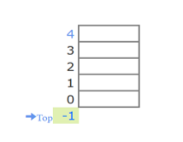

Queue
A queue is also a linear data structure which is based on the principle of First-In-First-Out (FIFO) where the data entered first will be accessed first. It is built using the array structure and has operations which can be performed from both ends of the Queue, that is, head-tail or front-back. Operations such as adding and deleting elements are called En-Queue and De-Queue and accessing the elements can be performed. Queues are used as Network Buffers for traffic congestion management, used in Operating Systems for Job Scheduling and many more.
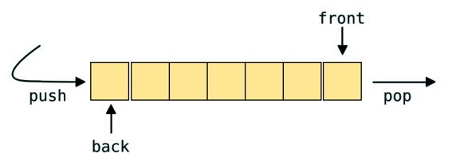

Tree
Trees are non-linear Data Structures which have root and nodes. The root is the node from where the data originates and the nodes are the other data points that are available to us. The node that precedes is the parent and the node after is called the child. There are levels a tree has to show the depth of information. The last nodes are called the leaves. Trees create a hierarchy which can be used in a lot of real-world applications such as the HTML pages use trees to distinguish which tag comes under which block. It is also efficient in searching purposes and much more.
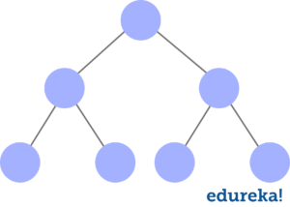

Sample Codes
Three ways of creating graphs
as a tuple,
as an adjacency list,
and as an adjacency matrix
https://www.youtube.com/watch?v=ukFNELi_U88

https://www.youtube.com/watch?v=j0IYCyBdzfA

