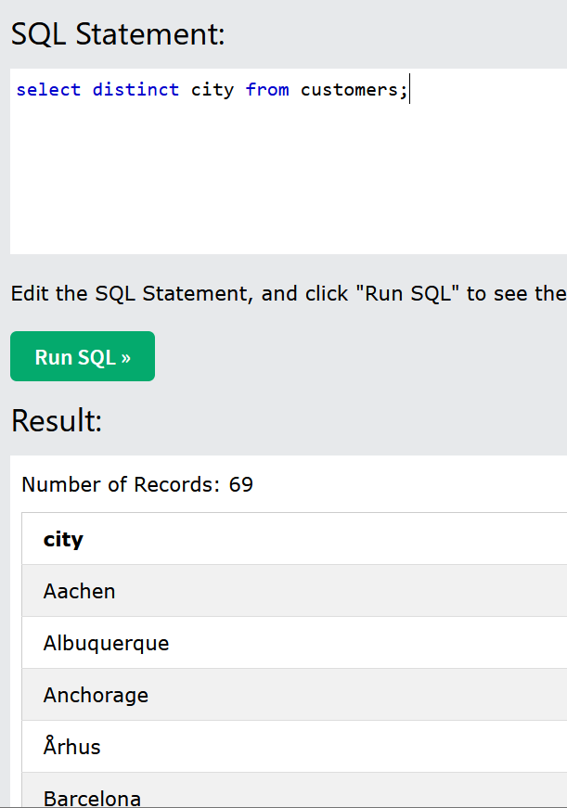

Added “9” because it was not obvious if the primary key auto incremented.

