MindShift (Cryptography)

For this challenge, a bunch of characters were given:  
*& *$ ^^ $( ** %) !)) *) *^ &) %& !!@ *^ ^% ^! ^!

The first hint was included in the title of the challenge (Shift). If you hold down the “shift” key and then type in the characters, you will get:

87 84 66 49 88 50 100 80 86 70 57 112 86 65 61 61

which is an ASCII code. When you decode it, you’ll get:

This looks like a base64 encryption. When you decrypt it with any base64 decoder, you’ll get this:

StegoCat (Steganography)

There are multiple ways of solving this. One of the ways is to open the given .jpg file with 7zip, and that will reveal a text file. Inside the text file, you should see a base64 encoded message:

After decoding with a base64 decoder, you should get:

Star Spangled Banner (Steganography)

There was an audio file. The audio itself has nothing to do with the flag. If you open that up with the tool ‘audacity’, you should be able to find the flag quickly. After opening that, when you go to “spectogram”, you should be able to see the hidden flag:

As you can see, the hidden flag was STaR-SpAngLeD.

Meow (OSINT)

This challenge had a .jpg file. You needed to view its metadata to solve it. You can use any exif metadata viewer for this. When you look at the data, you’ll come across the owner field:

The name itself is kind of an indicator that the user might have an Instagram account. If you go to his user account on Instagram, you’ll come across a QR code:

If you go to a QR code reader or decoder online and paste the QR code after downloading it, you should see a decrypted message:

Hear_Me_Out (Cryptography)

For this challenge, you needed to use DTMF decoder which can decode dial tones. 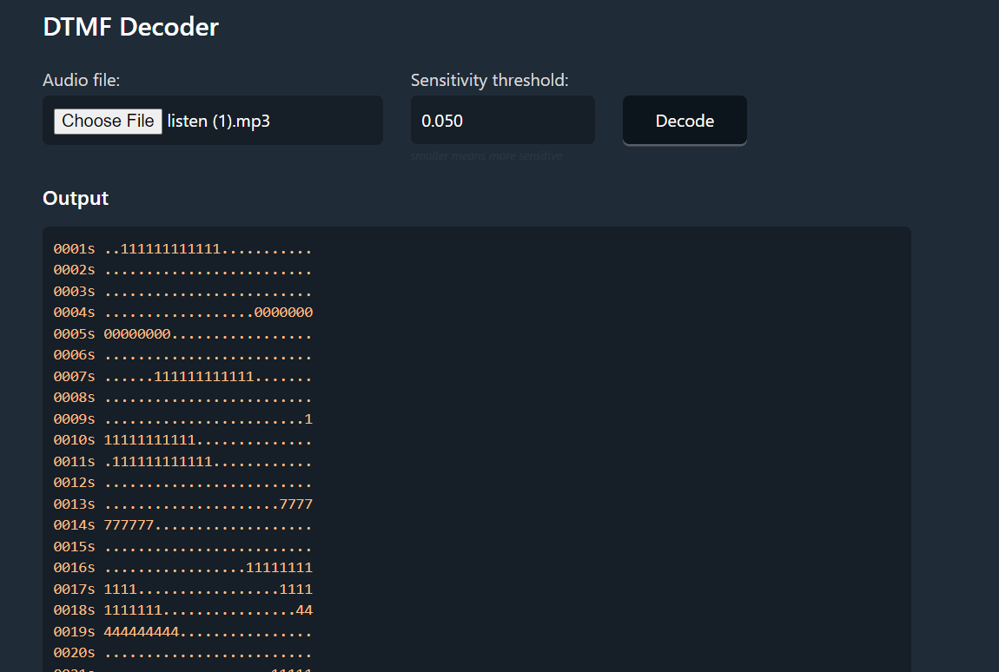

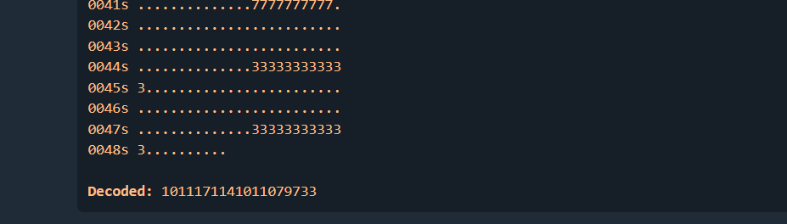

The decoded data is ASCII code in this case. When you convert that to a text, you get the flag: eureka!

