实验六 matlab中gui、app开发操作

1. 实验目的
2. 了解matlab实现gui、app开发等操作方法
3. 编写并尝试matlab中的gui、app开发等方法
4. 实验平台

MATLAB 2022b

三、实验步骤

1. GUI设计基础范例

我们要做一个GUI界面，可以选择peaks、membrane和sinc三种三维图数据，选择画出surf、mesh和contour三种图像。

1. 打开gui

每个版本打开方式可能都不一样，但有一个是相同的，就是在命令行输入guide回车。

1. 绘制控件

大概就绘制成这样，在左边的工具栏拖动出来就行。选中多个控件，点击上面的串串，还可以进行对齐和等间距分布。上方绿色三角按钮为启动程序。如果想重新打开设计好的gui则需要点击左上角选择打开保存好的fig文件。

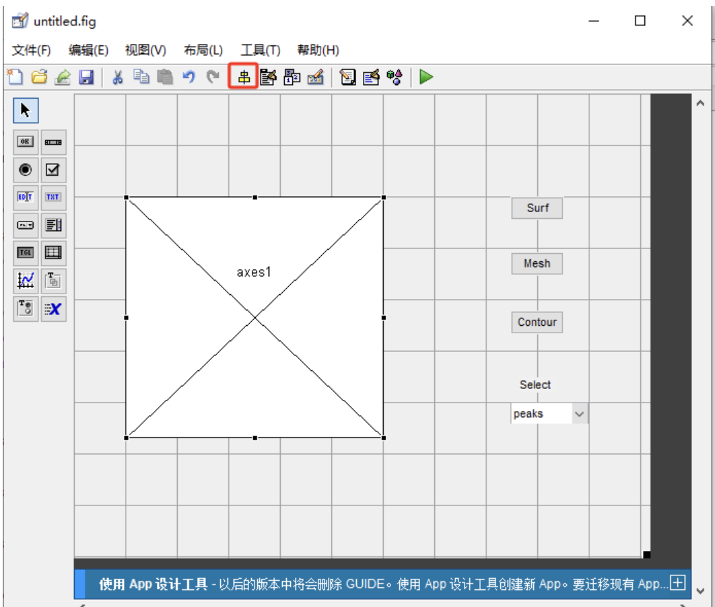

1. 设置控件属性

对着控件双击即可，普通按钮的string属性设置为Surf/Mesh/Contour，Tag属性设置为surf_pushbutton/mesh_pushbutton/contour_pushbutton。有兴趣可以改点大小颜色什么的。

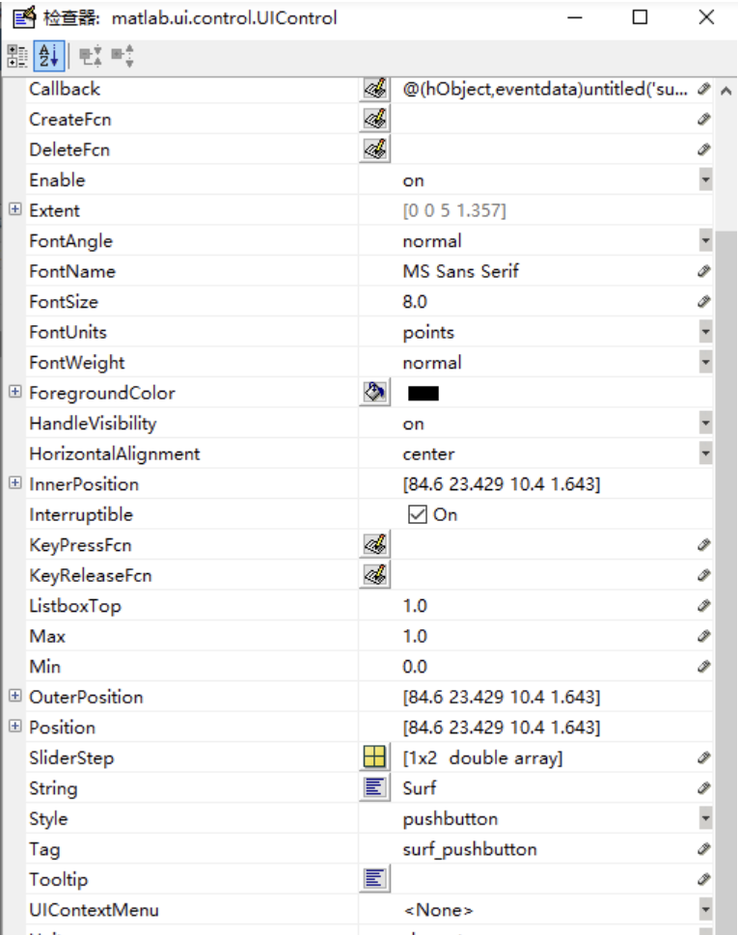

下拉菜单的String会特殊一点，得写几行。点开String属性旁边的小按钮进行多行编写。

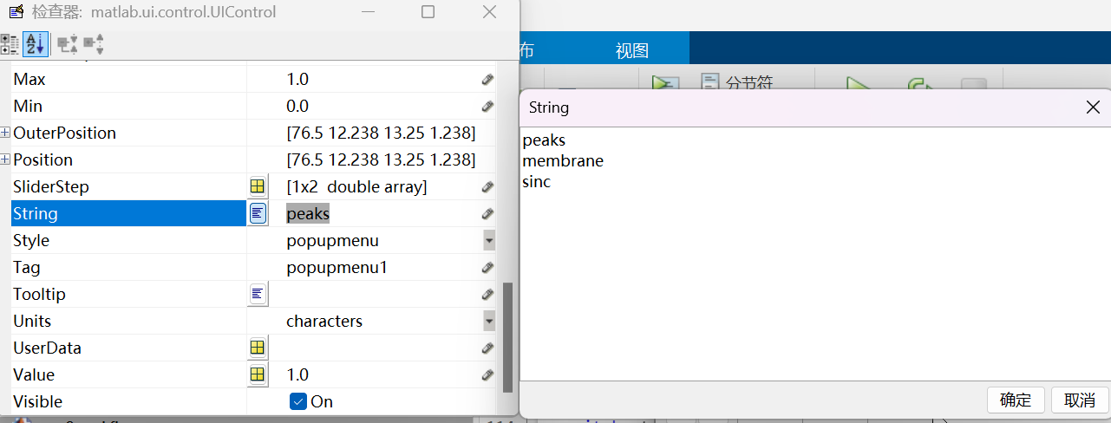

1. M文件编写

只需要把刚才的界面保存一下就好了，界面会保存为一个.fig文件，然后自动生成一个.m文件，里面有每个控件对应的处理函数。M文件中的函数名字很容易找，比如surf_pushbutton_Callback就是surf的普通按钮的回调函数，在下面写上自己想写的内容就行。

exp8_OpeningFcn是整个GUI打开时候执行的函数

% --- Executes just before exp8_gui is made visible.

function exp8_gui_OpeningFcn(hObject, eventdata, handles, varargin)

% This function has no output args, see OutputFcn.

% hObject handle to figure

% eventdata reserved - to be defined in a future version of MATLAB

% handles structure with handles and user data (see GUIDATA)

% varargin command line arguments to exp8_gui (see VARARGIN)

% Choose default command line output for exp8_gui

handles.output = hObject;

handles.peaks=peaks(35);

handles.membrane=membrane;

[x,y]=meshgrid(-8:0.5:8);

r=sqrt(x.^2+y.^2)+eps;

sinc=sin(r)./r;

handles.sinc=sinc;%创建结构体，保存3组数据

handles.current_data=handles.peaks;%默认绘制peaks图像

surf(handles.current_data);%绘制图形

% Choose default command line output for untitled

handles.output = hObject;%本来有的，选择默认命令行输出

% Update handles structure

guidata(hObject, handles);

% UIWAIT makes exp8_gui wait for user response (see UIRESUME)

% uiwait(handles.figure1);

在surf_pushbutton_Callback里面增加绘制图像命令

% --- Executes on button press in surf_pushbutton.

function surf_pushbutton_Callback(hObject, eventdata, handles)

% hObject handle to surf_pushbutton (see GCBO)

% eventdata reserved - to be defined in a future version of MATLAB

% handles structure with handles and user data (see GUIDATA)

surf(handles.current_data);%使用当前数据绘制surf图像

在mesh_pushbutton_Callback里面增加绘制图像命令

% --- Executes on button press in mesh_pushbutton.

function mesh_pushbutton_Callback(hObject, eventdata, handles)

% hObject handle to mesh_pushbutton (see GCBO)

% eventdata reserved - to be defined in a future version of MATLAB

% handles structure with handles and user data (see GUIDATA)

mesh(handles.current_data);%使用当前数据绘制surf图像

在contour_pushbutton_Callback里面增加绘制图像命令

% --- Executes on button press in contour_pushbutton.

function contour_pushbutton_Callback(hObject, eventdata, handles)

% hObject handle to contour_pushbutton (see GCBO)

% eventdata reserved - to be defined in a future version of MATLAB

% handles structure with handles and user data (see GUIDATA)

contour(handles.current_data);%使用当前数据绘制surf图像

popupmenu1_Callback是下拉菜单的回调函数

% --- Executes on selection change in popupmenu1.

function popupmenu1_Callback(hObject, eventdata, handles)

% hObject handle to popupmenu1 (see GCBO)

% eventdata reserved - to be defined in a future version of MATLAB

% handles structure with handles and user data (see GUIDATA)

val=get(hObject,'Value');

str=get(hObject,'String');

switch str{val}%判断选择了哪一组数据，将当前内容更新为对应的数据

case 'peaks'

handles.current_data = handles.peaks;

case 'membrane'

handles.current_data = handles.membrane;

case 'sinc'

handles.current_data = handles.sinc;

end

guidata(hObject,handles)%更新句柄handles结构和内容到hObject

% Hints: contents = cellstr(get(hObject,'String')) returns popupmenu1 contents as cell array

% contents{get(hObject,'Value')} returns selected item from popupmenu1

做到这里，项目有了个大致的模样。

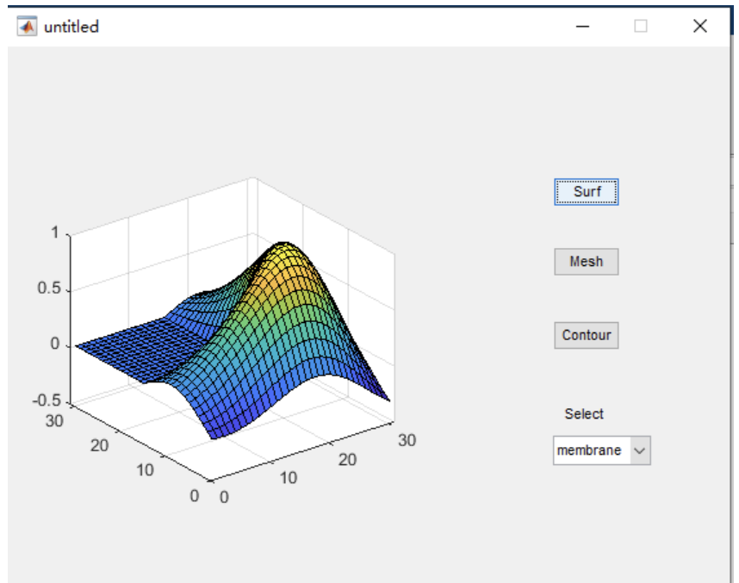

1. 窗口菜单

接下来就是锦上添花了

使用菜单编辑器新建菜单

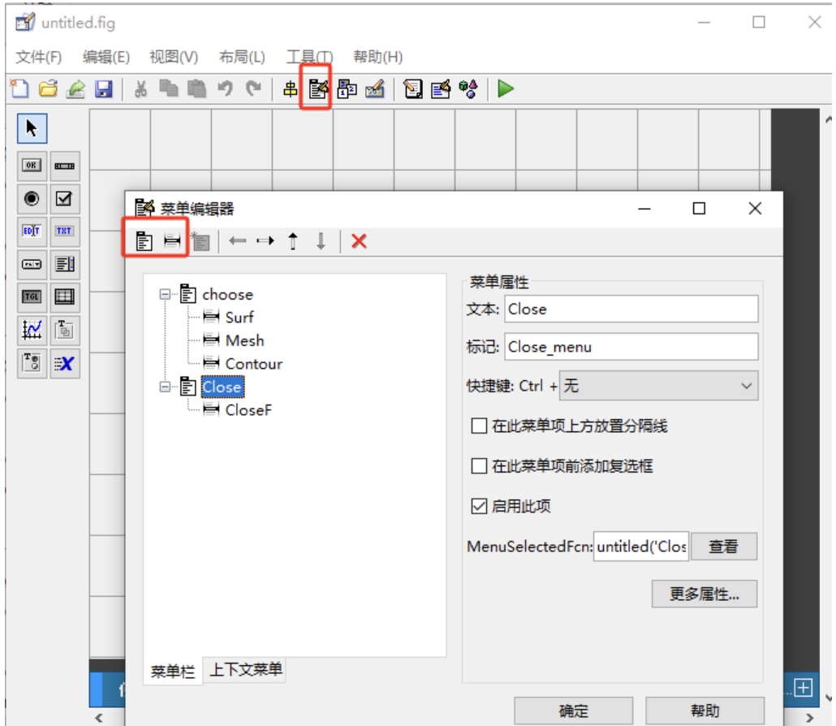

继续向.m文件添加代码

% --------------------------------------------------------------------

function choose_menu_Callback(hObject, eventdata, handles)

% hObject handle to choose_menu (see GCBO)

% eventdata reserved - to be defined in a future version of MATLAB

% handles structure with handles and user data (see GUIDATA)

% --------------------------------------------------------------------

function Close_menu_Callback(hObject, eventdata, handles)

% hObject handle to Close_menu (see GCBO)

% eventdata reserved - to be defined in a future version of MATLAB

% handles structure with handles and user data (see GUIDATA)

% --------------------------------------------------------------------

function CloseF_botton_Callback(hObject, eventdata, handles)

% hObject handle to CloseF_botton (see GCBO)

% eventdata reserved - to be defined in a future version of MATLAB

% handles structure with handles and user data (see GUIDATA)

close(gcf)

% --------------------------------------------------------------------

function Surf_botton_Callback(hObject, eventdata, handles)

% hObject handle to Surf_botton (see GCBO)

% eventdata reserved - to be defined in a future version of MATLAB

% handles structure with handles and user data (see GUIDATA)

surf(handles.current_data);

% --------------------------------------------------------------------

function Mesh_botton_Callback(hObject, eventdata, handles)

% hObject handle to Mesh_botton (see GCBO)

% eventdata reserved - to be defined in a future version of MATLAB

% handles structure with handles and user data (see GUIDATA)

mesh(handles.current_data);

% --------------------------------------------------------------------

function Contour_botton_Callback(hObject, eventdata, handles)

% hObject handle to Contour_botton (see GCBO)

% eventdata reserved - to be defined in a future version of MATLAB

% handles structure with handles and user data (see GUIDATA)

contour(handles.current_data);

实验效果

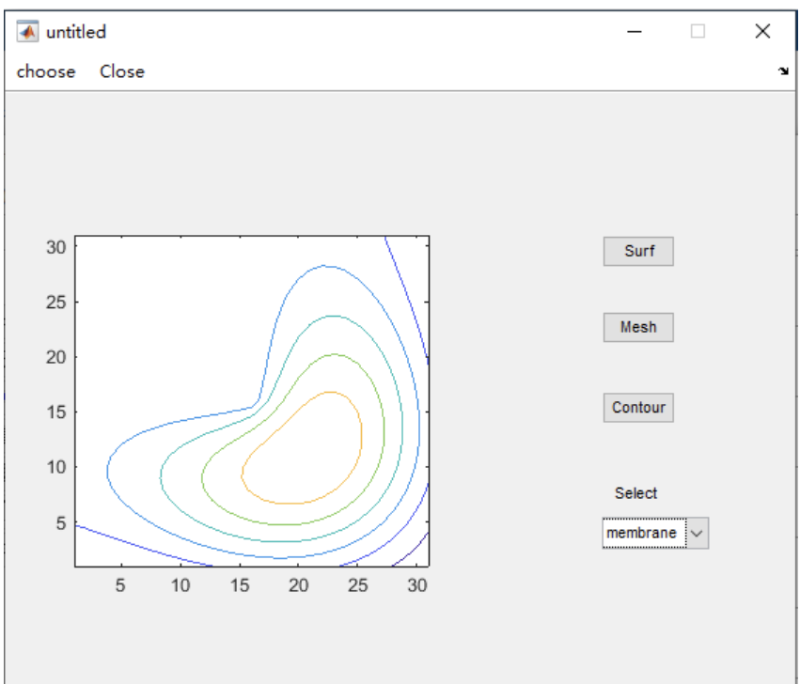

1. 上下文菜单

这个名字不太好理解，就是对着对象右击就可以出来的菜单。

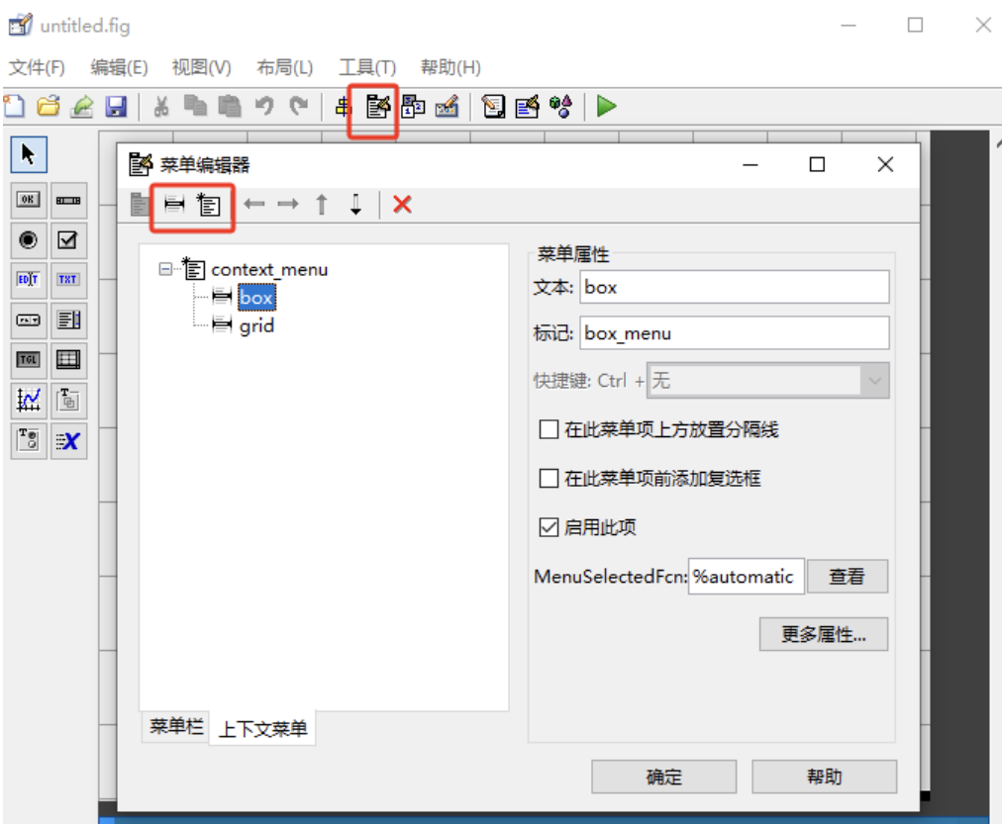

这里有个小技巧，当m文件太大的时候，点击查看就可以跳转到m文件对应的回调函数。

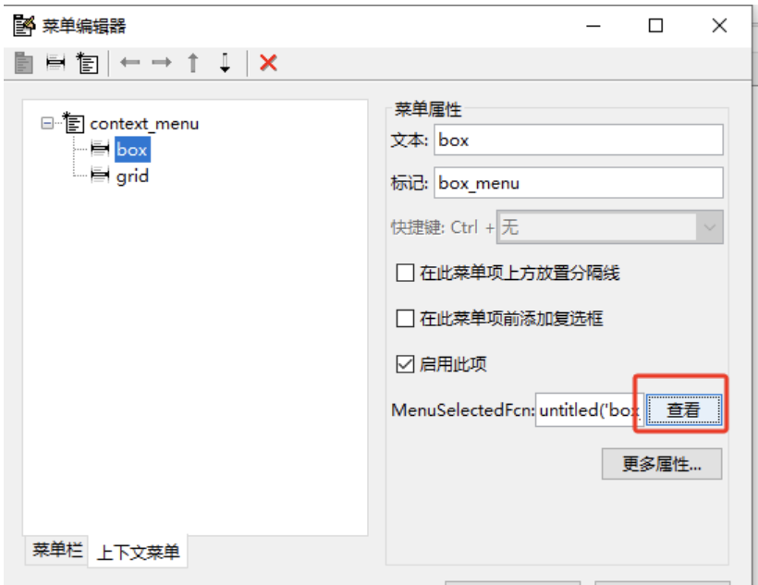

选择我们的上下文菜单

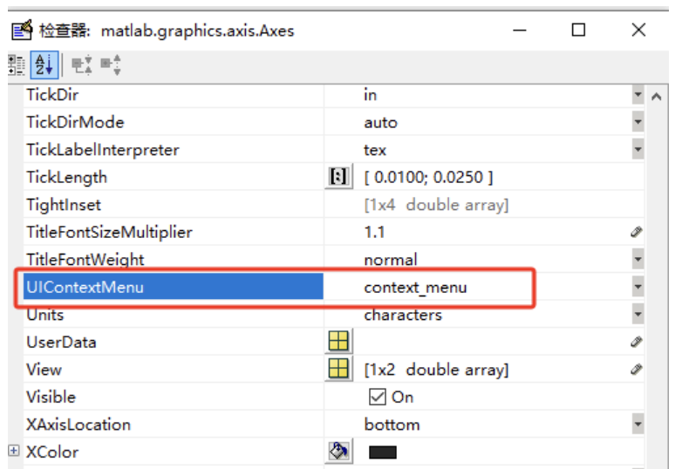

.m文件继续编写程序

% --------------------------------------------------------------------

function box_menu_Callback(hObject, eventdata, handles)

% hObject handle to box_menu (see GCBO)

% eventdata reserved - to be defined in a future version of MATLAB

% handles structure with handles and user data (see GUIDATA)

if strcmp(get(gcbo,'checked'),'on')

set(gcbo,'checked','off');

else

set(gcbo,'checked','on');

end

box;

% --------------------------------------------------------------------

function grid_menu_Callback(hObject, eventdata, handles)

% hObject handle to grid_menu (see GCBO)

% eventdata reserved - to be defined in a future version of MATLAB

% handles structure with handles and user data (see GUIDATA)

if strcmp(get(gcbo,'checked'),'on')

set(gcbo,'checked','off');

else

set(gcbo,'checked','on');

end

grid;

实验效果

