Analysis of Climate Data (ACD-App)

Version 1.0 (SASSCAL)

Rafael Posada

1st September 2017

Table of Contents

# Introduction

The *Analysis of Climate Data Application* (ACD-App) has been developed under the SASSCAL initiative (<http://www.sasscal.org>) through the Climate Task *Historical and ongoing climate data management* to facilitate the visualization of climate data in the meteorological services of Angola, Botswana and Zambia.

The App was conceived to facilitate the interaction with climate data stored in CLIMSOFT (<http://www.climsoft.org>), a Climate Data Management System (CDMS) developed in Africa and installed in the meteorological services of the SASSCAL countries. This App has been improved over the years so that it currently allows the interaction with climate data stored in ASCII files and create several climatic products.

The App provides specific features depending on the data source the user is working with (either CLIMSOFT or a local file)

The tool has been developed under Shiny, an open source R package that provides a powerful web framework for building web applications using R (<https://shiny.rstudio.com/>). Shiny helps turn data analyses into interactive web applications without requiring HTML, CSS, or JavaScript knowledge (RStudio, 2017)

This manual will give an overview of the Application, explaining how to install it, how to run it and how to use it.

# Requirements

## Software requirements

The following software is required for the installation of the App:

* Windows 7 or higher
* Java SE Runtime Environment 7 or higher (<http://www.oracle.com/technetwork/java/javase/downloads/index.html>)
* R v3.2.1 or higher (<https://cran.r-project.org/bin/windows/base/>)
* RStudio v0.99.467 or higher (<https://www.rstudio.com/products/rstudio/download/>)
* Rtools v.3.2 or higher (<https://cran.r-project.org/bin/windows/Rtools/>)
* A web-browser, such as Mozilla-Firefox, Chrome or Internet Explorer (v.11 or higher)

Besides these this software, the App also requires additional programs to be fully operational:

* MikTeX (<https://miktex.org/>): To create .pdf files properly
* Phantomjs (<http://phantomjs.org/>): To download leaflet maps as .png files in a proper way.
* Pandoc (<http://pandoc.org/>): A universal document converter. It will be required to build up the help files.

If these programs are not available in the localhost, the App will install them automatically. The following Table shows the default versions that the App will install, as well as the links to the download files. The user can install a later version of each program at any time.

|  |  |  |
| --- | --- | --- |
| Program | Default version | Link to downloader |
| MikTeX | v2.9.6361-x64 | <https://miktex.org/download> |
| Phantomjs | v2.1.1 | <https://bitbucket.org/ariya/phantomjs/downloads> |
| Pandoc | v1.19.2.1 | <http://pandoc.org/installing.html> |

## R-Packages

The ACD-App requires a number of R-packages to run properly. A R-package is the fundamental unit of shareable code in R. A package bundles together code, data, documentation, etc. and is easy to share with others (Wickham, 2017). Most of the packages required are available on-line and will be installed automatically by the App.

## caTools  
## cluster  
## data.table  
## DBI  
## downloader  
## DT  
## dygraphs  
## ggvis  
## htmltools  
## htmlwidgets  
## installr  
## leaflet  
## mapdata

## openair  
## plyr  
## R.utils  
## randomNames  
## RCurl  
## reshape2  
## rhandsontable  
## RJSONIO  
## rmarkdown  
## RMySQL  
## RODBC  
## rprojroot  
## rtf

## shiny  
## shinyBS  
## tcltk  
## uuid  
## webshot  
## XML  
## xtable  
## zoo

However, there are few packages developed specifically by SASSCAL that are not available on the Internet but are required by the App. These packages are included by default in the ACD-App folder, so that the App can have access to them. These packages are:

## climssc  
## data.from.climsoft.db  
## get.plots.from.ftp

Certain packages are required in a specific version, or are not easily downloadable from the Internet. These packages are included by default in the ACD-App so that the App does not have to download them from the Internet:

## lubridate rlang knitr

* lubridate package (v1.5.6. required). It is used to easily handle dates and times, is a special case, since the App requires a specific version (v1.5.6). The package can be downloaded from the Internet, but the most recent versions are not compatible with the ACD-App.
* knitr package (v1.14 required). It is required by the RMarkdown package to create the documentation files properly. The package can be downloaded from the Internet, but the most recent versions are not compatible with the RMarkdown.
* rlang package (v.0.1.1 required). It is required by different packages but in the R repository is only available in its source form. Therefore, the App would not be able to download the win.binary file from the Internet.

The packages are saved in the following path:

## ACD_standalone/ACD_App/www/R_pkgs/win.binary

# Install and uninstall

## Install

The Application is stored as a .zip file to reduce the size of it. There are two different .zip files available:

* ACD_compact.zip (approx. 12 Mb): Contains the minimum information to install the App. The user will **require Internet connection** to complete the installation, since the App will have to download the R-Packages from a R-CRAN repository (typically the repository: <http://cran.us.r-project.org>) and the required software (i.e. MikTeX, Phantom, Pandoc)
* ACD_full.zip (approx. 320 Mb): Contains all the R-Packages and software required for the installation of the App. The user will **not require Internet connection**.

To proceed with the installation, the user has to follow these steps:

1. **Unzip file**: The user has to unzip the ACD_compact.zip or ACD_full.zip file and place the content in any folder (e.g. Desktop, Documents or any other).
2. **Open ACD_standalone folder**: This folder contains all the information to install and run the App.
3. **Edit file ACD.bat**: Right click on that file and select Edit. An editor will open the .bat file and the user can then modify the path where R is located. The default path is:

* ## C:/Program Files/R/3.2.1/bin/i386
* where R-X.X.X is the version of R, and i386 contains the 32bit version of R. Once the changes have been done, please save the changes and close the Editor.

1. **Run ACD.bat:** Double click on the file. A command window will pop-up.
2. **Select Meteorological Service**: The user will be asked to enter the meteorological service (either DMS, INAMET or ZMD). This information has to be entered only once.

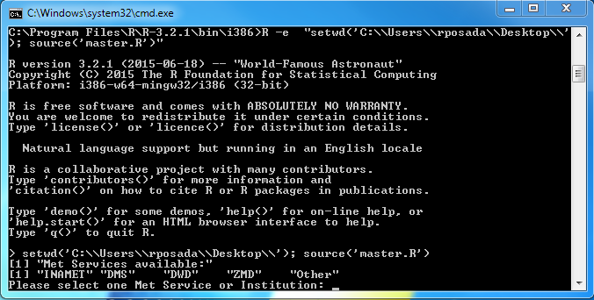

Figure 1. Select the Meteorological Service

1. **Download packages:** If the user uses the file ACD_compact.zip, then the App will download the required R-Packages automatically from an R-CRAN repository. Otherwise, the App will contain already the required packages. The packages will be saved in:

* ## ACD_standalone/ACD_App/www/R_pkgs/win.binary
* **Note:** This step may take some minutes. Please be patient.

1. **Unpack and install libraries:** Once the packages are saved locally, the App will proceed to unpack and install the packages as libraries. These libraries will be located in:

* ## ACD_standalone/ACD_App/www/libraries
* **Note:** This step may take some minutes. Please be patient.

1. **Download phantomjs:** If not available in the ACD_standalone folder, the exacutable file of phantomjs will be downloaded from the Internet.
2. **Download and install Pandoc:** If not available in the ACD_standalone folder, the installer file of Pandoc will be downloaded from the Internet. Once the installer file is available, it will be run automatically so that the installation wizard pops up. The user will have to follow the steps of the wizard.
3. **Download and install MikTeX:** If not available the ACD_standalone folder, the installer file of MikTeX will be downloaded from the Internet. Once the installer file is available, it will be run automatically so that the installation wizard pops up. The user will have to follow the steps of the wizard.

Once the installation process is finished, the ACD-App will open automatically.

The App can be stopped at any time by closing the command window. To re-run the App, execute the file ACD_App.bat again. The ACD_App will then pop-up automatically.

## Uninstall

To uninstall the App, just remove the ACD_standalone folder.

# Connection to a database

If the ACD-App is going to be used to interact with a CLIMSOFT database, it is necessary to set up a connection to that database. This has to be done through the *Open Database Connectivity* Tool (ODBC), a standard programming language middleware API (Application Programming Interface) for accessing database management systems (DBMS). ODBC accomplishes DBMS independence by using an ODBC driver as a translation layer between the application and the DBMS.

The application uses ODBC functions through an ODBC driver manager with which it is linked, and the driver passes the query to the DBMS. An ODBC driver can be thought as analogous to a printer driver or other driver, providing a standard set of functions for the application to use, and implementing DBMS-specific functionality (Wikipedia, 2017).

The ODBC will allow the ACD-App to identify and connect to the database of interest. Therefore, an ODBC connection has to be set up. To do so, it is necessary to follow these steps:

* Make sure you have administrator rights, since the ODBC-Administration Tool can only be opened by the administrator.
* Open the "ODBC-Administrator" by:
  + Clickling on the Start menu button (bottom-left of the screen), Control Panel, then Administrative Tools and then Data Sources (ODBC) (Figure 1), or
  + Running the file called: odbcad32.exe located in the folder: C:/Windows/SysWOW64/

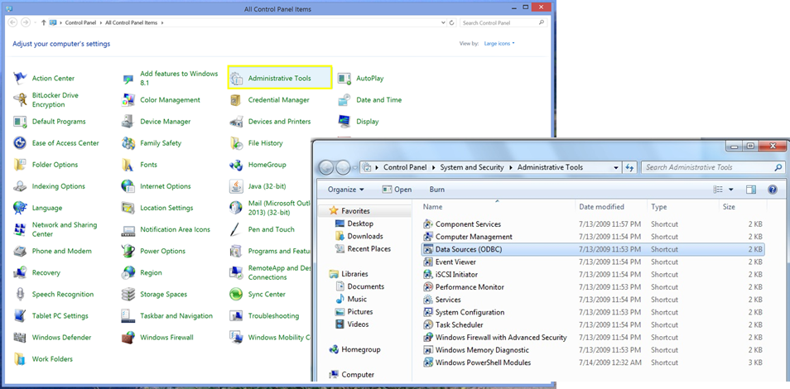

Figure 2. Selection of Administrative Tools and Data Sources (ODBC)

Once opened, a Window that looks like Figure 3 will pop-up.

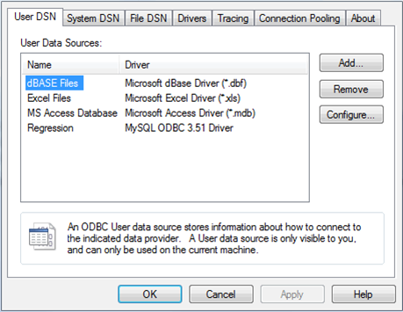

Figure 3. Window of Data Sources (ODBC)

* Click on the Add... option and select one of the drivers listed.

## Connect to MS-Access db

For connecting to MS-Access db, follow this steps:

* Select the driver Microsoft Access Driver (*.mdb, *.accdb) and press Finish. (Figure 4)

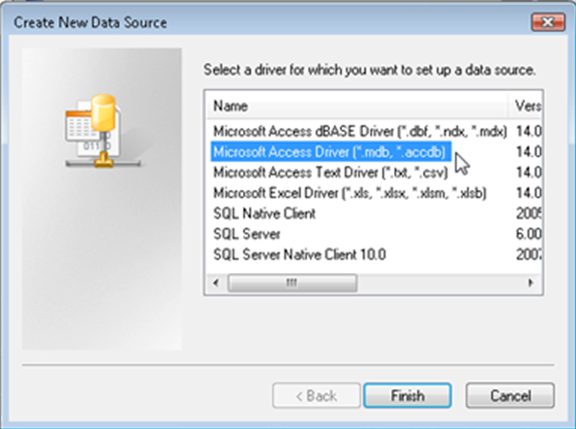

Figure 4. Window 'Create new data source'

* In the new Window (Figure 5), give a Data Source Name (DSN) to the connection and, if desired, add a description of such a connection. Please, make sure that the DSN contains the word **"CLIMSOFT"** (e.g. CLIMSOFT_db). After that, select the database to connect with by pressing the button Database: Select.

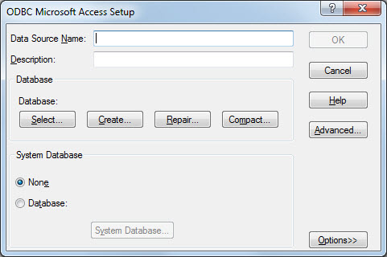

Figure 5. Window to Setup the ODBC for MS-Access database

* A new window pops-up (Figure 6) asks for the location of the database. Browse through your computer to find the location of the database (typically under C:/Program Files (x86)/CLIMSOFT/dbase/). Once the database has been selected, click OK.

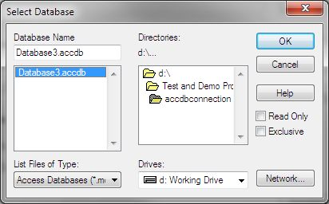

Figure 6. Window to select the MS-Access database

* Now it is necessary to set up the System database, since the CLIMSOFT databases join a Workgroup called climsoft. Therefore, it is necessary to locate the file climsoft.mdw that defines that Workgroup. For this, select the option Database within the System Database field. Then press the button System database.... This file is usually in the path C:/Windows/System32/ or C:/Windows/SysWOW64.

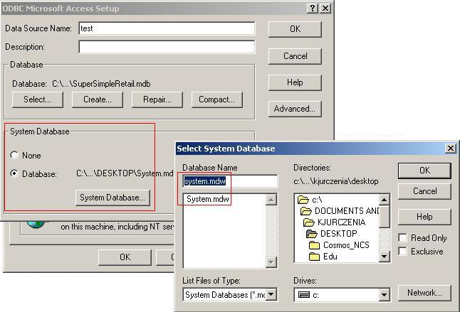

Figure 7. Select the System Database

* Once the file is selected, press OK to save changes and to close the Select System Database window, and press OK again to save the changes and close the ODBC Microsoft Access Setup Window.

## Connect to mariadb db

For connecting to a mariadb db:

* Select the driver MySQL ODBC X.X ANSI Driver, where X.X refers to the version of the MySQL ODBC (e.g. 5.5). If the MySQL driver is not available in the computer, it is possible to download it in <http://dev.mysql.com/downloads/connector/odbc/>. 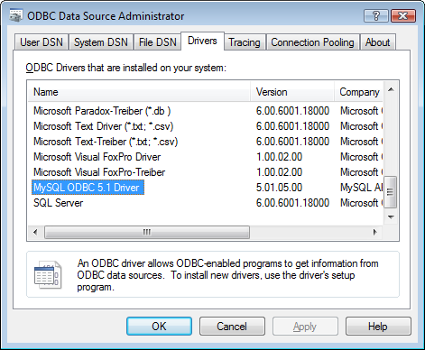
* Figure 8. Example of a MySQL ODBC driver.
* Fulfill the MySQL Connector Window (Figure 9) with the required information.
  + Data Source Name (DSN): Name of the connection. Please, make sure that the DSN contains the word **"CLIMSOFT"** (e.g. CLIMSOFT_db).
  + Description: A brief description of the connection (it is optional),
  + Server: Name of the server where the database is located. Usually it is localhost.
  + Port: Port in which mariadb server is installed.
  + User: User name that has to be used to connect to the mariadb db. (e.g. root).
  + Password: Password of the user.
  + Database: Select the database to which the connection should be done.
* It is possible to test the connection by pressing the Test button. A message will pop up to say whether this connection has been successfull.

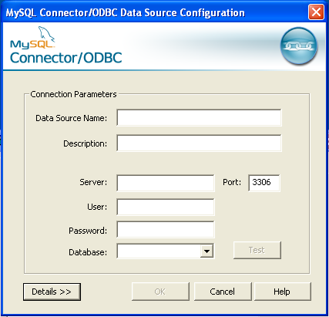

Figure 9. Window where to select the mariadb database

# Running the ACD-App

To run the application, just double click on the file ACD-App.bat. After a few seconds, a web browser opens. The ACD-App interface appears directly on the web-browser (see Figure 9). The application is ready to use!

It can also be accessed from other computers connected to the Intranet. To access to the ACD-App from another PC, open a browser (e.g. Mozilla) and type the following Address:

## http://141.38.15.166:3182

The user has to select then on of the following source of data:

* CLIMSOFT
* DWD-ftp
* LOCAL_FILE

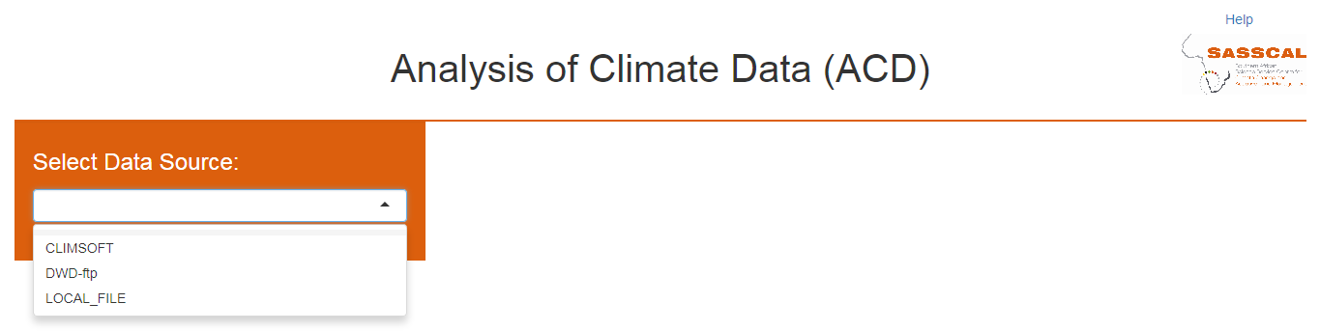

Figure 10. Data source available

# CLIMSOFT

If the option CLIMSOFT is selected, the user will be asked to select one type of database: access or mariadb.

Once one of both has been selected, a new field pops-up to select the Data Name Source (DNS) of the database to which the user wants to connect. Please notice that the options available are those DNS defined previously in the ODBC Tool (see Section Connection to a database) After selecting the database the user will be asked to log-in into the ACD-App prior any product can be created. The default users available are:

* admin: this user has full control of the ACD-App
* operator: this user has restricted acces to the ACD-App. The default settings allows the operator to create maps, create plots, make metadata reports and get an overview of the database. By default he is not allowed to download any data.

The admin has the possibility of adding, removing or modifying the user rights, as well as deleting or creating new user accounts.

The options available under CLIMSOFT are described below.

## Create Map

Creates a Map with the location of all the stations available in the CLIMSOFT database. The information required to plot the station location is stored in the CLIMSOFT database. If it is an MS-access db, then the information is retrieved from the tables station and station_location. If, instead, it is a mariadb db, the information will be retrieved from the tables station and stationlocationhistory.

It is an interactive map in which the user can select one station to know its latitude and longitude, as well as its WMO id. By default, all the stations are shown, but the user can filter the data by authority (see legend on the right side). This is specially usefull if the database has a lot of different data sources. Then the user can select the data source(s) in which he is interested.

The map can also be download as a .png file.

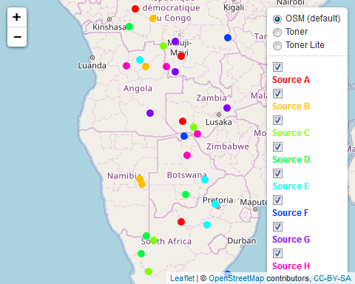

Figure 11. Example of an interactive map

## Create Table

Once a station is selected on the Map, the user will be able to visualize the data available for that station by selecting the Create Table option. The displayed come from the tables observation and obs_element in case of MS-access db, and observationinitial and obselement in case of mariadb db.

The Table allows filtering the data since each column includes a filter field below the header. Besides, the Table includes a search field to facilitate the search of a specific parameter, date, etc.

If the user has the rights to download data, then he will be able to download the Table in a .csv file.

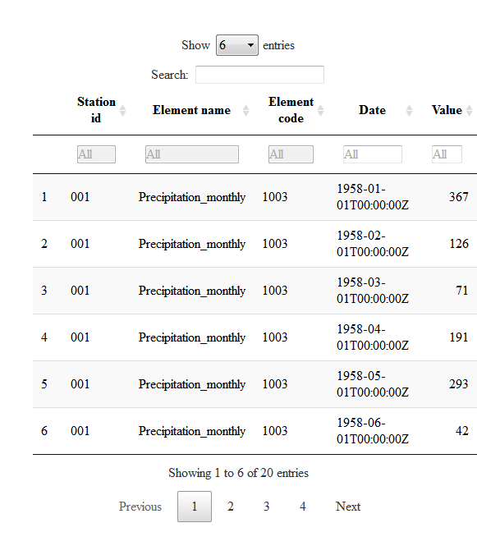

## Create Plots

This option allows the user to plot the data available in the database. The user can select one or more station, and one or more elements. The user can select then one of the following type of graphics: Histogram, Timeseries, Timeseries_comparison and Windrose (Similarly to what has been described in the section LOCAL_FILE). Before plotting, the user can also specify the date range. Examples of graphic types available are shown below.

* **Histogram**

Renderer: SVG | Canvas

Download

Figure 12. Example of an interactive Histogram

* **Timeseries & Timeseries comparison**

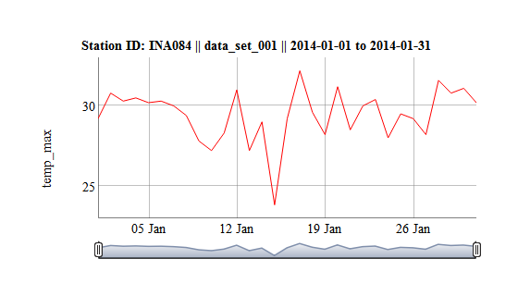

Figure 13. Example of an interactive timeseries

* **Windrose**

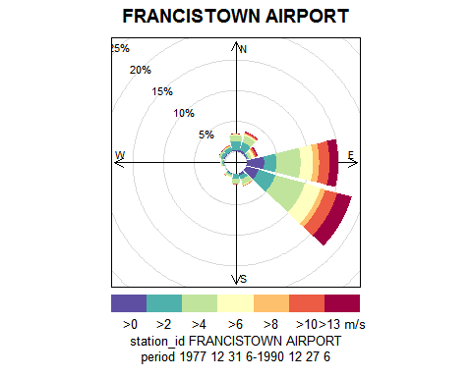

Figure 14. Example of windrose

## Create Report

The ACD-App allows creating a .pdf report for a given location. This report contains the main metadata related to the selected location(s). It is neccessary to have MikTeX installed in order to run this option properly. The App should be able to install the MikTeX program automatically when it is run for the first time. The user can download and install the program separately at any time (<https://miktex.org/download>).

The Report includes the following information:

* **Location:** A map with the location of the station(s) selected for the report.
* **Metadata:** Information about the metadata of the station(s), such as station id, authority , begin and end date of measurements, longitude, latitude, height, and id alias.
* **Elements available:** Availability of meteorological elements for the selected station(s). This includes the begin and end of the measurements for each element, the number of records expected, the actual number of records available in the database, and the corresponding estimated missing records (in per cent)

## Database Overview

This option has been included to get a quick overview of the data available in the CLIMSOFT database. This Overview allows the user to see the data availability organized by **Authority**, **Station** or **Element** in an interactive table in which the user is able to filter the results. The user can also download the overview data if he has the rights to do so.

## Download data

This option allows the user to make a data request to the database. First, the desired station(s) have to be selected (it is possible to select all the stations as well). Then the user can select the element(s) and date range of interest. When these fields are fulfilled, the button Request Data shows up. When pressing the button, a table with the requested data will appear. These data can be also filtered by the user using the filter fields placed just below the column headers. If the user has the Download right, he will be able to download the data in a .csv format. The download button is paced below the table.

## Set up User rights

**Note:** Option only available for the Administrator

The Administrator (default username: *admin*) can control the user rights with this option. The rights that can be given are:

* Map: If checked, the user will be able to create Maps (see Create Map section).
* Table: If checked, the user will be able to create a table with data of the station selected in the Map (see Create Table section)
* Plots: If checked, the user will be able to create Graphics (see Create Plots section)
* Report: If checked, the user will be able to create a Report with Metadata of selected location(s) (see Create Report section)
* Overview: If checked, the user will be able to have an overview of the data stored in the database (see Database Overview section)
* RClimDex: If checked, the user will be able to create different Climate Indices based on the R-Tool "RClimDex" (This option is currently deactivated)
* User Rights: If checked, the user will be able to control the user rights of other users (it is highly recommended that only the admin has access to this option)
* Download: If checked, the user will be able to, not only view the data, but also download data. The download of data will be then active within the following options:
  + Create Table
  + Create Plots
  + Overview
  + Download data

# LOCAL_FILE

If the option LOCAL_FILE is selected, the user will be asked to select one or more ASCII files with the data that the user wants to visualize. The formats accepted are: .txt and .csv

The structure of the data stored in the file can be different but it has to contain, at least, the following information:

* Station identifier (e.g. station_id)
* Date or datetime when the observation was done (e.g. date). In most cases, the App will be able to detected the date format automatically.
* Name of the element(s) observed (e.g. temp_max)

The table below shows an example of an accepted file structure:

|  |  |  |
| --- | --- | --- |
| station_id | date | temp_max |
| IDL001 | 1880-01-01 | 32.0 |
| IDL001 | 1880-01-02 | 34.7 |
| IDL001 | 1880-01-03 | 32.7 |
| IDL001 | 1880-01-04 | 33.2 |
| IDL001 | 1880-01-05 | 34.0 |
| IDL001 | 1880-01-06 | 33.4 |

You can download a .csv file example [here](../examples/localFile.csv).

Please, be aware that the ACD-App will only recognize the elements that have a specific header. These headers are defined in the function ident_var of the climssc package. You can find a list of default headers used in package climssc in this [file](../examples/default_labels.csv).

Once the file(s) have been selected, the App will try to recognize automatically the elements available in the file(s), as well as the date format. If it is not possible to detect these variables automatically, the user will get a message explaining what the problem is.

If the App recognizes the structure of the file(s), then it will ask the user to select one type of graphic. The options available are: Histogram, Timeseries, Timeseries_comparison and Windrose.

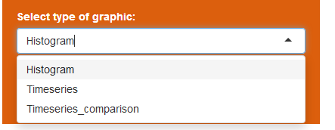

Figure 18. Type of graphics available

Once the user has selected one of the options, just click OK and the graphic(s) will be created (see Figure 19). The App allows the download of the graphic, but also the download of the data.



Figure 19. Example of an interactive timeseries retrieved from a .csv file

# References

ETCCDI/CRD (2017). *ETCCDI/CRD Climate Change Indices. Software* <http://etccdi.pacificclimate.org/software.shtml> [last accessed: 24.04.2017]

RStudio (2017). *Easy web applications in R*. <https://www.rstudio.com/products/shiny/> [last accessed: 11.04.2017]

Wickham (2017). *R Packages*. <http://r-pkgs.had.co.nz/intro.html> [last accessed: 12.04.2017]

Wikipedia (2017). *Open Database Connectivity*. <https://en.wikipedia.org/wiki/Open_Database_Connectivity> [last accessed: 11.04.2017]

# Annex 1

|  |  |
| --- | --- |
| element.label | default.label |
| Added_col | Added variable |
| alt | alt |
| atmospheric_radiation | atmospheric_radiation |
| capacity | capacity_max |
| cloudiness | cloudiness |
| complete_dates | complete_dates |
| constructor | constructor |
| convert_data | convert_data |
| count_over_threshold | count_over_threshold |
| daily | daily |
| data_end_date | data_end_date |
| data_name | data_name |
| data_start_date | data_start_date |
| date_asstring | date_asstring |
| date | date |
| date_list | date_list |
| date_time | date_time |
| day | day |
| day_start_time | day_start_time |
| dd | dry_day |
| dewpoint | dewpoint |
| discharge | discharge |
| dm | day_month |
| dos | dos |
| doy | doy |
| dycld | Day_with_cloud |
| dyfog | Day_with_fog |
| dyhail | Day_with_hail |
| dylgt | Day_with_Lightningq |
| dyrain | Day_with_rain |
| dythnd | Day_with_thunder |
| element_factor | element_type |
| end_date | end |
| end_of | end_of |
| end_of_rain | end_of_rain |
| evaporation | evaporation |
| extreme_event_day | extreme_event_day |
| fresh_snow | fresh_snow |
| geopotential | geopotential |
| global_radiation | global_radiation_label |
| identifier | identifier |
| insolation | insolation |
| insolation_max | insolation_max |
| insolation_min | insolation_min |
| insolation_percent | insolation_percent |
| lat | lat |
| leaf_dryness | leaf_dryness |
| leaf_wetness | leaf_wetness |
| lon | lon |
| max_evaporation | max_exaporation |
| max | Max |
| max_rainfall | max_rainfall |
| max_temp_max | max_temp_max |
| max_temp_min | max_temp_min |
| mean_evaporation | mean_evaporation |
| mean | Mean |
| mean_over_threshold | mean_over_threshold |
| mean_rain_per_rain_day | mean_rain_per_rain_day |
| mean_temp_max | mean_temp_max |
| mean_temp_min | mean_temp_min |
| med | med |
| merge_data | merge_data |
| merged_from | merged_from |
| min_evaporation | min_exaporation |
| min | Min |
| min_rainfall | min_rainfall |
| min_temp_max | min_temp_max |
| min_temp_min | min_temp_min |
| month | month |
| multiple_element | multiple_element |
| multiple_station | multiple_station |
| number_of_rain_days | number_of_rain_days |
| number_of_rain_hours | number_of_rain_hours |
| ozone | ozone |
| press_sl | press_sl |
| press_surf | press_surf |
| press_wv | press_wv |
| quintile | quintile |
| rain_amount | rain_amount |
| rain | rain |
| range | Range |
| rd | rain_day |
| relative_humidity | relative_humidity |
| relh_soil030 | soil_relh_030 |
| require_all_variables | require_all_variables |
| required_variable_list | required_variable_list |
| running_rain_totals | running_rain_total |
| running_summary | running_summary |
| scattered_radiation | scattered_radiation |
| sd_over_threshold | sd_over_threshold |
| season | season |
| season_start_day | season_start_day |
| seasonal_raindays | seasonal_raindays |
| seasonal_total | seasonal_total |
| skycover | Sky_cover |
| snow | snow |
| spell_length | spell_length |
| start_date | start |
| start_of | start_of |
| start_of_rain | start_of_rain |
| station | station |
| station_list | station_list |
| station_meta_data | station_meta_data |
| subdaily | subdaily |
| subyearly | subyearly |
| sum | Sum |
| summarized_from | summarized_from |
| summary_statistics | summary_statistics |
| sunshine | sunshine |
| temp_air | temp_air |
| temp_drybulb | temp_dry_bulb |
| temp_max | temp_max |
| temp_max_soil000 | max_soil_temperature_000 |
| temp_max_soil010 | max_soil_temperature_010 |
| temp_max_soil020 | max_soil_temperature_020 |
| temp_min_ground | temp_min_ground |
| temp_min | temp_min |
| temp_min_soil000 | min_soil_temperature_000 |
| temp_min_soil010 | min_soil_temperature_010 |
| temp_min_soil020 | min_soil_temperature_020 |
| temp_soil000 | soil_temperature_000 |
| temp_soil002 | soil_temperature_002 |
| temp_soil005 | soil_temperature_005 |
| temp_soil010 | soil_temperature_010 |
| temp_soil020 | soil_temperature_020 |
| temp_soil030 | soil_temperature_030 |
| temp_soil050 | soil_temperature_050 |
| temp_soil080 | soil_temperature_080 |
| temp_soil100 | soil_temperature_100 |
| temp_soil120 | soil_temperature_120 |
| temp_soil150 | soil_temperature_150 |
| temp_std | temp_std |
| threshold | threshold |
| time | time |
| time_period | time_period |
| total_rainfall | total_rainfall |
| visibility | visibility |
| water_equivalent | water_equivalent |
| waterbalance | waterbalance |
| wind_direction | wind_direction |
| wind_speed | wind_speed |
| wind_speed_max | wind_speed_max |
| wind_threshold | wind_threshold |
| year | year |
| year_month | year_month |
| yearly | yearly |