Quantitative strategies on High Frequency Data

submission of research project – SAMPLE REPORT

Team members: Author nr 1 and Author nr 2

# Approaches undertaken

This part should describe **with all the details** what particular methods you used, all entry/exit techniques considered, all additional assumptions.

For **each group of assets separately** You should also explain **WHAT different parameters** you considered (e.g. memories of moving averages, types of moving averages, types of volatility measures, memory of volatility measures, types of additional indicators, memories of additional indicators, etc.), what (if any) additional filtering rules you applied.

You should also explain with details **HOW** you searched for the best combination of parameters for a particular group of assets.

# Group 1 – summary of results (including out-of-sample)

## Finally selected strategy for group 1

Provide **all the details** (approach and a set of **final parameters**) for assets from **group 1**. (e.g. momentum strategy, cross over of two exponential moving averages EMA10 and EMA60).

## Summary of results for group 1

|  |  |  |  |  |  |  |
| --- | --- | --- | --- | --- | --- | --- |
| quarter | grossSR | netSR | av.ntrades | grossPnL | netPnL | stat |
| 2011Q1 | 2.303842 | -1.763254 | 14.36000 | 1578.848 | -1293.1516 | -17.32141 |
| 2011Q2 | 4.729891 | -1.558563 | 13.33333 | 1991.478 | -728.5216 | -11.20081 |
| 2011Q4 | 1.708645 | -2.069136 | 14.92000 | 1305.124 | -1678.8761 | -23.46378 |

your comments required !!!

## PnL of results for **group 1** – quarter 2011Q1

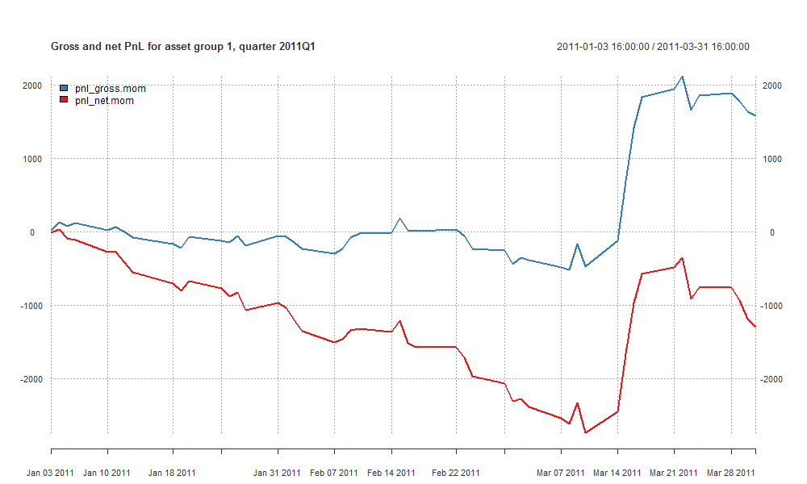

your comments required !!!

## PnL of results for **group 1** – quarter 2011Q2

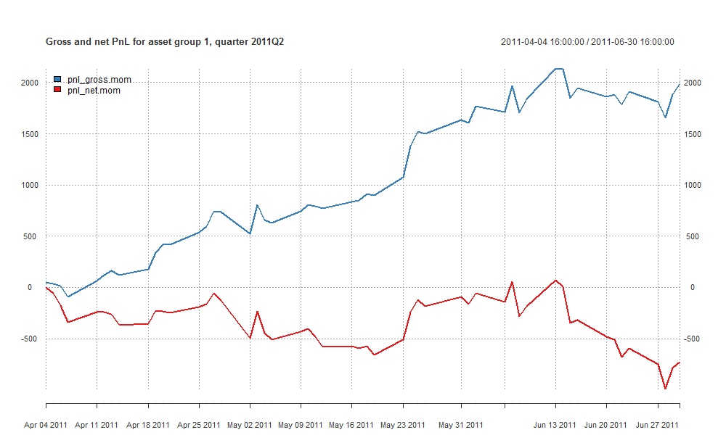

your comments required !!!

## PnL of results for **group 1** – quarter 2011Q3

your comments required !!!

## PnL of results for **group 1** – quarter 2011Q4

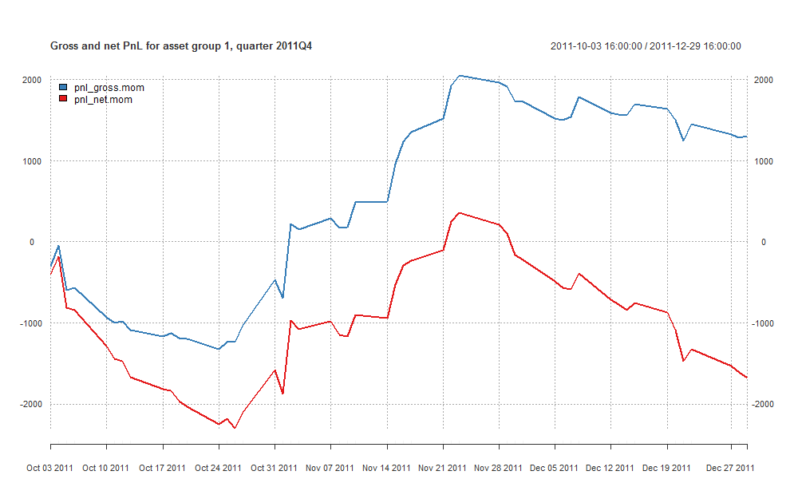

your comments required !!!

## PnL of results for **group 1** – quarter 2012Q1

your comments required !!!

# Group 2 – summary of results (including out-of-sample)

## Finally selected strategy for group 2

Provide **all the details** (approach and a set of **final parameters**) for assets from **group 2**. (e.g. momentum strategy, cross over of two exponential moving averages EMA10 and EMA60 applied to EVERY single asset separately and then putting individual results into the portfolio with the weights: 50% for NASDAQ futures, 25% for AAPL stocks and 25% for MSFT).

## Summary of results for group 2

|  |  |  |  |  |  |  |
| --- | --- | --- | --- | --- | --- | --- |
| quarter | grossSR | netSR | av.ntrades | grossPnL | netPnL | stat |
| 2011Q1 | 1.7243658 | -3.758442 | 14.84360 | 381.19403 | -901.226 | -31.17230 |
| 2011Q2 | 1.9591087 | -6.801334 | 15.47373 | 254.22030 | -1025.116 | -61.01161 |
| 2011Q4 | -0.1397798 | -5.088869 | 15.17040 | -33.77934 | -1328.627 | -51.62553 |

your comments required !!!

## PnL of results for **group 2** – quarter 2011Q1

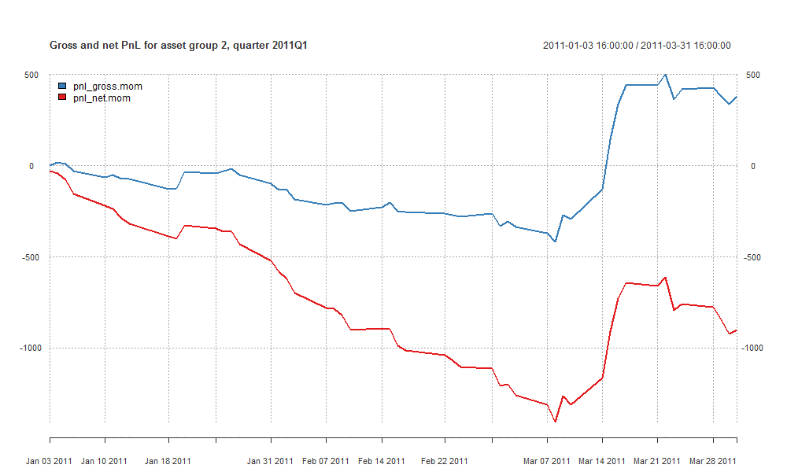

your comments required !!!

## PnL of results for **group 2** – quarter 2011Q2

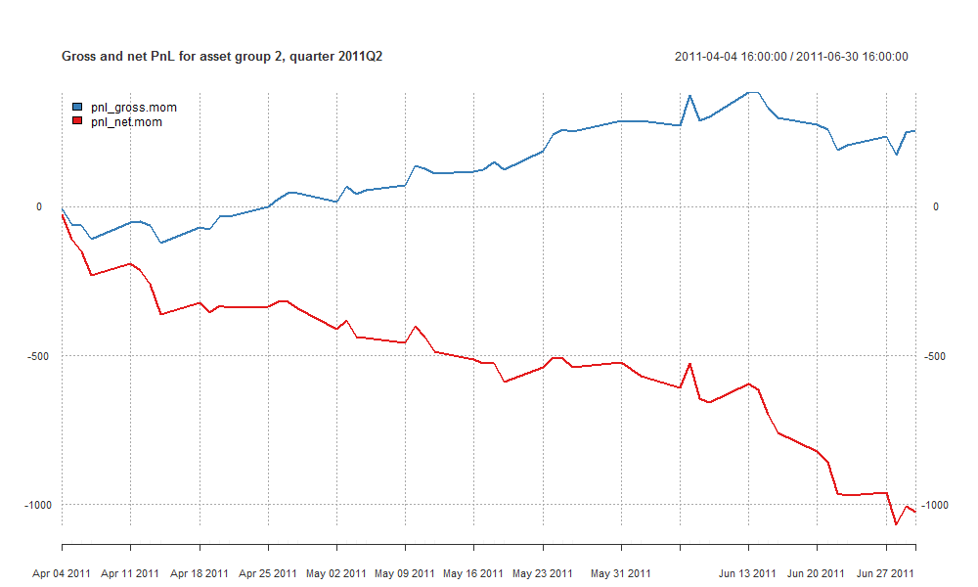

your comments required !!!

## PnL of results for **group 2** – quarter 2011Q3

your comments required !!!

## PnL of results for **group 2** – quarter 2011Q4

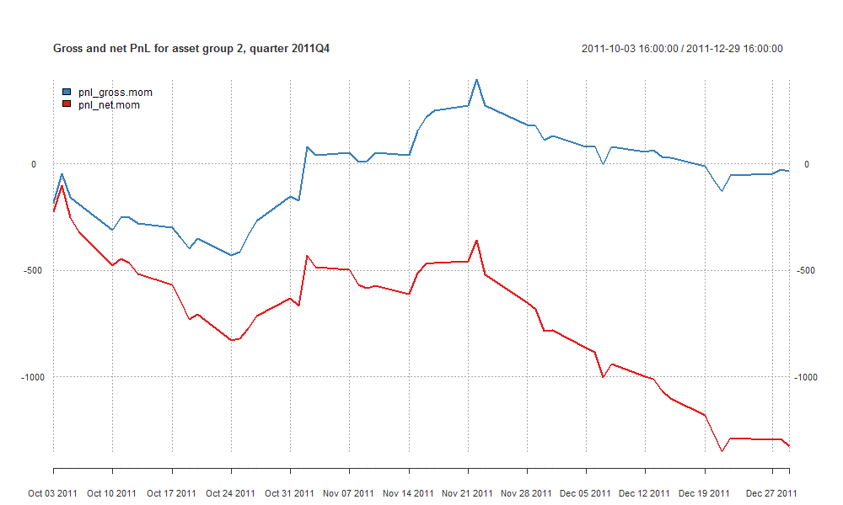

your comments required !!!

## PnL of results for **group 2** – quarter 2012Q1

your comments required !!!

# Summary and conclusions

Here you should include a summary of obtained results and some conclusions.