Oregon DEQ Water Quality Status and Trend Web Application User Guide

Version 2.1 – May 2016 – Peter Bryant, Watershed Management, Environmental Solutions Division

## Purpose

The purpose of this web application is to facilitate data discovery, data comparison to Oregon’s Water Quality Standards, evaluation of trends and graphic display of data and tabular results. Additional features include dynamic mapping and a 303(d) list query.

## Instructions for use

Make sure to open the application in Google Chrome. Currently, it is the only supported browser.

### Data Query Tab

The landing page looks like SCREEN 1 sample below. You will start at the Data Query page.

SCREEN 1

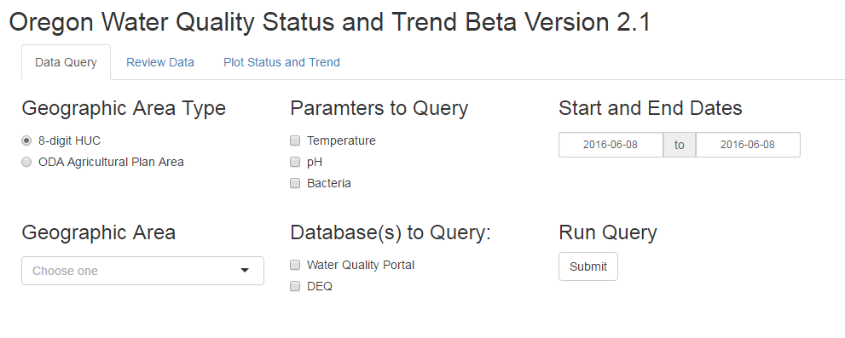

6.

5.

2.0..

4.0..

3.0..

1.0..

The following is a list of sequential steps to initiate a site specific data query:

1. Select the Geographic Area Type to restrict where you query. Options currently include query by 8-digit HUC and ODA Agricultural Plan Area name.
2. Select the Geographic Area to query.
3. Check the parameters to include in the query.
4. Choose the Database(s) to query.
   1. Choose Water Quality Portal to query nationally available databases (USGS’s National Water Information System for continuous and grab data; and EPA’s STORET database where States, Tribes and other Agencies submit data).
   2. Choose DEQ to query LASAR and Element databases for DEQ continuous and grab data (The query is set up to include A, B, C and E grade data because we are not basing listing decisions on the results of this tool but rather providing information). Note: DEQ continuous data may only be available through 2012.
5. Click in the box to select Start and End Dates for the query. You can manually enter the dates but they must be in the format YYYY-MM-DD.
6. Click the Submit button to initiate the Run Query.
   1. A status bar will appear across the top of the window.
   2. If a date range of more than 10 years was specified the query can take several minutes to run.
   3. The Water Quality Portal queries are slower than DEQ alone.
7. Once the query has run and data are discovered, the screen will display that results are confirmed and will have buttons or tabs to select for the following data options as illustrated in SCREEN 2 sample.
8. View Map Button– Click to display Google-based map illustrating the sampling stations and 8 digit HUC or AG Plan Area. You can click on the map to zoom in or out to capture AG area, or zoom in to see detail around a sampling station. You can select the base map as the standard Google map or select Satellite in the top left corner to change the base map to aerial photography. Clicking on a station will provide name, location and summary of data queried.
9. Download the data button - Download data to your computer in order to use other software to generate data summaries, charts, graphs, etc.
10. Review Data Tab – This tab provides several tables for reviewing the data including a summary of the results returned with number of sampling stations and number of individual results.
11. Plot Status and Trend Tab– Ability to plot parameter data and exceedances of applicable standards at individual sampling stations.

**SCREEN 2**

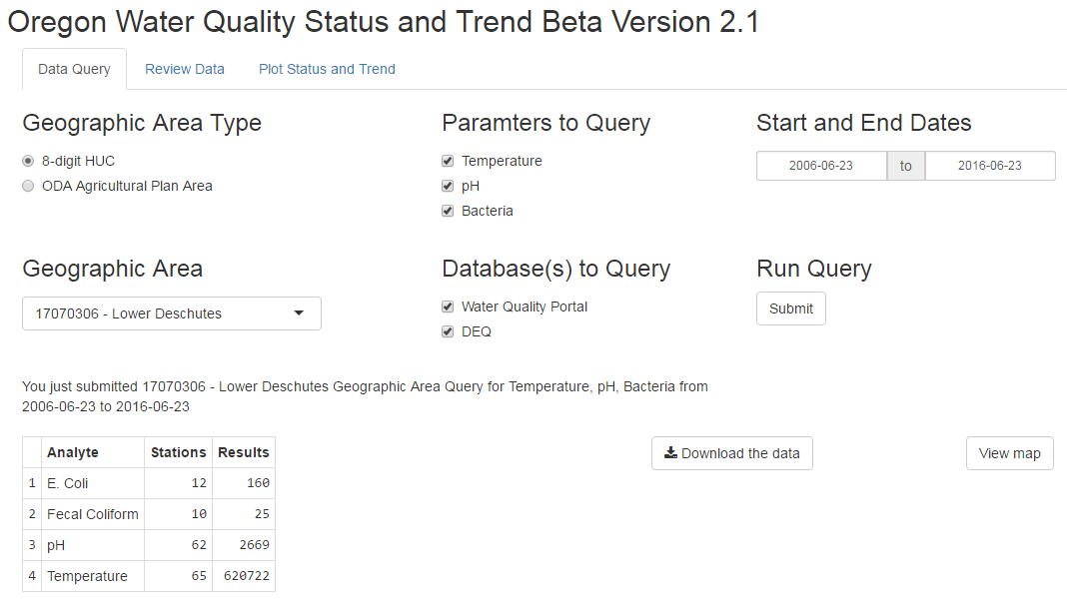

7.

8.

9.

10.0..

11.

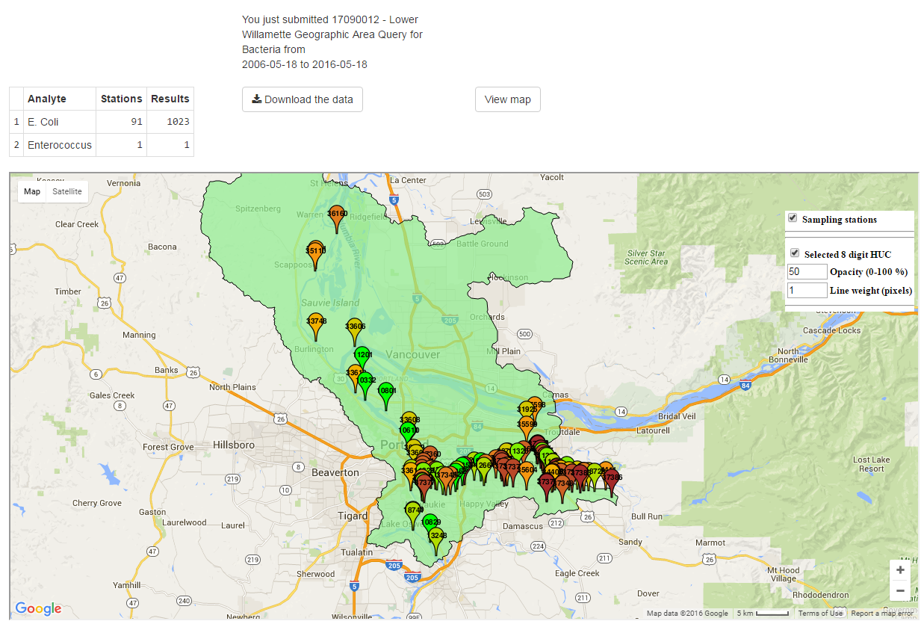

**Screen Shot Sample- 8. View Map**

### Review Data Tab

Users are advised to go to the Review Data Tab before the Plot Status Trend Tab to review the Parameter results by station table. Here you can sort the columns by clicking on the parameter names to see which stations have adequate data for plotting. The Seasonal Kendall Results table provides information on results of trend analysis but there is a requirement for 8 years of data in order to perform a trend analysis. The following are descriptions of each table provided in the Review Data Tab:

Parameter results by station: Column with Station ID number and total observations for each parameter at that location for the time period specified in the query.

Data in tabular format: Table of data processed to have consistent column names between each data source and data removed that does not pass QA/QC screen. The QA/QC screen involves removing data where the comments suggest a problem with the data result and adjusting result values to be numeric. Column descriptions follow:

|  |  |
| --- | --- |
| **Column Name** | **Description** |
| Client | Sampling organization or project |
| Analyte | Parameter name |
| Station_ID | Alpha-numeric station code |
| Station_Description | Station name |
| SampleType | Database dependent usually one of Grab, Field Primary, Field Duplicate, etc. |
| Result | Numeric result value |
| MRL | Minimum reporting limit |
| Unit | Unit of measurement for the Result |
| Status | For DEQ data this is the Data Quality Level or grade |
| Sampled | Sample date-time |
| DATUM | Datum reported for the latitude and longitude provided |
| DECIMAL_LAT | Latitude of the sampling location |
| DECIMAL_LONG | Longitude of the sampling location |
| StatusIdentifier | For Water Quality Portal data this is where QAQC information can be found |
| Comment | Text provided with the sample result |
| HUC | 8-digit HUC of the Sampling Location |
| Database | Source database that the data came from |
| Detect | Either a 1 or 0 to indicate if the sample is above the MRL |

**WQ Limited Waters within Geographic Area:** List of all water quality limited waterbodies with TMDLS and 303(d) listings for selected query parameters that are within or cross the selected Geographic Area. Refer to <http://www.deq.state.or.us/wq/assessment/assessment.htm> for descriptions of the columns. You can click on a listing here and a link will show up on the left under the table selection drop down. This link will bring the user directly to the 303(d) listings on that stream for that parameter. Make sure to click new search before leaving that page otherwise when you click on another row in the table the assessment web page will not be updated when you follow the query link. The correct sequence of events is:

1) Click on row in WQ limited waters table,

2) Click on Link in top left,

3) View listing in assessment database,

4) Click “New Search” on assessment database page,

5) Go back to Status and Trend tool and select a new row.

**Seasonal Kendall Results:** Table detailing results of Seasonal Kendall trend analysis for each parameter at each station. Column descriptions follow:

|  |  |
| --- | --- |
| **Column Name** | **Description** |
| Station_ID | Alpha-numeric station code |
| Analyte | Parameter name |
| Slope | Slope of the trend line |
| Pvalue | Significance of slope |
| Median | Median value of data |
| N | Number of samples used to evaluate trend |
| signif | Textual interpretation of p-value significance. Will also indicate if there was not enough years of data to perform the trend analysis. |

**QA – Summary by organization:** Table with summaries of data, stations and comments associated with each organization. This can be helpful in determining whether to use results from that organization. Typically when an organization has no comments, particularly if from STORET, there is a high likelihood that no QC information is provided and its adequacy cannot be determined.

**QA – Result values modified:** Table identifying all non-numeric values in the result column, how many times they occur and what they were replaced with. This is a necessary step for dealing with DEQ LASAR data.

**QA – Data removal information:** Table describing any observations that were removed as a result of the QA screen.

**QA – Unique comment values:** Comment value occurrence frequency to assist in determining whether there may be issues with the dataset retrieved.

### Plot Status and Trend Tab

This tab provides charts of data returned with the query specifications as well as a table detailing exceedances of the applicable or specified water quality standard. Each parameter has different plotting options. The plots are interactive in that they allow for zooming.

**Instructions for Zooming:**

1. Click and drag a box around the area you want to zoom to.
2. Then, double click in the box you just drew.
3. The plot will update to just the area selected.
4. To zoom out to the original or full zoom double click in the plot without drawing a box first.

Start by selecting the Station you are interested in plotting, then select the parameter you want to plot. Plotting options are described below for each parameter.

#### Temperature:

Two drop downs are provided to specify the applicable water quality standard. The two drop downs are:

*Select applicable spawning time period*: This drop down has the date range that you want to apply to specify when to apply the spawning criteria.

*Select applicable beneficial use*: This drop down has the applicable beneficial use which determines the criteria to apply in the non-spawning time periods.

Below the two drop downs is a link to the Water Quality Standards page which provides the maps for spawning and beneficial use designations.

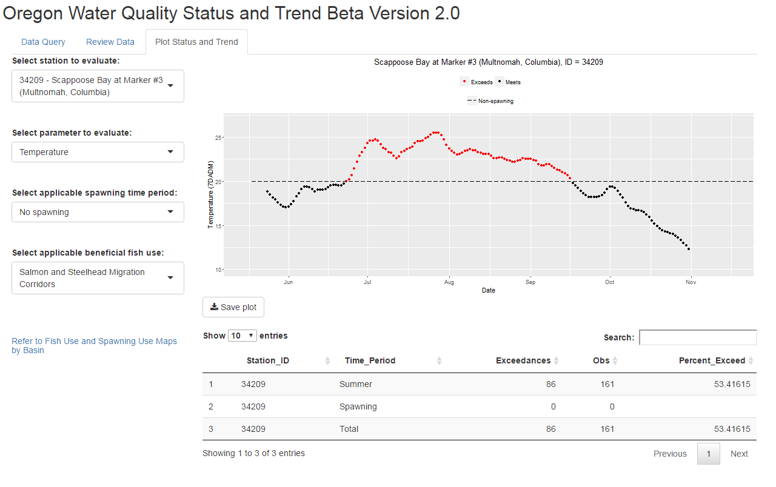

#### E. Coli/Enterococcus:

Two check boxes are provided for bacteria plotting.

1. The first is the option to re-plot the chart using a log scale for the y-axis.
2. The second is the option to plot the Seasonal Kendall trend line.

**Note:** It is important to note that even if a trend line will plot it does not mean the trend is statistically significant. Be sure to note the significance indicated in the sub-title of the plot. At least 8 years of data are needed to have a valid trend analysis. Reviewing Kendall Trend data under Review Data tab, prior to Plot Status and Trend, will identify if any trends are significant for monitoring locations. However, plot illustrates if standard is exceeded regardless of trend and can be informative as to status.

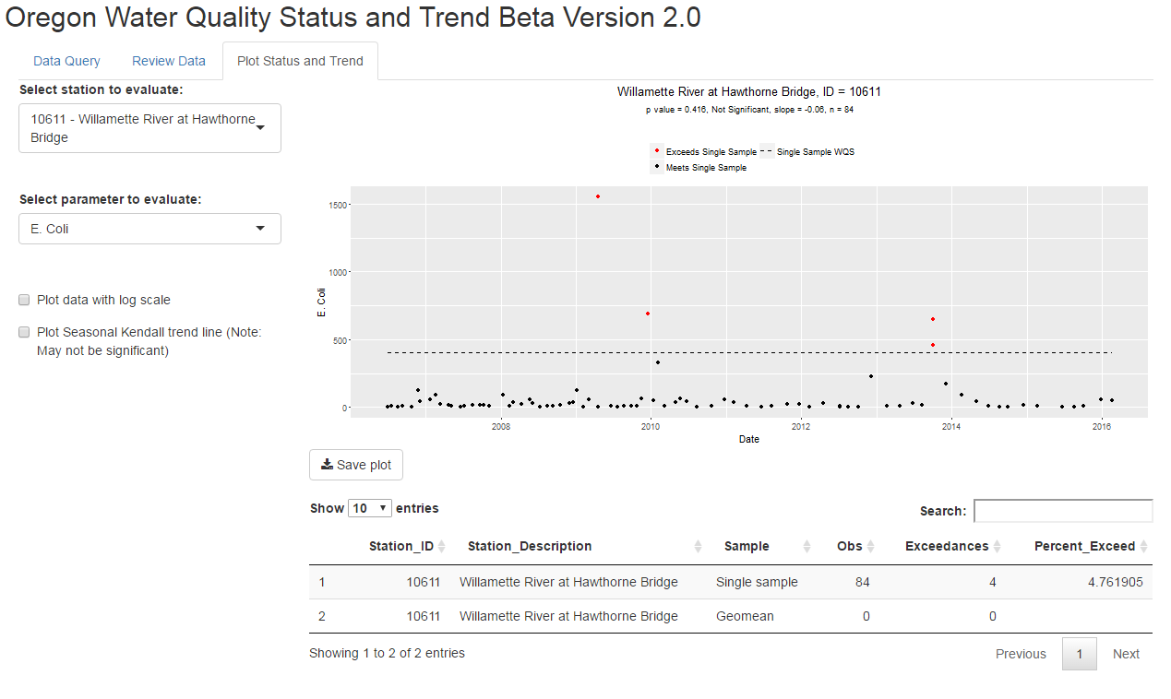

#### pH:

There are two options for plotting pH.

1. The first is the option to plot the Seasonal Kendall trend line.
2. The second is to specify the applicable OWRD Basin specific pH criteria. Use this if your selected location is in one of the unique locations that has a separate standard from the rest of the basin (examples include Columbia or Snake River main-stem or Cascade Lakes > 3,000ft)

**Note:** It is important to note that even if a trend line will plot it does not mean the trend is statistically significant. At least 8 years of data are needed to have a valid trend analysis. Reviewing Kendall Trend data under Review Data tab, prior to Plot Status and Trend, will identify if any trends are significant for monitoring locations. However, plot illustrates if standard is exceeded regardless of trend and can be informative as to status. Be sure to note the significance indicated in the sub-title of the plot.

