**INSTALLING AND RUNNING WHAT-IF**

A little guide to install and run WHAT-IF step by step.

**1 Download WHAT-IF**

* Go on <https://github.com/RaphaelPB/WHAT-IF>

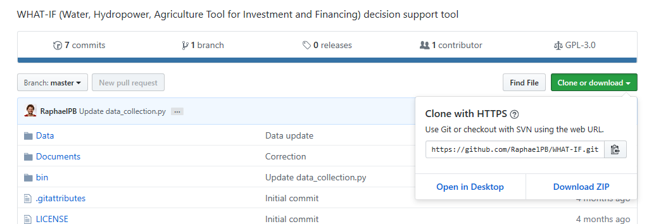

* Click the up right ”Clone or download” icon and then “Download ZIP”
* Unzip the downloaded folder where you want it to be
* It should look something like that inside (may vary according to version)

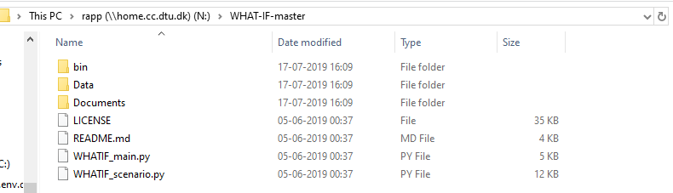

**2 Download Anaconda**

* Download Anaconda from <https://www.anaconda.com/distribution/> it is a great way of managing python packages and versions

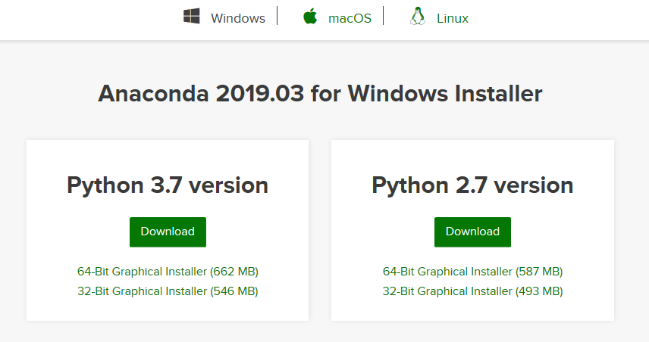

* Click on Windows, macOS or Linux according to your system and choose Python 3.7 version
* On windows, run the exe file downloaded (if it did not start on its own), choose all the default options of the installer (or customize if wanted), it takes 3.1 GB and approximately 10 min.
* You can open Anaconda (we will come back to it later)

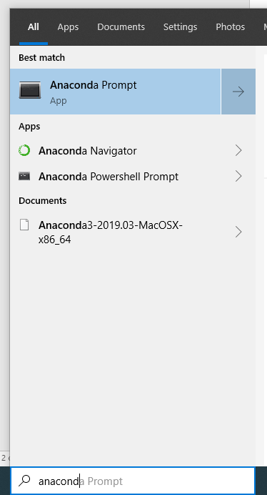**3 Create the WHAT-IF python environment**

* Look for anaconda prompt (command line version of anaconda)
* 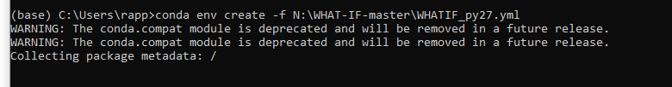Run the command:  
  conda env create –f PATHTOWHATIF\WHATIF_py27.yml  
  in the example PATHTOWHATIF = N:\WHAT-IF-master  
  it might take 5-10 min to install all necessary libraries
* This step is not unlikely to FAIL, e.g. :

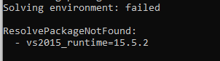

Please contact us for alternatives ([rapp@env.dtu.dk](mailto:rapp@env.dtu.dk))

* If it worked, you should be able to see the environment from the anaconda navigator (“Python36” here)

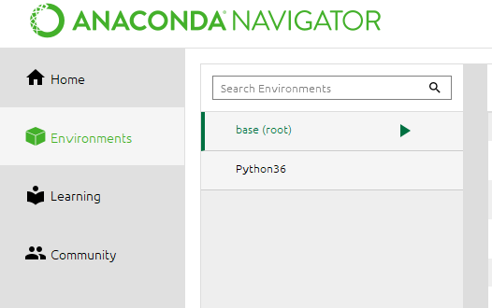

* You can activate the environment either by clicking on it in the anaconda navigator or running

conda activate Python36  
in the anaconda prompt, replace Python36 by the name of the environment if different (it might not be the same name as the .yml file)  
You need to install the environment once, but you might need to activate it each time.

**4 Run WHAT-IF**

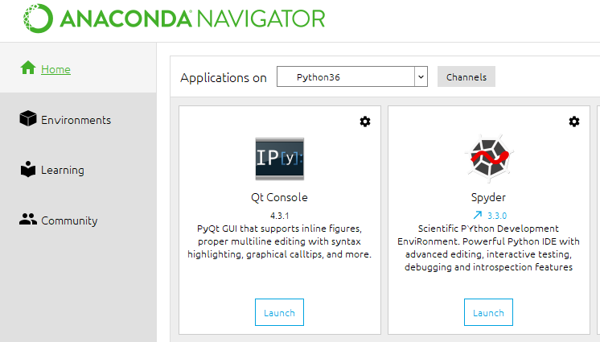Almost there, last steps:

* Launch Spyder from anaconda or windows  
  from windows: make sure you select spyder with the good environment, here:   
  Spyder (Python36)

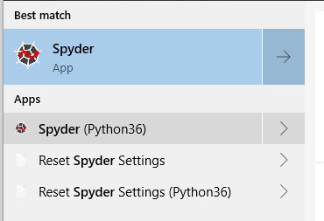from anaconda navigator: make sure you activated the good environement (see previous point)

‘

* Open WHATIF_main from the WHATIF folder you downloaded
* Press the green play button and RUN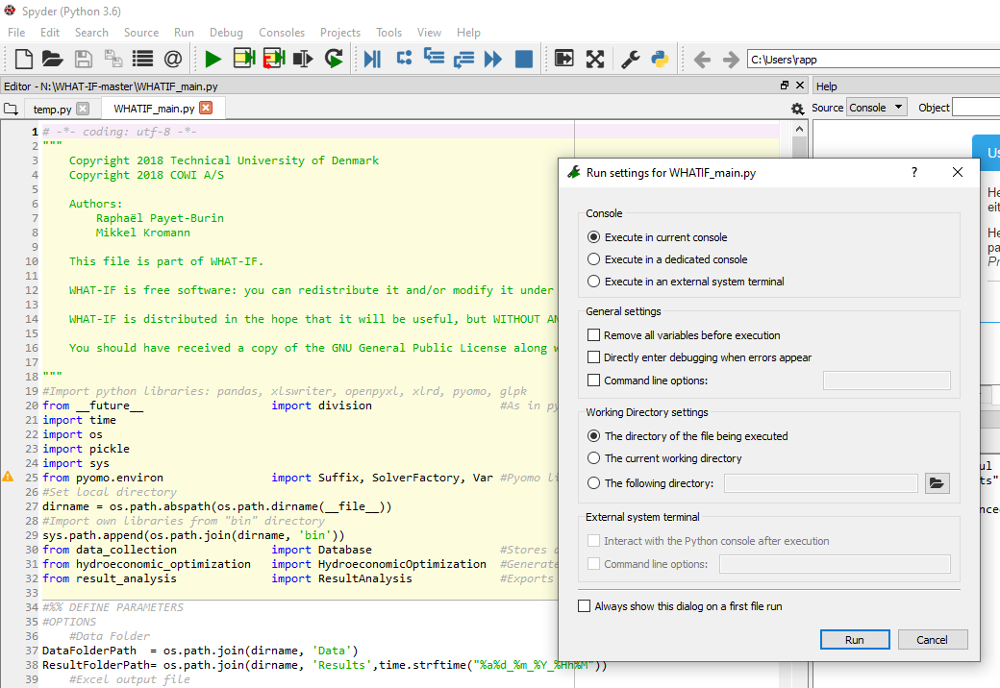
* The downloaded version comes with the input data for the Zambezi case, the first time it might take some time to gather the excel data, in the next run (or directly actually), you can change the UPDATE parameter to 1, to skip some parameter loading (Warning: by doing this the model will not update all the data every time, which data is updated can be chosen in the excel files)

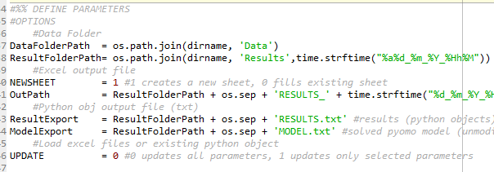

* The results of the run will appear in a “Result” folder, you can modify the data in the “Data” folder and run your own case.