Weather Dashboard User’s Guide

By: Michael Bradshaw

Loading Files

To load files first be sure you are on the Load Files tab.

Next to select the files to upload click on the Browse button.

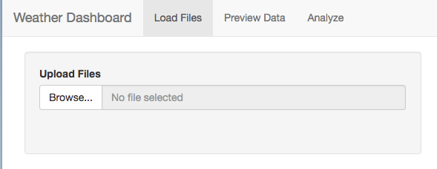

You should now have a popup with access to your own file system. Select the files you wish to upload and click Open in the bottom left. Note: currently only the CSV (comma separated values) file format is supported.

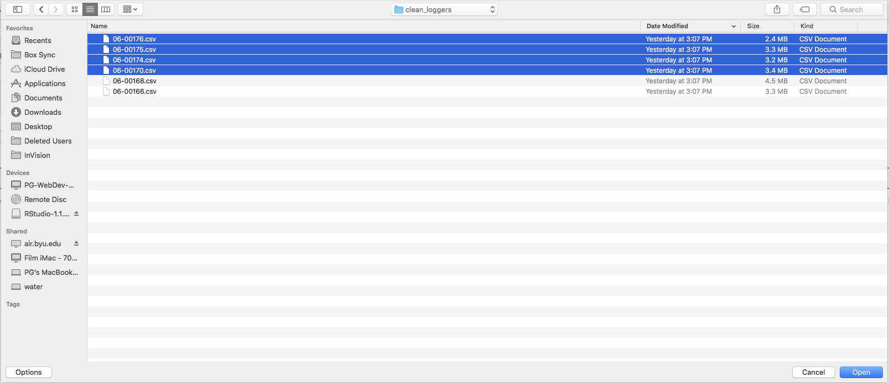

Your files will now begin uploading. This could take several minutes depending on the size of the files you are uploading. The uploading process will remove all non-alpha numeric character removed from column names. Once uploaded the file names should appear in the table at the bottom of the screen.

More files can be uploaded at any time by the same process.

Assigning Groups

By default, when files are uploaded they are assigned to Group1. To change one or more files’ group

1. Select the file(s) by clicking on it in the table. A selected file will be highlighted in a pale blue color.
2. Enter a new group name in the text area labeled “Enter Name of Group”.
3. Click “Group Selected Files” to change the group of the selected files to the previously entered name.

You may create as many groups as you choose.

Data Previewing