Summarizing the geographic setting of soil map units

By Alena Stephens and Stephen Roecker

# Introduction

This job aid demonstrates how to run a knitr report on spatial data using RStudio. The report can be used to automate the analysis of data, and produce a standardized summary. With minimal editing and the push of a button, each user can produce their own report. Ultimately this is intended to useful for summarizing the geographic setting for a list of soil map units associated an SDJR project.

# Objectives

* Create cache folder
* Load R packages
* Download report
* Build list of map unit keys (i.e. mukey) to analyze
* Edit mukey list and file paths
* Run knitr report

# Requirements

* User is familiar with Rstudio
  + If not see the Job-Aids [webpage](http://www.nrcs.usda.gov/wps/portal/nrcs/detail/soils/edu/ncss/?cid=nrcs142p2_054322#database_gen) for an introduction
* QGIS, R, and Rstudio are installed
* geodata are loaded

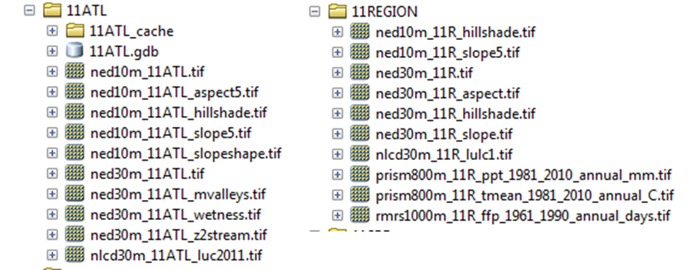

Figure : Example of geodata from the project_data folder.

# Instructions

## Create a cache folder

Copy and paste the box below into the R console, but be sure to edit the office name (e.g. 11IND). This will create a cache folder in same location that the MUPOLYGON file geodatabase is stored.

dir.create(path="M:/geodata/project_data/11IND/cache", recursive=T) # create directory

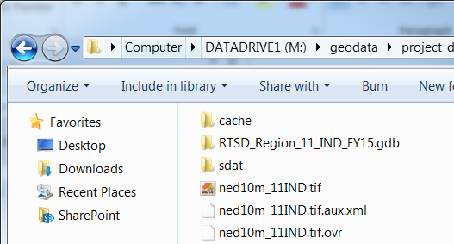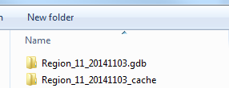

## Open RStudio

## Load and Update Packages

Install the following R packages if not previously installed. Copy and paste into the box below into the “R console”. Then, click “Enter” on your keyboard to process.

install.packages(c('circular', 'gdalUtils', 'sp', 'raster', 'rgdal', 'reshape', 'plyr', 'lattice', 'xtable', 'XML', 'RCurl', 'maps') , dependencies=TRUE)

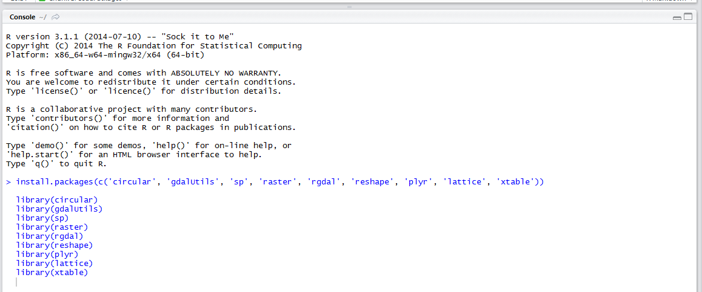

Click on the ‘Packages’ tab in the lower right corner > Click on Update and update packages as needed.

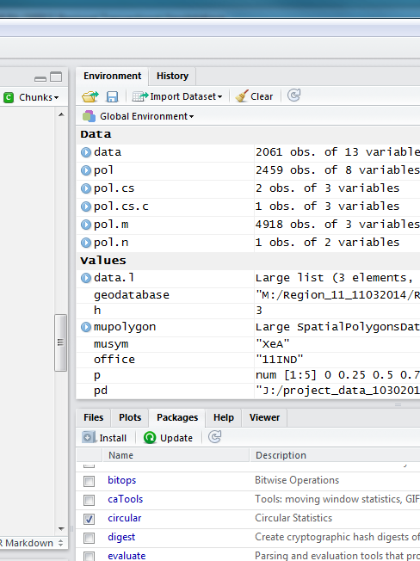

## Download the knitr report from Github

Copy and paste the box below into the R console.

# Create directory

dir.create(path="C:/soil-pit/soilReports", recursive=T)

# Download latest report

download.file("https://raw.githubusercontent.com/sroecker01/soil-pit/master/soilReports/mapunit_summary_by_mukey.Rmd", "C:/soil-pit/soilReports/mapunit_summary_by_mukey.Rmd")

File > Open File… > mapunit_summary_by_mukey RMD > Open

## Build a list of MUKEY to analyze

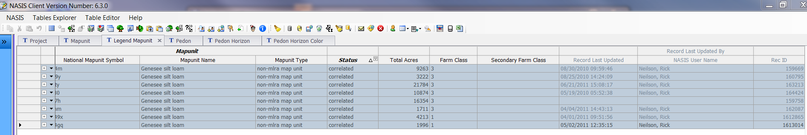

* Load the Legend Mapunit table for the map units you wish to analyze into NASIS. This tables Record ID matches the MUKEY, used to match NASIS to SSURGO. Don’t forget to only select correlated mapunits.
* Copy and paste this table into an Excel spreadsheet, and save it in the “C:/soil-pit/soilReports” folder as “test.csv” using the CSV (Comma delimited)(*.csv) format. Remember you can select the table using Crtl-A, and copy the table using Crtl-C.
* Copy and paste the box below into the R console.

test <- read.csv("test.csv")

mukey <- test$Rec.ID

paste0("c(", paste0("'", mukey, "'",collapse=","), ")")

* This will create a properly formatted list that you can copy and paste for the next step.

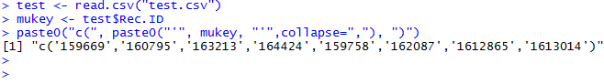

Figure : Example of formatted list of mukey.

## Edit the mukey and file paths for processing

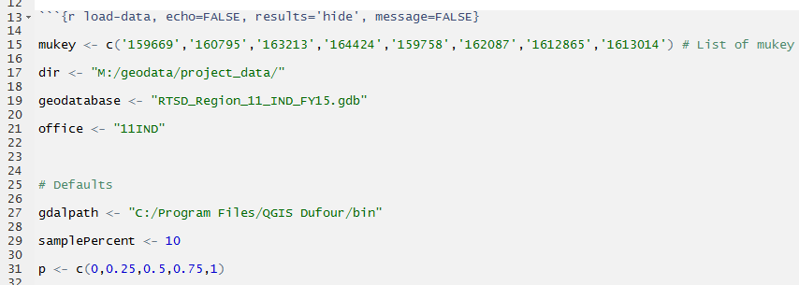

* Edit line 15 by copying and pasting the mukey list from the previous step, or type manually (if typed be sure to include quotation marks around mukey i.e. (“159669”), and add comma between multiple mukeys i.e. (“159669”, “160795”).
* Edit line 17 that references the file path for the “project_data” folder
* Edit line 19 that refers to the name of the file geodatabase containing the MUPOLYGON feature class
* Edit line 21 to match MLRA office designation

### Optional or in case of error

* Check line 27 so that QGIS installation path is correct
* If you copy and paste the file path names from that windows explorer be aware that it uses backslashes (\) while R uses forwards slash (/).
* Make sure to include a forward slash after the “dir” folder name in line 17.
* If needed, edit Slope.list (line 199) and slope breaks (line 215) according to the mapunits.

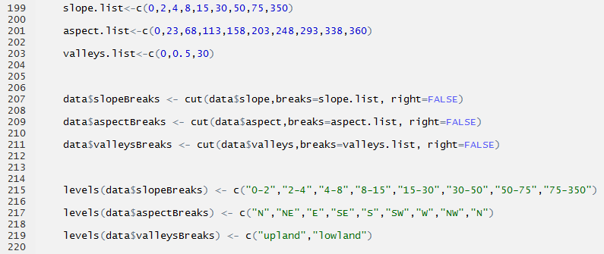

## Click on Knit HTML button to process the report.

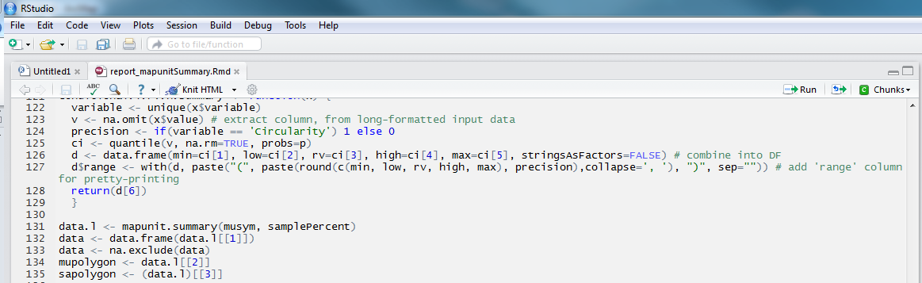

# Sample Report

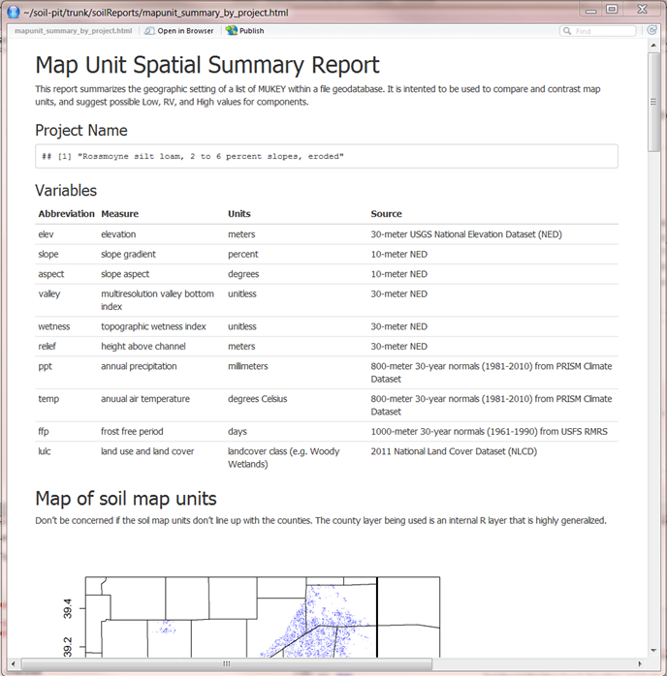

If the tool fails to process:

* Check that packages are loaded and updated
* Check file names and folder paths