Summarizing the geographic setting of soil map units

By Alena Stephens and Stephen Roecker

# Introduction

This job aid demonstrates how to run a knitr report on spatial data using RStudio. The report can be used to automate the analysis of data, and produce a standardized summary. With minimal editing and the push of a button, each user can produce their own report. Ultimately this is intended to useful for summarizing the geographic setting for a list of soil map units associated an SDJR project.

# Objectives

* Create the Project Record ID
* Create a cache folder
* Load the R packages
* Download the report
* Edit the project name and file paths
* Run the knitr report

# Requirements

* User is familiar with Rstudio
  + If not see the Job-Aids [webpage](http://www.nrcs.usda.gov/wps/portal/nrcs/detail/soils/edu/ncss/?cid=nrcs142p2_054322#database_gen) for an introduction
* QGIS, R, and Rstudio are installed
* geodata are loaded

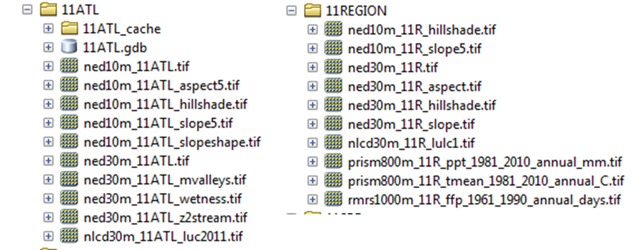

Figure : Example of geodata from the project_data folder.

# Instructions

## Create the Project Record ID

Create the Project Record ID in the RTSD file geodatabase prior to processing this report. Refer to the [Digital Editing Guidelines](https://ems-team.usda.gov/sites/NRCS_SSRA/mo-11/Soils%20%20GIS/Forms/AllItems.aspx) for help.

## Create a cache folder

Copy and paste the box below into the R console, but be sure to edit the office name (e.g. 11IND). This will create a cache folder in same location that the MUPOLYGON file geodatabase is stored.

dir.create(path="M:/geodata/project_data/11IND/cache", recursive=T) # create directory

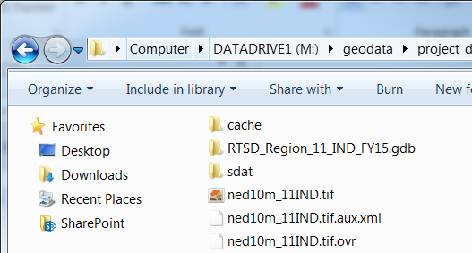

## Open RStudio

## Load and Update Packages

Install the following R packages if not previously installed. Copy and paste into the box below into the “R console”. Then, click “Enter” on your keyboard to process.

install.packages(c('circular', 'gdalUtils', 'sp', 'raster', 'rgdal', 'reshape', 'plyr', 'lattice', 'xtable', 'XML', 'RCurl', 'maps') , dependencies=TRUE)

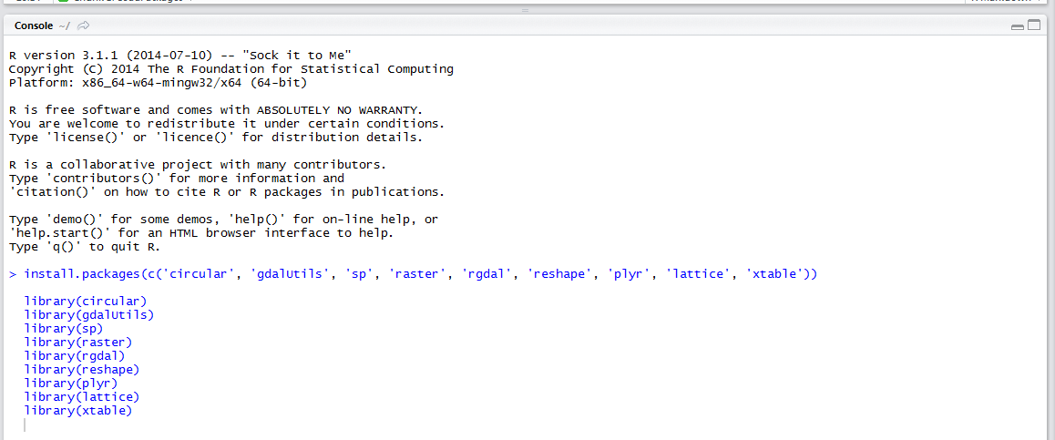

Click on the ‘Packages’ tab in the lower right corner > Click on Update and update packages as needed (e.g. monthly).

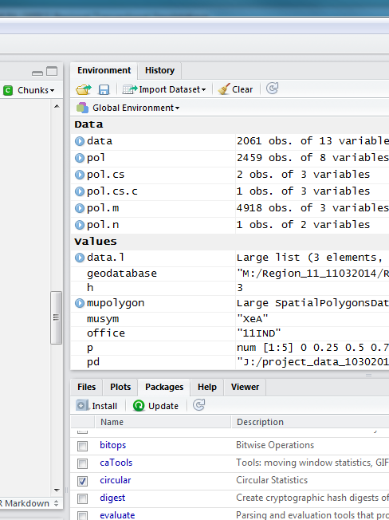

## Download the knitr report from Github

Copy and paste the box below into the R console.

# Create directory

dir.create(path="C:/soil-pit/soilReports", recursive=T)

# Download latest report

download.file("https://raw.githubusercontent.com/sroecker01/soil-pit/master/soilReports/mapunit_summary_by_project.Rmd", "C:/soil-pit/soilReports/mapunit_summary_by_project.Rmd")

Open the file.

File > Open File… > C:/soil-pit/soilReports/mapunit_summary_by_project RMD > Open

## Edit the project and file paths for processing

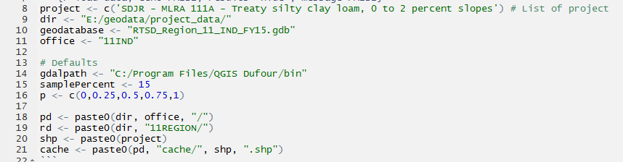

* Edit line 8 by copying and pasting the project name from one of the NASIS master list reports or project record ID.
* Edit line 9 that references the file path for the “project_data” folder
* Edit line 10 that refers to the name of the file geodatabase containing the MUPOLYGON feature class
* Edit line 11 to match MLRA office designation

### Optional or in case of error

* Check line 14 so that QGIS installation path is correct
* If you copy and paste the file path names from that windows explorer be aware that it uses backslashes (\) while R uses forwards slash (/).
* Make sure to include a forward slash after the “dir” folder name in line 17.
* If needed, edit Slope.list (line 102) and slope breaks (line 112) according to the mapunits.

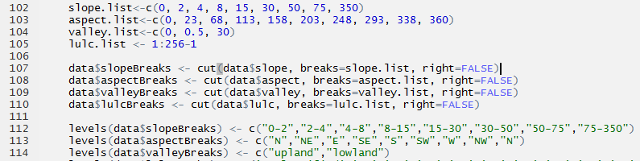

## Click on Knit HTML button to process the report.

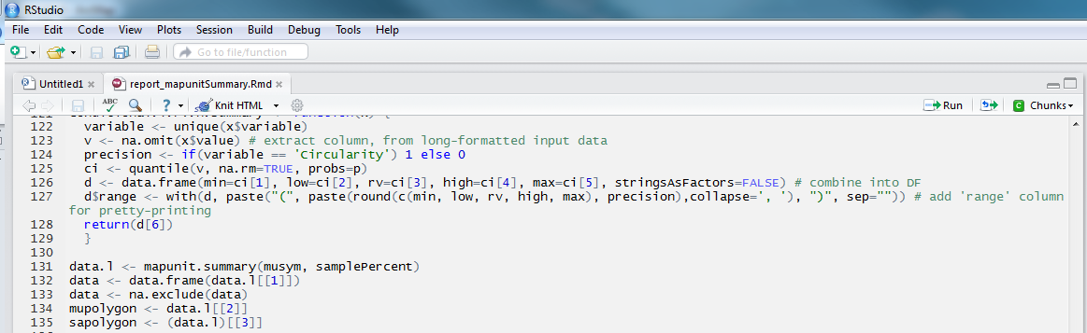

## Save the report

The report is automatically saved upon creation in the same folder as the R report. However, it is given the same generic name as the R report (i.e. C:/soil-pit/soilReports/pedon_summary_by_taxonname.html), and will be overwritten the next time the report is run. Therefore, if you wish to save the report, rename the .html file to a name of your choosing. Also upon reopening the .html file, click on “Allow blocked content” if prompted. Otherwise Internet Explorer may alter the formatting within the document.

# Sample Report

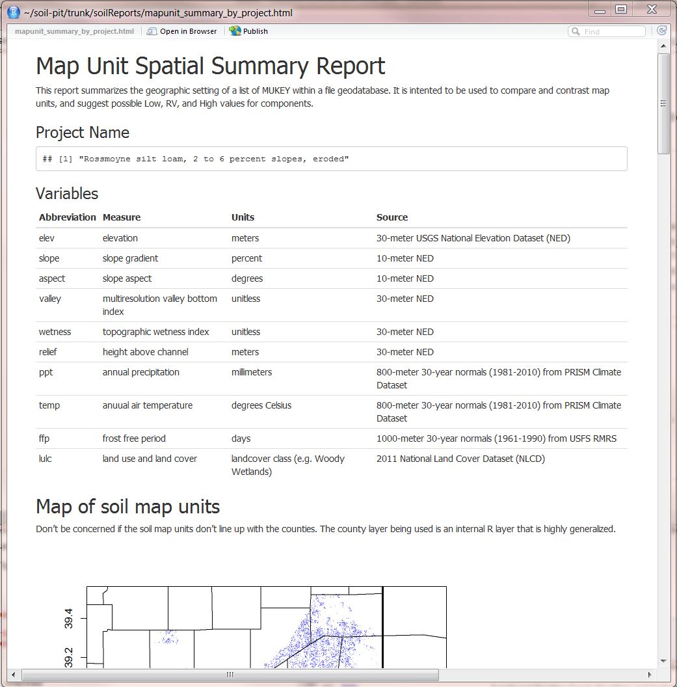

If the tool fails to process:

* Check that packages are loaded and updated
* Check file names and folder paths
* Check that the Project Record ID resides in the RTSD file geodatabase prior to processing the report