Summarizing pedon and lab data for a soil series

By Stephen Roecker

# Introduction

This job aid demonstrates how to run a knitr report on pedon and lab data from NASIS using RStudio. These reports can be used to automate the analysis of data, and produce a standardized summary. With minimal editing and the push of a button, each user can produce their own report. Ultimately this is intended to useful for summarizing the range in characteristics of pedons for developing OSD or Components. It is also useful to evaluate how accurately data is populated.

# Objectives

* Load your NASIS selected set with Pedon and Site tables (both are required)
* Install R packages
* Download report
* Run knitr report

# Requirements

* Data is properly populated, otherwise the report may fail. Common examples include:
  + Horizon depths don’t lineup
  + Both the Pedon and Site tables aren’t loaded
* The user is familiar with Rstudio, if not see the Job-Aids [webpage](http://www.nrcs.usda.gov/wps/portal/nrcs/detail/soils/edu/ncss/?cid=nrcs142p2_054322#database_gen) for an introduction
* ODBC connection to NASIS is setup, if not see the Job-Aids [webpage](http://www.nrcs.usda.gov/wps/portal/nrcs/detail/soils/edu/ncss/?cid=nrcs142p2_054322#database_gen) for instructions
* The user has assigned generalized horizon labels (GHL) to the “Comp_Layer_ID” column within the pedon horizon table within NASIS, or setup GHL using pattern matching. For an introduction to pattern matching see the Job-Aid, [Assigning Generalized Horizon Labels](https://r-forge.r-project.org/scm/viewvc.php/*checkout*/docs/aqp/gen-hz-assignment.html?root=aqp).

# Instructions

## Load NASIS selected set

Run a query such as “POINT - Pedon/Site/NCSSlabdata by upedonid and Taxon Name” to load your selected set. Be sure to target both the pedon and site tables. Remove from your selected set the pedons and sites you wish to exclude from the report.

## Open Rstudio and install packages

Copy and paste the box below into the R console.

install.packages(c('aqp', 'soilDB', 'RODBC', 'RCurl', 'circular', 'colorspace', 'RColorBrewer', 'plyr', 'ggplot2', 'reshape2', 'lattice', 'maps', 'sp', 'knitr', 'rmarkdown', 'xtable'), dependencies=TRUE)

This step only need run once. Afterwards you only need to update your R packages intermittently, by clicking the button on the Packages tab from the lower right hand window. The first time can be a bit lengthy, so go get some coffee or bug your boss.

## Download and open the pedon report

Copy and paste the box below into the R console

dir.create(path="C:/soil-pit/soil_reports", recursive=T)

dir.create(path="C:/soil-pit/soil_reports/genhz_rules", recursive=T)

# Download latest report and rules

setInternet2(TRUE)

download.file("https://raw.githubusercontent.com/ncss-tech/soil-pit/master/soil_reports/pedon_summary_by_taxonname.Rmd", "C:/soil-pit/soil_reports/pedon_summary_by_taxonname.Rmd")

download.file("https://raw.githubusercontent.com/ncss-tech/soil-pit/master/soil_reports/lab_summary_by_taxonname.Rmd", "C:/soil-pit/soil_reports/lab_summary_by_taxonname.Rmd")

download.file("https://raw.githubusercontent.com/ncss-tech/soil-pit/master/soil_reports/report_functions.R", "C:/soil-pit/soil_reports/report_functions.R")

download.file("https://raw.githubusercontent.com/sroecker01/soil-pit/master/soil_reports/genhz_rules/genhz_rules.zip", "C:/soil-pit/soil_reports/genhz_rules/genhz_rules.zip")

unzip(zipfile="C:/soil-pit/soil_reports/genhz_rules/genhz_rules.zip", exdir="C:/soil-pit/soil_reports/genhz_rules")

Navigate to the file path specified above and open the pedon_summary_by_taxonname.Rmd or lab_summary_by_taxonname.Rmd file in Rstudio.

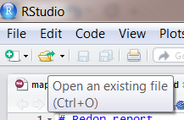

## Check or create a genhz_rules file for your soil series

In order to aggregate the pedons by horizon designation, a genhz_rules file (e.g. Genesee_rules.R) is needed. See below.

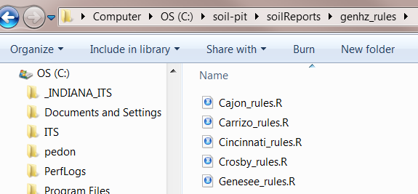

If none exists see the following job aid on how to create one, [Assigning Generalized Horizon Labels](https://r-forge.r-project.org/scm/viewvc.php/*checkout*/docs/aqp/gen-hz-assignment.html?root=aqp).

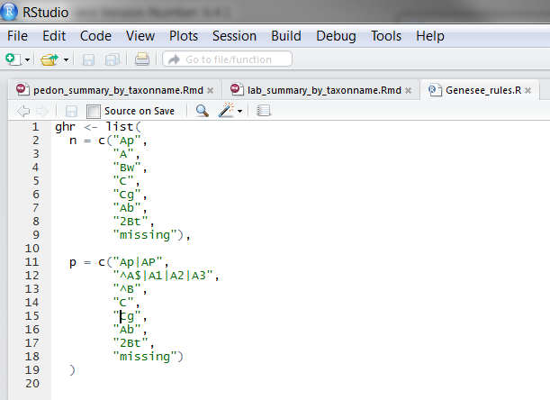

Figure 1: Example of patch matching file for Genesee.

Pay special attention to how carrot “^” and dollar “$” symbols are used. They function as anti-wildcards. For example, a “^” placed before an A horizon, “^A”, will match any horizon designation that follows A, such as Ap, Ap1, etc. Also, placing a “$” after a Bt horizon, “Bt$”, will match any horizon designation that precedes Bt, such as 2Bt or 3Bt. Encapsulating a horizon with both “^” and “$” symbols will result only in exact matches. For example ^A$, will only match A, not Ap or A1.

## Enter your Soil Series and Knit

Enter/replace the soil series of interest, and hit the knit button . Be sure to encase the soil series name in quotations, using either “name” or ‘name’

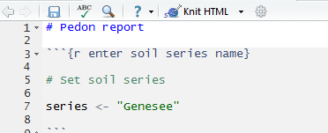

## Save the report

The report is automatically saved upon creation in the same folder as the R report. However, it is given the same generic name as the R report (i.e. C:/soil-pit/soil_reports/pedon_summary_by_taxonname.html), and will be overwritten the next time the report is run. Therefore, if you wish to save the report, rename the .html file to a name of your choosing. Also when reopening the .html with Internet Explorer, click on “Allow blocked content” if prompted. Otherwise Internet Explorer may alter the formatting within the document.

# Sample pedon report

# 

Figure 2: Example from the pedon report. Notice how some data is missing (i.e. NA).

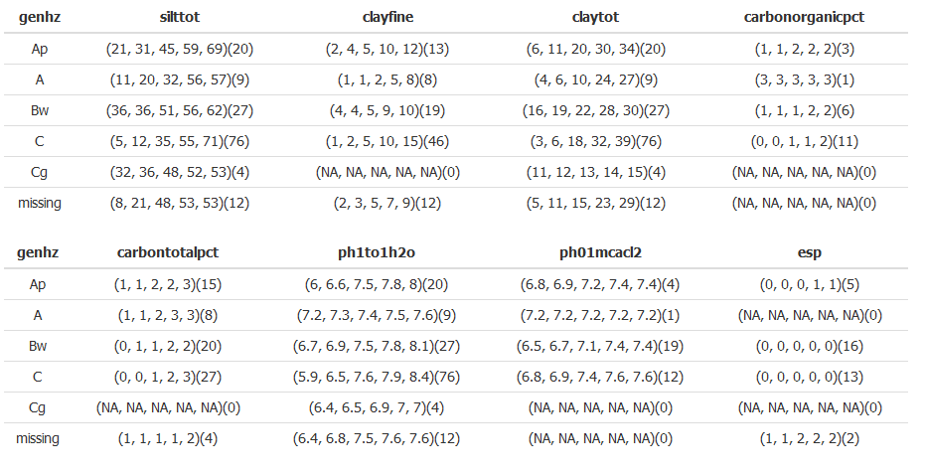

Figure 3: Example from the labreport. Notice how some data is missing (i.e. NA).