**Welcome to the Survey**

**Survey Motivation**

To respond to disasters in a chaotic environment, practitioners conduct complex and challenging tasks. While making decision on **relief distribution (RD)**, they face uncertainty to identify appropriate decision factors **(decision objectives, variables,** and **constraints)**. To assist them, we intend to develop a decision-making framework consisting of a list of decision aspects that need to be empirically tested and evaluated. So, we are approaching you since **you are one of those experts** who has adequate practical experiences in humanitarian logistics operations. Necessary terms are described in the following table for your convenience.

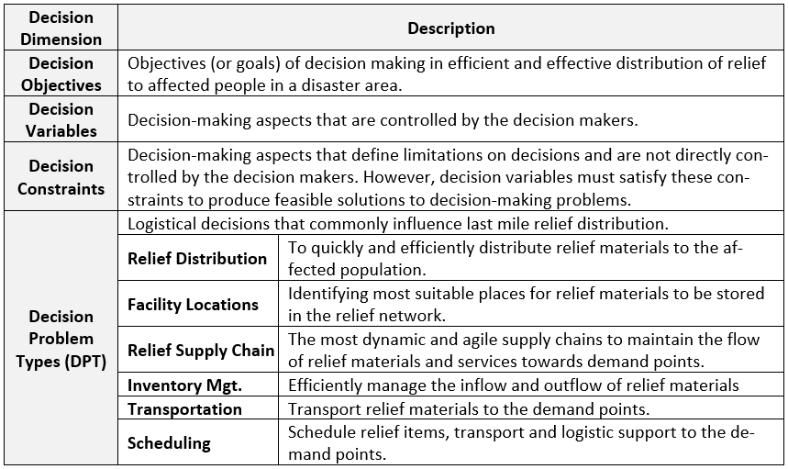

**Instruction to answer the questionnaire:**

**1.** Please make yourself familiar with the tabulated **decision-making dimensions**.

**2.** Please rank the importance of each attribute in relief distribution process in the scale of 1 to 6.

***1:*** *Not important and* ***6:*** *Very important*

**3.** If an individual relief distribution decision-making aspect is also **applied** to other decision problem types (DPT), check it out – multiplicity is possible.

**4.** Briefly **explain** your choice in the respective area in fourth column.

**5.** In the last row, please **state** **missing aspects** that you practically experienced and think should be listed. If possible, please **provide brief description** of them and **mention their influences** on other DPTs.



**List Items**

**Table**

**Button**

**Figure 3: Content of Page 1 (introduction.html)**

Text Box

Table

Check Box

Text Box

Text Box

**Figure 4: Content of Page 2 (survey.html)**