OreSat Structure September 9, 2019

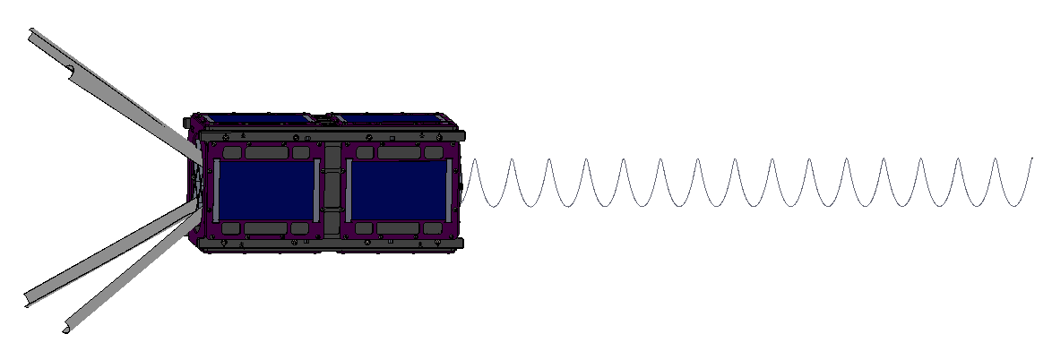

Figure 1: Side view of full, horizontal OreSat Structure

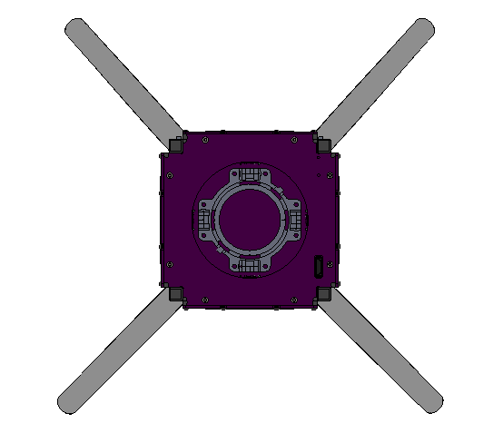

Figure 2: View looking down +Z end of OreSat, with helical deployer in center

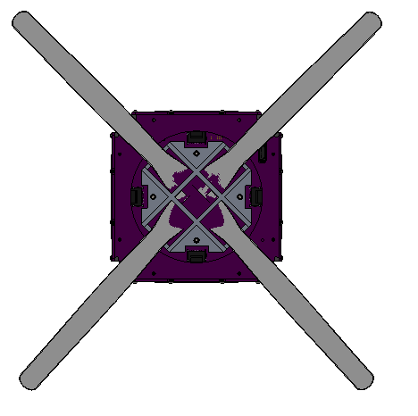

Figure 3: View looking down -Z end of OreSat, with turnstile antenna array in center

Figure 4: View of +X side of OreSat

Figure 5: View of +Y side of OreSat

Figure 6: View of cut-through from +X frame

Figure 7: View of cut-through from +Y frame