a1) Build a profile:

a. Married/Single?

Age

b. Balance Sheet

i. Assets

1. Liquid assets

a. (current/fixed/saving deposits)

2. Investment assets

a. CPF savings

b. Cash value of insurance

c. Portfolio of bonds/shares/ investments

3. Real estate

a. Market value of home

4. Personal properties

a. Cars

b. Jewelry

ii. Current Liabilities

1. Household expenses (annualized)

2. Personal expenses (annualized)

iii. Long-term liabilities

1. Home loan? Car loan?

iv. Calculate net-worth (asset - liabilities)

c. Joint Cash flow statement

i. Inflows

1. Net Salary (salary x 80%)

2. CPF from employee

3. CPF from employer

ii. Outflows

1. Fixed outflows:

a. Additional mortgage payments

b. Insurance

2. Variable outflows:

a. Family and personal expenses

b. House expenses

c. Taxable income

iii. Net inflow/outflows

RISK ASSESSMENT SURVEY:

1. **Your age is:**
2. **How much risk are you willing to take when investing?**
   1. **Are you conservative, moderate, or aggressive in your investment approach**

**OUTCOME OF SURVEY:**

1. **LOW RISK (bonds)**
2. **NEUTRAL (more diverse)**
3. **HIGH RISK (Shares)**

**Analysis of financial ratio: (based on financial ratio, give recommendations to adjust their ratios)**

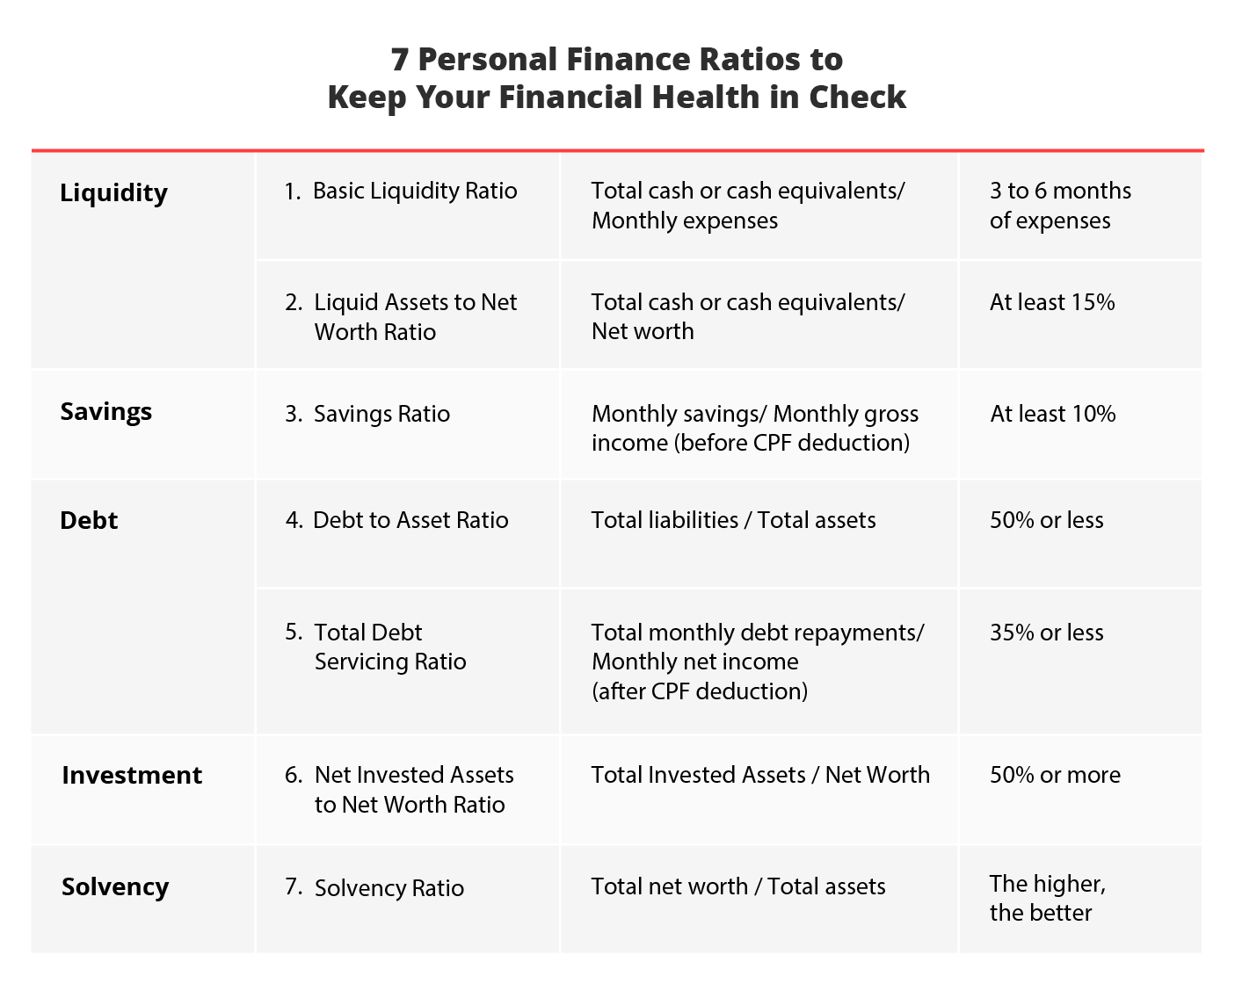

**INFO required: (FINANCIAL HEALTH)**

1. **Cash/Cash equivalents**
2. **Monthly expenses**
3. **Networth (Total asset - total liability)**
4. **Monthly savings**
5. **Monthly gross income (before CPF)**
6. **Total liability (Do you have any existing bank loan? E.g. car loan, home loan**

**Do you have any existing Credit card? If yes, what is the credit limit) backend x2% of credit limit for the credit card**

1. **Total assets (How much is your property worth, do you own any jewellery? How much is your car worth if you own one)**
2. **Total monthly debt repayment (How much do you need to pay monthly on your debts e.g. car loan, home loan, credit card)**
3. **Monthly net income (can calculate from monthly gross income (income x 80%)**
4. **Total invested assets (What is the total value of your invested assets?, What is the allocation of your assets? E.g. 50% bonds 50% shares)**

**Investments: (IF LESSER THAN 50%) DO THIS SURVEY**

1. **What are you current investments allocation? (if any e.g. 50% stocks 50% bonds)**

**BENCHMARK → 120 - age = % of assets to be allocated to stocks while the rest to safer, stable investment instruments (recommendation)**

**Add inflation:**

**Life expectancy - Wanted retirement age = retire years**

**Years to retirement = retirement age - current age**

**Using average inflation of 3%.**

**Let i = 3%**

**Let n = retire years**

**Let x = Years to retirement**

**Total savings = current Total savings x (1 + i)^x + (monthly savings x [(1+i)^x -1] / i**

**How much CPF in a retirement account? (OA + SA)**

**IF AGE < 55 , contribution is 37%**

**IF AGE <60, contribution 31%**

**IF AGE < 65, contribution is 22%**

**Assume returns from CPF is 4%.**

**M = n x 12 (months)**

**Total CPF contribution = (Wage x contribution) x [(1+i)^m -1] / 4%**

**Total CPF at future date = Current CPF x (1+4%)^x**

**Total CPF contribution + total cpf at future date = total CPF in RA**

**Total Assets at retirement = Total CPF in RA + total savings**

**Total expenses cost in future = (Monthly expenses x 12) x (1+3%)^x**

**Total amount required for expenses = Total expenses cost in future x 1/(1+3%)^n**

**Check if total amount = Total assets - total expenses**

**NEED TO HAVE SURPLUS**