**Lecture Slides:** [Blender Week 1.](http://kieranhicks.com/Presentations/Blender_Week_1.html#0) : http://kieranhicks.com/Presentations/Blender_Week_1.html#0

**Tutorial Videos:** [If you get stuck.](https://www.youtube.com/playlist?list=PL9057AB8E3C66AE80) : https://www.youtube.com/playlist?list=PL9057AB8E3C66AE80

**Task 1:**

This is a repeat of the max task from a couple of weeks ago to introduce you to the work flow of blender. Using “Join”, “Flip”, “Merge” and “Bridge” tools to fix the 3 objects to look like the image below. You can download the base blender file on GitHub.

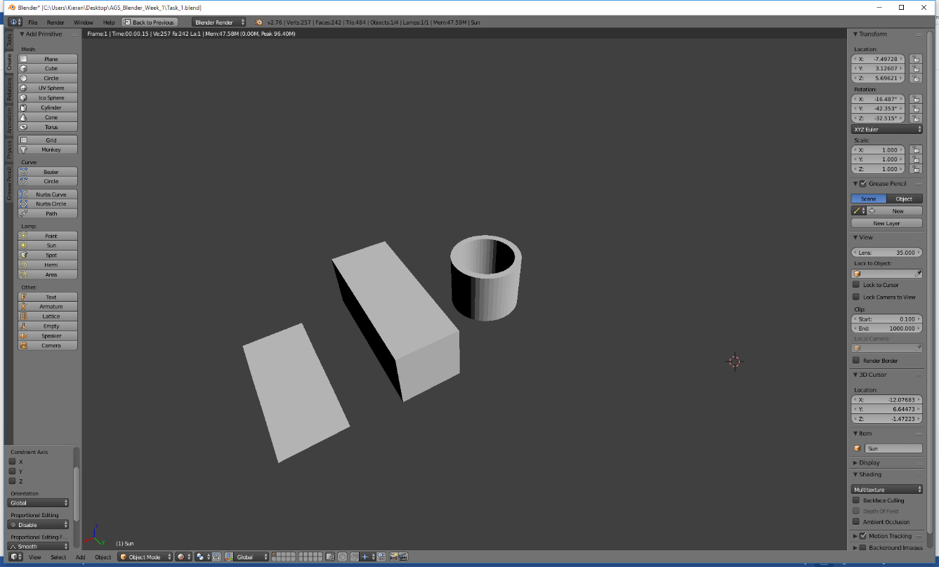

**Task 2:**

For task 2 you are going to create a low poly landscape that would be used in a game. To do this open a new blender file, making sure to save task 1 before doing so.

* Add a plane and scale it up to a suitable size
* Subdivide the plane to a few times to get a decent amount of faces.
* Using the randomise and proportional edit tool add some detail to your mesh
* When you are happy with how you’re terrain looks save the file.

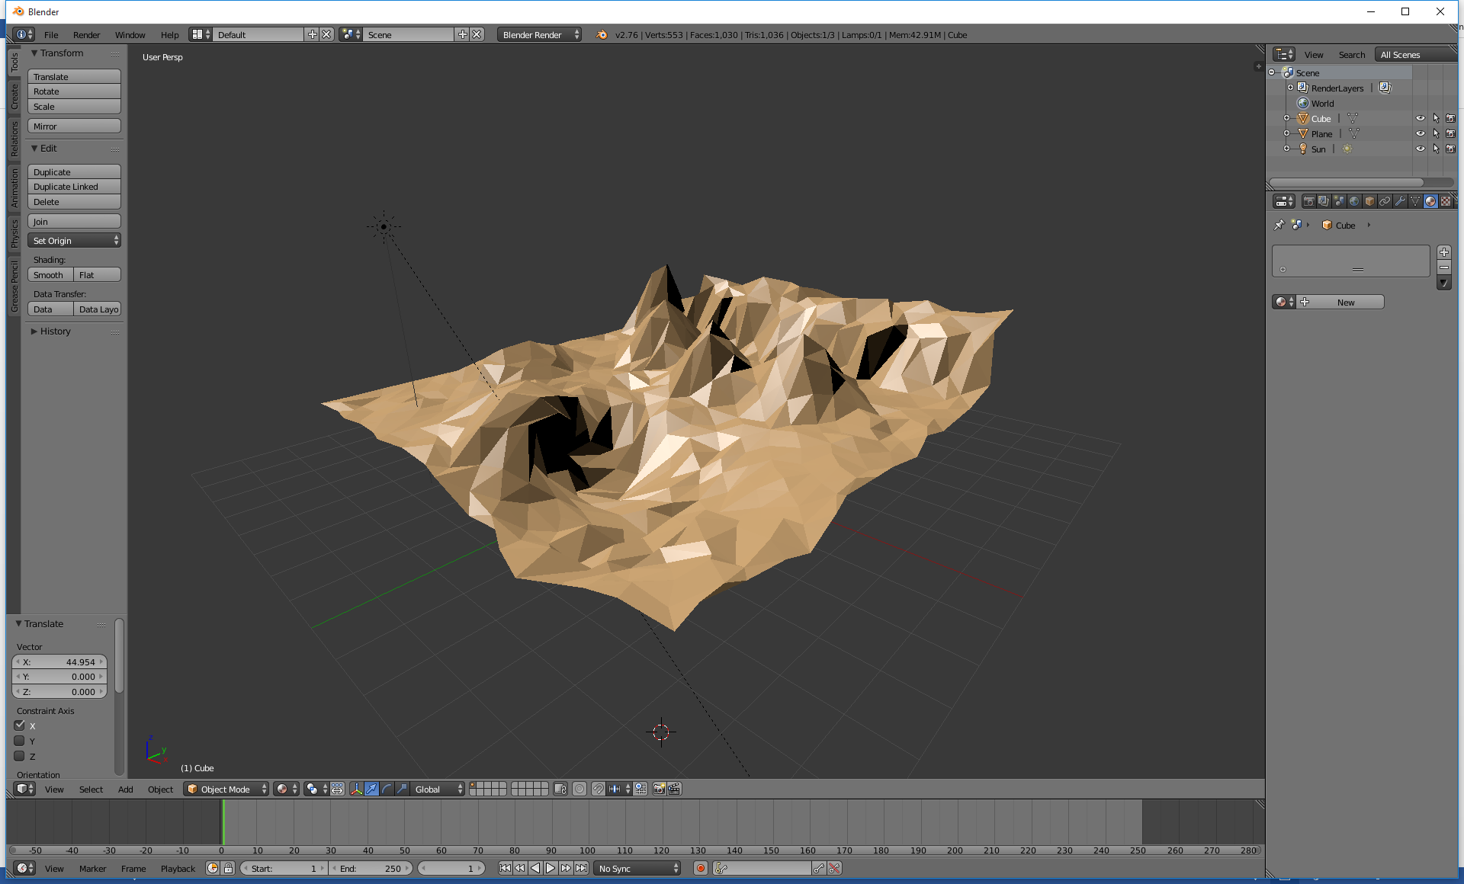

**Task 3 :**

So we have created a landscape, now lets create some objects to populate it. You are now going to create a tree similar to the one I showed during the lecture. To do this load up a new blender file and add a cylinder to the scene.

* Change the amount of vertices(left hand side) in the cylinder to around 8.
* Using the Add Ring Cut (shortcut Ctrl + R) add several(4-6) new rings on the cylinder.
* Repeat this step adding rings near existing rings.
* Now use a combination of the Grab (G) and the Scale(S) to move and scale these new rings around to add some structure to the tree.
* Now make the tree look a bit more detailed by going into vertex mode and moving them around.
* Lastly we need to add a trunk to the tree by adding another cylinder and joining it with the existing object.

