**University of Lincoln**

**School of Computer Science**

Unity 5 Taster Session: Flappy-like Bird

This taster session will illustrate some of the features of 2D development in Unity3D. It will also take you through developing a game in 2D.

1. Set up a new project, and set the default behaviours to 2D:

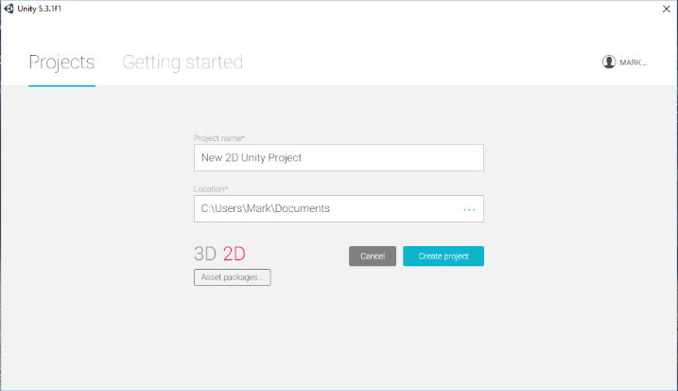

Drag the Flappy Bird Assets folder into the Asset window – you should see the four sprites listed.

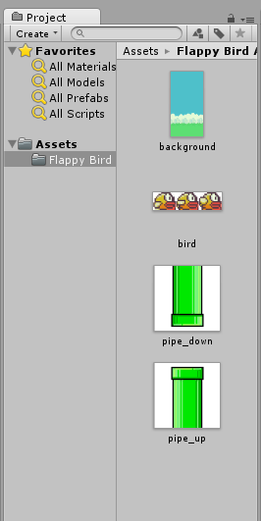

Select the ‘background’ sprite, and see its properties appear in the ‘Inspector’ window.

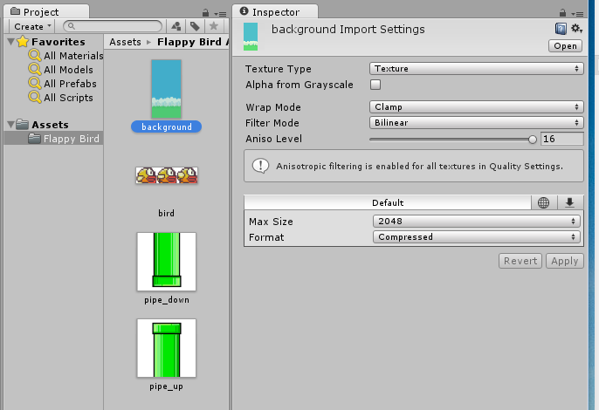

Change the ‘Texture Type’ from ‘Texture’ to ‘Sprite (2d and UI), and click ‘apply’.

You will see the background appear in your Scene window and the Game window.

Make sure that the ‘2D’ button is pressed in the Scene window bar, and that, with ‘Main Camera’ selected in the Hierarchy window, the projection setting is set to ‘Orthographic’.

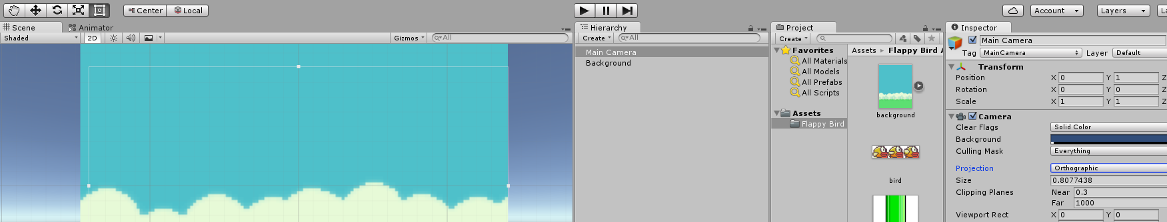

Resize the orthographic camera window (you can see the camera view outline as a rectangle), so that the background fills the game window.

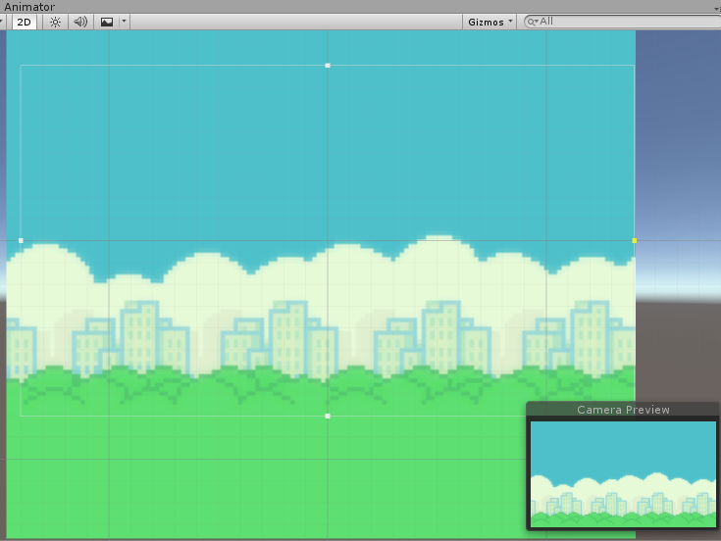

Let’s add the bird!

Select the ‘bird’ sprite sheet in the Asset window. Set it to be a Sprite (2D and UI), but also set the Sprite Mode to ‘multiple’:

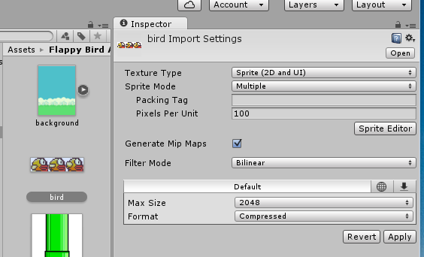

Open the Sprite Editor by pressing the button:

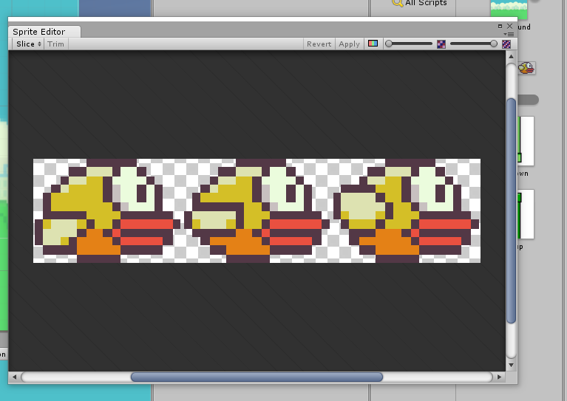

You will see the bird sprites appear as above. We can use the Sprite Editor to ‘slice’ this sheet up into animation frames.

Select the ‘Slice’ button, and see the bird automatically split into frames.

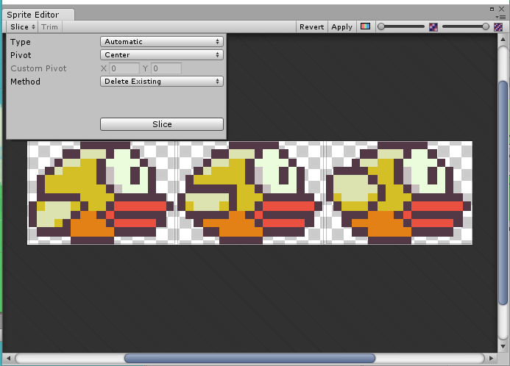

Click ‘Apply’ in the Sprite Editor,

Clicking the arrow on the sprite in the asset window will show all of the individual sprites with have been sliced up:

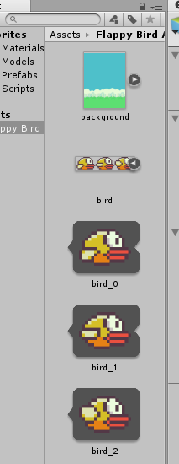

Select all three frames of animation (use the CTRL key to multiple select), and drag them onto the scene. You will be prompted to save a New Animation – just agree.

Playing the game now, you should see the background and the bird sprite (stationary) but flapping its wings…!

Lets give the bird some movement and respond to gravity.

To make it act under gravity is easy in Unity. With the bird selected in the Hierarchy, add a ‘component’, and select the ‘Rigidbody2D’ component, within the Physics2D collection.

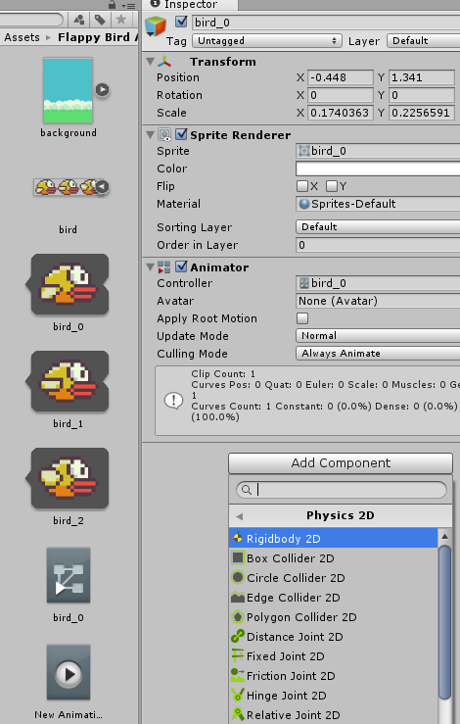

The ‘Rigidbody2D’ component will now be showing in the Inspector for the bird. Change the ‘Gravity Scale’ setting, from 1 to something smaller – say 0.1. Run the game and see what happens!

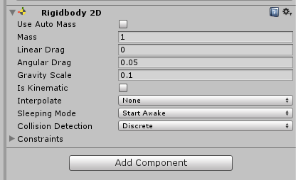

To make the bird move sideways, we have to add a ‘script’. This a developers way of telling Unity what exactly to do with an asset – by using programming. We will be using C# (although you can also use JavaScript).

With the bird selected, press ‘Add Component’ and select ‘New Script’. There is a space for naming the script – call it ‘BirdMovement’. Then press ‘Create and Add’.

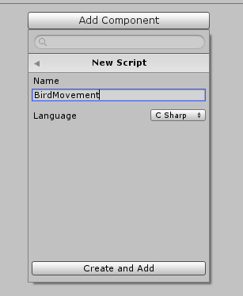

You will see the script component appear in the bird’s Inspector window. Selecting the ‘cog’ on the right hand side of the component will bring up a number of options – select ‘edit script’ as we want to start to add to it. You should start to see Visual Studio start up and show the component.

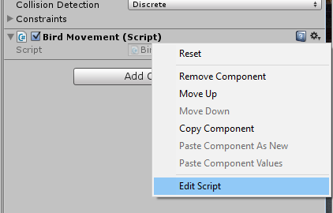

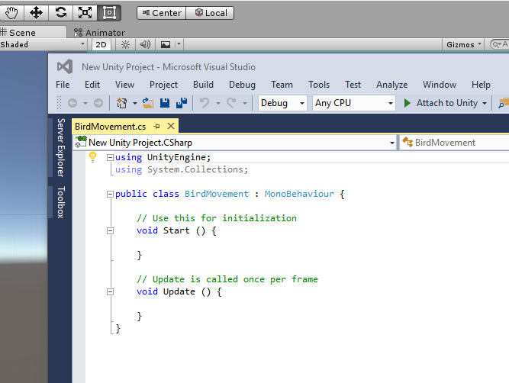

The ‘Start’ function runs once when the script is started. The ‘Update’ function is run each frame of the game.

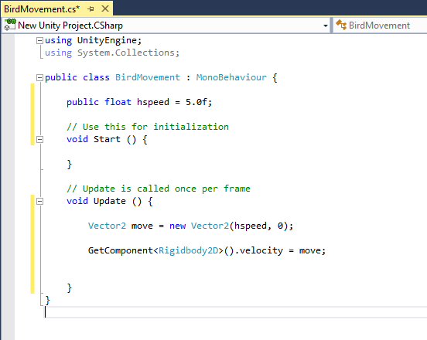

Add the lines of code shown above. When you have finished, leave the window open and just save the script file:

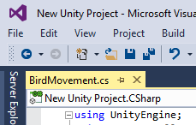

The variable ‘hspeed’ will now be visible in Unity in the script component – allowing it to be changed! We don’t have to keep going to Visual Studio to change this number, we can do it within Unity!

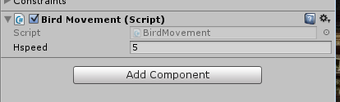

5 is too fast (try it!). Set it to something like 0.1 and see the difference when you run the game.

Lets make the bird respond to some user input.

In your script file (in Visual Studio, which you should have still open), we need to add some more lines of code:

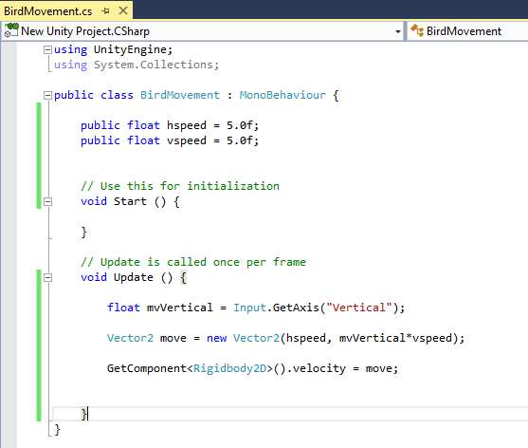

The ‘GetAxis’ function gets the up/down/left/right key which is input by the user.