1. Introduction
Graph-structured data appears naturally in many real-world applications, such as social networks, citation networks, biological networks, and knowledge graphs. In these settings, the entities are represented as nodes, and the interactions or relationships between them are represented as edges. Traditional machine learning models typically assume that data points are independent and identically distributed, which is not true for nodes in a graph. As a result, standard models are not directly applicable without explicitly modeling the graph structure.
Graph Representation Learning addresses this problem by learning low-dimensional vector representations (embeddings) for nodes that preserve both their feature information and their position in the network. These embeddings can be used for downstream tasks such as node classification, link prediction, and clustering.
In this project, I focus on node classification in citation networks. The goal is to predict the research topic (class label) of each paper based on its bag-of-words features and the citation graph structure. I use two benchmark datasets, Cora and Citeseer, and compare two representative approaches:
- DeepWalk: an unsupervised method based on random walks and the Word2Vec model.
- Graph Convolutional Networks (GCN): a neural network architecture that directly propagates and aggregates features over the graph.
The main objective of this work is to implement both methods from scratch, evaluate them on Cora and Citeseer, and analyze their strengths and weaknesses using Accuracy and Macro AUC as evaluation metrics
2. Related Work
Early node classification techniques relied on handcrafted graph features or label propagation.
DeepWalk introduced the first neural approach to unsupervised graph representation learning by generating random walks and applying Word2Vec to learn node embeddings [1].
Node2Vec extended DeepWalk by using biased sampling to balance BFS/DFS exploration, improving control over structural vs. homophilic patterns [2].
GraphSAGE later enabled inductive learning using neighborhood sampling—making graph representation learning scalable on large and unseen nodes [4].
Graph Convolutional Networks further improved learning by integrating node features with adjacency structure through message passing, showing strong performance on Cora and Citeseer datasets [3].
Cora and Citeseer are widely used benchmark datasets for evaluating graph learning models [5].
In this project, I implement DeepWalk and GCN for node classification and compare their performance under identical experimental settings.
3. Method
In this section, we describe the implementation details of both models used in the project.
3.1 DeepWalk with Logistic Regression
DeepWalk is a two-stage algorithm:
(1) Random Walk Generation
For each node in the graph, we generate multiple random walks of fixed length. These walks simulate sequences analogous to sentences in natural language.
(2) Word2Vec Embedding Training
We use the Skip-gram Word2Vec model to learn embeddings for each node based on these walks. Each node becomes a vector in a low-dimensional space that captures its neighborhood structure.
Once node embeddings are obtained, we train a Logistic Regression classifier using these embeddings as features. The classifier predicts the category of each node.
The complete implementation and source code for this project are available at:
https://github.com/sshadian-max/CSCE566-Graph-Project
Hyperparameters used:
- Number of walks per node: 10
- Walk length: 40
- Embedding dimension: 128
- Word2Vec window size: 5
- Skip-gram (sg = 1)
3.2 Graph Convolutional Network (GCN)
GCN uses spectral graph convolution with normalized adjacency matrices. The model architecture used in this project includes two GCN layers:
- GCN Layer 1:
1. Input → Hidden dimension 2. ReLU activation 3- Dropout for regularization
- GCN Layer 2:
- Hidden dimension → Output classes 2. Produces logits for classification
The propagation rule for each GCN layer is:
$$H^{(l+1)}=σ(\tilde{A}H^{(l)}W^{(l)})$$
where:
- $\tilde{A}$= normalized adjacency matrix with self-loops
- $H^{(l)}$= layer input
- $W^{(l)}$= learnable weights
- $σ$= activation (ReLU)
Hyperparameters:
- Hidden dimension: 64
- Dropout rate: 0.5
- Learning rate: 0.01
- Weight decay: 5e-4
- Optimizer: Adam
- Loss: Cross-entropy on training nodes
- Number of epochs: 300
The dataset is split into 60% train, 20% validation, 20% test using stratified sampling.
4. Experiments
4.1 Datasets
Dataset | Nodes | Features | Classes
Cora | 2708 | 1433 | 7
Citeseer | 3327 | 3703 | 6

4.2 Evaluation Metrics
I use two evaluation metrics:
- Accuracy:
$$\text{Accuracy}=\frac{\text{correct predictions}}{\text{total predictions}}$$
- Macro AUC:
Multi-class AUC is computed by binarizing labels and averaging AUC across classes.
These metrics allow us to evaluate both overall predictive performance and class-level separability.
4.3 Results
The results for Cora and Citeseer are shown in Table 1.

Table 1: Node Classification Results on Cora and Citeseer
Dataset | Model | Accuracy | AUC
Cora | DeepWalk | 0.8401 | 0.9688
Cora | GCN | 0.8561 | 0.9778
Citeseer | DeepWalk | 0.6600 | 0.8710
Citeseer | GCN | 0.7421 | 0.9225

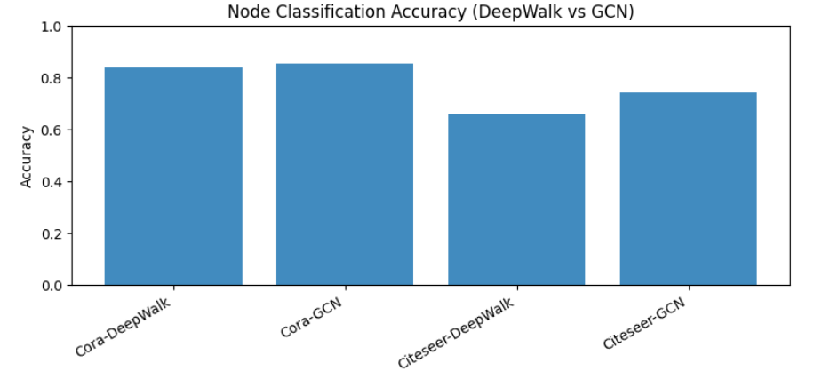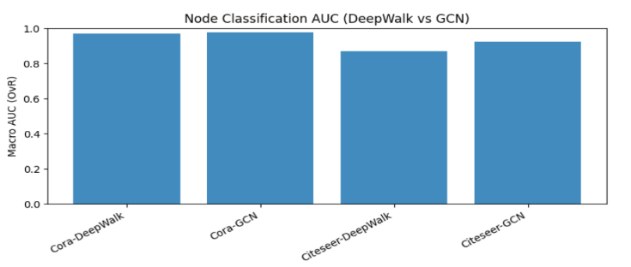
4.4 Analysis
The results show that the GCN model outperforms DeepWalk in both accuracy and macro AUC.
While DeepWalk successfully captures structural information through random walks, it does not use the high-dimensional bag-of-words node features. GCN, on the other hand, jointly learns from graph structure and node features, allowing it to make more informed predictions.
5. Conclusions
This project compared two major approaches for node representation learning on graph datasets: DeepWalk and GCN.
DeepWalk learns representations through random walks and skip-gram training, while GCN aggregates information across neighborhoods using node features and structure jointly. Experimentally, GCN achieved higher Accuracy and Macro-AUC on both Cora and Citeseer, confirming its advantage when node attributes are available.
DeepWalk, however, remains useful as a lightweight unsupervised model, particularly in feature-limited scenarios.
Future experiments may extend this work by evaluating attention-based models (e.g., GAT) or integrating DeepWalk embeddings into neural architectures to combine the benefits of both.
6. References
- Perozzi, B., Al-Rfou, R., & Skiena, S. (2014). DeepWalk: Online Learning of Social Representations. KDD.
- Grover, A., & Leskovec, J. (2016). Node2Vec: Scalable Feature Learning for Networks. KDD.
- Kipf, T. N., & Welling, M. (2017). Semi-Supervised Classification with Graph Convolutional Networks. ICLR.
- Hamilton, W., Ying, Z., & Leskovec, J. (2017). Inductive Representation Learning on Large Graphs. NeurIPS.
- Keras GNN Citation Example - https://keras.io/examples/graph/gnn_citations/
- Kipf - GCN GitHub Implementation - https://github.com/tkipf/gcn

