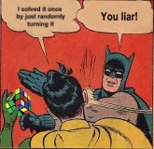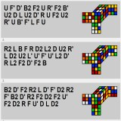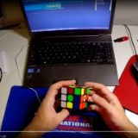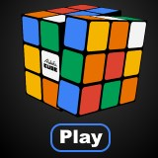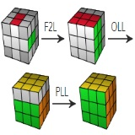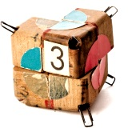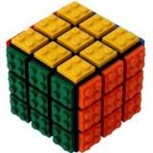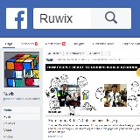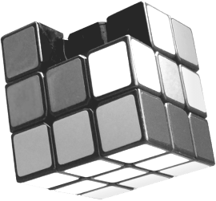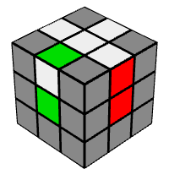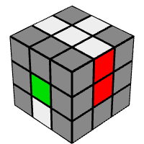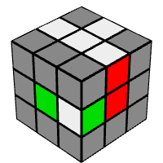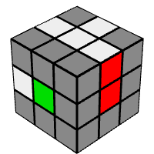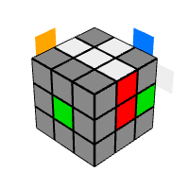

|  |  |  |  |  |  |  |  |
| --- | --- | --- | --- | --- | --- | --- | --- |
| **Home** | **Programs** | **Rubik's Cube** | **Puzzles** | Search... | **Play** | **Learn** | **Solve** |

[Home](https://ruwix.com/) » [How To Solve The Rubik's Cube](https://ruwix.com/the-rubiks-cube/how-to-solve-the-rubiks-cube-beginners-method/) » Step 1: First Layer Edges

|  |  |  |  |  |
| --- | --- | --- | --- | --- |
| **Ruwix** | **See all steps** | | | **Advanced Method** |
| **Step 1: Solve the White Edge Pieces in the First Layer** | | |
| Twisty Puzzle Wiki |
| **[Home page](https://ruwix.com/)** |
| **[Programs](https://ruwix.com/rubiks-cube-programs/)** | The easiest step is solving the first layer edges of | | |
| **[Rubik's Cube](https://ruwix.com/the-rubiks-cube/)** |
| the Rubik's Cube. Choose one color you want to | | |
| **[Twisty Puzzles](https://ruwix.com/twisty-puzzles/)** |
| start with. In [this beginner's tutorial](https://ruwix.com/the-rubiks-cube/how-to-solve-the-rubiks-cube-beginners-method/) we're going to | | |
| **[Rubik's Programs](https://ruwix.com/rubiks-cube-programs/)** | start with the white face. | | |
| **[Rubik's Cube](https://ruwix.com/the-rubiks-cube/)** | I suggest you try to solve the first face without | | | **First Prototype** |
| reading these instructions, so you can feel the | | |
| **[Beginner's Solution](https://ruwix.com/the-rubiks-cube/how-to-solve-the-rubiks-cube-beginners-method/)** |
| sense of accomplishment when you complete it all | Good white cross | Bad white cross |
| [1: First layer edges](https://ruwix.com/the-rubiks-cube/how-to-solve-the-rubiks-cube-beginners-method/step-1-first-layer-edges/) |
| alone. This step is not so hard because you don't |
| [2: First layer corners](https://ruwix.com/the-rubiks-cube/how-to-solve-the-rubiks-cube-beginners-method/step-2-first-layer-corners/) |
| have to take care of so many solved cubelets yet. | | |
| [3: Second layer (F2L)](https://ruwix.com/the-rubiks-cube/how-to-solve-the-rubiks-cube-beginners-method/step3-second-layer-f2l/) |
| You can determine where a piece comes according to the colour of the center pieces which never swap | | |
| [4: Yellow cross](https://ruwix.com/the-rubiks-cube/how-to-solve-the-rubiks-cube-beginners-method/step-4-yellow-cross/) |
| [5: Swap the yellow edges](https://ruwix.com/the-rubiks-cube/how-to-solve-the-rubiks-cube-beginners-method/step-5-swap-yellow-edges/) |
| places. Every edge must fit to the side center piece too. See the attached image. | | |
| [6: Position yellow corners](https://ruwix.com/the-rubiks-cube/how-to-solve-the-rubiks-cube-beginners-method/step-6-position-yellow-corners/) |
| The idea is to put the first edge to the right spot, oriented correctly, then the second piece so you don't | | |
| [7: Orient last layer corners](https://ruwix.com/the-rubiks-cube/how-to-solve-the-rubiks-cube-beginners-method/orient-yellow-corners-how-to-solve-last-layer-corner/) |
| **[Magnetic Cubes](https://ruwix.com/the-rubiks-cube/the-best-speedcube-competition-cubes-moyu-dayan-shengshou-yuxin/magnetic-cubes/)** |
| mess up the one you have already solved. When you solve the fourth you have to take care not to mess | | |
| **[Puzzles](https://ruwix.com/twisty-puzzles/)** | up the three solved pieces so it gets harder step by step. | | |
| **[Latest News »](https://ruwix.com/blog/)** | Example Tricks | | |
| Check out [the algorithms](https://ruwix.com/the-rubiks-cube/algorithm/) below to see what moves you need to know. | | |
| **Yiheng Wang: 4.48 Rubik's** |
| **Cube Average Record** |

**[New World Record Single](https://ruwix.com/blog/max-park-rubik-single-record-313/)**   
**[by Max Park](https://ruwix.com/blog/max-park-rubik-single-record-313/)**

|  |  |  |
| --- | --- | --- |
| **[New World Record](https://ruwix.com/blog/yiheng-wang-record-4-69/)** | **Flipping An Edge** | **Bandaged Cubes** |
| **[Average Yiheng Wang](https://ruwix.com/blog/yiheng-wang-record-4-69/)** |
| **[Santa Claus Shaped Cube](https://ruwix.com/blog/santa-claus-rubiks-cube/)** | The most complicated case is when three edges are done and the last one is oriented wrong. This is |
| **[New 3x3 Average World](https://ruwix.com/blog/tymon-kolasinski-509-rubiks-cube-average-record/)** |
| the fastest way to flip an edge: **F** takes the edge to the equator, **U'** moves the empty spot in place, **R** |
| **[Record](https://ruwix.com/blog/tymon-kolasinski-509-rubiks-cube-average-record/)** |
| moves the edge up in the top again, now well-oriented, **U** restores the position. |
| **[NxNxN cube simulator &](https://ruwix.com/blog/nxnxn-cube-simulator-solver/)** |
| **[solver](https://ruwix.com/blog/nxnxn-cube-simulator-solver/)** |
| **Donald Trump Rubik's** | **Press the play button to see the animations.** |
| **Cube - 3D print timelapse** |

**[Rubik's Cube SpongeBob:](https://ruwix.com/blog/spongebob-rubiks-cube-3d-pen-drawing/)**   
**[3D drawing](https://ruwix.com/blog/spongebob-rubiks-cube-3d-pen-drawing/)**   
**[New world record:](https://ruwix.com/blog/yusheng-du-record-347/)**   
**[Yusheng Du - 3.47 s](https://ruwix.com/blog/yusheng-du-record-347/)**   
**[25 amazing Rubik's](https://ruwix.com/blog/25-amazing-rubiks-cube-facts/)**   
**[Cube facts](https://ruwix.com/blog/25-amazing-rubiks-cube-facts/)**

**[MORE...](https://ruwix.com/blog/)**

**[Like Ruwix](https://www.facebook.com/online.rubiks.cube.solver)**

F U' R U   
 0/4 **Share this page!**

**From The Bottom Layer**

Another tricky situation is when the last white edge is on the front face but you can't just simply move it to the top because it would end up facing in the wrong direction. We can use the previous trick starting with a double front turn:

**F2** followed by **(F U' R U)**, which gives **F' U' R U** because three quater turns of a face in one direction is in fact a reverse rotation.

F' U' R U   
 0/4

**From The Middle Layer**

Similar to the previous cases, sometimes you find the last edge in the second layer oriented wrong.

U' R U   
 0/3

The same case mirrored:

U L' U'   
 0/3

The example below shows an example when the last unsolved white edge is stuck in the equator but not in the position mentioned above.

U' R' U   
 0/3

**[Back to the tutorial](https://ruwix.com/the-rubiks-cube/how-to-solve-the-rubiks-cube-beginners-method/)**  **[Next step](https://ruwix.com/the-rubiks-cube/how-to-solve-the-rubiks-cube-beginners-method/step-2-first-layer-corners/)**

**Steps of the [Beginner's Rubik's Cube Solution:](https://ruwix.com/the-rubiks-cube/how-to-solve-the-rubiks-cube-beginners-method/)**

**[1. White Edges](https://ruwix.com/the-rubiks-cube/how-to-solve-the-rubiks-cube-beginners-method/step-1-first-layer-edges/)**

**[2. White Corners](https://ruwix.com/the-rubiks-cube/how-to-solve-the-rubiks-cube-beginners-method/step-2-first-layer-corners/)**

**[3. Second Layer](https://ruwix.com/the-rubiks-cube/how-to-solve-the-rubiks-cube-beginners-method/step3-second-layer-f2l/)**

**[4. Yellow Cross](https://ruwix.com/the-rubiks-cube/how-to-solve-the-rubiks-cube-beginners-method/step-4-yellow-cross/)**

**[5. Swap Yellow Edges](https://ruwix.com/the-rubiks-cube/how-to-solve-the-rubiks-cube-beginners-method/step-5-swap-yellow-edges/)**

[OK](https://ruwix.com/the-rubiks-cube/how-to-solve-the-rubiks-cube-beginners-method/step-6-position-yellow-corners/) **[6. Position Yellow Corners](https://ruwix.com/the-rubiks-cube/how-to-solve-the-rubiks-cube-beginners-method/step-6-position-yellow-corners/)**

**[7. Orient Yellow Corners](https://ruwix.com/the-rubiks-cube/how-to-solve-the-rubiks-cube-beginners-method/orient-yellow-corners-how-to-solve-last-layer-corner/)**

**Comments**

|  |  |  |
| --- | --- | --- |
| **Rubik Quiz** | **Funny Images** | **Pranx.com** |

|  |  |  |
| --- | --- | --- |
| **Puzzle Scrambler** | **YouTube Channels** | **3D Rubik Simulator** |

© Ruwix | All Rights Reserved. | [About Ruwix](https://ruwix.com/about-us/) | Author: [Denes Ferenc](https://ruwix.com/denes-ferenc/) | [Contact](https://ruwix.com/contact/)   
Template by [HTML5 Templates](https://html5-templates.com/)   
[Mobile Website](https://ruwix.com/amp/) | [Spanish Site](https://ruwix.es/)| [Chinese Site](https://ruwix.cn/) | [Contribute](https://ruwix.com/contribute/)   
[Privacy, Terms and Conditions](https://ruwix.com/terms-and-conditions-privacy-policy/) | [SiteMap](https://ruwix.com/sitemap/)   
This website is using cookies to improve the user experience, to collect anonymous visitor analytics and to show personalised ads.