Holistic approach to power plant management

KIT, 01.12.2017

1. We did a “warm-up” with a video of Hans Rosling, a master of presenting data. <https://www.youtube.com/watch?v=4IkHtTgn3Nk>
2. In this session we started to learn about the academic or mathematical concepts to deal (roughly speaking) with a “random world”. For this purpose, we need to understand what a:
   1. Random variable
   2. A stochastic process
   3. A Markov process
   4. A random walk
   5. A martingale
   6. A stochastic differential equation (SDE) and the Ito integral

|  |  |
| --- | --- |
| F:\Udacity\KIT Vorlesung WS16_17\videos 011217\IMG_4558.JPG | F:\Udacity\KIT Vorlesung WS16_17\videos 011217\IMG_4557.JPG |

is. This sounds intimidating and it indeed is, given the vast literature about these topics. On the other hand, thanks to modern computers all these topics can be easily worked with in practice by means of Monte Carlo simulations.

But the most important message I would like to convey is a change in mindset: on the one hand there is a deterministic worldview which believes in fixed cause-and-effect relationships. This means when you look at past data or more generally at history the interpretation is that this and only this history could have happened. You take a time series and fit a polynomial function to it and you use this function to extrapolate future states. The more historical data points you have, the more accurate you belief you can predict the future.

On the other hand, you have a mindset which interprets past data as the symptoms of a stochastic process. This mindset believes that not a single history could have happened but that millions and billions of different histories could have happened and that we have only observed one of them. You use past data to determine what kind of stochastic process could have generated this data. You then use the fitted process to determine millions and billions of future, possible paths or scenarios. You acknowledge that it is impossible to predict a specific path and that you only can make some probability estimates how likely this path will be. Welcome to random variables!

Now let’s make a concrete example. You own a student apartment for which you paid 20k€. You know that in 5 years you will graduate and move to another city for your first job. Then you have to sell your apartment. But which price will you get then? You can look at the price trends now in 2017 and you will see a history of constantly rising prices, so you might extrapolate that your apartment will be worth 30k€ in 2022. This is the deterministic approach to historical time series (i.e. linear extrapolation). If you are smart you look back much longer into the history of house prices and you might also observe that given the price volatility your apartment might be worth only 5k€ in 2022. This would mean that you make a loss of 15k€! You hate uncertainty and you would like to insure against this loss, so I offer you an option contract, more specifically a so called “European put option” contract with a strike price K=21k€. The strike price can be whatever value we decide, but for the sake of concreteness let’s assume 21k€.

This means that in 2022 you have the right (but not the obligation) to sell this apartment to me and I guarantee you that I pay you 21k€ for it. So now you have removed all your downside risks to me and you are certain that you make no loss at all. But this I now carry all the risks I cannot sell you the option contract for free. I demand a fee form you which compensates me for the risks. The big question we will go to answer is: what is a fair price of such an option contract?

The answer comes from a very famous formula: the Black-Scholes-Merton formula for options. We will see later how this works. For the time being let me explain what a fair price is: a fair price means that overall the above transaction is a zero-sum game: Nobody wins and nobody loses. The fair price or the fair value means that I use this cash you pay me for the option to build a suitable portfolio of government bonds and house price investments which insures me completely against the risk of up or downside movements in house prices. In principle you could construct such a portfolio yourself with your own “insurance” money, but since I am more “sophisticated” you will let me do this for a small, extra fee. For this purpose, we assume that we are having “complete markets” as it is called in financial theory. “Complete” means that it is possible to construct such an insurance portfolio with the help of the investment contracts the existing market is offering.

What would happen if the market is not fair, or if the option price is not fair? Then there would be arbitrage opportunities. Due to your lack of understanding of the market you would accept an option price from me which allows me to make a sure bet, i.e. get a guaranteed, positive profit from the contract. This is also sometimes called insider trading because I know something about the market which the outside world doesn’t. Many financial regulations are there to prevent insider trading and to make sure that trading is a zero-sum game. But then the question is: why do people trade so often? Why are there millions of transactions happening every day?

Even if everyone has the same amount of information the difficulty lies in the interpretation of the data. Investors create their own, calibrated stochastic models and therefore the value of an option contract may differ for different models or model calibrations. This results in a situation in which some people consider a contract overvalued and sell it to some other parties who consider it undervalued.

The first concept we need to understand is what a random variable is. First, there is a sample space which contains the complete set of events which can ever happen. There are small, discrete sample spaces and there are vast, multi-dimensional samples spaces. One of the simplest sample space is created when you toss a coin: it can come up either as heads or tails. Hence the sample space is Or we toss a coin three times and the sample space is . A random variable or is a real valued function which assigns to every event in the sample space a real number. For example . In many applications S is the payoff: you win 10€ if you get heads and you lose 5€ if you get tails. There is a special random variable which is called a probability “measure” . This function P assigns every event a number between 0 and 1 and if we sum over all events we get 1: . With this “measure” we can calculate expectations values, as usual: . If you have a “fair” coin it is .

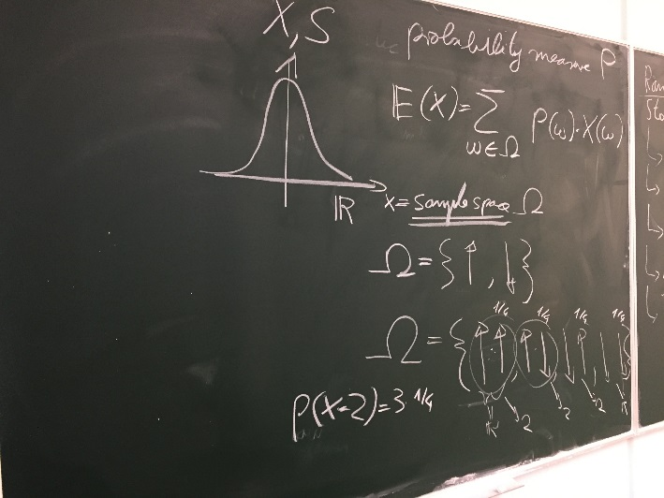

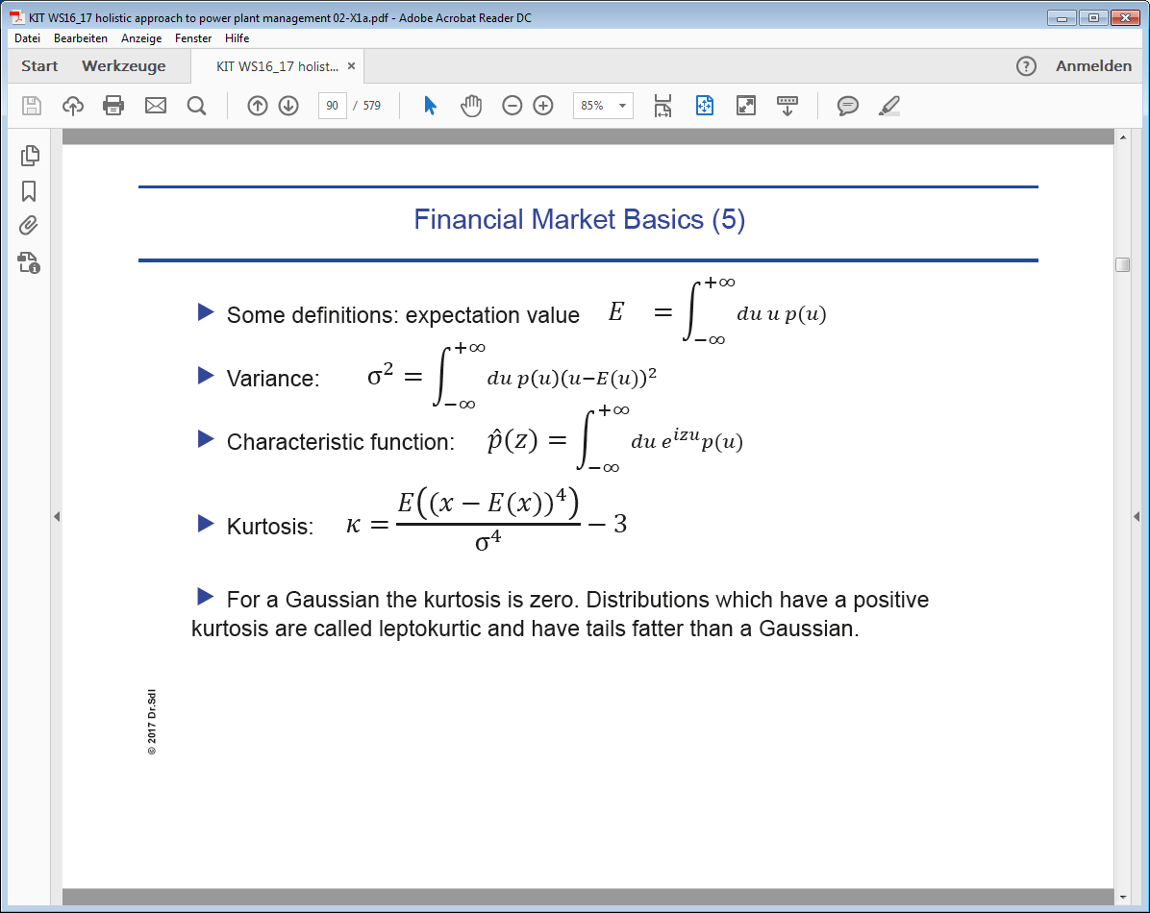

1. A very “famous” probability measure is the Gaussian function or the “normal distribution”. It is so famous because it plays an important role in the classical central limit theorem and for closed systems in thermal equilibrium in statistical thermodynamics. In short: if you have a probability measure with whatever distribution (e.g. square, discrete, polynomial) with the only assumption that the variance of P is finite and if you repeat the “experiment” n-times, i.e. you create the sample space , then the probability distribution over this space converges to the normal distribution. More compact: “the sum of a large number of identically distributed random variables from a finite variance distribution will be normally distributed.” This plays an important role in casinos: the games are on purpose designed to have a large variance but a small edge for the casino. The casual player will have enough “win” events to belief that the game is fair. But by playing a very large number of games the casino will always realize its advantage. An exemption is poker, in which you do not play against the casino but against other and potentially weaker opponents. In this case you might have a real but small edge.

|  |  |
| --- | --- |
| F:\Udacity\KIT Vorlesung WS16_17\videos 011217\IMG_4562.JPG | F:\Udacity\KIT Vorlesung WS16_17\videos 011217\IMG_4563.JPG |

1. The popularity of the normal distribution conceals the fact that there exists a large number of other distributions: LogNormal distribution, Poisson distribution, Levy distribution, Stable distribution etc. see: <http://reference.wolfram.com/language/guide/ParametricStatisticalDistributions.html>

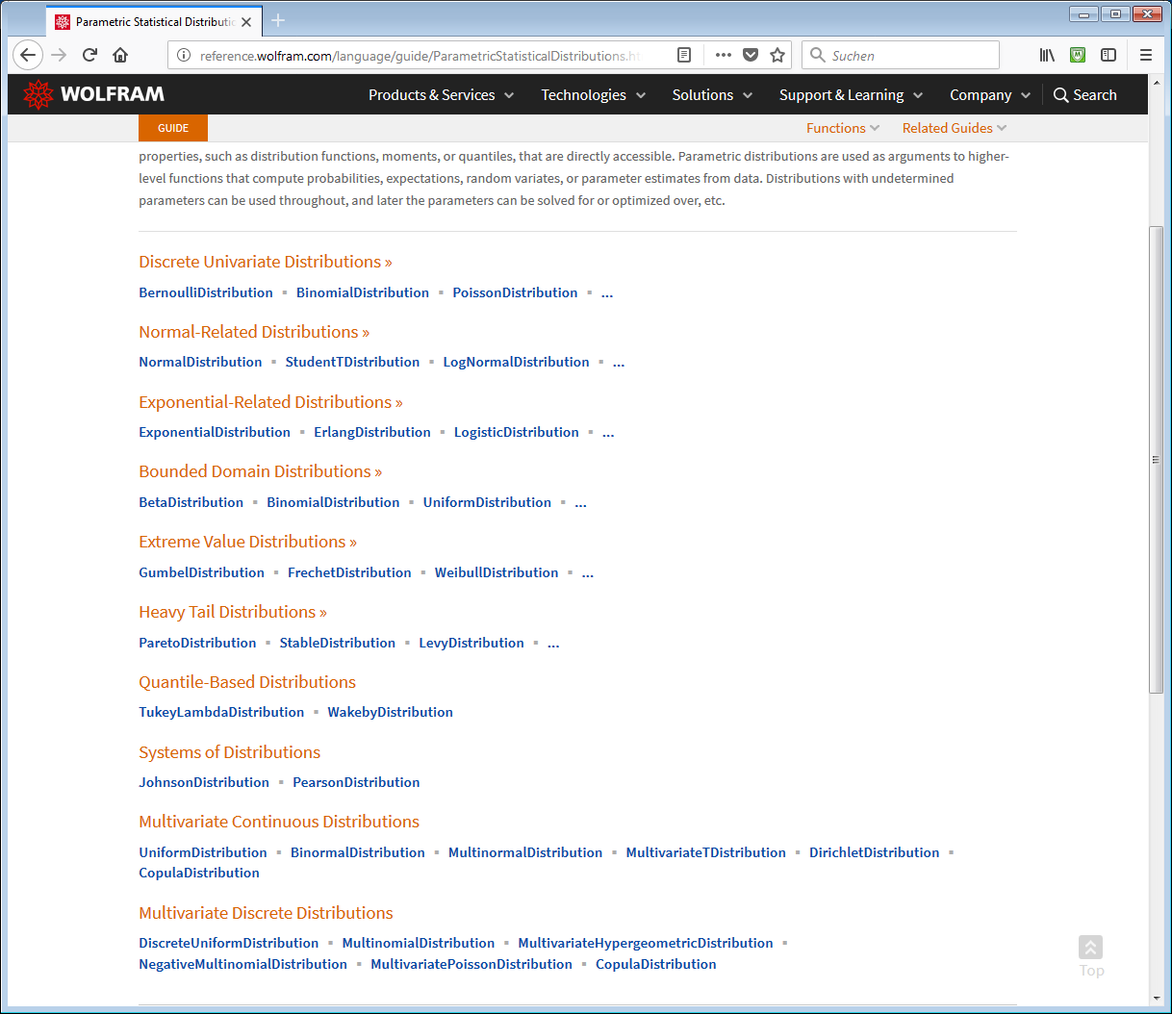

1. One very important class of distributions is the family of StableDistributions. To them the fait tail distribution like the Levy distribution belong. Fat tailed distributions have a finite mean but an infinite variance. These distributions are often used to model price behavior on exchange markets like stock markets, electricity markets or commodity markets. There exists a generalized central limit theorem: “these Levy distributions are fixed points for the addition of random variables with infinite variances just like the Gaussian distribution is the attractor or fixed point for the addition of random variables with finite variance.”
2. Next: a random process. This is a series of random variables. o If we define a random process on paper it is up to us how we define the relationship between and etc. We could make this relationship arbitrarily complicated. A random process can be discrete as or it can be defined for all values or some intervals in , in short . If we deal with continuous processes we can think of as a set of paths connecting time t=0 with time t=T.
3. We considered a very simple, one step stochastic process:

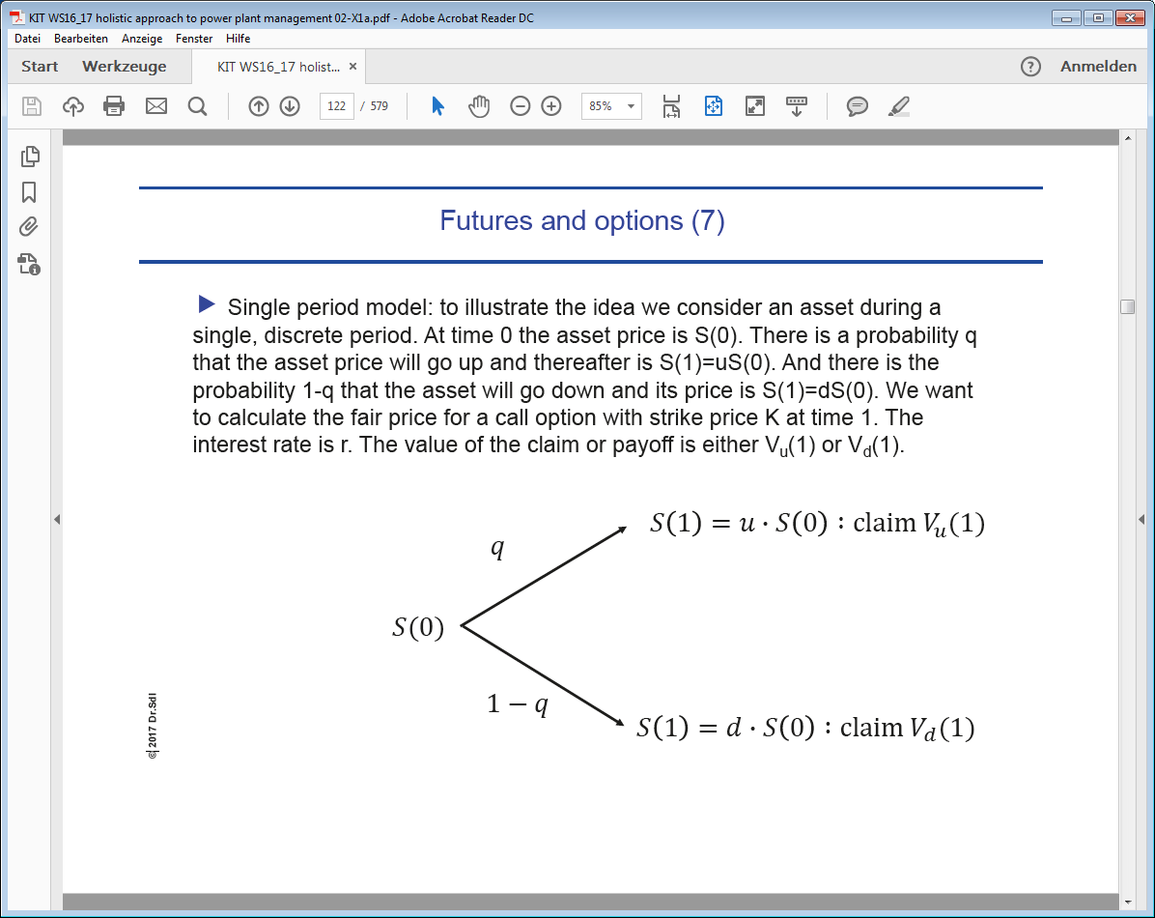

|  |  |
| --- | --- |
| F:\Udacity\KIT Vorlesung WS16_17\videos 011217\IMG_4561.JPG | F:\Udacity\KIT Vorlesung WS16_17\videos 011217\IMG_4560.JPG |

Given the value S(0) the asset price can either go up to S(1)=uS(0) or go down to dS(0). We want to hedge the risk of the price movement by buying a contract or claim V which pays V(1). The question is: what is a fair price for V, i.e. what is the fair price or value V(0)? In reality V could be either a call or a put option, for example.

1. A fair price means that there is that it is a zero-sum game, which leads to two equations with two unknowns: if you are the seller of V you receive cash X(0), which is your initial wealth. The goal is that you invest X(0) in the asset S(0) and in safe government bonds and exactly reach the wealth X(1) which is necessary for you to pay out the claim, independently of how the market as moved.

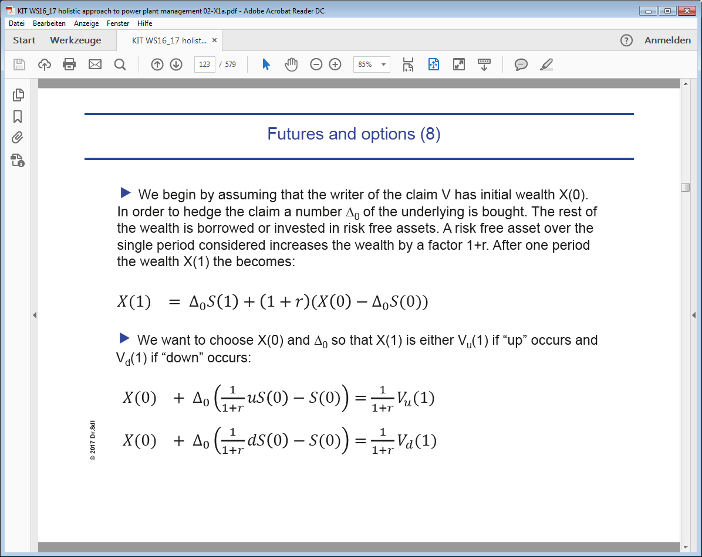

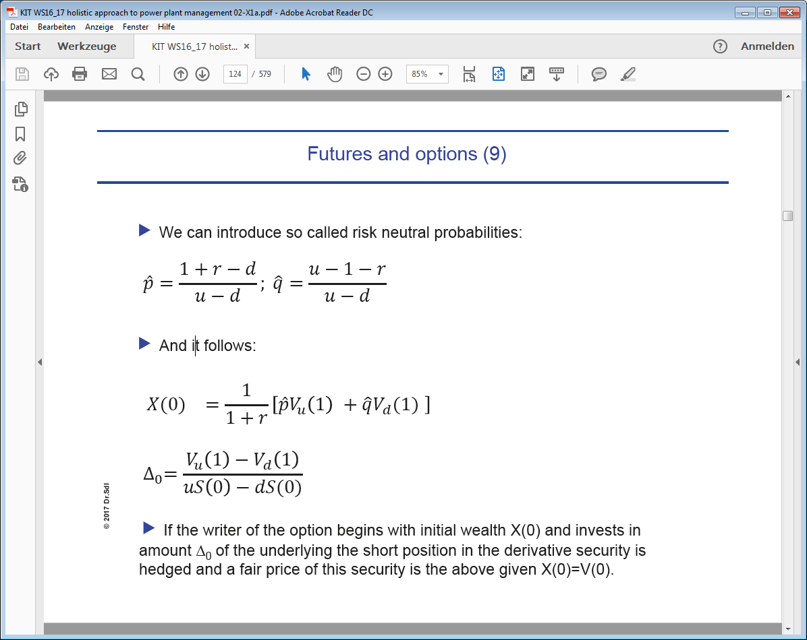

1. Martingales: In order to understand what a martingale is we need to introduce conditional expectations:. We are at step and have observed the path until step n. This means we have already observed the event sequence and that the sequence is still unknown. We want to determine . This is the expectation value for under the condition of partial observation. While is a real number, is a random variable!! Because it is a function of the path of events until step n. Here are some properties of conditional expectations:

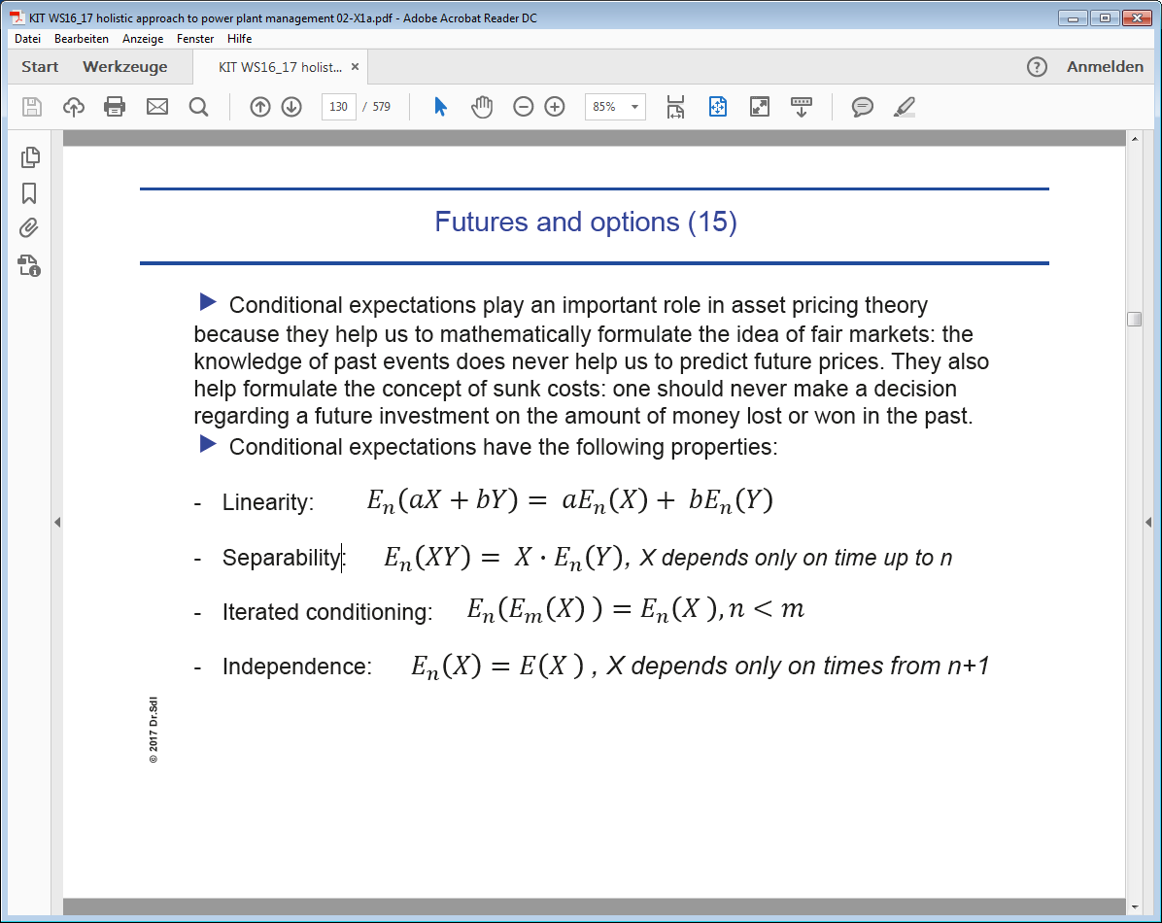

We can now rewrite in the above example the relationship between S(0) and S(1) for risk neutral probabilities: . In plain words: the expectation value of S(1) given the observation S(0) is the same as S(0) up to the discount factor 1/(1+r).

Finally, a martingale: and hence

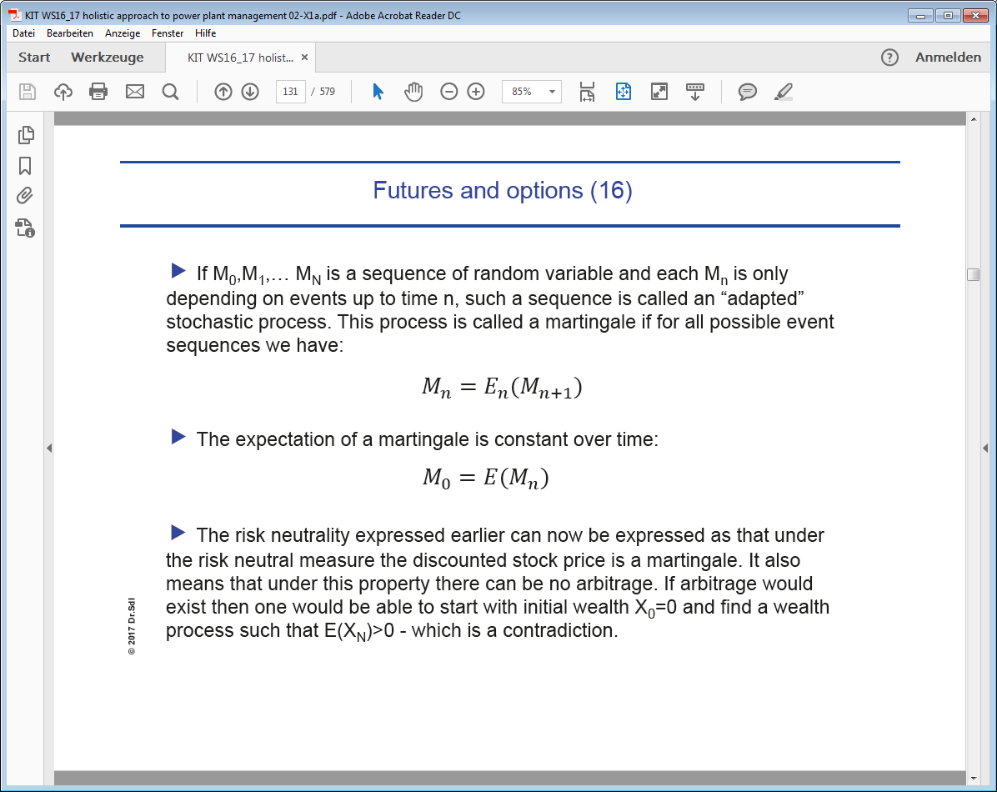

1. A Markov process: loosely speaking this is a forgetful process in the sense that the next step only depends on the value of the current step. In mathematical terms:

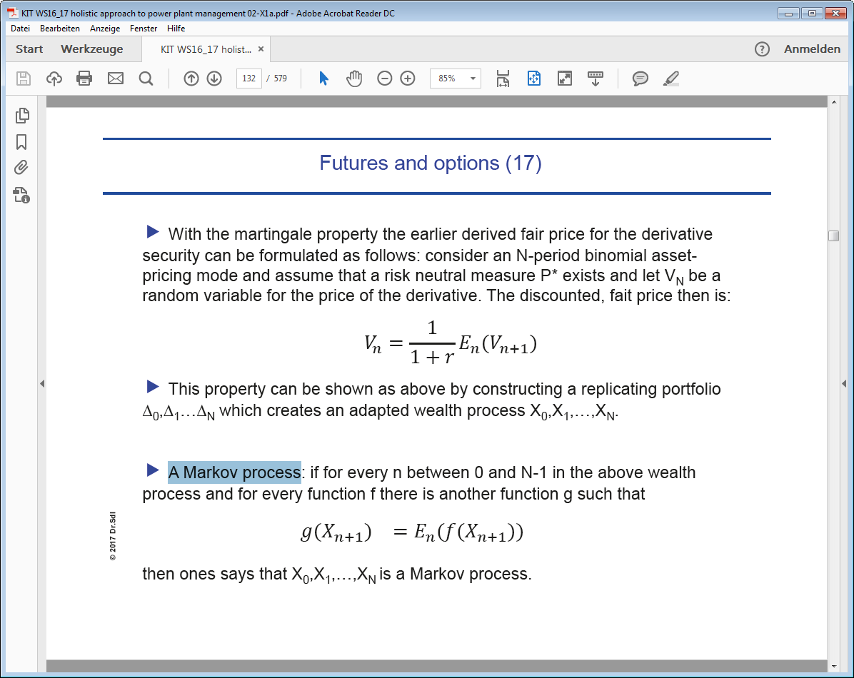

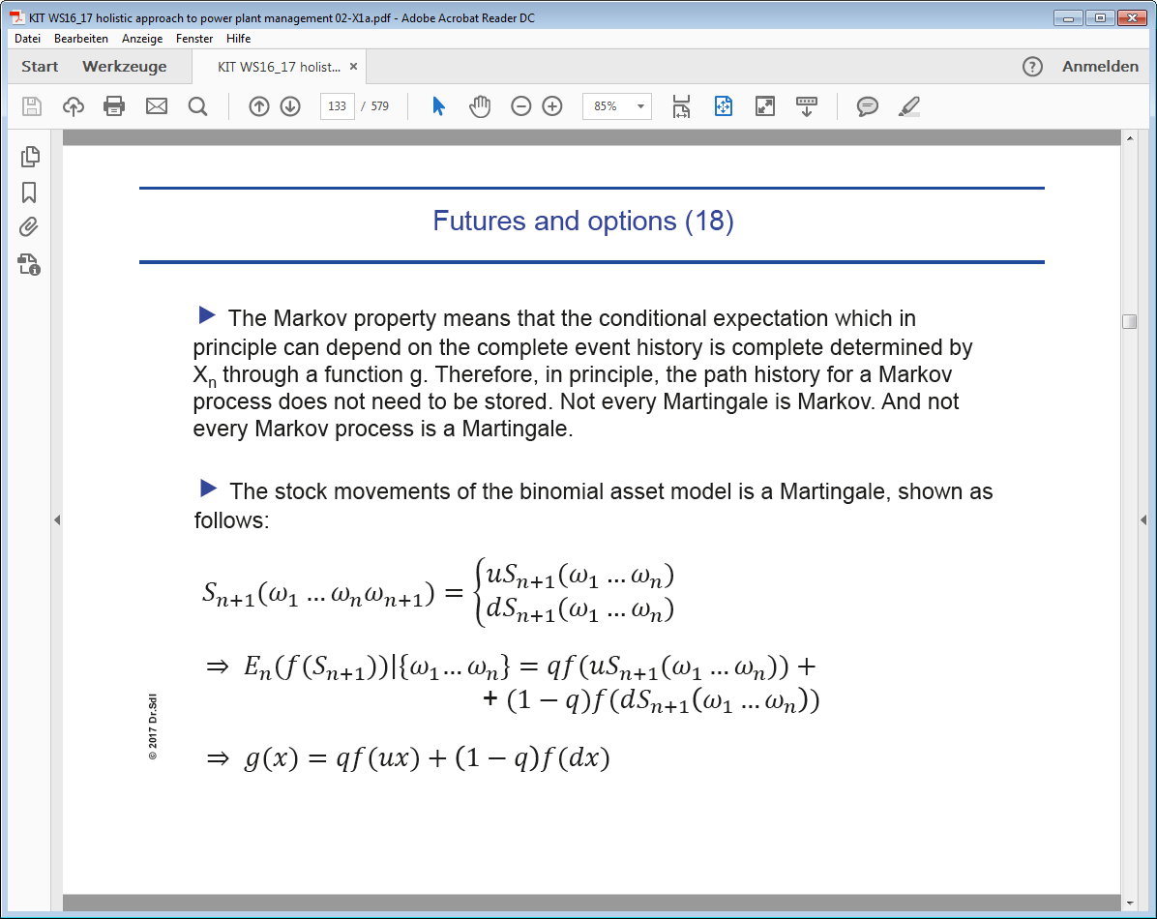

1. Brownian motion is both martingale and Markov. We visualized it here: <https://www.youtube.com/watch?v=FAdxd2Iv-UA>
2. So what is this all good for? If you understand it you will be able to write a PhD thesis like: <https://www1.unisg.ch/www/edis.nsf/SysLkpByIdentifier/4076/$FILE/dis4076.pdf> Here the GARCH (generalized autoregressive conditional heteroskedasticity) process was used to predict electricity spot prices.