Holistic approach to power plant management

KIT, 03.11.2017

1. We focused on the Known Unknowns today. This is simple risk analysis: we can figure out all the relevant threats, know the scenarios to consider and can give probabilities of the scenarios to happen. There is no uncertainty. Only probabilities. The element is the impact. How strong does a scenario impact you? What counts is the expectation value: probability times loss.

|  |  |
| --- | --- |
| F:\Udacity\KIT Vorlesung WS16_17\videos 031117\IMG_4484.JPG | F:\Udacity\KIT Vorlesung WS16_17\videos 031117\IMG_4483.JPG |

1. Interview with Phil Tetlock: <https://www.youtube.com/watch?v=-07DJ7xVBis>

How to make good forecasts? Try yourself: <https://www.gjopen.com/>

1. The Brier score: (<https://en.wikipedia.org/wiki/Brier_score>) how to track your forecasting capabilities.
2. The BASEL regulations (e.g. <https://www.bis.org/list/bcbs/tid_28/index.htm>) demand from banks, for example, a lot of analysis of their Value at Risk (VaR) in order to prove that their capital reserves are adequate, “stress testing”.
3. A method to make good estimates: the “Fermi Approach”: reduce one big questions to a series of smaller questions you can answer (classical example: how many piano tuners are working in Chicago?)

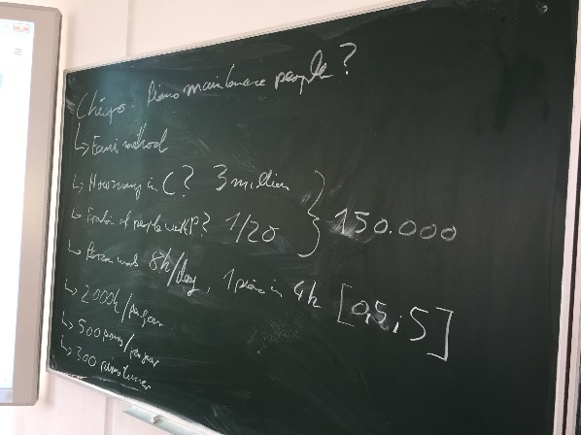

1. How to make your estimates foolproof: triangulate with believable people who disagree with you and find out why. Believable people are people who have a track record (e.g. Brier score) of making correct predictions or good judgements.
2. In order to systematically make good decisions, i.e. be consistent and logical, you need models. One basic model to decide into which kind of power generation (i.e. wind, coal, gas, nuclear) to invest is the LCOE model: levelized cost of electricity generation over the full life time of the asset.

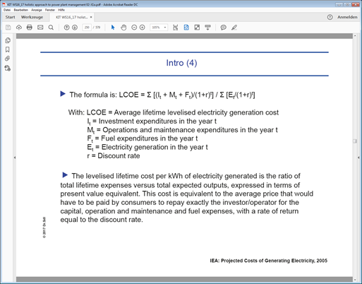

1. LCOE data: <https://www.oecd-nea.org/ndd/pubs/2015/7057-proj-costs-electricity-2015.pdf> or <https://www.iea.org/publications/freepublications/publication/Next_Generation_Windand_Solar_PowerFrom_Cost_to_ValueFull_Report.pdf>
2. We made a simple example with two generators with the following cost curves:

$$C_{1}\left(P_{G1}\right)=1000+20P_{G1}+0.01P_{G1}^{2}\left(\$/\text{h}\right)$$

$$C_{2}\left(P_{G2}\right)=400+15P_{G2}+0.03P_{G2}^{2}( \$/\text{h} )$$

The aim is to minimize the overall cost: $min\left\{C_{1}+C_{2}\right\}$ while fulfilling the total demand (constraint): $$P_{G1}+P_{G2}=D=500MW$$

Solution: create a Lagrange function with a Lagrange multiplier lambda (minimization with constraint)

$$L\left(P_{G1},P_{G2},λ\right)=C_{1}\left(P_{G1}\right)+C_{2}\left(P_{G2}\right)-λ(P_{G1}+P_{G2}-D)$$

We explored to method to minimize : analytically finding the position of gradient zero and doing a numerical solution with the tensorflow library in python.

1. We went into details of the paper: “Assessing operating regimes of CCS power plants in high wind and energy storage scenarios” (<http://www.sciencedirect.com/science/article/pii/S1876610214026046>)

This is basically the same approach as in 9) with some more boundary conditions and the requirement that wind generation always has priority

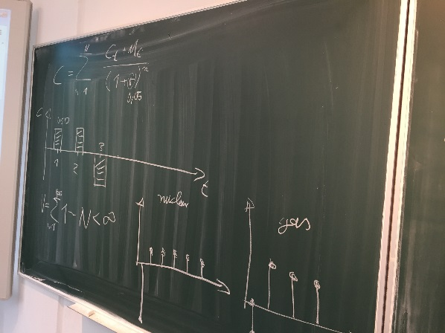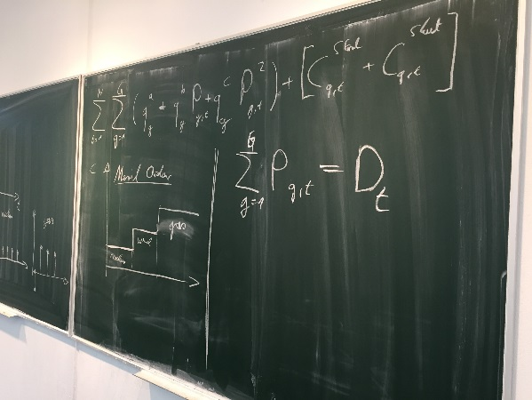

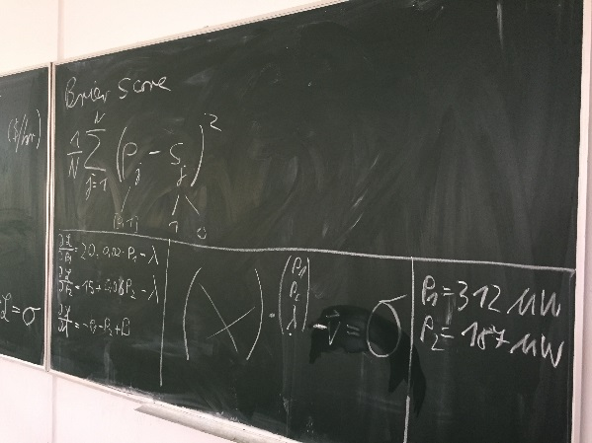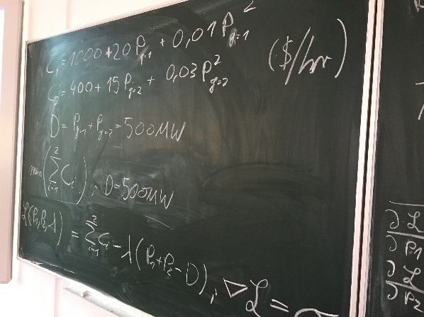

1. An example in which models failed spectacularly: The California power crisis in 2001:

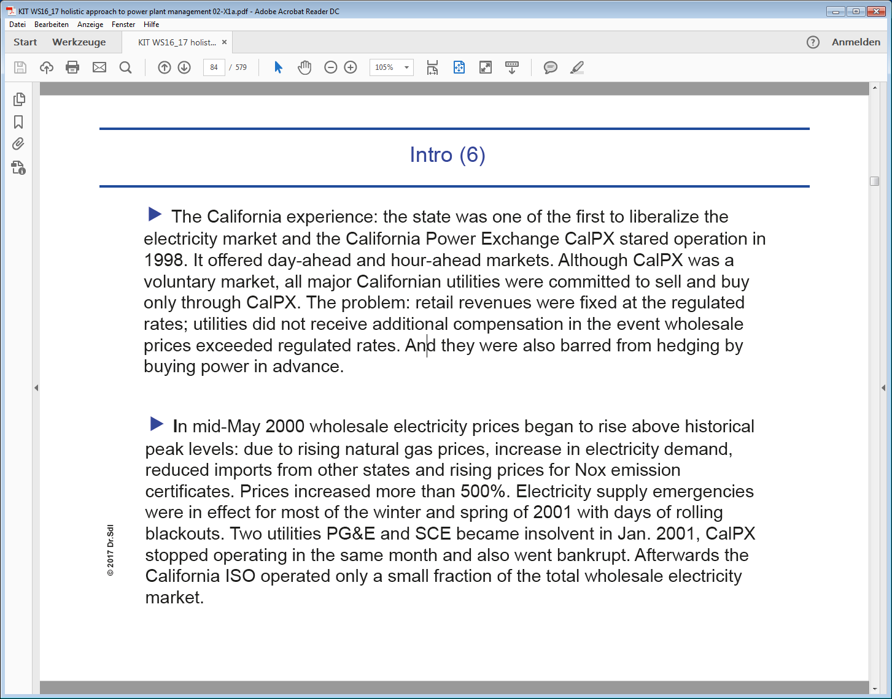

1. We discussed the benefits of python:
   1. <https://www.python.org/>
   2. <http://www.numpy.org/>
   3. <https://www.anaconda.com/download/>
   4. <https://matplotlib.org/>
   5. <https://www.jetbrains.com/pycharm/>
   6. <https://www.tensorflow.org/>
2. We did some simple “warm-up” programs:
   1. <https://github.com/DrSdl/RiskX/blob/master/PowerGeneration_example01.py>
   2. <https://github.com/DrSdl/RiskX/blob/master/PowerGeneration_example02.py>
   3. <https://github.com/DrSdl/RiskX/blob/master/PowerGeneration_example03.py>
   4. <https://github.com/DrSdl/RiskX/blob/master/PowerGeneration_example03.nb>
   5. <https://github.com/DrSdl/RiskX/blob/master/TimeValueOfMoney.py>
3. Remember: homepage of lectures: [www.hedge4.me](http://www.hedge4.me) // vimeo channel: [www.vimeo.com/channels/risk](http://www.vimeo.com/channels/risk) // github repository: <https://github.com/DrSdl/RiskX>
4. Upcoming dates can be seen here: <https://www.inr.kit.edu/90.php>

|  |
| --- |
|  |