Holistic approach to power plant management

KIT, 12.01.2018

1. We went back to the roots: what did I mean with “holistic”? => Present at all factors which are relevant for making decisions in the energy sector. We spoke a lot about randomness and how to treat it academically, but the question is: where does all this randomness come from?
2. One important contribution to this randomness is that only very few decision makers are “rational” in the very sense of the word. Humans behave not like atoms, i.e. the same facts, boundary conditions and information lead often to very different outcomes.
3. There are many examples of modern engineering projects which have failed: running out of budget, running out of time and sometimes being abandoned or being finished much later at a much larger cost. How can this be? Do we not understand the laws of nature, do we fail to plan for contingencies, are modern engineering projects too complex…? See for example the Channel tunnel, the new nuclear power stations in Flamanville, Olkiluoto, the Joint Strike Fighter Project, the Airbus A400M or the Hamburg Elbphilharmonie. Nevertheless, in classic economic theory decision makers are considered to be rational: they do know all alternatives available to them, they exactly understand the discounted costs of a project, they can correctly identify opportunity costs, they strictly forget sunk costs, they exactly know what is in their best interest.

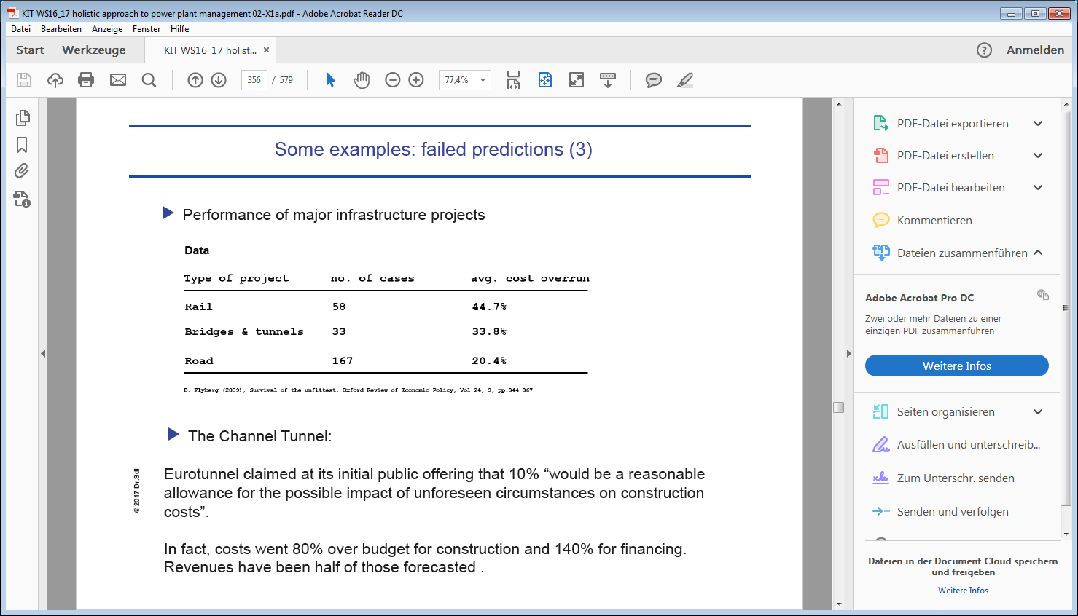

1. Some famous quotations:

•1876: "The Americans have need of the telephone, but we do not. We have plenty of messenger boys." — William Preece, British Post Office.

•1876: "This 'telephone' has too many shortcomings to be seriously considered as a means of communication." — William Orton, President of Western Union.

•1889: “Fooling around with alternating current (AC) is just a waste of time. Nobody will use it, ever.” — Thomas Edison

•1903: “The horse is here to stay but the automobile is only a novelty – a fad.” — President of the Michigan Savings Bank advising Henry Ford’s lawyer, Horace Rackham, not to invest in the Ford Motor Company.

•1921: “The wireless music box has no imaginable commercial value. Who would pay for a message sent to no one in particular?”

•1946: "Television won't be able to hold on to any market it captures after the first six months. People will soon get tired of staring at a plywood box every night." — Darryl Zanuck, 20th Century Fox.

•1955: "Nuclear powered vacuum cleaners will probably be a reality within 10 years." — Alex Lewyt, President of the Lewyt Vacuum Cleaner Company.

1. Daniel Kahneman and Amos Tversky are considered pioneers in the field of what factors influence human decision making: over-optimism, risk-aversion in the prospect of sure wins and risk seeking in the prospect of sure losses, the framing effect, the hindsight-bias, the preference of anecdotes over statistical evidence.
2. T.C. Schelling 1968: The Life You Save May Be Your Own. “Let a six year old girl with brown hair need thousands of dollars for an operation that will prolong her life until Christmas, and the post office will be swamped with nickels and dimes to save her. But let it be reported that without sales tax the hospital facilities of Massachusetts will deteriorate and cause a barely perceptible increase in preventable death – not too many will drop a tear or reach for their checkbooks.
3. Kahneman and Tversky formulated prospect theory: <https://www.princeton.edu/~kahneman/docs/Publications/prospect_theory.pdf>
4. Opportunity costs of a decision is what you give up by doing it. If you decide to build a gas fired power station instead of a wind farm, then the opportunity cost of building the conventional plant is the foregone net present value of the wind farm. In practice you would observe the following behavior: a wine collector has purchased some bottles long ago for $10 which are now worth more than $100 each. The collector says that he occasionally drinks one of these bottles, but he would neither sell the bottles at current prices nor would he buy such a bottle for $100. This is illogical. If he is willing to drink a bottle that he could sell for $100, then drinking must be worth more than $100. So why does he refuse to buy such a bottle for $100? In theory the opportunity cost of drinking the bottle should be equal to the market price of selling it. The opportunity cost remains unchanged if you drink the bottle or if you buy a new one. This is an example of opportunity cost versus out-of-pocket cost. Giving up the opportunity to sell something does not hurt as much as taking the money out of your wallet to pay for it.
5. The endowment effect: the things which you own is part of your endowment and people seem to value things that are already part of their endowment more highly than things that could be part of their endowment, that are available but not yet owned.
6. Availability heuristics: humans have limited time and brainpower. As a result they have to use simple rules of thumb to make judgements. For example, in guessing how frequent something is, we tend to ask ourselves how often we can think of instances of that type. Ask people whether there are more gun deaths caused by homicides or suicide in the U.S. and most people will guess homicide, but in fact there are almost twice as many gun deaths by suicide than homicides.
7. Searching for confirmation: decision makers have a natural tendency to search for confirmation rather than for discomforting evidence. This confirmation bias will be stronger when unwarranted assumptions make some kinds of discomforting evidence seem more unlikely.
8. Utility theory as created by Von Neumann and Morgenstern relies on cancellation, transitivity, dominance and invariance. Utility functions are built upon a mode basic idea: preferences. The value of something does not only depend on its cash value but also from the state of the decision maker himself or herself. Utility is a necessary mathematically construct to capture the fact that one and the same outcome of an event has different value for different market participants.
9. One important question is: which is an appropriate or true utility function? Is it unique or are there many? Von Neumann and Morgenstern were able to show the following: If a person is able to express preferences between every possible outcome, then it is possible that one can introduce utility associations in such a manner, that if the person is guided solely by the utility expected value, the person will act in accord with the true tastes – provided only that there is an element of consistency in the tastes.