Holistic approach to power plant management

KIT, 15.12.2017

1. We first looked at “motivation”: why do we need the concept of random variables, stochastic processes? Because we want to model an uncertain world. This week we saw:
   1. <https://www.bloomberg.com/news/articles/2017-12-14/craziest-week-in-gas-markets-we-re-now-flat-on-last-week>
   2. <https://www.bloomberg.com/news/articles/2017-12-12/u-k-gas-surges-after-explosion-in-austria-tightens-supply>
2. We also looked at the presentation of a colleague of mine; why having a batch of small gas engines instead of a single, big gas turbine is advantageous in a world of fluctuating supply from renewable sources: <https://www.tuhh.de/t3resources/iue/docs/veranstaltungen/RingvorlesungSommer2017/Vortrag_TUHH_Teupen_Sektorenkopplung.pdf>
3. We performed some numeric experiments:
   1. Understanding the central limit theorem: <https://github.com/DrSdl/RiskX/blob/master/CentralLimitTheorem_Gauss_versus_Levy.nb>
   2. Building our own Stochastic process: <https://github.com/DrSdl/RiskX/blob/master/StochasticProcess_MyOwn.nb>
   3. Hands-on experience of how a Levy distribution behaves and how a “Levy flight” looks like: <https://github.com/DrSdl/RiskX/blob/master/StochasticProcess_LevyFlight.nb>

The central limit theorem in its classic form says that if you have a random variable with finite variance and repeat the experiment “drawing values from this random variable” infinitely many times the average of mean value of all the results is distributed like a Gaussian or normal distribution. This is one reason why the Gaussian is so “famous”. But the theorem says nothing about how fast the convergence is and we did experiments with a uniform distribution for example.

|  |  |
| --- | --- |
| F:\Udacity\KIT Vorlesung WS16_17\videos 151217\IMG_4637.JPG | F:\Udacity\KIT Vorlesung WS16_17\videos 151217\IMG_4636.JPG |

A discrete time stochastic process is an ordered sequence of random variables . The rule for constructing this sequence can be as fancy as you can imagine.

For example, every variable can be independent of any previous variable like variables , or a function like or more complicated like . There is no limit to your imagination! We have already seen some stochastic processes with names like GARCH, for example. In all cases the objective is: take some historical data and construct a process which best matches the data and which is still general enough to predict some future properties. Predicting future properties does not mean to exactly predict some value like price at a future date, but to predict some more abstract properties like volatility or number of price spikes per year or intervals of price movements.

The above approach is “business as usual” in the financial markets and slowly these concepts are also beginning to be used in other fields. We talk here a lot about prices, but it could also be about predicting results of an election or predicting the time delay of a project.

1. Next, we focused on continuous time stochastic processes. This means that we have a process:

This means that we define a random variable for every real number t. So, we have a stochastic process etc.

|  |  |
| --- | --- |
| F:\Udacity\KIT Vorlesung WS16_17\videos 151217\IMG_4638.JPG | F:\Udacity\KIT Vorlesung WS16_17\videos 151217\IMG_4640.JPG |

Why do we need this? We later want to work with differential changes like , which means how the random variable changes from time step to time step. This in effect means that we are then able to create differential equations for stochastic variables and hence we can create “generator” equations for stochastic processes. This is more generally known as the field of “stochastic differential equations”. It is a very advanced subject and we only scratch the surface. But fundamentally it is simply a way to create rules and prescriptions for how a random process is defined. Loosely speaking it is the formalization to create a sequence like . Just like in Newtonian mechanics where we have equations like to define differential changes in momentum over time we here create similar prescriptions to define changes in time of random variables.

Some more info: <http://reference.wolfram.com/language/guide/StochasticDifferentialEquationProcesses.html>

or a classic text book:

<http://www.springer.com/de/book/9783540047582>

By the way, for this class it is only important to remember that things like “stochastic differential equations” (SDE) exist, what they are meant to do and why they are helpful.

1. So, what do we want to do with an SDE? For example, we want to calculate the fair price of an European call or put option (BSM formula). This gives us a famous formula, derived by Black, Scholes and Merton and for which a Nobel price in economics was awarded:

<https://www.nobelprize.org/nobel_prizes/economic-sciences/laureates/1997/scholes-lecture.html>

|  |  |
| --- | --- |
| F:\Udacity\KIT Vorlesung WS16_17\videos 151217\IMG_4641.JPG | F:\Udacity\KIT Vorlesung WS16_17\videos 151217\IMG_4642.JPG |

1. The first step is to define a Wiener process:

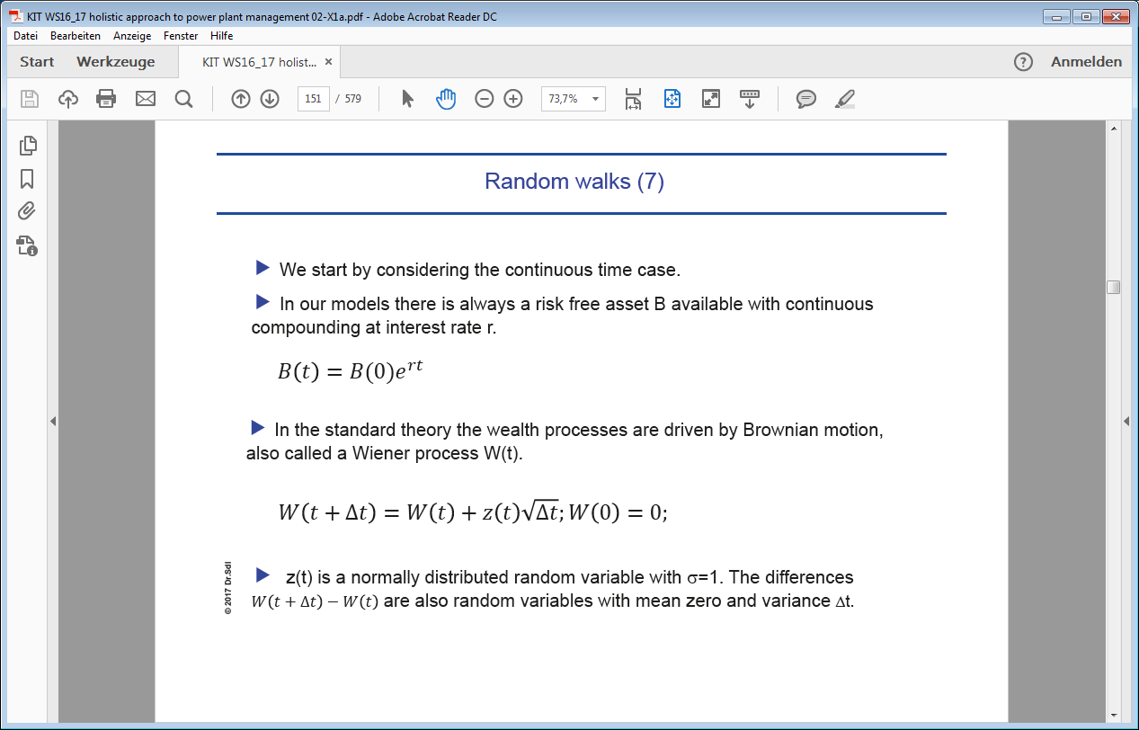

The Wiener process means that we construct paths through time and every time step creates a change in magnitude by drawing random values from the normal distribution.

1. Continuous time stochastic processes have the property that they create continuous functions or paths which are **nowhere** differentiable. Yes, such creatures exist! Another way to look at “continuous time stochastic processes” is by imagining an ensemble of paths from time t1 to time t2. Each path is a continuous, real valued function x(t). But x(t) cannot be differentiated at any point in time. This property can be seen by looking at the following expectation value:

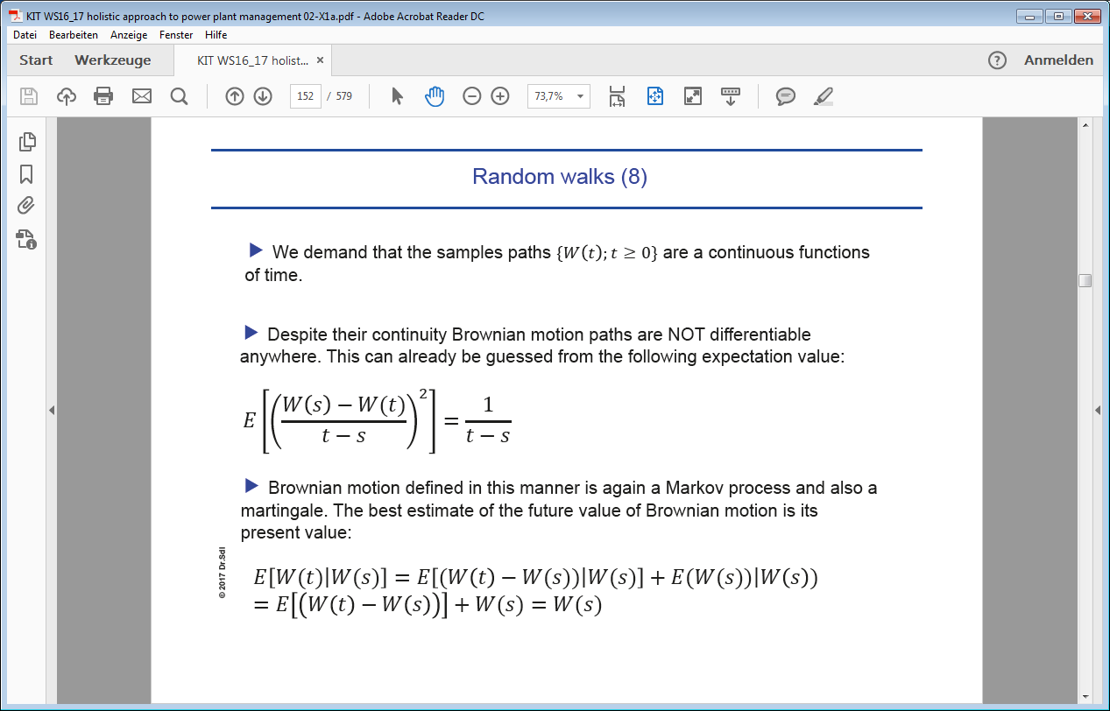

1. Given the Wiener process, a generator function of a “continuous time stochastic process” often is defined as follows (this is just an example, but a heavily used one in practice):

So, what does this equation mean? It prescribes how the random variable X changes over time step dt. and are real valued functions of two variables, no surprise so far. But: instead of putting a real value x into or , we put in the random variable X. This means and themselves become random variables. It is always helpful to remember what this means numerically: in practice you want to generate a path from t0 to time t1. First, you create on full path w(0), w(0+),…. for the Wiener process from t0 to t1 by calculating values for the random variables W(0), W(0+),….

You then start with an initial definition for the random variable X(0) – and you draw the first value x0 from the distribution X(0). Then you construct a new random variable for X at time (0+:

Given the value the next path point is then approximated as

The steps can be derived from the already constructed path for the Wiener process. This then creates a possible path for X. Of course, with the above procedure you can create infinitely many possible paths, derived from all the possible paths of the Wiener process.

1. One important rule is the so called “Ito’s rule”. If we have a real valued function f(t,x) and replace x with a random variable X then f also becomes a random variable which changes according to Ito’s rule:

if:

This is almost the rule from classical calculus except for the term.

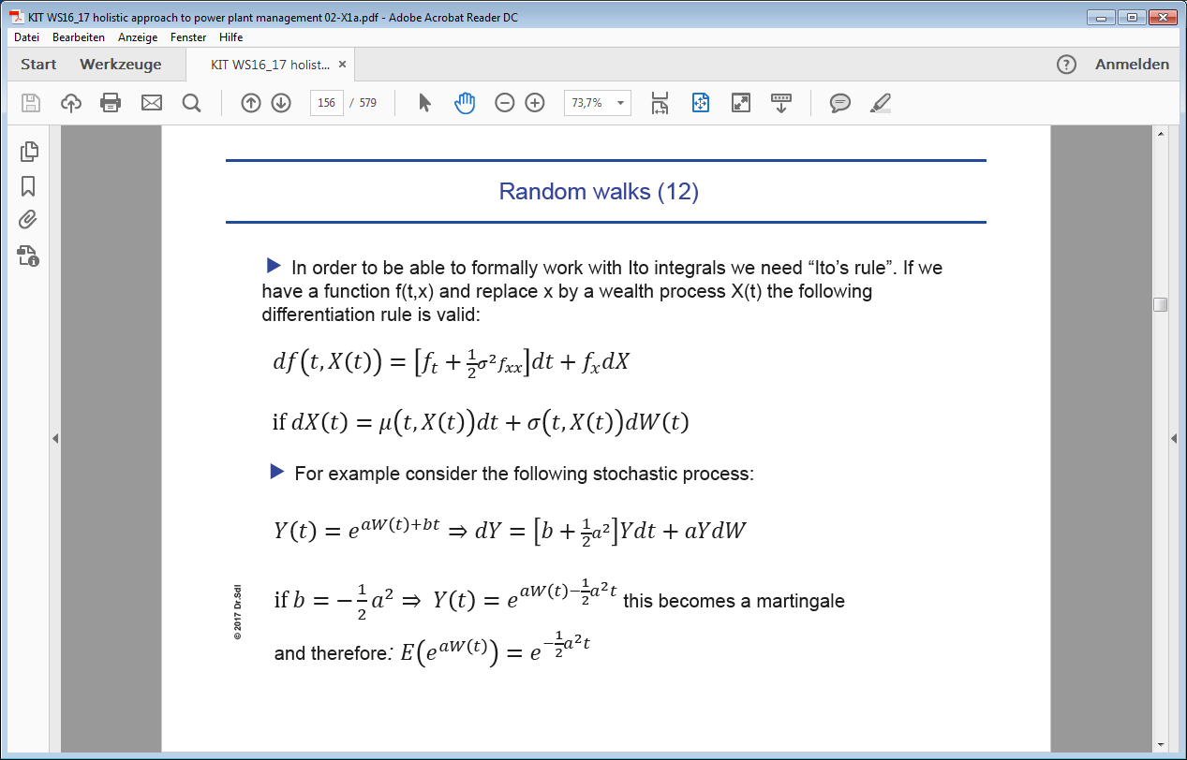

1. The idea of Brownian motion in wealth processes was already used by Louis Bachelier in 1900. His work was way ahead of his time and it was not noticed by economists and mostly ignored by mathematicians. It was only later formally introduced by Paul Samuelson in the 1950s and further developed by his student Robert Merton in the late 1960s. The Black-Scholes-Merton model of option pricing was first published in 1973 and lead to a Nobel Price for Merton and Scholes in 1997.

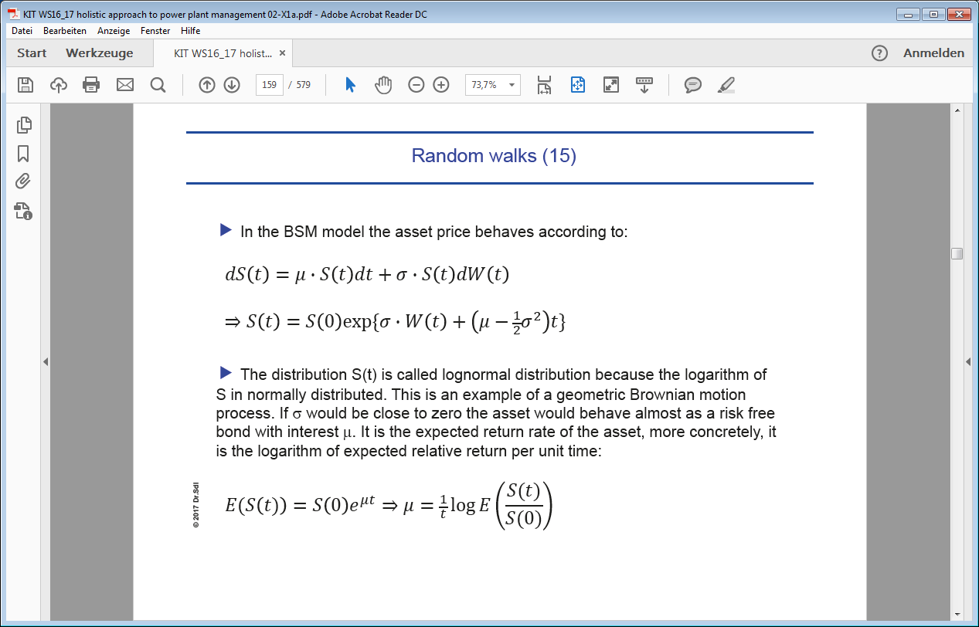

|  |  |
| --- | --- |
| F:\Udacity\KIT Vorlesung WS16_17\videos 151217\IMG_4644.JPG | F:\Udacity\KIT Vorlesung WS16_17\videos 151217\IMG_4646.JPG |

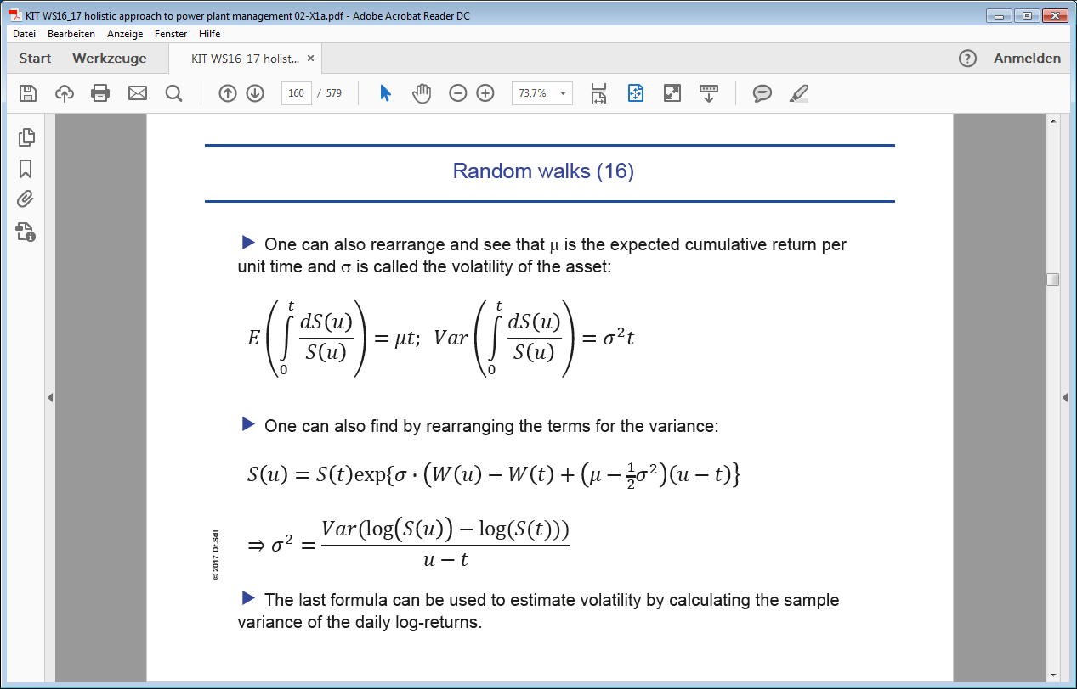

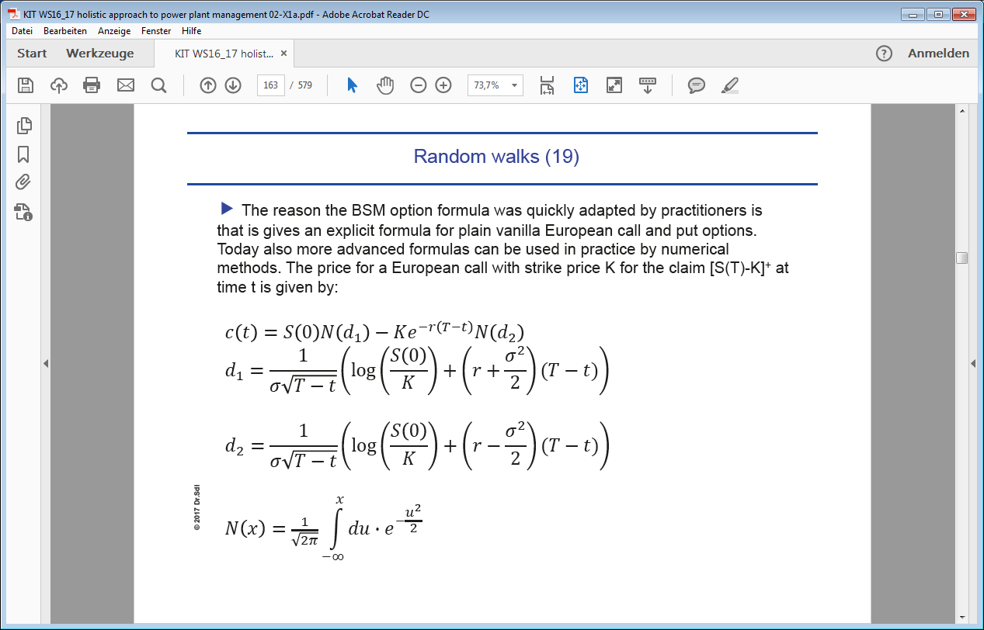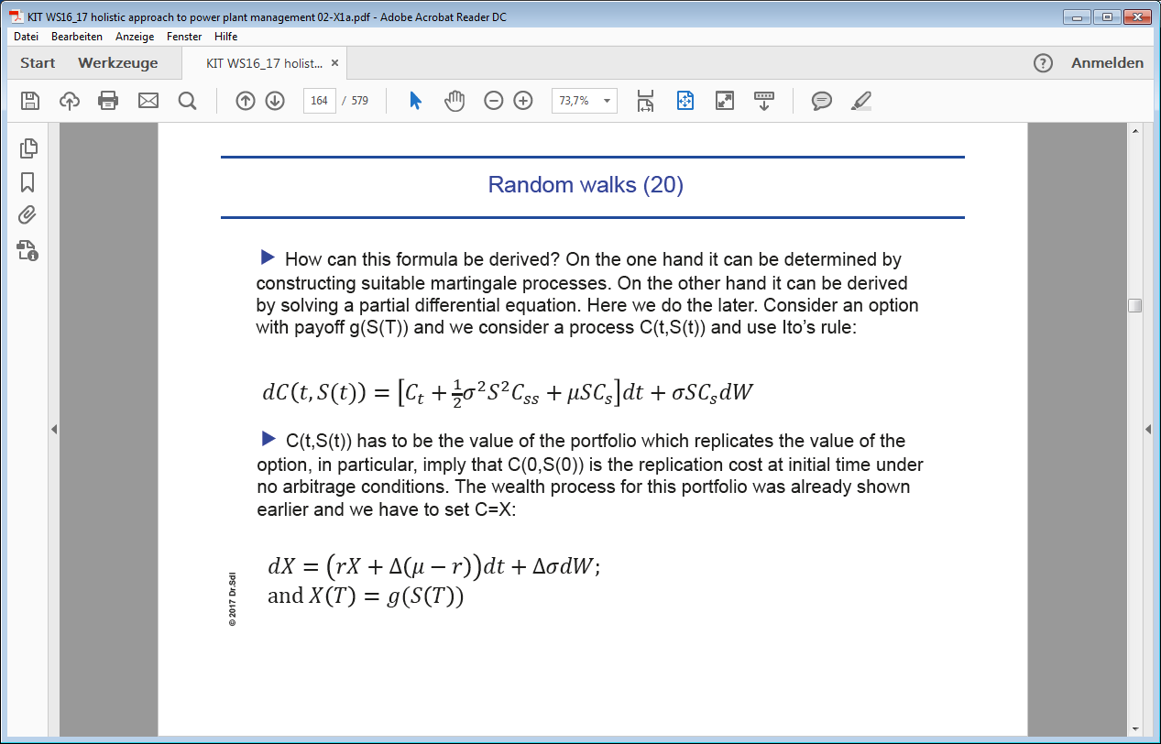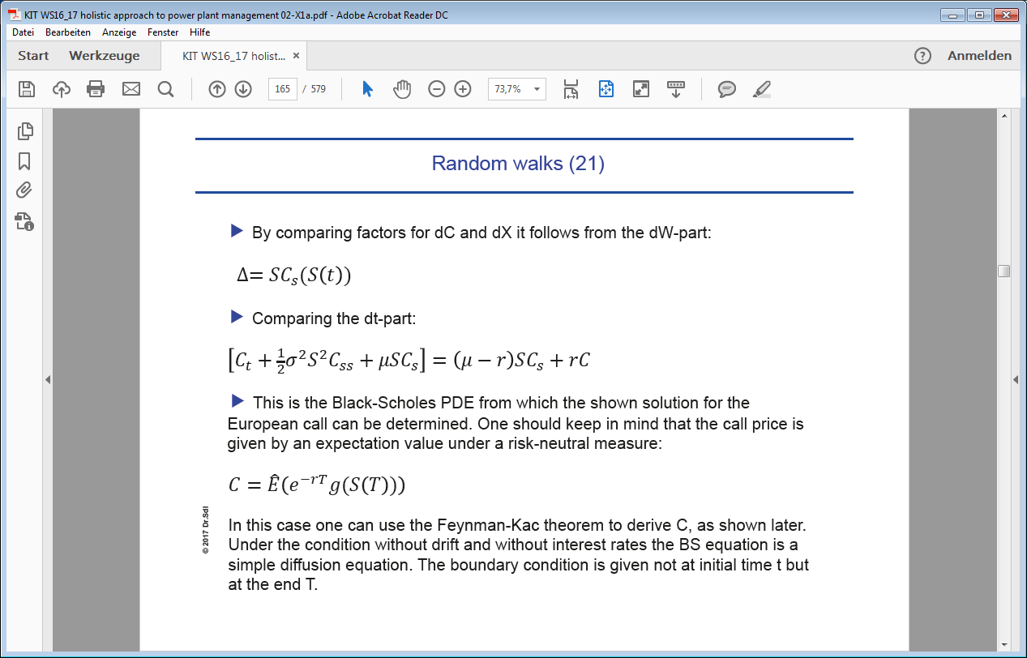

1. The above exercise showed you how to use the formalism of SDEs and Ito’s rule to derive a classical partial differential equation for the value of a European call or put option. Let us remember what this result means: say, we produce electricity and need 30€ per MWh to break even. At the moment the market price is at 40€. We fear that in one year from now the price might fall to 20€. We buy a put option with strike price K=30€ and maturity T=1year. This gives us the right to sell our electricity guaranteed at 30€ regardless of what the spot price is in one year. Now the question is: what value or which fair price does this option have today? Since the price currently is at 40€, you might expect that the option has zero value at the moment. This is wrong, because you would neglect the stochastic movement of prices. In the BSM formula it is assumed that the underlying stochastic process is a Wiener process. Then the BSM formula tells you what the fair price of the option is today. Of course, the underlying stochastic process can be whatever you reasonably can imagine. It is up to your modelling capabilities. Hence different option sellers might come to different conclusion about option value, depending on their assumptions of the underlying stochastic process.
2. We used Mathematica (<https://github.com/DrSdl/RiskX/blob/master/Option_Pricing_Numerical_Example.nb>) to calculate the value of an option with built-in functions and we numerically simulated the value of an option. Numerically the procedure is as follows: we construct an ensemble of paths for the electricity price from today to 1 year in the future for whatever underlying stochastic process we consider reasonable. For all the price data points in 1 year we can create a histogram, i.e. putting the values into buckets or finite intervals and count how many values fall into each bucket. With the help of this histogram we can calculate probabilities that the price will fall into a certain price range. The option contract defines a cash transfer, depending on where the price is. The histogram will give us the expectation value of the money we receive of we have to cash out.
3. With this approach you can basically also insure yourself against car accidents, for example: you calculate your risk of being involved in a car accident in the next five years and construct a series of paths showing your cash needs in this period. From this you can calculate an estimate of the cash you need to put into your bank account every month to sufficiently insure yourself against any liabilities.
4. Let us consider another scenario: you have the predict the probability B(t) that someone wins an election or that you stay within a project’s budget, or that you meet a certain deadline. You do your estimate at B(t0), B(t1),… until “maturity” T, i.e. until election day or until the project is finished or the deadline arrives. B(t) can be considered a stochastic process with paths having values in the interval [0,1]. So far so good. The challenge is: can we say something about your strategy of updating the bets? At t0 you make your first bet given the information you have. Later more information arrives, and you need to update your bets. How do you do this consistently?

We demand that B(t) is a martingale: . This means that the conditional expectation value of B at some later time , given all the information until time t, is Having a martingale means that the bets are “arbitrage free” or “fair”. Expressed differently: if the martingale property is violated, then you fool yourself or are not updating your bets consistently. For example, you start with an initial expectation of . Then you construct your random variable to update the bet at time 1. If , then you would know at time 0 more about the future than admitting.

As an example, assume for the underlying stochastic process: and B=B(t,X).

Then we get with Ito’s rule: . The martingale property leads to the following partial differential equation:

This was just a simple example how “stochastic” thinking works. The problem with the above process definition is that B is still not bounded between 0 and 1 and more elaborate definitions are necessary.