Holistic approach to power plant management

KIT, 17.11.2017

1. In this session we focused on data: we want to answer big questions like “what is the LCOE of our new power plant project?” and in order to find answers we have to create smaller questions which we can answer (Fermi’s method). We want to know the investment costs and we want to know the operation and maintenance costs and we need to estimate the decommissioning costs.

|  |  |
| --- | --- |
|  |  |

1. Some videos on wind power plant project planning from colleagues at DTU:
   1. <https://www.youtube.com/watch?v=eoWySJ2pBNw>
   2. <https://www.youtube.com/watch?v=wEvFPFutRSA>
   3. <https://www.youtube.com/watch?v=WSYPlEHHzgg>
2. When we speak of investment costs one important aspect is: what is the fair price we are willing to pay for a wind turbine or for a gas turbine? We can use historical price data but this may not be a suitable price for a project which will be realized 5 years from now. This is again the “art of prediction”. There are many examples where investors did naïve extrapolation of past data and made big mistakes: e.g. overcapacities of conventional power plants in Europe, for example, or excess capacity on oil and gas. In the 1980s researchers (“club of rom”) were speaking about “peak oil” but today there is a huge surplus due to shale gas resources. Around 2000 European utilities could not imagine that consumers would be willing to pay higher prices and subsidies for clean, renewable energy. This has also led to problems at suppliers of conventional power plants, see Siemens and GE:
   1. <https://www.bloomberg.com/news/articles/2017-11-10/ge-s-100-billion-wipeout-heralds-reckoning-for-an-american-icon>
   2. <https://www.bloomberg.com/news/articles/2017-10-19/siemens-is-said-to-plan-thousands-of-job-cuts-over-two-divisions>
3. Now everybody takes it for granted that there will be electric cars around everywhere in a few years – but again this is a prediction which has a lot of uncertainty. Technological innovation is hard to predict. So, these are the two basic approaches: you can do trend following of past data or you can consider everything a stochastic process, which we will discuss in one of the next lectures.
4. The tale of two markets: Renewable energy has priority in consumption, hence the piece of the pie which remains for the “free” market shrinks, and prices become depressed and even can turn negative. Negative prices mean that instead of shutting down a power station, utilities keep them operating and pay large consumers an incentive to use the excess electricity, i.e. demand is increased by making prices negative (much like quantitative easing depresses interest rates to increase credit demand).

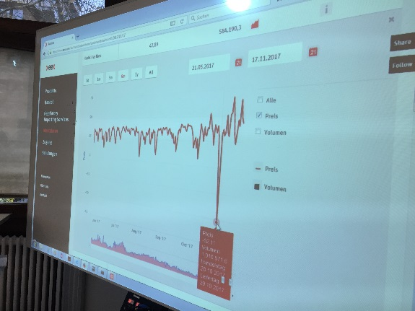

1. But there is a problem: sometimes there is a “Dunkelflaute”, i.e. a few days were neither wind blows, nor much sunshine is. In these days there has to be a 100% backup with conventional power stations. This means in effect that a country builds up twice the capacity it needs. The backup can be conventional or “new batteries”, i.e. wind-to-gas (<http://www.powertogas.info/>) or pumped hydroelectric storage (<http://energystorage.org/energy-storage/technologies/pumped-hydroelectric-storage>), for example.

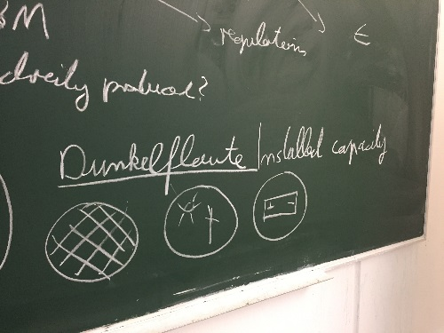

1. How do providers of wind power stations, for example, get their revenue? On the “free market”, i.e. <https://www.eex.com/de/> or <https://www.nordpoolgroup.com/> consumers and producers determine prices on their own: there is an “order book” where buyers and sellers submit bids (i.e. buyers) and asks (sellers). The “market clearing price” is determined by maximizing the trading volume for a given status of the order book. This is the point where the demand and supply curves intersect.
2. With the classical “feed in tariff” scheme renewable power stations do not need to participate in the free markets because they would almost always be priced out, i.e. conventional, amortized power stations would dominate supply. Hence renewable power stations are compensated regardless of demand based on the “metering”, i.e. the amount of electricity they supplied into the grid, for example 5cent per every kWh. But given the meter reading, how does the cash flow into the pockets of renewable power plant owners. The feed in tariff is a guaranteed entitlement by law which needs a series of rules and regulations to make the cash flow. In Germany the “Bundesnetzagentur” is responsible for this (<https://www.bundesnetzagentur.de/DE/Sachgebiete/ElektrizitaetundGas/Unternehmen_Institutionen/DatenaustauschundMonitoring/MaStR/RegistrPVAnlagen/RegistrPVAnlagen_node.html>).

The owner of a solar power station, for example, gets compensated from the grid operator (TSOs) to which the PV is connected. The TSOs are entitled to get compensated by the utilities for the PV cash flows. Finally, the utilities charge consumers for the PV payments. This is known in Germany as the “EEG-Umlage” (<https://www.netztransparenz.de/EEG/EEG-Umlage>). Now, this scheme has become more advanced over time. TSOs can trade the electricity they receive from PVs on the “free market” and already obtain some compensation. More information is here: <https://www.bundesnetzagentur.de/SharedDocs/FAQs/DE/Sachgebiete/Energie/Verbraucher/Energielexikon/EEGUmlage.html>

1. Some data resources to help you make predictions about electricity demand:
   1. <https://www.gapminder.org/tools/#_chart-type=bubbles>
   2. <https://www.iea.org/publications/freepublications/publication/world-energy-outlook-2017---executive-summary---german-version.html>
   3. <https://www.oecd-nea.org/ndd/pubs/2015/7057-proj-costs-electricity-2015.pdf>
   4. <https://flowcharts.llnl.gov/>
   5. <https://www.bp.com/en/global/corporate/energy-economics/energy-outlook.html>
   6. <http://irena.masdar.ac.ae>
   7. <https://www.ferc.gov/market-oversight/mkt-electric/overview.asp>
   8. <https://www.eia.gov/analysis/studies/worldshalegas/>
   9. <https://fred.stlouisfed.org/>
2. How an order book works: <https://player.vimeo.com/video/226656902>
3. Python example to process an order book: <https://github.com/DrSdl/RiskX/tree/master/orderbook>
4. Analyzing historical wind speed data with Python. Download data from <http://www.met.ie/climate-request/>. Use script at: <https://github.com/DrSdl/RiskX/blob/master/WindDataDownload.py>

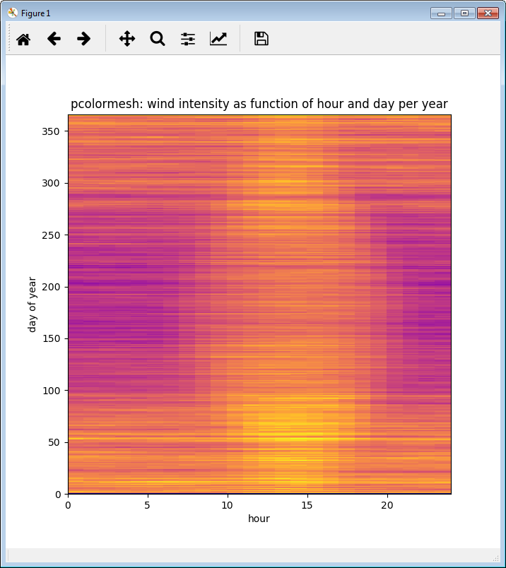

1. How does the electricity grid work?
   1. <https://www.youtube.com/watch?v=vX0G9F42puY>
   2. <https://www.youtube.com/watch?v=OBYzvkY2-eA>

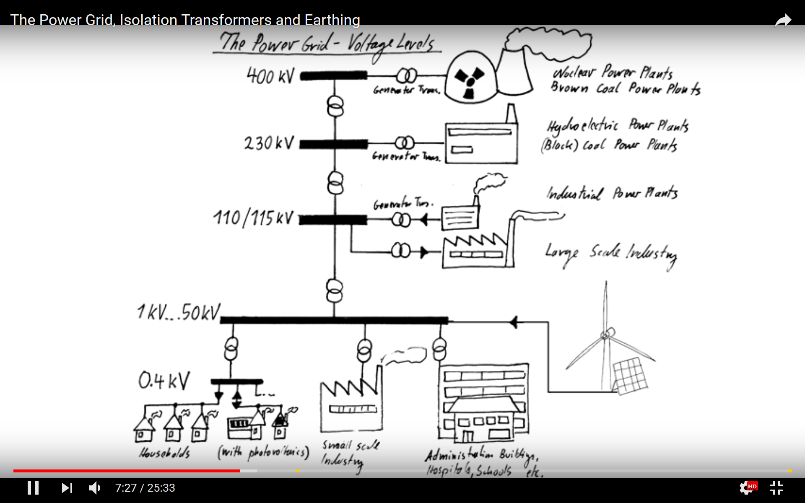

1. Example of a local, big energy consumer: <https://www.basf.com/de/de/company/about-us/sites/ludwigshafen/commitment-for-the-region/education/angebote-7-13/unterrichtsmaterialien/Steamcracker.html>
2. BASF & Schott: <https://www.youtube.com/watch?v=o3JXWYLLrl4>
3. Primary, secondary and tertiary reserve: <https://www.regelleistung.net/ext/>
4. California TSO: <http://www.caiso.com/pricemap/Pages/default.aspx>
5. Pennsylvania TSO: <https://www.pjm.com/markets-and-operations/energy.aspx>