Holistic approach to power plant management

KIT, 20.10.2017

1. What is management? It is about organization and leading of people. On a more abstract basis it is making decisions about the FUTURE

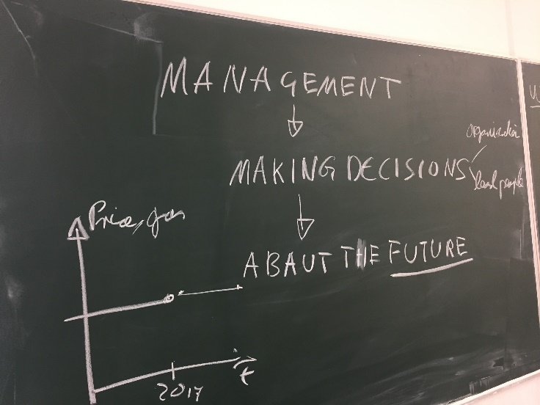

1. What are the puzzle pieces we have to think about? Fuel, machines, maintenance, personnel, customers, demand, market supply, emissions, regulations,…

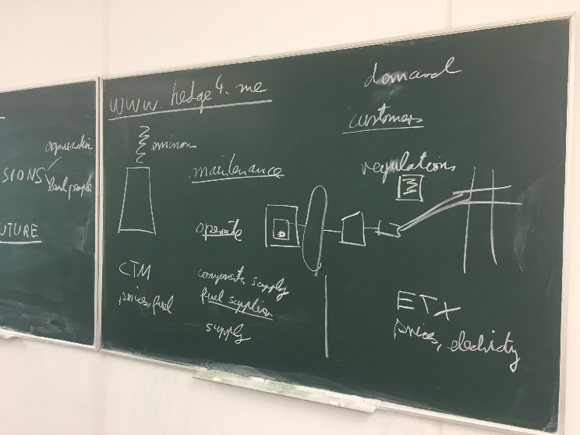

1. What is the difference between risk and uncertainty?

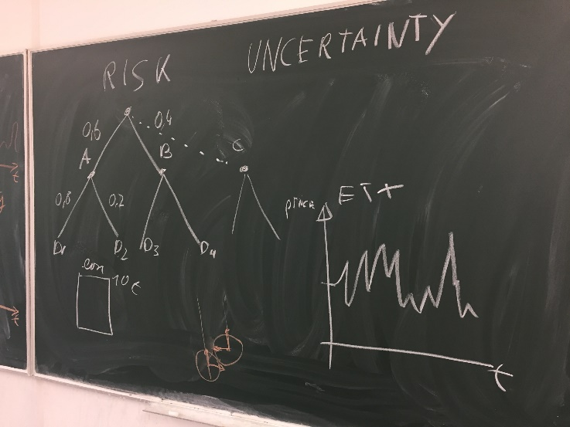

1. How to characterize complex systems? Using methods of machine learning or stochastic processes?

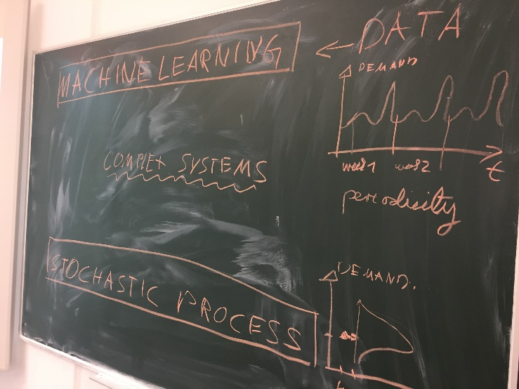

1. The curse of dimensionality and the problem of induction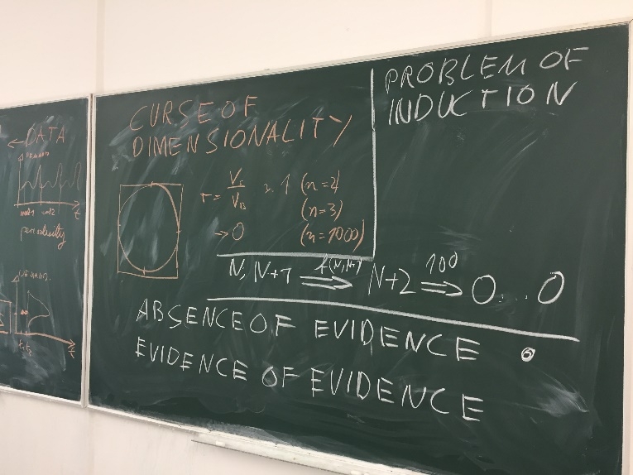
2. Visualizing random processes with Mathematica:

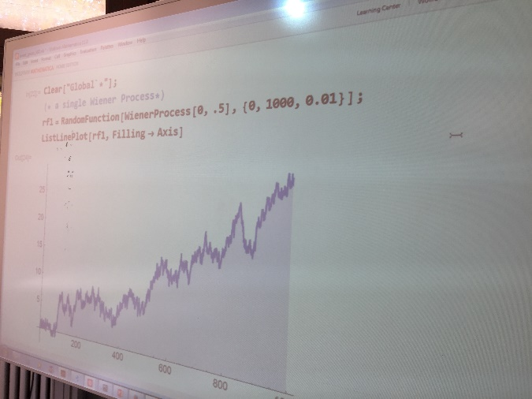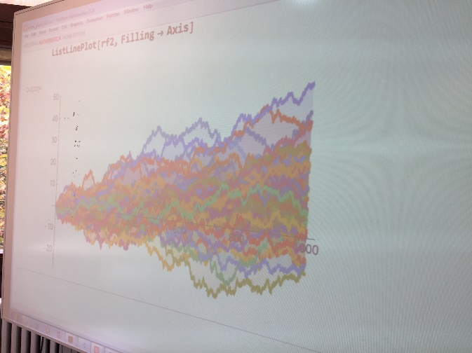

1. Understanding errors of type 1 and type 2. The problem of the limits on information to find out the “truth”

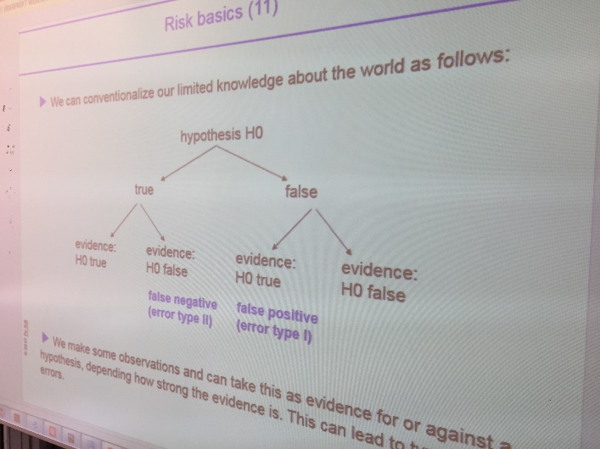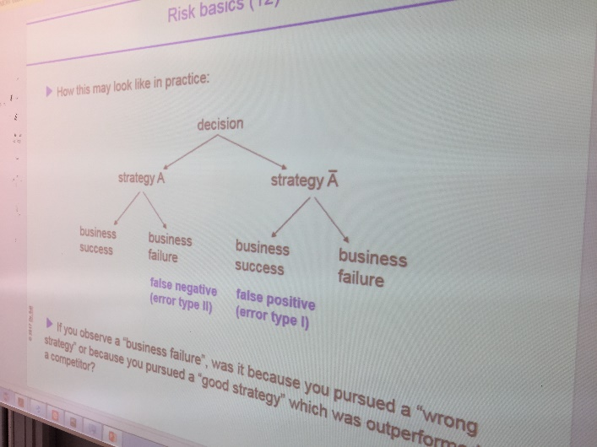

1. Studying complex systems: 4 disks inside a box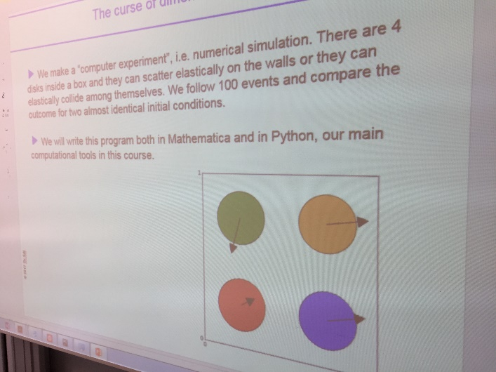
2. Taking a look at regulations:

<https://www.bmwi.de/Redaktion/DE/Publikationen/Energie/gesetzeskarte.html>

<http://eur-lex.europa.eu/legal-content/DE/TXT/HTML/?uri=CELEX:32009L0072&from=DE>

<https://www.gesetze-im-internet.de/enwg_2005/BJNR197010005.html>

1. The questions we want to answer:

* Predicting the cost of fuel, spare parts, components, personnel
* Predicting project costs and time requirements
* Predicting electricity demand and prices
* Finding the optimal point in time to shut down a power plant
* Finding the optimal point in time to do maintenance
* When and where to invest in new power plants, which technology to use
* Predicting macro-economic variables and events

1. Caveats about predictions:

<https://www.bloomberg.com/news/articles/2017-01-14/bone-chilling-winter-from-berlin-to-davos-causes-energy-scramble>

<https://www.bloomberg.com/news/articles/2001-12-16/the-fall-of-enron>

<https://www.bloomberg.com/news/articles/2016-12-27/shale-specter-haunts-opec-s-feast-as-oil-seen-rallying-into-2017-ix6qxjn0>

<https://www.bloomberg.com/news/articles/2016-12-27/toshiba-finds-u-s-nuclear-renaissance-a-nightmare-for-costs>

1. Some historic work on the nature of predictions:

* von Neumann, John, and Oskar Morgenstern, 1944, Theory of Games and Economic Behavior. Princeton, NJ: Princeton University Press.
* von Mises, Richard, 1928, Wahrscheinlichkeit, Statistik und Wahrheit, Vierte Auflage, 1972, Springer Verlag Wien New York.
* de Finetti, Bruno, 1937, “La Prévision: Ses Lois Logiques, Ses Sources Subjectives.” Annales de l’Institut Henri Poincaré, vol. 7: 1–68. C
* Bachelier, Louis. 1900. “Théorie de la Speculation.” Annales Scientifiques de l’École Normale Supérieure, série 3, tome 17:21–86
* Bernoulli, Daniel. 1738. “Specimen Theoriae Novae de Mensara Sortis.” Commentarii Academiae Scientiarum Imperialis Petropolitanae, vol. 5:175–192
* Hume, David, 1748, Enquiry Concerning Human Understanding
* Keynes, John Maynard, 1921, A Treatise on Probability. London: Macmillan.
* Knight, Frank H, 1921, Risk, Uncertainty, and Profit, New York.
* Shackle, George, 1949, Expectation in Economics. Cambridge,U.K.: Cambridge University Press.

1. The difference between objective approach and subjective approach to risk: the frequentist versus Bayes world view
2. The unkown unkowns: an historic perspective, see <http://papers.rumsfeld.com/>

* If you had been a security policy-maker in the world's greatest power in 1900, you would have been a Brit, looking warily at your age-old enemy, France.
* By 1910, you would be allied with France and your enemy would be Germany.
* By 1920, World War I would have been fought and won, and you'd be engaged in a naval arms race with your erstwhile allies, the U.S. and Japan.
* By 1930, naval arms limitation treaties were in effect, the Great Depression was underway, and the defense planning standard said "no war for ten years.“
* Nine years later World War II had begun.
* By 1950, Britain no longer was the world’s greatest power, the Atomic Age had dawned, and a "police action" was underway in Korea.
* Ten years later the political focus was on the "missile gap," the strategic paradigm was shifting from massive retaliation to flexible response, and few people had heard of Vietnam.
* By 1970, the peak of our involvement in Vietnam had come and gone, we were beginning détente with the Soviets, and we were anointing the Shah as our protégé in the Gulf region.
* By 1980, the Soviets were in Afghanistan, Iran was in the throes of revolution, there was talk of our "hollow forces" and a "window of vulnerability," and the U.S. was the greatest creditor nation the world had ever seen
* By 1990, the Soviet Union was within a year of dissolution, American forces in the Desert were on the verge of showing they were anything but hollow, the U.S. had become the greatest debtor nation the world had ever known, and almost no one had heard of the internet.
* Ten years later, Warsaw was the capital of a NATO nation, asymmetric threats transcended geography, and the parallel revolutions of information, biotechnology, robotics, nanotechnology, and high density energy sources foreshadowed changes almost beyond forecasting.