Holistic approach to power plant management

KIT, 25.01.2018

1. We looked at some academic models which might help us to predict how two agents might behave during a transaction. “Behaving” here means that each agent has a set of possible actions at his or her disposal. “Transaction” means that the two agents want to achieve a certain goal with their actions, for example buying and selling oil or a turbine or making a contract.
2. Game theory is typically used in these situations. It usually assumes in its simplest form that we have two market participants and each has a set of fixed strategies available. Participant 1 has strategies (a1,a2,…) and participants 2 has (b1,b2,…) available. Each strategy results in an outcome Oij which has different utils for each participant. If we are analyzing the situation from the perspective of participant 1 then our goal is that we want to decide which strategy is “optimal”.
3. In normal form games with two players we have a Bi-matrix, each containing the two players’ utility of for each combination of actions. Game theory usually distinguishes between “decisions under certainty”, “decisions under risk” and “decisions under uncertainty”. In all cases it is assumed that there is a finite set of strategies. Risk means that we know the probabilities that “participant 2” will take a certain action. Uncertainty means that we do not know anything about those probabilities.
4. One important question is: which is an appropriate or true utility function? Is it unique or are there many? Von Neumann and Morgenstern were able to show the following: If a person is able to express preferences between every possible outcome, then it is possible that one can introduce utility associations in such a manner, that if the person is guided solely by the utility expected value, the person will act in accord with the true tastes – provided only that there is an element of consistency in the tastes.
5. Extensive and normal forms of games. The extensive form of a game is roughly speaking the game tree which shows all possible paths the game can take, all possible outcomes and all information sets the players have: The tree starts at the distinguished node. Each nodes shows which player has to make a choice. The set of choices at each node is called a move. In some situations, a player may not know or only partially know the choices the other players have made and this is shown by indicating the information sets for every player. Each outcome is assigned a utility for each participant.
6. Often even the simplest games produce very complex tree structures and a new level of abstraction is necessary to enable theoretical progress. Games in normal forms are described by the set of “strategies” available to each participant. In principle a “strategy” describes all the decisions a player will make at every node of a tree for any given information set. Since there is only a finite number of nodes there are also only a finite number of strategies. A simple strategy could be to “take the right path” at every node independent of the decisions and outcomes taken before.

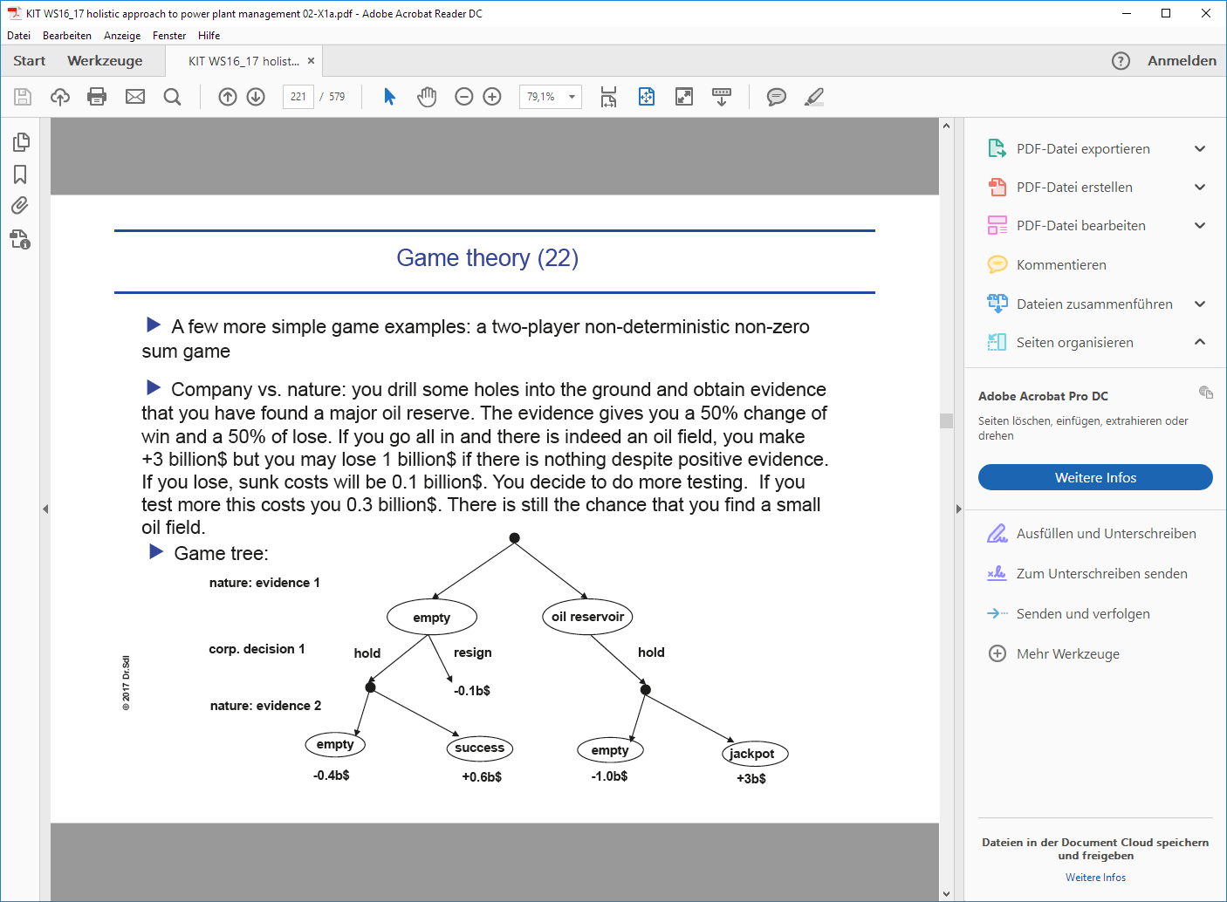

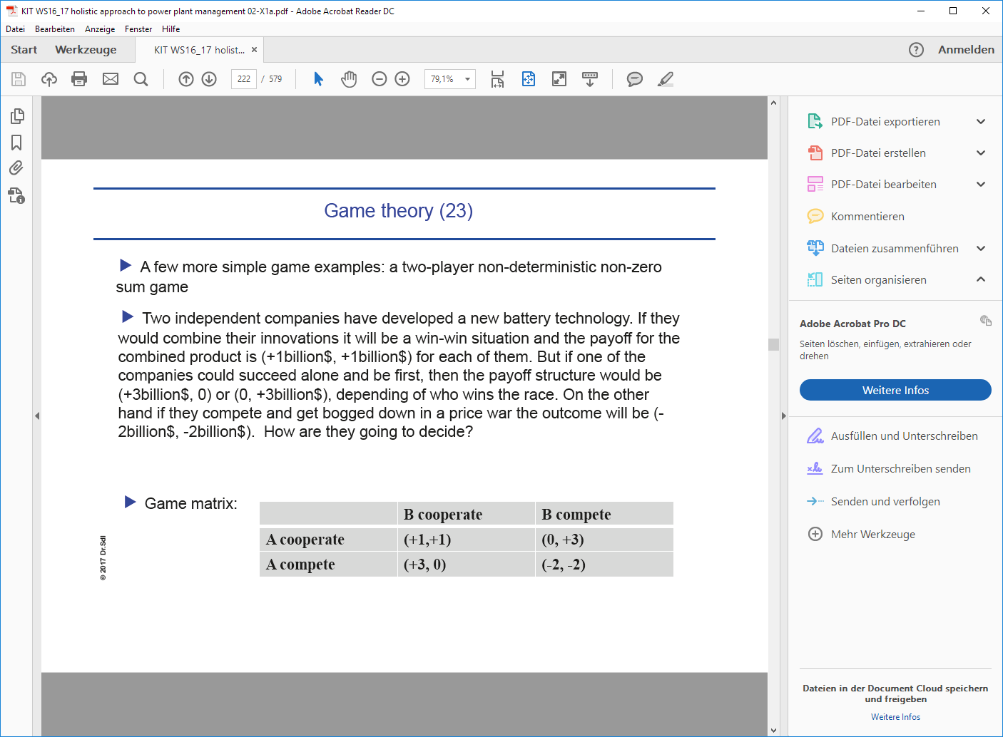

1. The most important concepts to solve these games: pure strategy, mixed strategy, minmax and maxmin strategies.