AHCE-FL: Communication-Aware Hierarchical Federated Learning for Efficient Distributed Cloud Environments

Abstract
We evaluated Adaptive Hierarchical Communication-Efficient Federated Learning (AHCE-FL) in 96 CIFAR-10 simulation runs: 51 baseline and initial sensitivity runs plus 45 additional resource-weight and synchronisation experiments. Across three paired seeds and 100 training rounds, baseline AHCE-FL reached 0.473067 mean accuracy using 366004619 modelled bytes, whereas reconstructed FedAvg reached 0.643467 using 308560000 bytes. Altering resource-selection weights did not provide Holm-adjusted evidence of improved accuracy. Joint gap–threshold tests showed that a low divergence threshold caused cloud synchronisation every round; with divergence triggering disabled, maximum gaps of 1, 3 and 5 produced 100, 33 and 20 cloud exchanges. These results quantify simulated trade-offs, not hardware communication or energy savings.
Keywords: federated learning, communication efficiency, cloud-edge computing, hierarchical aggregation, client selection, CIFAR-10, non-IID data, parameter sparsification, adaptive synchronization, model update compression

1. Introduction
In federated learning, clients retain their data and send model parameters to a server (McMahan et al., 2017, Kairouz et al., 2021). An edge server can average the client updates before forwarding them. If that server still sends an aggregate after every round, the frequency of cloud exchanges stays the same.
After a round with no cloud exchange, the next group of clients at an edge can start from its cached model. If the scheduler repeatedly selects clients with the same non-IID partitions, successive local updates can widen the gap between that model and the global copy. The size of the client upload depends on a separate decision. The encoder uses sparsification only when the bytes saved by dropping coefficients exceed the cost of storing the indices of those it retains. We compare the resulting byte counts with final accuracy to see what the smaller uploads cost in predictive performance.
Before local training, the scheduler ranks eligible clients using five resource descriptors. At the end of training, each selected client sends the difference between its trained parameters and its starting parameters. The edge reconstructs each model by adding the decoded difference to that client’s starting model, then averages the reconstructions by sample count. Aggregates from active edges form the cloud candidate.
We use the same partitioning procedure for AHCE-FL and the reconstructed FedAvg, FedProx, FedCS and HFL baselines. In both the τ and G sweeps, each run lasts 100 rounds and comparisons pair runs at seeds 11, 23 and 42. We hold client selection fixed across the τ sweep so that the threshold changes the encoding of updates from the same participants.
Within the threshold sweep, τ = 0.05 yielded the fewest bytes and the lowest accuracy. The first gap sweep recorded an exchange in every round, so it could not isolate the timer. With the divergence trigger suppressed, maximum gaps of 1, 2, 3 and 5 yielded 100, 50, 33 and 20 exchanges, respectively. Section 5.6 identifies the measurements needed to assess those settings on devices.

2. Related Work

2.1 Communication-efficient federated learning
McMahan et al. (2017) reported a reduction of 10× or more in the number of FedAvg communication rounds. Konečný et al. (2016) addressed the size of each message through structured and sketched updates. In an indexed sparse update, every coefficient that survives carries an index. The sparse encoding can exceed the dense update in length, so we report the encoded byte count alongside final accuracy.
After applying the magnitude threshold to an update tensor, AHCE-FL compares the bytes needed for indices and retained values with the length of the original dense difference. The encoder sends the dense difference whenever the sparse representation costs as much or more. When it sends a sparse message, it carries no error-feedback residual for the discarded coefficients into the next round. Every setting in the threshold sweep uses the same dense fallback.

2.2 Client selection under heterogeneous resources
Selecting a client also selects its data. As Kairouz et al. (2021) and Lim et al. (2020) discuss, a preference for better-resourced devices can repeatedly favour the same partitions. AHCE-FL normalises synthetic bandwidth, energy, accuracy, latency and compute values and ranks clients by their combined score. Because those values stay fixed within a run, high-ranked clients can return many times and leave other non-IID partitions underrepresented.
AHCE-FL and the reconstructed FedCS both rank clients using the synthetic resource scores. FedAvg, FedProx and HFL draw participants randomly and can expose the model to a different mixture of labels. The baseline results compare those complete policies. The separate CIFAR-10 τ sweep changes the threshold within AHCE-FL and holds the remaining settings fixed.

2.3 Hierarchical federated learning
ShapeFL changes the distribution seen at an edge (Deng et al., 2024). HiFlash addresses who connects to which edge and how stale those updates can become (Wu et al., 2023). Async-HFL allows different arrival times (Yu et al., 2023). In our comparisons, we reproduce the baseline policies under the same experimental budget.
The same hierarchy can behave differently when edges serve different clients, keep older models or exchange updates with the cloud at different times (Wu et al., 2023, Yu et al., 2023, Deng et al., 2024, Ma et al., 2024, Lin et al., 2024). Our experiments keep client–edge association fixed so that we can vary indexed sparsification and round-level cloud exchange.
The assignment e = i mod E fixes the edge for client i throughout the run. In a given round, the cloud candidate includes an aggregate from an edge only if the scheduler selected at least one client there. If the coordinator keeps the current global model, each participating edge stores its new aggregate locally. The frequency of cache refreshes can differ across edges according to how often their clients participate.

2.4 Asynchronous and controlled synchronization
Hierarchical training introduces a timing question because the models at the edge and in the cloud can have different ages (Yu et al., 2023, Lin et al., 2024). We evaluate the synchronization rule at the end of the round, once the edge aggregates are available. The coordinator uses two quantities at that point. It measures the ℓ₂ distance between the cloud candidate and the stored global model and counts the rounds since the last exchange.
Wen et al. (2025) examine how edges coordinate asynchronously. In our timer sweep, the synchronization decision has a fixed place in the round. Selected clients complete local training, the edges compute their averages, and the coordinator then decides whether to exchange the model.
The scheduling decision depends on what the system needs to allocate. Chowdhury (2023) studies resources shared by federated learning and blockchain services. In vehicular networks, Shabariram et al. (2026) focus on where to offload tasks. Tseng et al. (2026) use semantic-aware graph attention to decide when communication should occur. Our simulation uses synthetic resource values to decide which clients train.

2.5 Privacy and security of model exchange
In these runs, the CIFAR-10 training images stay with the clients, and model representations pass between participants (Table 1). Those messages can disclose information about the training data or introduce malicious parameter changes (Bagdasaryan et al., 2020, Truex et al., 2020). We ran the experiments without a differential-privacy accountant, secure aggregation or encrypted transport. Inference and poisoning were outside the experimental design.
Table 1. Mechanism-level comparison of relevant approaches.
Approach | Selection | Compression | Hierarchy | Sync policy | Explicit privacy
FedAvg (McMahan et al., 2017) | Random | No | No | Each round | No
Communication strategies (Konečný et al., 2016) | Not central | Yes | No | Update rounds | No
HiFlash (Wu et al., 2023) | Heterogeneity-aware | Not this implementation | Yes | Staleness-aware | Not established here
Async-HFL (Yu et al., 2023) | System-dependent | Not this implementation | Yes | Asynchronous | Not established here
AHCE-FL implemented | Five-factor rank | Magnitude τ | Yes | Gap or divergence | Raw-data locality only

We use Table 1 to compare where each method makes its decisions, from client selection and update encoding to edge aggregation and cloud model replacement. The table also records the privacy measures covered by each study. Reported accuracies reflect different workloads and communication budgets.

3. Proposed AHCE-FL Framework and Mathematical Model

3.1 Conceptual workflow of the proposed AHCE-FL framework
In the round diagrammed in Figure 1, one cloud coordinator serves E = 5 edge groups and N = 50 clients. The scheduler uses five synthetic resource descriptors to rank the clients and selects 10. Each selected client starts from the global model or an available edge cache and completes 5 local epochs. Because the resource descriptors stay fixed within a run, some clients qualify again in later rounds.
After local training, the client sends the cheaper representation of its parameter difference. At the edge, decoding and reconstruction come before sample-weighted averaging. The cloud candidate is the weighted average of the active edge models. Equations (2)–(4) and Algorithms 1–2 specify the selection and aggregation steps. Under Eq. (5), the cloud keeps its previous model if the candidate remains within the distance threshold and the timer has yet to expire. Equation (6) accounts for the traffic in the sequence shown in Figure 2.

3.2 Client partition and training state
We partition 50,000 CIFAR-10 training images among N = 50 clients and keep the 10,000-image test set separate. For each seed, label-conditioned Dirichlet allocation with α_D = 0.5 determines the non-IID local indices. The clients belong to E = 5 fixed edge groups. The runner selects K = ceil(0.2 × 50) = 10 eligible clients per round and runs R = 100 rounds. In Eq. (1), D is the training set, Dᵢ is client i’s partition and card gives the number of examples in that partition.
$D\text{=}⨄_{i\text{=}1}^{N}D_{i},n_{i}\text{=}card\left(D_{i}\right),N\text{=}50,E\text{=}5,K\text{=}10,R\text{=}100$ (1)
Each selected client creates a fresh Adam optimiser and runs 5 epochs of cross-entropy training with mini-batches of 32 and learning rate 0.001. Its starting state comes from the cloud or an available edge cache, depending on the policy. The FedCS and HFL comparisons can differ in starting state as well as in which clients train.

3.3 Resource-ranked client participation
The selector assigns bandwidth $b_{i}$, energy $e_{i}$, accuracy $a_{i}$, latency $ℓ_{i}$ and compute $c_{i}$ to client $i$. Min–max normalisation across clients gives ${\tilde{b}}_{i}$, ${\tilde{e}}_{i}$, ${\tilde{a}}_{i}$, ${\tilde{ℓ}}_{i}$ and ${\tilde{c}}_{i}$ in $\left[0,1\right)$. We invert the latency score and give each feature weight 0.2 in Eq. (2).
$s_{i}\text{=}0.2\left({\tilde{b}}_{i}\text{+}{\tilde{e}}_{i}\text{+}{\tilde{a}}_{i}\text{+}\left(1−{\tilde{ℓ}}_{i}\right)\text{+}{\tilde{c}}_{i}\right)$ (2)
Eligible clients enter the list in decreasing score order. Ties go to the lower client index. The selector takes the first 10 when that many qualify. Because the synthetic descriptors stay fixed, the same non-IID partitions can enter multiple rounds (Algorithm 1).
Algorithm 1. Five-factor client ranking
Input: Eligible clients, resource arrays b, e, a, ℓ, c, weights w = [0.2, 0.2, 0.2, 0.2, 0.2] and K = 10
Output: A selected set S of at most K clients
01 for each resource feature q ∈ {b, e, a, ℓ, c}
02 normalize q across clients by min–max scaling
03 end for
04 for each eligible client i
05 compute sᵢ using Eq. (2)
06 end for
07 sort eligible clients by decreasing sᵢ and increasing client index
08 return the first K clients and terminate

3.4 Thresholded parameter transmission
Client $i$ trains from $θ_{base,i,r}$ to $θ_{i,r}$ in round $r$, then forms $Δ_{i,r}\text{=}θ_{i,r}−θ_{base,i,r}$. The sparse candidate retains coefficient $j$ if its absolute value reaches $τ$. With $P\text{=}38570$ trainable parameters and $M_{τ,i,r}$ retained coefficients, the modeled sparse cost is 8 bytes per retained coefficient, one Float32 value and one int32 index. Equation (3) gives the two candidate payload lengths.

$Δ_{i,r,j}^{sp}\text{=}Δ_{i,r,j}1\left(\text{abs}\left(Δ_{i,r,j}\right)≥τ\right),B_{sp,i,r}\text{=}8M_{τ,i,r},B_{dense}\text{=}4P$ (3)
The indicator in Eq. (3) equals one at or above the magnitude threshold and zero below it. The byte ledger includes the encoded parameters. Transport headers, tensor metadata, cryptographic data and retries sit outside that count.

The encoder sends the sparse candidate only when $B_{sp,i,r}\text{<}B_{dense}$. Otherwise it sends the original dense $Δ_{i,r}$, including coefficients below the threshold. If both $τ\text{=}0$ and $τ\text{=}0.001$ select dense fallback, they can deliver the same update. With $P\text{=}38570$ Float32 parameters, the dense representation costs 154280 bytes.

3.5 Edge aggregation and cloud synchronization
Let $S_{e,r}$ be the selected clients at edge $e$ in round $r$, $N_{e,r}\text{=}\sum_{i∈S_{e,r}}{n_{i}}$ their total sample count and $E_{r}$ the active edges. The edge reconstructs ${\hat{θ}}_{i,r}$ by adding the decoded difference to $θ_{base,i,r}$. The decoded difference is the thresholded sparse candidate or the original dense difference, according to the byte comparison in Eq. (3). Equation (4) averages the reconstructed models at each active edge and then averages the resulting edge models by their sample counts. An edge without a selected client contributes no model to the cloud candidate.

$θ_{e,r}\text{=}\frac{\sum_{i∈S_{e,r}}{n_{i}}{\hat{θ}}_{i,r}}{N_{e,r}},θ_{cand,r}\text{=}\frac{\sum_{e∈E_{r}}{N_{e,r}}θ_{e,r}}{\sum_{e∈E_{r}}{N_{e,r}}}$ (4)
Let $ℓ$ be the last synchronization round. The gate compares the candidate with the stored global parameters $θ_{global,ℓ}$ using the Euclidean parameter distance $d_{r}$. It opens when the elapsed round count reaches $G$ or the distance reaches $δ$. The indicator $1$ returns one when its condition holds and zero otherwise. Equation (5) uses it to record the gate decision as $I_{r}$.

$d_{r}\text{=}\sqrt{\sum_{j\text{=}1}^{P}{{\left(θ_{cand,r,j}−θ_{global,ℓ,j}\right)}^{2}}},I_{r}\text{=}1\left(\left(r−ℓ≥G\right)∨\left(d_{r}≥δ\right)\right)$ (5)
The standard controller uses $G\text{=}3$ and $δ\text{=}0.05$. The initial gap sweep recorded an exchange in every round. To isolate the timer, we raised the threshold to $δ\text{=}{10}^{9}$ and repeated the sweep for $G∈\{1,2,3,5\}$. Algorithm 2 lists the cache and global-state operations.
Algorithm 2. Edge aggregation and cloud-sync decision
Input: Selected clients, sample counts nᵢ, round r, edge count E, global model θglobal,ℓ, last synchronization round ℓ, divergence threshold δ and gap G
Output: Updated edge cache, global model and synchronization record
01 for each selected client i
02 train local model from current edge or cloud base
03 choose the sparse or dense delta using Eq. (3), then decode
04 reconstruct the client model from its starting state and decoded delta, then assign it to edge e = i mod E
05 end for
06 for each nonempty edge group e
07 compute the round-r edge model and its sample count using Eq. (4)
08 update edge-cache state for e
09 end for
10 compute the round-r cloud candidate using Eq. (4) and evaluate dᵣ using Eq. (5)
11 if (r − ℓ ≥ G) OR (dᵣ ≥ δ) then
12 replace the global model with the round-r candidate and set ℓ ← r
13 clear edge cache and record cloud upload/download
14 else
15 hold θglobal and record zero cloud transfer
16 end if
17 return synchronized state, event flag and trigger reason

3.6 Communication and delay accounting
Equation (6) counts transfers in both directions on each link used by the architecture. For AHCE-FL and HFL, we count client–edge payloads and add edge–cloud payloads in rounds with a cloud exchange. The encoder sets the AHCE-FL client-upload length, and downloads use the dense-model length. FedAvg, FedProx and FedCS use direct client–server communication. For each of those methods, we sum the archived client upload and download columns once and exclude the duplicate cloud entries. This adjustment changes only the reported flat-baseline byte totals.
$B_{total,r}\text{=}B_{client↑,r}\text{+}B_{client↓,r}\text{+}B_{cloud↑,r}\text{+}B_{cloud↓,r}$ (6)
We estimate the critical path from synthetic client latency and calculated transfer time. The byte ledger measures parameter payloads. Section 5.6 describes the separate measurements of framing, acknowledgements, retries, contention, queueing and energy that a device study would need.

4. Experimental Methodology

4.1 Data, partitions and execution platform
We keep the standard CIFAR-10 split of 50,000 training images and 10,000 test images. Label-conditioned Dirichlet allocation with αD = 0.5 determines which training indices each client receives for a given seed. The paired runs use seeds 11, 23 and 42. Table 2 gives the partition, training and gate settings for the single-process PyTorch runs.
Table 2. Reproduced CIFAR-10 simulation configuration.
Parameter | Archived setting
Dataset | CIFAR-10, 50000 training / 10000 test images
Clients | 50
Edge groups | 5
Communication rounds | 100
Local epochs | 5
Batch size | 32
Optimizer | Adam
Learning rate | 0.001
Participation ratio | 0.2
Selected clients per round | 10
Dirichlet αD | 0.5
Seeds | 11, 23, 42
Nominal τ | 0.01
Maximum gap G | 3
Nominal divergence δ | 0.05
FedProx coefficient µ | 0.01
Selection weights | [0.2, 0.2, 0.2, 0.2, 0.2]
Execution | Single-process PyTorch simulation

4.2 CNN specification and comparator implementation
The first 3 × 3 convolution produces 16 channels and feeds a ReLU followed by MaxPool2d. A second 3 × 3 convolution produces 32 channels before another ReLU. Adaptive average pooling reduces the field to 4 × 4. The classifier maps the resulting 32 × 4 × 4 activations through a 64-unit hidden layer to ten logits. The model has 38570 trainable parameters (Table 3).
Table 3. CNN architecture as implemented.
Stage | Operation | Output specification
Input | RGB CIFAR-10 image | 3 × 32 × 32
Conv 1 | Conv2d 3 → 16, kernel 3 | 16 channels
Activation | ReLU + MaxPool2d 2 | Spatial downsample
Conv 2 | Conv2d 16 → 32, kernel 3 | 32 channels
Activation | ReLU | 32 channels
Pool | AdaptiveAvgPool2d 4 × 4 | 32 × 4 × 4
Dense | Linear 512 → 64 + ReLU | 64 units
Output | Linear 64 → 10 | 10 logits
Parameter total | Trainable weights and biases | 38570
Dense state size | Float32 accounting | 154280 bytes

We use the same data partitions and participation fraction across the five reconstructed methods. FedAvg selects clients at random. FedProx uses the same selection rule and adds the proximal penalty µ = 0.01 from Li et al. (2020). FedCS orders clients by their synthetic resource values. HFL averages client models at an intermediate edge tier, which AHCE-FL combines with resource ranking and sparsification.

4.3 Experiment groups and outcome definitions
We pair runs within a contrast at seeds 11, 23 and 42. Since the 51 runs cover different experimental settings, the number of shared seeds determines the sample size for a given comparison. The paired Student-t calculation uses two degrees of freedom.

Each of the five baseline methods runs for 100 rounds at each of three seeds, which gives 15 baseline runs. Varying τ ∈ {0, 0.001, 0.01, 0.05} adds 12 runs. The first maximum-gap sweep contributes 12 more at G ∈ {1, 2, 3, 5}, with δ = 0.05 and τ = 0.01. That sweep recorded an exchange in every round at every gap setting. We repeated the same 12 runs at δ = 10⁹ to isolate the timer. Table 2 records the configurations for all 51 runs.

For every run, we keep the configuration and provenance records with the round-level metrics. Algorithm 3 pairs runs by seed and calculates a difference for each of the 3 outcomes, namely final accuracy, cumulative modeled bytes and cloud-event counts. We use those seed-level differences to calculate 95% Student-t confidence intervals and conduct two-sided tests.
Algorithm 3. Evidence-controlled multi-seed evaluation
Input: Methods M; seeds {11,23,42}; τ-grid; G-grid; δ-settings; 100 rounds
Output: Completed raw logs, paired comparisons and 95% t confidence intervals
01 for each predefined experiment configuration m
02 for each seed s ∈ {11,23,42}
03 fix the dataset partition, model initialization and simulation RNG
04 run exactly 100 rounds with the configured update policy
05 save round-level CSV and final JSON result
06 verify round count, last-round index and configuration signature
07 end for
08 end for
09 for each paired method or parameter comparison
10 compute seedwise accuracy difference
11 calculate mean, Student-t interval and two-sided paired p-value
12 end for
13 return results with provenance and explicitly bounded conclusions

5. Results and Discussion

5.1 Final accuracy and modeled communication across methods
At every seed, FedAvg finished with higher accuracy than AHCE-FL. Across seeds, mean final accuracy reached 0.643467 for FedAvg, 0.642400 for HFL and 0.473067 for AHCE-FL (Table 4, Figure 3). The magnitude of the mean paired gap was 0.170400 for FedAvg versus AHCE-FL. For AHCE-FL minus FedAvg, the 95% interval was [−0.2074960868302798, −0.13330391316972018], with an unadjusted two-sided p-value of 0.002550237458110635.
Table 4. Final CIFAR-10 accuracy by method and seed.
Method | Seed 11 | Seed 23 | Seed 42 | Mean
FedAvg | 0.6553 | 0.6271 | 0.6480 | 0.643467
FedProx | 0.6471 | 0.6271 | 0.6504 | 0.641533
FedCS | 0.5128 | 0.5051 | 0.5102 | 0.509367
HFL | 0.6547 | 0.6278 | 0.6447 | 0.642400
AHCE-FL | 0.4909 | 0.4677 | 0.4606 | 0.473067

FedAvg, FedProx and FedCS each used 308560000 modeled bytes over 100 rounds. AHCE-FL used 366004619 bytes and HFL used 450291893 (Table 5, Figure 4). Relative to FedAvg, AHCE-FL used 57444619 more modeled bytes, or 18.62% more, and reached lower final accuracy (Table 4). Relative to HFL, AHCE-FL used fewer modeled bytes and also reached lower accuracy.
Table 5. Mean modeled payload totals per 100-round baseline run, with each transfer counted once.
Method | Modeled bytes | Global updates | Modeled links
FedAvg | 308560000 | 100 | Direct client–server
FedProx | 308560000 | 100 | Direct client–server
FedCS | 308560000 | 100 | Direct client–server
HFL | 450291893 | 100 | Client–edge and edge–cloud
AHCE-FL | 366004619 | 100 | Client–edge and edge–cloud

5.2 Paired method comparisons
For AHCE-FL minus FedProx, the paired accuracy difference was −0.16846666666666665 with a 95% confidence interval of [−0.21453341373204105, −0.12239991960129226]. The HFL contrast was −0.16933333333333334, with interval [−0.2014319429720816, −0.13723472369458506]. FedCS reached 0.509367 mean accuracy (Table 6). Because the baselines also differ in how they choose clients, these comparisons reflect the full training policies.
Table 6. Exploratory paired accuracy differences, AHCE-FL minus comparator.
Comparator | Mean difference | 95% confidence interval | Raw p-value
FedAvg | −0.1704 | [−0.2074960868302798, −0.13330391316972018] | 0.002550237458110635
FedProx | −0.16846666666666665 | [−0.21453341373204105, −0.12239991960129226] | 0.004014699565220372
FedCS | −0.0363 | [−0.07078659593443942, −0.0018134040655605754] | 0.04545600474459761
HFL | −0.16933333333333334 | [−0.2014319429720816, −0.13723472369458506] | 0.001935319904713325

There are three paired seeds per comparison. The unadjusted p-values for the contrasts with FedAvg, FedProx and HFL fall below the Bonferroni cutoff of 0.0125. The FedCS contrast stays above that cutoff. Table 6 gives the unadjusted p-values and exact intervals.

5.3 Sensitivity to update sparsification threshold
Both τ = 0 and τ = 0.001 yielded a mean final accuracy of 0.505900 and a modeled total of 442269333 bytes. At τ = 0.01, mean accuracy declined to 0.473067 as traffic fell to 366004619 bytes. The highest threshold, τ = 0.05, produced the smallest payload in the sweep at 288659957 bytes and the lowest accuracy at 0.186133 (Table 7, Figures 5 and 6).

Table 7. Compression sensitivity over three paired seeds.
Threshold τ | Seed 11 | Seed 23 | Seed 42 | Mean accuracy | Modeled bytes
0 | 0.5074 | 0.5040 | 0.5063 | 0.505900 | 442269333
0.001 | 0.5074 | 0.5040 | 0.5063 | 0.505900 | 442269333
0.01 | 0.4909 | 0.4677 | 0.4606 | 0.473067 | 366004619
0.05 | 0.2014 | 0.1426 | 0.2144 | 0.186133 | 288659957

Relative to τ = 0, the paired accuracy difference at τ = 0.01 was −0.032833333333333305. Its 95% interval was [−0.06986059825498729, 0.004193931588320682], with raw p-value 0.062342233476246574. The contrast at τ = 0.05 was −0.31976666666666664, with interval [−0.4110296850175766, −0.2285036483157567] and raw p-value 0.004371151432413025. These 95% intervals come from the four cutoffs tested on this model and partitioning setup.

5.4 Diagnosis and correction of the synchronization experiment
We first varied G ∈ {1, 2, 3, 5} at δ = 0.05. The unchanged exchange counts are consistent with divergence opening the gate before the longer timers expired. The original logs record whether an exchange occurred, but omit the per-round divergence and trigger reason. We repeated the sweep at δ = 10⁹ to isolate the timer.

At each G in the first sweep, the coordinator synchronized 100 times in 100 rounds. Runs with the same seed reached identical final accuracies and modeled byte counts across the gap settings.

With δ = 10⁹, the completed cloud synchronization counts fell from 100 at G = 1 to 50 at G = 2, 33 at G = 3 and 20 at G = 5 (Table 8, Figure 7). The tally stops at the end of the run. Across the 12 corrected runs, the per-round logs attribute every exchange to the maximum-gap trigger.

Table 8. Corrected maximum-gap isolation experiment.
Max gap | Seed 11 | Seed 23 | Seed 42 | Mean accuracy | Syncs | Mean modeled bytes
1 | 0.4909 | 0.4677 | 0.4606 | 0.473067 | 100 | 366004619
2 | 0.4802 | 0.4659 | 0.4722 | 0.472767 | 50 | 296831840
3 | 0.4876 | 0.4726 | 0.4662 | 0.475467 | 33 | 273122664
5 | 0.4768 | 0.4706 | 0.4571 | 0.468167 | 20 | 253395056

Taking G = 1 as the reference, we obtained paired final-accuracy differences of −0.000300000000000004 at G = 2, 0.0023999999999999946 at G = 3 and −0.004899999999999997 at G = 5. The respective raw p-values were 0.967286134506588, 0.4893231706582333 and 0.42711279124708706. Each 95% interval in Table 9 spans zero. Figure 8 plots the corresponding means from the three paired seeds.
Table 9. Paired final-accuracy comparisons for corrected gap study.
Setting minus G=1 | Mean difference | 95% confidence interval | Raw p-value
G=2 | −0.000300000000000004 | [−0.028185483157732266, 0.027585483157732255] | 0.967286134506588
G=3 | 0.0023999999999999946 | [−0.009893344735519533, 0.01469334473551952] | 0.4893231706582333
G=5 | −0.004899999999999997 | [−0.02622889376882237, 0.016428893768822374] | 0.42711279124708706

With divergence below its threshold throughout these runs, the timer determined which rounds incurred cloud traffic. When a round ended without synchronization, the byte ledger recorded no cloud upload or download. The modeled total fell from 366004619 bytes at G = 1 to 273122664 bytes at G = 3. Section 5.6 discusses the scope of this comparison and the question of how to set δ and G together.

5.5 Interpretation of the communication–accuracy trade-off
Sparsification can shorten a client upload in Eq. (6). With divergence suppressed, a longer G saves bytes by reducing the number of edge–cloud exchanges. The final-accuracy intervals for the timer comparisons all include zero (Figures 8 and 9, Table 9).
Reconstructed FedAvg finished at higher accuracy and used fewer modeled bytes than baseline AHCE-FL. HFL also finished at higher accuracy, but its modeled traffic exceeded that of AHCE-FL. Within AHCE-FL, the threshold and timer sweeps show how the byte total changes when the encoder drops more coefficients or the cloud exchanges models less often.

5.6 Scope and remaining methodological boundaries
We count the bytes used for parameter values and sparse indices. Measuring headers, retries, acknowledgements, time in queues and contention would require packet captures. The critical-path estimate uses synthetic latency and calculated transfer time. The energy descriptor for client ranking comes without a corresponding battery-discharge measurement.
The 51-run archive uses one CIFAR-10 dataset, one CNN, N = 50 clients, E = 5 edge groups and three paired seeds. We keep the synthetic descriptors fixed within each run and suppress divergence in the corrected gap experiment. The earlier 50-to-200 client sweep, MNIST confirmation and physical radio or power tests lie outside this archive.

5.7 Additional resource-weight sensitivity experiments (P2)
To test whether the initially equal client-selection weights unduly determine the reported behavior, we completed 18 additional 100-round CIFAR-10 runs. Six prespecified resource-weight profiles were evaluated at the same paired seeds (11, 23 and 42). Each nonuniform profile assigns 0.40 to one descriptor and 0.15 to each of the other four, in the simulator's bandwidth, energy, accuracy, latency and computing-capability order. The equal-weight control assigns 0.20 to all five descriptors. All other study settings, including the synthetic resource descriptors, remain unchanged.
Table 10 reports mean final accuracy, its exploratory two-sided Student-t interval, and modeled transfer volume over the three paired seeds. Accuracy contrasts subtract the equal-weight result; p-values use paired two-sided t tests and are Holm-adjusted across the five nonuniform-weight comparisons. These tests quantify sensitivity under fixed simulator assumptions and do not establish that the selection descriptors are calibrated to real device conditions.
Table 10. Selection-weight sensitivity for AHCE-FL across three paired seeds.
Emphasis | Accuracy | 95% CI | Modeled bytes | Δ accuracy | Holm p
Equal | 0.473067 | [0.4337, 0.5124] | 366004619 | Reference | —
Bandwidth | 0.485500 | [0.4734, 0.4976] | 366214077 | +0.012433 | 0.7658
Energy | 0.473467 | [0.4288, 0.5181] | 371286365 | +0.000400 | 0.9716
Accuracy | 0.488033 | [0.4134, 0.5627] | 357693709 | +0.014967 | 0.9716
Latency | 0.494700 | [0.4306, 0.5588] | 373089776 | +0.021633 | 0.3260
Compute | 0.492067 | [0.4381, 0.5460] | 360925949 | +0.019000 | 0.7658
The largest observed mean final accuracy was 0.494700 under the latency-weighted profile, compared with 0.473067 under equal weights. None of the five paired contrasts met a Holm-adjusted 0.05 significance threshold. Consequently, these observations support parameter sensitivity, not a general accuracy advantage for a particular resource weight; the outcome remains limited by three seeds and simulated descriptors.

5.8 Joint synchronization-threshold and maximum-gap experiment (P3)
An additional 27 runs crossed the maximum synchronization gap G ∈ {1, 3, 5} with the divergence threshold δ ∈ {0.05, 0.5, 10⁹}, using the same paired seeds and 100-round configuration. The large threshold is a practical divergence-disabled control used to isolate the timer; it is not a recommended operational threshold. Round-level telemetry records whether synchronization resulted from divergence, the maximum gap, both mechanisms, or neither. As throughout the study, modeled bytes are parameter payload estimates, not measured packet traffic.
Table 11. Joint effects of maximum gap and divergence threshold on modeled communication and final accuracy (three paired seeds per setting).
G | δ | Accuracy | 95% CI | Cloud syncs | Modeled bytes
1 | 0.05 | 0.473067 | [0.4337, 0.5124] | 100.0 | 366004619
1 | 0.5 | 0.473067 | [0.4337, 0.5124] | 100.0 | 366004619
1 | 1e+09 | 0.473067 | [0.4337, 0.5124] | 100.0 | 366004619
3 | 0.05 | 0.473067 | [0.4337, 0.5124] | 100.0 | 366004619
3 | 0.5 | 0.476733 | [0.4392, 0.5142] | 76.7 | 332182613
3 | 1e+09 | 0.475467 | [0.4482, 0.5028] | 33.0 | 273122664
5 | 0.05 | 0.473067 | [0.4337, 0.5124] | 100.0 | 366004619
5 | 0.5 | 0.476733 | [0.4392, 0.5142] | 76.7 | 332182613
5 | 1e+09 | 0.468167 | [0.4431, 0.4932] | 20.0 | 253395056
At δ = 0.05, all G = 1, 3 and 5 settings synchronized on every round, so changing the maximum gap could not reduce cloud exchanges. At δ = 0.5 and G = 3 or 5, divergence-triggered synchronization averaged 76.67 exchanges per run and the modeled payload was 332,182,613 bytes; the two gaps produced identical aggregate outcomes in this particular simulator configuration. With δ = 10⁹, synchronization was driven solely by the maximum gap: 100 events for G = 1, 33 for G = 3 and 20 for G = 5. Mean modeled payload consequently fell from 366,004,619 to 273,122,664 and 253,395,056 bytes, respectively. These effects are a consequence of the stated triggering conditions, rather than evidence of reliable network-level adaptation.
In paired final-accuracy contrasts relative to the G = 1, δ = 10⁹ control, none of the eight other settings reached a Holm-adjusted p-value below 0.05. Since only three seeds were observed, a nonsignificant difference must not be interpreted as an equivalence or non-inferiority result. The joint study isolates how the divergence gate and gap ceiling interact in the simulator; it does not independently validate wireless delivery, energy use, device heterogeneity or privacy protection.

5.9 Figure, numerical provenance, and external validation boundaries
The additional 45 runs were verified against their 100 consecutively numbered rounds, seed-specific configurations, final-result summaries and SHA-256 manifests. The numerical figures and nine original manuscript tables remain linked to the preceding 51-run baseline and sensitivity archive. Figures 1–9 are retained without alteration; their presence and raster dimensions are checked separately, but image-level agreement between every plotted mark and its underlying data has not yet been independently certified. The two new tables are generated solely from the additional archived runs.
No real-radio experiment, packet capture, measured battery energy or physical end-to-end timing result is included in this revision. Such measurements require a separately specified hardware protocol and cannot be inferred from the single-process PyTorch simulation. The 96-run combined archive constitutes two study stages (51 original and 45 new) rather than 96 independent replications of the same experimental condition.

6. Conclusion
The 51 CIFAR-10 runs show how the two controls save bytes. With τ = 0.05, AHCE-FL used 288659957 modeled bytes and reached 0.186133 mean final accuracy. After we suppressed divergence, increasing G from 1 to 5 cut cloud exchanges from 100 to 20 (Table 8, Figure 7).
In the baseline runs, AHCE-FL reached 0.473067 mean final accuracy and used 366004619 modeled bytes. Reconstructed FedAvg reached 0.643467 and used 308560000 bytes under direct client–server accounting. Further runs across seeds, datasets and models would show how sensitive the accuracy gap is to the training setup. Packet traces, execution times and energy measurements would be needed to assess the effects of sparsification and less frequent synchronization on devices.
In an additional 45-run, three-seed evaluation, the five nonuniform selection-weight policies did not yield Holm-adjusted evidence of higher final accuracy than the equal-weight control. A joint gap–threshold experiment exposed the dependence of cloud synchronization on divergence-trigger settings: short thresholds forced synchronization every round even when the maximum gap was lengthened, whereas suppressing the divergence trigger isolated reductions associated with G. These results extend mechanism-level sensitivity evidence but do not reverse the baseline FedAvg comparison or establish network-, hardware- or energy-level superiority.

Data availability and reproducibility
The AHCE-FL GitHub repository [Repository identity withheld for double-blind review. Access details supplied to editor separately] archives the code, experiment configurations, per-round CSV records, final JSON summaries, plots, analysis scripts and SHA-256 hashes for all 51 CIFAR-10 runs. The baseline records are under reproducibility/cifar10_100round. The compression and original gap sweeps share reproducibility/cifar10_sensitivity. Records from the timer-isolation sweep are under reproducibility/sync_corrected, and the analysis summaries are under reproducibility/revision_analysis. Git commit 608f2a7 identifies the corrected archive. The communication ledger counts modeled parameter payloads in the single-process PyTorch simulator. CIFAR-10 is a third-party dataset, and the repository contains none of its original files. The supplementary P2/P3 campaign contains 45 individually verified seed–configuration pairs with per-round CSVs, final JSON summaries, checksum manifests and a reproducible paired statistical synthesis; blinded access details may be provided to the editor.

Declarations
Funding: No funding was received for this research.
Conflicts of interest: All authors declare that they have no conflicts of interest.
AI-assisted editorial and research-support tools: OpenAI ChatGPT was used to assist with manuscript editing, reference-metadata checks, experimental-analysis scripting and consistency audits. The authors remain responsible for independently checking the calculations, source attribution, interpretation and final manuscript. No AI tool is listed as an author.

References
Bagdasaryan, E., Veit, A., Hua, Y., Estrin, D. and Shmatikov, V. (2020) 'How to backdoor federated learning', Proceedings of the 23rd International Conference on Artificial Intelligence and Statistics, Proceedings of Machine Learning Research, Vol. 108, pp. 2938–2948. Available at: https://proceedings.mlr.press/v108/bagdasaryan20a.html (accessed 3 November 2026).
Chowdhury, M. (2023) 'Merit: an on-demand IoT service delivery and resource scheduling scheme for federated learning and blockchain empowered 6G edge networks with reduced time and energy cost', International Journal of Ad Hoc and Ubiquitous Computing, Vol. 44, No. 2, pp. 79–103. doi:10.1504/IJAHUC.2023.134603.
Deng, Y., Lyu, F., Xia, T., Zhou, Y., Zhang, Y., Ren, J. and Yang, Y. (2024) 'A communication-efficient hierarchical federated learning framework via shaping data distribution at edge', IEEE/ACM Transactions on Networking, Vol. 32, No. 3, pp. 2600–2615. doi:10.1109/TNET.2024.3363916.
Kairouz, P. et al. (2021) 'Advances and open problems in federated learning', Foundations and Trends in Machine Learning, Vol. 14, Nos. 1–2, pp. 1–210. doi:10.1561/2200000083.
Konečný, J., McMahan, H.B., Yu, F.X., Richtárik, P., Suresh, A.T. and Bacon, D. (2016) 'Federated learning: strategies for improving communication efficiency', NeurIPS Workshop on Private Multi-Party Machine Learning. arXiv:1610.05492. doi:10.48550/arXiv.1610.05492.
Li, T., Sahu, A.K., Zaheer, M., Sanjabi, M., Talwalkar, A. and Smith, V. (2020) 'Federated optimization in heterogeneous networks', Proceedings of Machine Learning and Systems, Vol. 2, pp. 429–450.
Lim, W.Y.B., Luong, N.C., Hoang, D.T., Jiao, Y., Liang, Y.C., Yang, Q., Niyato, D. and Miao, C. (2020) 'Federated learning in mobile edge networks: a comprehensive survey', IEEE Communications Surveys & Tutorials, Vol. 22, No. 3, pp. 2031–2063. doi:10.1109/COMST.2020.2986024.
Lin, F.P.C., Hosseinalipour, S., Michelusi, N. and Brinton, C.G. (2024) 'Delay-aware hierarchical federated learning', IEEE Transactions on Cognitive Communications and Networking, Vol. 10, No. 2, pp. 674–688. doi:10.1109/TCCN.2023.3329024.
Ma, C., Li, X., Huang, B., Li, G. and Li, F. (2024) 'Personalized client-edge-cloud hierarchical federated learning in mobile edge computing', Journal of Cloud Computing, Vol. 13, Article 161. doi:10.1186/s13677-024-00721-w.
McMahan, B., Moore, E., Ramage, D., Hampson, S. and Agüera y Arcas, B. (2017) 'Communication-efficient learning of deep networks from decentralized data', Proceedings of the 20th International Conference on Artificial Intelligence and Statistics, Proceedings of Machine Learning Research, Vol. 54, pp. 1273–1282. Available at: https://proceedings.mlr.press/v54/mcmahan17a.html (accessed 3 November 2026).
Shabariram, C.P., Shanthi, N., Shinaz, A. and Ranganathan, L. (2026) 'Intelligent task offloading in vehicular edge computing using federated learning and Kolmogorov Arnold networks (FL-KAN)', International Journal of Ad Hoc and Ubiquitous Computing, Vol. 51, No. 1, pp. 37–55. doi:10.1504/IJAHUC.2026.151264.
Truex, S., Liu, L., Chow, K.H., Gursoy, M.E. and Wei, W. (2020) 'LDP-Fed: federated learning with local differential privacy', Proceedings of the 3rd ACM International Workshop on Edge Systems, Analytics and Networking, pp. 61–66. doi:10.1145/3378679.3394533.
Tseng, F.-H., Wang, Y.-C., Cho, H.-H. and Baihan, A. (2026) 'SCGAT-HFL: a semantic-aware hierarchical federated learning via communication-gated graph attention networks for 6G services', IEEE Network, early access. doi:10.1109/MNET.2026.3719448.
Wen, A., Fu, Y., Liu, Z., Wang, Z. and Zhang, W. (2025) 'Hierarchical asynchronous federated learning algorithm for edge computing networks', Journal of Internet Technology, Vol. 26, No. 5, pp. 617–629.
Wu, Q., Chen, X., Ouyang, T., Zhou, Z., Zhang, X., Yang, S. and Zhang, J. (2023) 'HiFlash: communication-efficient hierarchical federated learning with adaptive staleness control and heterogeneity-aware client-edge association', IEEE Transactions on Parallel and Distributed Systems, Vol. 34, No. 5, pp. 1560–1579. doi:10.1109/TPDS.2023.3238049.
Yu, X., Cherkasova, L., Vardhan, H., Zhao, Q., Ekaireb, E., Zhang, X., Mazumdar, A. and Šimunić Rosing, T. (2023) 'Async-HFL: efficient and robust asynchronous federated learning in hierarchical IoT networks', Proceedings of the International Conference on Internet-of-Things Design and Implementation (IoTDI 2023). doi:10.1145/3576842.3582377.

Figures
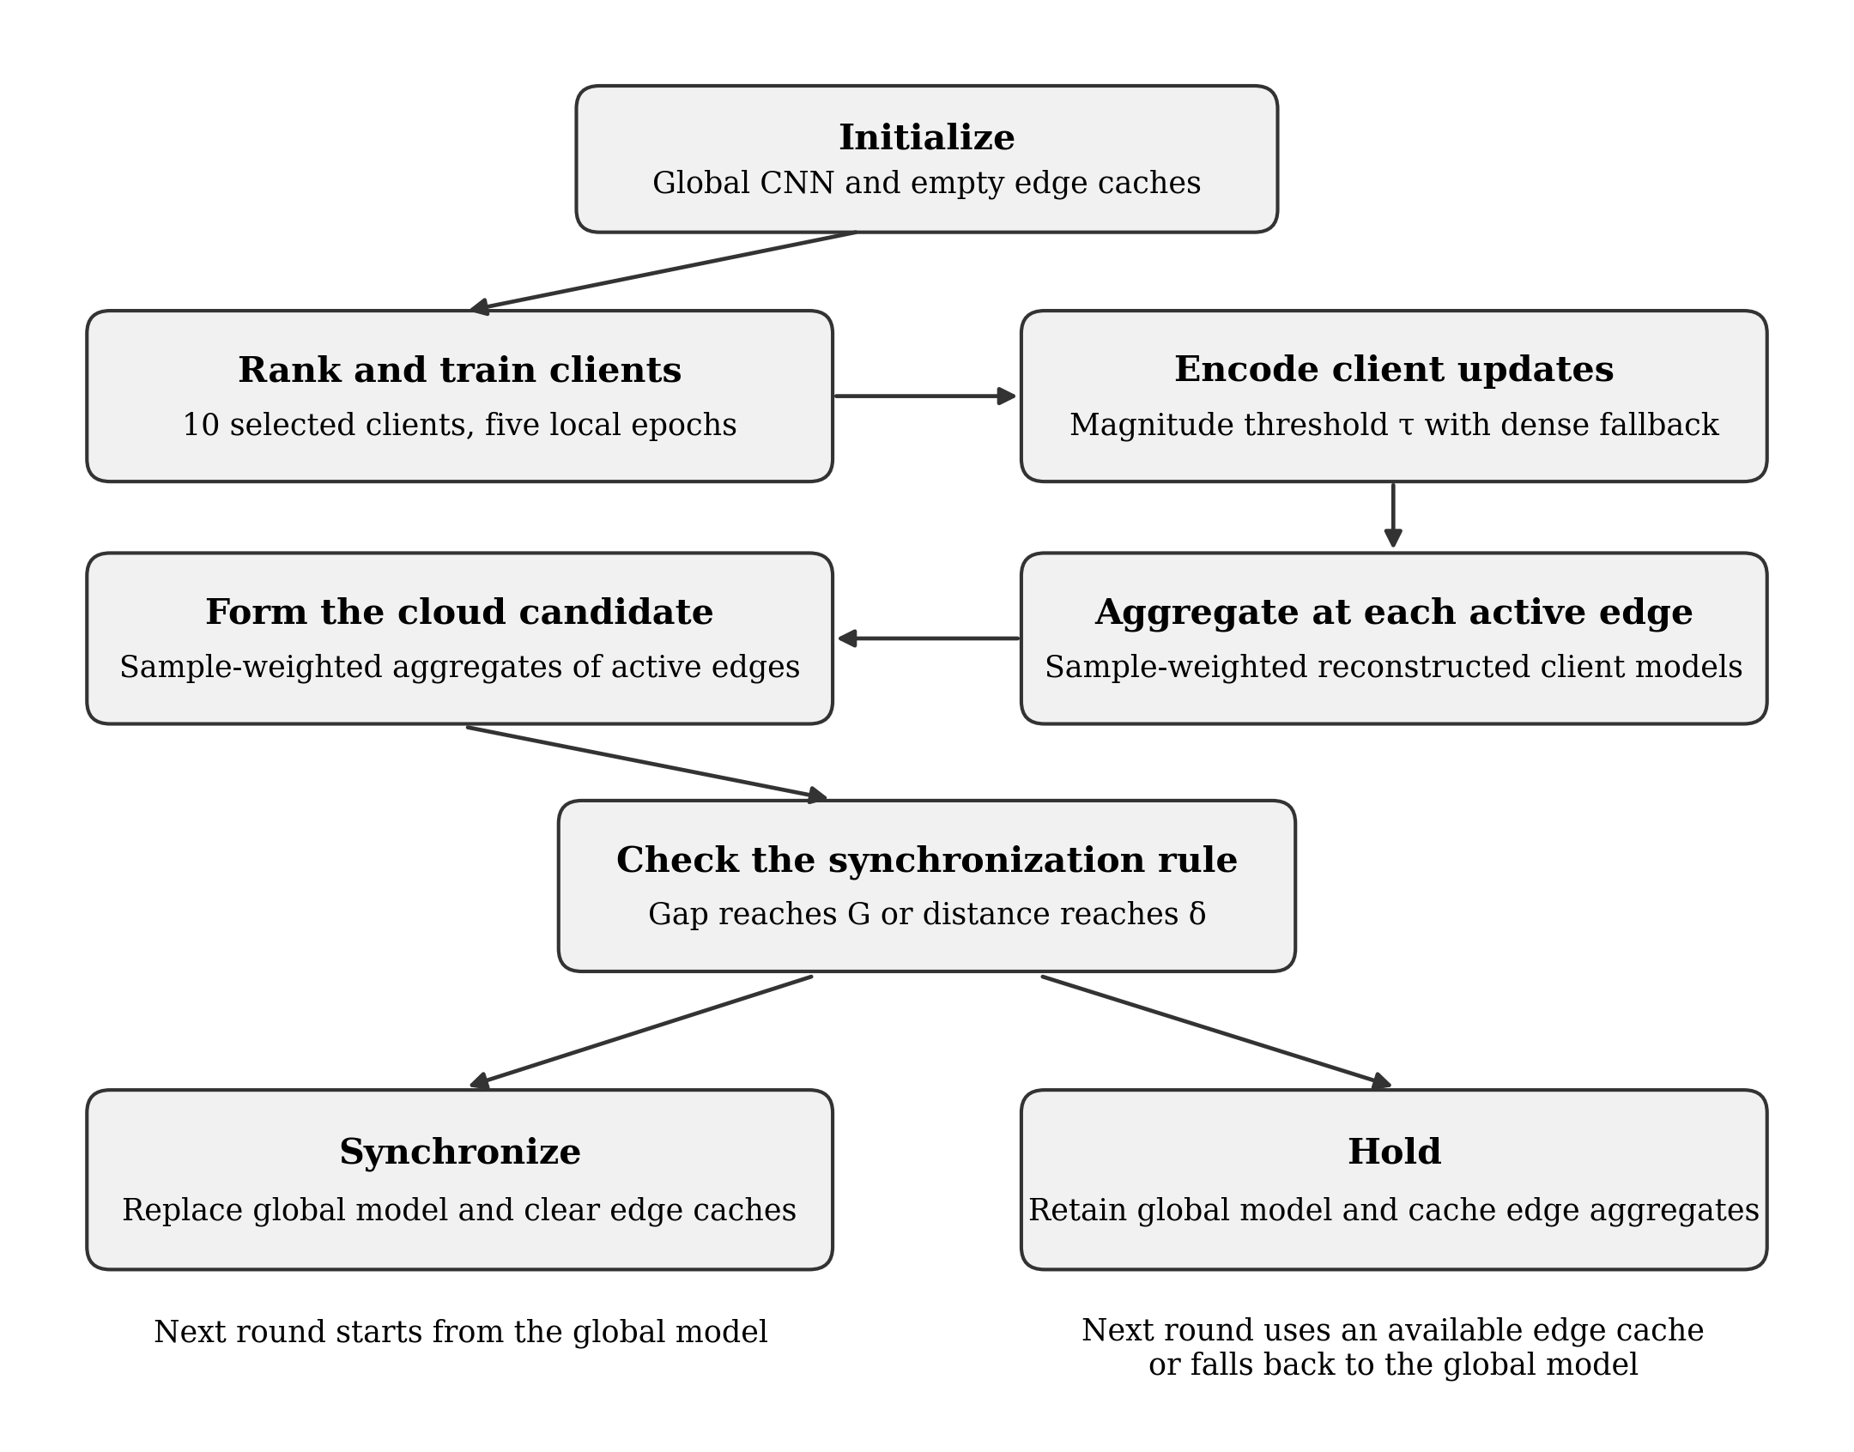
Figure 1. Conceptual workflow of the proposed AHCE-FL framework, from ranked client participation to conditional cloud synchronization.
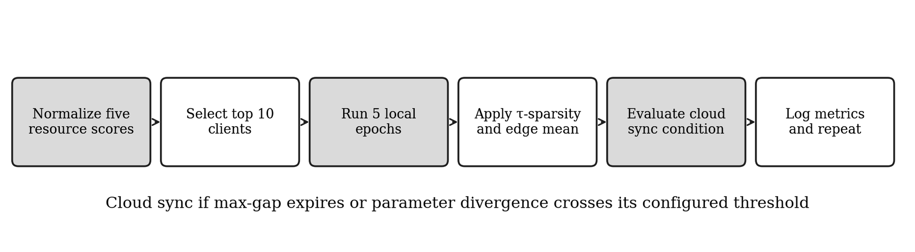
Figure 2. Operational sequence in the PyTorch simulator.
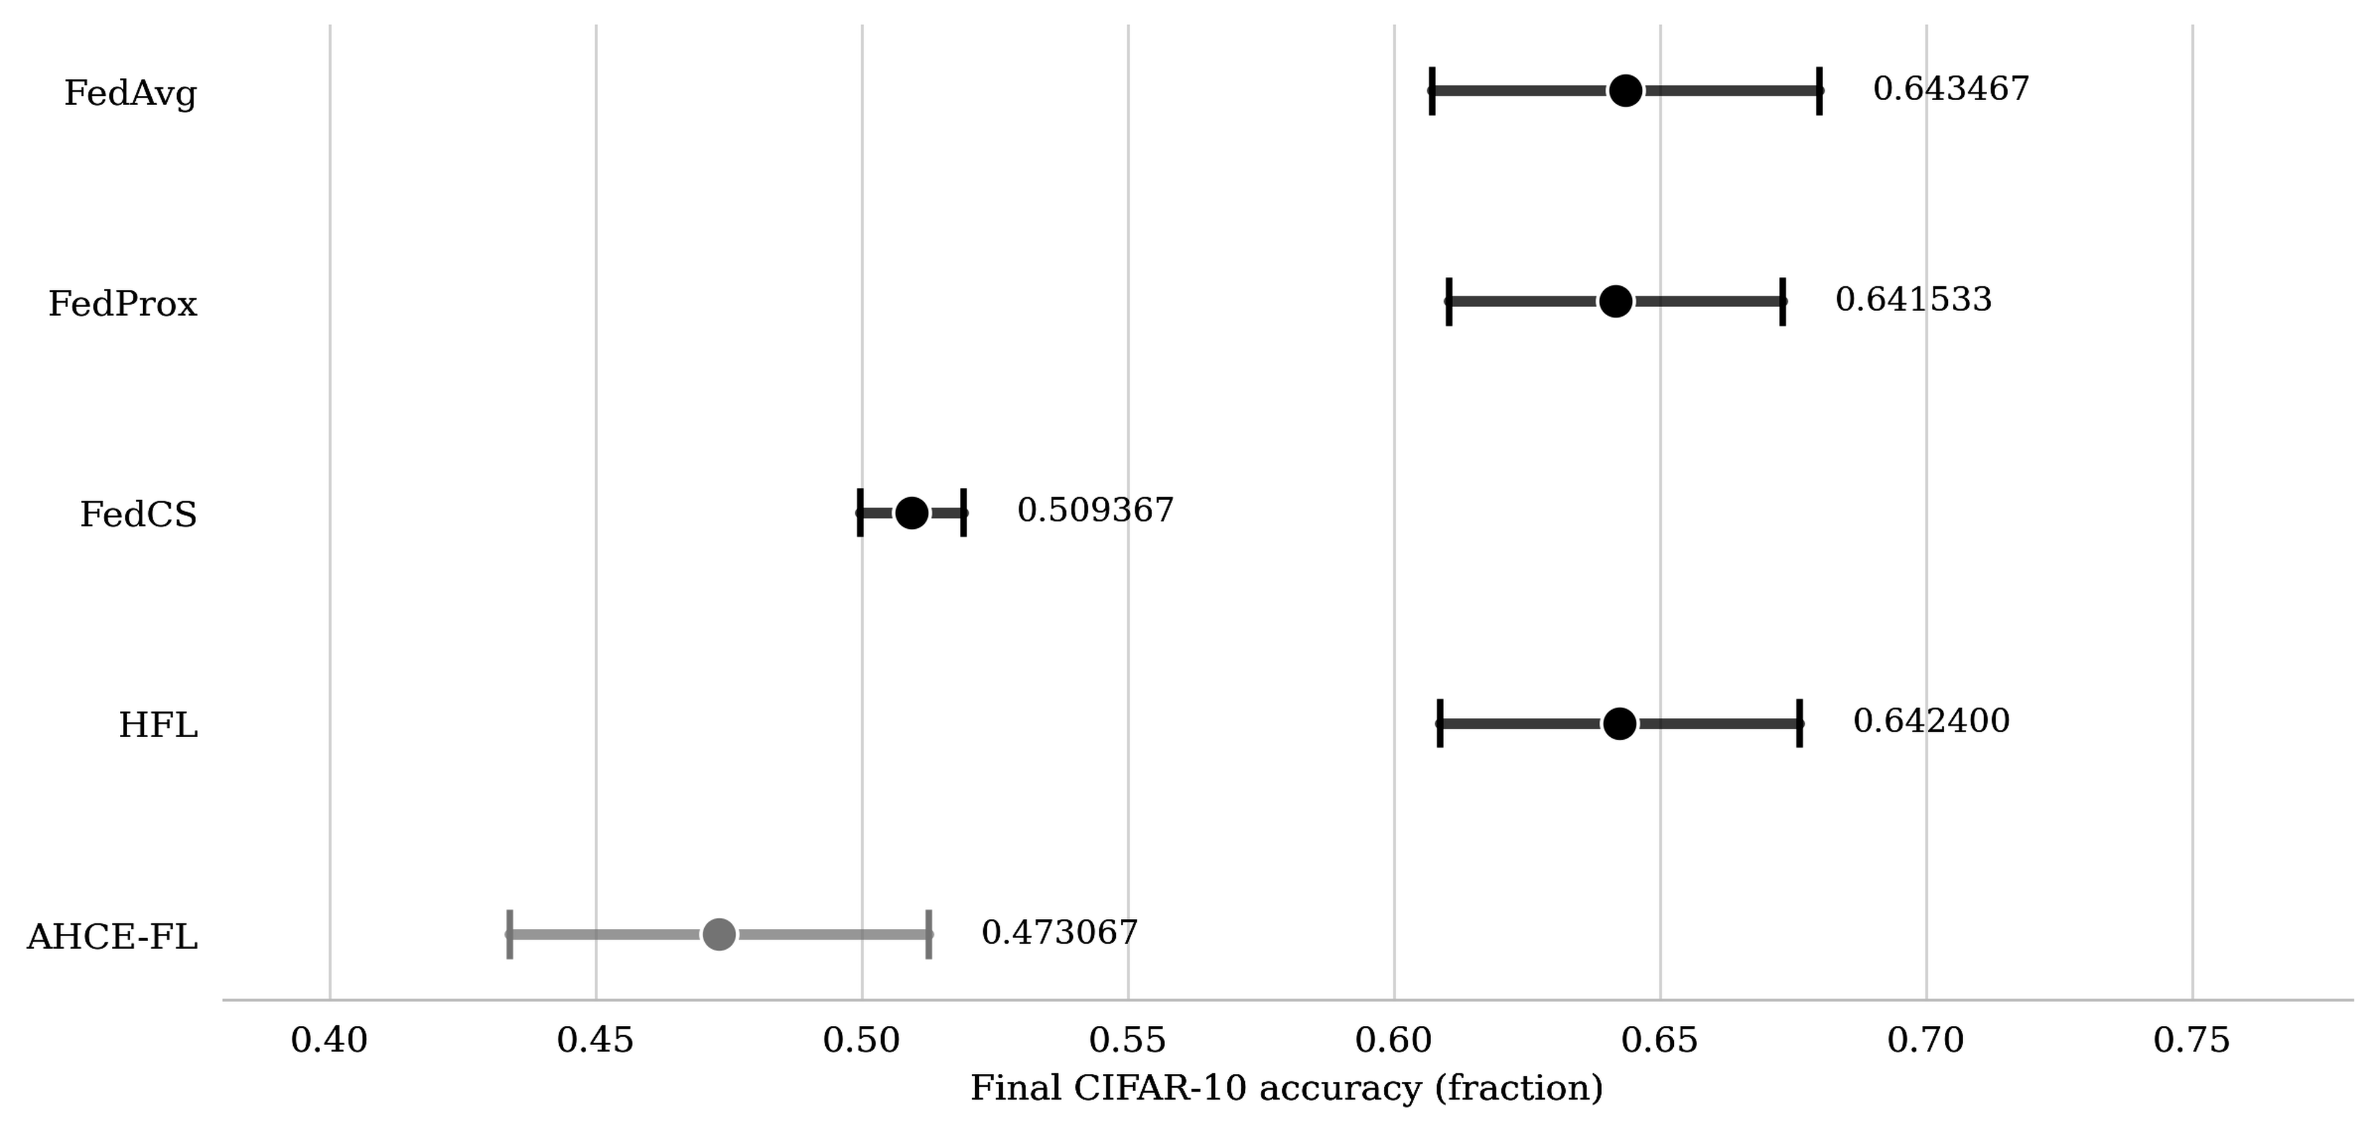
Figure 3. Mean final CIFAR-10 accuracy across three seeds. Bars show 95% Student-t confidence intervals for each method’s mean.
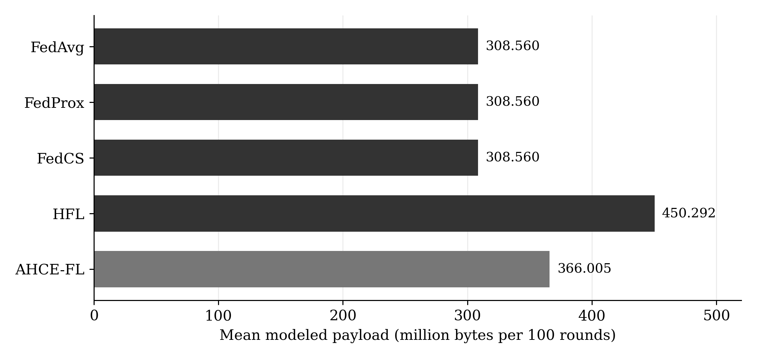
Figure 4. Mean modeled payload per 100-round baseline run. The flat baselines count each direct client–server transfer once.
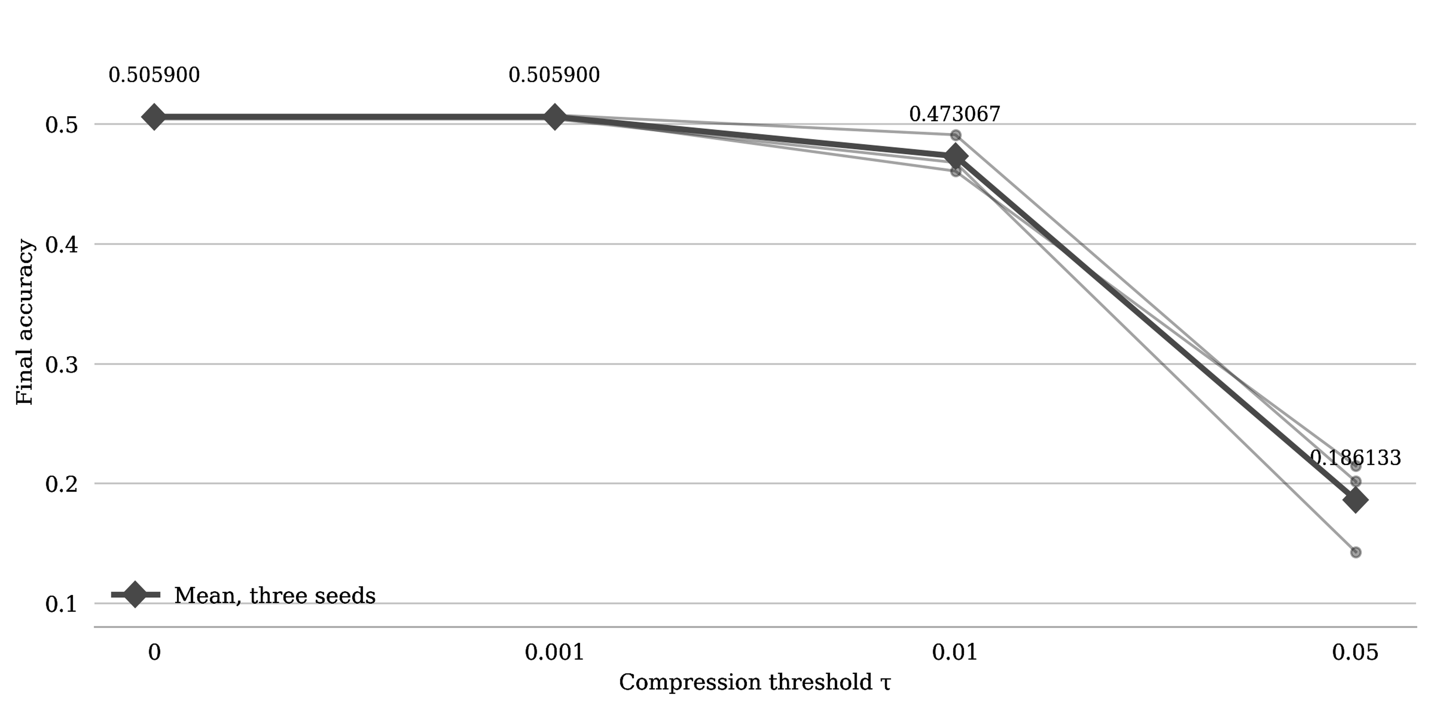
Figure 5. Final accuracy under four magnitude thresholds. Thin lines show individual seed trajectories, and diamonds mark the mean across three seeds.
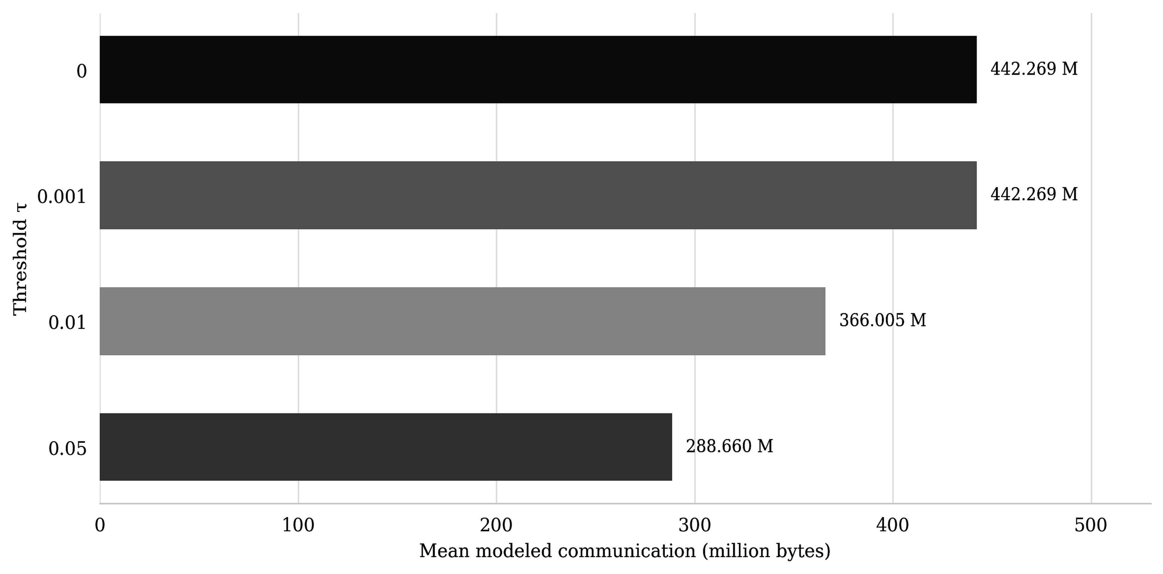
Figure 6. Modeled communication under four magnitude thresholds.
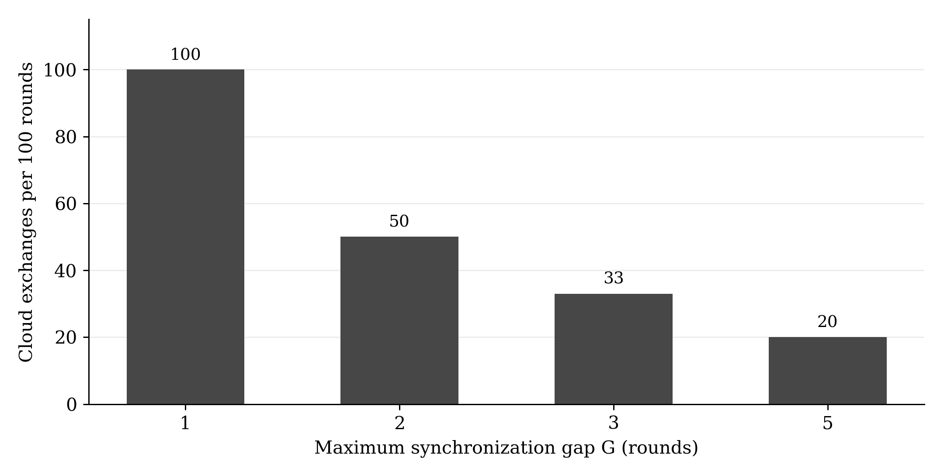
Figure 7. Completed cloud exchanges at the four tested maximum gaps in the corrected sweep.
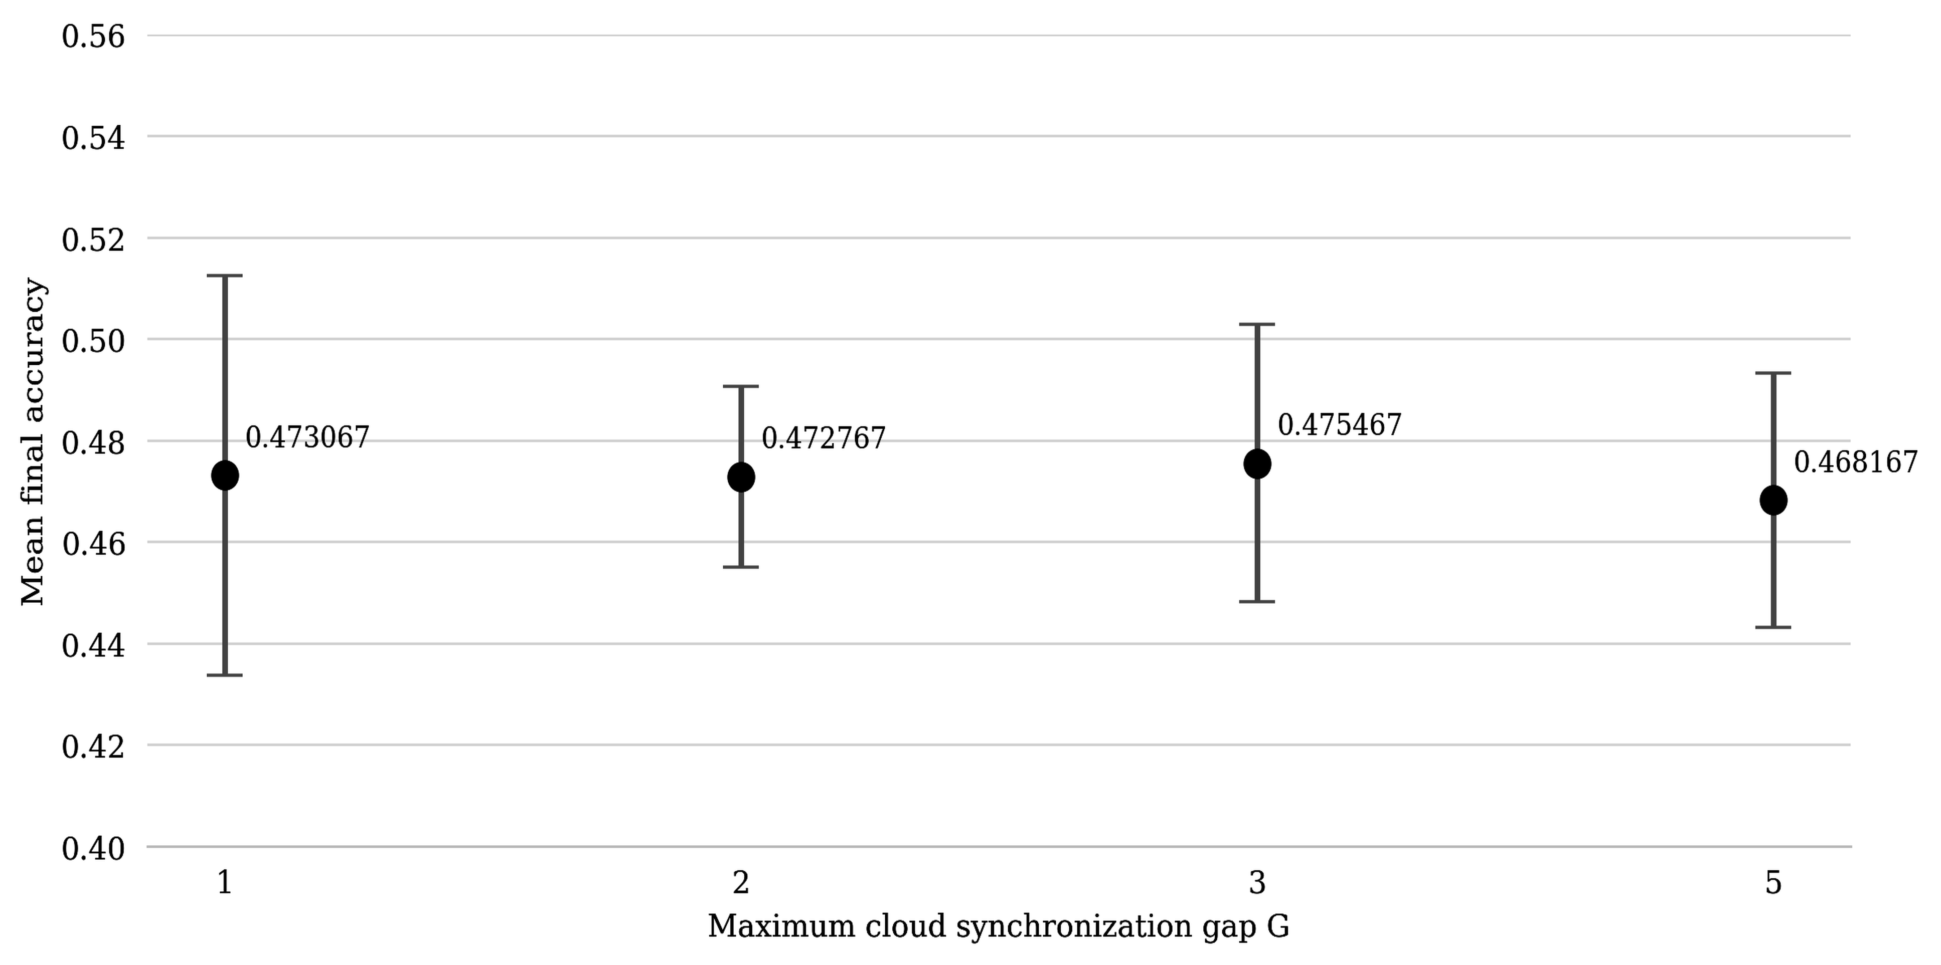
Figure 8. Mean final accuracy under isolated maximum-gap control. Bars show 95% Student-t confidence intervals for each setting’s mean across three seeds.
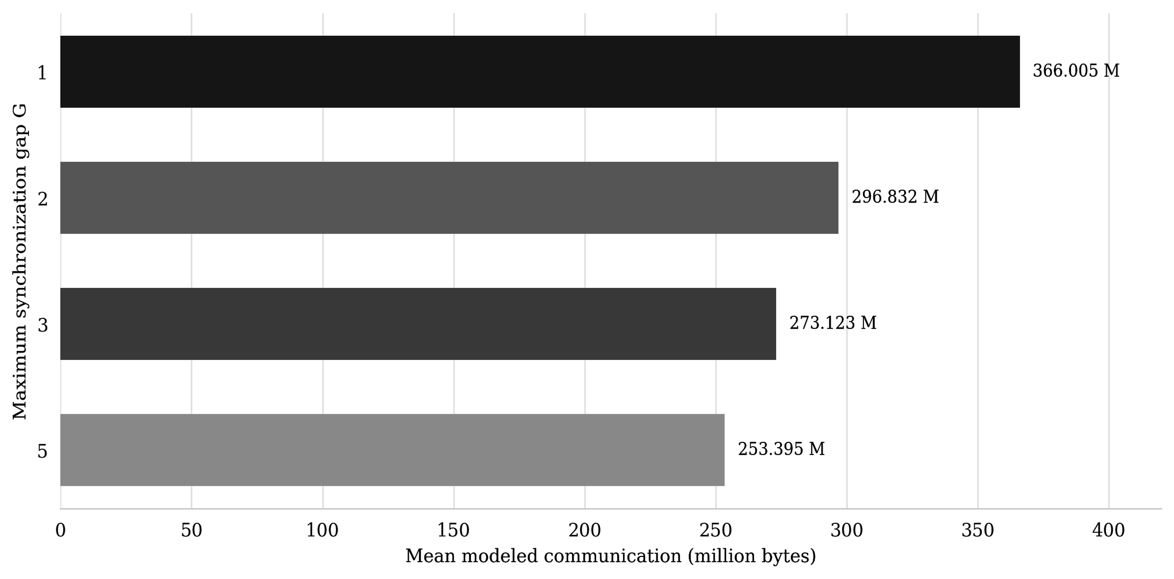
Figure 9. Modeled communication under isolated maximum-gap control.

