Local Attention Routing for Wireless Sensor Networks with Reliability and Latency Constraints
Shivam Bhardwaj¹*, Jitendra Nath Srivastava², Akash Sanghi³
¹,²,³ Faculty of Engineering and Technology, Invertis University, Bareilly, Uttar Pradesh 243123, India
Corresponding author: Shivam Bhardwaj, shibambhardwaj@gmail.com
Co-author emails: jitendranathshrivastava@gmail.com; sanghiakash@gmail.com
Running title: Risk aware local attention routing

Abstract
Routing feedback can change both forwarding decisions and the traffic they depend on. We evaluate local-attention constrained PPO routing through capacity-matched comparisons and packet-level wireless transfer. A 600-run telemetry study found no corrected architecture advantage, while the proof-based mechanism reduced delivery relative to a proof-disabled control. We then froze a receipt-assisted passive evidence ledger and evaluated 750 runs on 30 new fixtures. Under blackholes, censored feedback delivered 75.94% of packets versus 71.28% with active proofs, a gain of 4.67 percentage points (95% CI 2.36–6.97; Holm p=0.0161). The prespecified incremental gate passed, including non-inferiority to frozen-prior attention. Censoring and attention did not independently establish superiority over their matched controls. The evidence supports a bounded replacement of costly proof traffic. It does not establish live intrusion detection, hardware energy savings, general routing superiority or satisfaction of the original absolute service budgets.
Index Terms: Constrained reinforcement learning, Local attention, Risk-aware routing, Wireless sensor networks

I. Introduction
Wireless sensor networks (WSNs) serve distributed sensing, industrial monitoring, and smart infrastructure. Route selection is constrained by battery energy and must respond to changing radio links, queue conditions, and unreliable forwarding [1, 2, 3, 4, 5]. Traffic requirements also differ: a route suitable for delay-tolerant packets may be unsuitable for packets with short deadlines. A neighbor can look attractive in terms of expected transmissions or progress toward the sink yet become a poor choice when little deadline slack remains, its queue grows, or its forwarding record worsens.
Deep reinforcement learning (DRL) maps observations to sequential forwarding decisions through interaction with the network environment [6, 7, 8, 9]. Recent routing studies already combine value-based and policy-gradient learning with attention, graph neural networks, federated learning, trust information, and action masks [10, 11, 12, 13, 14, 15, 16, 17, 18, 19, 20, 21, 22, 23]. We therefore examine a specific design question: how does a local candidate-set representation affect routing outcomes compared with a fixed-slot representation when both receive the same information and training budget?
LA-CPPO processes each candidate-neighbor feature row with a shared encoder. A query derived from the packet context scores the candidates, so a permutation of their rows produces the same permutation of actor logits. The critic uses a masked mean of the encoded rows. The action set contains at most eight candidates, and the model has no node-specific parameters. Training combines a scalar reward with six cost channels: total delay violation and loss for each of three traffic classes. A Beta forwarding-trust model and a smoothed queue-excess signal provide online risk context without exposing attack labels to the controller.
The architecture, reward coefficients, training budget, seed list, co-primary endpoints, multiplicity correction, guardrails, and decision rule were fixed before confirmatory outcomes were generated. The two learning arms share the state content, candidate set, mask, reward, costs, simulator settings, and evaluation-seed scheme. Their policy and value representations differ. Hidden width is matched, but parameter count is not; the comparison estimates the difference between the two specified implementations.
LA-CPPO reduced the critical-class total delay-violation rate and passed the delivery and energy guardrails, while Class-0 mean delivered delay remained numerically higher. Exploratory analysis associated the violation reduction mainly with fewer losses and a larger share of delivered three-hop packets. We then evaluated two residual-slack variants under a separate development protocol. Neither qualified for confirmation, and the reserved confirmatory seeds remained unused.
This study sets out a candidate-equivariant actor and invariant critic, a six-channel QoS formulation that uses online forwarding evidence, and a prespecified comparison with a state-matched MLP. The empirical finding is a reliability–latency trade-off: the mean-delay endpoint failed, and the later development refinement was unsuccessful. These outcomes limit the conclusions that can be drawn about the method’s routing performance.

II. Related work

A. Classical WSN routing and quality metrics
Earlier WSN research established energy-aware organization, link quality, and distributed forwarding with low overhead as central routing concerns [1, 2, 3, 4, 5]. LEACH uses clustering to spread the energy burden [3], while ETX expresses expected transmission requirements in terms of loss probability [4]. RPL later provided a standardized routing framework for low-power and lossy networks [5]. These approaches remain useful baselines and design references. Their largely hand-designed rules, however, do not directly optimize heterogeneous application constraints as security and queue conditions change.

B. DRL routing, attention, and graph representations
Recent reviews show that DRL routing now spans value-based, policy-gradient, actor-critic, graph-based, and multi-agent methods across wired and wireless settings [10]. PPO has also entered QoS-aware ad hoc routing [17], while attention and hierarchical or multi-agent mechanisms appear in IoT-WSN routing frameworks [18, 23]. Local forwarder selection with DQN is used in opportunistic WSN routing [19], and graph-policy architectures are explicitly developed for routing generalization and permutation-related structural transfer [15, 16]. Consequently, PPO, attention, local-neighbor scoring, and permutation-aware learning cannot be claimed as individually novel primitives.
LA-CPPO shares candidate encoding and scoring across rows and pools the critic input symmetrically. A fixed-slot MLP receives the same serialized state. The historical comparison matches hidden width; the independent validation approximately matches total parameter count. Neither design matches every computational or architectural property.

C. Secure and trust-aware intelligent routing
Trust-aware routing was established before recent DRL methods. Yang et al. combined reinforcement learning with blockchain-based routing trust [11]. Subsequent studies use trust, cryptography, federated learning, or intrusion detection [21, 22, 24], and failure-risk-aware DQN routing incorporates reliability information into multi-hop decisions [14]. Comparisons between these approaches depend on what the router can observe. In LA-CPPO, attack labels remain inside the simulator; the policy receives forwarding observations, queue state, and the risk estimates derived from them.

D. Hybrid routing and clustering
Metaheuristic clustering and learned route selection are established hybrid designs. Wang et al. combine quantum-inspired Harris hawk optimization with DRL [12], and other IoT-WSN frameworks incorporate clustering or federated learning [13, 21, 23]. AF-v3 disables clustering, hierarchy masks, and the hard security shield to focus the primary comparison on local routing. A legacy ROA-based method is retained only as a descriptive baseline. Table I summarizes the methodological positioning.

III. System model and constrained routing problem

A. Network, radio, traffic, and threat model
The primary simulator uses N=100 static sensor nodes placed uniformly in a 150 m × 150 m region, with the sink at (75,75) m. Each node starts with 0.5 J. The nominal communication range is 50 m, packets are 4000 bits, and the physical data rate is 250 kbps. Radio energy follows first-order transmit/receive accounting with distance-dependent free-space and multipath terms. Link behavior also includes log-distance path loss, 3 dB shadowing, interference-dependent PDR, and up to three MAC retries. Queue pressure and interference persist across packet episodes and are refreshed at every sixth packet boundary rather than being reset for each packet.
Traffic is divided into three classes with generation probabilities 0.35, 0.45, and 0.20, deadlines of 90, 350, and 1500 ms, and target PDRs of 0.985, 0.96, and 0.90. Their delay-violation budgets are 0.015, 0.04, and 0.10. Class 0 is the critical low-latency class used for the co-primary endpoints. In the mixed-attack scenario, 25% of nodes are marked malicious for evaluation and are assigned blackhole, selective-drop, or flooding behavior internally. Selective dropping occurs with probability 0.65, while flooding raises local queue pressure. The policy observes neither the malicious-node labels nor the assigned attack types. Tables II and III summarize the configuration and threat-model visibility.

B. Virtual QoS debt
For each traffic class $c$, separate virtual queues track deadline-violation and packet-loss pressure. Let $u$ ∈ {d, ℓ} identify the deadline and loss channels, respectively. The index $n$ counts completed packets of class $c$; only that class is updated at its packet termination:
$Z_{c}^{\left(u\right)}\left(n\text{ + 1}\right)\text{ = max}\left\{\text{0, }Z_{c}^{\left(u\right)}\left(n\right)\text{ + }C_{c}^{\left(u\right)}\left(n\right)\text{ - }b_{c}^{\left(u\right)}\right\}\text{, }u\text{ ∈ \{d, l\}.}$ (1)
The binary event $C_{c}^{\left(u\right)}$ equals one for the corresponding terminal violation, as defined in Section III.D. Before entering the policy state, each debt is mapped to $\frac{Z_{c}^{\left(u\right)}}{\text{1 + }Z_{c}^{\left(u\right)}}$. The six transformed debts retain the ordering of accumulated QoS pressure while bounding the input scale. Debts from other classes remain unchanged at that termination. These virtual queues provide memory across packet episodes; they do not impose a hard per-packet delivery guarantee [25].

C. Label-free Bayesian forwarding risk
Every sensor starts with a Beta(1, 1) forwarding-trust prior. A forwarding observation at sensor $i$ has weight $w_{i}\text{ = clip(}{PDR}_{i}^{\text{exp}}\text{, 0.05, 1)}$. Success adds this weight to $α_{i}$; failure adds it to $β_{i}$. The posterior mean and standard deviation are $μ_{i}\text{ = }\frac{α_{i}}{α_{i}\text{ + }β_{i}}$ and $σ_{i}$, respectively. For rate excess $x_{i}\text{ = clip((}q_{i}\text{ - 0.4)/0.6, 0, 1)}$, the slow-state refresh applies $a_{i}\text{ ← 0.85}a_{i}\text{ + 0.15}x_{i}$. The mean risk and uncertainty-adjusted score are
$ρ_{i}\text{ = 0.75}\left(\text{1 - }μ_{i}\right)\text{ + 0.25}a_{i}\text{,}$ (2)
$ρ_{i}^{\text{UCB}}\text{ = clip}\left(ρ_{i}\text{ + 1.645 · 0.75}σ_{i}\text{, 0, 1}\right)\text{.}$ (3)
Here $q_{i}$ is normalized queue pressure and $a_{i}$ is its smoothed excess-rate signal. The standard deviation follows the Beta variance ${σ_{i}}^{2}\text{ = }\frac{α_{i}β_{i}}{{\left(α_{i}\text{ + }β_{i}\right)}^{2}\left(α_{i}\text{ + }β_{i}\text{ + 1}\right)}$. Both risk quantities enter the candidate state. Forwarding evidence updates the current transmitting sensor after an attempted hop; attack identity never enters this estimator. The UCB term is an uncertainty-aware routing score, not a calibrated intrusion probability or a supervised IDS prediction.

D. Constrained routing objective
Let $π_{θ}$ denote the next-hop policy. Consider a packet from class $c$ with deadline $D_{c}$. Let D denote its observed end-to-end delay. The terminal costs are
$\begin{aligned}C_{c}^{\left(d\right)}\text{ = 1}\left\{\text{not delivered or delivered with }D\text{ > }D_{c}\right\}\text{,} \\ C_{c}^{\left(l\right)}\text{ = 1}\left\{\text{not delivered}\right\}\text{.}\end{aligned}$
Loss therefore contributes to both channels. Continuing transitions have zero terminal costs. The six-element implementation vector stores the active class at positions 2c and 2c + 1. Delay-violation budgets are [0.015, 0.04, 0.10], and loss budgets are the complements of the target PDRs: [0.015, 0.04, 0.10]. The constrained scalar objective is
$\begin{aligned}{\text{max}}_{θ} J_{R}\left(θ\right)\text{ = }{\text{E}}_{π_{θ}}\left[\sum_{t\text{ = 0}}^{T\text{ - 1}}{γ^{t}r_{t}}\right]\text{,} \\ \text{subject to }J_{c}^{\left(u\right)}\left(θ\right)\text{ = }{\text{E}}_{π_{θ}}\left[C_{c}^{\left(u\right)}\text{ | class = }c\right]\text{ ≤ }b_{c}^{\left(u\right)}\text{,} \\ c\text{ ∈ \{0, 1, 2\}, }u\text{ ∈ \{d, l\}.}\end{aligned}$ (4)
The expectation in each constraint is conditioned on the packet class; a global average over all traffic would dilute the class-specific budget. Here $T$ is the number of forwarding decisions in the packet episode, and $γ$ = 0.99. The training routine estimates each class/channel rate from completed packets of that class in the current batch. Absent classes do not trigger multiplier updates. Section IV.E specifies the projected update and its order relative to PPO.
PPO uses reward and cost generalized advantages. With $Ā^{R}$ denoting the reward advantage after the batch-standardization rule in Section IV.E, the combined advantage is
$A_{t}^{\text{CPPO}}\text{ = }Ā_{t}^{R}\text{ - }\sum_{\text{c = 0}}^{2}{\left[λ_{c}^{\left(d\right)}A_{t,c}^{\left(d\right)}\text{ + }λ_{c}^{\left(l\right)}A_{t,c}^{\left(l\right)}\right]}\text{.}$ (5)
Equation (4) states the routing objective and class-specific service targets. Equation (5) is the implemented PPO training surrogate: it combines standardized reward advantages with unstandardized, discounted cost advantages. The projected multipliers respond to undiscounted terminal violation rates. This procedure provides a penalty-based approximation to constrained learning; it does not establish exact feasibility of Eq. (4) [7, 8, 9, 25].

IV. Proposed LA-CPPO routing architecture
LA-CPPO maps a packet context and a bounded set of neighboring candidates to a next-hop action. Figure 1 shows how the persistent network state, class-specific QoS debt and online forwarding-risk estimates enter that decision. Shared candidate encoders produce the actor logits, while a symmetric masked pool supplies the reward and cost critics. Packet outcomes update the observed state online; batches of completed episodes drive the policy, critic and multiplier updates during training.

A. Packet context and candidate preselection
For each forwarding decision $t$, we represent the observation by a context vector $x\text{ ∈ }{\text{R}}^{13}$, a candidate matrix $H\text{ ∈ }{\text{R}}^{\text{8 × 10}}$, and an eight-slot binary mask $m$. The context records the current energy fraction and queue pressure, sink distance relative to the deployment diagonal, remaining slack relative to the class deadline, a three-class one-hot vector, and six transformed QoS debts. We serialize the context and candidates into 93 values for batching, while retaining their distinct mathematical roles.
A candidate row records ten quantities: a sink indicator, residual-energy fraction, link PDR, normalized RSSI, queue pressure, normalized sink progress, mean posterior risk, risk-UCB, expected retries, and expected hop delay. We clip energy fractions and RSSI to [0, 1], with RSSI transformed as clip((RSSI + 110)/60, 0, 1). Sink progress is divided by the radio range and clipped to [−1, 1]. Expected retries use min(1/max(PDR, 10⁻³) − 1, 4)/4, and the delay feature is clip(expected hop delay/class deadline, 0, 2)/2. For a sink candidate, energy is one and queue/risk entries are zero. These transforms use fixed physical scales or ratios; their limits are not fitted through dataset-dependent min–max normalization.
Preselection considers alive, reachable neighbors that have not yet been visited, adding the sink when it is reachable. Candidate $j$ is ranked using
$s_{j}\text{ = 1.25}p_{j}\text{ + 0.75}{\text{PDR}}_{j}\text{ + 0.25}e_{j}\text{ - 0.55}ρ_{j}^{\text{UCB}}\text{ - 0.20}q_{j}\text{.}$ (6)
In this score, $p_{j}$ measures the reduction in sink distance divided by the radio range, $e_{j}$ is the residual-energy fraction, and $q_{j}$ is candidate queue pressure. We retain the eight highest-scoring candidates and zero-pad and mask any missing rows. The ranking determines which next-hop options are available; the actor makes the final choice. The mask excludes unavailable slots after physical and visited-node filtering. The environment enforces the 22-hop limit at termination, without an additional learned or security mask.

B. Shared local-attention actor
The context encoder $f_{x}$ and shared candidate encoder $f_{h}$ each contain two affine layers with tanh activations and hidden width $d$ = 96. The context query and candidate keys use bias-free linear projections. A candidate-wise bias network has widths 96 → 48 → 1 with a tanh hidden activation. Candidate $j$ receives the unmasked logit
$l_{j}\text{ = }\frac{\left\langle W_{q}f_{x}\text{(x), }W_{k}f_{h}\left(h_{j}\right)\right\rangle }{\sqrt{d}}\text{ + }b_{\text{act}}\left(f_{h}\left(h_{j}\right)\right)\text{.}$ (7)
All rows share the same encoding, projection and bias parameters. Masked slots receive logit −10⁹ before softmax. During training, the action is sampled from this categorical distribution; evaluation chooses its argmax. The bias function $b_{\text{act}}$ is distinct from the QoS budgets $b_{c}^{\left(u\right)}$. No node identifier, cluster role, attack label or global topology embedding enters the actor.

C. Invariant critics and representation properties
The critics use the masked mean $g$ of the encoded candidate rows:
$g\text{(H, m) = }\frac{\sum_{\text{j = 1}}^{K}{m_{j}f_{h}\left(h_{j}\right)}}{\text{max}\left(\text{1, }\sum_{\text{j = 1}}^{K}{m_{j}}\right)}\text{.}$
We concatenate $f_{x}\text{(x)}$ with $g$ to form a 192-dimensional input to the critic’s 96-unit tanh layer. Separate linear heads produce one reward value and six cost values. Applying the same permutation matrix $P$ to the candidate rows and mask gives the following identities through shared row operations and symmetric pooling:
$\begin{aligned}L\text{(x, PH, Pm) = P}L\text{(x, H, m),} \\ V\text{(x, PH, Pm) = }V\text{(x, H, m).}\end{aligned}$
Reordering the selected candidates therefore reorders the logits and masked action probabilities in the same way. The reward value and all six cost values remain unchanged. These identities apply after the candidate set has been selected. Ties can still affect node choice: deterministic argmax tie-breaking and selection at the top-K boundary need not preserve the chosen node after reordering. The representation property alone establishes neither network-size transfer nor superiority at equal capacity [26, 27]. Encoding and scoring grow linearly with K at fixed hidden width; the model does not use all-pairs candidate self-attention.

D. Hop reward and terminal-event handling
Once an attempted hop passes action validation, ${Δd}_{t}$ denotes progress toward the sink in metres, $R$ = 50 m is the radio range, $n_{t}$ is the number of transmission attempts, and $d_{t}$ is the hop distance. The base reward is
$\begin{aligned}r_{t}^{\text{hop}}\text{ = 0.90 clip}\left(\frac{{Δd}_{t}}{R}\text{, -1, 1}\right)\text{ - 0.20}q_{t}\text{ - 0.35}\frac{n_{t}E_{\text{tx}}\left(d_{t}\right)}{E_{0}} \\ \text{- 0.45 }{\text{1}}_{\left\{a_{t}\text{ ≠ sink}\right\}}ρ_{a_{t}}^{\text{UCB}}\text{ - 0.04 max}\left(n_{t}\text{ - 1, 0}\right)\text{.}\end{aligned}$ (8)
The selected target is $a_{t}$, the transmitting node’s queue pressure is $q_{t}$, and $E_{0}$ = 0.5 J. The term ${\text{E}}_{\text{tx}}\left(d_{t}\right)$ gives the transmit energy for one packet attempt. Equation (8) charges the transmitter’s attempts; the simulator tracks receiver energy separately. The indicator omits the candidate-risk penalty on sink-directed hops. Sink risk is zero, so no sensor-risk lookup is needed for the sink.
Before an attempted hop, the environment checks the selected slot and its range. An invalid, empty, or out-of-range action ends the episode with reward −3.0. For other actions, Eq. (8) applies even if forwarding fails. Failed forwarding adds −2.0. Successful delivery to the sink adds +2.5, with a deduction of 0.8 for late delivery. After a successful relay hop, a loop, the hop limit, or a dead end adds −2.0 and ends the episode. Continuing hops receive no terminal increment. The active class’s delay/loss costs and QoS debts update at packet termination, whereas forwarding-risk evidence updates after every attempted hop. We fixed all coefficients before observing the confirmatory outcomes.
Algorithm 1 summarizes a forwarding decision and the resulting transition.
Algorithm 1. One LA-CPPO forwarding decision
Input: Node i, class c, visited set S, policy θ, persistent network and QoS state.
Output: Next-hop transition (o, a, r, C, o′, done).
1. N ← alive, reachable neighbors of i outside S
2. if sink is reachable then N ← N ∪ {sink}
3. for each j ∈ N do
4. hⱼ ← CandidateFeatures(i, j, c); sⱼ ← Score(i, j) [Eq. (6)]
5. end for
6. H, m ← TopKAndPad({(sⱼ, hⱼ)}, K = 8)
7. x ← PacketContext(i, c, remaining slack, six QoS debts)
8. ℓ ← MaskedActor(x, H, m) [Eq. (7)]
9. a ← Sample(softmax(ℓ)) in training; argmax(ℓ) in evaluation
10. o′, r, C, done ← EnvironmentStep(a) [Eq. (8); terminal rules]
11. return ((x, H, m), a, r, C, o′, done)

E. Constrained PPO training and matched comparator
Each seed uses eight training updates, 50 complete packet episodes per update, and three full-batch PPO epochs per update. Reward and all six cost advantages use GAE with γ = 0.99 and λGAE = 0.95. If the reward-advantage standard deviation exceeds 10⁻⁶, its batch mean is subtracted and it is divided by its standard deviation plus 10⁻⁸; otherwise it is retained. Cost advantages are not standardized. Reward and cost return targets are computed before reward-advantage standardization [7, 8].
After collecting a batch, $Ĵ_{c}^{\left(u\right)}$ is the average terminal cost among packets of class $c$ in that batch. The multiplier starts at zero and is updated before the three PPO epochs:
$λ_{c}^{\left(u\right)}\text{ ← }{\text{Π}}_{\text{[0, 50]}}\left[λ_{c}^{\left(u\right)}\text{ + }η_{λ}\left(Ĵ_{c}^{\left(u\right)}\text{ - }b_{c}^{\left(u\right)}\right)\right]\text{, }η_{λ}\text{ = 0.03.}$ (9)
Equation (9) is applied only to classes represented in the batch; absent classes retain their multipliers. Projection clips both the lower and upper bounds. The resulting multipliers remain fixed across the three PPO epochs and are used in Eq. (5).
For policy ratio $R_{t}\text{(θ) = }\frac{π_{θ}\left(a_{t}\text{ | }o_{t}\right)}{π_{θ_{\text{old}}}\left(a_{t}\text{ | }o_{t}\right)}$, the clipped policy objective is
$L^{\text{clip}}\text{(θ) = }{\text{Ê}}_{t}\left[\text{min}\left(R_{t}\text{(θ)}A_{t}^{\text{CPPO}}\text{, clip}\left(R_{t}\text{(θ), 0.8, 1.2}\right)A_{t}^{\text{CPPO}}\right)\right]\text{.}$ (10)
The joint loss minimizes the negative of Eq. (10), subtracts 0.01 times mean policy entropy, and adds the reward and cost mean-squared-error terms. Each value error is first multiplied by 0.5 and then weighted by a further 0.5 in the joint loss; the cost error averages over transitions and all six channels. Adam uses learning rate 3 × 10⁻⁴, and the joint gradient norm is clipped at 1.0. Algorithm 2 states the implemented order.
Algorithm 2. Lagrangian PPO training
Input: Actor/critic parameters θ, ψ; class budgets b; frozen training configuration.
Output: Trained parameters θ, ψ and final multipliers λ.
1. λ ← 0
2. for update = 1, …, 8 do
3. B, Ĵ, active ← Collect(50 packet episodes; Algorithm 1)
4. Aᴿ, Gᴿ, Aᶜ, Gᶜ ← GAE(B; γ = 0.99, λGAE = 0.95)
5. Āᴿ ← StandardizeIfVarying(Aᴿ); retain the raw cost advantages
6. λ ← ProjectActive(λ, Ĵ − b; ηλ = 0.03, bounds [0, 50]) [Eq. (9)]
7. Aᶜᴾᴾᴼ ← CombinedAdvantage(Āᴿ, Aᶜ, λ) [Eq. (5)]
8. for epoch = 1, 2, 3 do
9. Form the clipped policy, entropy and value losses [Eq. (10)]
10. Backpropagate; clip gradient norm at 1.0; take one Adam step
11. end for
12. end for
13. return θ, ψ, λ

Evaluation uses 240 packet episodes in a newly initialized environment with separate seed offsets, the trained model weights, and deterministic actions. Forwarding evidence and QoS debts continue to update online during evaluation; the policy and critic weights remain frozen. The fixed-slot MLP receives the same 93 observation values, candidate mask, reward/cost signals, optimizer settings and training budget. Its two 96-unit tanh layers process the flattened observation, followed by actor and value heads.
The historical comparison was not parameter-count matched: attention had 63,368 parameters and the same-width MLP had 19,791. The separate new validation approximately matches total parameter count and is reported in Section IX. Neither design isolates architecture at equal computation cost.

V. Confirmatory experimental methodology

A. Prespecified hypothesis, estimands, and seeds
The confirmatory hypothesis required local attention to outperform the identical-state MLP on both Class-0 endpoints. Differences are reported as attention minus MLP, so negative values are favorable. Thirty fresh seeds were reserved before AF-v3 outcomes were generated and were not used for structural qualification, smoke tests, or development. Training-environment, Torch, NumPy, and evaluation streams use fixed seed offsets so that the evaluation stream does not simply continue the training stream. All 30 paired seeds were retained.
We estimate the across-seed paired differences in Class-0 mean delivered delay and Class-0 total delay-violation rate. A total violation includes either non-delivery or arrival after the 90 ms deadline. Using both endpoints makes the selection effect in delivered-packet latency visible: the mean can look lower when difficult packets are lost and never enter the delay calculation.

B. Statistical analysis and decision rule
For each co-primary endpoint, the prespecified analysis reports the paired mean difference, a two-sided 95% confidence interval, a paired t-test, Cohen dz, and a Wilcoxon signed-rank sensitivity analysis. We apply Holm adjustment to the two paired t-test p-values. Delivery and energy are assessed with two one-sided 95% non-inferiority checks: the lower confidence bound for the overall delivery-rate difference must exceed -0.01, and the upper confidence bound for the geometric energy-per-delivered-packet ratio must not exceed 1.05. A strict PASS requires favorable differences on both co-primary endpoints, both Holm-adjusted p-values below 0.05, and both guardrails to pass. It also requires all matched seeds, apart from a documented whole-seed integrity failure, and no protocol deviation.

C. Simulation data and evaluation samples
We generated the training and evaluation data as simulator trajectories. Each learning arm used 400 training packet episodes and 240 evaluation episodes per seed, giving 12,000 and 7,200 episodes across the 30 seeds. During evaluation, actions are deterministic but the environment remains stochastic. The realized Class-0, Class-1, and Class-2 counts are 2,514, 3,283, and 1,403 for attention and 2,527, 3,230, and 1,443 for the MLP. Random class draws and policy-dependent consumption of the random stream account for these differences. Training and evaluation start from separately initialized environments. There is no offline train–test split or supervised intrusion-detection dataset.

D. Random-stream pairing
Both policies use the same seed to initialize a network. Subsequent external events are not replayed from a policy-independent schedule, however. Source and traffic-class draws use the same environment random stream as some transition events, so different actions and episode lengths can alter later draws. The pairing therefore aligns the initial conditions without ensuring identical traffic, radio, or attack events thereafter. Separate random streams or replay of an exogenous event schedule would improve a future replication.

E. Reproducibility and protocol integrity
We fixed the architecture and analysis plan before evaluating efficacy. The AF-v3 E1 record is GitHub Actions run 34178527532 at source commit 0f60eb5; full identifiers and artifact digests are listed in the provenance manifest. An earlier execution completed the scientific computation but failed while writing provenance paths. The technical rerun preserved the architecture, seeds, coefficients, budgets, endpoints, and statistical rules.

F. Descriptive training diagnostics
Figure 2 follows training across the 30 seeds. Between archived update 0 and update 7, mean episode reward rose from 0.056 to 1.729 for attention and from −0.090 to 1.866 for the MLP. Mean training delivery rose from 0.534 to 0.749 and from 0.501 to 0.759, respectively. These curves show progress within the allocated budget, but they do not establish convergence or optimality. The shading represents pointwise 95% t intervals for the across-seed mean.

VI. Results

A. Co-primary confirmatory endpoints

Figures 3 and 4 show seedwise outcomes for both policies on the co-primary endpoints. Mean delivered delay is numerically higher under attention, and its confidence interval includes zero. It therefore meets neither the directional requirement nor the multiplicity-adjusted significance requirement. The Class-0 total violation rate falls by 0.03125 absolute, with its confidence interval entirely below zero and Holm-adjusted p=0.007703. The paired standardized effect is moderate (dz=-0.574). Both endpoints had to succeed, so these results do not confirm the prespecified superiority hypothesis. Table IV reports the paired inferential results.

B. Non-inferiority guardrails

Attention passed both non-inferiority checks. Overall delivery was higher on average, and energy per delivered packet stayed within the prespecified margin. The failed mean-delay endpoint nevertheless means that the joint success criterion was not met. Table V reports the estimates and frozen margins.

C. Descriptive baselines
Table VI reports static energy-risk-ETX and periodic ROA energy-risk-ETX routing as descriptive baselines. Both use the AF-v1 configuration, whose clustering, hierarchy, and shield settings differ from the primary experiment. These comparisons provide context but cannot isolate the effect of policy representation. They are therefore outside the confirmatory endpoint family and strict decision rule.

VII. Exploratory mechanism analysis
The analyses in this section were carried out after the confirmatory decision and are treated as exploratory. They are used to understand why the two primary endpoints moved differently; they do not modify the pre-specified verdict or introduce a new success criterion.

A. Exact decomposition of total violation
For Class 0, a total violation consists of one of two mutually exclusive outcomes: the packet is not delivered, or it is delivered after the 90 ms deadline. The attention-minus-MLP difference is -0.027483 for Class-0 loss and -0.003771 for the delivered-late fraction. These components sum to -0.031254, exactly reproducing the confirmatory total-violation difference. In magnitude, about 87.9% of the observed improvement therefore comes from fewer losses rather than from fewer late deliveries. Table VII summarizes this decomposition.

B. Route-length composition and survivor bias
Figure 5 shows the route-length composition. Among delivered Class-0 packets, attention increases the per-seed mean hop count by about 0.0648 and the three-hop share by about 0.0458. Within a fixed hop count, pooled delivered delays are not higher for attention: 30.083 versus 30.136 ms at one hop, 60.926 versus 62.098 ms at two hops, and 90.196 versus 96.368 ms at three hops. The larger difference is in route composition: attention delivers 186 three-hop Class-0 packets, whereas the MLP delivers 75.
The pooled delivered means are 52.19 ms for attention and 51.26 ms for the MLP. Reweighting attention’s within-hop means with the MLP hop proportions gives 50.35 ms. This calculation is consistent with route composition contributing to the observed delay difference. It does not establish that attention causally improves delay within comparable packets: the delivered populations differ, and the reweighting is neither randomized nor a mediation analysis.

C. Security-drop pattern
The overall security-drop rate is 0.0308 for attention and 0.0649 for the MLP, and the paired Class-0 delivery difference is approximately +0.0275. These descriptive results are consistent with greater use of lower-risk forwarding opportunities. The logs do not identify which individual packets would have survived under both policies, so they cannot establish a causal path from risk scoring to route length and delay.

VIII. Development-only residual-slack sensitivity
After AF-v3 E1, we fixed a separate AF-v4 development protocol and evaluated two residual-slack attention variants against a state-matched slack-aware MLP on 20 fresh seeds. Neither met the selection criteria. The candidate-minus-MLP Class-0 mean-delay differences were +3.226 ms for the slack-feature model and +1.628 ms for the slack-monotone model, although both delivery and energy guardrails passed. No candidate was selected, and the 30 reserved AF-v4 confirmatory seeds remained unused. Appendix A reports the criteria, intervals, and decision.

IX. Independent reviewer-led validation
This validation was specified separately after the historical AF-v3 and AF-v4 programs. The original gates and outcomes remain unchanged. Thirty new evaluation seeds, 41001–41030, were fixed before the new outcomes were generated. Each arm received eight updates of 50 training episodes and three PPO epochs per update. Trained weights were evaluated for 240 episodes in each setting and retained as checkpoints.
The attention model contains 63,368 parameters. The nearest-size fixed-slot MLP contains 63,554. Its width was chosen from parameter count alone. This controls total parameter count approximately; compute, layer structure and inductive bias remain different. Two additional attention arms remove risk from candidate features, preselection and reward, or observe only 80% of forwarding outcomes. The latter is a missing-feedback sensitivity analysis, not a live-traffic implementation.
Separate seeded generators govern traffic selection, queue dynamics, attack transitions, radio draws and feedback omission. Radio consumption therefore does not alter later traffic-class draws. Policy-dependent radio and attack draws remain possible, and source eligibility can diverge after node death. The experiment does not replay an identical per-edge external-event schedule.
The nominal comparison family consists of the six paired tests formed by three comparators and two critical-class endpoints. Holm correction is applied jointly to these six tests. Paired 95% intervals are unadjusted. Transfer evaluations retain the trained weights and change only the node count to 200 in the same area or the malicious-node ratio to 10% or 40%. These secondary results measure sensitivity; increasing density is not a density-preserving scalability test. Table IX summarizes the nominal and transfer outcomes.
Against the capacity-matched MLP, attention changed mean delivered delay by +0.8205 ms (95% CI -0.1212 to +1.7623; Holm p=0.3409). Total violations changed by -1.5223 percentage points (95% CI -2.7538 to -0.2909; Holm p=0.08581). Table VIII reports all nominal comparisons, and Fig. 6 shows their effect intervals. Unfavorable and inconclusive contrasts are retained.
In the nominal simulation study, forwarding observations come from simulator outcomes. The separate UDP diagnostics below validate packet/feedback software integration but retain synthetic link features and omit realistic radio overhead.

A. Packet feedback and frozen policy integration
The software feedback adapter sends an actual UDP datagram to the selected relay and accepts an acknowledgment only from the intended endpoint with matching sequence and nonce. A separate sink socket witnesses downstream receipt before the relay acknowledges forwarding. The acknowledgment or timeout updates the Bayesian posterior before the next observation and policy inference. No attack label or fault-target identifier is supplied to the policy. Nonces prevent packet confusion but do not authenticate peers. Expected link PDR remains model-derived. In the simulator, a hop outcome is credited to the current transmitting node; in the UDP diagnostic, a downstream receipt is credited to the selected relay after its relay-to-sink forwarding. The observation point differs, so the diagnostic is an interface-transfer test rather than a bitwise reproduction of simulator feedback.
A preliminary periodic-fault fixture changed policy probabilities but produced no next-hop changes in 360 attempts. A subsequent persistent initial-relay fault diagnostic used all 30 frozen attention checkpoints and 30 fresh fixtures. Twenty-five fixtures selected an alternative relay; five did not. In the 25 first-switch decisions, the faulty relay remained a candidate and was unmasked. These exploratory diagnostics motivated the separately specified capacity comparison below; they are not confirmatory trials.

B. Shared target capacity comparison
Thirty fresh topology seeds, 73001–73030, were paired with the existing attention and capacity-MLP checkpoints, 41001–41030. Each fixture used two shared fault targets: the relay initially preferred by attention and the relay initially preferred by the MLP. Both controllers faced both targets for 30 attempts each. No model was retrained or selected after the outcomes. Source position, energy, queues and QoS state stayed fixed within each run; only forwarding-risk posteriors evolved. The relay fault was persistent and targeted, rather than a sample from a random malicious-node distribution.
The two target choices coincided in 26 fixtures. We averaged their outcomes within fixture before paired inference, retaining n = 30 rather than treating the 120 executed runs as independent experiments. Both policies initially chose the faulty relay in 56 of their 60 scenarios. Mean sink delivery was 85.39% for attention and 32.22% for the capacity-matched MLP. The paired difference was 53.17 percentage points (95% Student-t interval, 35.31–71.02; two-sided paired p = 1.246 × 10⁻⁶). Attention performed better in 21 fixtures, tied in eight and worse in one. Table X and Fig. 7 report these diagnostic outcomes.

C. Verification and interpretation limits
Across 3,600 attempts, the sink witnessed 2,117 deliveries and 1,483 attempts timed out. The adapter and sink witness agreed on every recorded outcome. A separate verifier reconstructed the observations, risk posteriors, checkpoint hashes, policy probabilities and selected actions for all records. All 47 repository tests passed. This verifies internal software consistency; it is not an external packet-capture or authenticated observer audit.
The UDP payload is a seven-byte fixture message plus JSON metadata, not the simulator’s 4,000-bit application packet. Relays communicate directly with the localhost sink regardless of radio reachability. The 20 ms timeout is a harness setting, not a measured wireless deadline. MAC contention, fading, sleep currents, acknowledgment energy and distributed authentication are absent. The positive diagnostic therefore supports a feedback-responsive frozen routing pipeline in this targeted fixture, while the earlier nominal co-primary results remain unchanged.

D. Topology constrained radio feedback
An initial ns-3.44 LR-WPAN transfer used 30 new fixtures, seeds 75001–75030, and both frozen architectures under benign and 25% blackhole conditions. All selected hops obeyed a 50 m radio range. Forwarding proofs were separate reverse radio frames emitted after downstream MAC success. Across 120 runs and 3,600 packets, the trace verifier reconstructed 5,840 actions and checked 2,240 received proofs. Under blackholes, delivery was 91.89% for attention and 87.44% for the capacity MLP, a paired gain of 4.44 percentage points (95% CI 1.91–6.98; four-test Holm p=0.00494). Both delivered all benign packets. This first transfer retained synthetic candidate features and did not integrate radio energy; it is exploratory evidence from a clean, low-load setting.

E. Local telemetry and radio overhead controls
A subsequent transfer replaced synthetic observations with local measurements and delayed neighbour reports. Thirty disjoint fixtures, seeds 76001–76030, each paired the corresponding checkpoints trained on seeds 41001–41030. The 600 runs cross five conditions with attention, the capacity MLP, attention with risk disabled, and attention with forwarding proofs disabled. Each run generates 60 packets. Source schedules, traffic classes and uniform blackhole sets are policy independent. The high-load condition compresses the source interval from 20 ms to 2 ms; the weak-link condition increases reference propagation loss from 40 to 54 dB. Technical pilot seed 75901 is excluded. The configuration was fixed before these evaluation outcomes, but this program is an exploratory transfer rather than a preregistered confirmatory study.
Each node maintains its own risk posterior, link-success counts and service-time estimate. Untried links use a declared Beta(9,1) prior. Energy and queue reports arrive through 64-byte radio beacons every 500 ms, staggered across nodes, and expire after 750 ms. Unknown neighbours are unavailable to the policy. Candidate geometry is configured in advance. The former RSSI-proxy slot now contains received LQI divided by 255; this semantic change and the new telemetry distribution make the experiment a frozen-policy transfer, not an exact reproduction of the training observation model. Queue occupancy is pending MAC requests divided by 32. A source updates service debt from radio delivery receipts relayed along the reverse path, or from a 1.5 s receipt timeout; the controller does not receive sink-delivery ground truth for that update.
All radios are integrated over a common four-second horizon. The assumed current model uses 3 V, 17.4 mA during transmission, 18.8 mA during reception or listening, and 20 microampere during the off state. These are explicit simulation assumptions, not hardware measurements. PHY state residence times include data, proof and beacon frames, reverse delivery receipts, MAC acknowledgments and retransmissions. Sensor-radio energy excludes the sink, which is reported separately. Each 64-byte application frame contains 12 identifier bytes and 52 payload bytes. CPU inference, cryptography and physical sensor energy remain uncharged. The payload differs from the historical 4,000-bit packet; cross-program energy values are not directly comparable.

F. Telemetry transfer results and interpretation
Table XII reports the paired architecture comparison. The inferential unit is the independent fixture, n=30. One 45-test Holm family covers five conditions, three comparators and three endpoints: delivery, critical-class total violation and radio energy per delivered payload byte. Unadjusted 95% paired t intervals accompany each effect. All contrasts, including unsuccessful ablations and undefined energy ratios, remain in the machine-readable results. The proof-disabled arm removes both proof traffic and proof-driven risk updates; it is a joint feedback-cost control, not a pure airtime intervention.
In benign conditions, attention delivery was 80.11% and capacity-MLP delivery was 79.33%. The paired delivery difference was +0.78 percentage points (95% CI -0.56 to +2.11; Holm p=1). The critical-violation difference was -0.65 percentage points (Holm p=1).
In blackhole conditions, attention delivery was 68.22% and capacity-MLP delivery was 66.72%. The paired delivery difference was +1.50 percentage points (95% CI -0.84 to +3.84; Holm p=1). The critical-violation difference was -1.87 percentage points (Holm p=1).
In congested benign conditions, attention delivery was 24.61% and capacity-MLP delivery was 24.17%. The paired delivery difference was +0.44 percentage points (95% CI -1.00 to +1.89; Holm p=1). The critical-violation difference was -0.72 percentage points (Holm p=1).
In congested blackhole conditions, attention delivery was 23.61% and capacity-MLP delivery was 22.89%. The paired delivery difference was +0.72 percentage points (95% CI -0.42 to +1.86; Holm p=1). The critical-violation difference was +0.31 percentage points (Holm p=1).
In weaklink benign conditions, attention delivery was 77.89% and capacity-MLP delivery was 77.94%. The paired delivery difference was -0.06 percentage points (95% CI -1.75 to +1.64; Holm p=1). The critical-violation difference was +0.46 percentage points (Holm p=1).
The feedback control exposes a practical cost. Disabling forwarding proofs increased delivery by 5.06 percentage points in benign traffic, 7.50 points under blackholes and 6.89 points in the weak-link setting (Holm p=0.00444, 0.00222 and 0.03060). Under blackholes, enabling proofs increased critical violations by 8.95 points (Holm p=0.00947) and energy per delivered byte by 0.001158 J/B (Holm p=0.02322). No capacity-MLP contrast survived the 45-test correction. These results do not support a net benefit from the evaluated proof-driven risk mechanism. Because proof removal also disables its risk updates, the comparison does not isolate whether traffic overhead or changed routing decisions caused the difference.
Across the 90 attack-free attention runs, 2022 forwarding timeouts occurred at benign relays. Missing forwarding evidence therefore cannot be interpreted as an attack label. Beacon contention, incomplete neighbour caches and receipt loss alter the available action set and service debt. The verifier reconstructs the complete recorded feature vectors and frozen actions, replays local risk updates, checks valid data/proof paths, and verifies the state-time energy identity for every node. Cache snapshots are linked to transmitted beacon values; raw beacon-reception callbacks and QoS/link-history updates are not independently replayed. This is an internal reproducibility audit, not an external capture or intrusion-detection validation.

G. Receipt assisted censoring and locked holdout validation
The 76001–76030 telemetry fixtures informed one feedback redesign and were not reused for its inference. The new ledger combines passive forwarding observations with delivery receipts already present in the network. Overhearing is established watchdog practice and has known collision, receiver-loss and collusion ambiguities [28]; no invention of watchdog monitoring is claimed. The tested change conditions credit on the observer’s own successful MAC acknowledgment, censors missing evidence, and deduplicates repeated observations without generating separate proof packets. A received forwarding frame supplies half-strength evidence of an attempt; a reverse delivery receipt supplies full-strength evidence of path delivery. Neither observation is an authenticated attack label.
For observer u, selected relay v and packet p, the ledger retains the strongest observed evidence s and the already credited amount c. A passive frame and a delivery receipt cannot accumulate beyond one unit for the same record. The evidence-strength rule is
$s_{uvp} ← max\{s_{uvp}, 0.5 I_{overheard}, I_{receipt}\} (11)$
Only after the first-hop MAC acknowledgment succeeds and the uncredited evidence is positive, the observer increases the relay’s effective trust count using its expected link-success weight q:
$α_{uv} ← α_{uv} + clip(q_{uv} max\{0, s_{uvp} − c_{uvp}\}, 0.05, 1), c_{uvp} ← s_{uvp} (12)$
The corresponding failure count remains at its prior in the censored arm. Failed first links and missing observations do not increment it. A late receipt can still resolve an acknowledged but censored record. These effective counts supply the existing routing score; their asymmetric observation process does not define a calibrated probability of maliciousness. The rate-anomaly term is inactive in this transfer. The naive passive control uses the same evidence and deduplication but penalizes missing acknowledged forwarding, whereas the active-proof control retains the earlier proof and timeout convention.
Design, implementation and decision criteria were published at commit 4027f071322cb5682f39329f656d76df3b68ff62 before evaluating the new fixtures. Seeds 77001–77030 pair with the unchanged checkpoints trained on 41001–41030; technical pilot 76901 is excluded. Five arms cross the same five radio/traffic settings, producing 750 runs and 45,000 source packets. The additional controls are frozen-prior attention, which retains the same initial risk coordinates without updates, and the capacity-matched MLP with the censored ledger. All arms retain the existing beacon, reverse-receipt and listening costs. No extra listening mode is enabled; an actual duty-cycled implementation may incur different acquisition and CPU costs.
The 60 two-sided paired tests form one Holm family. The all-required mechanism gate combines a positive, Holm-significant blackhole delivery contrast against active proofs with three one-sided 95% non-inferiority checks against frozen-prior attention: delivery above −1 percentage point, critical violations below +1 point, and geometric energy per delivered byte below a 1.02 ratio. This is a bounded incremental criterion, not the original absolute QoS constraint or a field-deployment criterion.
Under blackholes, censored passive attention delivered 75.94% of packets and active-proof attention delivered 71.28%. The paired gain was 4.67 percentage points (95% CI 2.36–6.97; Holm p=0.0161). Radio energy per delivered payload byte decreased by 0.0006443 J/B (95% CI −0.0009740 to −0.0003145; Holm p=0.0239). The critical-violation decrease of 4.52 points did not survive the 60-test correction. No other setting’s delivery contrast against active proofs survived that correction. Figure 8 shows the unadjusted delivery intervals; Table XIII reports the blackhole contrasts.
The frozen-prior comparison changed blackhole delivery by only +0.056 points (95% CI −0.498 to +0.609; Holm p=1). Its one-sided lower delivery bound was −0.405 points, the upper critical-violation bound was +0.925 points, and the upper geometric energy ratio was 1.00505. All frozen gate checks passed. Neither the naive passive control nor the censored capacity MLP was significantly worse than censored attention on the blackhole endpoints. The result supports replacing the costly proof-based mechanism under the specified conditions; it does not demonstrate a unique performance benefit from censoring, from updating evidence, or from attention itself.
All four passive or frozen-prior arms emitted zero forwarding-proof packets; the active arm requested 3,369 across its 150 runs. The audit reconstructed 67,522 feature/action decisions, 24,747 matched passive observations, 28,353 evidence updates and 75,750 node-energy identities. It checked the selected relay, observer range, data-frame provenance, local risk counts and per-record deduplication. These internal traces do not provide external packet-capture, authenticated-feedback or IDS validation. Absolute critical-class violations remain about 26% in the blackhole setting, far above the original 1.5% budget.
Beacon energy and queue values are carried in simulator-side metadata keyed to a transmitted beacon identifier and become available only after an actual radio receive event. Their values are not decoded from serialized beacon fields. The charged 64-byte beacon frame is therefore a modeled telemetry transport, not a demonstrated embedded wire implementation. Geometry and packet-class configuration are also simulator inputs; this transfer does not establish a distributed embedded deployment.

X. Discussion

A. Reliability and delivered-packet delay
In the tested 100-node mixed-attack setting, LA-CPPO lowered Class-0 total violations relative to the fixed-slot MLP under the same training budget. Both the Holm-adjusted paired t-test and the Wilcoxon sensitivity analysis supported this endpoint, and the delivery and energy guardrails passed. Because non-delivery counts as a violation, the improvement chiefly reflects a useful reliability gain.
Passing the relative guardrails does not imply that the absolute class budgets were met. The across-seed Class-0 total-violation and loss rates under attention were 0.1242 and 0.0480, respectively, against budgets of 0.015 for each channel. Class-1 rates also exceeded their 0.04 budgets. Table XI reports all six descriptive rates. The finite-budget Lagrangian training procedure therefore did not establish empirical constraint satisfaction in the evaluated setting.
Attention had a numerically higher mean delivered delay, with a confidence interval spanning zero, and the joint success criterion failed. Mean delay among delivered packets can favor a policy that loses the more difficult traffic. The reliability gain must therefore be read alongside this unsuccessful delay endpoint.

B. Representation-level interpretation
The fixed-slot MLP can use deterministic candidate rank as a cue. The shared attention model has no equivalent slot-specific parameters. Route-composition and security-drop patterns suggest that the two implementations use candidate information differently, but unequal parameter counts prevent an attribution to attention at equal capacity. The unsuccessful AF-v4 refinement also shows that the tested residual-slack additions did not remove the delay trade-off.

C. Implications for evaluation of learned routing
Loss, delivered-packet delay, and total violations need to be reported together when evaluating learned routing. Holding state content and masks constant helps interpret an architectural comparison, while prespecified guardrails state how much deterioration in delivery or energy is acceptable. Effect sizes, confidence intervals, multiplicity control, and the reporting of failed endpoints make the limits of a local performance result clear.

D. Scope relative to current literature
Recent work combines DRL, attention, graph representations, trust, and federated learning in many routing settings [12, 13, 14, 15, 16, 17, 18, 19, 20, 21, 22, 23]. LA-CPPO’s contribution lies in its explicit local candidate-set formulation and its evaluation: an equivariant actor and invariant critic conditioned on QoS debt and online posterior risk, compared with a state-matched MLP under a fixed protocol. The present experiment establishes neither priority over all related architectures nor state-of-the-art performance.

XI. Study limitations
The confirmatory evidence comes entirely from simulation and from a single nominal setting of 100 nodes in a 150 m × 150 m area. It should not be read as evidence of field-deployment performance.
Historical confirmation uses a 25% mixed-attack setting. The separate validation changes attack prevalence to 10% and 40% but retains the same attack mechanisms. Robustness to unseen attack types, collusion, adaptive evasion, Sybil attacks and wormholes remains unknown.
Historical AF-v3 transfer and overhead experiments were not run after its failed gate. The later packet-level studies provide bounded simulator-transfer evidence. The final study charges all simulated PHY radio states, including control traffic, but uses assumed currents and excludes CPU, cryptographic and sensing costs. No physical hardware benchmark has been performed.
The Beta model supplies forwarding-risk context rather than a validated intrusion detector. The radio study explicitly measures timeouts at benign relays. Feedback and telemetry producers are trusted under a non-forging blackhole threat model. Authentication, spoofing, malicious beacons, collusion and calibrated IDS accuracy remain outside the evaluated claims.
AF-v4 is development evidence only. It is kept separate from the AF-v3 confirmatory sample and is not used to redefine the primary endpoint or enlarge the inferential sample.
Candidate preselection still relies on a hand-designed score. Both learning arms receive the same ranked candidate set, which keeps the primary comparison aligned, but this study does not isolate the effect of the preselection rule itself.
The seed-paired experiment aligns initial stochastic conditions but does not replay an identical exogenous event trace across policies. Policy-dependent random-number consumption can therefore make later traffic, radio, or attack events diverge. This limits a strict common-random-number causal interpretation and should be addressed with split random streams or event replay in future replication.
The historical MLP is matched on state content and training budget rather than parameter count. The new comparison controls total capacity approximately; neither comparison establishes an isolated effect of representation at equal computation cost.

XII. Reproducibility record
The public package contains source code, configurations, historical results, frozen checkpoints, UDP traces, all ns-3 validation programs and the passive-feedback ledger, PHY energy totals, paired analyses and verification scripts. Distinct seed ranges and protocol snapshots separate the programs. Exact historical training requires its original commit and environment; the later programs do not claim bitwise equivalence.

XIII. Conclusion
Historical and capacity-matched evaluations did not establish the proposed architecture’s joint superiority. Explicit radio telemetry then exposed a practical cost of active forwarding proofs. A separately frozen receipt-assisted passive ledger passed its incremental holdout gate: blackhole delivery improved over active proofs and remained within the declared delivery, critical-violation and energy margins against frozen-prior attention. The matched naive and frozen-prior controls prevent attribution of this gain specifically to censoring or evidence updates, and the architecture comparison remains inconclusive. The defensible result is a bounded feedback-mechanism replacement under the evaluated radio and traffic assumptions. Authentication, live IDS, physical energy calibration and the original absolute QoS guarantees remain unestablished.

Appendix A Historical development and constraint rates
The AF-v4 development output retained two unsuccessful candidates. Their mean-delay differences against the slack-aware MLP were +3.225549 ms and +1.628427 ms. Neither passed the frozen development selection gate; no candidate was selected. Raw development comparisons, episode logs and selection_decision.json are supplied under data/historical_af_v4. These outcomes are not pooled with either 30-seed study.

Declarations
Conflict of interest: The authors declare that they have no known competing financial interests or personal relationships that could have appeared to influence the work reported in this paper.
Funding: No external funding is declared for this study.
Ethics approval: Not applicable. This simulation study involves no human participants, animals, clinical data, or identifiable personal data.
Data and code availability: Source code, configurations, historical AF-v3 raw outputs, new validation trajectories, seed summaries, trained checkpoints and analysis scripts are available at https://github.com/DrShivamBhardwaj/JICCE_LA_CPPO_Reproducibility. Historical and new evidence are separated, and the original failed joint criterion is retained.
Credit author statement: Shivam Bhardwaj: Conceptualization, methodology, software, investigation, formal analysis, visualization, writing - original draft. Jitendra Nath Srivastava: Supervision, validation, writing - review and editing. Akash Sanghi: Supervision, validation, writing - review and editing.

Declaration of generative AI and AI-assisted technologies in the manuscript preparation process
The authors used OpenAI tools to assist with language editing and preparation of code and analysis. They reviewed the methods, experimental outputs and manuscript and take responsibility for the final content.

References
[1] I. F. Akyildiz, W. Su, Y. Sankarasubramaniam, and E. Cayirci, “Wireless sensor networks: a survey,” Computer Networks, vol. 38, no. 4, pp. 393-422, 2002. DOI: 10.1016/S1389-1286(01)00302-4.
[2] J. N. Al-Karaki, and A. E. Kamal, “Routing techniques in wireless sensor networks: a survey,” IEEE Wireless Communications, vol. 11, no. 6, pp. 6-28, 2004. DOI: 10.1109/MWC.2004.1368893.
[3] W. R. Heinzelman, A. Chandrakasan, and H. Balakrishnan, “Energy-efficient communication protocol for wireless microsensor networks,” in Proceedings of the Hawaii International Conference on System Sciences, 2000. DOI: 10.1109/HICSS.2000.926982.
[4] D. S. J. De Couto, D. Aguayo, J. Bicket, and R. Morris, “A high-throughput path metric for multi-hop wireless routing,” Proceedings of the 9th annual international conference on Mobile computing and networking, pp. 134-146, 2003. DOI: 10.1145/938985.939000.
[5] T. Winter et al., “RPL: IPv6 routing protocol for low-power and lossy networks,” IETF, RFC 6550, 2012. DOI: 10.17487/RFC6550.
[6] R. S. Sutton and A. G. Barto, Reinforcement Learning An Introduction, 2nd ed. Cambridge, MA: MIT Press, 2018.
[7] J. Schulman, F. Wolski, P. Dhariwal, A. Radford, and O. Klimov, “Proximal policy optimization algorithms,” arXiv:1707.06347, 2017.
[8] J. Schulman, P. Moritz, S. Levine, M. I. Jordan, and P. Abbeel, “High-dimensional continuous control using generalized advantage estimation,” in Proceedings of ICLR, 2016. arXiv:1506.02438.
[9] J. Achiam, D. Held, A. Tamar, and P. Abbeel, “Constrained policy optimization,” in Proceedings of ICML, vol. 70, pp. 22–31, 2017.
[10] Y. Song, M. Ni, and J. Liu, “Deep reinforcement learning for network routing optimization: A systematic survey,” Neurocomputing, vol. 666, Art. no. 132263, 2026. DOI: 10.1016/j.neucom.2025.132263.
[11] J. Yang, S. He, Y. Xu, L. Chen, and J. Ren, “A trusted routing scheme using blockchain and reinforcement learning for wireless sensor networks,” Sensors, vol. 19, no. 4, Art. no. 970, 2019. DOI: 10.3390/s19040970.
[12] C. Wang, H. Hu, and X. Fan, “Intelligent clustering and routing protocol for wireless sensor networks using quantum inspired Harris Hawk optimizer and deep reinforcement learning,” Ad Hoc Networks, vol. 178, Art. no. 103914, 2025. DOI: 10.1016/j.adhoc.2025.103914.
[13] N. Manogaran, M. T. M. Raphael, R. Raja, A. K. Jayakumar, M. Nandagopal, B. Balusamy, and G. Ghinea, “Developing a novel adaptive double deep Q-learning-based routing strategy for IoT-based wireless sensor network with federated learning,” Sensors, vol. 25, no. 10, Art. no. 3084, 2025. DOI: 10.3390/s25103084.
[14] S. Tao, H. Tang, J. Wang, and B. Li, “A Failure Risk-Aware Multi-Hop Routing Protocol in LPWANs Using Deep Q-Network,” Sensors, vol. 25, no. 14, Art. no. 4416, 2025. DOI: 10.3390/s25144416.
[15] Y. Song, J. Zhou, X. Li, and J. Liu, “Enabling robust and generalized DRL-driven routing optimization via exploration of graph neural networks,” IEEE Transactions on Cognitive Communications and Networking, vol. 11, no. 6, pp. 4281–4298, 2025. DOI: 10.1109/TCCN.2025.3544276.
[16] J. Wigmore, and E. Modiano, “Generalizable Policy Learning using Graph Neural Networks,” Proceedings of the Twenty-sixth International Symposium on Theory, Algorithmic Foundations, and Protocol Design for Mobile Networks and Mobile Computing, pp. 251-260, 2025. DOI: 10.1145/3704413.3764422.
[17] V. C., S. Al-Otaibi, B. V. V., S. T., M. M. Jamjoom, and S. J., “AI-enhanced routing and slicing strategy for QoS-aware mobile ad hoc networks,” Scientific Reports, vol. 16, no. 1, Art. no. 4468, 2026. DOI: 10.1038/s41598-025-34588-x.
[18] S. Betam, S. Nagendram, B. P. Kumar, M. B. Chennaiah, S. S. Aravinth, M. Rafi, Q. N. Naveed, S. Islam, and B. G. Assefa, “A dynamic reward framework for scalable and efficient IoT-WSN routing using deep reinforcement learning,” Scientific Reports, vol. 16, no. 1, Art. no. 31920, 2026. DOI: 10.1038/s41598-026-61080-x.
[19] A. A. Lata, and M. Kang, “RLFS-OR: Reinforcement Learning-Based Forwarder Selection for Opportunistic Routing in Wireless Sensor Networks,” Electronics, vol. 15, no. 5, Art. no. 910, 2026. DOI: 10.3390/electronics15050910.
[20] A. Iqbal and M. F. Siddiqui, “Feasibility-aware reinforcement learning for reliable hop-constrained routing in wireless sensor networks,” Computers, Materials and Continua, vol. 89, no. 1, Art. no. 85, 2026. DOI: 10.32604/cmc.2026.084851.
[21] K. Bala, D. Venu, B. P. Dudi, V. Nirmala, K. A. Kumar, and M. Manohara, “Federated deep reinforcement Q-learning for secure and energy-efficient data routing in internet of things networks,” Peer-to-Peer Networking and Applications, vol. 19, no. 3, Art. no. 88, 2026. DOI: 10.1007/s12083-026-02236-4.
[22] R. Gupta, S. K. Gupta, S. B. Singh, R. Kumar, and R. Muthukkumar, “Adaptive deep reinforcement learning–based secure routing for wireless sensor networks,” Scientific Reports, 2026. DOI: 10.1038/s41598-026-62519-x.
[23] S. S. Mercy, “Coordinate attention-driven multi-agent adaptive deep reinforcement learning model for resilient and energy-efficient routing in WSNs,” Sustainable Computing: Informatics and Systems, vol. 51, Art. no. 101427, 2026. DOI: 10.1016/j.suscom.2026.101427.
[24] S. Ramachandra, and M. Baskar, “Real-time multi-level trust-based secure routing for improved QoS in WSN using blockchain,” Results in Engineering, vol. 26, Art. no. 104732, 2025. DOI: 10.1016/j.rineng.2025.104732.
[25] M. J. Neely, Stochastic Network Optimization with Application to Communication and Queueing Systems. Morgan and Claypool, 2010.
[26] A. Vaswani et al., “Attention is all you need,” Advances in Neural Information Processing Systems, vol. 30, pp. 5998–6008, 2017.
[27] M. Zaheer, S. Kottur, S. Ravanbakhsh, B. Poczos, R. Salakhutdinov, and A. J. Smola, “Deep sets,” Advances in Neural Information Processing Systems, vol. 30, pp. 3391–3401, 2017.
[28] S. Marti, T. J. Giuli, K. Lai, and M. Baker, “Mitigating routing misbehavior in mobile ad hoc networks,” in Proceedings of MobiCom, 2000. DOI: 10.1145/345910.345955.

Table I. Positioning against representative recent intelligent-routing studies.
Study | Setting | Learning structure | Primary emphasis | Representation/design | Evaluation design reported
Wang et al. [12] | WSN | QHHO + DRL | Energy/lifetime | Cluster-dependent hybrid | Method positioning; no cross-paper numerical comparison
Manogaran et al. [13] | IoT-WSN | Adaptive DDQN + FL | Energy/routing | Learned routing; federated | Method positioning; no cross-paper numerical comparison
Tao et al. [14] | LPWAN | DQN | Failure risk | Risk-aware multi-hop | Method positioning; no cross-paper numerical comparison
Song et al. [15] | General networks | DRL + graph transformer | QoS/generalization | Graph-structured policy | Method positioning; no cross-paper numerical comparison
Wigmore & Modiano [16] | Queueing networks | GNN policy learning | Generalization | Permutation-aware graph policy | Method positioning; no cross-paper numerical comparison
Venkatesan et al. [17] | MANET | PPO + slicing | QoS | Local topology/queue state | Method positioning; no cross-paper numerical comparison
Betam et al. [18] | IoT-WSN | Hybrid DRL + attention | Energy/delay/throughput | Attention + hierarchy | Method positioning; no cross-paper numerical comparison
Iqbal & Siddiqui [20] | WSN | Feasibility-aware RL | Hop reliability/trust | Hard feasibility mask | Method positioning; no cross-paper numerical comparison
This work | IoT-WSN | Local attention + Lagrangian PPO | QoS + online risk | Candidate equivariance + invariant critic | 30 paired seeds; frozen endpoints; Holm + NI guardrails

Table II. Frozen primary simulator and training configuration.
Parameter | Frozen value
Network / deployment | 100 nodes; 150 m × 150 m; sink at (75,75) m
Initial energy / radio range | 0.5 J per node / 50 m
Packet / data rate | 4000 bits / 250 kbps
MAC retries | 3 retries; at most 4 transmission attempts per hop
Traffic-class probabilities | [0.35, 0.45, 0.20]
Deadlines (ms) | [90, 350, 1500]
Target PDR | [0.985, 0.96, 0.90]
Delay-violation budgets | [0.015, 0.04, 0.10]
Malicious-node ratio | 0.25
Selective-drop probability | 0.65
Candidate limit | K=8
Hidden width / learning rate | 96 / 3 × 10⁻⁴
PPO clip / entropy | 0.20 / 0.01
Discount factor γ / GAE λ | 0.99 / 0.95
Lagrange learning rate | 0.03
Training per seed | 8 updates x 50 episodes x 3 PPO epochs
Evaluation per seed | 240 episodes; deterministic policy
Clustering / hierarchy / shield | disabled / disabled / disabled

Table III. Threat-model behavior and controller visibility.
Component | Simulator behavior | Controller-visible information
Blackhole | Malicious forwarder drops forwarding attempts | No attack label; only posterior forwarding evidence
Selective drop | Drops with frozen probability 0.65 | No attack label; posterior evidence only
Flooding | Adds queue pressure / congestion | Queue and link effects are observable; attack type is not
Attack truth | Evaluator-only malicious-node metadata | Never exposed to policy or risk estimator

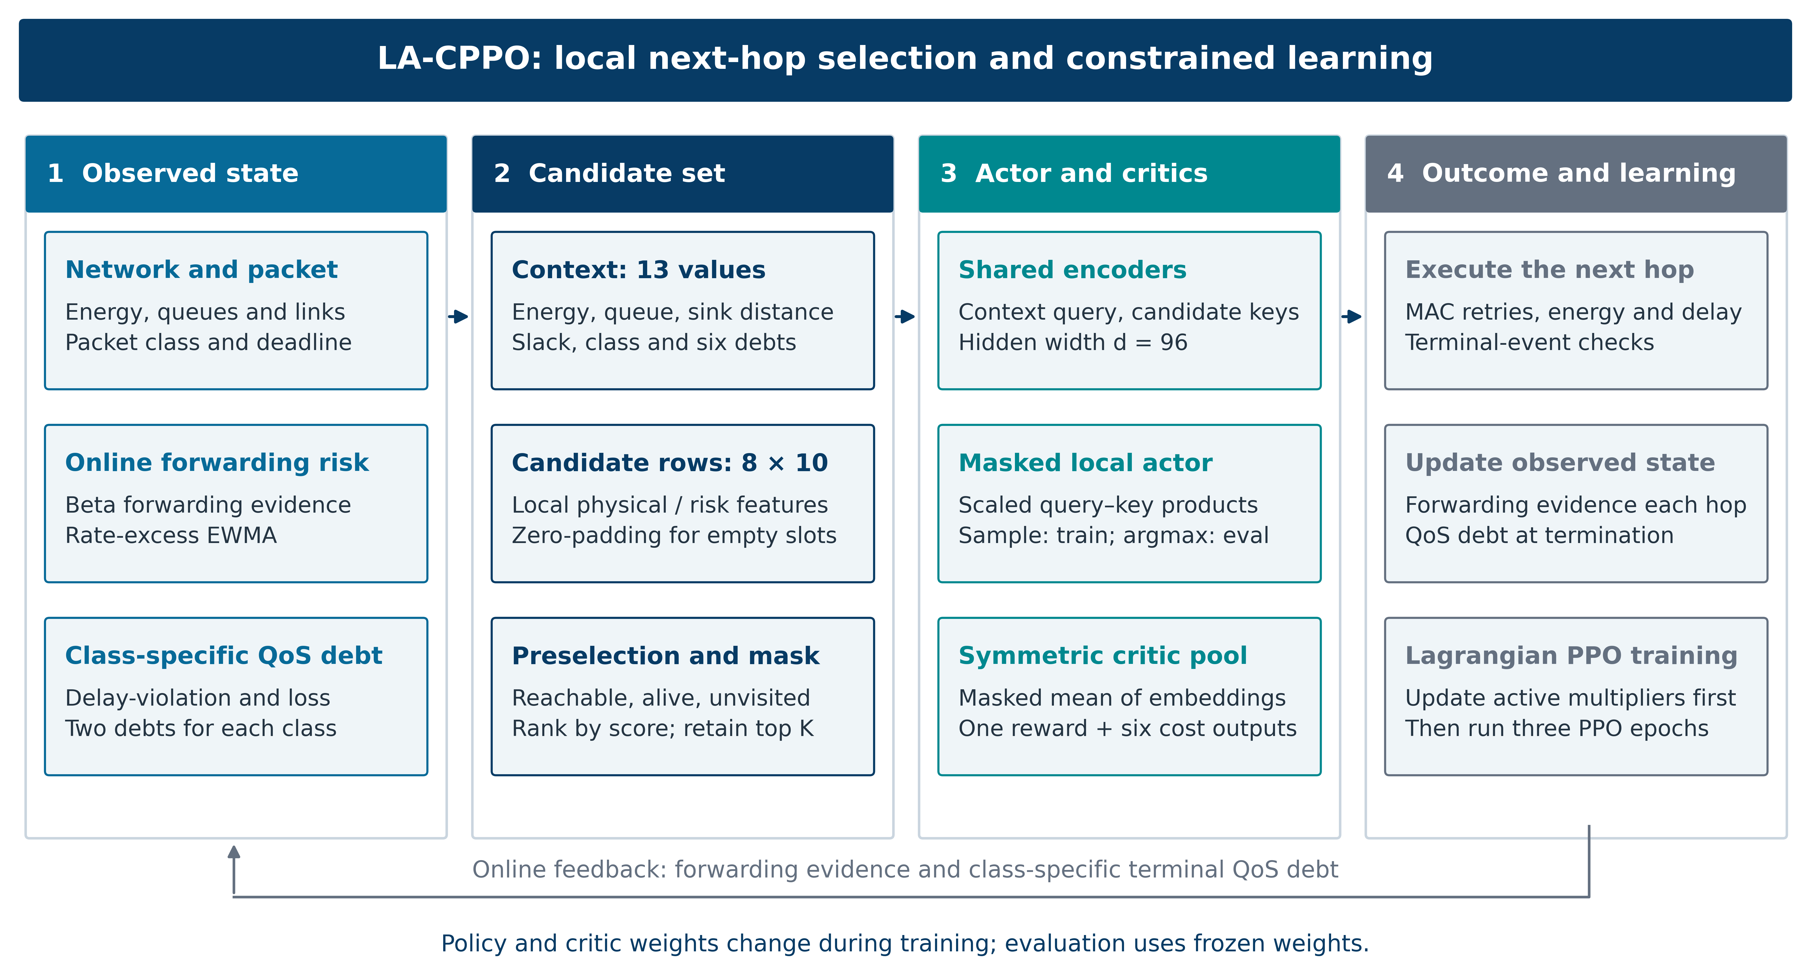
Fig. 1. Routing architecture and constrained training procedure for LA-CPPO.

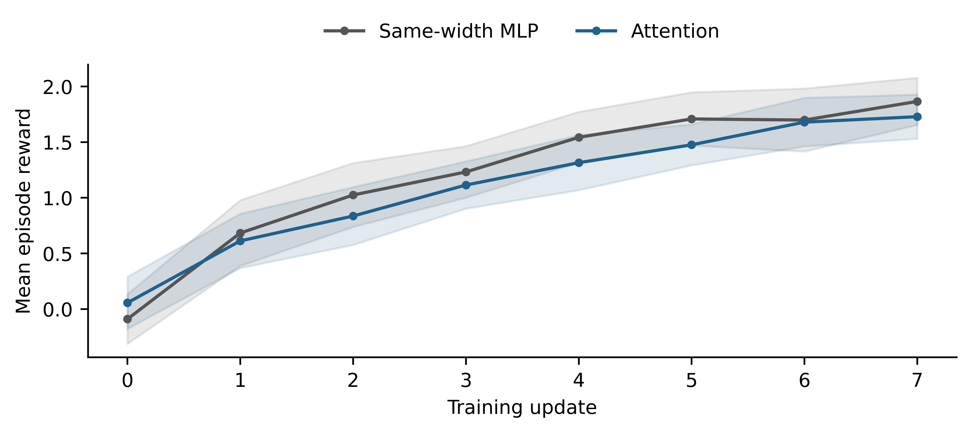
Fig. 2. Training reward across 30 historical seeds. Shading shows pointwise 95% t intervals.

Table IV. AF-v3 E1 co-primary confirmatory results (n=30 matched seeds).
Endpoint | Mean diff. | 95% CI | Holm p | Wilcoxon p | Cohen d_{z} | Direction
Class-0 mean delivered delay | +1.0158 ms | [-0.5039, +2.5354] | 0.1821 | 0.1981 | +0.2496 | Not favorable
Class-0 total delay-violation rate | -0.03125 | [-0.05160, -0.01091] | 0.007703 | 0.003475 | -0.5736 | Favorable

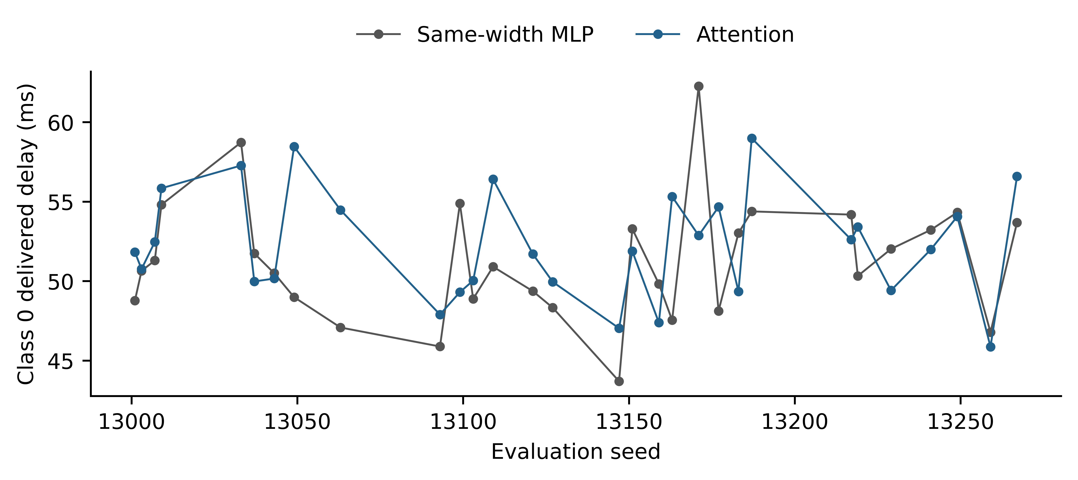
Fig. 3. Class-0 mean delivered delay for each paired seed.

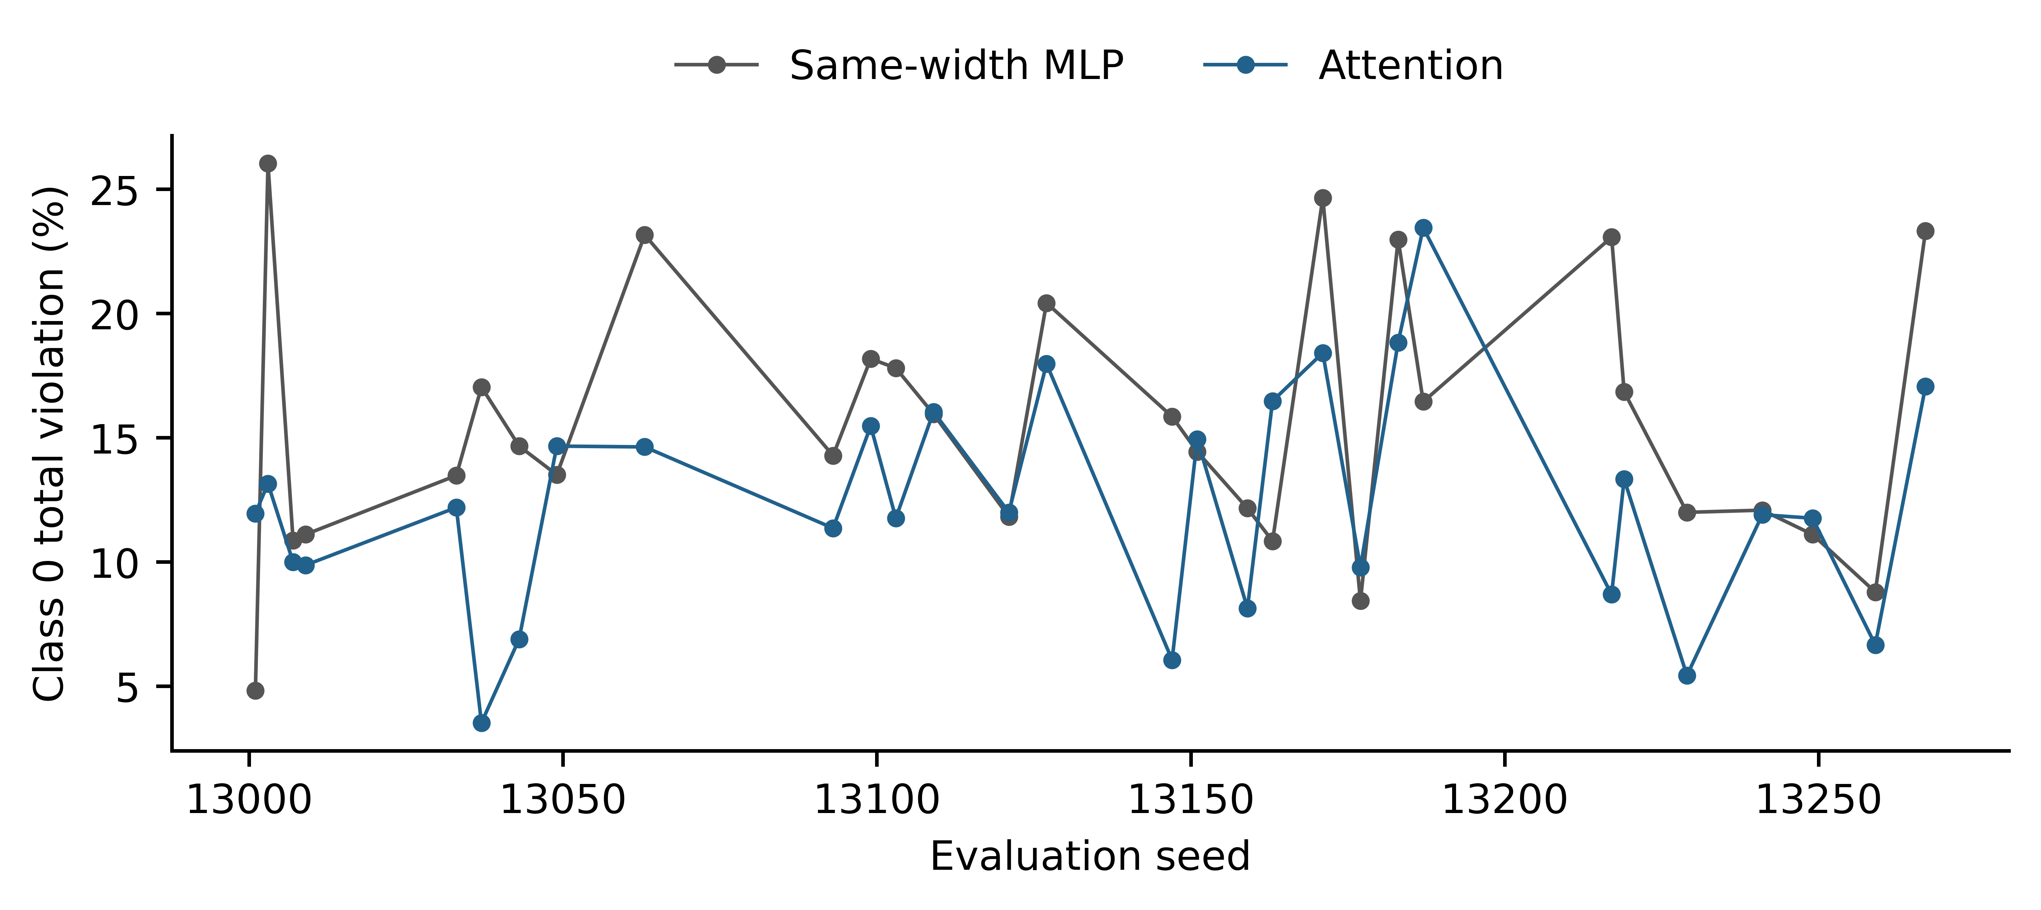
Fig. 4. Paired-seed Class-0 total delay-violation rate.

Table V. Prespecified guardrails for delivery and energy.
Guardrail | Estimate | Confidence bound | Frozen margin | Result
Overall delivery rate | +0.03153 absolute | one-sided 95% LB = +0.02158 | >-0.01 | PASS
Energy per delivered packet | GMR = 0.97180 | one-sided 95% upper = 1.00040 | ≤1.05 | PASS

Table VI. Mean evaluation metrics across 30 seeds; baseline rows are descriptive only.
Policy | Delivery | C0 delay (ms) | C0 violation | Energy/deliv. (mJ) | Security-drop rate
LA-CPPO attention | 0.9543 | 52.27 | 0.1242 | 0.7372 | 0.0308
Matched MLP CPPO | 0.9228 | 51.25 | 0.1554 | 0.7597 | 0.0649
Static energy-risk-ETX | 0.8807 | 56.86 | 0.2392 | 1.0383 | 0.1128
Periodic ROA + energy-risk-ETX | 0.8814 | 57.58 | 0.2332 | 1.0056 | 0.1093

Table VII. Exploratory decomposition of the Class-0 total violation difference.
Component | Attention - MLP | Interpretation
Class-0 loss rate | -0.02748 | Dominant contributor to lower total violation
Delivered-late Class-0 fraction | -0.00377 | Small difference; exploratory CI includes zero
Total Class-0 violation | -0.03125 | Confirmatory co-primary effect

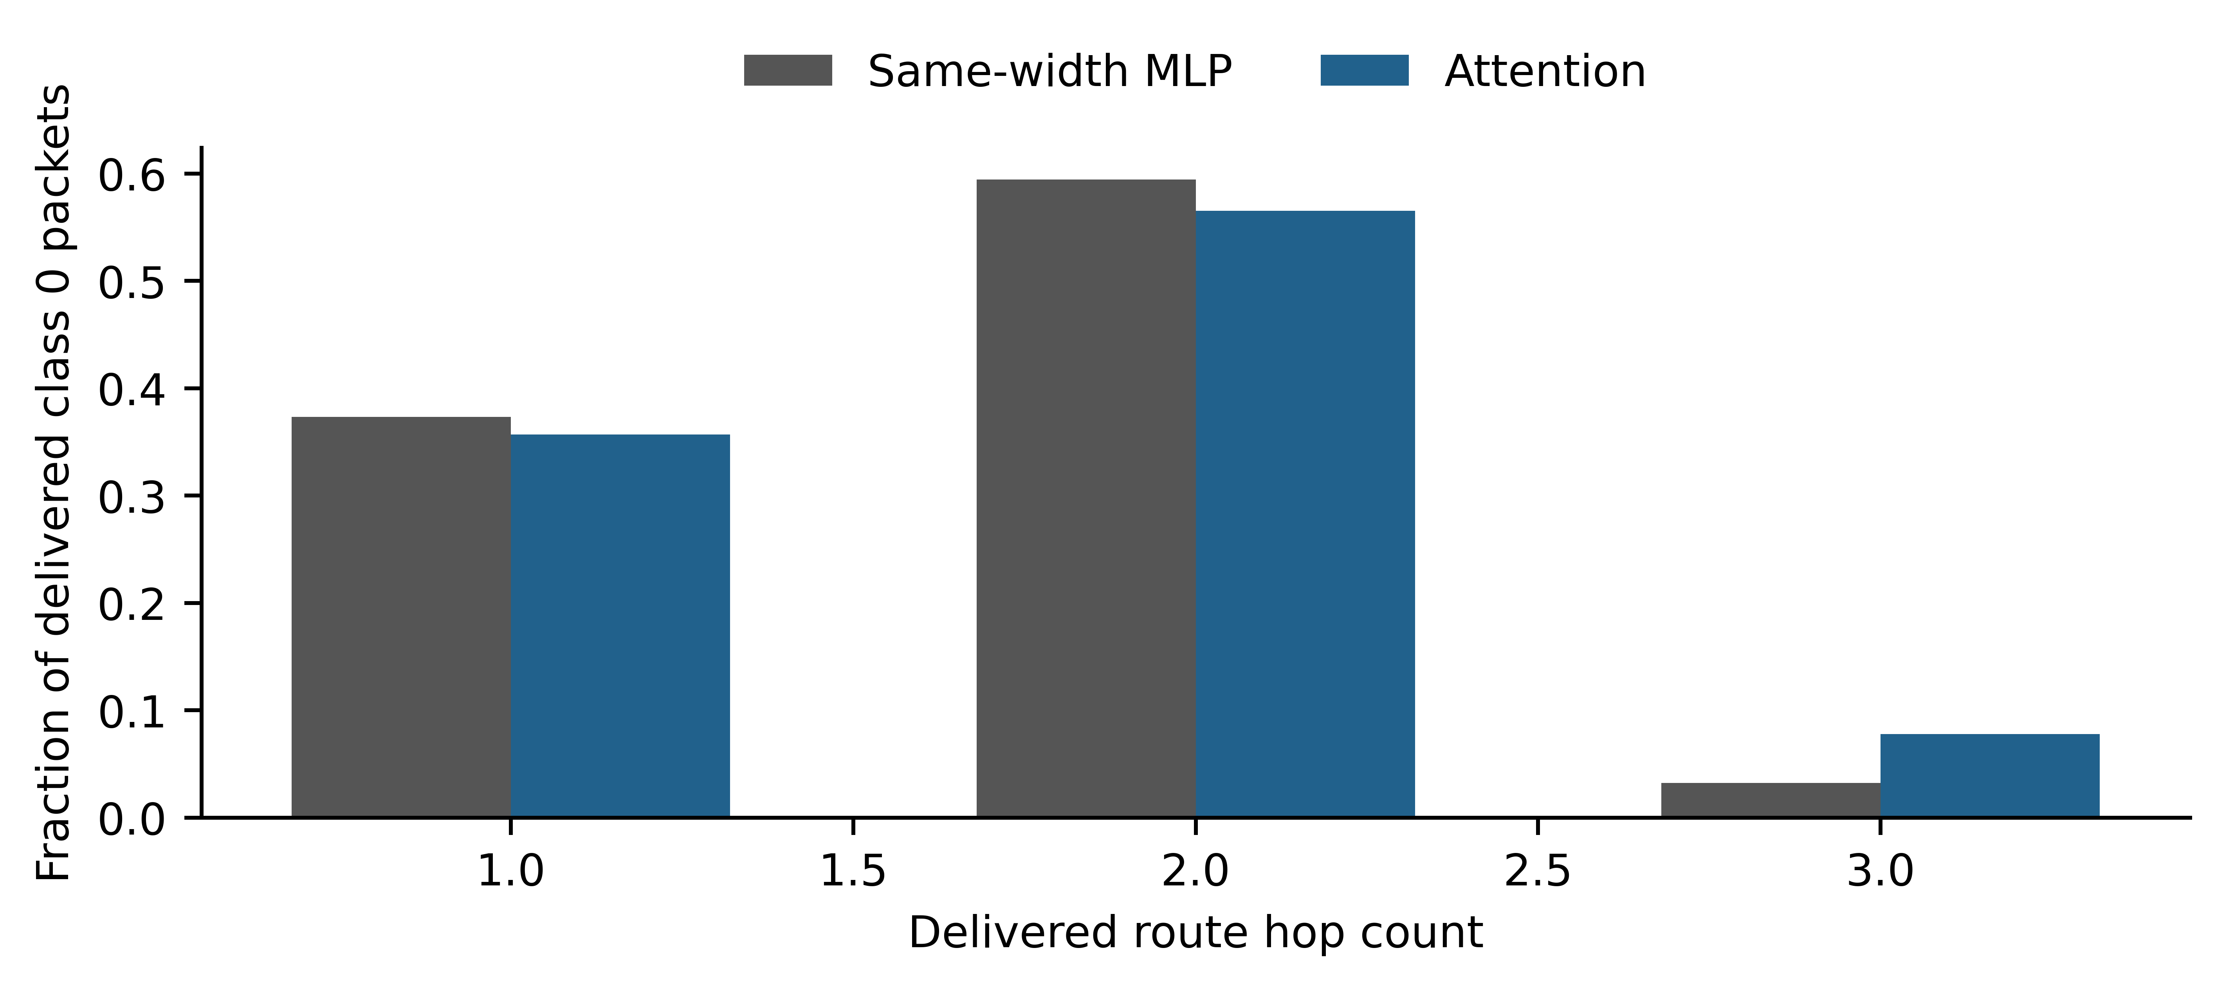
Fig. 5. Pooled hop-count composition of delivered Class 0 packets in the historical experiment.

Table VIII. New nominal validation effects for attention minus each comparator.
Comparator | Endpoint | Difference | 95% CI | Holm p
Capacity-matched MLP | Delay ms | +0.821 | [-0.121, +1.762] | 0.3409
Capacity-matched MLP | Violation pp | -1.522 | [-2.754, -0.291] | 0.08581
Attention without risk | Delay ms | +0.597 | [-0.651, +1.846] | 1
Attention without risk | Violation pp | -7.934 | [-10.143, -5.725] | 2.586e-07
Attention with 80% feedback | Delay ms | -0.258 | [-1.068, +0.552] | 1
Attention with 80% feedback | Violation pp | -0.518 | [-1.761, +0.726] | 1

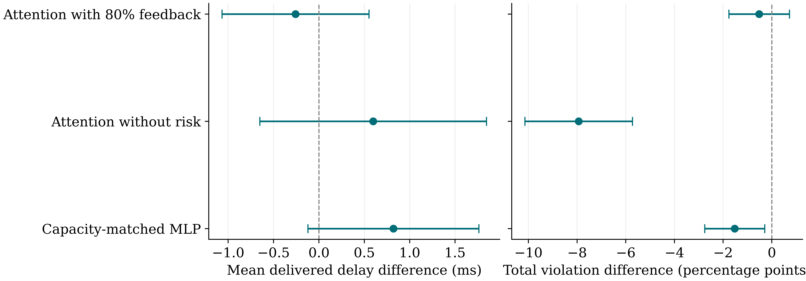
Fig. 6. New nominal paired effects with unadjusted 95% intervals across 30 seeds. Negative differences favor attention.

Table IX. Frozen-policy transfer summaries across 30 seeds.
Setting | Policy | Delivery % | C0 delay ms | C0 violation %
attack10 | attention | 98.01 | 49.66 | 7.36
attack10 | capacity_mlp | 97.15 | 48.95 | 8.13
attack40 | attention | 93.83 | 53.46 | 15.74
attack40 | capacity_mlp | 89.94 | 51.67 | 18.43
nominal | attention | 96.92 | 51.11 | 9.68
nominal | capacity_mlp | 94.96 | 50.29 | 11.20
size200 | attention | 95.92 | 51.82 | 11.52
size200 | capacity_mlp | 94.15 | 51.26 | 13.33

Table X. Shared-target UDP diagnostic across 30 paired fixtures.
Policy | Parameters | Executed runs | Mean delivery %
Capacity MLP | 63,554 | 60 | 32.22
Attention | 63,368 | 60 | 85.39

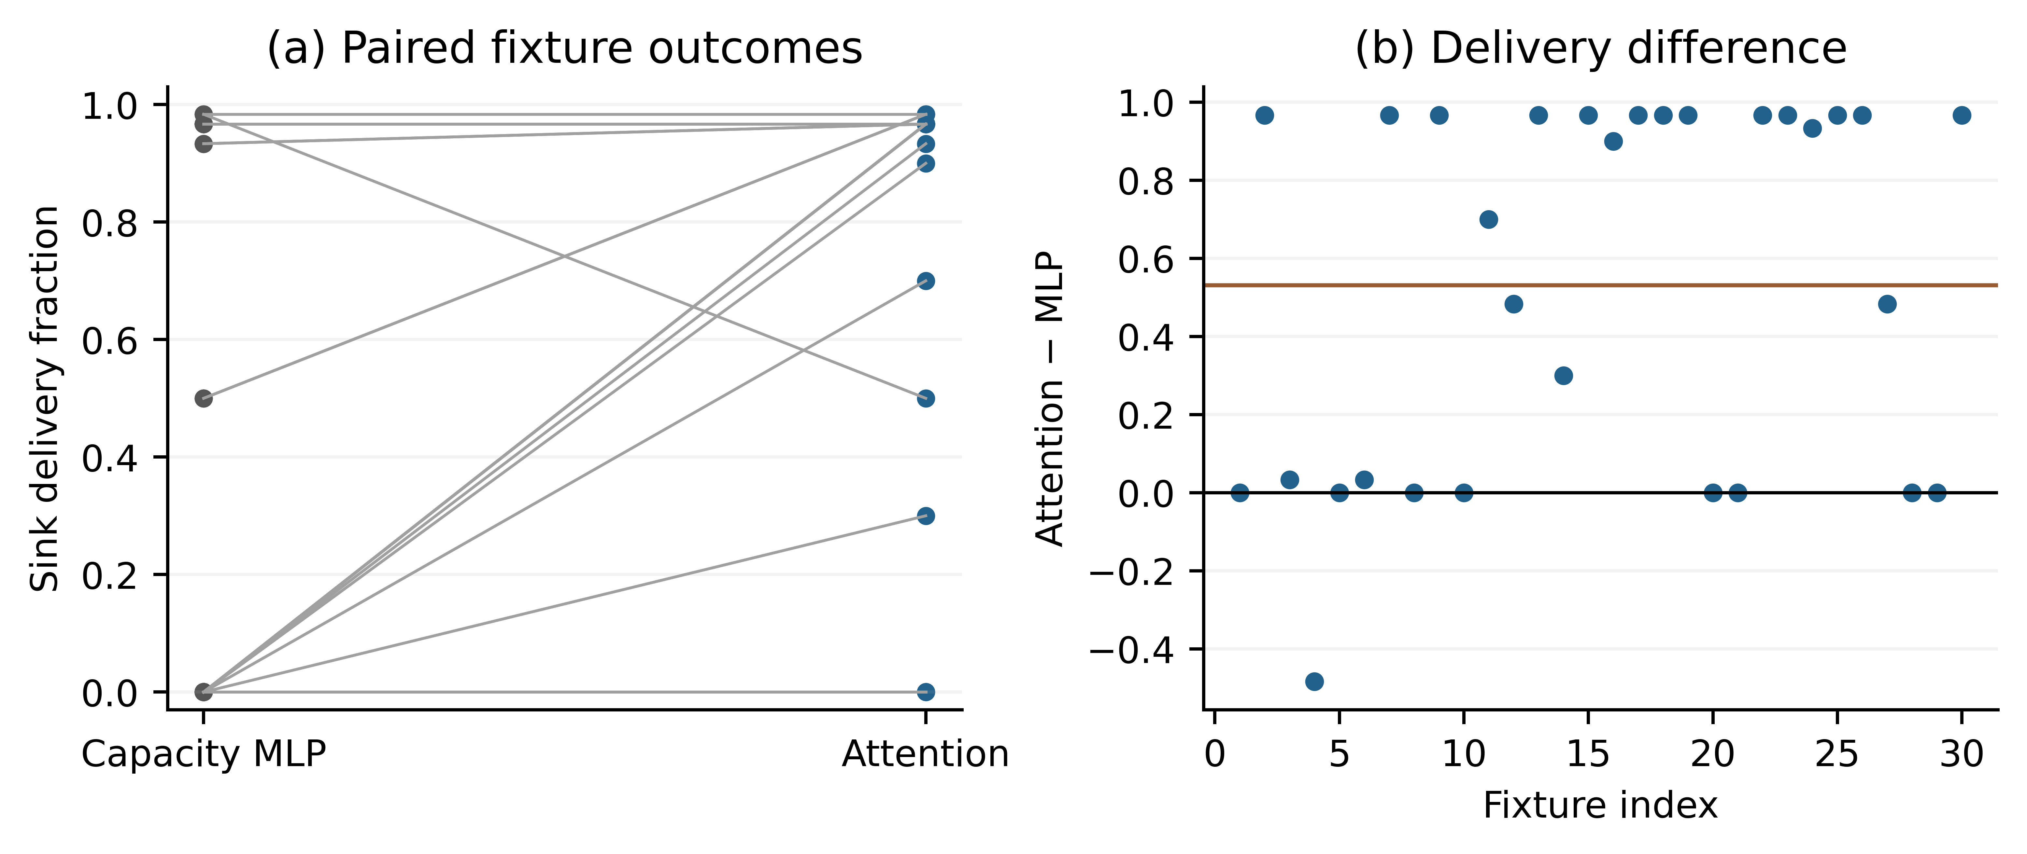
Fig. 7. Shared-target UDP delivery. Each fixture averages two fault-target strata; lines join paired controller outcomes.

Table XI. Historical attention constraint rates across 30 seeds.
Class | Total violation rate | Loss rate | Budget for each channel
0 | 0.1242 | 0.0480 | 0.015
1 | 0.0444 | 0.0444 | 0.04
2 | 0.0455 | 0.0455 | 0.1

Table XII. Local telemetry transfer effects for attention minus the capacity MLP.
Condition | Delivery difference pp | Critical violation difference pp | Energy per delivered byte difference J/B
benign | +0.7778  [-0.5573, +2.113]  p=1 | -0.6488  [-3.775, +2.477]  p=1 | -0.0001019  [-0.0002602, +5.644e-05]  p=1
blackhole | +1.5  [-0.8363, +3.836]  p=1 | -1.871  [-4.977, +1.235]  p=1 | -0.0003038  [-0.0006972, +8.957e-05]  p=1
congested benign | +0.4444  [-0.9984, +1.887]  p=1 | -0.7197  [-2.263, +0.8239]  p=1 | -0.0003557  [-0.00195, +0.001239]  p=1
congested blackhole | +0.7222  [-0.4181, +1.863]  p=1 | +0.3088  [-2.15, +2.767]  p=1 | -0.0007281  [-0.002186, +0.0007299]  p=1
weaklink benign | -0.05556  [-1.75, +1.639]  p=1 | +0.4582  [-1.728, +2.644]  p=1 | -6.513e-06  [-0.0002357, +0.0002227]  p=1

Table XIII. Blackhole holdout effects for censored passive attention minus each comparator.
Comparator | Delivery pp | Critical violations pp | Radio energy J/B
Naive passive | -0.1667  [-1.557, +1.223]  p=1 | -0.01653  [-2.381, +2.348]  p=1 | -6.597e-05  [-0.0004155, +0.0002836]  p=1
Active proofs | +4.667  [+2.365, +6.969]  p=0.01612 | -4.518  [-8.253, -0.7829]  p=1 | -0.0006443  [-0.000974, -0.0003145]  p=0.02385
Frozen prior | +0.05556  [-0.4983, +0.6094]  p=1 | -0.1245  [-1.388, +1.139]  p=1 | -1.06e-05  [-7.794e-05, +5.673e-05]  p=1
Capacity MLP | +0.4444  [-1.461, +2.35]  p=1 | -2.384  [-6.065, +1.298]  p=1 | -7.61e-05  [-0.0003642, +0.000212]  p=1

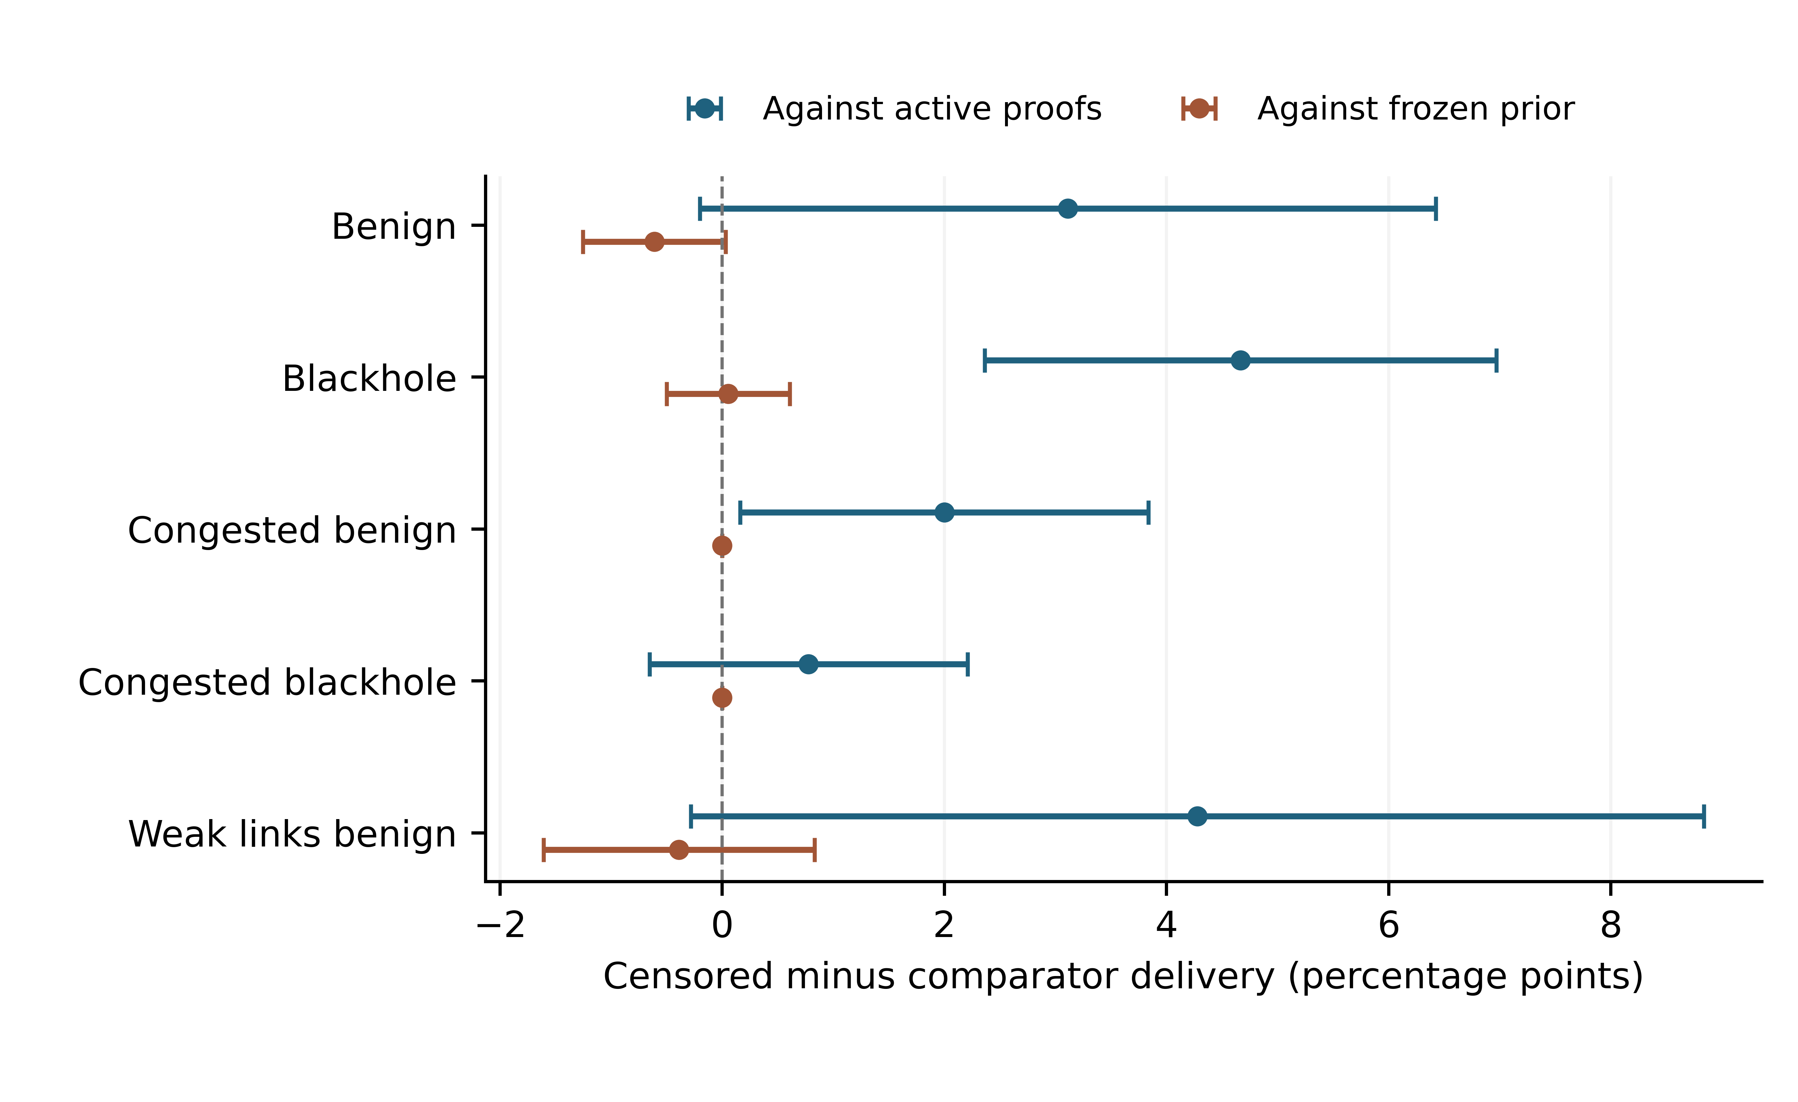
Fig. 8. Holdout delivery effects with unadjusted paired 95% intervals. Positive differences favor censored passive attention.

