Energy-Information Co-Design for Resource-Bounded Edge Intelligence: A Systems-Learning Federated Framework
Abhinandan Tripathi¹, Vijay Kumar Tiwari², Mohd. Arif³, Abhishek Kumar Pandey⁴*, Shivam Bhardwaj⁵
¹Department of Computer Science and Engineering, Buddha Institute of Technology, Gorakhpur, India
²Department of Information Technology, Madan Mohan Malaviya University of Technology (MMMUT), Gorakhpur, India
³Department of Computer Science and Engineering, Galgotias University, Greater Noida, India
⁴Department of Computer Science and Engineering, Bennett University, Greater Noida, India
⁵ Department of Computer Application, United Institute of Management, Prayagraj, India
Emails: ¹abhinandan282@bit.ac.in; ²vktitca@mmmut.ac.in; ³md.arif@galgotiasuniversity.edu.in; ⁴abhishek.pandey2@bennett.edu.in; ⁵shibambhardwaj@gmail.com
ORCID: Abhishek Kumar Pandey — 0000-0003-3799-9754; Shivam Bhardwaj — 0009-0005-4554-7397
*Corresponding author: Abhishek Kumar Pandey (abhishek.pandey2@bennett.edu.in)

Abstract
In a multi-hop edge network, the client that is most useful for learning can also be the most expensive one to reach. We study that conflict directly instead of treating communication as a transparent pipe between clients and the cloud. The proposed controller lets learning utility, route ETX, residual energy, relay pressure, update age, and Top-k retention enter the same round-level decision, while error feedback preserves coordinates omitted by sparsification. To keep parameter choice separate from evaluation, tuning and final inference use disjoint seed sets. The real-data study also corrects two-level aggregation influence, uses an overlap-safe within-client split for UCI HAR, and compares against compression-matched controls and a FedCG-adapted selector. On Intel Berkeley Lab data at correlation 0.9, the proposed controller obtains 1.7348 °C RMSE with 0.992 Mbit of model-update traffic. Resource-adaptive is better on pure error and network cost, whereas the proposed controller is much closer to its utility-derived participation target, reducing utility-target divergence by 86.0%. On UCI HAR, accuracy reaches 88.67%, 1.16 percentage points above resource-adaptive, but the improvement is accompanied by 26.8% more model-update traffic and a 628.9% increase in maximum relay energy. Adaptive fidelity is responsible for most of the traffic reduction: relative to the same proposed selector at fixed 50% Top-k, model-update traffic falls by 58.2% on Intel and 64.0% on HAR. We also price the pre-selection metadata. ETX-weighted signaling contributes 1.219 Mbit on Intel and 0.306 Mbit on HAR; after adding it, adaptive fidelity still reduces control-inclusive uplink traffic by 38.4% and 63.3%, respectively. Finally, ns-3.47 IEEE 802.15.4 replay shows how the lower offered load changes delivery, delay, and channel contention. Taken together, the results describe a workload-dependent trade-off between learning value and network cost rather than a universally dominant scheduler.
Keywords: resource-bounded edge intelligence; energy-information co-design; distributed AI; federated learning; adaptive sparsification; network-aware learning; relay energy; staleness; edge-cloud systems.

1. Introduction
Edge learning is rarely constrained by computation alone. In many sensing deployments, the radio budget, relay load, and remaining battery energy are just as important as the local model. That matters because the sample or client that would help the model most is not always the one that is cheapest to contact. Environmental monitoring, wearables, infrastructure sensing, and industrial IoT all face some version of this mismatch, so client selection has a physical consequence as well as a statistical one.
In a multi-hop deployment, selecting a client implicitly selects a path as well. That path determines how many transmissions are likely to be needed, which relays carry the update, and when the update can reach the edge server. This is where learning and networking begin to interfere with one another. A client may be statistically valuable and still be expensive to serve; a nearby client may be cheap to reach but contribute little new information. Ignoring either side can therefore shift cost elsewhere in the system rather than remove it.
The controller was built around this coupling. Before a round is scheduled, the learning score is evaluated alongside route cost, residual-energy scarcity, relay pressure, the retained update fraction, and the age of delayed updates. The resulting decision is not only a client-selection decision. It also determines how aggressively that client's update is sparsified and, later, how strongly a delayed contribution should count at aggregation.
These objectives are not aligned by default. In our runs, resource-oriented selection can reduce network expenditure while concentrating participation on easier routes, whereas utility-oriented selection can repeatedly draw traffic through costly relay corridors. Top-k retention adds a separate compromise because fewer coordinates reduce traffic at the expense of update detail. We therefore keep prediction error, communication volume, relay stress, and participation behavior as separate outcomes. Collapsing them into one headline score would hide the operating point that produced the result.
The individual building blocks are not new in isolation. ETX-aware routing, residual-energy terms, hierarchy, sparsification, and staleness handling all have prior literature. The question examined here is narrower: what changes when these signals are exposed to the same scheduling loop instead of being handled independently? We apply the same restraint to the metrics. The participation queue is driven by a controller-defined utility target, so its Jensen-Shannon divergence is used only as a target-alignment measure. Distributional coverage is checked separately, and cloud influence is computed only after both stages of hierarchical normalization.
The principal contributions are:
1. A systems-learning co-design formulation in which client participation prices multi-hop route burden, residual-energy scarcity, and relay-pressure externalities while retaining a utility-target participation-deficit term.
2. A client-specific finite-set Top-k fidelity rule with error feedback, coupled to the same network state that informs scheduling.
3. Correct two-level aggregation-influence accounting and an explicit separation between controller-target alignment, participation equality, and independent data-distribution coverage.
4. A measured control-plane audit that accounts for the bytes and a conservative radio-energy upper bound required to obtain pre-selection metadata instead of treating scheduler information as free.
5. A held-out evaluation protocol with disjoint tuning and evaluation seeds, compression-matched controls, a FedCG-adapted comparator, component ablations, exact paired statistical tests, and real sensing datasets.
6. Discrete-event ns-3.47 IEEE 802.15.4 replay that tests the packet-network consequences of the offered load produced by the learning/compression stack while explicitly distinguishing open-loop replay from closed-loop co-simulation.
The analytical and empirical evidence serve different purposes. Exact queue identities, finite-set compression decisions, top-k score selection, and error-feedback conservation are established for the implemented controller. By contrast, packet contention, acknowledgments, retransmissions, finite deadlines, and delayed arrivals are discrete systems phenomena that disappear when the network is reduced to a smooth communication penalty. We therefore use mathematical analysis where it applies exactly and executable network replay where the physical abstraction matters, rather than claiming a non-convex convergence theorem for a relaxed system that is not the one being executed.

2. Related Work and Positioning
Client-edge-cloud HFL was formalized by Liu et al. [1], and resource-aware client selection for IoT FL predates the present study [2]. Dynamic client-edge association and resource allocation have also been optimized jointly [3]. Long-term participation under volatile clients has been studied explicitly [4], while recent fairness-oriented analysis further distinguishes participation equality from distributional and performance fairness [13]. These results make hierarchy, multicriteria resource scoring, and participation-aware selection established ingredients rather than sufficient novelty claims.
Synchronization and heterogeneity have likewise been studied extensively. HiFlash couples adaptive staleness control with heterogeneity-aware client-edge association [5]. ShapeFL reduces communication by shaping edge-level data distributions [7], while cost-efficient HFL formulations jointly optimize selection and wireless resource allocation [8]. Recent graph-based HFL also combines client clustering with communication-resource allocation under non-IID data [17], learning-topology co-optimization has been studied for device-to-device HFL [18], and multi-job HFL jointly addresses client selection and resource allocation for consumer-grade UAVs [19]. Energy-efficient HFL has additionally been developed for marine IoT settings [20].
A related line of work focuses on selection diversity and compression. FedCG combines representative gradient-based client selection with adaptive compression [6]. Because its original communication model is not the multi-hop client-edge-cloud topology used here, we implement a clearly labeled FedCG-adapted comparator: a greedy facility-location selector over current client gradients with capability cost and adaptive compression. This is a favorable comparator because it has access to current gradient vectors for eligible clients; its information-acquisition overhead is not added to traffic accounting. It is not presented as an exact reproduction of FedCG.
Multi-hop FL itself is also established. Prior studies consider in-network aggregation with routing and spectrum allocation [9], network-accelerated FL over physical wireless edge systems [10], and multi-hop HFL grouping/resource allocation [11]. A topology-aware FL survey summarizes this broader design space [12]. The present work therefore does not claim novelty for ETX routing, multi-hop FL, fairness, compression, staleness, or hierarchy individually. Its research object is the joint control of utility-target participation, model-update fidelity, route burden, relay pressure, and staleness under a measured WSN substrate and held-out evaluation.

3. System Model and Problem Definition
Consider a WSN-IoT graph $G=\left(V,E\right)$, a set of learning-capable clients $C$, edge gateways $G$, and a cloud server. Client $i$ owns local data $D_{i}∼P_{i}\left(X,Y\right)$, where generally $P_{i}≠P_{j}$. At communication round $t$, a binary variable $x_{i}\left(t\right)$ determines whether client $i$ participates.
The network layer supplies a route $P_{i}\left(t\right)$ from client $i$ to an edge gateway. For link $\left(u,v\right)$, let ${ETX}_{uv}\left(t\right)$ be its expected transmission count. Route burden is
Ciroutet=u,v∈Pit​ETXuvt.
If $b_{i}\left(t\right)$ update bits are transmitted, expected traffic is
$$B_{i}^{eff}\left(t\right)=x_{i}\left(t\right)b_{i}\left(t\right)C_{i}^{route}\left(t\right).$$
Unlike a single-hop abstraction, the same update consumes energy on intermediate relays. The cumulative burden on relay $r$ is
ErcumT=t=1Ti​xit1r∈PitEirrelayt.
The learning problem is therefore not equivalent to selecting clients with minimum route cost. A high-loss or historically informative client can have a poor route, while cheap clients can dominate repeated selections. The controller is designed to expose rather than hide this trade-off.
Figure 1 is a conceptual systems schematic, not a prescribed physical deployment. The illustrated client-relay-edge-cloud branches communicate the hierarchy used by the controller; routing and scheduling operate on graph/network state rather than on a rigid geometric layout or a fixed floor plan.
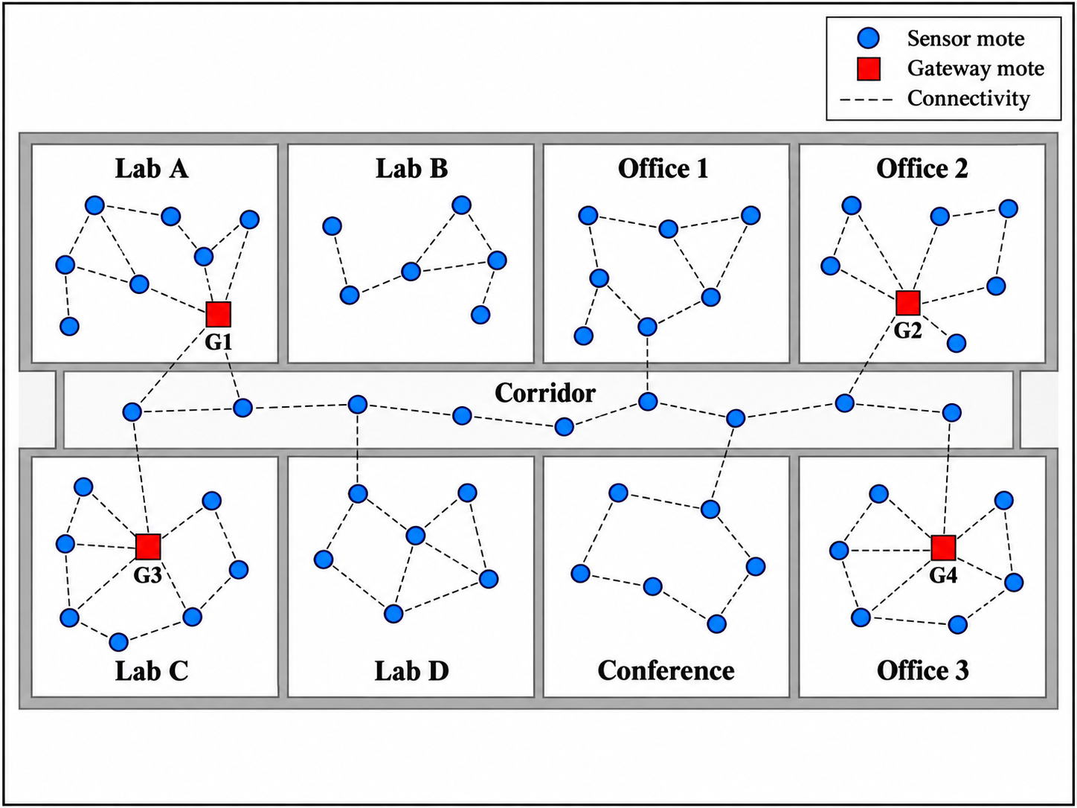
Figure 1. Conceptual cross-layer HFL architecture..

4. Systems-Learning Co-Design Controller

4.1 Executed utility signal
Conceptually, a client utility can contain novelty, learning difficulty, and distribution information:
$$U_{i}\left(t\right)=α_{g}G_{i}\left(t\right)+α_{l}L_{i}\left(t\right)+α_{h}H_{i}\left(t\right),$$
where $G_{i}$ denotes update novelty, $L_{i}$ learning difficulty/progress, and $H_{i}$ an optional rarity term. The executed pre-selection utility is more specific: it is 0.55 times the per-round min-max-normalized current local loss plus 0.45 times the min-max-normalized exponentially smoothed utility history. No distribution-rarity term is used directly in the executed scheduling score. After a selected client trains, its history is updated from cosine novelty and non-negative local improvement. The improvement transform uses task-specific saturation constants documented in the repository. Raw examples remain local, but scalar loss/utility metadata are assumed available to the scheduler; this is not a formal privacy guarantee.
Throughout Sections 4-8, notation is fixed consistently. U_i(t) denotes the executed pre-selection utility used by the target share and scheduling score; Q_i(t) denotes the client participation-deficit queue; Z_r(t) denotes relay-pressure state; and rho_i(t) denotes the retained Top-k fraction, not the discarded fraction. The post-training novelty/improvement signal updates the smoothed utility history and the utility attached to the transmitted update; it is not substituted retrospectively into the pre-selection score.
The normalized desired utility-target participation share is
πit=Uit+ϵj​Ujt+ϵ.

4.2 Utility-target participation-deficit queue
A virtual queue tracks the difference between desired and realized participation share:
Qᵢ(t + 1) = [Qᵢ(t) + πᵢ(t) − aᵢ(t)]⁺.
Here $a_{i}\left(t\right)=x_{i}\left(t\right)/k_{t}$ for a selected set of size $k_{t}>0$, and $a_{i}\left(t\right)=0$ when no client is selected. The mechanism does not enforce equal-frequency participation. Instead, persistent shortfall relative to the utility-derived target increases future scheduling pressure. Directly from the recursion,
1Tt<T​ait≥1Tt<T​πit-QiT-Qi0T.
Rate stability of $Q_{i}$ is therefore sufficient for the long-run participation-share target. It does not prove equality between the target and final cloud influence, because compression, drops, staleness, edge normalization, and cloud normalization occur after selection.

4.3 Relay-pressure queue
For relay $r$, the controller maintains a virtual pressure queue relative to a relay-energy reference level:
Zᵣ(t + 1) = [Zᵣ(t) + Eᵣʳᵉˡᵃʸ(t) − Ēᵣ]⁺,
and route pressure for client $i$ is
Rit=r∈Pit​Zrt.
The relay reference is used as feedback, not as a strict energy ceiling. Repeated use of the same relay corridor increases its virtual backlog, which raises the cost of selecting routes through that corridor in subsequent rounds. In that sense the scheduler carries forward a memory of recent relay stress. Because the queue is advisory rather than a hard feasibility constraint, a finite run can still exceed a desired cumulative relay budget.

4.4 Adaptive update fidelity
Let $ρ_{i}\left(t\right)$ denote the retained Top-k fraction. The controller exhaustively evaluates the finite candidate set and minimizes
$$J_{i}^{comp}\left(ρ\right)=ρ\left({\tilde{C}}_{i}^{route}+η_{E}{\tilde{S}}_{i}+η_{R}{\tilde{R}}_{i}\right)+βU_{i}\left(t\right){\left(1-ρ\right)}^{2}.$$
The scarcity term is evaluated from max(initial-energy/residual-energy - 1, 0) and then min-max normalized within the current round; eta_E is fixed at 0.5. Route burden and relay pressure are normalized at the same point in the computation. The held-out protocol uses eta_R = 5 and beta = 0.10, both selected exclusively from the tuning seeds in Section 5.2. Top-k omission is temporary rather than destructive: the unsent coordinates remain in the error-feedback residual and can re-enter later updates.

4.5 Queue-informed scheduling score
For each eligible client,
$$Γ_{i}\left(t\right)=V{\tilde{U}}_{i}\left(t\right)+Q_{i}\left(t\right)-Vρ_{i}\left(t\right)\left({\tilde{C}}_{i}^{route}+η_{E}{\tilde{S}}_{i}+η_{R}{\tilde{R}}_{i}\right).$$
Using eta_E = 0.5, eta_R = 5, and V = 0.5, the implementation first removes unavailable or energy-ineligible clients and then ranks the remaining candidates by Gamma_i(t). The required number of clients is taken from the top of that ranking. No additional look-ahead test is imposed to guarantee, before selection, that a client can pay the full future cost of both local training and communication.
For this reason we use the term drift-plus-penalty inspired. The implemented rule is not the canonical Lyapunov minimizer: feature normalization is refreshed each round, compression is chosen through a separate finite-set surrogate, and relay pressure enters through a normalized path term. Those details are part of the executable policy, but they also mean that the classical unnormalized drift expression should not be presented as if it were solved exactly here.

4.6 Utility-aware staleness
If an update generated at round $t_{i}$ arrives at round $t$, its staleness is $s_{i}=t-t_{i}$. Edge aggregation uses
$$ω_{i}\left(t\right)=n_{i}e^{-λ_{s}s_{i}}\left(1+μU_{i}\left(t_{i}\right)\right),$$
followed by normalization. Age penalizes delayed updates, while the utility term allows a high-value delayed update to retain additional weight.

4.7 Correct hierarchical influence accounting and evaluation metrics
Within an edge gateway, client weights are normalized to sum to one. Edge aggregates are then weighted again at the cloud. The revised implementation records a client's cloud influence as the product of its within-edge normalized coefficient and the normalized cloud coefficient of that edge. A dedicated unit test verifies a known two-edge example and that the resulting cloud coefficients sum to one. This corrects the earlier diagnostic implementation that accumulated only within-edge coefficients.
Two different JS metrics are intentionally separated. Utility-target JS compares cumulative true cloud influence with the cumulative utility-derived target. It measures controller-target alignment and is partly endogenous to the controller. It is not treated as an independent population-representativeness metric. Independent coverage JS compares the cloud-influence-weighted empirical data distribution with a pooled training-data reference: a 10-bin temperature distribution for Intel and the six-class activity distribution for HAR.

4.8 Round-level execution
Algorithm 1 makes the execution order explicit. Metadata are collected before selection; the retained fraction is chosen from the finite candidate set; the top-scoring eligible clients train; compressed updates are placed on their routes; client and relay queues are updated; and only arrived updates enter hierarchical aggregation. This ordering matters because a method that computes utility after client selection, or charges route pressure only after aggregation, implements a different controller.

Algorithm - 1. Energy-Information Co-Design HFL Procedure
Input: Client set C = {C₁, C₂, …, Cₙ}; communication rounds T; client-selection limit K; candidate retention set R = {0.15, 0.30, 0.50, 0.75, 1.00}; route ETX state; residual-energy state; parameters V, η_E, η_R, β, λ_s, and μ.
Output: Final global model wᵀ and the corresponding client/relay queue states.
1. | Start
2. | Initialize global model w⁰, client-deficit queues Qᵢ(0)=0, relay-pressure queues Zᵣ(0)=0, utility histories, and error-feedback residuals.
3. | For communication round t = 1 to T do
4. | Update the current multi-hop routes, route ETX burdens Cᵢʳᵒᵘᵗᵉ(t), residual-energy state, and client availability.
5. | Collect one 21-byte pre-selection metadata packet from each candidate client: header, local loss, residual-energy estimate, and availability flag.
6. | Compute the pre-selection utility Uᵢ(t) for every candidate client.
7. | Compute the utility-target participation share: πit=Uit+ϵj​Ujt+ϵ
8. | Construct the eligible client set Aₜ using availability and residual-energy conditions.
9. | For every eligible client i ∈ Aₜ do
10. | Compute route burden, energy-scarcity state, and accumulated relay pressure for client i.
11. | For every retained Top-k fraction ρ ∈ R do
12. | Evaluate the compression objective: $J_{i}^{comp}\left(ρ\right)=ρ\left({\tilde{C}}_{i}^{route}+η_{E}{\tilde{S}}_{i}+η_{R}{\tilde{R}}_{i}\right)+βU_{i}\left(t\right){\left(1-ρ\right)}^{2}$
13. | End for
14. | Select the retained Top-k fraction: $ρ_{i}\left(t\right)=arg\min_{ρ∈R}J_{i}^{comp}\left(ρ\right)$
15. | Compute the scheduling score: $Γ_{i}\left(t\right)=V{\tilde{U}}_{i}\left(t\right)+Q_{i}\left(t\right)-Vρ_{i}\left(t\right)\left({\tilde{C}}_{i}^{route}+η_{E}{\tilde{S}}_{i}+η_{R}{\tilde{R}}_{i}\right)$
16. | End for
17. | Set the number of participating clients as $K_{t}=min\left(K,\left|A_{t}\right|\right)$, then choose the eligible clients having the largest scheduling scores.
18. | Update the client participation-deficit queue: $Q_{i}\left(t+1\right)=max\{0,Q_{i}\left(t\right)+π_{i}\left(t\right)-a_{i}\left(t\right)\}$
19. | For every selected client i do
20. | Perform local optimization using the current global model wᵗ and obtain the raw local update uᵢ(t).
21. | Update the client utility history using update novelty and non-negative local learning improvement.
22. | Add the previous error-feedback residual: $g_{i}\left(t\right)=u_{i}\left(t\right)+e_{i}\left(t\right)$
23. | Apply Top-k compression: $c_{i}\left(t\right)={TopK}_{ρ_{i}\left(t\right)}\left[g_{i}\left(t\right)\right]$
24. | Update the error-feedback residual: $e_{i}\left(t+1\right)=g_{i}\left(t\right)-c_{i}\left(t\right)$
25. | Transmit cᵢ(t) through the selected multi-hop route toward the associated edge gateway.
26. | Accumulate source transmission energy, relay transmission/reception energy, ETX-weighted traffic, and modeled arrival time.
27. | End for
28. | Update each relay-pressure queue: $Z_{r}\left(t+1\right)=max\{0,Z_{r}\left(t\right)+E_{r}^{relay}\left(t\right)-{\overset{‾}{E}}_{r}\}$
29. | Discard an update when its modeled arrival exceeds the permitted staleness limit.
30. | For every arrived client update i do
31. | Compute the utility-aware staleness weight: $ω_{i}\left(t\right)=n_{i}e^{-λ_{s}s_{i}}\left[1+μU_{i}\left(t_{i}\right)\right]$
32. | End for
33. | Aggregate the arrived client updates at their corresponding edge gateways using the normalized weights.
34. | Normalize the edge contributions and perform cloud-level aggregation to obtain the next global model wᵗ⁺¹.
35. | Record each client’s true cloud influence after both within-edge and cloud-level normalization.
36. | End for
37. | Return the final global model wᵀ and the associated diagnostics.
38. | Stop

4.9 Analytical properties of the implemented controller
Proposition 1 (finite-horizon queue guarantees). Define
Lt=12i​Qi2t+12r​Zr2t.
Let $d_{i}\left(t\right)=π_{i}\left(t\right)-a_{i}\left(t\right)$ and $h_{r}\left(t\right)=E_{r}^{relay}\left(t\right)-{\overset{‾}{E}}_{r}$. Using ${\left({\left[q+y\right]}^{+}\right)}^{2}≤q^{2}+y^{2}+2qy$,
Lt+1-Lt≤Bt+i​Qitdit+r​Zrthrt,
where Bt=12i​di2t+12r​hr2t. Telescoping gives
1Tt<T​ait≥1Tt<T​πit-QiT-Qi0T,
and
1Tt<T​Errelayt≤Er+ZrT-Zr0T.
Thus rate stability of the corresponding queues is sufficient for the long-run participation-share and relay-energy constraints.
Proposition 2 (per-round decision exactness). Exhaustive enumeration of the finite compression set returns the exact minimizer of the stated compression surrogate, and the top-k operation exactly maximizes the implemented additive client score over eligible subsets of the required cardinality. These are statements about the implemented surrogates, not global optimality of the end-to-end FL objective.
Lemma 1 (error-feedback conservation). For raw update $u_{i}\left(t\right)$, residual $e_{i}\left(t\right)$, and transmitted sparse update $c_{i}\left(t\right)$,
$$e_{i}\left(t+1\right)=u_{i}\left(t\right)+e_{i}\left(t\right)-c_{i}\left(t\right),$$
which implies
t<T​cit=t<T​uit+ei0-eiT.
Hence omitted coordinates are retained in the residual rather than permanently discarded.
The coupled system is intentionally not replaced by a smooth convex relaxation solely to obtain a stronger-looking convergence statement. Binary participation, finite-set sparsification, route changes, availability, packet retransmissions, and delayed arrivals are part of the executed system. A stylized theorem obtained after removing these mechanisms would characterize a different optimization problem. The paper therefore separates exact controller-level properties from packet-level empirical evidence: the former establish what the implemented decision rules guarantee, whereas ns-3 replay evaluates communication phenomena that the analytical abstraction omits.
These guarantees remain narrower than the classical Lyapunov result of an $O\left(1/V\right)$ time-average penalty gap with $O\left(V\right)$ backlog [14]. The executed normalized controller does not directly minimize the canonical drift-plus-penalty bound, and the utility-target participation shares sum to one. We therefore do not transfer the classical scaling theorem to this policy and do not claim a complete non-convex convergence theorem for the coupled selection-compression-hierarchy-staleness process.

5. Experimental Methodology

5.1 Protocol and parameter summary
Table 1. Reproducible experimental protocol and executed controller parameters.
Item | Value | Role
Tuning seeds | 7, 11, 19, 23, 29, 31, 37, 41, 43, 47 | parameter selection only
Held-out evaluation seeds | 53, 59, 61, 67, 71, 73, 79, 83, 89, 97 | final comparisons and inference
Resource-data correlation | 0, 0.5, 0.9 | controlled stress levels
Relay-pressure coefficient | 5.0 | selected on tuning seeds
Compression-distortion coefficient | 0.10 | selected on tuning seeds
Drift parameter | 0.5 | scheduling score
Top-k candidates | 0.15, 0.30, 0.50, 0.75, 1.0 | adaptive fidelity
Fixed-compression controls | 0.50 | matched ablation/control
Scarcity coefficient | 0.5 | scheduler and compression surrogate
Staleness decay / utility coefficient | 0.35 / 0.80 | aggregation
Tx / Rx energy per bit | 1.5e-6 / 8.0e-7 J | modeled radio energy
Local-step energy | 0.004 J | modeled local training energy
Relay-pressure reference | 0.004 J per round | virtual-queue reference, not hard cap
Header / value / index bits | 96 / 32 / 16 | model-update traffic accounting
Candidate metadata packet | 168 bits = 21 bytes | 96-bit header + 32-bit loss + 32-bit residual-energy estimate + 8-bit availability
Intel rounds / selected clients / lr / L2 | 30 / 10 / 0.010 / 0.010 | regression
HAR rounds / selected clients / lr / L2 | 25 / 8 / 0.020 / 0.001 | classification
HAR holdout | 10-window blocks; one-in-five test; one-neighbor purge | overlap-safe within-client validation

5.2 Tuning and held-out evaluation
The 12-point grid combines relay-pressure values 1, 2, 3, and 5 with compression-distortion values 0.1, 0.2, and 0.4. Only the 10 tuning seeds are used for this grid. A point is considered learning-feasible when Intel RMSE is within 0.010 °C of the best tuning-grid RMSE and HAR accuracy is within 0.5 percentage points of the best tuning-grid accuracy. Among feasible points, the selected setting minimizes an equal-weight min-max-normalized systems score over effective bits, total modeled energy, and maximum relay energy on both datasets. Utility-target JS and independent coverage metrics are excluded from parameter selection and reserved for evaluation. This protocol selects relay-pressure 5 and compression-distortion 0.10. All final comparisons and statistical tests use the disjoint held-out evaluation seeds.

5.3 Synthetic correlated heterogeneity
The controlled simulator uses 24 clients, four gateways, multi-hop ETX/residual-energy-aware routes, non-IID class distributions, adaptive Top-k compression, and explicit source/relay energy accounting. Correlation levels 0, 0.5, and 0.9 progressively couple statistical rarity with poorer availability and energy state. Random, resource-only, utility-only, and proposed policies use the same held-out 10-seed set.

5.4 Intel Berkeley Lab WSN
The Intel Berkeley Research Lab dataset [15] provides sensing traces, mote locations, and a directed connectivity matrix for 54 Mica2Dot devices. We use four well-connected, spatially separated motes as edge gateways and remove them from the learning population, leaving 48 clients. Each client performs next-temperature regression from a 16-step history of temperature, humidity, log-light, and voltage, with the local sequence split in time. Link ETX is derived from the measured bidirectional delivery probabilities; when no usable path exists, the implementation assigns a conservative ETX value of 100.
Figure 2 is included as a visual guide to the Intel deployment. It should not be read as a literal floor-plan reconstruction. The plotted positions help show the spatial spread of the motes; the experimental routes themselves are obtained from the measured connectivity matrix and the resulting ETX values.
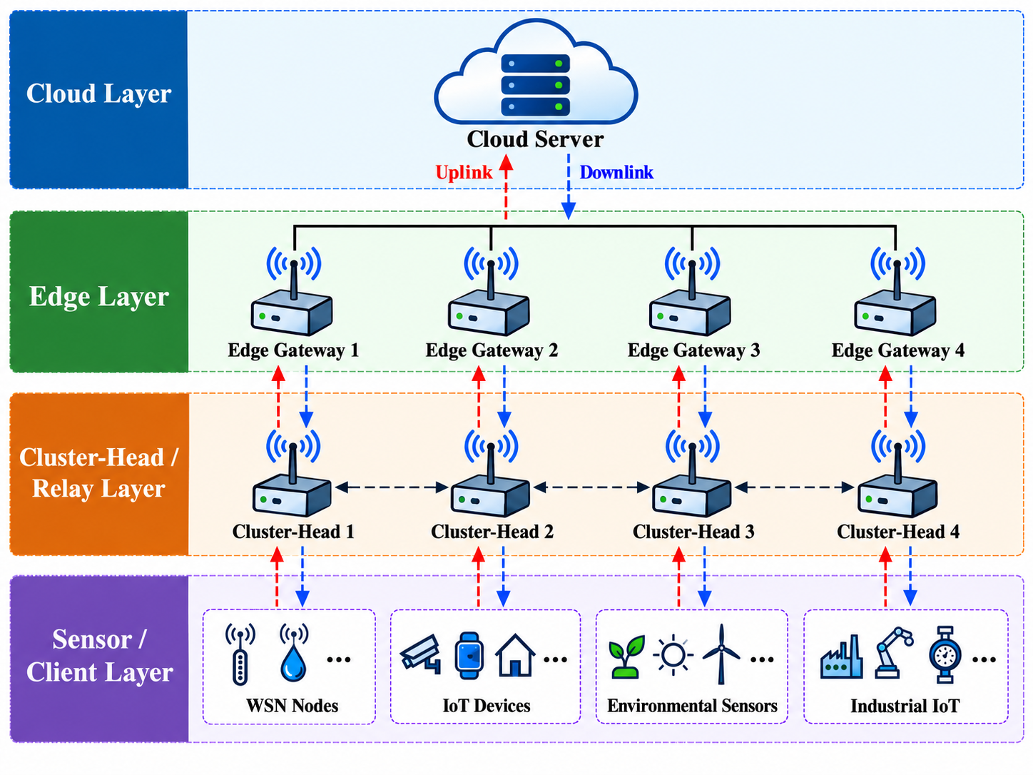
Figure 2. Intel Berkeley Lab WSN measured topology abstraction. Gateway motes are the configured edge gateways. Dashed links show a visually filtered subset of measured bidirectional-connectivity support; routing uses the full measured connectivity matrix and ETX values.

5.5 UCI Human Activity Recognition
UCI HAR contains smartphone inertial features for 30 subjects and six activities [16]. Each subject is treated as a persistent FL client. Because the original benchmark separates subjects between train and test, the files are recombined before constructing per-subject local datasets. The original HAR windows overlap by 50%; a random within-subject split can therefore leak overlapping signal content. The revised protocol preserves window order, partitions each subject record into contiguous 10-window blocks, assigns one of every five blocks to test using a deterministic subject-specific offset, and removes the immediately adjacent training window at each test boundary. This yields an approximately 80/20 overlap-safe within-client holdout. It is not the canonical unseen-subject UCI HAR benchmark.

5.6 Baselines and matched controls
The core fixed-compression baselines are random, resource-only, and utility-only selection. To isolate the role of compression, random-adaptive, resource-adaptive, and utility-adaptive controls receive the same client-specific Top-k ratio rule as the proposed controller while retaining their original selection logic. The proposed-fixed-compression ablation applies the proposed selection rule at a fixed 50% Top-k ratio.
The FedCG-adapted comparator uses current eligible-client gradient vectors in a greedy facility-location selection objective with a capability-cost penalty, followed by adaptive compression. Because this is a favorable adaptation with gradient access and because the original FedCG topology differs from the multi-hop HFL system, results are labeled FedCG-adapted rather than FedCG.

5.7 Metrics and statistical analysis
Learning metrics are RMSE/MAE for Intel and accuracy/Macro-F1 plus worst-client and 10th-percentile accuracy for HAR. Systems metrics include expected transmitted bits, modeled local-plus-radio energy, maximum relay energy, residual energy, route hops, and ETX. Jain's index describes selection-frequency equality. Utility-target JS evaluates corrected cloud-influence alignment with the controller target. Temperature-coverage JS and class-coverage JS are independent distributional diagnostics.
Final real-data comparisons use exact paired sign-flip tests on the 10 held-out seeds, percentile bootstrap 95% confidence intervals for paired mean differences, paired effect sizes, and Holm correction within each dataset-baseline metric family.

5.8 Control-plane signaling audit
Client-aware scheduling needs information before a client is selected, so we account for that signaling explicitly. Each candidate is assigned one 168-bit (21-byte) report per round: a 96-bit header, 32 bits for local loss, 32 bits for the residual-energy estimate, and an 8-bit availability flag. The raw count is T × N × 168 bits. For a network-level comparison, each report is also weighted by the client's realized route ETX. We then obtain a conservative radio-energy upper bound by multiplying those ETX-weighted bits by the configured transmit-plus-receive energy per bit. This accounting is post-hoc and does not feed the metadata cost back into residual energy or change any scheduling decision.
This audit asks a simple accounting question: does adaptive compression still save traffic after the scheduler's own metadata are charged? The answer is reported separately for each dataset rather than assumed in advance. The calculation covers the uplink control path only. Global-model download is outside this total, so the reported values are not a complete device-level communication budget.

5.9 ns-3.47 communication replay
Packet behavior is evaluated by replaying the held-out synthetic traffic in ns-3.47 using LR-WPAN with CSMA/CA, acknowledgments, retries, and contention. In the main mapping, compressed update size is converted to hop-equivalent offered load and ns-3 is allowed to generate its own retransmissions. We also retain an ETX-equivalent stress mapping, with the caveat that ETX already represents expected transmission attempts. The resulting design contains five load/scaling conditions, four policies, two mappings, and 10 held-out seeds, for 400 ns-3 runs. The federated-learning optimizer remains in Python and is not executed inside ns-3.

5.10 Open-loop replay versus closed-loop co-simulation
The replay is intentionally one-way. Python first produces the learning trajectory and its traffic trace; ns-3 then tells us what that load does to a contending IEEE 802.15.4 network. Packet loss, retries, and delay therefore do not alter later client selections in the current experiment. A closed-loop setup would be different: a missed deadline could remove a client from the realized round, stale arrivals could change aggregation, measured retransmission energy could increase relay pressure, and new link statistics could alter later routes. We use the open-loop replay to isolate the network consequence of offered load, not as a substitute for a full network-learning co-simulation.

5.11 Reproducibility campaign
The primary evaluation contains 240 tuning-grid HFL runs, 540 held-out real-data comparison runs, 100 held-out ablation runs, and 120 held-out synthetic runs: 1,000 HFL simulations in total, plus 400 ns-3 runs. The control-plane audit adds 40 accounting runs (proposed and proposed-fixed compression across the 10 held-out seeds on both real datasets). A regression test verifies two-level aggregation influence, and the frozen-table integrity checks are retained.
Repository verification is explicit rather than implicit. The tuning and held-out seed sets are defined in src/wsn_hfl/config.py and mirrored in reproducibility/seed_config.json; host hardware and the evidence boundary are documented in reproducibility/HARDWARE_SPECIFICATIONS.md; reproduction commands are listed in reproducibility/REPRODUCTION_COMMANDS.md; Tables 2 and 3 trace to the per-seed real-data outputs, aggregate summaries, and validation/statistics/statistical_tests.csv; and the control-plane audit is reproduced by analyze_control_plane_overhead.py. Dataset checksums, operating-point selection records, and frozen publication-table hashes are also committed.

6. Results

6.1 Synthetic stress test
At correlation 0.9, held-out mean accuracy is 93.90% for random, 94.12% for resource-only, 93.93% for utility-only, and 93.97% for the proposed controller. The corresponding proposed effective traffic is 0.532 Mbit compared with 1.468 Mbit for resource-only. Utility-target JS is 0.0076 for proposed versus 0.0669 for resource-only. However, independent class-coverage JS is 0.00869 for proposed and 0.00728 for resource-only, reinforcing that target alignment and data-distribution coverage are different quantities.

6.2 Intel WSN held-out evaluation
Table 2. Intel Berkeley Lab WSN results at correlation 0.9. Values are mean ± 95% confidence interval over 10 held-out evaluation seeds.
Method | RMSE (°C) ↓ | MAE (°C) ↓ | Effective Mbit ↓ | Energy (J) ↓ | Max relay E (J) ↓ | Utility-target JS ↓ | Temp.-coverage JS ↓
Resource | 1.7473 ± 0.0018 | 0.8369 ± 0.0048 | 2.230 ± 0.010 | 6.328 ± 0.022 | 0.1378 ± 0.0050 | 0.1057 ± 0.0045 | 0.00082 ± 0.00008
Resource-adaptive | 1.7285 ± 0.0034 | 0.7638 ± 0.0114 | 0.916 ± 0.013 | 3.307 ± 0.031 | 0.0902 ± 0.0026 | 0.0843 ± 0.0044 | 0.00034 ± 0.00003
FedCG-adapted | 1.7362 ± 0.0023 | 0.7903 ± 0.0065 | 0.980 ± 0.013 | 3.454 ± 0.030 | 0.0964 ± 0.0016 | 0.0911 ± 0.0033 | 0.00027 ± 0.00003
Proposed-fixed 50% | 1.7369 ± 0.0029 | 0.8048 ± 0.0080 | 2.373 ± 0.010 | 6.658 ± 0.022 | 0.1430 ± 0.0047 | 0.0283 ± 0.0023 | 0.00258 ± 0.00021
Proposed | 1.7348 ± 0.0030 | 0.7790 ± 0.0060 | 0.992 ± 0.021 | 3.482 ± 0.049 | 0.0969 ± 0.0024 | 0.0118 ± 0.0013 | 0.00375 ± 0.00019

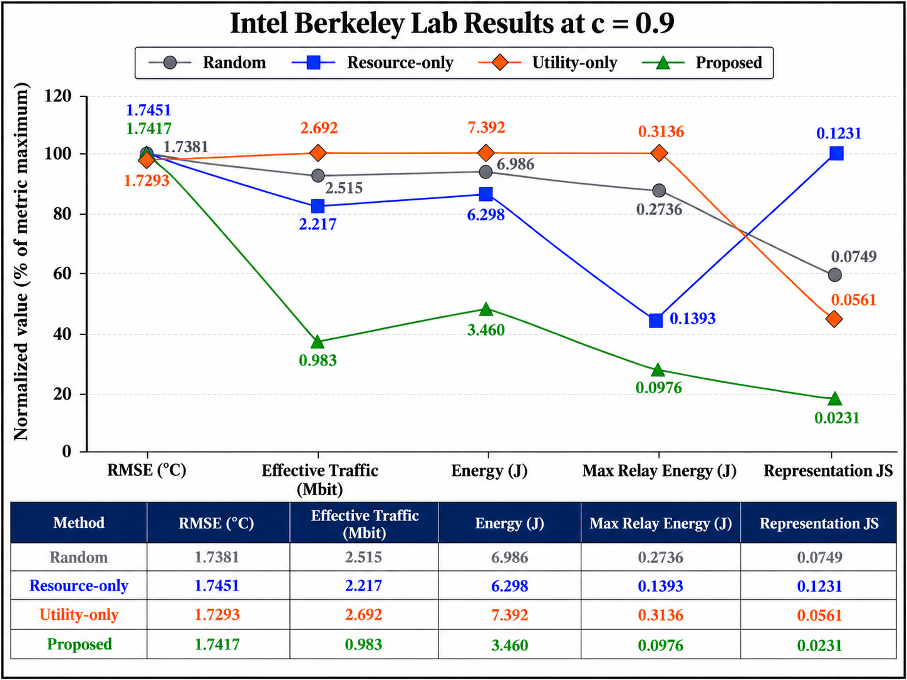
Figure 3. Intel held-out evaluation at c = 0.9. Raw means are annotated and tabulated. The line plot normalizes each metric to its own within-metric maximum only for visual comparison; it is not a composite performance score. Confidence intervals are reported in Table 2.
Relative to the fixed-compression resource baseline, the proposed controller reduces traffic by 55.5% and modeled energy by 45.0%, but the matched resource-adaptive control shows that those headline savings cannot be attributed to scheduling alone. Resource-adaptive uses 8.3% less traffic and 5.3% less modeled energy than proposed and obtains lower RMSE and MAE. The proposed controller instead reduces utility-target JS by 86.0% relative to resource-adaptive. Its temperature-coverage JS is worse, not better. Against FedCG-adapted, RMSE, traffic, energy, and maximum relay energy are statistically comparable after Holm correction, while utility-target JS is 87.1% lower. This result supports a target-alignment trade-off rather than statistical-representativeness superiority.

6.3 UCI HAR held-out evaluation
Table 3. UCI HAR results at correlation 0.9 using the overlap-safe blocked within-client holdout. Values are mean ± 95% confidence interval over 10 held-out evaluation seeds.
Method | Accuracy ↑ | Macro-F1 ↑ | Worst-client acc. ↑ | Effective Mbit ↓ | Energy (J) ↓ | Max relay E (J) ↓ | Utility-target JS ↓ | Class-coverage JS ↓
Resource | 0.8641 ± 0.0114 | 0.8565 ± 0.0140 | 0.5467 ± 0.0227 | 28.785 ± 0.898 | 44.73 ± 1.44 | 0.459 ± 0.088 | 0.1716 ± 0.0207 | 0.000081 ± 0.000032
Resource-adaptive | 0.8751 ± 0.0047 | 0.8698 ± 0.0057 | 0.5567 ± 0.0254 | 8.872 ± 0.363 | 14.34 ± 0.57 | 0.170 ± 0.036 | 0.1553 ± 0.0203 | 0.000075 ± 0.000038
FedCG-adapted | 0.8760 ± 0.0033 | 0.8705 ± 0.0041 | 0.5367 ± 0.0270 | 9.311 ± 0.389 | 15.34 ± 0.65 | 0.643 ± 0.135 | 0.1341 ± 0.0199 | 0.000070 ± 0.000024
Proposed-fixed 50% | 0.7947 ± 0.0253 | 0.7570 ± 0.0392 | 0.5032 ± 0.0512 | 31.232 ± 1.001 | 49.26 ± 1.98 | 0.807 ± 0.322 | 0.1010 ± 0.0191 | 0.000078 ± 0.000020
Proposed | 0.8867 ± 0.0012 | 0.8827 ± 0.0011 | 0.5683 ± 0.0294 | 11.253 ± 0.352 | 19.20 ± 0.75 | 1.242 ± 0.275 | 0.0275 ± 0.0034 | 0.000064 ± 0.000018

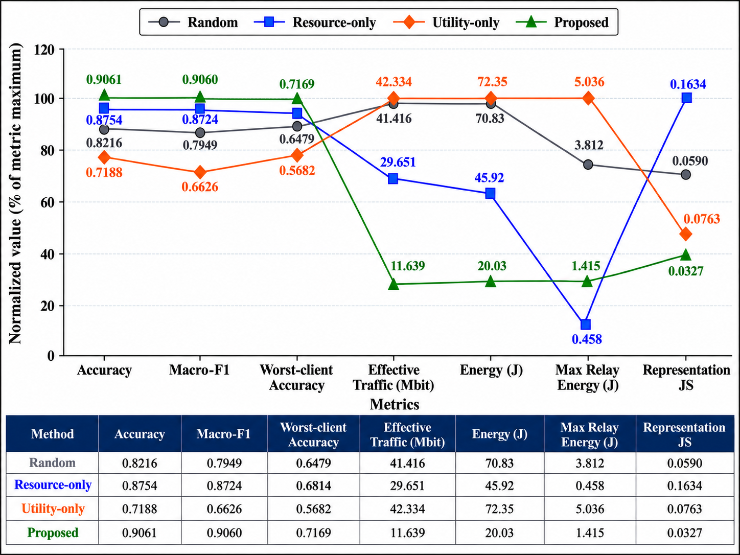
Figure 4. UCI HAR held-out evaluation at c = 0.9 using the blocked overlap-safe within-client split. Raw means are annotated and tabulated. The line plot uses within-metric normalization only for visualization; it is not a composite score. Confidence intervals are reported in Table 3.
On HAR, the accuracy gain is real, but it is not free. The proposed controller is 1.16 percentage points above resource-adaptive and 1.07 points above FedCG-adapted after Holm correction. Relative to resource-adaptive, however, model-update traffic rises by 26.8%, modeled energy by 33.9%, and maximum relay energy by 628.9%. Against FedCG-adapted, the corresponding increases are 20.9%, 25.1%, and 93.0%. The proposed controller also reduces utility-target JS by 82.3% and 79.5%, respectively, while the class-coverage JS differences remain small and non-significant. This is why we keep target alignment and distributional coverage as separate quantities.

6.4 Compression and component ablations
On Intel, adaptive fidelity reduces proposed traffic from 2.373 Mbit at fixed 50% compression to 0.992 Mbit, a 58.2% reduction, and modeled energy falls by 47.7%; RMSE changes only from 1.7369 to 1.7348 °C. Removing the participation-deficit queue increases utility-target JS from 0.0118 to 0.0318. Removing relay pressure increases maximum relay energy from 0.0969 J to 0.1062 J.
On HAR, adaptive fidelity reduces proposed traffic from 31.232 Mbit to 11.253 Mbit, a 64.0% reduction, and energy falls from 49.26 J to 19.20 J. Accuracy simultaneously rises from 79.47% to 88.67% because the fixed-compression traffic incurs larger latency/staleness and dropout consequences in the modeled system. Removing the participation-deficit queue lowers network cost but increases utility-target JS from 0.0275 to 0.0854 and reduces accuracy from 88.67% to 88.39%. Removing relay pressure lowers utility-target JS but raises maximum relay energy from 1.242 J to 1.599 J, illustrating that individual terms can improve one objective while worsening another.
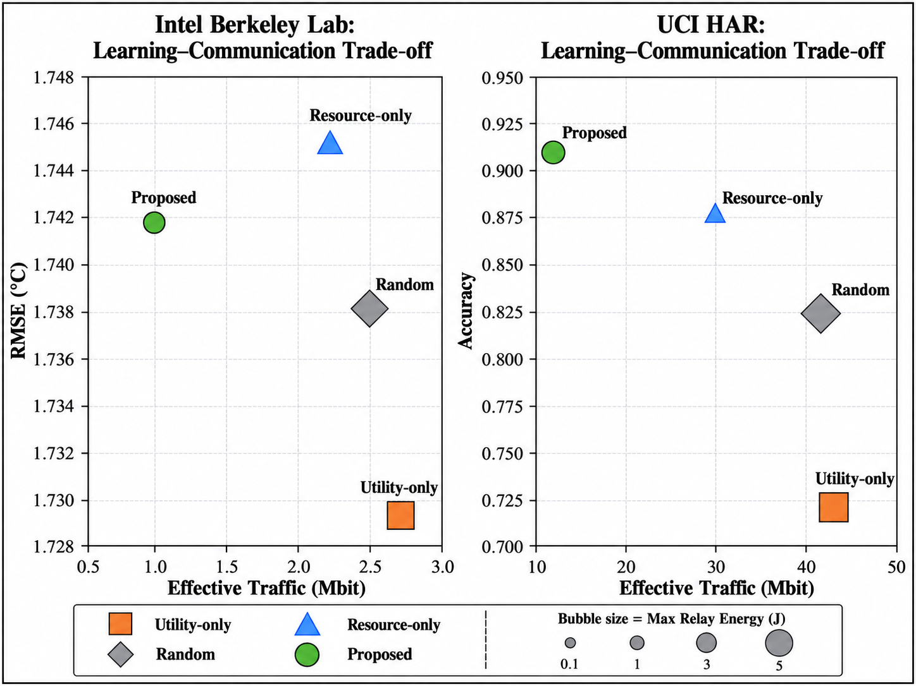
Figure 5. Held-out component ablations on Intel and UCI HAR at c = 0.9. 'No deficit' removes the utility-target participation-deficit term. Adaptive fidelity is the principal source of traffic reduction, while relay pressure and participation deficit affect different trade-off dimensions.

6.5 Control-plane overhead audit
The control-plane result is workload dependent rather than universally negligible. On Intel, 48 learning clients over 30 rounds generate 241,920 raw metadata bits (29.53 KiB). ETX weighting increases the held-out mean to 1.219 Mbit, with a conservative metadata radio-energy upper bound of 2.803 J. This is 122.8% of the proposed controller's 0.992 Mbit compressed model-update traffic, so control signaling is material for the small regression model.
On HAR, 30 clients over 25 rounds generate 126,000 raw metadata bits (15.38 KiB). The ETX-weighted mean is 0.306 Mbit with a 0.705 J conservative radio-energy upper bound, only 2.72% of the proposed 11.253 Mbit model-update traffic.
Table 4. Conservative pre-selection metadata audit at correlation 0.9. Values are means over 10 held-out evaluation seeds.
Dataset | Raw metadata | ETX-weighted metadata (Mbit) | Metadata radio-energy upper bound (J) | Metadata / proposed model traffic | Proposed control-inclusive uplink (Mbit) | Proposed-fixed control-inclusive uplink (Mbit) | Adaptive reduction after metadata
Intel | 29.53 KiB | 1.219 | 2.803 | 122.8% | 2.211 | 3.592 | 38.4%
UCI HAR | 15.38 KiB | 0.306 | 0.705 | 2.72% | 11.559 | 31.539 | 63.3%

Thus metadata does not erase the adaptive-fidelity advantage, but it materially changes the size of that advantage for lightweight models. The correct claim is therefore that control overhead is small relative to model traffic for HAR but not for Intel. Even under the conservative all-client-per-round accounting model, proposed adaptive fidelity retains a 38.4% control-inclusive uplink reduction on Intel and 63.3% on HAR relative to the same proposed selector at fixed 50% Top-k. These totals still exclude downlink global-model dissemination.

6.6 ns-3 communication replay
Under the dense-nominal hop-equivalent replay, the proposed traffic profile corresponds to 1,204 payload bits per report-equivalent update, compared with 3,431 for resource-only. Report delivery averages 99.47% versus 85.79%, and delivered-report delay averages 12.26 ms versus 35.99 ms. At the 24-sensor scale-nominal setting, delivery is 96.56% for proposed and 57.72% for resource-only. The useful conclusion is therefore about load and network behavior: a smaller offered load remains smaller once contention, retries, and acknowledgments are simulated, and the network responds with fewer failures and lower delay. Because the replay is open loop, these packet-level gains should not be read as an independent proof that the learning scheduler itself is superior. Adaptive compression is also a major contributor to the reduced load.
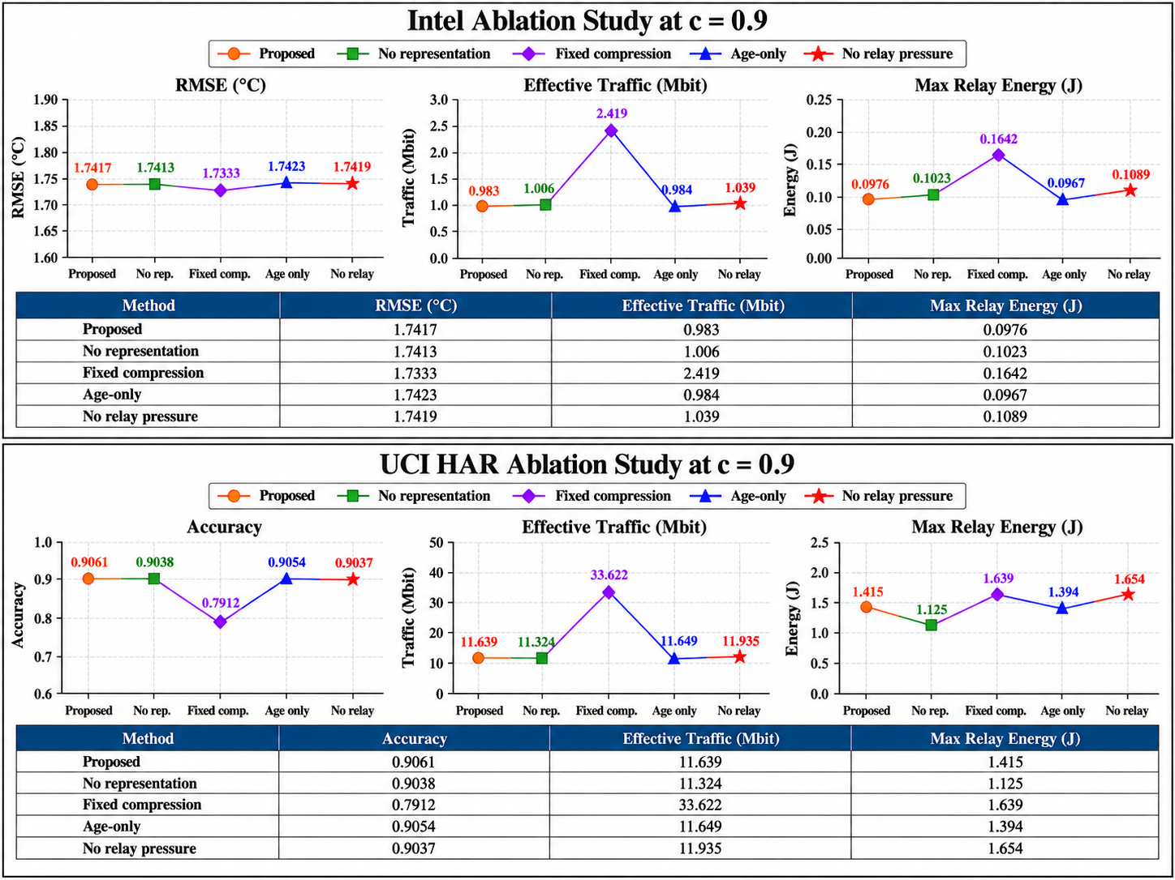
Figure 6. ns-3.47 IEEE 802.15.4/LR-WPAN hop-equivalent replay of held-out synthetic traffic. Report delivery ratio, delivered-report delay, and channel-access failures are shown for dense-nominal and 24-sensor-nominal conditions. The HFL controller itself is not executed inside ns-3.

6.7 Cross-dataset interpretation
Putting the two real datasets side by side, there is no single winner. On Intel, resource-adaptive gives the better prediction/resource point: it has lower error, traffic, total modeled energy, and relay burden, while the proposed method follows its utility-derived target much more closely. FedCG-adapted is statistically comparable to proposed on Intel RMSE and systems cost. HAR moves the balance in the other direction. Proposed improves accuracy from 87.51% to 88.67% relative to resource-adaptive, but pays 26.8% more model-update traffic, 33.9% more modeled energy, and 628.9% more maximum relay energy. Against FedCG-adapted, the accuracy gain is 1.07 percentage points with 20.9% more traffic and 93.0% more maximum relay energy. We treat these costs as part of the result, not as secondary implementation details.
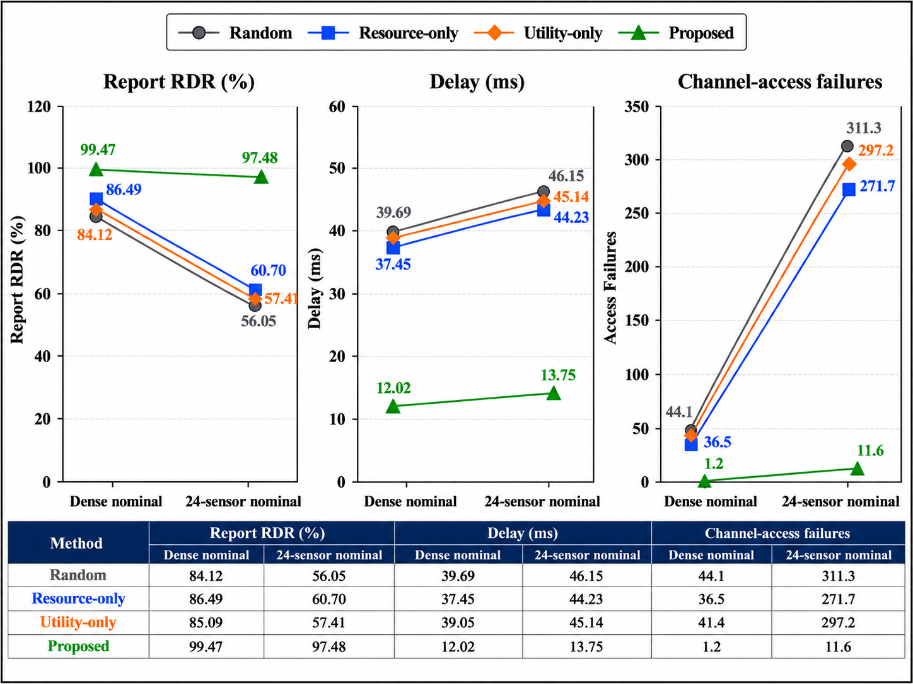
Figure 7. Held-out learning-versus-uplink-model-update-traffic trade-offs at c = 0.9. Marker area scales with maximum relay energy. The figure includes compression-matched controls, the FedCG-adapted comparator, and the proposed controller.
The preferred operating point therefore depends on the deployment objective. In the present HAR experiment, a system operator who is primarily protecting relay lifetime would have good reason to choose resource-adaptive. A deployment that values the observed accuracy gain more highly could instead accept the added traffic and hotspot cost of the proposed setting. The role of the controller is to expose that choice quantitatively, not to make the trade-off disappear.
The matched controls are important for another reason: they prevent compression gains from being mistaken for scheduling gains. A fixed-compression baseline can make the full controller appear much more communication-efficient even when the adaptive retained fraction explains most of the reduction. The opposite trade-off also appears in the results, where a resource-oriented selector spends less network energy but follows the utility target less closely. Keeping these controls separate makes the source of each gain easier to trace.

7. Discussion

7.1 Evidence hierarchy: exact analysis and executable systems behavior
Several revisions altered how we read the results. Correcting the two-stage influence calculation means that the JS diagnostic now reflects the coefficient that actually reaches the cloud, although the reference distribution is still generated by the controller itself. Separating tuning seeds from evaluation seeds removes reuse of the same randomness for both model selection and final inference. Finally, the matched-compression experiments show that most of the traffic reduction comes from adaptive fidelity rather than from the client-ranking rule alone. These corrections reduce the scope of the headline claims, but they also make the remaining conclusions better supported.
A convergence-rate theorem is therefore not used as the sole validation target. Obtaining such a theorem would require smoothing or relaxing several mechanisms that are active in the implementation, including binary participation, finite Top-k choices, changing routes, retransmissions, deadlines, and delayed arrivals. We keep exact analysis for the queue identities and finite decisions that genuinely remain exact, and use the real-data experiments plus ns-3 replay to examine behavior introduced by the network. These two forms of evidence are complementary; neither is a substitute for the other.

7.2 Model-complexity scaling
The present experiments use linear predictors so that communication and scheduling effects are not obscured by a large local compute workload. That choice also limits how far the energy balance can be extrapolated. A 1D-CNN or MobileNet-class TinyML model would increase both the number of trainable parameters and the amount of local arithmetic. With the same sparse encoding, retaining rho of P parameters requires approximately 96 + ceil(rho P)(32 + 16) bits. Because every retained value also carries a 16-bit index, sparse transmission stops being smaller than a dense 32-bit update once rho exceeds about two thirds, aside from the fixed header.
Deeper models do not necessarily make communication optimization more or less important in a uniform way. A larger parameter vector increases the cost of sending a dense update and can make sparsification more valuable. At the same time, convolutions, activation storage, and repeated memory transfers raise the cost of local training; on a small MCU, those terms may dominate the radio cost. The direction of the shift is therefore architecture- and platform-dependent rather than something that can be inferred from parameter count alone.
For a candidate architecture m, the balance can be approximated by comparing the radio work associated with B_m(rho) transmitted bits against the arithmetic and memory work required locally. In the projection below, h_ETX represents the mean ETX-weighted path burden, while N_MAC,m and N_mem,m denote arithmetic and memory-access counts. The expression is used only to reason about scaling; none of its coefficients were fitted to a particular MCU in this study.
$χ_{m}\left(ρ\right)≈\frac{B_{m}\left(ρ\right) h_{ETX} e_{radio/bit}}{N_{MAC,m} e_{MAC}+N_{mem,m} e_{mem}}$
The projected ratio is useful mainly as a break-point indicator. A large value means that radio activity still consumes a substantial share of the per-round budget, so reducing update size remains worthwhile. A small value means that arithmetic and memory movement have become dominant, in which case more aggressive sparsification offers less benefit. The actual break point will move with the MCU, local-epoch count, and network depth. It may also favor layer-wise or structured sparsification, because a single global Top-k threshold can behave poorly when update magnitudes differ substantially across layers.
The reported joules should be interpreted as a common accounting model for policy comparison, not as measurements from a particular sensor board. On a physical platform, the corresponding terms would be obtained from voltage and current measurements in transmit, receive, compute, memory-access, and sleep states, together with the time spent in each state. A battery-lifetime estimate becomes meaningful only after those platform measurements are available; the first-order relation below shows how such measurements would enter the calculation.
$N_{rounds}≈\frac{η_{bat} E_{bat}}{E_{sense}+E_{idle}+E_{comp}+E_{radio}}$
In this relation, E_bat denotes usable battery energy rather than the nameplate capacity, and eta_bat represents losses introduced by regulation, discharge characteristics, and cutoff voltage. Converting N_rounds to elapsed lifetime also requires the actual interval between rounds. Energy may not be the first deployment limit in any case: weights and activations must fit the available flash and SRAM, local training must complete within the round period, and data movement can consume a non-trivial part of the MCU budget. We therefore use modeled joules only for relative comparison here. Reporting lifetime in days or months would require current traces and timing measurements on the target MCU-radio pair.

7.3 Pareto interpretation across workloads
Intel and HAR do not rank the controllers in the same way, which is exactly the point of reporting both. Intel favors resource-adaptive on error and systems cost, while proposed tracks the utility target more closely. HAR gives proposed a modest accuracy advantage over resource-adaptive and FedCG-adapted, but the relay and traffic penalties are substantial. That reversal argues against a fixed claim that one orchestration policy is best across sensing workloads.
The broader claim is therefore limited to resource-aware edge intelligence, not environmental sustainability. We can measure how a learning decision changes modeled traffic and relay cost, but turning those quantities into battery replacement intervals or lifecycle impact needs hardware measurements from the intended deployment. Environmental monitoring, infrastructure sensing, and wearable systems all face the same coupling, but the physical scale of the cost will differ from platform to platform.
Utility-target alignment is most relevant when communication should follow current learning need rather than reproduce the pooled data distribution. A fault-monitoring example is illustrative: if one sensor suddenly develops a large loss or produces an update that differs sharply from the recent model history, repeated access to that node may be desirable because it may be observing a new operating condition. Similar behavior is useful under concept drift or a spatially localized event. In these cases, a low utility-target JS indicates that participation is tracking the scheduler's present learning priorities. It should not be interpreted as class, demographic, or geographic representativeness. Where broad coverage is the objective, the independent temperature- or class-coverage measures are the more appropriate criterion.

8. Limitations
Several evidence boundaries should remain explicit. The energy model is not a measurement from IEEE 802.15.4 hardware, so we make no claim about MCU current draw, radio current, RSSI/LQI, battery lifetime, embodied energy, or environmental sustainability. The Intel experiment uses historical sensing and connectivity traces; the original motes do not execute the FL code. Likewise, the HAR evaluation is a blocked within-client holdout for subject-as-client FL and should not be compared directly with the canonical unseen-subject benchmark.
The utility metric has a similar boundary. Its target is created by the controller, so a low utility-target JS means that realized influence follows that target; it does not establish population representativeness. The control-plane audit also remains an accounting exercise rather than a closed-loop energy charge. It prices all-client pre-selection metadata, but excludes global-model downlink traffic. Event-triggered, eligibility-gated, or piggybacked metadata could reduce the Intel overhead, but those mechanisms are not implemented here.
The ns-3 result is also open loop. Packet contention, retries, delivery, and delay are simulated after the learning trace has been generated, so a missed packet cannot change a later route, client set, or queue state. A closed-loop Python-ns-3 experiment would provide stronger evidence about feedback between network failure and learning behavior.
FedCG-adapted should be read as a strong reference implementation, not as an exact reproduction of FedCG. We retain its gradient-diversity/facility-location idea and adaptive compression, but the original topology and optimization assumptions are different from the multi-hop hierarchy studied here. Our adaptation also sees current eligible-client gradients without charging the cost of acquiring them, which makes the comparison favorable rather than artificially weak.
Two limitations are especially relevant to future extensions. First, the lightweight local models used here do not capture the compute and memory behavior of a larger TinyML network, so the useful sparsification range may move once the local model changes. Second, the relay queue discourages repeated use of stressed routes but does not enforce a hard prospective energy budget; the large HAR hotspot cost is an example of that distinction. The formal analysis is correspondingly limited to properties that hold for the implemented finite-horizon mechanism—queue bounds, finite-set compression selection, top-k score selection, and error-feedback conservation. A complete non-convex convergence result for the full coupled system is outside the present evidence.

9. Conclusion
The experiments leave a fairly simple message: in a multi-hop edge system, learning quality and network cost cannot be separated after the fact. A client choice changes the data seen by the model and, at the same time, changes route load, relay energy, delay, and the useful lifetime of the update.
Our controller makes those quantities visible to one round-level decision process, but the results do not support a claim of universal dominance. On Intel, resource-adaptive is the better choice if prediction error and systems cost are the main criteria, while proposed follows the utility target more closely. On HAR, proposed gains accuracy at a noticeable communication and relay-energy cost. We regard that reversal as useful evidence: the preferred policy depends on which resource or learning objective is binding in the deployment.
The ablations also clarify where the savings come from. Adaptive update fidelity accounts for most of the reduction in model traffic. Charging the scheduler's metadata reduces that apparent gain on the small Intel model, but it does not remove it: control-inclusive uplink traffic is still 38.4% lower than proposed-fixed on Intel and 63.3% lower on HAR.
The ns-3 replay closes the loop only partway. It confirms that a lower offered load translates into fewer packet-level problems under contention, but packet outcomes do not yet influence future learning rounds. A closed-loop packet/learning experiment and measurements on nonlinear TinyML models are the two most direct next steps before the framework can be treated as a deployment-level energy result.

Author contributions
All authors contributed equally to the conceptualization, methodology, investigation, validation, formal analysis, interpretation of results, manuscript preparation, critical revision, and final approval of the work.

Funding
This research received no external funding.

Declaration of interests
The authors declare no competing interests.

Declaration of generative AI and AI-assisted technologies in the writing process
During the preparation of this manuscript, the authors used OpenAI ChatGPT to support literature-review organization and language editing. The tool was not treated as an evidence source and was not used to replace author verification of citations, data, analyses, or conclusions. All AI-assisted material was critically reviewed, verified, and edited by the authors, who take full responsibility for the accuracy, integrity, citations, and final content of the manuscript.

Resource availability

Lead contact
Requests concerning the manuscript should be directed to the corresponding author, Abhishek Kumar Pandey (abhishek.pandey2@bennett.edu.in).

Materials availability
This computational study did not generate new physical materials.

Data and code availability
Code, experiment manifests, tuning and held-out seed lists, raw per-seed outputs, statistical analyses, control-plane audit outputs, and the seven user-verified manuscript figures are available in the public project repository: https://github.com/DrShivamBhardwaj/Relevance_Aware_RE_ETX_/tree/wsn-hfl-crosslayer-final. Intel Berkeley Lab sensor data and UCI HAR are publicly available from their original providers. The repository records the operating-point selection rule, corrected hierarchical-influence test, seed configuration, host-hardware specification, reproduction commands, and SHA-256 hashes that lock the approved final figure set.

References
[1] L. Liu, J. Zhang, S. H. Song, and K. B. Letaief, “Client-Edge-Cloud Hierarchical Federated Learning,” IEEE International Conference on Communications, 2020. DOI: 10.1109/ICC40277.2020.9148862.
[2] S. AbdulRahman, H. Tout, A. Mourad, and C. Talhi, “FedMCCS: Multicriteria Client Selection Model for Optimal IoT Federated Learning,” IEEE Internet of Things Journal, 8, 4723–4735, 2021. DOI: 10.1109/JIOT.2020.3028742.
[3] W. Y. B. Lim, J. S. Ng, Z. Xiong, D. Niyato, C. Miao, and D. I. Kim, “Dynamic Edge Association and Resource Allocation in Self-Organizing Hierarchical Federated Learning Networks,” IEEE Journal on Selected Areas in Communications, 39(12), 3640–3653, 2021. DOI: 10.1109/JSAC.2021.3118401.
[4] T. Huang, W. Lin, L. Shen, K. Li, and A. Y. Zomaya, “Stochastic Client Selection for Federated Learning With Volatile Clients,” IEEE Internet of Things Journal, 9(20), 20055–20070, 2022. DOI: 10.1109/JIOT.2022.3172113.
[5] X. Chen, T. Ouyang, Z. Zhou, X. Zhang, S. Yang, and J. Zhang, “HiFlash: Communication-Efficient Hierarchical Federated Learning With Adaptive Staleness Control and Heterogeneity-Aware Client-Edge Association,” IEEE Transactions on Parallel and Distributed Systems, 2023. DOI: 10.1109/TPDS.2023.3238049.
[6] Z. Jiang, Y. Xu, H.-Z. Xu, Z. Wang, and C. Qian, “Heterogeneity-Aware Federated Learning with Adaptive Client Selection and Gradient Compression,” IEEE INFOCOM, 2023. DOI: 10.1109/INFOCOM53939.2023.10229029.
[7] Y. Deng, F. Lyu, T. Xia, Y. Zhou, Y. Zhang, J. Ren, and Y. Yang, “A Communication-Efficient Hierarchical Federated Learning Framework via Shaping Data Distribution at Edge,” IEEE/ACM Transactions on Networking, 32(3), 2600–2615, 2024. DOI: 10.1109/TNET.2024.3363916.
[8] B. Wu, F. Fang, X. Wang, D. Cai, S. Fu, and Z. Ding, “Client Selection and Cost-Efficient Joint Optimization for NOMA-Enabled Hierarchical Federated Learning,” IEEE Transactions on Wireless Communications, 23(10), 14289–14303, 2024. DOI: 10.1109/TWC.2024.3411479.
[9] X. Chen, G. Zhu, Y. Deng, and Y. M. Fang, “Federated Learning Over Multihop Wireless Networks With In-Network Aggregation,” IEEE Transactions on Wireless Communications, 2022. DOI: 10.1109/TWC.2022.3168538.
[10] P. Pinyoanuntapong, P. Janakaraj, R. Balakrishnan, M. Lee, C. Chen, and P. Wang, “EdgeML: Towards Network-Accelerated Federated Learning over Wireless Edge,” Computer Networks, 218, 109396, 2022. DOI: 10.1016/j.comnet.2022.109396.
[11] T. V. Nguyen, N. D. Ho, H. T. Hoang, C. D. Do, and K.-S. Wong, “Toward Efficient Hierarchical Federated Learning Design Over Multi-Hop Wireless Communications Networks,” IEEE Access, 10, 111910–111922, 2022. DOI: 10.1109/ACCESS.2022.3215758.
[12] J. Wu, F. Dong, H. Leung, Z. Zhu, J. Zhou, and S. Drew, “Topology-Aware Federated Learning in Edge Computing: A Comprehensive Survey,” ACM Computing Surveys, 56(10), Article 262, 1–41, 2024. DOI: 10.1145/3659205.
[13] M. Alsofyani, I. Al-Turaiki, and H. Mathkour, “A Fairness Perspective on Client Selection and Aggregation Methods for Non-IID Mitigation in Federated Learning: A Survey,” Electronics, 2026. DOI: 10.3390/electronics15143178.
[14] M. J. Neely, Stochastic Network Optimization with Application to Communication and Queueing Systems, Morgan & Claypool, 2010. DOI: 10.2200/S00271ED1V01Y201006CNT007.
[15] Intel Berkeley Research Lab sensor dataset. Available: https://db.csail.mit.edu/labdata/labdata.html.
[16] UCI Machine Learning Repository, “Human Activity Recognition Using Smartphones.” DOI: 10.24432/C54S4K.
[17] E. Yu, S. Liu, Q. Li, H. Chen, H. V. Poor, and S. Shamai, “Graph-Based Joint Client Clustering and Resource Allocation for Wireless Distributed Learning: A New Hierarchical Federated Learning Framework With Non-IID Data,” IEEE Transactions on Mobile Computing, 24(5), 3579–3596, 2025. DOI: 10.1109/TMC.2024.3515037.
[18] M. Wu, M. Boban, and F. Dressler, “Hierarchical Federated Learning in Device-to-Device Networks With Learning-Topology Co-Optimization,” IEEE Transactions on Mobile Computing, 25(8), 12488–12505, 2026. DOI: 10.1109/TMC.2026.3673393.
[19] W. Hu, Y. Yu, X. Hao, X. Cai, Y. Qian, L. Guo, and Y. Li, “Multi-Job Hierarchical Federated Learning for Consumer-Grade UAVs: A Joint Client Selection and Resource Allocation Approach,” IEEE Transactions on Consumer Electronics, 71(3), 8021–8032, 2025. DOI: 10.1109/TCE.2025.3587021.
[20] “Joint Communication and Computing Resource Allocation for Energy Efficient Hierarchical Federated Learning in Marine Internet of Things,” IEEE Transactions on Network Science and Engineering, 12(5), 4114–4127, 2025. DOI: 10.1109/TNSE.2025.3568875.

