Isolating Traffic Reduction from Relevance-Directed Allocation: A Controlled Evaluation of Adaptive Payload Length over RE-ETX Routing in WSNs
Shivam Bhardwaj, Jitendra Nath Srivastava and Akash Sanghi
Faculty of Engineering and Technology, Invertis University, Bareilly, Uttar Pradesh 243123, India
Corresponding author: shibambhardwaj@gmail.com
E-mail: jitendranathshrivastava@gmail.com; sanghiakash@gmail.com

Abstract
Fixed-length reporting treats a routine sample and an unusual observation as if they deserve the same radio budget. We test a temporal-spatial relevance controller that changes application payload length while residual-energy expected-transmission-count (RE-ETX) routing is kept as the forwarding substrate. The controller uses only observed innovations, not event labels, and produces byte-aligned reports between 1000 and 4000 bits. A seven-configuration, ten-seed study separates full-payload routing, the exploratory relevance-age route term, equal-budget fixed reporting, shuffled relevance, temporal-only relevance, and the retained temporal-spatial controller. With fixed 4000-bit RE-ETX (C1), mean first-, half-, and last-node death occur at 125.5, 409.1, and 1268.6 rounds. Under the retained controller (C3), the corresponding values are 275.2, 870.1, and 2636.4 rounds; PDR rises by 2.462 percentage points, while mean delay and communication energy per delivered report fall by 54.0% and 54.2%, respectively. Those large network gains are mainly a traffic-volume effect: the equal-budget fixed control C5 uses 1744 bits versus 1747.8 attempted bits for C3 and reproduces most of them. After Holm correction, C3 retains advantages over C5 in HND, delay, and energy per delivered report, but not in FND, LND, PDR, or retries. C6, which shuffles the adaptive payload assignments within each round, is statistically indistinguishable from C3 on the tested network outcomes. The relevance signal nevertheless changes where the reduced budget is spent. In event-active rounds, C3 assigns on average 1218.7 more bits to event reports than to non-event reports, compared with 0 bits for C5 and 13.3 bits for C6; event-payload preservation is 0.802 for C3 versus 0.436 and 0.592. Topology tests spanning about 1.5 to 4.9 initial route hops retain the large C3-versus-C1 benefit, whereas equal-budget C3-versus-C5 differences become mixed as routes deepen. The supported claim is therefore relevance-directed allocation of a reduced payload budget, not universal equal-budget superiority. The primary results assume centrally available neighbour observations and use a radio-only energy ledger that excludes sensing, computation, routing-control signalling, acknowledgements and idle listening; receiver-side reconstruction and downstream task utility are not established.
Keywords: wireless sensor networks; residual energy; expected transmission count; adaptive payload; relevance estimation; communication energy.

1. Introduction
Sensor nodes have to divide a small energy reserve among sensing, computation and radio use. In practice, unreliable links and uneven relay duties make that budget hard to manage [1]. LEACH addressed part of the imbalance by rotating communication roles [2, 3]. ETX tackles a different problem by favouring routes that are likely to need fewer transmission attempts [4]. RPL and its minimum-rank-with-hysteresis objective function later provided a standard setting for combining routing metrics in low-power and lossy networks [5, 6]. None of these mechanisms, however, decides how much application data should be sent for a particular observation.
Another option is to reduce the traffic before routing begins. Prediction and recovery schemes exploit regularity in environmental measurements [7], adaptive sensing changes reporting effort as the signal evolves [8], and correlation can suppress redundant updates from nearby devices [9]. This leaves a practical question for any combined design: are the network gains coming from the route, from a smaller source report, or from both? A single proposed-versus-baseline comparison cannot separate those effects.
We therefore keep the two decisions separate in the simulator. Temporal change and spatial disagreement produce a relevance score, and that score only sets report length. Route cost is computed from link reliability and residual energy. A relevance-age term is included as a test condition rather than as a required part of the final method. This arrangement lets the experiments attribute changes to source traffic, routing, or their interaction.
The primary contribution lies in a controlled experimental design that isolates the effects of traffic-volume reduction from relevance-directed payload allocation. The study implements an auditable temporal-spatial novelty estimator and byte-aligned payload controller over a residual-energy ETX forwarding substrate, then uses equal-budget fixed and shuffled-allocation controls to distinguish reduced-traffic effects from relevance-based targeting. The evaluation also reports route-depth-dependent limits rather than claiming general protocol superiority.
We test two modest expectations. First, a smaller source report should allow more reporting opportunities for the same modelled communication-energy budget. Second, the relevance score should reserve more of that budget for unusual observations. The first expectation is checked against 4000-bit reporting; the second against equal-budget and shuffled controls. We do not assume that relevance must improve every network metric at the same average bit budget, and no claim is made here about receiver reconstruction or downstream task accuracy.

2. Related work and positioning

2.1. Routing and source-data control
ETX selects reliable paths through an additive transmission-cost metric [4], whereas residual-energy penalties seek to avoid repeated use of depleted relays. ETXRE explicitly combines link reliability with remaining energy within RPL [10]. The present RE-ETX implementation uses the same broad engineering principle, but it is a custom sink-rooted shortest-path simulator rather than an implementation of RPL or ETXRE. Its contribution is therefore assessed through integration and ablation, without claiming residual energy as a new routing signal.
Prediction-based communication reduction has a longer history than contemporary semantic networking. Wu et al. combine prediction, compression and recovery for clustered monitoring [7]. Bou Tayeh et al. couple real-time prediction with adaptive sensing [8]. More recently, Arnaiz et al. coordinate energy and relevance objectives under hard monitoring-energy constraints [11], and Płaczek uses prediction to reduce communication associated with target-node selection [12]. These studies make source reconstruction or application decisions part of their evaluation. The present network simulator instead treats payload length as a transmission budget; it has no implemented source decoder.
The distinction from Arnaiz et al. [11] is one of control granularity and evaluation target. Their method coordinates a dynamic sampling-period controller with a dual-prediction scheme, adapting both monitoring cadence and prediction error thresholds to meet a battery-life target while evaluating signal reconstruction accuracy. The present controller does not alter the sampling period or run a source-side predictor/receiver decoder: it computes temporal and spatial statistical novelty from observations already generated and maps the resulting score to the length of each report. Its primary evaluation therefore concerns network traffic, delivery, delay, communication energy and the allocation of a matched source-bit budget. The C5 and C6 controls isolate the effect of that allocation rule; they do not substitute for the receiver-fidelity evaluation provided in [11].

2.2. Freshness, relevance and semantic communication
Information age measures the time since the generation of a received update, while age of incorrect information also accounts for whether the receiver’s information is wrong [13, 14]. Kountouris and Pappas connect communication effort to the significance of information for a networked task [15]. DeepSC provides an example in which a learned source representation and semantic recovery are evaluated explicitly [16]. Correlation-aware reinforcement learning has also been used to schedule sensor updates with energy awareness [17]. These formulations motivate selective reporting, but their objectives are not interchangeable.
Surveys by Luo et al. [18], Gündüz et al. [19] and Getu et al. [20] distinguish message meaning, task outcomes, source representations and communication resources. Accordingly, this paper uses relevance to mean statistical novelty under a specified estimator. A relevance-weighted age variable is not age of incorrect information because receiver estimation error is absent. Likewise, preserving a payload floor is a transmission safeguard, not a demonstrated event-recall guarantee.
Recent WSN- and IoT-oriented studies further illustrate the distinction. Yang et al. [23] evaluate adaptive semantic communication against task requirements in WSNs, while Kaya et al. [24] select transmission rates using predicted channel conditions and semantic-distortion constraints for IoT sensor streams. Both explicitly address semantic/task fidelity or distortion. The present controller instead uses a statistical novelty score to choose a raw application-payload length; without a source encoder and receiver decoder, it should not be described as a semantic communication system.
Recent work makes the novelty boundary fairly clear. Senouci and Benaouda optimise ETX-based routing with machine learning [21], while Hwang et al. adapt payload structure and transmission policy for harsh-channel WSN collection [22]. Neither direction is treated here as new on its own. The question is instead whether a simple, auditable relevance signal can control report length over an energy-aware ETX substrate, and whether matched controls can identify which part of that composition actually changes network behaviour. Table 1 summarises that position.
Table 1. Representative prior work and the control evaluated in this study.
Study | Main control | Relationship to this work
ETX [4]; ETXRE [10] | Route/link cost | Reliability and energy substrate
Prediction and recovery [7, 8] | Data reduction; sensing | Receiver fidelity is evaluated in those works
Correlated-information scheduling [9, 17] | Update timing | Correlation is used here to set report length
Energy/relevance monitoring [11] | Sampling and prediction | Closely related source-control motivation
Learned ETX [21] | Learned routing metric | No learned routing model is used here
Adaptive payload management [22] | Payload structure and transmission | Contemporary payload-control context
Present study | Payload length over RE-ETX | Seven-case controlled evaluation of relevance-directed payload length over RE-ETX
Table 1 makes the claim boundary explicit: route adaptation, residual-energy protection, correlation-aware sensing, and payload control all have prior art. The contribution lies in the particular transparent composition and, more importantly, in the controls that separate traffic-volume effects from relevance-directed allocation.
Table 2. Statistical novelty used for payload control versus representative semantic-communication frameworks.
Dimension | Statistical novelty in this study | Semantic communication [15,16,19,20,23,24]
Definition | Departure of an observation from a node's historical temporal and spatial baseline; a statistical priority signal. | Task- or meaning-relevant information selected for a communication objective; semantics depend on the application and framework.
Computation | Normalised temporal innovation and spatial deviation from a neighbour median; weighted combination (0.6/0.4), followed by exponential squashing. | May use learned encoders, semantic features, task models or knowledge/context representations; there is no single universal computation.
Transmission action | Changes the length of the raw application report (1000–4000 bits); it does not change the sampling interval or encode a semantic representation. | Transmits a task-relevant or semantically compressed representation; the representation and rate depend on the encoder and task.
Receiver requirement | The submitted system has no implemented source decoder; reconstruction fidelity and task utility are not established. | A receiver-side decoder or task estimator is normally needed to evaluate semantic reconstruction or task-level utility.
Evaluation | Payload allocation, PDR, delay, communication energy and event-associated bit allocation; these are not semantic-fidelity metrics. | Semantic distortion, reconstruction quality, task accuracy/utility and communication-resource cost, as appropriate to the framework.

3. Network and communication model

3.1. Topology, traffic and sensing
The simulated field contains 100 static sensors uniformly positioned in a 100 m × 100 m square. Each sensor starts with 0.5 J, and an externally powered sink is located at (50, 150) m. Every sensor alive at a round’s start generates one report. Source order rotates between rounds, and transmissions occupy one serialised shared channel. A route is computed once per round and remains fixed while that round’s sources are served. Consequently, a relay may die before a later source uses its assigned path.
The synthetic background follows a spatially correlated autoregressive process. For background vector $b\left(t\right)$ and an independent standard normal vector $z\left(t\right)$,
$$b\left(t\right)=ϕb\left(t-1\right)+σ_{n}\sqrt{1-ϕ^{2}} C^{1/2}z\left(t\right), C_{ij}=exp\left(-d_{ij}/l_{s}\right). \left(1\right)$$
Here $ϕ=0.85$, $σ_{n}=0.10$ and $l_{s}=25$ m. A spatial Gaussian event of amplitude 3 and width 18 m is superimposed on the observations. While no event is active, a new event starts with probability 0.03 per round and lasts 4–10 rounds. Events are superimposed on the background rather than fed back into its autoregression. Ground-truth event labels are not passed to the runtime relevance controller.
The sensing field and estimator continue to evaluate all original node positions after some sensors have died. Current neighbourhood observations are therefore available centrally without communication cost in this implementation. This is an explicit modelling boundary: it does not demonstrate a deployable distributed exchange of those observations.

3.2. Channel, fragmentation and energy
REVISION EVIDENCE — The supplementary node-state energy study now debits modeled sensing, CPU, idle, neighbour-context/control, radio and approximate ACK costs. Moderate and high additional-cost profiles are assumptions, not hardware-calibrated current measurements. Therefore, any original radio-only reduction percentage must be identified as such and must not be generalized to deployment-wide energy.
The channel combines log-distance path loss with static log-normal shadowing. A BPSK-equivalent bit-error abstraction gives $p_{b}=1/2erfc\left(\sqrt{γ}\right)$ at linear signal-to-noise ratio $γ$. Independent bit errors yield frame success probability ${\left(1-p_{b}\right)}^{B}$ for a frame of $B$ bits. This abstraction is not a complete IEEE 802.15.4 physical or medium-access layer.
Each application report of $L$ bits is fragmented into payloads of at most $M=800$ bits, with $H=216$ overhead bits per fragment:
$$F\left(L\right)=ceil\left(L/M\right), B\left(L\right)=L+HF\left(L\right). \left(2\right)$$
Thus, 4000 application bits require five frames and 5080 transmitted bits per hop before retries. A 1000-bit report requires two frames and 1432 bits. Frame retries are hop-by-hop, with at most four attempts per frame. Failure of a required fragment prevents successful delivery of that application report.
The first-order radio model uses the free-space and multipath forms associated with classical WSN energy modelling [3]:
$$E_{TX}\left(B,d\right)=BE_{elec}+B\left\{\begin{matrix}ϵ_{fs}d^{2}, & d<d_{0}, \\ ϵ_{mp}d^{4}, & d≥d_{0},\end{matrix}\right. ; E_{RX}\left(B\right)=BE_{elec}. \left(3\right)$$
The crossover is $d_{0}=\sqrt{ϵ_{fs}/ϵ_{mp}}=87.71$ m. Transmit energy and relay-receive energy are charged for attempted frames, including corrupted frames; sink energy is excluded. An energy-deficient sender consumes its remaining energy during a partial frame. Acknowledgements, idle listening, sensing, relevance computation and routing-control traffic are outside the ledger. Table 3 records the principal settings.
Table 3. Parameters used in the archived experiments.
Parameter | Value | Parameter | Value
Sensors; initial energy | 100; 0.5 J each | Field; sink | 100 × 100 m; (50,150) m
Full application report | 4000 bits | Frame payload; overhead | 800; 216 bits
Bit rate; retry limit | 250 kbps; 3 retries | Processing delay | 1 ms per hop
Carrier; transmit power | 2.4 GHz; 0 dBm | Noise floor | −100 dBm
Path-loss exponent | 2.4 | Shadowing standard deviation | 4 dB
Sensor-link radius | 30 m | Full-message eligibility | Success ≥0.90
Electronics energy | 50 nJ/bit | Amplifier coefficients | 10 pJ/bit/m²; 1.3 fJ/bit/m⁴
Temporal correlation | 0.85 | Spatial correlation length | 25 m
Innovation-noise scale | 0.10 | Event start probability | 0.03 per inactive round
Event amplitude; width | 3; 18 m | Event duration | 4–10 rounds
Relevance neighbourhood | 20 m | Warm-up; EWMA factor | 50 rounds; 0.02
Temporal/spatial weights | 0.6 / 0.4 | Energy weight in ablation | 0.25
Minimum payload ratio | 0.25 | Protection thresholds | 0.50 and 0.85
Stop condition | All nodes dead | Maximum rounds | 5000
Table 3 describes a single operating regime. The 30 m radius applies to sensor-to-sensor candidate edges; sink links are filtered by reliability without that distance limit. If the quality-filtered graph provides no route, the source attempts its direct sink link as a tracked fallback. This policy prevents disconnected sensors from remaining artificially alive indefinitely, while exposing them to potentially poor delivery conditions.

4. Relevance-aware payload adaptation over RE-ETX

4.1. Statistical relevance
For sensor $i$, temporal novelty compares the current and previous observation; spatial novelty compares the current observation with the median of neighbours within 20 m:
$$u_{i}^{T}\left(t\right)=\left|x_{i}\left(t\right)-x_{i}\left(t-1\right)\right|, u_{i}^{S}\left(t\right)=\left|x_{i}\left(t\right)-{median}_{j∈N_{i}}x_{j}\left(t\right)\right|. \left(4\right)$$
An empty neighbourhood gives zero spatial novelty. The first 50 rounds initialise per-node feature means and variances and return zero relevance. Thereafter, each feature is normalised against its historical baseline and clipped to the interval [0,8]. With these clipped scores $z_{i}^{T}$ and $z_{i}^{S}$,
$$v_{i}\left(t\right)=1-exp\{-0.6z_{i}^{T}\left(t\right)-0.4z_{i}^{S}\left(t\right)\}. \left(5\right)$$
Scoring occurs before baseline adaptation. The update clips an incoming feature at the previous mean plus three standard deviations and applies an exponentially weighted moving average with factor 0.02; variance is bounded below by ${10}^{-8}$. This reduces rapid baseline contamination by large deviations. These rules define a statistical priority score, not a probability that an event has occurred.

4.2. Payload mapping and safeguards
EQUATION (6) CLARIFICATION — The original submitted Word equation already contains a three-branch safeguard: ρ(v)=0.25+0.75v for v<0.50; ρ(v)=max(0.75,0.25+0.75v) for 0.50≤v<0.85; and ρ(v)=1 for v≥0.85. The existing Word equation therefore gives L(0.50)=3000 bits, not 2500 bits. The reviewer appears to have evaluated only the unguarded linear branch. The executable source and a complete mapping table are available as verification evidence. Preserve the original editable Word equation; provide a clearer rendering/interpretation in the response.
The payload ratio follows a linear base mapping with two protective thresholds:
$$ρ\left(v\right)=\left\{\begin{matrix}0.25+0.75v, & v<0.50, \\ max\left(0.75,0.25+0.75v\right), & 0.50≤v<0.85, \\ 1, & v≥0.85.\end{matrix}\right. L\left(v\right)=8ceil\left(4000ρ\left(v\right)/8\right). \left(6\right)$$
Once relevance reaches 0.50, the mapping never assigns less than 3000 bits; at 0.85 it assigns the full 4000 bits. The selected length is rounded to a whole number of bytes and clipped to the 4000-bit ceiling. During the 50-round warm-up, relevance is zero, so payload-enabled modes send the 1000-bit minimum. Those warm-up reports remain part of every result. The threshold names in the code are safeguards only; they are not backed by a measured event-recall rate.
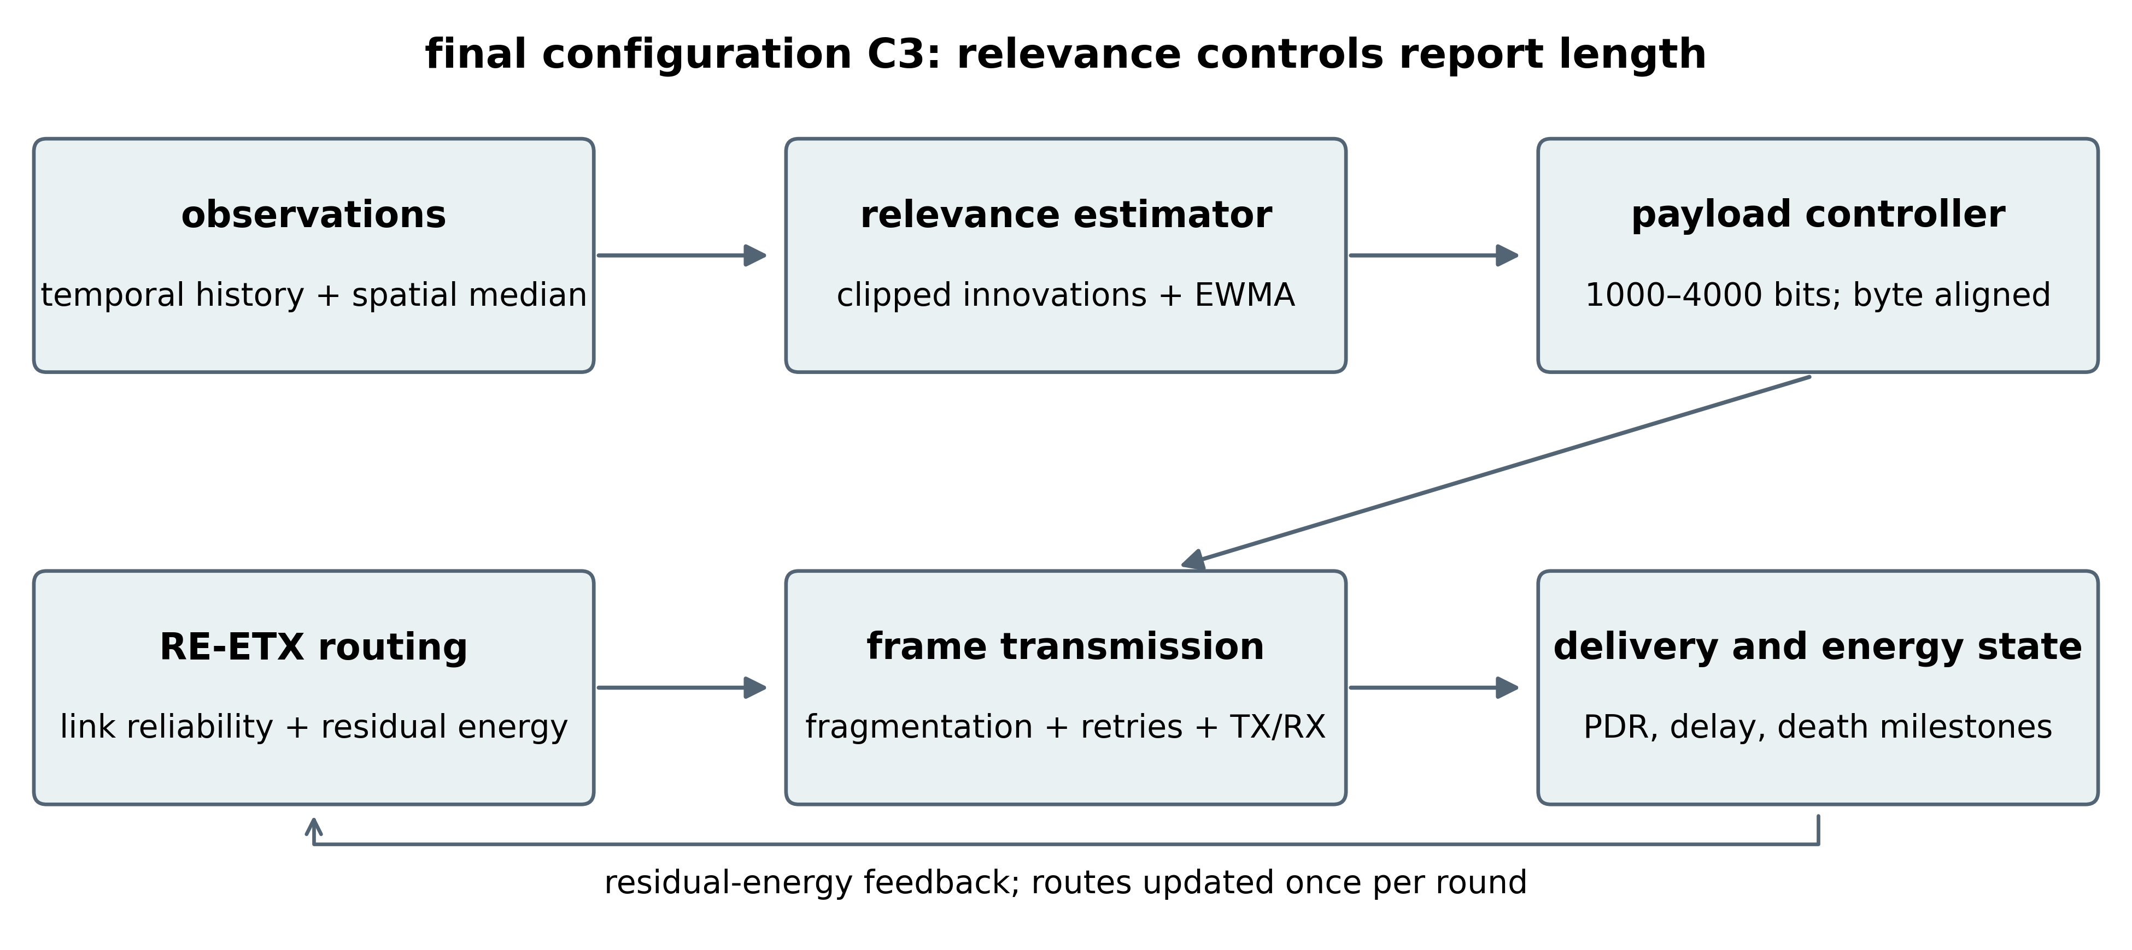
Figure 1. Data path used by C3 in the supplied simulator. Spatial context is read centrally in this implementation, so the cost of exchanging neighbour observations is not charged.
In C3, source adaptation and routing act on different variables. Relevance sets the number of application bits; residual energy and link reliability set the path cost. After a length is chosen, the simulator rebuilds the fragment list and accounts for the frames that are actually transmitted. Energy therefore follows the realised frame sequence rather than a fixed-packet estimate scaled by a nominal reduction ratio.
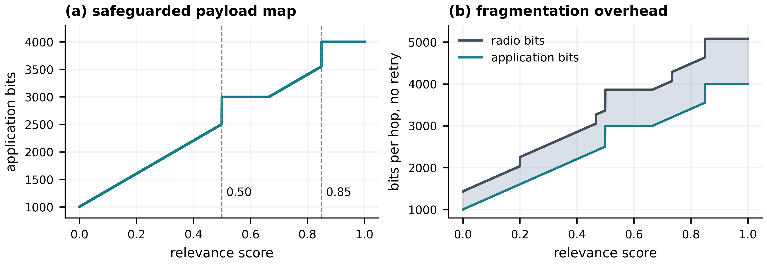
Figure 2. Payload map and one-hop framing cost implied by equations (2) and (6), before retransmissions. The gap in panel (b) is framing overhead; the curves are analytical rather than averages from the runs.
Figure 2 explains why application-bit reduction and radio-bit reduction differ. The minimum report retains 25% of the application budget but 28.19% of the one-hop no-retry radio budget. At intermediate lengths, fragment boundaries create additional steps. Consequently, a shorter report can use less energy while exhibiting a lower ratio of application bits to radio bits.

4.3. RE-ETX and the routing ablation
The static graph evaluates full-report one-attempt success probability $q_{ij}^{\left(0\right)}$ and assigns a message-level ETX surrogate $m_{ij}=1/max\left(q_{ij}^{\left(0\right)},ε\right)$. This differs from the bidirectional data-and-acknowledgement ETX in [4] and from the exact expected number of bounded frame attempts. Let $e_{i}$ be residual energy normalised by initial energy and clipped away from zero, and let $ψ_{i}=e_{i}^{-1}-1$. For sensor-to-sensor links,
$$c_{ij}=m_{ij}\left[1+λ_{E}\left(ψ_{i}+ψ_{j}\right)/2\right], c_{iB}=m_{iB}\left[1+λ_{E}ψ_{i}/2\right]. \left(7\right)$$
The routing edge costs are strictly positive; this condition ensures the validity of one sink-rooted Dijkstra search per round after dead sensors are removed. Graph eligibility and $m_{ij}$ remain based on the full 4000-bit report even when the actual report is shorter. This is a conservative, fixed reliability substrate; payload-dependent route eligibility is not implemented.
For C2 and C4, the implementation also tracks a slotted age $a_{i}$, reset to one after a successful report, and forms $s_{i}=1-exp\left(-v_{i}a_{i}/10\right)$. The term $λ_{S}\left(s_{i}+s_{j}\right)/2$ is added inside the sensor-link bracket in equation (7), while $λ_{S}s_{i}$ is added to the sink-link bracket. Here $λ_{S}=1$. In these two ablation cases, greater age only raises the route penalty. It does not move a stale source earlier in the service order or give that source more bandwidth. That distinction matters when reading the routing result.

4.4. Execution and computational cost
Within a round, observations are generated first, followed by relevance scores and payload lengths. The live routing graph is then built, and sources are served in the rotated order. A source uses its selected path when possible; otherwise the tracked direct fallback is attempted. Frame outcomes update energy, delivery counters and age state, and death milestones are checked after the round. As a consistency check, every generated report must end in either a successful delivery or one of the recorded drop categories.
With neighbourhood lists already stored, temporal scoring and the payload map scale linearly with node count. Computing spatial medians still depends on the number of neighbour observations examined. Using a heap, the shortest-path step costs $O\left(\left(\left|V\right|+\left|E\right|\right)log\left|V\right|\right)$. The current code also stores dense distance and link matrices, requiring $O\left(N^{2}\right)$ memory, and scans dense neighbourhood masks for relevance. These are implementation properties of the simulator rather than evidence for constant-cost distributed execution.

5. Experimental design and metric audit

5.1. Data provenance and experimental controls
All seven configurations use the same ten seeds: {11, 23, 42, 67, 101, 137, 173, 211, 257, 307}. For a given seed, topology, shadowing and the sensing process are fixed across cases. The frame-error generator starts from the same seed as well, but different payloads and routes consume that stream in different orders, so individual frame outcomes are not counterfactual pairs. This produces 70 control runs. We also ran 40 energy-weight cases at 0, 0.25, 0.50 and 1.00. Event and targeting analyses reuse the deterministic sensing streams and reveal event truth only after the relevance decision. The topology study uses ten seeds per mode for each of the three calibrated route-depth profiles.
Table 4. Configuration definitions and experimental control roles.
Paper case | Age route term | Payload rule | Experimental role
C1 | Off | Fixed 4000 bits | Full-payload RE-ETX reference
C2 | On | Fixed 4000 bits | Routing-age ablation
C3, retained method | Off | Temporal-spatial relevance adaptive | Retained payload controller
C4 | On | Temporal-spatial relevance adaptive | Full extension
C5 | Off | Fixed 1744 bits | Equal-budget fixed-payload control
C6 | Off | C3 payloads shuffled within round | Equal-budget relevance-allocation control
C7 | Off | Temporal-only relevance adaptive | Spatial-feature ablation
Table 4 extends the original C1-C4 ablation with three source controls. Independent C1 and C3 executions at seed 42 reproduce the pre-extension network trajectories, and a repeated C6 execution reproduces the shuffled-control result exactly. C5 is byte-aligned to the attempted C3 payload budget in the baseline topology. C6 keeps the same round-level adaptive payload multiset as C3 but randomly reassigns those payloads among reports, breaking the link between a report’s relevance and its payload while preserving the round budget. C7 removes the spatial feature calculation and retains only temporal relevance. Event truth is read only for offline evaluation after relevance has been computed; it never enters routing or payload selection.

5.2. Outcomes and denominators
First-, half- and last-node death (FND, HND and LND) are measured in rounds at the first occurrence of at least 1, 50 and 100 dead sensors. Network lifetime depends on the service definition [25]; these milestones do not certify coverage or connectivity. All observed runs reach LND before 5000 rounds, so these results are not right-censored.
For generated reports $G$, delivered reports $D$, consumed communication energy $E$ and cumulative channel airtime $T_{ch}$, the primary ratios are
$$PDR=D/G, E_{D}=E/D, R_{G}=R/G, g=B_{D}/T_{ch}, \left(8\right)$$
where $R$ is the retry count and $B_{D}$ is delivered application bits. Delay includes a source’s accumulated channel waiting time, its transmission airtime and its own propagation/processing delay. It is a schedule-specific simulation quantity. Cumulative channel airtime excludes an external sensing period and is not wall-clock deployment lifetime.
There are two payload averages in the archive, and they answer different questions. The legacy printed mean includes every original sensor position in every simulated round, even after a node has died; for C3 it is 1787.2 bits. The attempted-report mean includes only reports that reach transmission and is about 1747.8 bits, a 56.30% reduction from 4000 bits. C5 is matched to this second quantity at the nearest lower byte-aligned value, 1744 bits. An archived diagnostic named ‘semantic radio efficiency’ is not used as a main result because it counts offered application bits in the numerator and reserves a full frame in the radio-bit count even when a sender dies during that frame.

5.3. Statistical analysis
The statistical unit is the seed. Report-level observations are not treated as independent replicates. For each configuration we summarise the ten seed values by their mean and sample standard deviation, and paired differences by marginal 95% t intervals. The original C1-C4 study defined 21 two-sided paired tests: seven outcomes across three planned contrasts. Those p-values are adjusted together with Holm's procedure [26]. The later source-control, event, targeting and topology analyses were planned as separate contrast families, so they have their own adjusted tables. Keeping those families separate avoids rewriting the multiplicity rule after the additional controls were added.
As a sensitivity check on the original ablation, we also retain the exact sign-flip calculation and Wilcoxon signed-rank results [27]. They provide a second view of the paired seed differences; they do not make the ten reused seeds an independently randomised experiment. The energy-weight sweep, parameter exploration and main control study still belong to one simulation regime. The topology experiment widens the route-depth range, but it remains a robustness study inside the same model rather than external validation.

6. Results

6.1. Energy-weight trade-off
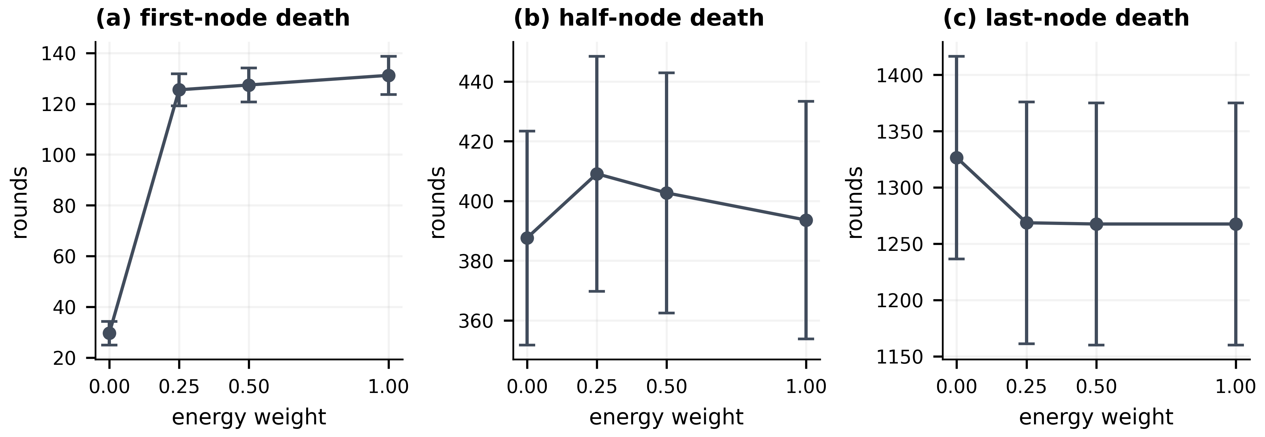
Figure 3. FND, HND and LND across the four residual-energy weights. Points are ten-seed means and error bars are 95% t intervals; each panel uses its own vertical scale.
The largest change in the weight sweep occurs early in network life. Moving the residual-energy weight from 0 to 0.25 raises mean FND from 29.6 to 125.5 rounds. HND moves only from 387.6 to 409.1, while LND falls from 1326.5 to 1268.6. Increasing the weight beyond 0.25 gives a little more FND but no consistent improvement in the later milestones. We therefore use 0.25 as a practical setting for this study, not as a global optimum.

6.2. Four-way ablation
Table 5. Ten-seed mean ± sample standard deviation for the original C1-C4 ablation.
Outcome | C1 | C2 | C3 | C4
FND, rounds | 125.5 ± 8.8 | 123.8 ± 9.0 | 275.2 ± 20.6 | 267.1 ± 17.8
HND, rounds | 409.1 ± 55.0 | 409.0 ± 54.8 | 870.1 ± 126.6 | 873.3 ± 127.3
LND, rounds | 1268.6 ± 150.1 | 1268.2 ± 152.1 | 2636.4 ± 278.0 | 2637.5 ± 278.0
PDR, % | 95.351 ± 2.072 | 95.379 ± 2.039 | 97.812 ± 0.963 | 97.818 ± 0.953
Delay, ms | 1046.1 ± 96.1 | 1045.4 ± 96.1 | 481.6 ± 43.5 | 480.9 ± 43.6
Communication energy per delivered report, mJ | 1.147 ± 0.104 | 1.148 ± 0.105 | 0.526 ± 0.047 | 0.526 ± 0.047
Retries per generated report | 0.1916 ± 0.0866 | 0.1913 ± 0.0865 | 0.0918 ± 0.0409 | 0.0916 ± 0.0411
Channel airtime, s | 1295.9 ± 54.3 | 1296.1 ± 53.9 | 1295.7 ± 54.2 | 1296.7 ± 53.9
Goodput, kbps | 135.52 ± 10.60 | 135.45 ± 10.68 | 129.02 ± 9.88 | 128.86 ± 9.97
C1 and C2 exhibit negligible differences across all reported metrics in Table 5, which matches the later finding that the age term adds little. Relative to C1, C3 raises mean FND, HND and LND by 119.3%, 112.7% and 107.8%, respectively. C4 does not improve those gains and has a slightly lower mean FND than C3. For that reason, C3, without the relevance-age routing term, is kept as the final configuration.
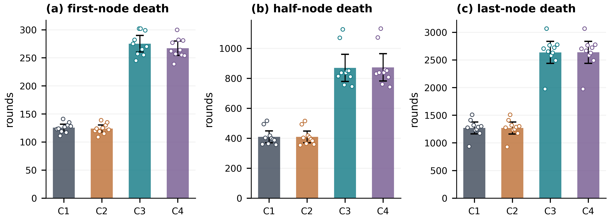
Figure 4. Four-case lifetime comparison. Bars show means, whiskers show 95% t intervals, and circles show the ten seed values. FND, HND and LND use different vertical scales.
Figure 4 makes both effect magnitude and seed variability visible. The payload-enabled configurations extend all three round milestones across the ensemble. Shorter reports slow energy depletion and shift several death thresholds together.
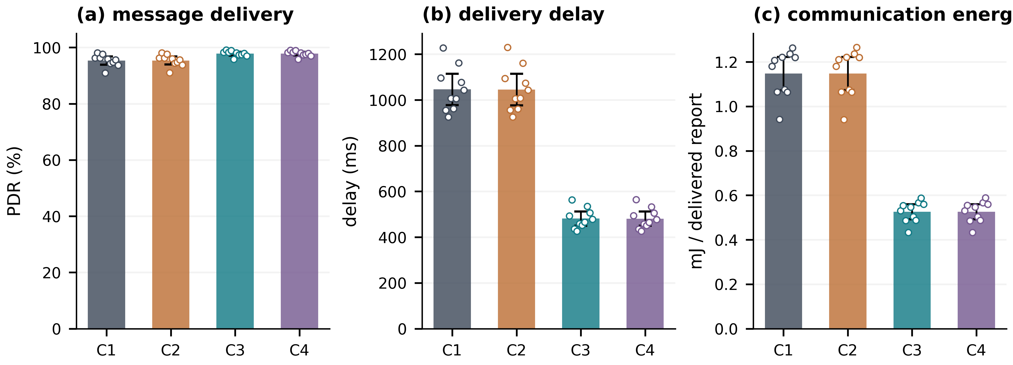
Figure 5. Message-level PDR, delay and energy per delivered report. Bars, intervals and points follow the convention of Figure 4. Panel (a) starts at zero to avoid exaggerating the PDR difference.
Figure 5 shows that C3 increases mean PDR by 2.462 percentage points while reducing delay by 54.0% and communication energy per delivered report by 54.2%. Fewer fragments shorten service time and reduce exposure to required frame failures. Nevertheless, a delivered C3 report generally contains fewer bits than a delivered C1 report. These comparisons describe communication service and cannot establish equal recovered information quality.

6.3. Paired uncertainty and the negative routing result
Table 6. C1→C3 paired changes. Confidence intervals are marginal 95% intervals; adjusted p-values use all 21 principal tests.
Outcome | Mean change | 95% interval | Holm p
FND, rounds | +149.7 | [138.8, 160.6] | 3.55 × 10⁻⁹
HND, rounds | +461.0 | [408.1, 513.9] | 1.74 × 10⁻⁷
LND, rounds | +1367.8 | [1243.7, 1491.9] | 2.32 × 10⁻⁸
PDR, percentage points | +2.462 | [1.667, 3.256] | 0.00100
Delay, ms | −564.4 | [−602.7, −526.1] | 1.93 × 10⁻⁹
Energy/delivered report, mJ | −0.622 | [−0.663, −0.580] | 1.83 × 10⁻⁹
Retries/generated report | −0.0997 | [−0.1325, −0.0670] | 0.00107
Table 6 shows that the seven C1→C3 changes remain significant under the declared family correction. Every seed changes in the favourable direction for these seven outcomes, yielding an unadjusted two-sided sign-flip p-value of 0.001953 for each. This corroborates directional consistency within the ensemble; it does not substitute for additional topologies, sensing processes or application workloads.
The age term does not show a corrected benefit in either C1→C2 or C3→C4. In C3→C4, for instance, mean FND changes by −8.1 rounds; its marginal interval is [−13.7, −2.5], but the Holm-adjusted p-value is 0.140. That result should not be read as proof that the two configurations are identical. It says only that this added routing term did not produce a reliable benefit in the tested regime, which is not enough reason to keep the extra complexity.

6.4. Reporting lifetime versus elapsed channel time
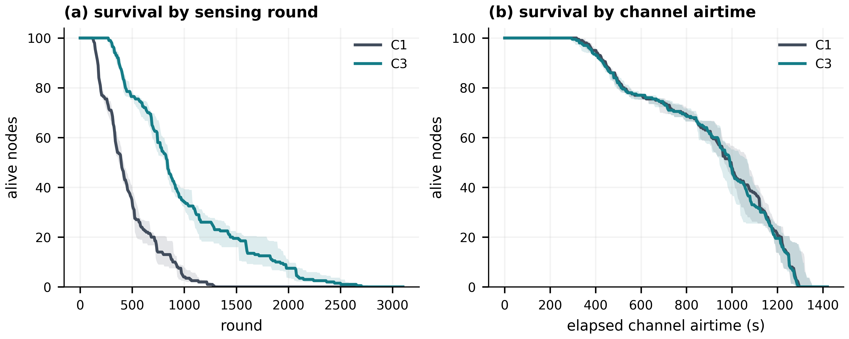
Figure 6. C1 and C3 survival trajectories. Lines are seed-wise medians and bands are interquartile ranges, not confidence intervals. A completed run contributes zero alive nodes after its last-node death.
Figure 6 reveals the consequence of the time base. C3 remains active for many more sensing rounds, but C1 and C3 use nearly identical total channel airtime: 1295.85 and 1295.66 s on average, a difference of approximately −0.015%. A longer count of scheduled rounds is therefore compatible with essentially unchanged channel-use duration. An application with a fixed external sampling interval could benefit differently, but such an interval and its idle/sensing energy would have to be modelled explicitly.
Both configurations exhaust the same initial 50 J at LND. C3 delivers approximately 95,882 reports compared with 43,933 for C1, so dividing that energy by delivered-report count produces the lower per-report value. The result is more report deliveries per modelled joule, not a reduction in total energy consumed at full depletion.
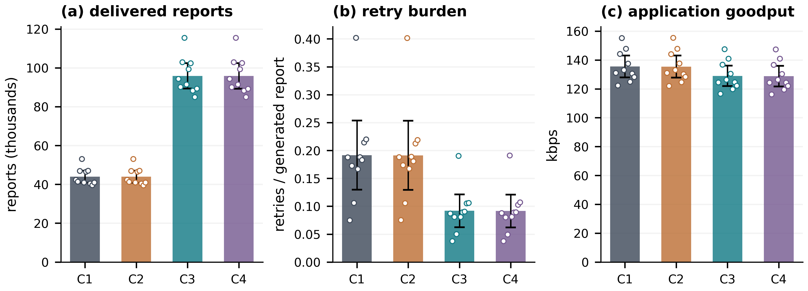
Figure 7. Workload outcomes over complete network runs. Means, 95% intervals and seed points are shown. Report count and application-bit goodput are deliberately presented as different outcomes.
Figure 7 makes the workload trade-off explicit. C3 cuts retries per generated report by 52.1%, but application goodput falls from 135.52 to 129.02 kbps, or 4.8%. Mean delivered-hop count is almost unchanged, moving from 1.4028 in C1 to 1.4000 in C3. The improvement is therefore consistent with lighter frame traffic, not with C3 finding materially shorter routes.

6.5. What remains after matching the source bit budget
RECEIVER DIAGNOSTIC (new reference codec, NOT part of the submitted original): The 100-round matched-seed DCT experiment gave receiver RMSE 0.06534 for C3 and 0.06060 for C5. Paired C5 minus C3 RMSE was −0.004742 (95% CI −0.005711 to −0.003772; Holm-adjusted p = 0.000011; ten seeds). C3 did not establish a reliable event-F1 improvement over C5. These are codec-specific results and do not establish the application fidelity of the original length-only reporting scheme.
The C1-to-C3 difference by itself cannot tell us whether relevance is responsible for the network gain. C5 is the budget check: it sends a fixed 1744 bits per attempted report, almost the same as C3's 1747.8-bit mean. Against C1, that fixed-length control recovers most of the gains in lifetime, PDR, delay, retries and communication energy, so the smaller traffic load explains most of the large effect. The more informative comparison is C3 versus C5. After Holm adjustment, C3 has a 26.1-round HND advantage, 11.36 ms lower mean delay and about 0.0127 mJ lower communication energy per delivered report; FND, LND, PDR and retries do not differ significantly. C6 makes the test stricter by keeping C3's round-level set of payload sizes but shuffling them across reports. After correction, none of the tested network outcomes differs significantly between C6 and C3. In other words, the experiments do not support a general equal-budget network advantage for relevance-based allocation.
Table 7. Baseline source-control outcomes, mean over ten seeds.
Outcome | C3 | C5 | C6 | C7
Attempted mean payload, bits | 1747.84 | 1744.00 | 1748.05 | 1610.89
FND, rounds | 275.2 | 267.6 | 295.8 | 297.8
HND, rounds | 870.1 | 844.0 | 869.6 | 929.8
LND, rounds | 2636.4 | 2626.6 | 2634.0 | 2825.8
PDR, % | 97.812 | 97.758 | 97.825 | 97.956
Delay, ms | 481.6 | 493.0 | 481.2 | 448.7
Energy/delivered report, mJ | 0.526 | 0.538 | 0.525 | 0.489
Retries/generated report | 0.0918 | 0.0941 | 0.0922 | 0.0861
C7 should not be read as an equal-budget winner over C3. Its mean attempted payload is only 1610.9 bits, so its lower delay and energy and its later death milestones are partly explained by a smaller traffic load. C7 is useful as a feature ablation: it shows what remains when the spatial term is removed, not whether temporal relevance is intrinsically better at the same budget.

6.6. Offline event targeting and relevance alignment
Event labels provide a separate test of what the relevance score is actually doing. They are never available to the online controller; they are consulted only after payload selection and routing so that event-active and non-event reports can be compared offline. Event-report delivery probability is already high for all reduced-payload controls and is not higher for C3 than for C5. The useful distinction is payload allocation. C3 attempts a mean of 3208 bits on event reports versus 1681 bits on non-event reports. It preserves 80.2% of the full 4000-bit event budget and delivers 78.4% of that budget. C5 preserves 43.6% by construction, while C6 preserves 59.2% after the relevance assignments are shuffled.
Table 8. Offline event-quality and targeting measures, mean over ten seeds.
Measure | C3 | C5 | C6 | C7
Event-report delivery ratio | 0.9784 | 0.9815 | 0.9810 | 0.9841
Event mean attempted payload, bits | 3208.0 | 1744.0 | 2367.7 | 1863.9
Non-event mean attempted payload, bits | 1681.4 | 1744.0 | 1719.8 | 1599.3
Event payload preservation | 0.8020 | 0.4360 | 0.5919 | 0.4660
Event payload delivery ratio | 0.7840 | 0.4280 | 0.5803 | 0.4580
Within-round event/non-event payload gap, bits | 1218.7 | 0.0 | 13.3 | 201.6
To see whether relevance actually changes which reports receive the bits, the most useful statistic is the event/non-event gap within the same round. For C3, that gap averages 1218.7 bits, with a 95% interval from 1143.1 to 1294.3 bits. C5 is exactly 0, as expected for a fixed payload, and C6 averages 13.3 bits with an interval that crosses zero. The paired C5-to-C3 and C6-to-C3 contrasts remain significant after Holm adjustment. This is evidence about payload targeting; it is not an event-detector score and it says nothing about reconstruction quality at the receiver.

6.7. Sensitivity to multi-hop topology depth
INTERPRETATION LIMITATION — The archive supports depth-specific C3/C5 paired contrasts, but per-packet information age and event-to-receipt staleness were not recorded. Hop count alone is not sufficient to attribute the deep-topology reversal to stale relevance. No causal staleness mechanism is asserted.
The baseline field produces short routes, so a separate calibration stretches the field while keeping 100 sensors and placing the sink 50 m above the upper boundary. The selected shallow, medium, and deep profiles have initial mean route lengths of 1.483, 2.910, and 4.929 hops with full initial coverage. C5 is re-matched to C3 within each profile at 1744, 1648, and 1568 bits, respectively. Across all three profiles, C3 retains the large advantage over 4000-bit C1 in HND, LND, PDR, delay, and energy per delivered report, although medium-topology FND is not significant after correction.
Table 9. Topology-depth sensitivity for C1, C3, and matched-budget C5, mean over ten seeds.
Profile (initial mean hops) | Mode | HND | LND | PDR, % | Delay, ms | Energy/delivered report, mJ
Shallow (1.483) | C1 | 200.7 | 1290.4 | 90.496 | 958.1 | 1.631
Shallow (1.483) | C3 | 383.3 | 2642.5 | 95.404 | 442.3 | 0.744
Shallow (1.483) | C5 | 357.8 | 2663.8 | 95.294 | 452.8 | 0.764
Medium (2.910) | C1 | 49.9 | 1063.3 | 86.443 | 2170.4 | 4.917
Medium (2.910) | C3 | 112.3 | 2138.4 | 93.765 | 959.5 | 2.105
Medium (2.910) | C5 | 96.2 | 2206.6 | 93.404 | 1002.1 | 2.209
Deep (4.929) | C1 | 29.1 | 934.4 | 86.343 | 2512.2 | 7.604
Deep (4.929) | C3 | 74.7 | 1952.7 | 94.160 | 1050.6 | 3.082
Deep (4.929) | C5 | 65.5 | 2303.9 | 94.299 | 1018.6 | 2.983
The equal-budget C3-versus-C5 result is topology- and metric-dependent. C3 improves HND in all three profiles, but LND slightly favours C5 in the shallow profile and clearly favours C5 in the deep profile; most other deep-profile equal-budget network differences are not significant. At the same time, C3 keeps a large positive within-round targeting gap in every profile, about 1297, 1249, and 1124 bits from shallow to deep. Route depth therefore changes the network consequence of relevance-directed allocation without removing the allocation effect itself.

7. Discussion and limitations
NEW CONTROLLED ENERGY SCENARIOS — In 10 paired seeds, C3 LND was 2636.4 rounds with no added cost, 1862.7 with the moderate assumed cost profile, and 1047.7 with the high-cost profile. Corresponding C1 LND values were 1268.6, 1042.9 and 725.9 rounds. The modeled advantage narrows as previously uncharged costs increase. Device-current calibration, context contention, ACK timing and chip duty-state measurements remain open.
COOJA / FIT IoT-LAB SCOPE — Fifteen Cooja stress cases verified direct, fragmented NullNet/CSMA transport. FIT IoT-LAB Grenoble M3 experiment 458478 captured actual source transmissions and sink report reassembly. Neither study implemented the paper-equivalent distributed RE-ETX route-selection policy. Partial-window serial matching is not physical PHY PDR.
SEPARATE PHYSICAL POWER PILOT — In the single Grenoble M3 consumption-profile experiment 458482, 694 raw OML samples across three nodes gave time-integrated mean device powers of 0.10480 W, 0.10231 W, and 0.10050 W and trace energies of 50.553 J, 49.301 J, and 48.349 J, respectively. This is total board power of a NullNet fragmentation probe, not a measurement of source sensing, CPU, idle, control or RE-ETX energy separately. The simulation overhead profiles remain uncalibrated.
The expanded controls separate two effects that were blended in the original four-case analysis. Sending fewer bits explains most of the large network-level improvement relative to 4000-bit C1. C5 and C6 reproduce most of C3's lifetime, PDR, delay, and energy behaviour at almost the same attempted bit budget. Relevance adds a different kind of evidence: it changes which reports receive those bits. C3 concentrates substantially more payload on event-active observations than either the fixed-budget or shuffled controls. The contribution is therefore best described as relevance-directed allocation of a reduced source budget over an energy-aware ETX substrate, not as proof that relevance alone creates all network gains.
The energy ledger is deliberately incomplete. It charges transmission, relay reception, retransmissions and sender depletion, but not sensing, relevance computation, routing control, acknowledgements, idle listening or exchange of neighbour observations. In particular, the simulator reads current spatial context centrally and does not charge for acquiring it. A real distributed implementation would have to exchange or estimate that context. Depending on how often that happens and which nodes carry the traffic, the added overhead could reduce, or even remove, the communication-energy margin reported here.
Stretching the topology makes the robustness result more informative, but it does not turn the simulator into a deployment experiment. The calibrated cases reach about 4.9 initial hops, and the large C1-to-C3 traffic-reduction benefit is still present. The equal-budget story is less uniform: deep-topology LND favours C5, and several other C3-to-C5 differences are not significant. The channel and radio model also remain simplified: shadowing is static, frame errors are independent, access is serialised, acknowledgements are simplified, and contention, burst loss, processor-state energy and hardware-specific effects are omitted.
The first 50 rounds are a learning period. Because the relevance baseline has not yet been established, payload-enabled modes send the minimum-length report during that period. An application that needs full early observations would require a different start-up rule. The same ten-seed family is also used for parameter exploration and the main statistical analysis. The reported intervals should therefore be interpreted as variation within this simulated setting, not as uncertainty across all plausible sensing fields, radios or deployments.
The negative route-age result should also remain local to the tested construction. The penalty changes path cost; it does not schedule stale sources earlier or allocate extra service. C2 and C4 therefore show that this particular relevance-age term adds no demonstrated benefit, not that freshness-aware networking is generally ineffective. The most useful next validation step is receiver-side reconstruction or task performance under a matched delivered-bit budget, followed by an implementation in which neighbourhood context, control traffic, sensing, and processing costs are explicitly charged.

8. Conclusions
EVIDENCE-CONSTRAINED CONCLUSION — The results establish a radio-only and scenario-based lifetime advantage over fixed full-payload reporting in the tested simulator, not universal semantic reconstruction superiority. A newly introduced reference codec exposed a C3 reconstruction disadvantage against equal-budget C5. Complete source encoding/decoding, independent task utility, hardware-calibrated energy and deployed RE-ETX firmware remain prerequisites for stronger claims.
A safeguarded temporal-spatial relevance controller has been evaluated over residual-energy ETX routing with seven matched configurations and ten seeds. Against fixed 4000-bit C1, C3 more than doubles the major round-based lifetime milestones, raises PDR by 2.462 percentage points, and roughly halves delay and communication energy per delivered report. The added controls change the interpretation of those gains. A 1744-bit fixed controller reproduces most of the network benefit, and a shuffled-relevance controller is statistically indistinguishable from C3 on the tested network outcomes. Reduced traffic is therefore the main cause of the large C1-to-C3 network change.
Relevance still has a measurable role: within event-active rounds, C3 assigns about 1.22 kbit more payload to event reports than to non-event reports, while the matched fixed control has no gap and the shuffled control is near zero. That targeting persists across calibrated shallow-to-deep topologies, even though equal-budget network differences become mixed and deep-topology LND can favour C5. The final claim is consequently specific: the controller directs a reduced payload budget toward statistically unusual observations while RE-ETX handles forwarding. Receiver reconstruction and downstream task utility remain necessary before application-level superiority can be claimed. Validation must also account for distributed context exchange and full sensing, processing and control-energy accounting before deployment-level superiority can be claimed.

Data and code availability
Code, experiment drivers, seed-level outputs, paired statistical tables, topology-sensitivity results are archived in the public repository https://github.com/DrShivamBhardwaj/Relevance_Aware_RE_ETX_. The validated development branch is dual-journal-validation, and the submission snapshot is tagged submission-ready-v1. Canonical analysis outputs are stored under results/master_validation/, including the equal-budget, shuffled-relevance, event-quality, within-round targeting, residual-energy-weight, and topology-depth studies.
Funding
The authors received no financial support for the research, authorship, and/or publication of this article.
Competing Interests
The authors declare that they have no financial or non-financial competing interests.

References
[1] Akyildiz I F, Su W, Sankarasubramaniam Y and Cayirci E 2002 A survey on sensor networks. IEEE Communications Magazine 40(8): 102–114. https://doi.org/10.1109/MCOM.2002.1024422
[2] Heinzelman W R, Chandrakasan A and Balakrishnan H 2000 Energy-efficient communication protocol for wireless microsensor networks. In: Proceedings of the 33rd Hawaii International Conference on System Sciences. https://doi.org/10.1109/HICSS.2000.926982
[3] Heinzelman W B, Chandrakasan A P and Balakrishnan H 2002 An application-specific protocol architecture for wireless microsensor networks. IEEE Transactions on Wireless Communications 1(4): 660–670. https://doi.org/10.1109/TWC.2002.804190
[4] De Couto D S J, Aguayo D, Bicket J and Morris R 2003 A high-throughput path metric for multi-hop wireless routing. In: Proceedings of ACM MobiCom, pp. 134–146. https://doi.org/10.1145/938985.939000
[5] Winter T et al. 2012 RPL: IPv6 routing protocol for low-power and lossy networks. IETF RFC 6550. https://doi.org/10.17487/RFC6550
[6] Gnawali O and Levis P 2012 The minimum rank with hysteresis objective function. IETF RFC 6719. https://doi.org/10.17487/RFC6719
[7] Wu M, Tan L and Xiong N 2016 Data prediction, compression, and recovery in clustered wireless sensor networks for environmental monitoring applications. Information Sciences 329: 800–818. https://doi.org/10.1016/j.ins.2015.10.004
[8] Bou Tayeh G, Makhoul A, Laiymani D and Demerjian J 2018 A distributed real-time data prediction and adaptive sensing approach for wireless sensor networks. Pervasive and Mobile Computing 49: 62–75. https://doi.org/10.1016/j.pmcj.2018.06.007
[9] Hribar J, Costa M, Kaminski N J and DaSilva L A 2019 Using correlated information to extend device lifetime. IEEE Internet of Things Journal 6(2): 2439–2448. https://doi.org/10.1109/JIOT.2018.2869986
[10] Nait Abbou A and Manner J 2023 ETXRE: Energy and delay efficient routing metric for RPL protocol and wireless sensor networks. IET Wireless Sensor Systems 13(6): 235–246. https://doi.org/10.1049/wss2.12070
[11] Arnaiz D, Moll F, Alarcón E and Vilajosana X 2024 Energy and relevance-aware adaptive monitoring method for wireless sensor nodes with hard energy constraints. Integration 94: 102097. https://doi.org/10.1016/j.vlsi.2023.102097
[12] Płaczek B 2024 Prediction-based data reduction with dynamic target node selection in IoT sensor networks. Future Generation Computer Systems 152: 225–238. https://doi.org/10.1016/j.future.2023.11.007
[13] Maatouk A, Kriouile S, Assaad M and Ephremides A 2020 The age of incorrect information: A new performance metric for status updates. IEEE/ACM Transactions on Networking 28(5): 2215–2228. https://doi.org/10.1109/TNET.2020.3005549
[14] Yates R D, Sun Y, Brown D R III, Kaul S K, Modiano E and Ulukus S 2021 Age of information: An introduction and survey. IEEE Journal on Selected Areas in Communications 39(5): 1183–1210. https://doi.org/10.1109/JSAC.2021.3065072
[15] Kountouris M and Pappas N 2021 Semantics-empowered communication for networked intelligent systems. IEEE Communications Magazine 59(6): 96–102. https://doi.org/10.1109/MCOM.001.2000604
[16] Xie H, Qin Z, Li G Y and Juang B H 2021 Deep learning enabled semantic communication systems. IEEE Transactions on Signal Processing 69: 2663–2675. https://doi.org/10.1109/TSP.2021.3071210
[17] Hribar J, Marinescu A, Chiumento A and DaSilva L A 2022 Energy-aware deep reinforcement learning scheduling for sensors correlated in time and space. IEEE Internet of Things Journal 9(9): 6732–6744. https://doi.org/10.1109/JIOT.2021.3114102
[18] Luo X, Chen H H and Guo Q 2022 Semantic communications: Overview, open issues, and future research directions. IEEE Wireless Communications 29(1): 210–219. https://doi.org/10.1109/MWC.101.2100269
[19] Gündüz D, Qin Z, Estella Aguerri I, Dhillon H S, Yang Z, Yener A, Wong K K and Chae C B 2023 Beyond transmitting bits: Context, semantics, and task-oriented communications. IEEE Journal on Selected Areas in Communications 41(1): 5–41. https://doi.org/10.1109/JSAC.2022.3223408
[20] Getu T M, Kaddoum G and Bennis M 2024 A survey on goal-oriented semantic communication: Techniques, challenges, and future directions. IEEE Access 12: 51223–51274. https://doi.org/10.1109/ACCESS.2024.3381967
[21] Senouci O and Benaouda N 2025 Supervised machine learning-based ETX optimization for energy-efficient routing in IoT-enabled WSNs. Ad Hoc Networks 178: 103972. https://doi.org/10.1016/j.adhoc.2025.103972
[22] Hwang A, Yum S H, Yoon D J, Kim S M and Park S H 2026 An SDN-based adaptive payload structure and transmission management for reliable WSN data collection in extreme cold region environments. ICT Express, article in press. https://doi.org/10.1016/j.icte.2026.08.005
[23] Yang H, Zhu X, Yang J, Li J, Qing L, He X and Wang P 2025 Scalable semantic adaptive communication for task requirements in WSNs. Sensors 25(9): 2823. https://doi.org/10.3390/s25092823
[24] Kaya O, Karabulut M A, Eyüpoğlu C and Karakuş O 2026 Prediction-aided adaptive semantic communication for IoT sensor streams under outdated channel state information. Sensors 26(19): 6124. https://doi.org/10.3390/s26196124
[25] Dietrich I and Dressler F 2009 On the lifetime of wireless sensor networks. ACM Transactions on Sensor Networks 5(1): article 5. https://doi.org/10.1145/1464420.1464425
[26] Holm S 1979 A simple sequentially rejective multiple test procedure. Scandinavian Journal of Statistics 6(2): 65–70. https://www.jstor.org/stable/4615733
[27] Wilcoxon F 1945 Individual comparisons by ranking methods. Biometrics Bulletin 1(6): 80–83. https://doi.org/10.2307/3001968

