Relevance-aware payload adaptation with residual-energy ETX routing for wireless sensor networks
Shivam Bhardwaj, Jitendra Nath Srivastava and Akash Sanghi
Faculty of Engineering and Technology, Invertis University, Bareilly, Uttar Pradesh 243123, India
Corresponding author: shibambhardwaj@gmail.com
E-mail: jitendranathshrivastava@gmail.com; sanghiakash@gmail.com

Abstract
Fixed-length reporting can spend a substantial communication budget on routine observations in battery-constrained wireless sensor networks. This study evaluates a temporal-spatial relevance controller that adapts application payload length over residual-energy expected-transmission-count (RE-ETX) routing. A seven-configuration, ten-seed control study separates full-payload routing, equal-budget fixed reporting, shuffled relevance, temporal-only relevance and temporal-spatial relevance. With fixed 4000-bit RE-ETX (C1), mean first-, half- and last-node death occurs at 125.5, 409.1 and 1268.6 rounds. Under the retained temporal-spatial controller (C3), the corresponding values rise to 275.2, 870.1 and 2636.4 rounds. C3 also raises packet delivery ratio by 2.462 percentage points while cutting mean delay and per-report communication energy by about 54%. The equal-budget fixed control C5 uses 1744 bits versus 1747.8 attempted bits for C3 and reproduces most network-level gains; after Holm correction C3 retains advantages in HND, delay and energy per delivered report, whereas FND, LND, PDR and retries are not significantly different. The shuffled-relevance control C6 is statistically indistinguishable from C3 on the tested network outcomes after correction. The offline event-labelled analysis gives a different view of the controller. Within the same event-active round, C3 allocates on average 1218.7 more bits to event reports than to non-event reports. The corresponding gaps are 0 bits for C5 and 13.3 bits for C6. Event payload preservation is 0.802 for C3, compared with 0.436 for C5 and 0.592 for C6. Calibrated topology tests spanning approximately 1.5 to 4.9 initial route hops retain the large C3-versus-C1 traffic-reduction benefit, while equal-budget C3-versus-C5 network differences become mixed in deeper multi-hop regimes. The evidence therefore supports relevance as a mechanism for directing payload budget toward event-active reports, but not a universal claim that relevance allocation itself improves all network metrics at an equal average bit budget.
Keywords: wireless sensor networks; residual energy; expected transmission count; adaptive payload; relevance estimation; communication energy.

1. Introduction
Wireless sensor networks must allocate a finite battery budget among sensing, computation and communication. Their design is complicated by unreliable links and unequal forwarding responsibilities [1]. Early work on LEACH showed how rotating communication roles and exploiting application structure can distribute energy expenditure [2, 3]. Reliability-aware routing addresses another part of the problem: expected transmission count (ETX) favours paths that require fewer transmission attempts [4]. RPL and its minimum-rank-with-hysteresis objective function provide an established context for combining routing metrics in low-power and lossy networks [5, 6]. These mechanisms influence the paths used by reports, but do not by themselves determine how many application bits each observation deserves.
Source-data reduction offers a complementary control. Prediction and recovery can exploit regularity in environmental measurements [7], while adaptive sensing changes reporting effort as observations evolve [8]. Correlated information can also reduce redundant updates among nearby devices [9]. These ideas motivate a practical question: how much of a network-level gain comes from choosing better routes, and how much comes from shortening the traffic injected into those routes? A combined method cannot answer that question through a single proposed-versus-baseline comparison.
This paper investigates a compact relevance-aware payload controller over an interpretable RE-ETX substrate. Temporal innovation and spatial disagreement produce a scalar score, and a safeguarded mapping converts that score to a report length. Reliability and residual energy determine forwarding costs independently. A separate relevance-age route term is retained only as an experimental factor. The expanded evaluation uses fixed-budget, shuffled-relevance and temporal-only controls so that traffic-volume reduction can be distinguished from source-to-relevance alignment.
The study makes four contributions. First, it specifies the implemented relevance, payload, routing and frame-accounting rules sufficiently to reproduce their interaction. Second, it introduces equal-budget fixed and shuffled-relevance controls that separate the network effect of transmitting fewer bits from the informational effect of assigning more bits to more relevant observations. Third, it evaluates relevance targeting against offline event truth using event payload preservation and a within-round event/non-event payload gap that removes round-level allocation confounding. Fourth, it tests the principal C1, C3 and equal-budget C5 configurations across calibrated shallow, medium and deeper multi-hop regimes in addition to the residual-energy-weight sweep.
The research hypotheses are deliberately separated. The first is that reducing the application payload under the stated radio model should improve reporting opportunities and communication service relative to fixed 4000-bit reporting. The second is that a genuine relevance controller should assign substantially more payload to event-active than to non-event reports when compared with an equal-budget fixed controller and a shuffled-relevance controller. A universal network-level advantage of relevance over every equal-budget allocation is not assumed; it is tested empirically.

2. Related work and positioning

2.1. Routing and source-data control
ETX selects reliable paths through an additive transmission-cost metric [4], whereas residual-energy penalties seek to avoid repeated use of depleted relays. ETXRE explicitly combines link reliability with remaining energy within RPL [10]. The present RE-ETX implementation uses the same broad engineering principle, but it is a custom sink-rooted shortest-path simulator rather than an implementation of RPL or ETXRE. Its contribution is therefore assessed through integration and ablation, without claiming residual energy as a new routing signal.
Prediction-based communication reduction has a longer history than contemporary semantic networking. Wu et al. combine prediction, compression and recovery for clustered monitoring [7]. Bou Tayeh et al. couple real-time prediction with adaptive sensing [8]. More recently, Arnaiz et al. coordinate energy and relevance objectives under hard monitoring-energy constraints [11], and Płaczek uses prediction to reduce communication associated with target-node selection [12]. These studies make source reconstruction or application decisions part of their evaluation. The present network simulator instead treats payload length as a transmission budget; it has no implemented source decoder.

2.2. Freshness, relevance and semantic communication
Information age measures the time since the generation of a received update, while age of incorrect information also accounts for whether the receiver’s information is wrong [13, 14]. Kountouris and Pappas connect communication effort to the significance of information for a networked task [15]. DeepSC provides an example in which a learned source representation and semantic recovery are evaluated explicitly [16]. Correlation-aware reinforcement learning has also been used to schedule sensor updates with energy awareness [17]. These formulations motivate selective reporting, but their objectives are not interchangeable.
Surveys by Luo et al. [18], Gündüz et al. [19] and Getu et al. [20] distinguish message meaning, task outcomes, source representations and communication resources. Accordingly, this paper uses relevance to mean statistical novelty under a specified estimator. A relevance-weighted age variable is not age of incorrect information because receiver estimation error is absent. Likewise, preserving a payload floor is a transmission safeguard, not a demonstrated event-recall guarantee.
Recent work further narrows the novelty claim. Senouci and Benaouda investigate learned ETX optimisation for energy-efficient WSN routing [21]. Hwang et al. study adaptive payload structure and transmission management for WSN collection in extreme cold environments [22]. Here the question is narrower: what changes when an auditable source controller is introduced while the routing substrate is kept unchanged? Table 1 summarises the resulting position.
Table 1. Representative prior work and the control evaluated in this study.
Study | Main control | Relationship to this work
ETX [4]; ETXRE [10] | Route/link cost | Reliability and energy substrate
Prediction and recovery [7, 8] | Data reduction; sensing | Receiver fidelity is evaluated in those works
Correlated-information scheduling [9, 17] | Update timing | Correlation is used here to set report length
Energy/relevance monitoring [11] | Sampling and prediction | Closely related source-control motivation
Learned ETX [21] | Learned routing metric | No learned routing model is used here
Adaptive payload management [22] | Payload structure and transmission | Contemporary payload-control context
Present study | Payload length over RE-ETX | Seven-configuration validation with equal-budget, shuffled-relevance, temporal-only and topology-depth controls
Table 1 shows that route adaptation and source adaptation are established research directions. The incremental contribution lies in their transparent coupling and the evidence identifying which component affects the evaluated network.

3. Network and communication model

3.1. Topology, traffic and sensing
The simulated field contains 100 static sensors uniformly positioned in a 100 m × 100 m square. Each sensor starts with 0.5 J, and an externally powered sink is located at (50, 150) m. Every sensor alive at a round’s start generates one report. Source order rotates between rounds, and transmissions occupy one serialised shared channel. A route is computed once per round and remains fixed while that round’s sources are served. Consequently, a relay may die before a later source uses its assigned path.
The synthetic background follows a spatially correlated autoregressive process. For background vector $b\left(t\right)$ and an independent standard normal vector $z\left(t\right)$,
$$b\left(t\right)=ϕb\left(t−1\right)+σ_{n}\sqrt{1−ϕ^{2}} C^{1/2}z\left(t\right), C_{ij}=exp\left(−d_{ij}/ℓ_{s}\right). \left(1\right)$$
Here $ϕ=0.85$, $σ_{n}=0.10$ and $ℓ_{s}=25$ m. Observations add a spatial Gaussian event of amplitude 3 and width 18 m. While no event is active, a new event starts with probability 0.03 per round and lasts 4–10 rounds. Events are superimposed on the background rather than fed back into its autoregression. Ground-truth event labels are not passed to the runtime relevance controller.
The sensing field and estimator continue to evaluate all original node positions after some sensors have died. Current neighbourhood observations are therefore available centrally without communication cost in this implementation. This is an explicit modelling boundary: it does not demonstrate a deployable distributed exchange of those observations.

3.2. Channel, fragmentation and energy
The channel combines log-distance path loss with static log-normal shadowing. A BPSK-equivalent bit-error abstraction gives $p_{b}=1/2erfc\left(\sqrt{γ}\right)$ at linear signal-to-noise ratio $γ$. Independent bit errors yield frame success probability ${\left(1−p_{b}\right)}^{B}$ for a frame of $B$ bits. This abstraction is not a complete IEEE 802.15.4 physical or medium-access layer.
Each application report of $L$ bits is fragmented into payloads of at most $M=800$ bits, with $H=216$ overhead bits per fragment:
$$F\left(L\right)=ceil\left(L/M\right), B\left(L\right)=L+HF\left(L\right). \left(2\right)$$
Thus, 4000 application bits require five frames and 5080 transmitted bits per hop before retries. A 1000-bit report requires two frames and 1432 bits. Frame retries are hop-by-hop, with at most four attempts per frame. Failure of a required fragment prevents successful delivery of that application report.
The first-order radio model uses the free-space and multipath forms associated with classical WSN energy modelling [3]:
$$E_{TX}\left(B,d\right)=BE_{elec}+B\left\{\begin{matrix}ϵ_{fs}d^{2}, & d<d_{0}, \\ ϵ_{mp}d^{4}, & d≥d_{0},\end{matrix}\right. ; E_{RX}\left(B\right)=BE_{elec}. \left(3\right)$$
The crossover is $d_{0}=\sqrt{ϵ_{fs}/ϵ_{mp}}=87.71$ m. Transmit energy and relay-receive energy are charged for attempted frames, including corrupted frames; sink energy is excluded. An energy-deficient sender consumes its remaining energy during a partial frame. Acknowledgements, idle listening, sensing, relevance computation and routing-control traffic are outside the ledger. Table 2 records the principal settings.
Table 2. Parameters used in the archived experiments.
Parameter | Value | Parameter | Value
Sensors; initial energy | 100; 0.5 J each | Field; sink | 100 × 100 m; (50,150) m
Full application report | 4000 bits | Frame payload; overhead | 800; 216 bits
Bit rate; retry limit | 250 kbps; 3 retries | Processing delay | 1 ms per hop
Carrier; transmit power | 2.4 GHz; 0 dBm | Noise floor | −100 dBm
Path-loss exponent | 2.4 | Shadowing standard deviation | 4 dB
Sensor-link radius | 30 m | Full-message eligibility | Success ≥0.90
Electronics energy | 50 nJ/bit | Amplifier coefficients | 10 pJ/bit/m²; 1.3 fJ/bit/m⁴
Temporal correlation | 0.85 | Spatial correlation length | 25 m
Innovation-noise scale | 0.10 | Event start probability | 0.03 per inactive round
Event amplitude; width | 3; 18 m | Event duration | 4–10 rounds
Relevance neighbourhood | 20 m | Warm-up; EWMA factor | 50 rounds; 0.02
Temporal/spatial weights | 0.6 / 0.4 | Energy weight in ablation | 0.25
Minimum payload ratio | 0.25 | Protection thresholds | 0.50 and 0.85
Stop condition | All nodes dead | Maximum rounds | 5000
Table 2 describes a single operating regime. The 30 m radius applies to sensor-to-sensor candidate edges; sink links are filtered by reliability without that distance limit. If the quality-filtered graph provides no route, the source attempts its direct sink link as a tracked fallback. This policy prevents disconnected sensors from remaining artificially alive indefinitely, while exposing them to potentially poor delivery conditions.

4. Relevance-aware payload adaptation over RE-ETX

4.1. Statistical relevance
For sensor $i$, temporal novelty compares the current and previous observation; spatial novelty compares the current observation with the median of neighbours within 20 m:
$$u_{i}^{T}\left(t\right)=\left|x_{i}\left(t\right)−x_{i}\left(t−1\right)\right|, u_{i}^{S}\left(t\right)=\left|x_{i}\left(t\right)−{median}_{j∈N_{i}}x_{j}\left(t\right)\right|. \left(4\right)$$
An empty neighbourhood gives zero spatial novelty. The first 50 rounds initialise per-node feature means and variances and return zero relevance. Thereafter, each feature is normalised against its historical baseline and clipped to the interval [0,8]. With these clipped scores $z_{i}^{T}$ and $z_{i}^{S}$,
$$v_{i}\left(t\right)=1−exp\{−0.6z_{i}^{T}\left(t\right)−0.4z_{i}^{S}\left(t\right)\}. \left(5\right)$$
Scoring occurs before baseline adaptation. The update clips an incoming feature at the previous mean plus three standard deviations and applies an exponentially weighted moving average with factor 0.02; variance is bounded below by ${10}^{−8}$. This reduces rapid baseline contamination by large deviations. These rules define a statistical priority score, not a probability that an event has occurred.

4.2. Payload mapping and safeguards
The payload ratio follows a linear base mapping with two protective thresholds:
$$ρ\left(v\right)=\left\{\begin{matrix}0.25+0.75v, & v<0.50, \\ max\left(0.75,0.25+0.75v\right), & 0.50≤v<0.85, \\ 1, & v≥0.85.\end{matrix}\right. L\left(v\right)=8ceil\left(4000ρ\left(v\right)/8\right). \left(6\right)$$
The controller assigns at least 3000 bits once relevance reaches 0.50 and the full 4000 bits at 0.85. Report lengths remain byte aligned and are bounded by the full budget. During warm-up, zero relevance assigns the minimum 1000-bit report; this initial behaviour is included in all payload-enabled results. No empirical event-recall claim is attached to the threshold names used in the source code.
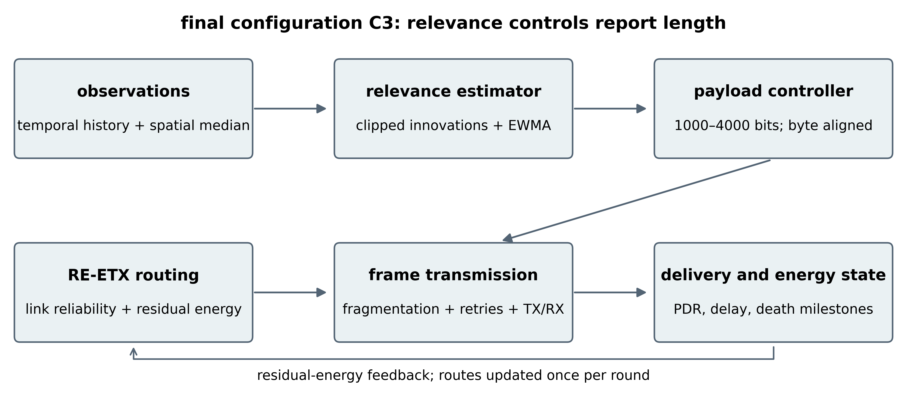
Figure 1. Original diagram of the retained C3 configuration, derived from the supplied implementation. Current spatial context is available centrally in the simulator; its exchange cost is not included.
Figure 1 separates source adaptation from route selection. Relevance changes the report budget, while residual energy changes path costs. The transmission engine receives the actual selected length, rebuilds the fragment list and updates delivery and energy state. Thus, energy is calculated from transmitted frames rather than obtained by multiplying fixed-packet energy by a nominal reduction ratio.
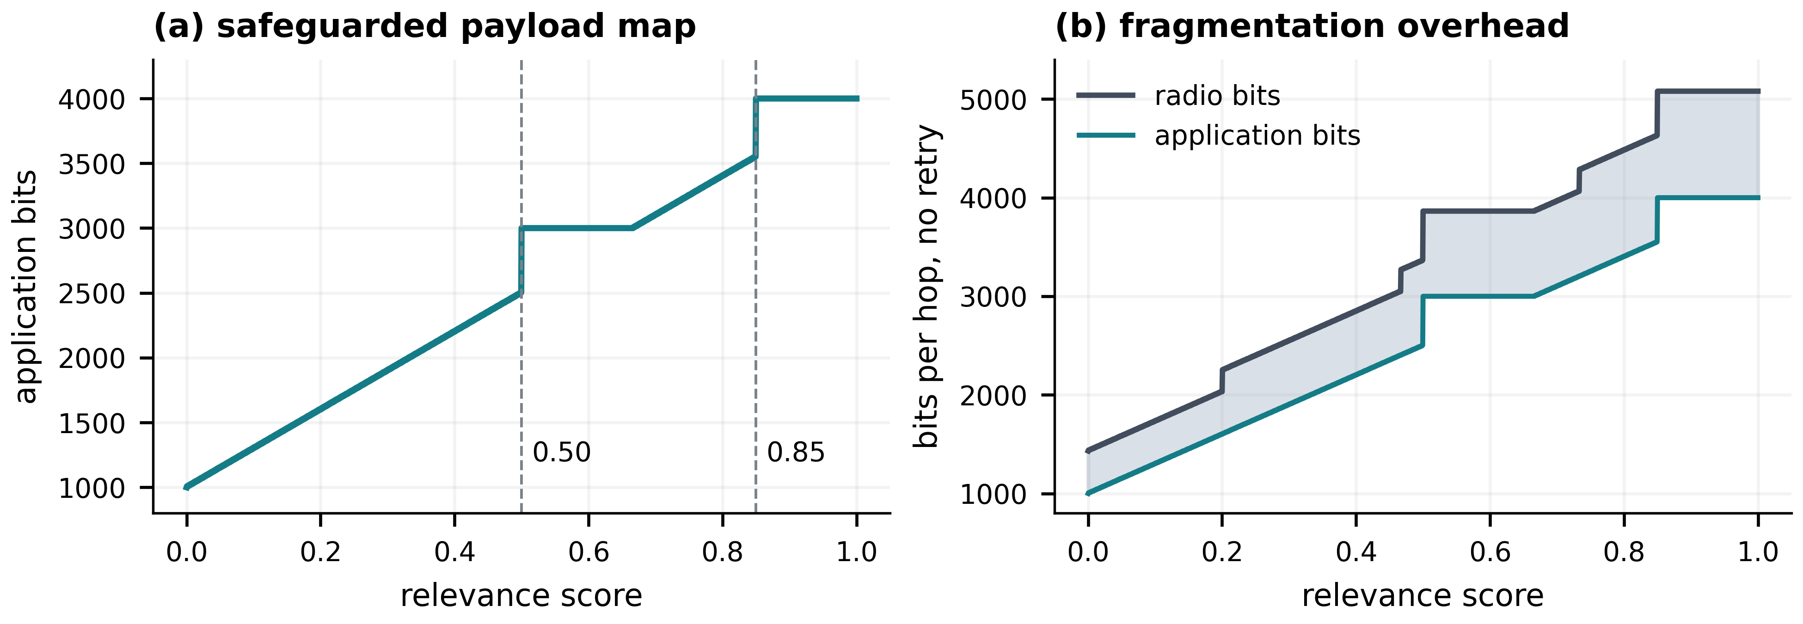
Figure 2. Exact controller mapping and one-hop fragmentation cost from equations (2) and (6), without retransmissions. The shaded difference in panel (b) is frame overhead; these are analytical curves, not experimental averages.
Figure 2 explains why application-bit reduction and radio-bit reduction differ. The minimum report retains 25% of the application budget but 28.19% of the one-hop no-retry radio budget. At intermediate lengths, fragment boundaries create additional steps. Consequently, a shorter report can use less energy while exhibiting a lower ratio of application bits to radio bits.

4.3. RE-ETX and the routing ablation
The static graph evaluates full-report one-attempt success probability $q_{ij}^{\left(0\right)}$ and assigns a message-level ETX surrogate $m_{ij}=1/max\left(q_{ij}^{\left(0\right)},ε\right)$. This differs from the bidirectional data-and-acknowledgement ETX in [4] and from the exact expected number of bounded frame attempts. Let $e_{i}$ be residual energy normalised by initial energy and clipped away from zero, and let $ψ_{i}=e_{i}^{−1}−1$. For sensor-to-sensor links,
$$c_{ij}=m_{ij}\left[1+λ_{E}\left(ψ_{i}+ψ_{j}\right)/2\right], c_{iB}=m_{iB}\left[1+λ_{E}ψ_{i}/2\right]. \left(7\right)$$
Positive costs permit one sink-rooted Dijkstra search per round after removing dead sensors. Graph eligibility and $m_{ij}$ remain based on the full 4000-bit report even when the actual report is shorter. This is a conservative, fixed reliability substrate; payload-dependent route eligibility is not implemented.
For C2 and C4 only, the implementation also tracks slotted age $a_{i}$, reset to one after a successful report, and forms $s_{i}=1−exp\left(−v_{i}a_{i}/10\right)$. It adds $λ_{S}\left(s_{i}+s_{j}\right)/2$ inside the sensor-link bracket in equation (7), and $λ_{S}s_{i}$ inside the sink-link bracket. Here $λ_{S}=1$. A larger age increases a link penalty; it does not grant a source earlier service or additional bandwidth. The distinction is important when interpreting the routing-only result.

4.4. Execution and computational cost
Each round first generates observations and relevance scores, then selects payload lengths and constructs the live routing graph. Sources are served in rotated order. Every selected route is attempted or replaced by a tracked direct fallback. Frame outcomes update residual energy, delivery counters and ages; death milestones are recorded after the round. The simulator checks that successful deliveries and all drop categories exactly partition generated reports.
With stored neighbourhoods, temporal processing and payload mapping are linear in node count. Neighbourhood medians require work proportional to the local observations processed. One shortest-path computation costs $O\left(\left(\left|V\right|+\left|E\right|\right)log\left|V\right|\right)$ with a heap. The supplied dense distance and link matrices require $O\left(N^{2}\right)$ storage, and the relevance implementation scans dense neighbourhood masks. These implementation costs should not be replaced by a claim of constant-cost distributed operation.

5. Experimental design and metric audit

5.1. Data provenance and experimental controls
The evaluation uses seeds {11, 23, 42, 67, 101, 137, 173, 211, 257, 307}. Each seed fixes topology, shadowing and sensing streams across configurations. Frame-error streams use the same seed but are consumed differently when payloads or routes change; individual channel outcomes are therefore not aligned counterfactually. The expanded main control study contains seventy runs: C1-C7 over all ten seeds. C5 fixes every attempted report at 1744 bits, the nearest lower byte-aligned value to the baseline-topology C3 attempted-report mean of 1747.84 bits. C6 preserves the current round's adaptive payload distribution but randomly permutes those payload assignments among sources. C7 sets the spatial relevance weight to zero so that only temporal innovation determines the adaptive payload. A separate forty-run sweep evaluates residual-energy weights 0, 0.25, 0.50 and 1.00 on the same seed ensemble.
Table 3. Configuration definitions and experimental control roles.
Paper case | Age route term | Payload/controller | Experimental role
C1 | Off | Fixed 4000 bits | Full-payload RE-ETX baseline
C2 | On | Fixed 4000 bits | Relevance-age routing ablation
C3, retained method | Off | Temporal-spatial relevance adaptive | Retained relevance-aware source controller
C4 | On | Temporal-spatial relevance adaptive | Combined payload + route-age ablation
C5 | Off | Fixed 1744 bits | Equal-budget source control
C6 | Off | Round-wise shuffled relevance payloads | Destroys source/relevance alignment at similar budget
C7 | Off | Temporal-only relevance adaptive | Spatial-feature ablation
Table 3 separates the original four-case ablation from the three source-control extensions. Independent C1 and C3 executions at seed 42 reproduce the pre-extension network trajectories, and repeated C6 execution reproduces the shuffled-control result exactly. Event truth is queried only after the relevance score has been computed and is used solely for offline evaluation; it is never supplied to payload selection or routing. The temporal-only C7 implementation bypasses the spatial feature calculation rather than merely setting its final coefficient to zero.

5.2. Outcomes and denominators
First-, half- and last-node death (FND, HND and LND) are measured in rounds at the first occurrence of at least 1, 50 and 100 dead sensors. Network lifetime depends on the service definition [23]; these milestones do not certify coverage or connectivity. All observed runs reach LND before 5000 rounds, so these results are not right-censored.
For generated reports $G$, delivered reports $D$, consumed communication energy $E$ and cumulative channel airtime $T_{ch}$, the primary ratios are
$$PDR=D/G, E_{D}=E/D, R_{G}=R/G, g=B_{D}/T_{ch}, \left(8\right)$$
where $R$ is the retry count and $B_{D}$ is delivered application bits. Delay includes a source’s accumulated channel waiting time, its transmission airtime and its own propagation/processing delay. It is a schedule-specific simulation quantity. Cumulative channel airtime excludes an external sensing period and is not wall-clock deployment lifetime.
Two payload statistics require separate denominators. The printed mean payload averages every original sensor position in every simulated round, including dead sensors. The attempted-report counter is therefore used for equal-budget controls. In the baseline topology the pooled C3 attempted-report mean is 1747.84 bits, or a 56.30% reduction from 4000 bits; C5 uses the byte-aligned 1744-bit fixed control. The archive's 'semantic radio efficiency' divides offered application bits by its radio-bit counter without restricting the numerator to delivered reports. The counter also reserves a full frame for a partial sender-death transmission. This ratio is retained only as a diagnostic and is not interpreted as recovered semantic information per physical bit.

5.3. Statistical analysis
Seeds, rather than individual reports, are the experimental units. Descriptive results use the mean and sample standard deviation. For seed-wise differences, marginal 95% t intervals are reported. The original seven-outcome C1→C2, C1→C3 and C3→C4 analysis remains one 21-test Holm family. A separate 21-test source-control family applies the same seven network outcomes to C1→C5, C5→C3 and C6→C3. The within-round targeting analysis uses the three planned contrasts C5→C3, C6→C3 and C3→C7 with Holm correction. Event-quality contrasts use separate six-metric Holm families. For topology sensitivity, eight outcomes are corrected within each topology/contrast family.
As a sensitivity analysis, all $2^{10}$ sign assignments of each paired-difference vector are enumerated. This exact sign-flip calculation requires a symmetric null difference distribution; it is not evidence of random treatment assignment. Wilcoxon signed-rank results [25] are included in the supplementary statistical file, with zero differences handled explicitly. The reused seed ensemble and parameter exploration make this a within-regime simulation analysis, not an independently preregistered confirmation study.

6. Results

6.1. Energy-weight trade-off
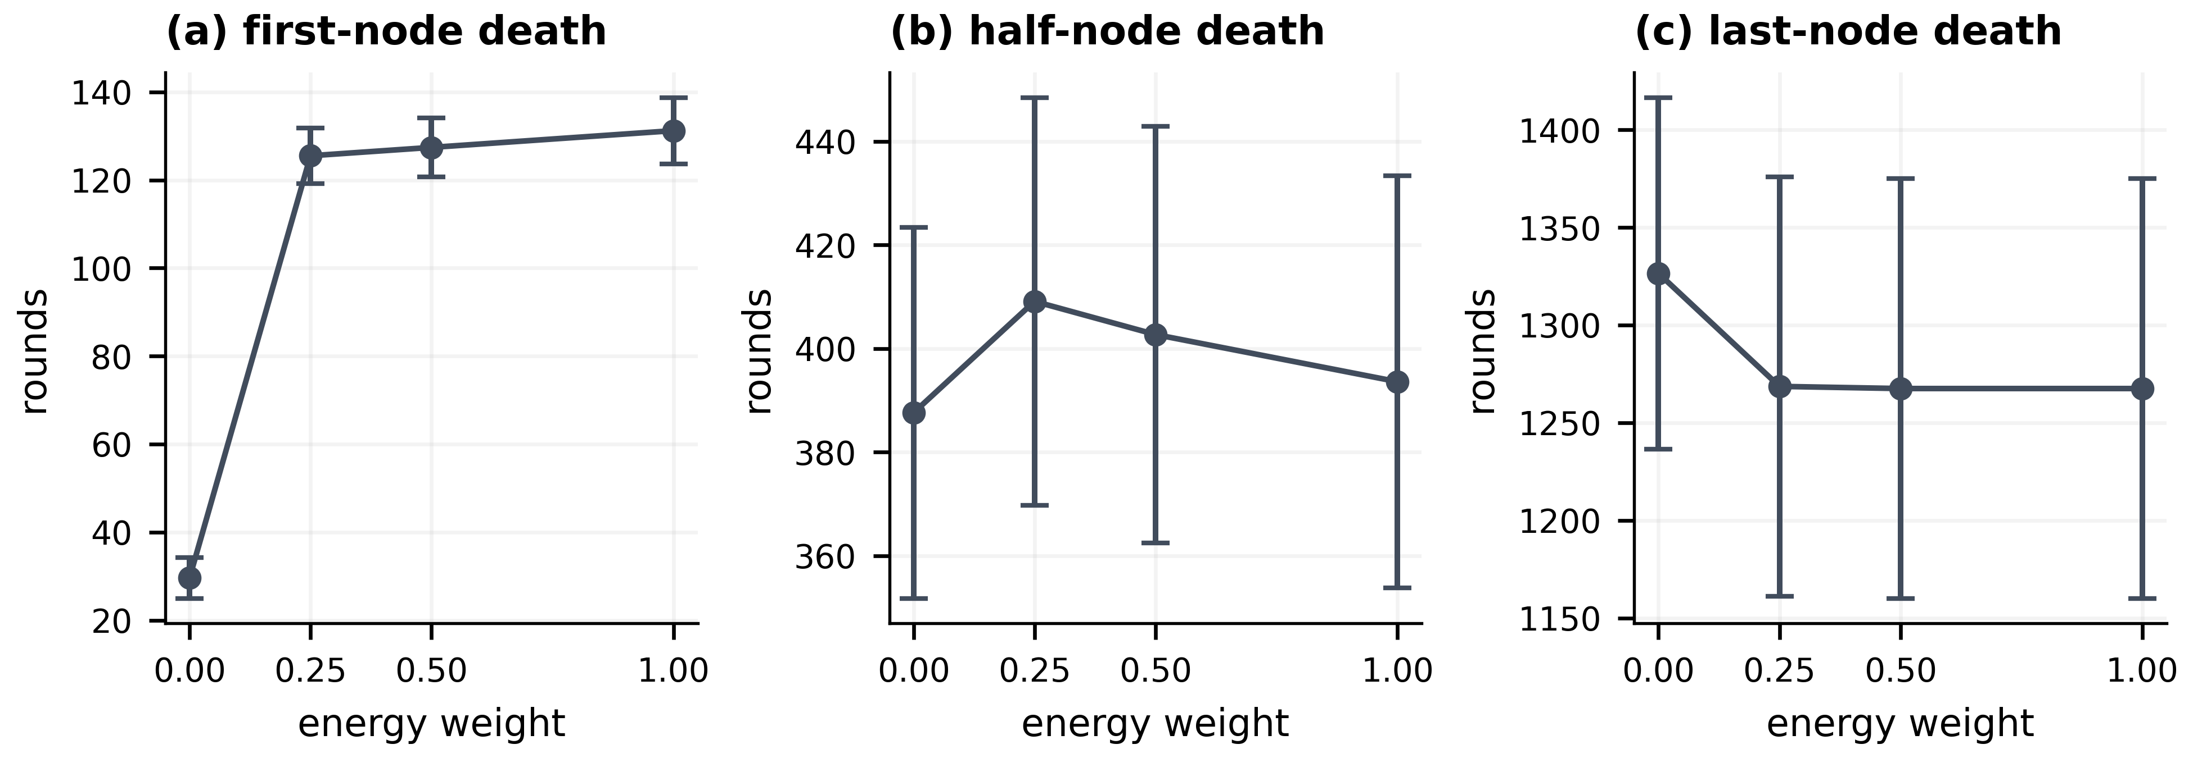
Figure 3. Death milestones versus residual-energy weight across ten seeds. Markers show means and error bars show 95% t intervals; each panel has its own vertical scale.
Figure 3 shows a strong early-lifetime effect. Increasing the weight from 0 to 0.25 changes mean FND from 29.6 to 125.5 rounds. HND changes from 387.6 to 409.1, whereas LND decreases from 1326.5 to 1268.6. Higher weights further increase FND but do not improve every milestone. Thus, 0.25 is a reasonable studied compromise rather than an established global optimum. The sweep also illustrates why a claim of universally improved lifetime would be incomplete.

6.2. Four-way ablation
Table 4. Recomputed ablation outcomes, mean ± sample standard deviation over ten seeds.
Outcome | C1 | C2 | C3 | C4
FND, rounds | 125.5 ± 8.8 | 123.8 ± 9.0 | 275.2 ± 20.6 | 267.1 ± 17.8
HND, rounds | 409.1 ± 55.0 | 409.0 ± 54.8 | 870.1 ± 126.6 | 873.3 ± 127.3
LND, rounds | 1268.6 ± 150.1 | 1268.2 ± 152.1 | 2636.4 ± 278.0 | 2637.5 ± 278.0
PDR, % | 95.351 ± 2.072 | 95.379 ± 2.039 | 97.812 ± 0.963 | 97.818 ± 0.953
Delay, ms | 1046.1 ± 96.1 | 1045.4 ± 96.1 | 481.6 ± 43.5 | 480.9 ± 43.6
Energy/delivered report, mJ | 1.147 ± 0.104 | 1.148 ± 0.105 | 0.526 ± 0.047 | 0.526 ± 0.047
Retries/generated report | 0.1916 ± 0.0866 | 0.1913 ± 0.0865 | 0.0918 ± 0.0409 | 0.0916 ± 0.0411
Channel airtime, s | 1295.9 ± 54.3 | 1296.1 ± 53.9 | 1295.7 ± 54.2 | 1296.7 ± 53.9
Goodput, kbps | 135.52 ± 10.60 | 135.45 ± 10.68 | 129.02 ± 9.88 | 128.86 ± 9.97
Table 4 isolates a consistent payload effect. C1 and C2 are close on all listed outcomes. C3 increases FND, HND and LND relative to C1 by 119.3%, 112.7% and 107.8%, respectively, using ratios of the corresponding group means. C4 adds little to C3 and reduces its mean FND. The retained method therefore omits the relevance-age route term.
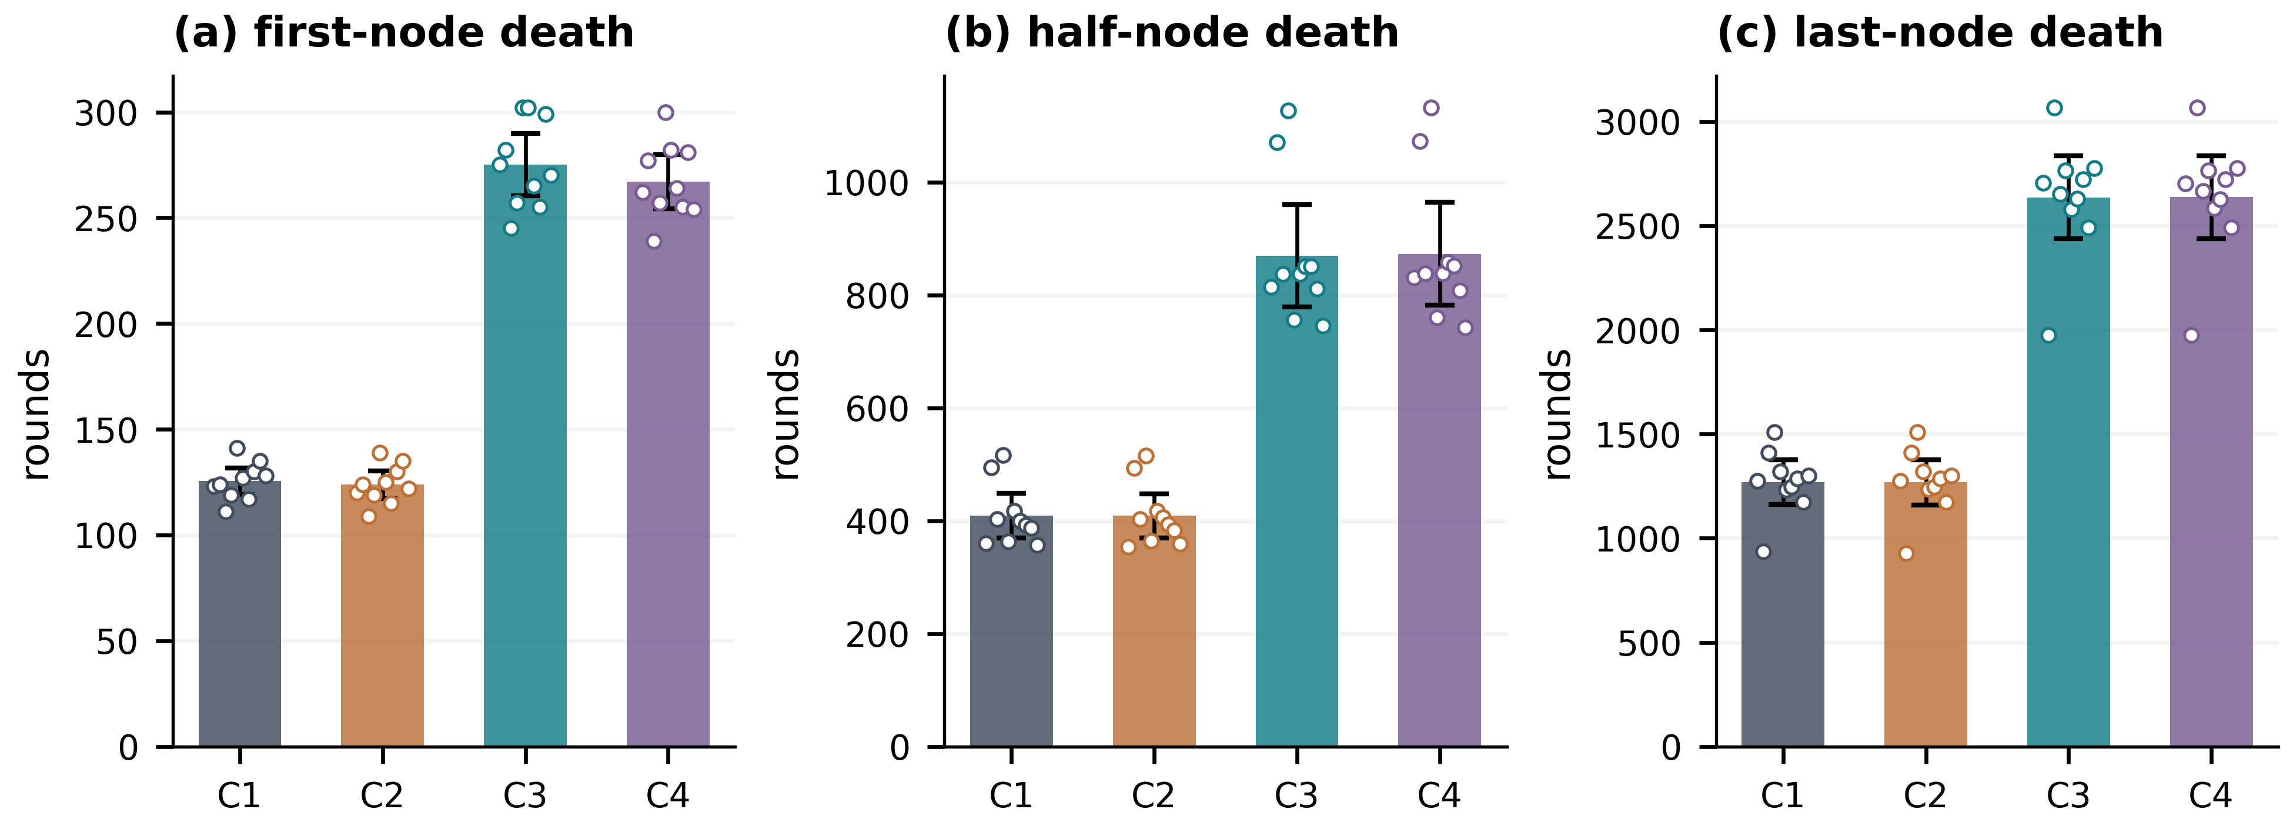
Figure 4. Four-case lifetime comparison. Bars show means, whiskers show 95% t intervals, and circles show the ten seed values. FND, HND and LND use different vertical scales.
Figure 4 makes both effect magnitude and seed variability visible. The payload-enabled configurations extend all three round milestones across the ensemble. Shorter reports slow energy depletion and shift several death thresholds together.
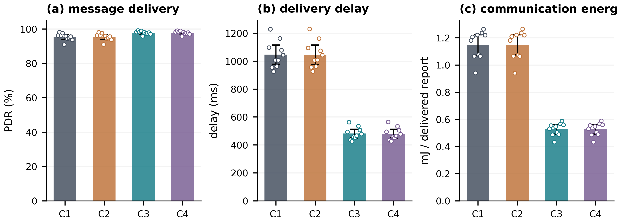
Figure 5. Message-level PDR, delay and energy per delivered report. Bars, intervals and points follow the convention of Figure 4. Panel (a) starts at zero to avoid exaggerating the PDR difference.
Figure 5 shows that C3 increases mean PDR by 2.462 percentage points while reducing delay by 54.0% and communication energy per delivered report by 54.2%. Fewer fragments shorten service time and reduce exposure to required frame failures. Nevertheless, a delivered C3 report generally contains fewer bits than a delivered C1 report. These comparisons describe communication service and cannot establish equal recovered information quality.

6.3. Paired uncertainty and the negative routing result
Table 5. C1→C3 paired changes. Confidence intervals are marginal 95% intervals; adjusted p-values use all 21 principal tests.
Outcome | Mean change | 95% interval | Holm p
FND, rounds | +149.7 | [138.8, 160.6] | 3.55 × 10⁻⁹
HND, rounds | +461.0 | [408.1, 513.9] | 1.74 × 10⁻⁷
LND, rounds | +1367.8 | [1243.7, 1491.9] | 2.32 × 10⁻⁸
PDR, percentage points | +2.462 | [1.667, 3.256] | 0.00100
Delay, ms | −564.4 | [−602.7, −526.1] | 1.93 × 10⁻⁹
Energy/delivered report, mJ | −0.622 | [−0.663, −0.580] | 1.83 × 10⁻⁹
Retries/generated report | −0.0997 | [−0.1325, −0.0670] | 0.00107
Table 5 shows that the seven C1→C3 changes remain significant under the declared family correction. Every seed changes in the favourable direction for these seven outcomes, yielding an unadjusted two-sided sign-flip p-value of 0.001953 for each. This corroborates directional consistency within the ensemble; it does not substitute for additional topologies, sensing processes or application workloads.
No principal C1→C2 or C3→C4 contrast is significant after the same correction. For example, adding the age term to C3 changes FND by −8.1 rounds, with a marginal interval [−13.7, −2.5], but a Holm p-value of 0.140. Failure to reject does not prove exact equivalence. The appropriate engineering conclusion is that the tested extension has no demonstrated added benefit sufficient to justify retaining its complexity.

6.4. Reporting lifetime versus elapsed channel time
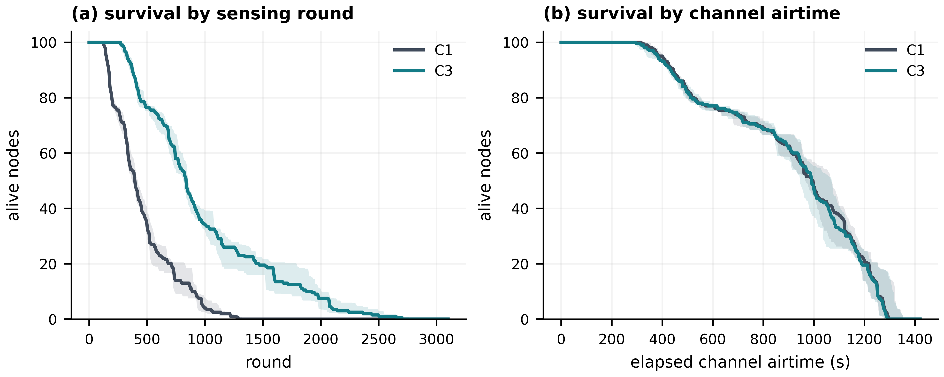
Figure 6. C1 and C3 survival trajectories. Lines are seed-wise medians and bands are interquartile ranges, not confidence intervals. A completed run contributes zero alive nodes after its last-node death.
Figure 6 reveals the consequence of the time base. C3 remains active for many more sensing rounds, but C1 and C3 use nearly identical total channel airtime: 1295.85 and 1295.66 s on average, a difference of approximately −0.015%. A longer count of scheduled rounds is therefore compatible with essentially unchanged channel-use duration. An application with a fixed external sampling interval could benefit differently, but such an interval and its idle/sensing energy would have to be modelled explicitly.
Both configurations exhaust the same initial 50 J at LND. C3 delivers approximately 95,882 reports compared with 43,933 for C1, so dividing that energy by delivered-report count produces the lower per-report value. The result is more report deliveries per modelled joule, not a reduction in total energy consumed at full depletion.
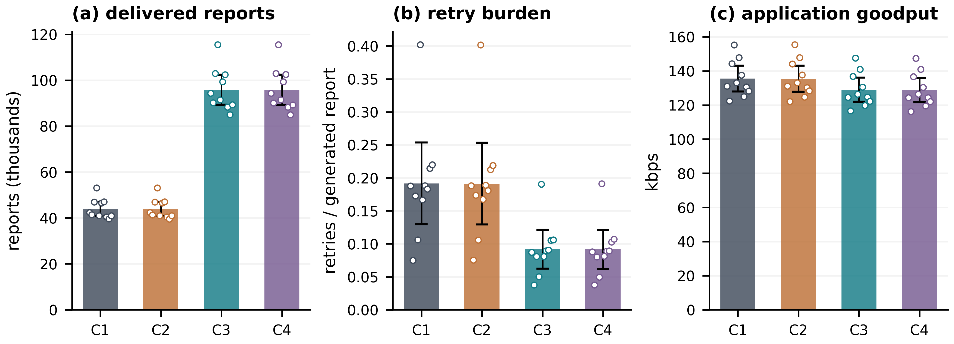
Figure 7. Workload outcomes over complete network runs. Means, 95% intervals and seed points are shown. Report count and application-bit goodput are deliberately presented as different outcomes.
Figure 7 shows that more delivered reports coexist with lower application goodput. C3 reduces retries per generated report by 52.1%, while goodput decreases from 135.52 to 129.02 kbps, or 4.8%. Mean delivered-hop count changes only from 1.4028 to 1.4000. These observations support reduced frame workload as the principal mechanism; they do not support a claim that C3 discovers substantially shorter paths.
6.5. Equal-budget and shuffled-relevance source controls
Table 6 compares the retained C3 controller with the fixed equal-budget C5 control, the shuffled-relevance C6 control and the temporal-only C7 ablation. C5 differs from C3 by only 3.84 attempted bits on the pooled baseline mean (1744 versus 1747.84 bits). Consequently, it reproduces most of the large C1→C3 network gain. For C5→C3, Holm-corrected differences remain for HND (+26.1 rounds), mean delay (−11.36 ms) and energy per delivered report (−0.0127 mJ), whereas FND, LND, PDR and retries per generated report are not significant after correction.
Table 6. Source-control outcomes, means over ten matched seeds.
Outcome | C3 | C5 | C6 | C7
Attempted payload, bits | 1747.84 | 1744.00 | 1748.05 | 1610.89
FND, rounds | 275.2 | 267.6 | 295.8 | 297.8
HND, rounds | 870.1 | 844.0 | 869.6 | 929.8
LND, rounds | 2636.4 | 2626.6 | 2634.0 | 2825.8
PDR, % | 97.812 | 97.758 | 97.825 | 97.956
Delay, ms | 481.6 | 493.0 | 481.2 | 448.7
Energy/delivered report, mJ | 0.526 | 0.538 | 0.525 | 0.489
Retries/generated report | 0.0918 | 0.0941 | 0.0922 | 0.0861
C6 is especially informative because it preserves approximately the same aggregate adaptive-payload budget while destroying the mapping between a source's relevance and its assigned payload. None of the seven tested C6→C3 network outcomes remains significant after Holm correction. Thus, the dominant network-level improvement is explained by reduced traffic volume; the baseline network metrics alone do not show that relevance-aware allocation is superior to a shuffled allocation at the same average budget. C7 has a smaller mean payload than C3, so its better lifetime and delay outcomes cannot be treated as evidence that temporal-only relevance is semantically superior.
6.6. Offline event targeting and relevance alignment
Network-level equality between C3 and C6 does not imply that the payload assignments are informationally equivalent. Event truth, which is unavailable to the runtime controller, permits an offline audit of where the bit budget is placed. Because event-active rounds can have a different overall payload distribution from inactive rounds, the principal targeting statistic is the event-minus-non-event payload difference computed within each round and then averaged across evaluable event rounds.
Table 7. Offline event-targeting diagnostics, means over ten matched seeds.
Metric | C3 | C5 | C6 | C7
Event report delivery ratio | 0.9784 | 0.9815 | 0.9810 | 0.9841
Event mean payload, bits | 3208.0 | 1744.0 | 2367.7 | 1863.9
Non-event mean payload, bits | 1681.4 | 1744.0 | 1719.8 | 1599.3
Event payload preservation | 0.8020 | 0.4360 | 0.5919 | 0.4660
Event payload delivery ratio | 0.7840 | 0.4280 | 0.5803 | 0.4580
Within-round targeting gap, bits | 1218.7 | 0.0 | 13.3 | 201.6
The mean within-round targeting gap is 1218.7 bits for C3, compared with 0 for C5 and 13.3 bits for C6. The paired C5→C3 and C6→C3 differences are both highly significant after Holm correction (adjusted p < 10^-9). C3 also preserves 80.2% of the full 4000-bit event payload budget, compared with 43.6% for C5 and 59.2% for C6, and delivers 78.4% of the full event payload budget versus 42.8% and 58.0%, respectively. Event-report delivery probability itself is not higher for C3 than C5. These results show that the relevance estimator directs substantially more application bits toward event-active reports. This measure characterises payload allocation and does not quantify detector performance or receiver-side reconstruction accuracy.
6.7. Sensitivity to multi-hop topology depth
A separate topology calibration increases field depth while retaining 100 sensors and positioning the sink 50 m above the upper field boundary. Three high-connectivity regimes were selected with initial mean route depths of approximately 1.483, 2.910 and 4.929 hops. Within each regime, C1, C3 and a topology-specific equal-budget C5 control are evaluated over all ten seeds. The C5 payloads are 1744, 1648 and 1568 bits in the shallow, medium and deep profiles, closely matching the corresponding C3 attempted means of 1745.5, 1649.2 and 1570.8 bits.
Table 8. Topology-depth sensitivity. Cells show C1 / C3 / C5 means over ten seeds.
Profile (initial hops) | HND, rounds | LND, rounds | PDR, % | Delay, ms | Energy/delivered, mJ
Shallow (1.483) | 200.7 / 383.3 / 357.8 | 1290.4 / 2642.5 / 2663.8 | 90.496 / 95.404 / 95.294 | 958.1 / 442.3 / 452.8 | 1.631 / 0.744 / 0.764
Medium (2.910) | 49.9 / 112.3 / 96.2 | 1063.3 / 2138.4 / 2206.6 | 86.443 / 93.765 / 93.404 | 2170.4 / 959.5 / 1002.1 | 4.917 / 2.105 / 2.209
Deep (4.929) | 29.1 / 74.7 / 65.5 | 934.4 / 1952.7 / 2303.9 | 86.343 / 94.160 / 94.299 | 2512.2 / 1050.6 / 1018.6 | 7.604 / 3.082 / 2.983
C3 remains substantially better than full-payload C1 on HND, LND, PDR, delay and communication energy as route depth increases, showing that the benefit of reducing frame workload is not confined to the original shallow topology. The equal-budget C5→C3 comparison is more qualified. C3 has higher HND in all three profiles, but LND is not improved in the medium profile and is 351.2 rounds lower than C5 in the deep profile after correction. In the deep profile, C3 also has no corrected advantage in PDR, delay, energy per delivered report or retry rate. The within-round targeting gap nevertheless remains large for C3 across shallow, medium and deep profiles (approximately 1297, 1249 and 1124 bits). Hence deeper multi-hop testing reinforces the distinction between relevance alignment and generic traffic reduction: targeting persists, whereas equal-budget network superiority is metric- and topology-dependent.

7. Discussion and limitations
The expanded evidence separates two effects that were confounded in the original four-case analysis. First, transmitting fewer bits is responsible for most of the large network-level improvement relative to 4000-bit C1. The equal-budget C5 and shuffled C6 controls reproduce most of C3's lifetime, PDR, delay and energy behaviour. Second, the relevance estimator is not arbitrary: C3 assigns far more payload to event-active reports than either the fixed-budget or shuffled controls, with a within-round targeting gap above 1.2 kbit in the baseline topology. The defensible contribution is therefore relevance-directed allocation of a reduced payload budget, not a claim that relevance uniquely causes every network-level gain.
The energy boundary is equally consequential. C1 and C3 consume approximately 1.093 and 0.514 mJ per generated report, leaving a first-order difference of 0.579 mJ. Any added sensing, processing or context-exchange cost must fit within that margin to preserve a net benefit under comparable service. The actual margin changes when these costs alter node deaths and routing, so subtracting a fixed overhead after the simulation would not establish deployment lifetime. Current neighbour observations, including those associated with dead nodes, should be replaced by an explicit local-information protocol before making that claim.
Several modelling decisions still constrain external validity. The original topology averages only about 1.4 delivered hops, but the new sensitivity study extends calibrated initial route depth to approximately 4.9 hops. The C3-versus-C1 advantage survives this extension, whereas equal-budget C3-versus-C5 outcomes become mixed and deep-profile LND favours C5. The sensitivity profiles change field height and candidate-link radius while holding node count fixed, so they should not be interpreted as a pure hop-count intervention or as a large-network scalability experiment. Static shadowing, independent frame errors and serialised access still exclude contention, interference, burst losses and realistic acknowledgements. The first-order radio model also omits measured processor and transceiver-state costs.
The warm-up assigns minimum-length reports before the baseline is calibrated. Its effect should be tested separately for applications that cannot tolerate early information loss. Threshold and energy-weight selection were explored on the same seed family used for analysis, limiting claims of generalisation. The manuscript’s statistically precise differences concern those seeds and fixed parameters; confidence intervals do not incorporate uncertainty in the sensing model or physical energy coefficients.
Finally, the route-age penalty is not a scheduling policy, and its global diagnostic includes dead-node ages. The negative ablation therefore concerns this specific cost construction. It should not be generalised to freshness-aware communication as a whole. Future evaluation should prioritise matched-budget reconstruction, locally available context with charged energy, larger topologies and an external contemporary routing baseline implemented under comparable conditions.

8. Conclusions
A safeguarded temporal-spatial relevance controller has been evaluated over residual-energy ETX routing using seven source/routing configurations and ten matched seeds. Relative to fixed 4000-bit C1, C3 approximately doubles the major sensing-round lifetime milestones and reduces delay and communication energy per delivered report by about 54%. Equal-budget and shuffled controls show, however, that most of these network-level gains arise from transmitting fewer bits. At approximately the same average payload, C3 and shuffled C6 are not significantly different on the seven tested network outcomes after Holm correction.
The relevance-specific evidence lies in payload placement. C3 produces a mean within-round event/non-event payload gap of 1218.7 bits, versus 0 for the fixed equal-budget control and 13.3 bits for shuffled relevance, while preserving about 80.2% of the full event payload budget. This targeting remains substantial under the deeper topology profiles, even though equal-budget network advantages are not universal and deep-profile LND favours C5. The result therefore supports relevance-aware payload prioritisation as an auditable traffic-allocation mechanism, while receiver fidelity, application utility, processing energy, neighbourhood-information exchange and larger-scale contention-aware deployments remain open validation requirements.

Data and code availability
The project repository is https://github.com/DrShivamBhardwaj/Relevance_Aware_RE_ETX_. The validated experimental package is available on branch 'dual-journal-validation' and is anchored by tag 'dual-journal-validation-v1'. The repository includes the C1-C7 multi-seed control data, event-quality and within-round targeting statistics, residual-energy-weight sweep, calibrated topology-depth sensitivity runs, paired tests, analysis scripts, batch runners, compressed per-round histories and reproducibility metadata.

References
[1] Akyildiz I F, Su W, Sankarasubramaniam Y and Cayirci E 2002 A survey on sensor networks. IEEE Communications Magazine 40(8): 102–114. https://doi.org/10.1109/MCOM.2002.1024422
[2] Heinzelman W R, Chandrakasan A and Balakrishnan H 2000 Energy-efficient communication protocol for wireless microsensor networks. In: Proceedings of the 33rd Hawaii International Conference on System Sciences. https://doi.org/10.1109/HICSS.2000.926982
[3] Heinzelman W B, Chandrakasan A P and Balakrishnan H 2002 An application-specific protocol architecture for wireless microsensor networks. IEEE Transactions on Wireless Communications 1(4): 660–670. https://doi.org/10.1109/TWC.2002.804190
[4] De Couto D S J, Aguayo D, Bicket J and Morris R 2003 A high-throughput path metric for multi-hop wireless routing. In: Proceedings of ACM MobiCom, pp. 134–146. https://doi.org/10.1145/938985.939000
[5] Winter T et al. 2012 RPL: IPv6 routing protocol for low-power and lossy networks. IETF RFC 6550. https://doi.org/10.17487/RFC6550
[6] Gnawali O and Levis P 2012 The minimum rank with hysteresis objective function. IETF RFC 6719. https://doi.org/10.17487/RFC6719
[7] Wu M, Tan L and Xiong N 2016 Data prediction, compression, and recovery in clustered wireless sensor networks for environmental monitoring applications. Information Sciences 329: 800–818. https://doi.org/10.1016/j.ins.2015.10.004
[8] Bou Tayeh G, Makhoul A, Laiymani D and Demerjian J 2018 A distributed real-time data prediction and adaptive sensing approach for wireless sensor networks. Pervasive and Mobile Computing 49: 62–75. https://doi.org/10.1016/j.pmcj.2018.06.007
[9] Hribar J, Costa M, Kaminski N J and DaSilva L A 2019 Using correlated information to extend device lifetime. IEEE Internet of Things Journal 6(2): 2439–2448. https://doi.org/10.1109/JIOT.2018.2869986
[10] Nait Abbou A and Manner J 2023 ETXRE: Energy and delay efficient routing metric for RPL protocol and wireless sensor networks. IET Wireless Sensor Systems 13(6): 235–246. https://doi.org/10.1049/wss2.12070
[11] Arnaiz D, Moll F, Alarcón E and Vilajosana X 2024 Energy and relevance-aware adaptive monitoring method for wireless sensor nodes with hard energy constraints. Integration 94: 102097. https://doi.org/10.1016/j.vlsi.2023.102097
[12] Płaczek B 2024 Prediction-based data reduction with dynamic target node selection in IoT sensor networks. Future Generation Computer Systems 152: 225–238. https://doi.org/10.1016/j.future.2023.11.007
[13] Maatouk A, Kriouile S, Assaad M and Ephremides A 2020 The age of incorrect information: A new performance metric for status updates. IEEE/ACM Transactions on Networking 28(5): 2215–2228. https://doi.org/10.1109/TNET.2020.3005549
[14] Yates R D, Sun Y, Brown D R III, Kaul S K, Modiano E and Ulukus S 2021 Age of information: An introduction and survey. IEEE Journal on Selected Areas in Communications 39(5): 1183–1210. https://doi.org/10.1109/JSAC.2021.3065072
[15] Kountouris M and Pappas N 2021 Semantics-empowered communication for networked intelligent systems. IEEE Communications Magazine 59(6): 96–102. https://doi.org/10.1109/MCOM.001.2000604
[16] Xie H, Qin Z, Li G Y and Juang B H 2021 Deep learning enabled semantic communication systems. IEEE Transactions on Signal Processing 69: 2663–2675. https://doi.org/10.1109/TSP.2021.3071210
[17] Hribar J, Marinescu A, Chiumento A and DaSilva L A 2022 Energy-aware deep reinforcement learning scheduling for sensors correlated in time and space. IEEE Internet of Things Journal 9(9): 6732–6744. https://doi.org/10.1109/JIOT.2021.3114102
[18] Luo X, Chen H H and Guo Q 2022 Semantic communications: Overview, open issues, and future research directions. IEEE Wireless Communications 29(1): 210–219. https://doi.org/10.1109/MWC.101.2100269
[19] Gündüz D, Qin Z, Estella Aguerri I, Dhillon H S, Yang Z, Yener A, Wong K K and Chae C B 2023 Beyond transmitting bits: Context, semantics, and task-oriented communications. IEEE Journal on Selected Areas in Communications 41(1): 5–41. https://doi.org/10.1109/JSAC.2022.3223408
[20] Getu T M, Kaddoum G and Bennis M 2024 A survey on goal-oriented semantic communication: Techniques, challenges, and future directions. IEEE Access 12: 51223–51274. https://doi.org/10.1109/ACCESS.2024.3381967
[21] Senouci O and Benaouda N 2025 Supervised machine learning-based ETX optimization for energy-efficient routing in IoT-enabled WSNs. Ad Hoc Networks 178: 103972. https://doi.org/10.1016/j.adhoc.2025.103972
[22] Hwang A, Yum S H, Yoon D J, Kim S M and Park S H 2026 An SDN-based adaptive payload structure and transmission management for reliable WSN data collection in extreme cold region environments. ICT Express, article in press. https://doi.org/10.1016/j.icte.2026.08.005
[23] Dietrich I and Dressler F 2009 On the lifetime of wireless sensor networks. ACM Transactions on Sensor Networks 5(1): article 5. https://doi.org/10.1145/1464420.1464425
[24] Holm S 1979 A simple sequentially rejective multiple test procedure. Scandinavian Journal of Statistics 6(2): 65–70. https://www.jstor.org/stable/4615733
[25] Wilcoxon F 1945 Individual comparisons by ranking methods. Biometrics Bulletin 1(6): 80–83. https://doi.org/10.2307/3001968

