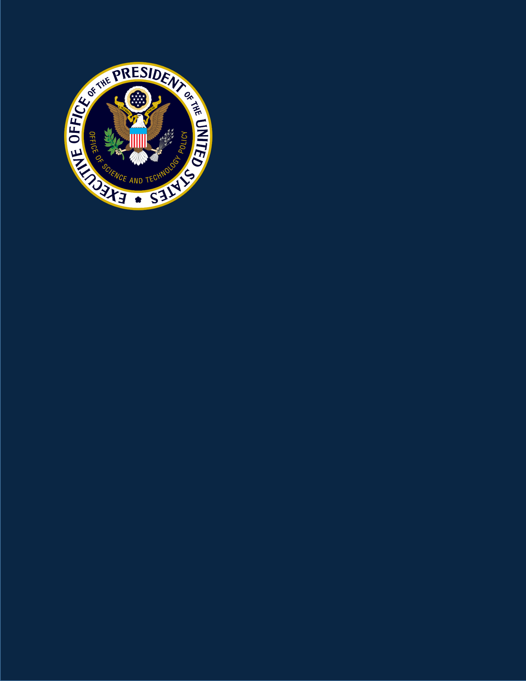2019 Progress Report: Federal R&D for Advanced Artificial Intelligence Technologies

SUMMARY OF THE 2019 WHITE HOUSE SUMMIT ON ARTIFICIAL INTELLIGENCE IN GOVERNMENT

*A Product of*

THE WHITE HOUSE

OFFICE OF SCIENCE AND TECHNOLOGY POLICY

SEPTEMBER 9, 2019

0

Summary of the 2019 White House Summit on Artificial Intelligence in Government

*“Together, we can use the world’s most innovative technology to make our government work better for the American people.”*

*Michael Kratsios*

*Chief Technology Officer of the United States*

2

Summary of the 2019 White House Summit on Artificial Intelligence in Government

**Background**

On September 9, 2019, The White House hosted *The Summit on Artificial Intelligence (AI) in Government*. *The Summit* brought together over 175 leaders and experts from government, industry, and academiato spark ideas for how the Federal government can adopt AI to achieve its mission and improve services to the American people.

Over the last several years, the private sector has demonstrated that AI can improve the quality of services, create new products, and increase efficiency. The Federal government now has the opportunity to improve its services on behalf of the American people by partnering with the private sector to leverage this knowledge and capability.

Some Federal agencies are already leading the way by using AI to process grant applications, check Federal solicitations for regulatory compliance, improve nautical charts, process satellite imagery, perform predictive maintenance, and much more. Still, there is significant room for growth. A number of inter-related challenges must be addressed — some technical, some requiring process changes, and some involving talent and workforce issues.

Through the discussion at the *AI in Government Summit*, the Federal government sought to find near-term solutions to these challenges to improve government services using AI.

The Trump Administration has already made artificial intelligence a priority with the launch of the [American AI Initiative,](https://www.whitehouse.gov/articles/accelerating-americas-leadership-in-artificial-intelligence/) our whole-of-government national strategy for U.S. leadership in AI. The American AI Initiative identified key areas of emphasis for the Federal government, such as investing in AI research and development, unleashing AI data and resources, setting governance standards, and building the AI workforce.

Our continued leadership depends upon leveraging AI to improve activities across the Federal government. AI technologies hold incredible potential to improve nearly every sector, from health care, to transportation, education, and security. The Trump Administration will make government more effective, efficient, and responsive to the American people.

*The Summit on AI in Government* highlighted the innovative efforts already underway at Federalagencies and looked ahead to future transformative AI applications.

**Event Summary**

*The Summit* kicked off with opening remarks from White House Deputy Chief of Staff for PolicyCoordination Chris Liddell and White House Office of Science and Technology Policy Director Dr. Kelvin Droegemeier. Dr. Lynne Parker, Assistant Director for Artificial Intelligence, acted as emcee of the event. Chief Technology Officer of the United States Michael Kratsios provided remarks on how the Trump Administration is advancing AI through the American AI initiative, and how these efforts can also drive transformation within the Federal government itself. Federal Chief Information Officer Suzette Kent discussed Federal opportunities to use AI for better delivery of mission and service; enhance the quality, usability, and accessibility of data; and develop and empower the workforce of today and the future.

Anil Cheriyan, Deputy Commissioner of the General Services Administration’s Federal Acquisition Service and Director of the Technology Transformation Services, reviewed ongoing work toward the establishment of an AI Center of Excellence that can help agencies apply AI to drive transformative improvements in government operations.

3

Summary of the 2019 White House Summit on Artificial Intelligence in Government

A panel discussion with Ivanka Trump, Advisor to the President, and Margaret Weichert, Deputy Director for Management at the Office of Management and Budget and Acting Director of the Office of Personnel Management, moderated by Mr. Kratsios, addressed the skills gap in the Nation and in the Federal workforce. The panel also discussed how the Administration is preparing the workforce through the National Council for the American Worker, the President’s Management Agenda, and other related efforts.

*Summit* attendees heard from key leaders in the U.S. government on ways agencies and departmentsare leveraging AI to improve their mission and operations. In the first case study, Lt. Gen. Jack Shanahan, Director of the Joint Artificial Intelligence Center (JAIC) in the Department of Defense (DoD), highlighted the Humanitarian Assistance/Disaster Relief mission initiative. This initiative is one of the JAIC’s first projects to help accelerate DoD’s adoption and integration of AI, with initial lines of effort centering on using AI-enabled capabilities to detect and track wildfires and provide flood analysis, road analysis, and building damage assessments.

In the second case study on the use of AI in government, Patricia Flatley Brennan, RN, PhD, Director of the National Library of Medicine, discussed how the National Institutes of Health employ AI to improve operations. Examples include the use of natural language processing to save time in the grant application referral process, and the use of AI and machine learning methods to provide fast and efficient access to the medical literature, via the PubMed repository.

The third case study was presented by Charles Keckler, Associate Deputy Secretary at the Department of Health and Human Services, on the use of AI to accelerate a data- driven approach to regulatory reform. In this work, natural language processing techniques, together with human expert insight, are successfully identifying outdated, burdensome, and duplicative regulations, with the potential of greatly reducing human workload in a highly labor-intensive process.

*Summit* attendees participated in a set of breakout sessions, focused on best practices in the use of AI,fostering collaboration through an AI Center of Excellence model, and developing a Federal AI workforce. Breakout sessions were led by senior staff from the White House and Federal agencies.

In addition to senior staff from The White House, Federal participants included senior officials from the Departments of Agriculture, Commerce, Defense, Education, Energy, Health and Human Services, Homeland Security, Housing and Urban Development, Interior, Justice, Labor, State, Transportation, Treasury, Veterans Affairs, as well as the Environmental Protection Agency, Federal Aviation Administration, General Services Administration, Intelligence Advanced Research Projects Activity, National Aeronautics and Space Administration, National Archives and Records Administration, National Institutes of Health, National Science Foundation, National Security Commission on AI, Nuclear Regulatory Commission, Office of Personnel Management, Small Business Administration, and Social Security Administration. This breadth of representation from senior official across the Federal Government illustrates the commitment of the Trump Administration to the innovative use of AI technologies to make government work better for the American people.

As The White House continues to designate AI as an Administration priority, we look forward to continued engagement and new partnerships across the Federal agencies, and with the private sector and academia, to increase the adoption of AI for improved government operations and services.

4

Summary of the 2019 White House Summit on Artificial Intelligence in Government

**Key Takeaways**

Key takeaways from breakout discussions include:

* **Best practices: Learning between government, industry, and academia.** Leveragingexperiences and best practices across government, industry, and academia can be an effective way to accelerate the use of AI to improve government. Attendees discussed which applications of AI are easiest and most useful for the government to implement in the near term, based on existing experience. Organizations shared how to best manage process changes that arise from the new capabilities that AI provides. Additional discussions focused on good strategies for building organizational trust in the adoption of AI.
* **Opportunities to foster collaboration through an AI Center of Excellence model.** A Centerof Excellence (COE) model can be an important mechanism for agencies to share AI expertise and best practices. Participants discussed the types of information, services, and expertise that would be particularly helpful for a COE to provide, in order to accelerate the use of AI in the government for improved operations and services. Individuals shared their views on the best engagement model between agencies, industry, and a COE to foster partnerships and encourage rapid scaling of AI utilization within the government. They also proposed ideas for types of COE outreach that could foster cross-organizational communication of best practices for AI adoption.
* **Hiring, training, and reskilling AI workers for the Federal government.** Increasing the useof AI in government requires a workforce skilled in the development and/or use of AI. Attendees discussed their individual views of how organizations can identify the right workers to accelerate the use of AI in government, and how organizations can provide opportunities for existing workers to learn the new skills needed to innovate using AI. They also discussed ways that industry and academia can partner with government to share expertise needed for AI adoption.

**Next Steps and Conclusion**

President Trump signed Executive Order 13859 on February 11, 2019, launching the *American AI* *Initiative*, our Nation’s AI strategy. This Initiative directs Federal agencies to pursue multiple pillars toadvance AI, with important emphases in areas of AI research and development, data and computation resources, technical standards and governance, education and workforce, international engagement, and protecting our AI advantage. In all of these actions, the *Initiative* emphasizes the importance of advancing AI innovation, while fostering public trust and confidence in AI technologies.

*The White House Summit for AI in Government* reflected on these pillars of the *American AI Initiative*, andhow they can drive transformation within the Federal government itself. Initiatives in AI R&D, data, and workforce, in particular, can all enhance the way government functions and delivers services. A number of inter-related challenges must be addressed — some technical, some requiring process changes, and some involving talent and workforce issues. By partnering across agencies and with the private sector and academia, the Federal government will find ways to address these challenges and transform government to reduce costs, improve quality of services, increase efficiency, and empower people across the Nation.

5

Summary of the 2019 White House Summit on Artificial Intelligence in Government

**Remarks by Michael Kratsios, Chief Technology Officer of the United States**

Welcome everyone to *The White House Summit* *on Artificial Intelligence in Government*. It is ourpleasure to host all of you here today. This is a truly unique opportunity to gather some of our great Federal workforce with a few of the best minds in the AI industry and in academia. Together, we can come up with practical ideas to use the world’s most innovative technology in a way that will make our government work better for the American people.

In the past decade, technology has transformed how the government operates in the service of the American people. By making public data sets open and available for innovation, new businesses have been launched, from advanced weather forecasting to health care and medical devices. Now anyone can easily go online and quickly find resources that can help them better live their lives. And within the government, technology is helping make sure that taxpayer dollars are being used more efficiently, with technology reducing redundancies and streamlining processes.

######

But this is just the beginning of what technology can do to improve government operations and empower Americans. Today I want to talk about what this Administration has done to advance AI, highlight some of the innovative uses of AI by our Federal agencies, and start the conversation on what more can be done by the government to better use technology to improve the lives of the American people.

Over the past few years, this Administration has taken amazing strides to advance AI and retain American leadership in this critical industry.

All of our efforts reached their peak this February when President Trump took the boldest federal action in our history on Artificial Intelligence by signing an executive order to launch the American AI Initiative—the United States’ National AI Strategy.

Under this strategy, we are completely committed to further developing our AI capabilities and making each new advance serve the best interests of the American people.

First, the initiative focuses on investments in AI R&D. The President has called for agencies across the government to prioritize AI research and development, and the Administration has released an update to our Artificial Intelligence R&D strategic plan. This update refreshes our priorities in the face of a fast-changing AI landscape. We will continue to leverage America’s vibrant R&D ecosystem of industry, academia, and government to advance the most cutting-edge ideas and to bring developments directly to all Americans.

Second, we are working to unleash Federal AI resources. We want to improve public access to high quality Federal data that can drive even more AI research and testing.

The third pillar of our *American AI Initiative* is to remove barriers to AI innovation. Our goal is to promote innovation while protecting American’s civil rights and privacy. We are developing official regulatory guidance that will determine how Federal agencies should approach the use of AI in the private sector.

6

Summary of the 2019 White House Summit on Artificial Intelligence in Government

We also are working to strengthen Federal engagement in the creation of the technical standards we need for AI development and deployment. The National Institute of Standards and Technology has already made great progress. Just last month, they released a plan for federal engagement in the development of AI standards that will support reliable, robust, and trustworthy AI systems.

Our fourth pillar focuses on the very root of our nation’s strength and success: the American worker. The President has directed federal agencies to prioritize artificial intelligence in their grants and fellowships. We are helping the American people gain AI-relevant skills through apprenticeships, workforce training, and STEM education, and other learning opportunities

Fifth, we are promoting an international environment supportive of American AI

innovation. Most recently, The Trump Administration made history by joining together with democracies of the world that share our common values when we signed an international consensus document on AI principles at the OECD. These principles are directly in concert with our own national strategy—and we look forward to continuing this partnership with our allies. We will continue to develop new AI technologies in a way that advances innovation, promotes public trust, protects civil liberties, and remains consistent with our common principles.

######

And now, today, we focus our attention on how all of these pillars of our American AI Initiative can also drive transformation within the Federal government itself. Initiatives in AI R&D, data, and workforce can all enhance the way government functions and delivers services.

Many agencies are already pioneers. At the Department of Defense, the Joint AI Center is developing AI-enabled capabilities for humanitarian assistance and disaster relief – focusing on detecting and tracking wildfires and providing flood analysis, road analysis, and building damage assessments.

The National Institutes of Health is using AI to improve their operations. For example, the National Library of Medicine is creating tools to help automate indexing for medical citations – significantly improving search quality and usability.

The Department of Health and Human Services is using artificial intelligence to analyze outdated, burdensome, and duplicative regulations—allowing us to more effectively cut the red tape holding our Nation back.

Today, we are proud to discuss new efforts to drive transformation in the Federal agencies through a Center of Excellence model for AI. This type of center could serve as a central hub of expertise that every agency could access as they begin to adopt and use AI in their work. We’ll be discussing this center of excellence model more later today.

We have so much potential to use AI in a way that reduces costs, improves quality of services, empowers people, and increases efficiency.

######

Before I close I want to thank the public servants in this room for everything you do every day to help the government better serve its people. It is the most important job you will ever do, and I am humbled and honored every day to serve alongside with you.

I hope you will find today’s meetings and discussions productive, and that they will inspire you to take some great ideas back to your agencies, your companies, and your universities so that we can all serve the American people better than ever before.

7