**Python for Scientific Computing TensorFlow for Artificial Intelligence**

Dates: 31st March – 3rd April, 2025 Dates: 4th April, 2025

**Certificate of Attendance:** Delegates must attend over 80% of the sessions.

Loughborough 5-day Hands-on Workshop on:

**Python for Scientific Computing**

**and**

**Artificial Intelligence**

By Professor Stephen Lynch NTF FIMA SFHEA

Homepage: [Professor Stephen Lynch at Loughborough University](https://www.lboro.ac.uk/departments/compsci/staff/stephen-lynch/)

Author of Two Patents and a National Teaching Fellow

Author of PYTHON™, MATLAB®, MAPLE™ AND MATHEMATICA® BOOKS

STEM Ambassador, Public Engagement Champion and Speaker for Schools

***A free copy of this 344-page reference e-book can be downloaded here:***

[***CRC Press***](https://www.routledge.com/Python-for-Scientific-Computing-and-Artificial-Intelligence/Lynch/p/book/9781032258713)

***This is a practical workshop using Python and TensorFlow.***

The workshop is based on Stephen’s book, “*Python for Scientific Computing and Artificial Intelligence*”, CRC Press, 2023.

**Attend this workshop and learn:**

* how to program Python using IDLE, SPYDER and JUPYTER/GOOGLE COLAB NOTEBOOKS
* how to model both CONTINUOUS and DISCRETE DYNAMICAL SYSTEMS
* about models in engineering, computing, biology, chemistry, economics, physics and mathematics
* how the brain works and about ARTIFICIAL INTELLIGENCE
* how to program deep neural networks In GOOGLE COLAB with TENSORFLOW

The workshop participants need no knowledge of any programming language.

The methods used in this workshop have been successfully tested on undergraduates and postgraduates for over 25 years. The workshop is highly interdisciplinary.

* This workshop is designed for anyone in the engineering, computing and scientific community who wants to learn how to use Python for Scientific Computing and TensorFlow for Artificial Intelligence (AI) programming.
* No prior knowledge of Python or programming is required to benefit from this workshop.
* The emphasis of the workshop is on practical applications by means of hands-on tutorials using Python and TensorFlow. The emphasis is **not** on the mathematical theory.



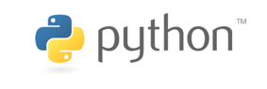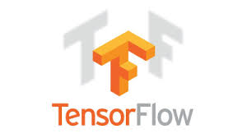



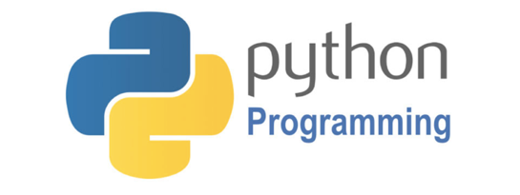

**OBJECTIVES**

The main objective of this workshop is to introduce delegates to Scientific Computing using Python and Artificial Intelligence using TensorFlow.

Participants will be introduced to Python and Scientific Computing before moving on to Artificial Intelligence. The workshop will focus on the Python and TensorFlow programs and **NOT** on the mathematical theory.

At the end of the workshop, delegates will have attained the following digital skillsets to add to their CV:

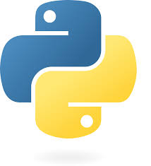



**

**WORKSHOP OUTLINE**

**Day 1: INTRODUCTION to PYTHON**

* Using Python as a powerful calculator
* Simple programming techniques including, defining functions, loops and if, then, else statements
* Simple plots using Turtle
* A tutorial introduction to NumPy and Matplotlib with Spyder

**Day 2: SCIENTIFIC COMPUTING in PYTHON**

* A tutorial introduction to SymPy
* JupyterLab and Google Colab
* Scientific Computing: Biology
* Scientific Computing: Chemistry

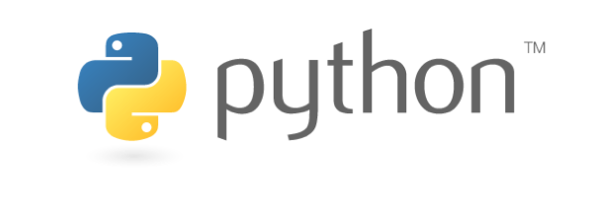

**Day 3: SCIENTIFIC COMPUTING in PYTHON**

* Scientific Computing: Data Science
* Scientific Computing: Economics
* Scientific Computing: Engineering
* Scientific Computing: Fractals & Multifractals

**DAY 4: SCIENTIFIC COMPUTING in PYTHON**

* Scientific Computing: Image Processing
* Scientific Computing: Numerical Methods
* Scientific Computing: Physics
* Scientific Computing: Statistics

**DAY 5: ARTIFICIAL INTELLIGENCE(AI)**

* Brain-Inspired Computing Invention
* Neural Networks & Neurodynamics
* Recurrent Neural Networks
* Convolutional Neural Networks

***The workshop includes practical, hands-on sessions where participants are given the opportunity to apply in practice the theory they have learnt. All Python and TensorFlow program files can be downloaded through GitHub:***

<https://github.com/proflynch/CRC-Press/>

***Delegates can view Python programs online via Jupyter notebooks:***

[https://www.routledge.com/Python-for-Scientific-Computing-and-Artificial-Intelligence/Lynch/p/book/9781032258713#](https://www.routledge.com/Python-for-Scientific-Computing-and-Artificial-Intelligence/Lynch/p/book/9781032258713)

Delegates will use the skills acquired in their research and writing project dissertations.



**WHO WILL BENEFIT FROM THIS WORKSHOP**

This workshop is aimed at a large professional audience: from academics and technicians, advanced undergraduate and graduate students to applied mathematicians, engineers, and researchers in a broad range of disciplines such as biology, chemistry, computing, data science, economics, population dynamics, physics, sports science and statistics.

The workshop will help to develop a practical understanding of how Python can be used to solve real-world problems and provide scientists with a means of presenting their results.

Python for employability:

<https://www.mathscareers.org.uk/python-for-a-level-maths-undergraduate-maths-and-employability/>

**WORKSHOP LEADER:** **Professor Stephen Lynch NTF FIMA SFHEA**

ResearchGate: <https://www.researchgate.net/profile/Stephen-Lynch-5>

Stephen is a **world leader** in the use of mathematics packages in teaching, learning, assessment, research and employability. He started using packages in the mid 1980’s whilst studying for his PhD in Pure Mathematics. Upon completion of his PhD, he started his lecturing career at Southampton University at the age of 24.

This Loughborough workshop has developed from a series of mathematics lectures to undergraduates and from both national and international Python and TensorFlow workshops.

Although educated as a pure mathematician, Stephen’s many interests now include applied mathematics, cell biology, electrical engineering, computing, neural networks, nonlinear optics and binary oscillator computing, which he co-invented with a colleague.

He has authored 2 international patents for inventions, 10 books, 4 book chapters, over 45 journal articles and a few conference proceedings.

In 2022, Stephen was awarded a **National Teaching Fellowship** for his work in Widening Participation, programming in the STEM subjects and interdisciplinary research feeding in to teaching.

He is a Fellow of the Institute of Mathematics and its Applications (FIMA) and a Senior Fellow of the Higher Education Academy (SFHEA). He is currently a Professor at Loughborough University and was concurrently an Associate Lecturer with the Open University from 2008-2012. In 2010, Stephen volunteered as a **STEM Ambassador**, in 2012, he was awarded **Public Engagement Champion** status and in 2014 he became a **Speaker for Schools**.

Stephen runs national workshops with the IMA on **Python for A-Level Mathematics and Beyond**, for pupils and teachers:

<https://ima.org.uk/events/conferences/>

Stephen is also the author of **MATLAB®, MapleTM** and **Mathematica®** books – all published by Springer International Publishing. According to **Springer**, there have been nearly **800,000** chapter downloads for all of his books up to December 2024. The chapters from the Python book alone have been downloaded over **200,000** times since late 2018.

According to ScholarGPS, Stephen is ranked **#18** in the world for Dynamical Systems.

Link to: [ScholarGPS](https://scholargps.com/scholars/53907764717005/stephen-lynch?e_ref=5a87db3a668bc9f521b3).

**PYTHON for SCIENTIFIC COMPUTING**

**and**

**TENSORFLOW for ARTIFICIAL INTELLIGENCE**

**Workshop Itinerary**

**Professor Stephen Lynch NTF FIMA SFHEA**



|  |  |
| --- | --- |
|  |  |
|  | page1image16669184 |
|  |  |

|  |  |  |  |
| --- | --- | --- | --- |
| Day 1: Morning Afternoon | | | |
| Using Python as a Calculator | 10am-11am | The Turtle Module | 1:30pm-2:30pm |
| Coffee Break | 11am-11:30am | Coffee Break | 2:30pm-3:00pm |
| Simple Programming | 11:30am-12:30pm | NumPy and MatPlotLib | 3:00pm-4:00pm |
| Day 2: Morning Afternoon | | | |
| Symbolic Computation (SymPy) | 10am-11am | Biology | 1:30pm-2:30pm |
| Coffee Break | 11am-11:30am | Coffee Break | 2:30pm-3:00pm |
| JupyterLab and Google Colab | 11:30am-12:30pm | Chemistry | 3:00pm-4:00pm |
| Day 3: Morning Afternoon | | | |
| Data Science | 10am-11am | Engineering | 1:30pm-2:30pm |
| Coffee Break | 11am-11:30am | Coffee Break | 2:30pm-3:00pm |
| Economics | 11:30am-12:30pm | Fractals & Multifractals | 3:00pm-4:00pm |
| Day 4: Morning Afternoon | | | |
| Image Processing | 10am-11am | Physics | 1:30pm-2:30pm |
| Coffee Break | 11am-11:30am | Coffee Break | 2:30pm-3:00pm |
| Numerical Methods | 11:30am-12:30pm | Statistics | 3:00pm-4:00pm |
| Day 5: Morning Afternoon | | | |
| Brain-Inspired Computing | 10am-11am | Recurrent Neural Networks | 1:30pm-2:30pm |
| Coffee Break | 11am-11:30am | Coffee Break | 2:30pm-3:00pm |
| Neural Networks & Neurodynamics | 11:30am-12:30pm | Convolutional Neural Networks | 3:00pm-4:00pm |

