**Workshop Dates Certificate of Attendance**

Dates: 31st March – 4th April, 2025 You must attend over 80% of the sessions.

Loughborough 5-day Hands-on Workshop on:

**A Simple Introduction**

**to**

**Python**

By Professor Stephen Lynch NTF FIMA SFHEA

Homepage: [Professor Stephen Lynch at Loughborough University](https://www.lboro.ac.uk/departments/compsci/staff/stephen-lynch/)

Author of Two Patents and Ranked **#18** in the World for Dynamical Systems

Author of PYTHON™, MATLAB®, MAPLE™ AND MATHEMATICA® BOOKS

National Teaching Fellow, STEM Ambassador, Public Engagement Champion and Speaker for Schools

The workshop is based on Stephen’s book, “*A Simple Introduction to Python*”, CRC Press, 2024.

**Attend this workshop and learn:**

* how to use Python as a powerful calculator
* how to program Python using IDLE
* how to plot fractals with the Turtle module
* how to plot 2-dimensional and 3-dimensional plots and animations
* how to do Mathematics with Python
* about cryptography, artificial intelligence, data science and object oriented programming

The workshop participants need no knowledge of any programming language.

The methods used in this workshop have been successfully tested on undergraduates and postgraduates for over 25 years.

***A free copy of this 124-page reference e-book can be downloaded here:***

[***CRC Press***](https://www.routledge.com/A-Simple-Introduction-to-Python/Lynch/p/book/9781032750293)

***This is a practical workshop using Python.***



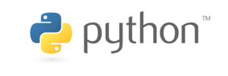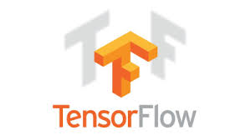

Aim

To learn a high-level general-purpose programming language.

Objectives

* Use Python as a powerful calculator.
* Write simple programs.
* Produce figures and animations.
* Write professional notebooks.
* Incorporate programming into research and project dissertations.

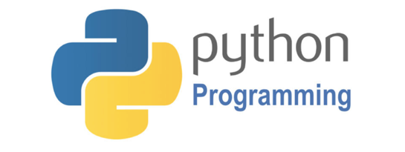

**OBJECTIVES**

The main objective of this workshop is to introduce delegates to programming using Python.

Participants will be introduced to Python and a number of platforms to perform the computations. Delegates can download software onto their own computers or use cloud computing.

At the end of the workshop, delegates will have attained the following digital skillsets to add to their CV:

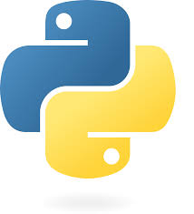

**WORKSHOP OUTLINE**

**Day 1: INTRODUCTION to PYTHON IDLE**

* Python as a Powerful Calculator
* Fractions and Symbolic Computation
* Powers
* The Math library
* Lists, Tuples, Sets & Dictionaries
* Defining Functions
* For and While Loops
* If, Elif, Else Statements

**Day 2: Turtle, NumPy and MatPlotLib**

* The Cantor Set Fractal
* The Koch Snowflake Fractal
* A Bifurcating Tree Fractal
* The Sierpinski Triangle Fractal
* Numerical Python (NumPy)
* MatPlotLib for Plotting and Animations
* Scatter Plots
* Surface Plots



**Day 3: Google Colab, SymPy and GitHub**

* Google Colab and Cloud Computing
* Formatting Notebooks
* Symbolic Python
* GitHub
* Basic Algebra
* Solving Equations
* Mathematical Functions
* Differentiation and Integration

**DAY 4: Cryptography and AI**

* The Caesar Cipher
* The XOR Cipher
* Rivest-Shamir-Adleman (RSA) Cryptosystem
* Simple RSA Algorithm Example
* Artificial Neural Networks (ANNs)
* AND/OR and XOR Gate ANNs
* The Backpropagation Algorithm
* Boston Housing Data

**DAY 5: Data Science and Object Oriented Programming**

* Introduction to Pandas and Data Frames
* Load, Clean and Preprocess the Data
* Exploring the Data
* Violin, Scatter and Hexagonal Bin Plots
* Classes and Objects
* Encapsulation
* Inheritance and Polymorphism
* The Brick Breaker Game

***The workshop includes practical, hands-on sessions where participants are given the opportunity to apply in practice the theory they have learnt. All Python solution program files can be downloaded through GitHub:***

[Solutions in GitHub](https://github.com/proflynch/A-Simple-Introduction-to-Python)

***Delegates can view Python solution programs online via Jupyter notebooks:***

[Solutions Jupyter Notebook](https://drstephenlynch.github.io/webpages/A-Simple-Introduction-to-Python-Solutions.html)

**A SIMPLE INTRODUCTION**

**to**

**PYTHON**

**Workshop Itinerary**

**Professor Stephen Lynch NTF FIMA SFHEA**

|  |  |
| --- | --- |
|  |  |
|  |  |
|  |  |

|  |  |  |  |
| --- | --- | --- | --- |
| Day 1: Morning Afternoon | | | |
| Using Python as a Calculator | 10am-11am | Simple Programming | 1:30pm-2:30pm |
| Coffee Break | 11am-11:30am | Coffee Break | 2:30pm-3:00pm |
| Exercises | 11:30am-12:30pm | Exercises | 3:00pm-4:00pm |
| Day 2: Morning Afternoon | | | |
| The Turtle Library | 10am-11am | NumPy and MatPlotLib | 1:30pm-2:30pm |
| Coffee Break | 11am-11:30am | Coffee Break | 2:30pm-3:00pm |
| Exercises | 11:30am-12:30pm | Exercises | 3:00pm-4:00pm |
| Day 3: Morning Afternoon | | | |
| Google Colab, SymPy and GitHub | 10am-11am | Python for Mathematics | 1:30pm-2:30pm |
| Coffee Break | 11am-11:30am | Coffee Break | 2:30pm-3:00pm |
| Exercises | 11:30am-12:30pm | Exercises | 3:00pm-4:00pm |
| Day 4: Morning Afternoon | | | |
| Cryptography | 10am-11am | Artificial Intelligence | 1:30pm-2:30pm |
| Coffee Break | 11am-11:30am | Coffee Break | 2:30pm-3:00pm |
| Exercises | 11:30am-12:30pm | Exercises | 3:00pm-4:00pm |
| Day 5: Morning Afternoon | | | |
| Data Science | 10am-11am | Object Oriented Programming | 1:30pm-2:30pm |
| Coffee Break | 11am-11:30am | Coffee Break | 2:30pm-3:00pm |
| Exercises | 11:30am-12:30pm | Exercises | 3:00pm-4:00pm |

