TITLE

YOUR NAME

H446 NEA A23cmp

Contents

Analysis 2
Problem Identification and Summary of Solution 2
Appendix A - Full Code of Solution 3

Analysis

Problem Identification and Summary of Solution
- I want to solve the problem of a lack of tools to visualise planets and orbital objects in space
- In order to solve this problem I will be creating a program that will allow the user to view the earth from all angles
- My model of the earth will use a dynamically generated sphere mesh with a variable resolution texture that at its highest will provide a very high level of detail
- I will also be including the moon in the solution, it will be orbiting the earth with its exact apoapsis (furthest point from the earth) periapsis (closest point to the earth) and inclination. In addition it will rotate in accordance to how it does in real life
- I will also try to include other orbital objects such as the Hubble telescope and the ISS
- If I am able to achieve all the previous tasks I will add Mars and the current mars rover's location
- All location data including date and time will be gathered from APIs on the internet but can also be calculated from the local time if no internet connection is found
To build my solution I will be using the Rust programming language, utilising libraries such as:
- Wgpu-rs - A wrapper for graphics libraries such as Vulkan, Direct-X, etc.
- Specs - An entity component system written for rust
- Tokio - A library providing an asynchronous runtime for Rust
- Serde - A parsing library that provides wrappers for many data storage formats such as JSON and TOML
- nAlgebra - A library that provides linear algebra functionality
- Rayon - A library that simplifies concurrency through the use of rust iterators
- Itertools - Additional iterator structures
I will develop my solution in the Helix text editor with the Rust Analyzer language server for code completion. Primarily I will be using a distribution of GNU/Linux called Artix (a derivative of the more known Arch Linux), but I will also be using Void Linux. Whilst I will not be actively developing my program for Windows it should be able to be compiled for Windows and I will use git to achieve this.

A1 – Stakeholders

Stakeholder | Description | Role | Stakeholder Needs/Requirements, How they will use the system
Miles Ray | Year 12 student of Computer Science at Farnborough Sixth Form College. Miles likes to try to break programs and find unintended ways to achieve goals. | Quality Assurance / System Tester | Miles would like to see space debris included in the simulation, he wants the program to use an API to gather information about where space debris is. I would not be including this as I believe there is no need to include space debris as it has no informational use about orbital bodies.  Miles would like to see shaders used to create the atmospheres of planets. e.g. using a scattering based shader to give the look that the earth has an atmosphere.  Miles would want to use this program as practice for breaking into programs and finding/exploiting bugs. I think my program could be useful for his needs because there are always likely to be bugs in programs and just trying to find bugs in any program is good experience for this.
Ollie McCandlish | Year 12 student of Computer Science at Farnborough Sixth Form College. Ollie has some knowledge of computer science and spends a lot of time playing video games, giving him knowledge about what makes a good user experience. | User Experience Tester | Ollie would like to see the a model of the International space station with its current location including in the program, as well as a visualisation of recent rocket launches.  Ollie would also like to see a customisation feature within the program, for example rockets may be seen launching from the earth and the user would be able to customise the colours and shapes of the rockets.  Ollie wants to use this program because he would find it fun to try changing the variables that hold the solar system together, e.g. mass of the sun, fundamental constant of gravity. This program is suited to this use case as a simulation mode will be included that allows the user to change such values from an easy to use UI.
Oscar Hitchcock-Smith | Year 12 student of Computer Science and Physics at Farnborough Sixth Form College. Oscar has extensive knowledge of space and orbital systems. | Casual User / Subject Expert | Oscar would like to see a solar system sandbox within the game, where you are able to change values such as the mass of the earth, the mass of the sun, the fundamental constant of gravity, etc.  In addition Oscar would like to be able to see how the International space station orbits the earth as well as when it visible from certain parts of the Earth.  As well as this Oscar would like to be able to explore the surface of the planets with a first person style controller and a VR interface.  Oscar would like to use this program as it could help him visualise the orbits of bodies within the solar system as well as helping him with orbital calculations for rocket simulations. My program is only partly suitable for this because it will be easy for him to visualise orbits from within my program. However I do not think it will be accurate enough to help with most orbital calculations for rocket simulations but may be enough if the calculations do not require a high amount of precision.
Kristian Dunn | Year 12 student of Computer Science at Farnborough Sixth Form College. Kristian has some knowledge of computer science and how programs are built. | Casual User | Kristian would like to be able to see the real time location of various satellites within the program. He would like to be able to select what kind of satellites would be shown, e.g. Starlink satellites. He would also like any new satellites to be added into the program through the use of an API.  Kristian would also like to be able to see how different bodies interact with each other, e.g. The Earth’s orbit is predominantly affected by the Sun however it is also influenced by the moon.  Kristian would like to use this program to find out information about different orbital bodies and how they orbit around other bodies. This program is suitable for this use case as it will provide information such as orbital height and inclination as well as bodies mass and radius.
Matthew Mason | Year 12 student of Computer Science at Farnborough Sixth Form College. | Casual User | Matthew would like to see a simulation mode within the program that allows the user to see what the orbits within the solar system would look like in the future and the past, as well as allowing the user to speed up and slow down time, whilst keeping a track on the in game date and time.  Matthew wants to use this program as he wants to be able to see the bodies that orbit the Earth in a greater detail and with real time locational data. My program suits this situation as It will gather real time data from various APIs about the location o orbital bodies and then use specific algorithms to simulate how those bodies will propagate throughout space over time.
Eline Cooper | Year 12 student of Computer Science at Farnborough Sixth Form College. |  | Eline would like to see the International space station included within the program as well as the position and models of some different satellites.  Eline would like to use this program because space is a topic that has always interested her, but she hasn’t seen any programs that could help her to see information about it, she would like to use the program as it would be a good way to visualise the objects orbiting the Earth.
Oliver Kendall | Year 12 student of Computer Science at Farnborough Sixth Form College. Oliver has extensive knowledge of iOS and Mac application development, giving him the knowledge of what makes a good user experience and how programs should cater for their users. | Casual User / User Experience Tester | Oliver would like to see the models of some satellites and asteroids within the program. He would like to locations of these objects to be accurate with their actual current location as well as adding new asteroids when they are discovered.  Oliver would also like to see destructible planets within the program, allowing the users to use natural objects such as black holes, asteroids and other planets to destroy other orbital bodies.  Oliver would like to use this program to simulate the experience of looking at the bodies within the solar system without having to buy specialist equipment and/or wait for suitable weather. My program suits this use as it will gather real time data from various APIs and then use algorithms to simulate how those bodies will propagate through space.

A2 – Research

Space Engine:

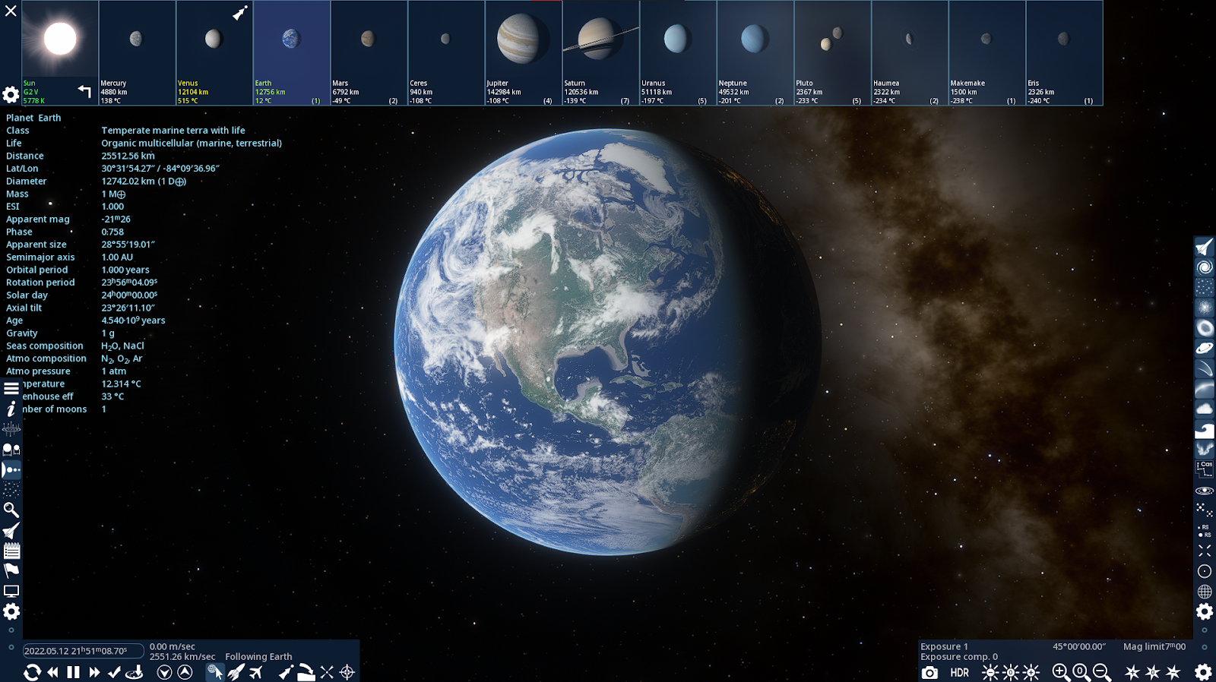
- User is able to select which body within the solar system they want to be viewing, bodies such as the Sun, Mercury, Venus, Earth and Mars are included. I will be including this in my program as it allows an easy way to navigate between bodies. In my program the user can press a keyboard shortcut or click a button on the screen to reveal a list of all the nearby bodies.
- User is able to see specific information about the currently selected body. e.g. it shows the name, the temperature, the diameter, the mass, etc. of the body. I will be including this in my program as one of my stakeholders wanted to be able to use the program for orbital calculations and displaying information such as orbital period, apoapsis, periapsis, etc. Is useful for these kind of orbital calculations.
- User is able to speed up time, reverse time and pause time through the use of the UI and keyboard shortcuts. I will be including this in my program, the user will be able to use keyboard shortcuts or click a button on the screen to change how time changes. I will be including this as one of my stakeholders said they wanted to be able to see how the bodies in the solar system propagate through space as time changes.

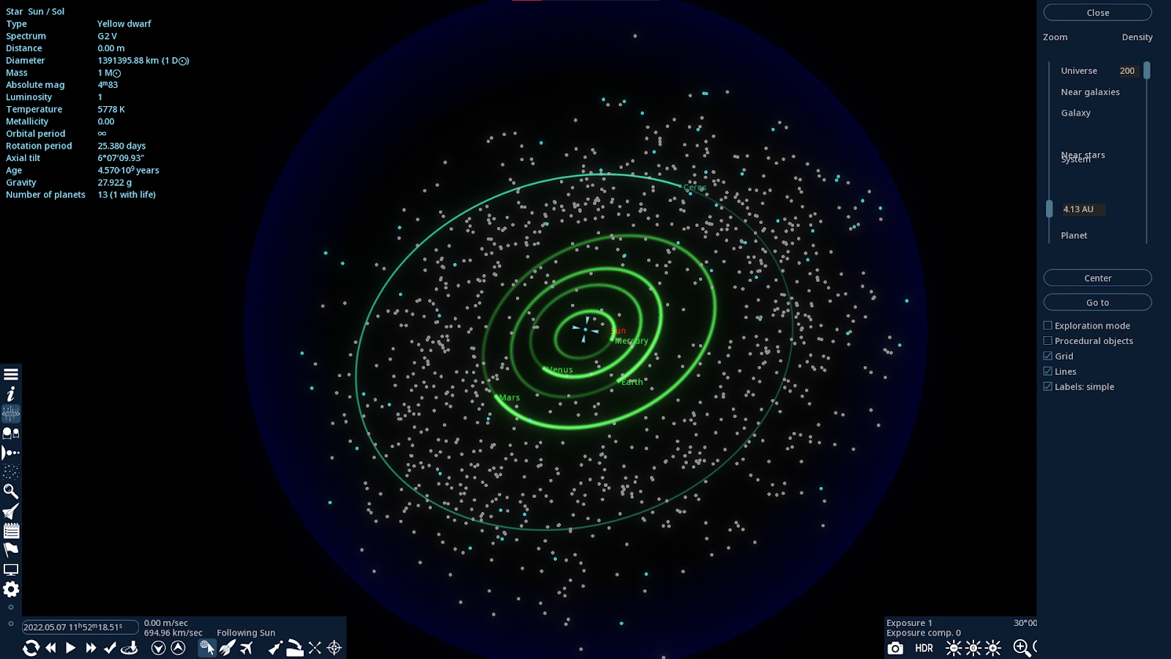
- User is able to select the scale of the objects they can see, they use a slider to select whether they want to see the observable universe, the near galaxy, the current galaxy, the nearby star systems, the current star system, and the current planet. I will be including this in my program however the user will not be able to zoom out as far as the observable universe. In my program users can only zoom out to visualise the whole solar system. I am including this as it allows for users to be able to visualise the orbital period of orbital bodies.
- User can choose to see a grid to show the scale of the distances between the orbital bodies, e.g. each square in the grid could show an area of 1 au² (1 au is the distance from the sun to the earth). I will not be including this in my program initially as it is out of the scope of my program, however this is a feature I would want to include after I have included all of the essential features. I want to be including this because, it can help the user visualise the distance between the orbital bodies in view.
- User can move the camera to position the currently selected body in the centre of the screen. I will be including this in my program as it allows the user to easily navigate back to having the planet in view if they accidentality move too far away from it and cannot find it again.
- User can view the currently selected body as well as the space around it in the centre of the screen. I will be including this in my program as this gives the user a window to see the body they have currently selected.
- The user can drag with the mouse in order to pan around the body (move the body around relative to the centre of the screen). I will be including this in my program as it allows users to inspect specific parts of the currently selected body more easily. This may not be particularly useful when viewing planets or moons however when view a body such as the Internation Space Station it will allow the user to view specific parts of the body at the angle they want.

Universe Sandbox:

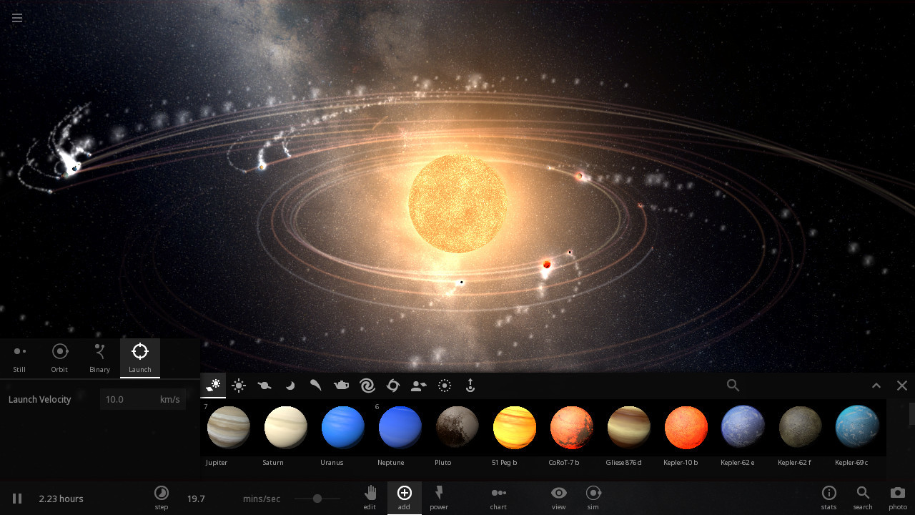
- The bodies that are orbiting the sun produce a trail behind them showing their orbital path. I will be including this into my program as it allows users to easily view the paths the bodies are creating. Users of my program can choose which bodies show a trail.
- The user can select what they would like to introduce into orbit around the sun. I will not be including this in my program to begin with as it is out of scope, however it may be useful to add as part of the simulation feature, allowing users to create their own star systems and also more easily introduce alternate star systems.
- Users can stop time with a pause button. I will be adding this into my program as it was a requirement of one of my stakeholders that users can manipulate the time of the simulation allowing them to view how the planets orbit the sun over time.
- Users can change the rate at which time passes by using the slider in the bottom bar. I will be adding this into my program as it was the requirement of one of my stakeholders that users can manipulate time in the simulation allowing them to see how the planets orbit the sun over time. My program will make use of a slider to determine the rate at which time passes.
- Users can take a photo of the current star system. I will not be adding this into my game as it is out of scope. My program is designed to be used for orbital calculations as well as teaching users about how density, mass and other factors dictate the interactions between orbital bodies. Including a feature such as allowing users to take a photograph is not within the main focus.

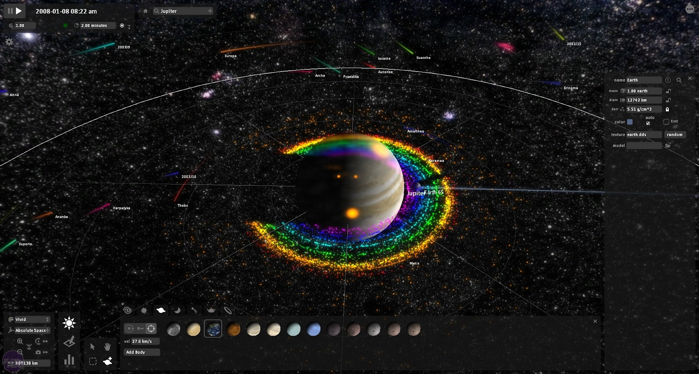
- Users can modify the mass, gravity, density of the selected body, allowing them to simulate how the orbits of other bodies would change. I will be including this In program as it is a requirement of one of the stakeholders that users would be able to modify the mass, diameter and gravity (through its density) of a body.
- Users can modify the value for G (fundamental gravitational constant). I will be including this in my program as it was a requirement of one of my stakeholders. Allowing users to modify the fundamental constant of gravity would allow them to see how different the universe would be if gravity was stronger or weaker.

A3 – Essential Features

- n-body Simulation: The program must use an n-body simulation to determine how bodies interact. The use of an n-body simulation allows for the program to account for different value of mass, diameter, etc. It also allows for custom orbital bodies to be made for the program.
- Orbital trails: The bodies orbiting the sun will show a trail behind them showing the path of their orbit. This allows users to see how the bodies orbit the sun and the paths they take from the interference of other orbital bodies.
- Information about orbital bodies. When a user selects a body they should be able to see information about the body including its mass, its radius, its density and its orbital/rotational period. This allows the user to get more of an understanding about how these quantities effect each other and the body’s interaction with other bodies.
- Time controls. The user can change the rate at which time passes as well as making time flow backwards. This allows them to see how bodies orbit each other without having to wait in real time for them to trace out a path.
- Variable manipulation. The user can change the mass, radius, density, etc. of an orbital body. This allows them to see how modifying these values effects how they interact with other orbital bodies within the solar system.
- Filters. The user can filter which types of bodies are visible. The user can select to only show planets, only show moons, etc. This allows the user to focus on the specific type of body they want to see information about without their screen being cluttered with unnecessary information.

A4 – Limitations of Proposed Solution

- The program will not include destructible planets as this is not the focus of the program despite this being a stakeholder requirement. My program is focused on teaching people/showing people how different orbital bodies interact with each other.
- The program will not include any orbital bodies except for those in the solar system. This is because my program is specifically meant to showcase the interactions of the bodies within our solar system and including other bodies would be out of the scope of this project. Despite this my program will include the ability to change the properties of the different orbital bodies.
- Ability to take photographs of the bodies on the screen. This is outside the scope of my program as my program is not focused on graphics merely the interactions between bodies within the solar system.
- Computer controlled rockets. Despite this being a stakeholder requirement I will not be including this in my program as it is not essential to showcasing the interactions of orbital bodies. Despite this however I may decide to include rockets and other space craft in orbit around the earth but I will not be including animations of the launching from earth.
- Game controller based inputs. My program is not designed to be a game and therefore there is no need to include the ability to take inputs from game controllers. Users will not be able to use any kind of analogue joystick only the keyboard and mouse.
- Planetary explorations. Despite this being a stakeholder requirement this is outside the scope of my program as my program is more tailored on the interactions between bodies rather than the specific features of the surface of a planet.
- VR interface. Despite this being a stakeholder requirement I will not be including this in my program as it is not a technical possibility with the programming language and libraries available to me. It may be possible to develop such a library to interface with a VR headset however to do so would not be possible within the allocated time period.

A5 – Computational Approach and Methods

Abstraction: An n-body simulation will be used to model the bodies, it will use newton’s equations for motion and gravity, but it will not include any models for special/general relativity. Despite the scale of the models being such that the effects of relativity would be significant, it is out of scope for this project.

Reusable components: Each body that exists in the simulation will be composed of multiple reusable components that will comprise an entity, this will be handled by an Entity Component System (ECS). Allowing for many attributes such as mass, position, velocity to be bound to an entity whilst allowing procedures (called systems) to efficiently act upon entities that have a certain composition of components.

Pipelining: Concurrency will be used for the simulation of the interaction of the bodies either through compute shaders allowing for GPU concurrency or through hardware threads on the CPU, concurrency will also be used to handle sound, a queue like system that allows for sending messages across threads called channels, will be used to send requests for certain sounds to be played. Additionally API calls will happen from a separate thread to the main application. My program will use a mix of hardware and software threads as IO bound processes such as logging, API calls and sound are most efficient within software threads whilst game logic that is performance hungry such as simulation is most efficient in hardware threads. I will be using a parallel runtime called Tokio to handle the software threads.

Caching: Caching will be used to store large data structures that could take a significant amount of time to compute, for instance the composition of the spheres for the planets will be computed at the start of the game and then stored within RAM to be used later by bodies of the same size. It is also useful to pre calculate how the light from the sun on the earth changes over time, this will then be stored in an image file that is loaded into memory upon the launch of the application.

Performance Modelling: Performance modelling will be used to see how my application performs when it is given large amounts of entities to simulate. I will be modelling the performance of the application on multiple different systems, allowing me to understand which parts might be slowing the program down on lower end machines as opposed to to higher end machines. This can in turn allow me to optimise the program to run efficiently on many different systems.

A6 – Success Criteria

- Simulate solar systems: Users must be able to simulate the solar system as well as changing certain parameters of the solar system, allowing them to understand how increasing the mass of the sun might affect the orbits of all the planets within the solar system. Justification: This requirement was outlined by one of the stakeholders and is considered to be very important as it could allow users to understand how each of the properties of the bodies within the solar system affects each other.
- Information about each body should be displayed: Users should be able to see information about the body they are currently viewing within the UI. Informations such as the mass of the planet; the average temperature; the orbital period; the rotational period; the diameter of the body; etc. Justification: This requirement is important as a stakeholder mentioned they would like to use the program for orbital calculations, whilst this program may not be accurate enough for these calculations displaying this data would allow for some simple and less accurate orbital calculations.
- Orbital based controls to visualise planets: Users can zoom in to a body and rotate their camera around a body to be able to see all parts of it. Justification: This would allow users to inspect specific parts of the body and focus on the parts of the orbital body they want to see. Users can zoom in to allow them to see specific parts of the orbital body in more detail. e.g. the user could zoom in to see the Great Red Spot on Jupiter to see the storm in more detail.
- Time warp: Users can speed up, slow down, reverse, and stop time allowing them to see where bodies are around the sun at a specific point in time. Justification: this was a requirement of one of the stakeholders as they want to be able to see where bodies might be in the future as part of their orbital calculations. This feature could be used for things such as calculating approximate times for a transfer window between two planets.
- Body selector: Users should be able to select which body they would like to view from the UI and also whether they want to view just that body or other bodies orbiting it. Justification: This requirement is necessary as without the UI containing a way to select which body to view, users would have to try to locate the body they wish to view by searching around the area of space and this is not realistic.
- Filtering objects: Users should be able to select which bodies they can see within the game. Justification this allows the user to tailor the information they are being shown to their specific use case in addition to preventing the program from doing unnecessary calculations that could slow down the program.
- Real time location of bodies: The program should use APIs to gather information about the location and orbital trajectories of bodies. Justification: This was outlined by one of the stakeholders as they would like to use the program to be able to tell when the International Space Station is passing over their home. In addition using APIs would also allow my program to dynamically update the bodies it includes. e.g. if a new satellite was sent into space the program would be able to detect it and then add the body to the game.
- Ability to export the current configuration of planets. Users can export the current configuration of the planets into a JSON format and be able to share that JSON file to other users that can then import them into the program. Justification this allows other users to create interesting scenarios that show important interactions between bodies the creator has configured.

A7 – Requirements

I will be developing my program using the Helix text editor, this text editor can run on any Linux and MacOS based Operating System. I will be using git as a version control system allowing me to revert changes that break my program and to back up my code to the cloud. I will be using github as the cloud host for my git project. Using github allows me to easily access my code from any computer and download the changes to my codebase from any location with an internet access.

Github also allows me to compile my code for MacOS, Windows and Linux targets using their workflow feature. This is helpful as I will be developing my program on a Linux based operating system meaning I will only be able to compile Linux binaries.

I have chosen to use a Linux distribution as my Operating System as it is free and open source, secure. In addition Linux has many applications easily accessible to it to help develop the program by downloading the required packages using a package manager. More specifically I will be using two Linux distributions (One on my desktop computer one on my laptop), Artix and Void Linux. Artix is an Arch Linux based distribution, meaning it is focused on rolling release and giving the user complete control over their system. This allows me to easily keep all the software on my computer up to date through the package manager, whilst simultaneously allowing me to not install any updates that would cause security issues. Artix linux differs from Arch in the fact it uses a system and service manager called runit, which is more stable and secure than the more common system manager used by arch linux called systemd. Void linux is a stand alone linux distribution meaning it was not based on any other previous distribution. Like Artix Void Linux uses the runit system manager. Void Linux also uses its own custom package manager called xbps that was developed to be the fastest package manager, however there are very few differences between Void Linux and Artix.

To run my program users will need a graphics card that supports the Vulkan graphics API (Or Metal on MacOS). They are also advised to have a dedicated graphics card as the program will be using 3d graphics as well as optionally using the GPU to run the n-body simulation that simulates the interactions of the planets.

Iterative Design

Iteration 1

D1 – Decomposition

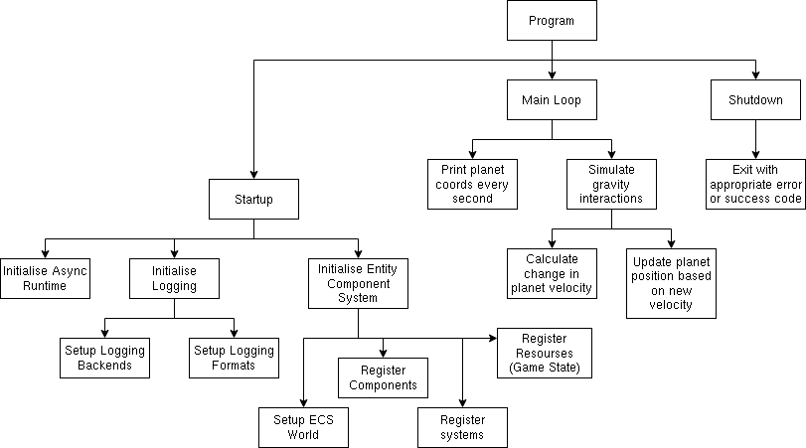

D2 – Structure of Solution

.
├── Cargo.lock
Cargo.lock contains information about the exact version of the dependencies of the programming. Cargo.lock is managed by Rust’s package manager Cargo and does not need to be manually editted
├── Cargo.toml
Cargo.toml contains the information about the dependencies of the program that allows Rust’s package manager Cargo to locate, install and compile the required version of a dependency
├── env
The env directory will contain stateful data. This is to prevent the program from adding unwanted log and config files to my home directory and can be changed using an environment variable
└── logs
The logs directory will contain all of the different log files used by the program.
└── src
The src directory contains all the source files for the program.
├── main.rs
main.rs contains the entry point for the program, the main function. This file is also where all other modules (files / sub-directories) are declared to be part of the program allowing them to be used in other modules of the program.
├── program.rs
program.rs contains the entry point for the application loop in which the Entity Component System will be initialised and the main loop started.
├── simulation
the simulation directory will contain all of the code that defines how the orbital bodies will interact with each other, it contains the necessary structure definitions used as components in the Entity Component System and the necessary Entity Component System System definitions.
│ ├── components.rs
components.rs contains all of the components used for the interaction between the orbital bodies within the simulation
│ ├── mod.rs
mod.rs is where all of the sub-modules within the simulation module are declared and made accessible to the rest of the program. It also allows for some items to be hidden fro, the main program if it is better for them to remain hidden.
│ ├── systems.rs
systems.rs is where all of the systems controlling the interaction behaviour for the Entity Component System are defined.
│ └── util.rs
util.rs is where all of the utility functions and structures for the simulation module are defined this includes the function to convert between Keplerian orbital elements and Cartesian functions
└── util.rs
util.rs is where all of the utility functions and structures for the while program are defined, this includes type aliases for the nalgebra libraries Vectors with the correct types.

D3 – Algorithms

function convertKeplerianToCartesian(a, e, w, omega, I, t0, t, M0, mu)
/* Converts Keplerian Oribit Elements into Cartesian State Vectors,
*
* Parameters (in mathematical notation):
* - a: Semi-major axis in meters
* - e: Eccentricity of orbit
* - w: (Lower case omega) Argument of periapsis (in radians)
* - omega: Longitude of ascending node (in radians)
* - t: Inclination (in radians)
* - t0: Epoch of mean anomaly (Julian date)
* - t: Considered epoch (Julian date) must be different to t0
* - M0: Mean anomaly (in radians) at epoch t0
* - mu: standard gravitational parameter, mu = G * M, where G is the
* universal gravitational constant, and M is the central body
* mass
*
* Returns the Cartesian state vectors for the orbit (position, velocity)
*/

if t == t0 then
Mt = M0
else
// Calculate the time difference, converting from Julian dates to
// seconds
dt = 86400 * (t - t0)

// Calculate the mean anomaly
Mt = M0 + dt * sqrt(mu / a ** 3)
endIf

// Solve Kepler's equation M(t) = E(t) - e * sin(E) for the anomaly E(T)
// using the Newton-Raphson method
solveIterations = 30
solutionErrorMargin = 0.0001
i = 0
E = Mt
F = E - e * sin(E) - Mt

/ Newton-Raphson iterations
while abs(F) > solutionErrorMargin and i < solveIterations do
E = E - F / (1 - e * cos(E))
F = E - e * sin(E) - Mt

i += 1
end

// Obtain the true anomaly nu(t)
nu = 2 * atan2(
sqrt(1 + e) * sin(E / 2),
sqrt(1 - e) * cos(E / 2),
)

// Use the eccentric anomaly E to get the distance to the central body
rc = a * (1 - e * cos(E))

// Obtain the position vector o in the orbital frame
// The z-axis is perpendicular to the orbital frame
// The x-axis is pointing to the periapsis of the orbit
o_x = rc * cos(nu)
o_y = rc * sin(nu)
o_z = 0

// Obtain the velocity vector odot in the orbital fram
// x and z axies are the same as above
odot_x = sqrt(mu * a) / rc * -sin(E)
odot_y = sqrt(mu * a) / rc * sqrt(1 - e*e) * math.cos(E)
odot_z = 0

// Transform o and odot to the inertial frame
r_x = o[0] * (cos(w) * cos(omega) - sin(w) * cos(i) * sin(omega)) – o[1]
* (sin(w) * cos(omega) + cos(w) * cos(i) * sin(omega))

r_y = o[0] * (cos(w) * sin(omega) + sin(w) * cos(i) * cos(omega)) – o[1]
* (cos(w) * cos(i) * cos(omega) - sin(w) * sin(omega))

r_z = o[0] * (sin(w) * sin(i)) + o[1] * (cos(w) * sin(i))

rdot_x = odot[0] * (cos(w) * cos(omega) – sin(w) * cos(i) * sin(omega))
- odot[1] * (sin(w) * cos(omega) + cos(w) * cos(i) * sin(omega))

rdot_y = odot[0] * (cos(w) * sin(omega) + sin(w) * cos(i) * cos(omega))
- odot[1] * (cos(w) * cos(i) * cos(omega) - sin(w) * sin(omega))

rdot_z = odot[0] * (sin(w) * sin(i)) + odot[1] * (cos(w) * sin(i))

return r_x, r_y, r_z, rdot_x, rdot_y, rdot_z
endFunction

procedure simulateInteractions(
positions : byRef,
velocities : byRef,
masses,
deltaT,
)
/* Simulates the interaction between all bodies
*
* Parameters:
* - positions: An array containing the positions of all orbital entities
* - velocities: An array containing the velocities of all orbital entities
* - masses: An array containing the masses of all orbital entities
* - deltaT: The time amount of time that will pass in this iteration of the
* the simulation
*
* positions, velocities and messes must be of the same lengthas the items
* contained within them at the same index correspond to components within the
* same orbital entity.
*
*/

// Universal Gravitational Constant
BIG_G = 6.6743015e-11

// Number of entities to be simulated
numEntities = positions.length

// Iterate through all permutations of entities
for i = 0 to numEntities – 1

// Initialise the resultant acceleration vector
// resultant = [0, 0, 0]
resultant_x = 0
resultant_y = 0
resultant_z = 0

// Second loop in permutations
for j = 0 to numEntities – 1
// Prevent an entity from interacting with itself
if i == j then
continue
endIf

// Simulate using Newtons law of universal gravitation
// F = G(m1 * m2 / r^2)
//
// Substituting in F = ma to find acceleration
// m1 * a = G(m1 * m2 / r^2)
// Giving
// a = G(m2 / r^2)
//
// Finally to get the accelerartion in the correct direction
// the right hand side of the equation needs to be multiplied
// by negative 1 to allow to make it accelerate towards the
// other body.
// a = -G(m2 / r^2)

// Calculate the displacement between the two bodies
// Equivalent to
// r = positions[i] - positions[j]
r_x = positions[i].x – positions[j].x
r_y = positions[i].y – positions[j].y
r_z = positions[i].z – positions[j].z

// Calculate the magnitude of the displacement squared
r_mag_squared = r_x*r_x + r_y*r_y + r_z*r_z

// Caluculate the acceleration of the body i towards the body j
a = -1 * BIG_G * masses[j] / r_mag_squared

// Calculate the magnitute frojm the magnitude squared to
// normalise the r vector
r_mag = sqrt(r_mag_squared)

// Add the acceleration to the resultant acceleration
// moving it to the correct direction in the process using
// the normalised displacement vector
// Equivalent to:
// resultant += a * normalised(r)
resultant_x += a * r_x / r_mag
resultant_y += a * r_y / r_mag
resultant_z += a * r_z / r_mag
next j

// Update the velocity of the current entity using the acceleration and the
// change in time (deltaT)
velocities[i].x += resultant_x * deltaT
velocities[i].y += resultant_y * deltaT
velocities[i].z += resultant_z * deltaT

// Update the position of the current entity using the previously calculated
// velocity and the change in time (deltaT)
positions[i].x += velocities[i].x * deltaT
positions[i].y += velocities[i].y * deltaT
positions[i].z += velocities[i].z * deltaT
next i
endProcedure

D4 – Key Variables and Data Structures Including Validation

Entites will be stored using components wich are separate objects, this is due to the nature of Rust and Entity component systems, however in the table bellow an orbital entity will be represented using one class style structure.

Attribute Name | Data Type | Description and justification
position | 3D Float Vector | Stores the position of the orbital entity within the cartesian coordinate system. This is needed to both render and simulate the orbital body as the displacment between two bodies needs to be calculated.
velocity | 3D Float Vector | Stores the velocity of the orbital entity. This is needed to simulate how the bofy propagates through space as time increases. This will be modified by the acceleration calculated during the simulation of the interactions between the bodies.
mass | Float | Stores the mass of the orbital entity. This is need to calculate the amount of force this body applies on other bodies using Netwon’s law of universal gravitation

D5 – Usability Features

D6 – Sample Data and Iteration Test

Test Name | Success criteria | Test details | Expected outcome
test_keplerian_conversion_earth | 1 and 3  (Converting bewteen methods of orbital information to be used during simulation) | Supply the function in question with the parameters:  Semi-major axis: 149.60e9  Eccentricity: 0.0167086  Argument of periapsis: 288.1 converted to radians  Longitude of ascending node: 174.9 converted to radians  Inclination of orbit 7.155 converted to radians,  The two epochs 2000.0, 2000.0  Mean anomaly: 171.1 converted to radians  Standard gravitational parameter: BIG_G * 1.9885e30 | The program will not panic verifying that the conversion fnuction has successfully converted from Keplerian Orbital Elements to Cartesian State Vectors.
test_keplerian_conversion_moon | 1 and 3  (Converting bewteen methods of orbital information to be used during simulation) | Supply the function in question with the parameters:  Semi-major axis: 384.748e6  Eccentricity: 0.0549006  Argument of periapsis: 318.15 converted to radians  Longitude of ascending node: 125.08 converted to radians  Inclination of orbit 6.4 converted to radians,  The two epochs 2000.0, 2000.0  Mean anomaly: 135.27 converted to radians  Standard gravitational parameter: BIG_G * 5.972e24 | The program will not panic verifying that the conversion fnuction has successfully converted from Keplerian Orbital Elements to Cartesian State Vectors.

D7 – Post Development Testing

D8 – Iterative Development

The first area of functionality that needs to be developed is the simulation of the planets themselves. (See structure chart in Design – Decomposition). When the user starts the program it should initialise the positions and velocities of the planets with a pre defined value that can be easily changed in later iterations. This meets success criteria one as the planets are able to be simulated with only the knowledge of their starting positions and velocity.

The planets are simulated by iterating through all of the permutations of planets and applying Newton’s equation for universal gravitation. I chose to use thos method because it was simple to implement however can be expanded upon to make it more efficient in later iterations, such as using parallelism which is implemented in a simple way in the current implementation as well as using methods that are more suited for greater numbers of bodies such as those in a galaxy due to their use of oct trees.

D13 – Prototypes

The user interface is currently logging which spits out information about each of the orbital bodies.
The position and velocity of these bodies is relative to an arbitrary point within 3D space, they are not relative to the position of the sun.

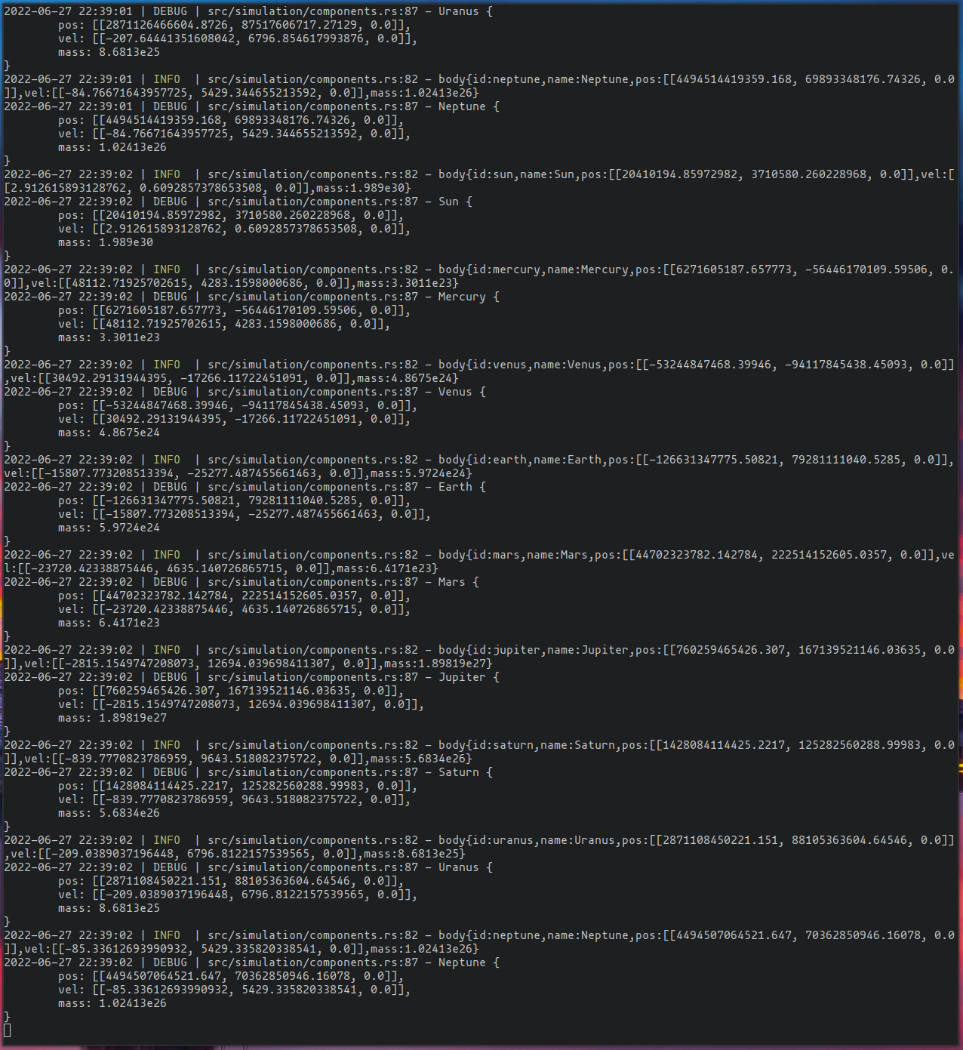

D14 – Review

Name | Platform(s) | Comments | Were they able to find the log files
Miles Ray | Windows | Miles did not have any issues running the program. He thought the log messages gave the user too much information within a short period of time, preventing the user from trying to visualise where each of the bodies liw in 3D space. | yes
Ollie McCandlish | Windows | Ollie did not have any problems running the program. He felt all the information was readable but it was hard to read all the information given to you at once before the next set of information is given to the user. | yes
Oscar Hitchcock-Smith | Windows | Oscar did not have any problems running the porgram. He felt that the coordinates were readable but it was impossible to read all of them in the time between receiving one lot and receiving the next. Oscar suggested using colour coding and spacing out the different statistics more than just the indentation I have currently implemented. Oscar also thinks that giving the coordinates of the orbital bodies relative to their parent body, (the Sun in the case of the earth) would be more useful than an arbetrary center. Oscar would also like a way to clear ogs as he found that after a few minutes of running the program the log files left would be over 10MB in size resulting in a very large file if the program was left running for too long. | yes
Kristian Dunn | Windows | Kristian was able to run the program however he encountered many security warnings that he had to bypass first to be able to run the program. Kristian found that the log messages were not readable due to their large quantity | yes
Oliver Kendall | Mac OS | Oliver was able to run the program with no issues. Oliver found that the log messages were readable however he thought the lack of units was counter-intuitive and suggested displaying some of the coordinates in km or Mm rather than just m and possibly adding an option to display fewer decimal places. | yes

In response to the comments made by my stakeholders next iteration I will be moving away from the use of logs as the interface wirth which user interact. Whilst I will still keep logs they will be fewer and farther between and will not contain information such as the position and velocities of the oribtal bodies. In response to Oscar’s comment about log files being too large, I will cretae a new log file for each run of the program and compress the logs as theprogram is running to minimise the amount of storage space they use. I wil not be making regular log messages more readable however I will use a better format for debug messages to makke them easier for the end user to read. Within the new user interface I will be following the feedback of Oliver, adding units to all information as well as limiting the number of decimal places a value is given at unless the user specififcally asks for a value with a higher precision.

D16 – Iterative testing

Test functions: (using the test feature built into Cargo)
#[test]
fn test_keplerian_conversion_earth() {
use crate::simulation::util::keplerian_to_cartesian;
use crate::util::BIG_G;

// Values from [Wikipedia](https://en.wikipedia.org/wiki/Earth's_orbit#Events)
let (earth_pos, earth_vel) = keplerian_to_cartesian(
149.60e9, // Semi-major axis
0.0167086, // Eccentricity
288.1_f64.to_radians(), // Argument of periapsis
174.9_f64.to_radians(), // Longitude of ascending node
7.155_f64.to_radians(), // inclination of orbit
2000.0, // Epoch
2000.0,
171.1_f64.to_radians(), // Mean anomaly
BIG_G * 1.9885e30, // Standard gravitational parameter
);

// The distance of the Earth from the Sun is within 30 Gm
assert!(
(earth_pos.magnitude() - 152.098_455e9).abs() < 30e6,
"Expected a distance of {}m but got {}m",
152.098_455e9,
earth_pos.magnitude() - 152.098_455e9,
);

// The speed is earth is within 10 meters of their actual value (at epoch 2000)
assert!(
(earth_vel.magnitude() - 29.29e3).abs() < 10.0,
"Expected a speed of {}ms^-1 but got {}ms^-1",
29.29e3,
earth_vel.magnitude(),
);
}

#[test]
fn test_keplerian_conversion_moon() {
use crate::simulation::util::keplerian_to_cartesian;
use crate::util::BIG_G;

// Values from [Nasa](https://ssd.jpl.nasa.gov/sats/elem/)
let (moon_pos, moon_vel) = keplerian_to_cartesian(
384.748e6, // Semi-major axis
0.0549006, // Eccentricity
318.15_f64.to_radians(), // Argument of periapsis
125.08_f64.to_radians(), // Longitude of ascending node
6.4_f64.to_radians(), // inclination of orbit
2000.0, // Epoch
2000.0,
135.27_f64.to_radians(), // Mean anomaly
BIG_G * 5.972e24, // Standard gravitational parameter
);

// The distance of the Moon from the Earth is within 4 Mm
assert!(
(moon_pos.magnitude() - 404.132e6).abs() < 4e6,
"Expected a distance of {}m but got {}m",
404.132e6,
moon_pos.magnitude(),
);

// The speed of the Moon is within 10 meters of their actual value (at epoch 2000)
assert!(
(moon_vel.magnitude() - 0.970e3).abs() < 10.0,
"Expected a speed of {}ms^-1 but got {}ms^-1",
1.022e3,
moon_vel.magnitude(),
);
}

Output from program: (using cargo test)
running 2 tests
test test::test_keplerian_conversion_earth ... ok
test test::test_keplerian_conversion_moon ... ok

test result: ok. 2 passed; 0 failed; 0 ignored; 0 measured; 0 filtered out; finished in 0.00s

D17 – Non trivial failes tests and remedies

I ran test_keplerian_conversion_earth and test_keplerian_conversion_moon. It did not return the expected result as the given speed of the Earth was 10 orders of magnitude lower than it was supposed to be (0.000004398386020349156ms⁻¹ instead of approximately 29290ms⁻¹), and the given speed of the moon was 8 orders of magnitude lower than it was supposed to be (0.000076393793192983ms⁻¹ instead of approximately 1022ms⁻¹).

The tests failed with the message:
running 2 tests
test test::test_keplerian_conversion_earth ... FAILED
test test::test_keplerian_conversion_moon ... FAILED

failures:

---- test::test_keplerian_conversion_earth stdout ----
thread 'test::test_keplerian_conversion_earth' panicked at 'Expected a speed of 29290ms^-1 but got 0.000004398386020349156ms^-1', src/test.rs:30:5
note: run with `RUST_BACKTRACE=1` environment variable to display a backtrace

---- test::test_keplerian_conversion_moon stdout ----
thread 'test::test_keplerian_conversion_moon' panicked at 'Expected a speed of 1022ms^-1 but got 0.000076393793192983ms^-1', src/test.rs:65:5

failures:
test::test_keplerian_conversion_earth
test::test_keplerian_conversion_moon

test result: FAILED. 0 passed; 2 failed; 0 ignored; 0 measured; 0 filtered out; finished in 0.00s

Apon re-reading the paper on which the algorithm was constructed from it was observed than I misread or mistyped the name of the ‘mu’ (µ) variable in the program as ‘nu’ (ν). µ is a very large number as it is the mass of the central body multiplied by the gravitational constant whereas ν is much smaller. This mistype caused a chain reaction of numbers getting smaller and smaller until resulting in the Earth moving at 4µms⁻¹

Code before:
/// # Arguments
///
/// * `a` - Semi-major axis (in meters)
/// * `e` - The eccentricity of the orbit
/// * `w` - (representing lower case omega) Argument of periapsis (in radians)
/// * `omega` - Longitude of ascending node (in radians)
/// * `i` - inclination of orbit (in radians)
/// * `t0` - Epoch of mean anomaly (in Julian date)
/// * `t` - Considered epoch (in Julian date)
/// * `m0` - Mean anomaly at epoch `t0` (in radians)
/// * `mu` - Standard gravitational parameter, mu = G * M where G is the Universal Gravitational
/// Constant and M is the central body mass
///
pub fn keplerian_to_cartesian(
a: f64,
e: f64,
w: f64,
omega: f64,
i: f64,
t0: f64,
t: f64,
m0: f64,
mu: f64,
) -> (Vec3, Vec3) {
let mt = if t == t0 {
m0
} else {
// Calculate the time difference, converting from Julian date to seconds
let dt = 86400.0 * (t - t0);

// Calculate the mean anomaly
m0 + dt * (mu / a.powi(3)).sqrt()
};

// Solve Kepler's equation M(t) = E(t) - e * sin(E) for the eccentric anomaly `big_e`
// using the Netwon-Raphson method

// Maximum iterations
const NEWTON_RAPHSON_ITERATIONS: usize = 30;
// Error margin
const ERROR_MARGIN: f64 = 0.0001;

// Initialise variables
let mut j = 0;
let mut big_e = mt;
let mut big_f = big_e - e * big_e.sin() - mt;

// Perform Newton-Raphson iterations, exiting after a maximum number of iterations
// or if the error margin becomes small enough
while big_f.abs() > ERROR_MARGIN && j < NEWTON_RAPHSON_ITERATIONS {
big_e -= big_f / (1.0 - e * big_e.cos());
big_f = big_e - e * big_e.sin() - mt;

j += 1
}

// Calculate the true anomaly `nu`
let nu = 2.0
* f64::atan2(
(1.0 + e).sqrt() * (big_e / 2.0).sin(),
(1.0 - e).sqrt() * (big_e / 2.0).cos(),
);

// Use the eccentric anomaly `big_e` to get the distance to the central body
let rc = a * (1.0 - e * big_e.cos());

// Obtain the position vector `o` in the oribtal frame
// - The z-axis is perpendicular to the orbital frame
// - The x-axis is pointing to the periapsis of the orbit
let o = rc * Vec3::new(nu.cos(), nu.sin(), 0.0);

// Obtain the velocity vector `o_dot` in the same orbital frame
// - The x and z axis are the same as above
let o_dot =
(nu * a).sqrt() / rc * Vec3::new(-big_e.sin(), (1.0 - e * e).sqrt() * big_e.cos(), 0.0);

// Transform `o` and `o_dot` to the inertial frame in bodycentric regular
// coordinates `r` and `r_dot`
let r = Vec3::new(
o.x * (w.cos() * omega.cos() - w.sin() * i.cos() * omega.sin())
- o.y * (w.sin() * omega.cos() + w.cos() * i.cos() * omega.sin()),
o.x * (w.cos() * omega.sin() + w.sin() * i.cos() * omega.cos())
- o.y * (w.cos() * i.cos() * omega.cos() - w.sin() * omega.sin()),
o.x * (w.sin() * i.sin()) + o.y * (w.cos() * i.sin()),
);

let r_dot = Vec3::new(
o_dot.x * (w.cos() * omega.cos() - w.sin() * i.cos() * omega.sin())
- o_dot.y * (w.sin() * omega.cos() + w.cos() * i.cos() * omega.sin()),
o_dot.x * (w.cos() * omega.sin() + w.sin() * i.cos() * omega.cos())
- o_dot.y * (w.cos() * i.cos() * omega.cos() - w.sin() * omega.sin()),
o_dot.x * (w.sin() * i.sin()) + o_dot.y * (w.cos() * i.sin()),
);

// Return the resulting cartesian state vectors
(r, r_dot)
}

Code after:
/// # Arguments
///
/// * `a` - Semi-major axis (in meters)
/// * `e` - The eccentricity of the orbit
/// * `w` - (representing lower case omega) Argument of periapsis (in radians)
/// * `omega` - Longitude of ascending node (in radians)
/// * `i` - inclination of orbit (in radians)
/// * `t0` - Epoch of mean anomaly (in Julian date)
/// * `t` - Considered epoch (in Julian date)
/// * `m0` - Mean anomaly at epoch `t0` (in radians)
/// * `mu` - Standard gravitational parameter, mu = G * M where G is the Universal Gravitational
/// Constant and M is the central body mass
///
pub fn keplerian_to_cartesian(
a: f64,
e: f64,
w: f64,
omega: f64,
i: f64,
t0: f64,
t: f64,
m0: f64,
mu: f64,
) -> (Vec3, Vec3) {
let mt = if t == t0 {
m0
} else {
// Calculate the time difference, converting from Julian date to seconds
let dt = 86400.0 * (t - t0);

// Calculate the mean anomaly
m0 + dt * (mu / a.powi(3)).sqrt()
};

// Solve Kepler's equation M(t) = E(t) - e * sin(E) for the eccentric anomaly `big_e`
// using the Netwon-Raphson method

// Maximum iterations
const NEWTON_RAPHSON_ITERATIONS: usize = 30;
// Error margin
const ERROR_MARGIN: f64 = 0.0001;

// Initialise variables
let mut j = 0;
let mut big_e = mt;
let mut big_f = big_e - e * big_e.sin() - mt;

// Perform Newton-Raphson iterations, exiting after a maximum number of iterations
// or if the error margin becomes small enough
while j < NEWTON_RAPHSON_ITERATIONS {
big_e -= big_f / (1.0 - e * big_e.cos());
big_f = big_e - e * big_e.sin() - mt;

j += 1
}

// Calculate the true anomaly `nu`
let nu = 2.0
* f64::atan2(
(1.0 + e).sqrt() * (big_e / 2.0).sin(),
(1.0 - e).sqrt() * (big_e / 2.0).cos(),
);

// Use the eccentric anomaly `big_e` to get the distance to the central body
let rc = a * (1.0 - e * big_e.cos());

// Obtain the position vector `o` in the oribtal frame
// - The z-axis is perpendicular to the orbital frame
// - The x-axis is pointing to the periapsis of the orbit
let o = rc * Vec3::new(nu.cos(), nu.sin(), 0.0);

// Obtain the velocity vector `o_dot` in the same orbital frame
// - The x and z axis are the same as above
let o_dot =
(mu * a).sqrt() / rc * Vec3::new(-big_e.sin(), (1.0 - e * e).sqrt() *
// ^ This variable name was `nu` Casusing significantly lower velocities
// Than expected
big_e.cos(), 0.0);

// Transform `o` and `o_dot` to the inertial frame in bodycentric regular
// coordinates `r` and `r_dot`
let r = Vec3::new(
o.x * (w.cos() * omega.cos() - w.sin() * i.cos() * omega.sin())
- o.y * (w.sin() * omega.cos() + w.cos() * i.cos() * omega.sin()),
o.x * (w.cos() * omega.sin() + w.sin() * i.cos() * omega.cos())
+ o.y * (w.cos() * i.cos() * omega.cos() - w.sin() * omega.sin()),
o.x * (w.sin() * i.sin()) + o.y * (w.cos() * i.sin()),
);

let r_dot = Vec3::new(
o_dot.x * (w.cos() * omega.cos() - w.sin() * i.cos() * omega.sin())
- o_dot.y * (w.sin() * omega.cos() + w.cos() * i.cos() * omega.sin()),
o_dot.x * (w.cos() * omega.sin() + w.sin() * i.cos() * omega.cos())
+ o_dot.y * (w.cos() * i.cos() * omega.cos() - w.sin() * omega.sin()),
o_dot.x * (w.sin() * i.sin()) + o_dot.y * (w.cos() * i.sin()),
);

// Return the resulting cartesian state vectors
(r, r_dot)
}

Appendix A - Full Code of Solution
::::::::::::::
src/args.rs
::::::::::::::
use clap::Parser;
use log::LevelFilter;

#[derive(Parser, Debug)]
#[clap(author, version)]
pub struct Args {
#[clap(short = 'l', long = "log-level", default_value_t = LevelFilter::Trace)]
pub max_log_level: LevelFilter,
3
#[clap(short = 'n', long = "no-log-files")]
pub no_log_files: bool,
}
::::::::::::::
src/main.rs
::::::::::::::
mod args;
mod program;
mod simulation;
mod test;
mod util;

#[macro_use]
extern crate lazy_static;

#[macro_use]
extern crate clap;

use anyhow::Result as AnyResult;
use log::{debug, error, info, trace, warn, LevelFilter};
use log4rs::{
append::{
console::{ConsoleAppender, Target},
file::FileAppender,
},
config::{Appender, Config as LogConfig, Root},
encode::pattern::PatternEncoder,
filter::threshold::ThresholdFilter,
};
use std::{env, path::PathBuf};

use crate::args::Args;
use clap::Parser;

const APPLICATION_NAME: &'static str = crate_name!();
const APPLICATION_AUTHOR: &'static str = crate_authors!();
const APPLICATION_VERSION: &'static str = crate_version!();

lazy_static! {
pub static ref LOG_DIR: PathBuf = {
// Check for the environment variable declaring the log directory
let log_dir = env::var("SS_LOG_DIR").map(|v| PathBuf::from(v.as_str()));

// If the log directory environment variable is not found use a default
// location

// On linux check for the $XDG_STATE_HOME environment variable first,
// if not found then coose the default location for $XDG_STATE_HOME
// at /home/<user>/.local/state
#[cfg(target_family = "unix")]
let log_dir = log_dir
.or(env::var("XDG_STATE_HOME")
.map(|v| PathBuf::from(v.as_str()))
.map(|v| v.join(APPLICATION_NAME).join("logs")))
.or(env::var("HOME")
.map(|v| PathBuf::from(v.as_str()))
.map(|v| {
v.join(".local")
.join("state")
.join(APPLICATION_NAME)
.join("logs")
}))
.expect("Failed to load log directory, no $HOME set");

// On Windows check for the %appdata% environment variable
#[cfg(target_family = "windows")]
let log_dir = log_dir
.or(env::var("appdata")
.map(|v| PathBuf::from(v.as_str()))
.map(|v| v.join(APPLICATION_NAME).join("logs")))
.expect("Failed to load log directory, no %AppData% set");

log_dir
};
}

fn main() -> AnyResult<()> {
let args = Args::parse();

// Only log when level is lower than or equal to Info when in release mode
let stdout_level = if cfg!(debug_assertions) {
LevelFilter::Trace.min(args.max_log_level)
} else {
LevelFilter::Info.min(args.max_log_level)
};

// Define the maximum log level for the log file,
// Debug and Trace logs are unwanted
let file_level = LevelFilter::Info;

// Get the log directory and define the locations of the logs files
let log_file = LOG_DIR.join("main.log");

// Debug log file is disabled in release mode
#[cfg(debug_assertions)]
let debug_log_file = LOG_DIR.join("debug.log");

// Define the pattern for logs in the log file, This includes all possible
// information to enable for easier debugging
let log_file_pattern = "{d} {P}:{i}:{I} {T} {M} {f}:{L} {l} - {m}{n}";

// Define the pattern for logs printed to Stdout, this is a more human
// readable format
let stdout_pattern = "{d(%Y-%m-%d %H:%M:%S)} | {h({l}):5.5} | {f}:{L} - {m}{n}";

// Define the appenders that tell the logger where to send messages.
// The logs are printed to Stdout in a readable format, a log file
// called main.log in a format that contains more information and
// in debug mode logs from Stdout are also added to a log file called
// debug.log
let stdout = ConsoleAppender::builder()
.encoder(Box::new(PatternEncoder::new(&stdout_pattern)))
.target(Target::Stdout)
.build();

let log_file = FileAppender::builder()
.encoder(Box::new(PatternEncoder::new(&log_file_pattern)))
.build(log_file)?;

// Debug log file is disabed in release mode
#[cfg(debug_assertions)]
let debug_log_file = FileAppender::builder()
.encoder(Box::new(PatternEncoder::new(&stdout_pattern)))
.build(debug_log_file)?;

// Define the config for the logger
let log_config = {
// Add the appenders that tell the logger how to log messages
// into the config.
let builder = LogConfig::builder().appender(
Appender::builder()
.filter(Box::new(ThresholdFilter::new(stdout_level)))
.build("stdout", Box::new(stdout)),
);

// Disable log files if specified in the Command-line arguments
let builder = if args.no_log_files {
builder
} else {
let builder = builder.appender(
Appender::builder()
.filter(Box::new(ThresholdFilter::new(file_level)))
.build("logfile", Box::new(log_file)),
);
// Disable the Debug log file if running in release
#[cfg(debug_assertions)]
let builder = builder.appender(
Appender::builder()
.filter(Box::new(ThresholdFilter::new(LevelFilter::Trace)))
.build("debugfile", Box::new(debug_log_file)),
);

builder
};

// Tell the logger which appenders to use when logging. The 'debugfile'
// logs that are logged to a file called debug.log is not included
// when the program is running in release mode
let root_builder = Root::builder().appender("stdout").appender("logfile");

// Do not include the debug log file as an appender in release mode
#[cfg(debug_assertions)]
let root_builder = root_builder.appender("debugfile");

// Build the config
builder
.build(root_builder.build(LevelFilter::Trace))
.unwrap()
};

// Initialise the logger with the previously declared config
let _handle = log4rs::init_config(log_config).unwrap();

// Logs use the 'trace', 'debug', 'info', 'warn' and 'error' macros.
// Corresponding to their repective log levels
info!("-------- Program started -------");
info!("Logging initialised");

// Declare if running in debug mode
#[cfg(debug_assertions)]
info!("Running in debug mode");

// The program ran successfully
program::run()
}
::::::::::::::
src/program.rs
::::::::::::::
use anyhow::Result as AnyResult;
use specs::{DispatcherBuilder, World, WorldExt};
use tokio::time;

use crate::simulation::{
DeltaTime, Identifier, Mass, Position, Printer, Simulator, Velocity, PLANET_EARTH,
PLANET_JUPITER, PLANET_MARS, PLANET_MERCURY, PLANET_NEPTUNE, PLANET_SATURN, PLANET_URANUS,
PLANET_VENUS, SUN,
};

pub fn run() -> AnyResult<()> {
// Create the 'world', a container for the components and other
// resources used by the entities
let mut world = World::new();
world.register::<Identifier>();
world.register::<Position>();
world.register::<Velocity>();
world.register::<Mass>();

// Register the Sun and all the planets as entities
SUN.register_entity(&mut world);
PLANET_MERCURY.register_entity(&mut world);
PLANET_VENUS.register_entity(&mut world);
PLANET_EARTH.register_entity(&mut world);
PLANET_MARS.register_entity(&mut world);
PLANET_JUPITER.register_entity(&mut world);
PLANET_SATURN.register_entity(&mut world);
PLANET_URANUS.register_entity(&mut world);
PLANET_NEPTUNE.register_entity(&mut world);

//Initialise the dispatchers for the ECS Systsmes
let mut simulation_dispatcher = DispatcherBuilder::new()
.with(Simulator::new(), "sys_simulator", &[])
.build();

let mut print_dispatcher = DispatcherBuilder::new()
.with(Printer::new(), "sys_printer", &[])
.build();

// Call the print dispatcher
print_dispatcher.dispatch(&mut world);

// Setup a new async runtime throwing an error if it did not
let runtime = tokio::runtime::Builder::new_current_thread()
.enable_all()
.build()?;

// Start the aysnc runtime blocking the current thread
runtime.block_on(async {
// The number of frames per second
const FRAME_RATE: f64 = 60.0;
// The number of iterations of the simulation to do per frame
// The higher the number the more accurate the simulation
const NUM_ITERATIONS_PER_FRAME: usize = 60;

const SIMULATION_SECONDS_PER_SECOND: f64 = (60 * 60 * 24) as f64;

// Add the delta time into the ECS world
world.insert(DeltaTime(SIMULATION_SECONDS_PER_SECOND));

// Initialise the intervals at which to run a new frame
let mut frame_interval = time::interval(time::Duration::from_secs_f64(1.0 / FRAME_RATE));
let mut start_time = time::Instant::now();

let mut frame_count = 0;

// Start the program loop
loop {
// Wait until a new frame is needed
frame_interval.tick().await;

// Calculate the time since the last frame was used
let now = time::Instant::now();
let dt = (now - start_time).as_secs_f64();
start_time = now;

// Update the delta time resource within the ECS world
{
let delta_time: &mut DeltaTime = world.get_mut().unwrap();

delta_time.0 = dt * SIMULATION_SECONDS_PER_SECOND / NUM_ITERATIONS_PER_FRAME as f64;
}

// Run the simulation the number of times specified
(0..NUM_ITERATIONS_PER_FRAME)
.into_iter()
.for_each(|_| simulation_dispatcher.dispatch(&mut world));

// Increment the fram count
frame_count += 1;

// If FRAME_COUNT number of frames have passed then print the information
// about each body
if frame_count % FRAME_RATE as u64 == 0 {
print_dispatcher.dispatch(&world);
}
}
});

// At the end of the program print the final locations of the bodies
print_dispatcher.dispatch(&mut world);

// Exit telling the calling scope that it ran successfully
Ok(())
}
::::::::::::::
src/simulation/components.rs
::::::::::::::
use log::{debug, info};
use specs::{Component, Join, ReadStorage, System, VecStorage};

use crate::util::Vec3;

// The position of an entity
#[derive(Debug, Clone, Copy)]
pub struct Position(pub Vec3);
impl From<Vec3> for Position {
fn from(v: Vec3) -> Self {
Self(v)
}
}
impl Component for Position {
type Storage = VecStorage<Self>;
}

// The velocity of an entity
#[derive(Debug, Clone, Copy)]
pub struct Velocity(pub Vec3);
impl From<Vec3> for Velocity {
fn from(v: Vec3) -> Self {
Self(v)
}
}
impl Component for Velocity {
type Storage = VecStorage<Self>;
}

// The mass of an entity
#[derive(Debug, Clone, Copy)]
pub struct Mass(pub f64);
impl From<f64> for Mass {
fn from(m: f64) -> Self {
Self(m)
}
}
impl Component for Mass {
type Storage = VecStorage<Self>;
}

// The Identifier and name of an entity
#[derive(Debug, Clone)]
pub struct Identifier {
id: String,
name: String,
}
impl Identifier {
pub fn new(id: String, name: String) -> Self {
Self { id, name }
}

pub fn get_id(&self) -> &str {
self.id.as_str()
}

pub fn get_name(&self) -> &str {
self.name.as_str()
}
}
impl Component for Identifier {
type Storage = VecStorage<Self>;
}

// The delta time container struct
#[derive(Default, Copy, Clone)]
pub struct DeltaTime(pub f64);

pub struct Printer;
impl Printer {
pub fn new() -> Self {
Self {}
}
}
impl<'a> System<'a> for Printer {
type SystemData = (
ReadStorage<'a, Identifier>,
ReadStorage<'a, Position>,
ReadStorage<'a, Velocity>,
ReadStorage<'a, Mass>,
);

fn run(&mut self, (id, positions, velocities, mass): Self::SystemData) {
// Iterate over every entity
(&id, &positions, &velocities, &mass)
.join()
.for_each(|(id, pos, vel, mass)| {
// Print the entity's id, name, pos, vel and mass as an informational log
info!(
"body{{id:{},name:{},pos:{:?},vel:{:?},mass:{:?}}}",
id.id, id.name, pos.0, vel.0, mass.0,
);

// Print the entity's name, pos, vel and mass as a debug log
debug!(
"{} {{\n\tpos: {:?},\n\tvel: {:?},\n\tmass: {:?}\n}}",
id.name, pos.0, vel.0, mass.0,
);
});
}
}
::::::::::::::
src/simulation/mod.rs
::::::::::::::
mod components;
mod planets;
mod simulator;
pub mod util;

pub use components::{DeltaTime, Identifier, Mass, Position, Printer, Velocity};
pub use planets::*;
pub use simulator::Simulator;
::::::::::::::
src/simulation/planets.rs
::::::::::::::
use specs::{Builder, Entity, World, WorldExt};

use super::{Identifier, Mass, Position, Velocity};
use crate::util::Vec3;

// A structure to contain the information about an orbital body
pub struct OrbitalBody {
id: &'static str,
name: &'static str,
initial_pos: [f64; 3],
initial_vel: [f64; 3],
mass: f64,
}
impl OrbitalBody {
pub fn get_pos(&self) -> Position {
Position::from(Vec3::from(self.initial_pos))
}

pub fn get_vel(&self) -> Velocity {
Velocity::from(Vec3::from(self.initial_vel))
}

pub fn get_mass(&self) -> Mass {
Mass::from(self.mass)
}

pub fn get_identifier(&self) -> Identifier {
Identifier::new(self.id.to_string(), self.name.to_string())
}

pub fn register_entity(&self, world: &mut World) -> Entity {
// Register the entity into the ECS world
world
.create_entity()
.with(self.get_identifier())
.with(self.get_pos())
.with(self.get_vel())
.with(self.get_mass())
.build()
}
}

// The hardcoded initial positions for each planet and the sun
// In later iterations these values will be calculated using
// data gathered about the orbits of these planets
pub const SUN: OrbitalBody = OrbitalBody {
id: "sun",
name: "Sun",
initial_pos: [0.0, 0.0, 0.0],
initial_vel: [0.0, 0.0, 0.0],
mass: 1.989e30,
};

pub const PLANET_MERCURY: OrbitalBody = OrbitalBody {
id: "mercury",
name: "Mercury",
initial_pos: [57.909e9, 0.0, 0.0],
initial_vel: [0.0, 47.36e3, 0.0],
mass: 0.33011e24,
};

pub const PLANET_VENUS: OrbitalBody = OrbitalBody {
id: "venus",
name: "Venus",
initial_pos: [108.209e9, 0.0, 0.0],
initial_vel: [0.0, 35.02e3, 0.0],
mass: 4.8675e24,
};

pub const PLANET_EARTH: OrbitalBody = OrbitalBody {
id: "earth",
name: "Earth",
initial_pos: [149.596e9, 0.0, 0.0],
initial_vel: [0.0, 29.78e3, 0.0],
mass: 5.9724e24,
};

pub const PLANET_MARS: OrbitalBody = OrbitalBody {
id: "mars",
name: "Mars",
initial_pos: [227.923e9, 0.0, 0.0],
initial_vel: [0.0, 24.07e3, 0.0],
mass: 0.64171e24,
};

pub const PLANET_JUPITER: OrbitalBody = OrbitalBody {
id: "jupiter",
name: "Jupiter",
initial_pos: [778.570e9, 0.0, 0.0],
initial_vel: [0.0, 13e3, 0.0],
mass: 1898.19e24,
};

pub const PLANET_SATURN: OrbitalBody = OrbitalBody {
id: "saturn",
name: "Saturn",
initial_pos: [1433.529e9, 0.0, 0.0],
initial_vel: [0.0, 9.68e3, 0.0],
mass: 568.34e24,
};

pub const PLANET_URANUS: OrbitalBody = OrbitalBody {
id: "uranus",
name: "Uranus",
initial_pos: [2872.463e9, 0.0, 0.0],
initial_vel: [0.0, 6.80e3, 0.0],
mass: 86.813e24,
};

pub const PLANET_NEPTUNE: OrbitalBody = OrbitalBody {
id: "neptune",
name: "Neptune",
initial_pos: [4495.060e9, 0.0, 0.0],
initial_vel: [0.0, 5.43e3, 0.0],
mass: 102.413e24,
};
::::::::::::::
src/simulation/simulator.rs
::::::::::::::
use log::debug;
use rayon::prelude::*;
use specs::{Entities, Join, ParJoin, Read, ReadStorage, System, WriteStorage};

use crate::util::{Vec3, BIG_G};

use super::{components::DeltaTime, Mass, Position, Velocity};

pub struct Simulator;
impl Simulator {
pub fn new() -> Self {
Self {}
}
}
impl<'a> System<'a> for Simulator {
type SystemData = (
WriteStorage<'a, Position>,
WriteStorage<'a, Velocity>,
ReadStorage<'a, Mass>,
Read<'a, DeltaTime>,
Entities<'a>,
);

fn run(&mut self, (mut positions, mut velocities, mass, dt, entities): Self::SystemData) {
// Iterate over every entity in parallel
(&entities, &positions, &mut velocities)
.par_join()
.for_each(|(e, pos, mut vel)| {
// Get a resultant acceleration using iterators
let resultant = (&entities, &positions, &mass)
.join()
// Make sure the body does not try to interact with itself
.filter(|(o, _pos, _mass)| e.id() != o.id())
.map(|(o, other, mass)| {
// Displacement from one body to the other
let r = other.0 - pos.0;

// Apply Newton's equation for universal gravitation
// The equation has been manipulated
// F = m1 * a
// F = G * m1 * m2 / |r|^2
// m1 * a = G * m1 * m2 / |r|^2
// a = G * m2 / |r|^2
let a = BIG_G * mass.0 / r.magnitude_squared();

// Get the direction of the other body from this
// And project the acceleration into that direction
a * r.normalize()
})
.reduce(|a, b| a + b);

// Apply the resultant acceleration to the velocity
if let Some(resultant) = resultant {
vel.0 += resultant * dt.0;
}
});

// Apply the velocity to the position
(&mut positions, &velocities)
.par_join()
.for_each(|(mut pos, vel)| {
pos.0 += vel.0 * dt.0;
});
}
}
::::::::::::::
src/simulation/util.rs
::::::::::::::
use crate::util::Vec3;

/// Returns Cartesian State Vectors converted from the given Keplerian
/// Orbital Elements
///
/// Based on the algorithm outline in
/// [this](https://downloads.rene-schwarz.com/download/M001-Keplerian_Orbit_Elements_to_Cartesian_State_Vectors.pdf)
/// paper by René Schwarz.
///
/// # Arguments
///
/// * `a` - Semi-major axis (in meters)
/// * `e` - The eccentricity of the orbit
/// * `w` - (representing lower case omega) Argument of periapsis (in radians)
/// * `omega` - Longitude of ascending node (in radians)
/// * `i` - inclination of orbit (in radians)
/// * `t0` - Epoch of mean anomaly (in Julian date)
/// * `t` - Considered epoch (in Julian date)
/// * `m0` - Mean anomaly at epoch `t0` (in radians)
/// * `mu` - Standard gravitational parameter, mu = G * M where G is the Universal Gravitational
/// Constant and M is the central body mass
///
pub fn keplerian_to_cartesian(
a: f64,
e: f64,
w: f64,
omega: f64,
i: f64,
t0: f64,
t: f64,
m0: f64,
mu: f64,
) -> (Vec3, Vec3) {
let mt = if t == t0 {
m0
} else {
// Calculate the time difference, converting from Julian date to seconds
let dt = 86400.0 * (t - t0);

// Calculate the mean anomaly
m0 + dt * (mu / a.powi(3)).sqrt()
};

// Solve Kepler's equation M(t) = E(t) - e * sin(E) for the eccentric anomaly `big_e`
// using the Netwon-Raphson method

// Maximum iterations
const NEWTON_RAPHSON_ITERATIONS: usize = 30;
// Error margin
const ERROR_MARGIN: f64 = 0.0001;

// Initialise variables
let mut j = 0;
let mut big_e = mt;
let mut big_f = big_e - e * big_e.sin() - mt;

// Perform Newton-Raphson iterations, exiting after a maximum number of iterations
// or if the error margin becomes small enough
while j < NEWTON_RAPHSON_ITERATIONS {
big_e -= big_f / (1.0 - e * big_e.cos());
big_f = big_e - e * big_e.sin() - mt;

j += 1
}

// Calculate the true anomaly `nu`
let nu = 2.0
* f64::atan2(
(1.0 + e).sqrt() * (big_e / 2.0).sin(),
(1.0 - e).sqrt() * (big_e / 2.0).cos(),
);

// Use the eccentric anomaly `big_e` to get the distance to the central body
let rc = a * (1.0 - e * big_e.cos());

// Obtain the position vector `o` in the oribtal frame
// - The z-axis is perpendicular to the orbital frame
// - The x-axis is pointing to the periapsis of the orbit
let o = rc * Vec3::new(nu.cos(), nu.sin(), 0.0);

// Obtain the velocity vector `o_dot` in the same orbital frame
// - The x and z axis are the same as above
let o_dot =
(mu * a).sqrt() / rc * Vec3::new(-big_e.sin(), (1.0 - e * e).sqrt() * big_e.cos(), 0.0);

// Transform `o` and `o_dot` to the inertial frame in bodycentric regular
// coordinates `r` and `r_dot`
let r = Vec3::new(
o.x * (w.cos() * omega.cos() - w.sin() * i.cos() * omega.sin())
- o.y * (w.sin() * omega.cos() + w.cos() * i.cos() * omega.sin()),
o.x * (w.cos() * omega.sin() + w.sin() * i.cos() * omega.cos())
+ o.y * (w.cos() * i.cos() * omega.cos() - w.sin() * omega.sin()),
o.x * (w.sin() * i.sin()) + o.y * (w.cos() * i.sin()),
);

let r_dot = Vec3::new(
o_dot.x * (w.cos() * omega.cos() - w.sin() * i.cos() * omega.sin())
- o_dot.y * (w.sin() * omega.cos() + w.cos() * i.cos() * omega.sin()),
o_dot.x * (w.cos() * omega.sin() + w.sin() * i.cos() * omega.cos())
+ o_dot.y * (w.cos() * i.cos() * omega.cos() - w.sin() * omega.sin()),
o_dot.x * (w.sin() * i.sin()) + o_dot.y * (w.cos() * i.sin()),
);

// Return the resulting cartesian state vectors
(r, r_dot)
}
::::::::::::::
src/test.rs
::::::::::::::
#![cfg(test)]

#[test]
fn test_keplerian_conversion_earth() {
use crate::simulation::util::keplerian_to_cartesian;
use crate::util::BIG_G;

// Values from [Wikipedia](https://en.wikipedia.org/wiki/Earth's_orbit#Events)
let (earth_pos, earth_vel) = keplerian_to_cartesian(
149.60e9, // Semi-major axis
0.0167086, // Eccentricity
288.1_f64.to_radians(), // Argument of periapsis
174.9_f64.to_radians(), // Longitude of ascending node
7.155_f64.to_radians(), // inclination of orbit
2000.0, // Epoch
2000.0,
171.1_f64.to_radians(), // Mean anomaly
BIG_G * 1.9885e30, // Standard gravitational parameter
);

// The distance of the Earth from the Sun is within 30 Gm
assert!(
(earth_pos.magnitude() - 152.098_455e9).abs() < 30e6,
"Expected a distance of {}m but got {}m",
152.098_455e9,
earth_pos.magnitude() - 152.098_455e9,
);

// The speed is earth is within 10 meters of their actual value (at epoch 2000)
assert!(
(earth_vel.magnitude() - 29.29e3).abs() < 10.0,
"Expected a speed of {}ms^-1 but got {}ms^-1",
29.29e3,
earth_vel.magnitude(),
);
}

#[test]
fn test_keplerian_conversion_moon() {
use crate::simulation::util::keplerian_to_cartesian;
use crate::util::BIG_G;

// Values from [Nasa](https://ssd.jpl.nasa.gov/sats/elem/)
let (moon_pos, moon_vel) = keplerian_to_cartesian(
384.748e6, // Semi-major axis
0.0549006, // Eccentricity
318.15_f64.to_radians(), // Argument of periapsis
125.08_f64.to_radians(), // Longitude of ascending node
6.4_f64.to_radians(), // inclination of orbit
2000.0, // Epoch
2000.0,
135.27_f64.to_radians(), // Mean anomaly
BIG_G * 5.972e24, // Standard gravitational parameter
);

// The distance of the Moon from the Earth is within 4 Mm
assert!(
(moon_pos.magnitude() - 404.132e6).abs() < 4e6,
"Expected a distance of {}m but got {}m",
404.132e6,
moon_pos.magnitude(),
);

// The speed of the Moon is within 10 meters of their actual value (at epoch 2000)
assert!(
(moon_vel.magnitude() - 0.970e3).abs() < 10.0,
"Expected a speed of {}ms^-1 but got {}ms^-1",
1.022e3,
moon_vel.magnitude(),
);
}
::::::::::::::
src/util.rs
::::::::::::::
use nalgebra::{Vector2, Vector3};

pub const BIG_G: f64 = 6.6743015e-11;

pub type Vec2 = Vector2<f64>;
pub type Vec3 = Vector3<f64>;

