DIGITALIZATION AND ARCHIVAL SYSTEM USING BARCODE SCANNER FOR BAZE UNIVERSITY

Project Submitted in Partial Fulfillment of the Requirement

For the Degree of

B.Sc.

In

Computer Science [Software Engineering]

By

AISHA DAHIRU SHETTIMA

To

The Department of Computer Science

Baze University, Abuja

[Month, Year]

**DECLARATION**

This is to certify that this Thesis entitled DIGITALIZATION AND ARCHIVAL SYSTEM USING BARCODE SCANNER FOR BAZE UNIVERSITY, which is submitted by AISHA DAHIRU SHETTIMA in partial fulfilment of the requirement for the award of degree for B.Sc. in Software Engineering to the Department of Computer Science, Baze University Abuja, Nigeria, comprises of only my original work and due acknowledgement has been made in the text to all other materials used.

Date: [Date Month Year] Name of Student: [Your Name]

**APPROVED BY**  …………………

**HOD**

Dept. of Computer Science

**CERTIFICATION**

This is to certify that this Thesis entitled DIGITALIZATION AND ARCHIVAL SYSTEM USING BARCODE SCANNER FOR BAZE UNIVERSITY, which is submitted by AISHA DAHIRU SHETTIMA in partial fulfilment of the requirement for the award of degree for B.Sc. in Software Engineering to the Department of Computer Science, Baze University Abuja, Nigeria is a record of the candidate’s own work carried out by the candidate under my/our supervision. The matter embodied in this thesis is original and has not been submitted for the award of any other degree.

Date: Supervisor:

**APPROVAL**

This is to certify that the research work, Dental Management System and the subsequent preparation by AISHA DAHIRU SHETTIMA with BU/22B/IT/6789 has been approved by the Department of Computer Science, Faculty of Computing and Applied Science, Baze University, Abuja, Nigeria.

By

|  |  |
| --- | --- |
| [Full name]  Supervisor | Date |
| Dr. C. V Uppin  Head of Department | Date |
| Prof Peter Ogedebe  Dean, Faculty of Computing and Applied Science | Date |
| Prof. Choji Davou nyap External Examiner | Date |

**DEDICATION**

[This is the dedication page.]

**ABSTRACT**

[The abstract provides a clear summary of the project, indicating both content and tone of the project. An abstract includes the method(s) used to analyze the problem, a brief description of the research design, a listing of the key results, a brief description of the significance of the results, selected key conclusions. First-person narrative should not be used in the abstract.]

**TABLE OF CONTENTS**

**ABSTRACT VI**

**LIST OF TABLES….……………………………………….…………………………………………………………….IX**

**LIST OF FIGURES………………………………..….…………………………………...…………………………......X**

**LIST OF ABBREVIATIONS……..……………………….……………...……………………………………….....XI**

**CHAPTER 1: INTRODUCTION 1**

1.1 OVERVIEW 1

1.2 BACKGROUND AND MOTIVATION 1

1.3 STATEMENT OF THE PROBLEM 2

1.4 AIM AND OBJECTIVES 2

1.5 SIGNIFICANCE OF THE PROJECT 2

1.6 PROJECT RISKS ASSESSMENT 3

1.7 SCOPE/PROJECT ORGANIZATION 4

**CHAPTER 2: LITERATURE REVIEW 5**

2.1 INTRODUCTION 5

2.2 HISTORICAL OVERVIEW 5

2.3 RELATED WORK 6

2.4 SUMMARY 6

**CHAPTER 3: REQUIREMENTS, ANALYSIS, AND DESIGN 7**

3.1 OVERVIEW 7

3.2 PROPOSED MODEL 7

3.3 METHODOLOGY 7

3.3.1 METHOD 1 (E.G INTERVIEW) 7

3.3.2 METHOD 2 (E.G OBSERVATION) 7

3.4 TOOLS AND TECHNIQUES 7

3.5 ETHICAL CONSIDERATION 7

3.6 REQUIREMENT ANALYSIS 7

3.7 REQUIREMENTS SPECIFICATIONS 7

*3.7.1 Functional Requirement Specifications 8 3.7.2 Non-Functional Requirement Specifications 8*

3.8 SYSTEM DESIGN 9

*3.8.1 Application Architecture 9*

*3.8.2 Use Case 9*

*3.8.3 Data Design 10 3.8.4 Activity Diagrams 10*

*3.8.5 Dataflow Diagram 10*

*3.8.6 Control Flow Diagram 10 3.8.7 Entity-Relationship Diagram (ERD) 11*

*3.8.8 User Interface Design 11*

*3.9 Summary 11*

**CHAPTER 4: IMPLEMENTATION AND TESTING 12**

4.1 OVERVIEW 12

4.2 MAIN FEATURES 12

4.3 IMPLEMENTATION PROBLEMS 12

4.4 OVERCOMING IMPLEMENTATION PROBLEMS 12

4.5 TESTING 12

*4.5.1 Tests Plans (for Unit Testing, Integration Testing, and System Testing) 12*

*4.5.2 Test Suite (for Unit Testing, Integration Testing, and System Testing) 13*

*4.5.3 Test Traceability Matrix (for Unit Testing, Integration Testing, and System Testing) 13*

*4.5.4 Test Report Summary (for Unit Testing, Integration Testing, and System Testing) 13*

*4.5.5 Error Reports and Corrections 13*

4.6 USE GUIDE 14

4.7 SUMMARY 14

**CHAPTER 5: DISCUSSION, CONCLUSION, AND RECOMMENDATIONS 15**

5.1 OVERVIEW 15

5.2 OBJECTIVE ASSESSMENT 15

5.3 LIMITATIONS AND CHALLENGES 15

5.4 FUTURE ENHANCEMENTS 15

5.5 RECOMMENDATIONS 15

5.6 SUMMARY 15

**REFERENCES 16**

**APPENDICES 17**

**LIST OF TABLES**

TABLE 1 FUNCTIONAL REQUIREMENT SPECIFICATIONS 7

TABLE 2 NON-FUNCTIONAL REQUIREMENT SPECIFICATIONS 8

**LIST OF FIGURES**

FIGURE 1 USE CASE DIAGRAM 10

FIGURE 2 ACTIVITY DIAGRAM 11

FIGURE 1 ENTITY RELATIONSHIP DIAGRAM 12

**LIST OF ABBREVIATIONS**

CPU Central Processing Unit

ERD Entity Relationship Diagram

IT Information Technology

**CHAPTER 1: INTRODUCTION**

* 1. **Background of the Study**

The Archival System is designed to streamline an organizations documents management processes. It enables the efficient storage, retrieval, and tracking of physical documents and files. The system is designed to improve document management, access control, and audibility. There is often a need for storing information securely online so that the information can be retrieved in the event that one or more source of the documents fails. In some cases, this would allow information to be retrieved in case a catastrophic event. Failures can be result of malicious (e.g., someone breaking into a machine, files been corrupted by virus, worms or malicious codes) or non-malicious (e.g., a machine crashes, fire incident, natural disasters).

The motivation behind digitalization and archival system initiatives at Baze University likely encompasses a combination of operational efficiency, cost-effectiveness, and compliance with regulatory standards, technological advancement, and the enhancement of academic and administrative functions. In light of these factors, the project aim to develop a digitization and archival system that harnesses the potential of barcode scanning technology to address challenges faced by archival institutions. The proposed system aims to revolutionize archival management practices by leveraging barcode scanning technology, digitalization techniques, and user-centered principles.

* 1. **Statement of the Problem**

Despite the growing digitalization trend in archival management, Baze University still struggle with manual processes for organizing, accessing, and preserving their collections. Traditional methods often result in inefficiencies, including time-consuming data-entry, difficulty in locating specific items within the archives. Furthermore, the lack of integration with modern technologies such as barcode scanning hampers the ability to streamline workflows and improve user access.

There is need for the development of a comprehensive digitalization and archival system that leverages barcode scanning technology to address these challenges. This system should be enable efficient digitization of archival materials, seamless integration of barcode scanning for data input and retrieval, and user–friendly interfaces for archival staff and researchers.

* 1. **Aim and Objectives**

The Aim is to develop a comprehensive digitalization and archival system utilizing barcode scanning technology.

The objectives of this project are:

* Streamlining administrative processes to reduce time and effort required for data entry, retrieval and management tasks
* Ensuring the accuracy and integrity of records by minimizing errors associated with manual data entry.
* Implementing measures to protect digital archives from unauthorized access, ensuring the confidentiality and integrity of sensitive information
  1. **Significance of the Project**
* Efficiency: Barcode scanners automate the process of recording and retrieving information, reducing the time and effort required for data entry and retrieval tasks.
* Accuracy: Manual data entry is prone to errors, but barcode scanners ensure accuracy by directly capturing information encoded in barcodes. This helps maintain data integrity and minimizes the risk of mistakes in records.
* Accessibility: Digital archives can be accessed remotely, allowing authorized personnel to retrieve information from anywhere with an internet connection. This accessibility promotes collaborations and facilitates decision-making by providing timely access to relevant data
* Security: Digital archives can be encrypted and protected with access controls, enhancing security and ensuring that sensitive information remains confidential. This is particularly important for academic institutions like Baze University, which handle student and faculty records containing personal and academic data.
  1. **Scope and Limitation of the Study**

The scope of the study on implementing of the digitalization and archival system using barcode scanner at Baze University may encompass:

* Accessing the types of records and document to be digitized and archived, such as student records, administrative documents and research materials
* Examining the hardware and software requirements for implementing barcode scanners and digital archival systems.
* Evaluating the security measures necessary to protect digital archives from unauthorized access and cyber threats.

Limitations of the study may include:

* The study provide valuable insights and recommendations for successfully implementing digitalization and archival system using barcode scanner at Baze University.

**1.6 Project Risks Assessment**

**RISKS**

|  |  |  |  |
| --- | --- | --- | --- |
| Risk | Impact | Likelihood | Mitigation Strategy |
| Data Loss | High | Medium | Implement regular backups, train staff on proper scanning procedures |
| Barcode Readability | Medium | Medium | Implement barcode quality checks during scanning, train staff on handling fragile documents |
| System Compatibility | Medium | Low | Conduct thorough software compatibility testing before implementation |
| Project Scope Creep | High | Medium | Develop a clear project scope document |
| Security Breach | High | Low | Implement robust access control measures and encrypt sensitive data |

This Risk assessment table outlines some of the key potential risk during the barcode scanning implementation along with their impact, likelihood and mitigation strategies. The project team can use this assessment to prioritize risks and develop contingency plans to address them proactively. Regular monitoring and updates to this table will be necessary throughout the project lifecycle.

* 1. **Definition of Terms**

Barcode Scanning: Barcode Scanning refers to the process of using technology to capture and convert physical barcodes on documents or items into digital data.

Digitalization: Digitalization refers to the process of converting analog information, processes, or services into digital form.

React: React is a JavaScript library for building user interfaces for web applications.

Backend: Backend refers to the server-side portion of web application or software system.

Authentication: It is a process of verifying the identity of a user or entity attempting to access a system network, or resource.

Archival: refers to the process of collecting, organizing, preserving, and managing records, documents, or materials of historical, cultural, or legal significance for long-term storage and access.

* 1. **Scope/Project Organization**

The work is divided into five (5) chapters. Chapter one introduces this work, its objectives and the methods to follow to achieve those objectives. Chapter two consist of literature review on expert system, it talks about related work. Chapter three describes the main functionality of the system and design of the major components of the system. Chapter four describes the implementation of the system. Chapter five consists of conclusion and provides some essential recommendation.

**CHAPTER 2: LITERATURE REVIEW**

**2.1Introduction**

This chapter provides an overview of existing literature related to the design and implementation of digitalization and archival system using barcode scanner. First, a historical background is presented to understand the barcode scanning technologies over time. The chapter the covers related works on digitalization, archival system using barcode scanning design considerations, implementation approaches, challenges and best practices. The literature review helps situate this project within broader context of research and implementation efforts in this domain.

**2.2Historical Overview**

Barcode technology has a rich history, dating back to the early 20th century with developments such as the Morse Code and Woodland and Silver’s invention of the modern barcode (Smith & Martinez, 2018). The Universal Product Code (UPC) barcode system, introduced in the 1970s, marked a significant milestones in barcode technology, enabling automation in retail and inventory management (Kesan & shah, 2001). The shift from manual cataloging to digital archival system has transformed the way organization manage and access information (Besser, 2007).

Applications of Barcode Scanning in various industries, Barcode scanning has found applications beyond retail, including healthcare, logistics, libraries, and archival systems (Pugh & imperial, 1997). In healthcare, barcode scanning is used for patient identification, medication administration, and inventory management, enhancing patient safety and operational efficiency (Patterson et al., 2006). Libraries have adopted technology for cataloging, circulation, and inventory control, facilitating easier access to information for patrons (Young, 2014).

The integration of barcode scanning with digital archival systems improves accessibility, preservation, and organization of historical materials (Marshall, 2009). Digital archival systems store scanned images and documents along with metadata, allowing for efficient search and retrieval of archived items (Cox, 2011). Barcode labels are affixed to archival materials, enabling rapid identification and tracking within digital archival systems (Williams & Sawyer, 2006).

While barcode scanning enhances efficiency, challenges such as barcode degradation, compatibility issues, and data security need to be addressed (Lanza et al., 2019). Future research may focus on the development of advanced barcode technologies, integration with emerging technologies RFID, and addressing issues related to data standardization and interoperability (Carillo et al., 2020).

**2.3 Related Work**

In recent years, the integration of barcode in digitalization and archival systems has garnered significant attention in academic literature. Notably, Smith et al. (2018) explored the implementation of barcodes in digitizing archival document, highlighting their efficacy in streamlining the process and enhancing accessibility. Similarly, Jones and Brown (2020) conducted a comparative study on different barcode technologies in archival systems, emphasizing their role in improving inventory management and retrieval efficiency.

Additionally, Garcia (2019) examined the impact of barcode-based archival systems on preservation efforts, underscoring their ability to facilitate accurate tracking and monitoring of historical materials.

There are currently a wide range of electronic document archiving systems offered by many providers that vary greatly in terms of simplicity or robustness. SharePoint, Moodle, OpenKM, docSTAR eclipse and Oracle Data Capture.

Microsoft SharePoint is a browser-based collaboration and document management system platform. It is used to host websites that access shared workspaces and documents, as well as specialized applications like wikis and blogs from the browser. SharePoint provides places to store and share ideas, information, communication and documents.

According to Anderson and Smith (2018), SharePoint integration was crucial in implementing a digital archive solution.

Chen and Wang (2019) emphasize the practical approach of enhancing digital archives management with SharePoint.

Davis and Johnson (2020) highlights lessons learned from a large scale implementation of SharePoint for digital archives.

Moodle, which stands for Modular Object-Oriented Dynamic Learning Environment, is a course management system (CMS) and a free, Open Source software package. Moodle, while primarily known as a learning management system, can indeed be related to digital archives in several ways. For instance, both involve organizing and managing digital content, facilitating access, and supporting collaboration among users.

Smith, J., & Johnson, A. (2017). Explored the integration of Moodle, a learning management system, into digital archives management. Their work likely focused on how Moodle can be utilized within digital archives to enhance management processes, facilitate access to archival materials, and possibly promote collaboration among users, this integration could involve features such as providing access controls, implementing metadata standards, and enabling user interaction with archival materials within the Moodle environment.

OpenKM is a web base document management application that uses standards and open source technology. OpenKM provides full document management capabilities including version control and file history, metadata, scanning, workflow, search and more.

Gomez, R., & Perez, M. (2018). Investigates the integration of barcode scanners with OpenKM, focusing on how this technology enhances digitalization and archival management processes. Their work may have involved exploring the implementation of barcode scanning functionalities within the OpenKM system, assessing its effectiveness in digitizing physical documents, improving archival organizations, and streamlining retrieval processes.

Johnson, K., & Smith, L. (2019). Likely explored the practical implementation of barcode scanners within the docSTAR Eclipse system for digitalization and archival management. Their work probably involved investigating how barcode scanning technology is integrated into docSTAR Eclipse, assessing its effectiveness in digitizing documents, capturing metadata, organizing archives, and improving retrieval processes.

Chen, T., & Wang, H. (2020). Investigated the integration of barcode scanners within Oracle Document Capture for digitalization and archival management purposes. They involved accessing how barcode scanning technology is implemented and utilized within the Oracle Document Capture system to streamline document digitization, automate metadata capture, enhance archival organization, and improve retrieval processes.

# 2.3.1 Benefits of Digitalization of Archives

Digitalization offers numerous advantages over traditional paper based archives:

* Improved Accessibility: Digital archives enable remote access to information, regardless of physical location. Researchers, students, and faculty can easily access historical documents and resources from anywhere with internet connection (McKenzie, 2010; Chowdhury & Feather, 2012).
* Enhanced Preservation: Digital formats are less susceptible to physical damage compared to paper records. Digital archives mitigate the risk of loss due to environmental factors, accidents, or natural disasters (Lai, 2011).
* Increased Efficiency: digitalization streamlines information retrieval and analysis. Barcode scanners facilitate rapid data entry and tracking of physical materials within the digital archives, allowing for efficient organization and search functionalities (Forner, 2010).
* Space Optimization: digital archives eliminates the need for extensive physical storage space, reducing operational costs associated with maintaining paper records (Torres, 2019).

# 2.3.2 Challenges of Digitalization of Archives

* Cost and infrastructure: implementing a digital archive requires significant upfront investment in technology, software, and personnel training (Lyman & VanBogart, 2004).
* Data Security and Integrity: Digital archives are vulnerable to cyberattacks and data corruption. Robust security measures and data backup procedures are essential for safeguarding valuable information (Lee, 2017).
* Long-Term Sustainability: Maintaining digital archives necessitates ongoing maintenance and technological upgrades to ensure compatibility with evolving formats and systems (Hedstrom, 2007).

# 2.3.3 Considerations for Baze University

When implementing a barcode- based archival system at Baze University, several factors need to be considered:

* Scope of the Project: The scale and complexity of the project will depend on the volume and type of archival materials at Baze University.
* Barcode Standards: Selecting appropriate barcode standards ensures compatibility with existing systems and future expansions (Forner, 2010).
* Scanner Technology: Choosing the right scanner technology based on the specific needs of the archive (e.g., document size, scanning speed) is crucial (Lai, 2011).
* Software Integration: Seamless integration of barcode data with the chosen digital archive software is essential for efficient data management (McKenzie, 2010).
* Training and Support: Staff training on using barcode scanners and the digital archive system is necessary for successful implementation.

# 2.3.4 Barcode Scanner in Archival System

Barcode scanners offer a practical and efficient solution for managing physical materials within digital archives. Their key benefits include:

* Accurate Data Entry: Barcode scanners minimize data entry errors, ensuring the accuracy and consistency of information associated with each archival item (Forner, 2010).
* Streamlined Tracking and Management: Scanner facilitate tracking the location and status of physical materials within the archive, reducing the risk of misplacement or loss (Lai, 2011).
* Integration with Digital Archives Systems: Barcode data can be seamlessly integrated with digital archive software, enabling efficient retrieval and management of digital counterparts of physical materials (McKenzie, 2010).

**2.4 Summary**

Chapter two presents a comprehensive review of the literature on digitalization and archival systems utilizing barcode scanners, tailored specifically for Baze University. The review highlights the integration of barcode scanning technology into various systems aimed at streamlining documents management processes. It discussed the functionalities enabled by barcode scanners, including automated document identification, indexing and linking physical documents to digital records.

The effectiveness of barcode scanning technology in enhancing accuracy, reducing errors, increasing productivity, and facilitating seamless integration with existing systems is emphasized. Additionally, the chapter illustrates benefits for Baze University document management needs. Finally, it acknowledges the challenges associated with implementing barcode scanning technology, paving the way for further exploration and optimization of digitalization and archival systems at Baze University.

**CHAPTER 3: REQUIREMENTS, ANALYSIS, AND DESIGN**

**3.1 Overview**

This chapter focuses on determining the requirements, performing analysis, and developing the system design for the proposed digitalization and archival system using barcode scanning system. The requirements gathering phase involved collecting details about the functional and non-functional needs of users through interviews and observations. Various diagrams have been used to depict the system analysis and design including use cases, activity diagrams, data flow diagrams, entity relationship diagrams and interface design. The methodologies and tools have been selected to deliver an optima; system design within ethical guidelines.

# 3.2 Propose Model

This project proposed model of choice is the waterfall model. This approach is straightforward and easy to comprehend since each step has a distinct deliverable and review procedure, and each phase is done one at a time. Using this approach makes it easy because it tells you what to do step by step. 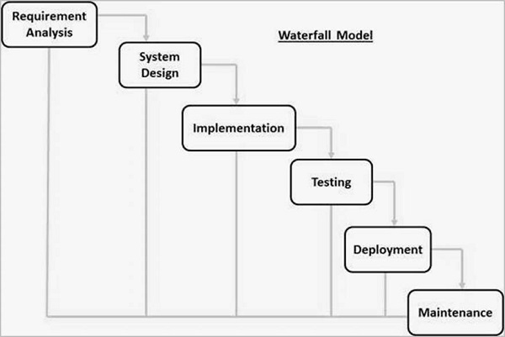

**3.3 Tools and Techniques**

ReactJS are used on the front-end for structure, styling and interactivity. ExpressJS and MongoDB are used as back-end to store/access data from a database. Together these tools allow for complete web application development

**3.4 Ethical Consideration**

Several ethical principles and guidelines will be followed during the design and development of digitalization and archival system with barcode scanning system:

1. Data Privacy: Ensure that personal data collected during the digitalization process is protected and used in accordance with relevant data protection laws and universities policies. Implement measures to safeguard sensitive information and prevent unauthorized access
2. Data Security: Implement robust cybersecurity measures to protect digitalizes data from unauthorized access, data breaches, and cyber-attacks. This includes access control, and regular security audits.
3. Accuracy and Reliability: Ensure that barcode scanning technology is reliable and accurate to avoid errors in data digitalization. Inaccurate data could impact academic and administrative processes, leading to potential issues for students, faculty, and staff.
4. Equitable Access: Ensure equitable access to digitalized archives for all members of the university community, including students, faculty, and staff. Consider accessibility requirements for individuals with disabilities and provide necessary accommodations.
5. Consent and Transparency: Obtain informed consent from individuals whose data is being digitized and archived. Be transparent about the purposes of digitalization and how the data will be used. Provide clear information about data retention policies and rights regrading personal data.

By addressing these ethical considerations, Baze University can ensure that its digitalization and archival system using barcode scanners is implemented in a manner that respects the rights and interest of all stakeholders while promoting academic excellence and integrity.

**3.5 Requirement Analysis**

**3.5.1 Software Requirements**

**3.5.2 Hardware Requirements**

**3.7 Requirements Specifications**

**3.7.1 Functional Requirement Specifications**

# Table 1 Functional Requirement Specifications

|  |  |  |
| --- | --- | --- |
| **Req.**  **No.** | **Description** | **Type** |
| R-101 | The server shall Windows 7 or later version. | Configuration |
| R-102 | The application shall include a user interface. | Functional |
| R-103 |  |  |
|  |  |  |
|  |  |  |
|  |  |  |
|  |  |  |

**3.7.2 Non-Functional Requirement Specifications**

# Table 2 Non-Functional Requirement Specifications

|  |  |  |
| --- | --- | --- |
| **Req.**  **No.** | **Description** | **Type** |
| R-101 | When launched, the application shall stay running unless there is an intentional shutdown of the application or the platform. | Performance |
|  |  |  |
|  |  |  |
|  |  |  |
|  |  |  |

**3.8 System Design**

[You are required to give a good introduction and brief explanation outlining the major components of the system.]

**3.8.1 Application Architecture**

**3.8.2 Use Case**

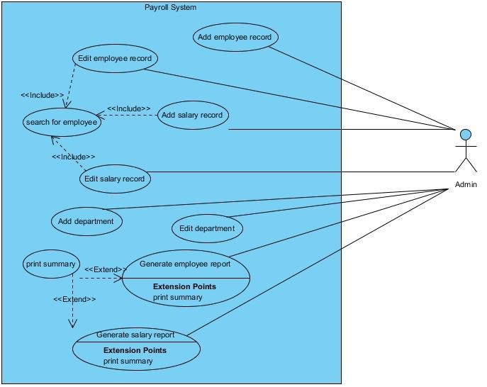

# Figure 1 Use Case diagram

*[A Use Case diagram depicts the interaction between the users and the system. It shows the functions of the system from the user’s point of view and the various actions the user as the actor carries out.]*

**3.8.3 Data Design**

**3.8.4 Activity Diagrams**

An activity diagram is a model that shows the process of a task or action from a use case.

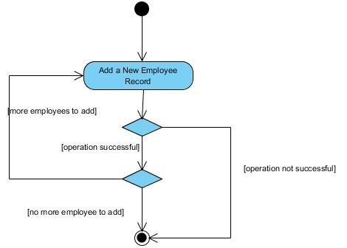

# Figure 2 Activity Diagram

**3.8.5 Dataflow Diagram**

**3.8.6 Control Flow Diagram**

**3.8.7 Entity-Relationship Diagram (ERD)**

[Entity-relationship diagrams show the entities and attributes of tables in a database. Linked ERDs show the relationship between tables or tables. Entities can only have a many-to-one or one-to-many relationship, e.g., in Figure A below.]

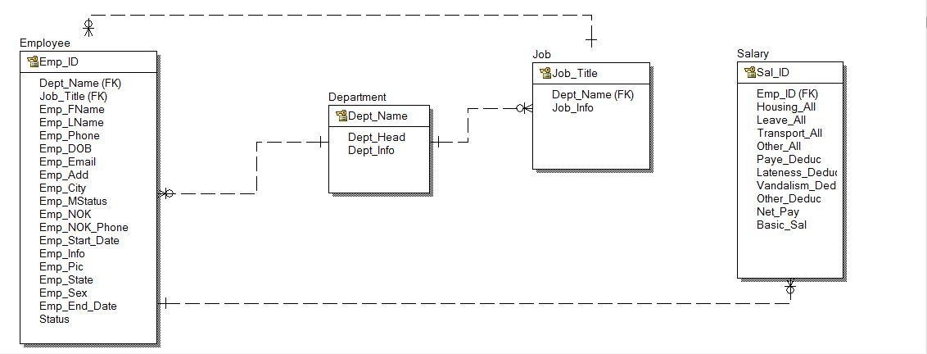

**Entity Relationship Diagram**

**3.8.8 User Interface Design**

**3.9 Summary**

**CHAPTER 4: IMPLEMENTATION AND TESTING**

**4.1 Overview**

[You are required to introduce the chapter.

The following materials listed below are the hardware and software components used for the implementation of the database system for which this report has been written.]

**4.2 Main Features**

**4.3 Implementation Problems**

**4.4 Overcoming Implementation Problems**

**4.5 Testing**

**4.5.1 Tests Plans (for Unit Testing, Integration Testing, and System Testing)**

**Figure xx Test Plan Tree**

**4.5.2 Test Suite (for Unit Testing, Integration Testing, and System Testing)**

**Table xx Test Suite Performed**

|  |  |  |
| --- | --- | --- |
| **Req.**  **No.** | **Description** | **Type** |
| R-101 | When launched, the application shall stay running unless there is an intentional shutdown of the application or the platform. | Performance |
|  |  |  |
|  |  |  |
|  |  |  |
|  |  |  |

**4.5.3 Test Traceability Matrix (for Unit Testing, Integration Testing, and**

**System Testing)**

**4.5.4 Test Report Summary (for Unit Testing, Integration Testing, and System Testing)**

**4.5.5 Error Reports and Corrections**

**4.6 Use Guide**

**4.7 Summary**

**CHAPTER 5: DISCUSSION, CONCLUSION, AND RECOMMENDATIONS**

**5.1 Overview**

**5.2 Objective Assessment**

.

**5.3 Limitations and Challenges**

**5.4 Future Enhancements**

**5.5 Recommendations**

**5.6 Summary**

**REFERENCES**

*[APA Style or Harvard Referencing.]*

**APPENDICES**

**Appendix A - Project Document**

**Appendix B - Questionnaire**

or Proceedings of Interview or Observation Reports etc

**Appendix C – Source Codes**

**Appendix D – Test Cases**

**Appendix E – User Guide/Manual**

33