CHAPTER 2

LITERATURE REVIEW

2.1 Introduction

This chapter talks about past works and existing body of research relevant to the development of this project. It reviews theoretical and thematic findings from previous studies on collaborative learning, gamification in education, academic competitions, and the use of digital learning platforms in Nigerian universities. This chapter will also analyze related systems, both globally and within Nigeria , highlighting their features, strengths, and limitations.

2.2 Historical Overview

2.2.1 Precolonial Education in Nigeria

In precolonial Nigeria, education was not confined to a formal school setting like it is today. To fully understand the development of education and technology in Nigeria, it is important to first examine how knowledge was transmitted in the precolonial era. Education at this time involved the individual and their society. It was believed that engaging in community projects developed well rounded individuals and fostered cooperation among the people (Ogunlola, 2020). Before the introduction of foreign ideals, there was major emphasis on moral education because it was regarded as a major catalyst for societal growth. They used folklore, proverbs, tales etc. to teach moral values and pass on cultural values and traditions.

Many Nigerian ethnicity operated the apprentice system. (Nnonyelu & Onyeizugbe, 2020) referred to an apprentice as a person who has agreed to submit himself/herself within a period of time under the tutelage of a master/mistress, with the aim of acquiring practical, hands on, experience, and mastering the nitty-gritty of a trade, vocation or profession. They employed apprenticeship to keep the youth from being idle and to propagate their expectation of a promising future where everybody can provide a livelihood for himself or herself. Skills in commerce, brick laying, welding, painting, vulcanisers, barbing, fashion designing, blacksmithing, mechanics or car/bicycle repairs, were passed down from master to apprentice. The apprentice will then be observed by the master to assess their readiness.

Thus, education was holistic, preparing the individual for moral uprightness and practical livelihood. However, this indigenous system of education was later disrupted with the coming of colonialism and the introduction of Western formal schooling.

2.2.2 Colonial Education Era

Western Education was introduced by British Christian missionaries, establishing the first primary school in Nigeria in the 1840s (Evgeniou, 2022). They prioritized teaching biblical and English history in order to celebrate the imperial agenda while disregarding African history and culture before the Europeans. The lack of focus on indigenous education like the vernacular and cultural history prompted the early educated Nigerian elites to challenge these colonial policies. (Akanbi & Jekayinfa, 2021).

The 1882 Education Ordinance was the first education policy crafted by the British government for the establishment of a General Board of Education to build new schools in villages, certify teachers, and determine schools eligibility for government grants. The policy designed a curriculum for formal education focused solely on reading, writing, arithmetic, religion, English language and needle work for girls (Ofobuike, 2025). The 1948 education act prepared for the establishment of higher education institutions in Nigeria, as before that emphasis was placed on primary and secondary schools (Ofobuike, 2025).

In addition to shaping the curriculum and school structure, the colonial masters also dictated how knowledge was assessed. Nigerian students would sit for examinations that were tailored to the British, providing little to no benefit to the indigenous people. These examinations would be set by the London University School Examinations and Matriculation Council; University of Cambridge Local Examinations Syndicate; the London Chamber of Commerce; The Royal Society of Arts (RSA) and The City and Guilds of London Institute (Anyanwu, 2023).

Thus, the colonial education era not only made indigenous culture insignificant in education, but also created a dependency on foreign curricula which continues to shape the post-colonial education policies.

2.2.3 Education in Post-Independence Nigeria: Policies, Examinations, and the Past Questions Culture

After Nigeria gained its independence in 1960, its crucial task became creating a solid foundation for future prosperity of the nation. They aimed to use the education policy to nurture educated individuals in the society and build a thriving economy. It was the inadequacies of the previous policy that brought about the 1969 National Conference. The conference was a necessary step toward educational emancipation. Academic institutions, local governments, trade unions among others expressed their dissatisfaction with the existing educational system and called for a review and reform of the national goals for education in Nigeria at all levels (Okparaugo et al., 2021).

The conference led to the creation of the Nation Policy on Education (NPE) of 1977. The policy clearly stated the national goals of education, established the 6-3-3-4 education system (6 years primary, 3 years junior secondary, 3 years senior secondary, 4 years tertiary), and focused on integrating Nigerian culture into education.

At the same time, examinations became an equally powerful influence on the education system. In 1952, the West African Examination Council (WAEC) was established and its first examination was conducted under the name Public Service Executive Competitive Examination (Anyanwu, 2023). Due to this development, Nigerian students became increasingly reliant on past examination question papers (PEPQs) to prepare for upcoming examinations. Most students use PEPQs as a way to test themselves before the examination. It has become so common for candidates to seek out PEPQs for national examinations like West African Examination Council (WAEC), Universities and Tertiary Matriculation Examination (UTME) conducted by the Joint Admission and Matriculation Board (JAMB), and even internal tests organized by tertiary institutions (Umuerhi & Urhiewhu, 2023). This practice emerged because students noticed recurring patterns in the examinations. It allowed students to be able to predict possible questions, therefore they studied inline with previous questions.

Noticing the demand, PEPQs were compiled into exam guide booklets and were sold to schools and students across all levels of education. Students were able to find gaps in their knowledge, and practice under improvised examination conditions, but it also reinforced the mindset that passing examinations meant being educated. As a result, teaching and learning became focused on memorization instead of understanding, and values high performance in tests rather than problem solving and critical thinking skills.

2.2.4 Introduction of ICT and Ed Tech in Nigerian Schools

Daramola and Aladesusi (2022) defined Information Communication Technologies (ICT) as electronic technologies used for information storage and retrieval. ICT is becoming an integral part of education at all levels. It has played a major role in enhancing learning and improving students’ ability to understand and retain information (Rani et al., 2023). It was crucial that Nigeria kept up with the global adoption of ICT in education in order to modernize it.

Computer Education was first issued in 1988 and teachers who were not professionally experienced would teach with unapproved documents or self-compiled topics until computer education was made a compulsory subject in primary and junior secondary schools, and a curriculum was designed for it in 2004 and 2002 respectively (Tshukudu et al., 2023). The curriculum covered the basic concepts and applications of ICT in the primary level and basic computer operations, computer hardware, and software in secondary level.

ICT has reshaped the pedagogical approach. Twahirwa et al. (2021) indicate the failure of traditional teaching methods to engage learners, leading to passive learning, which in turn conveys surface knowledge. Many schools across the country are gradually replacing restrictive tools like textbooks, blackboards, and chalk with multimedia tools such as Smart Boards, which can make learning more dynamic, collaborative, and engaging (Olugbade et al., 2023).

Furthermore, the application of ICT in library access and management is necessary for enhancing the accessibility of information from different electronic devices. University libraries are fully involved in improving the digitization, dissemination, and preservation of academic resources like textbooks, lecture notes, research papers, past questions, and so on. Digital libraries can enable students’ immediate access and active participation with digital academic resources (Igbo et al., 2022).

In addition to ICT being introduced in various aspects of learning, it was also used as a method of testing, also known as ‘E-testing’ or ‘Computer-Based Test’ (CBT). Computer-based testing is a method of using computers to administer assessments. In 2015, Unified Tertiary Matriculation Examinations (UTME) was written using computer-based technology, marking the beginning of CBT in Nigeria (Buoye & Bada, 2021).

2.2.4.1 Rise of EdTech Platforms

Education Technology (EdTech) is the effective use of technology tools in learning. It combines the use of software, hardware, education, and learning. Any technology-related tool that facilitates learning and research is referred to as EdTech (Oshodi, 2022). Examples of EdTech include: educational apps, gamification, virtual classrooms, learning management systems, artificial intelligence, and Interactive Smart Boards (ISB).

The rapid increase in demand for technological advancements has given rise to EdTech entrepreneurship in Nigeria. EdTech aims to provide innovative solutions in the educational sector through the development of new technologies.

Nigerian EdTech startups include but are not limited to:

1. uLesson - an online education platform that provides interactive courses for various subjects.
2. Edukoya - connects African learners with the best teachers—on-demand tutors.
3. Tuteria Limited - provides personalized lessons from verified tutors.
4. Pass.ng - simulates examinations to test students and prepare them for national examinations.

Digital platforms like these are essential for improving learners’ performance and understanding outside the formal classroom. They offer features like online quizzes, gamified learning, and engaging learning experiences.

Although the benefits of adopting EdTech are undeniable, significant challenges persist. Issues such as low bandwidth in rural areas, high cost of mobile devices such as tablets or laptops, and lack of willingness of teachers to adopt technology (Patil et al., 2024). The COVID-19 pandemic further revealed the importance of technology-driven solutions in ensuring learning activities were efficient and accessible (Ebohon et al., 2021). Today, ICT and EdTech are increasingly recognized as essential tools for access and inclusivity in Nigeria's education system.

2.3 Thematic Review

2.3.1 Collaborative Learning in Higher Education

Collaborative learning is an educational approach where two or more students work together in a coordinated, synchronous activity to maintain a shared understanding of a problem and to provide solutions to that problem. Qureshi et al. (2021) describe it as a powerful method of active learning, where students participate and interact in group environments to manage relationships and develop content. This process integrates students into communities where they can share knowledge and develop a deeper understanding of a specific area. Members of these knowledge communities depend on each others expertise to build collective cognizance, extending beyond the individuals capacity and knowledge.

Studies have shown that peer interaction lead to a successful collaborative learning, as it improves students' interest , helps them explore different ideas, and enhances their learning outcomes (Qureshi et al., 2021). In these interactive environments, students serve as learning mediums for each other by talking, observing others' work, and sharing information. As noted by Yusof et al. (2022), Social Network Systems (SNS) like Facebook, WhatsApp, and Telegram have become vital tools for facilitating collaborative learning and fostering peer learning skills, by allowing students to build a social network of like minded people, share ideas, and engage in group discussions. Lipponen (2023) suggests that these digital tools can enhance peer interaction, facilitate the sharing of knowledge among community members, and break down the physical and temporal barriers of traditional pedagogy.

A study by Tolorunleke et al. (2023) in Kogi State, Nigeria, found that WhatsApp was used by all 370 student respondents for learning, with Facebook, Twitter, and Youtube also being popularly utilized for collaborative learning. Regardless of the availability of these tools, students tend to use them primarily for entertainment purposes, rarely exploring its effectiveness in teaching and learning. The popularity of these online tools among Nigerian students have brought up a need to supplement conventional learning methods with digital ones in order to simulate students' interest and improve academic performance.

The success of collaborative learning can be reduced by several challenges. Kerman et al. (2023) highlight the lack of trust in peers' competence to provide high-quality contributions, as students may be sceptical about their peers being sufficiently educated on a topic. The issue of trust can also be related to a phenomenon Boud & Bearman (2022) call ‘*freeloading*’, which is compounded by uneven participation, where some group members contribute significantly more than others. Furthermore, certain infrastructural barriers, such as poor internet connectivity and lack of devices, can impede digital learning, especially for students that reside in rural areas(Yusof et al., 2022). The social dynamics of peer interactions can also be complex; Sridharan et al. (2023) found that issues like fear of disapproval, social pressure, and discomfort in marking peers can negatively impact honest assessment.

Digital platforms can directly address these challenges by creating a trusted, structured academic space that facilitates organized collaboration. Such platforms help expand student interaction beyond informal social networks like WhatsApp and group chats limited to a particular university. Features like anonymity can reduce social pressure and foster more objective feedback (Sridharan et al., 2023; Topping, 2023), while structured tools can enhance the quality and fairness of peer contributions, thereby building the trust that Boud and Bearman (2022) and Kerman et al. (2023) identify as central to productive collaboration.

2.3.2 Gamification in Education

Gamification is the process of applying game-like elements and mechanics to non-game contexts, such as the classroom, to engage people, stimulate action, promote learning, and solve problems (Kapp, 2012, as cited in Sabornido et al., 2022; Nwachukwu & Johnson, 2020). The core idea is to transform conventional learning tasks into interactive and enjoyable activities, thereby creating attractive experiences that arouse curiosity and capture students’ attention. It is however different from Game-Based learning (GBL) which is when a complete game is used to teach. The aim of gamification is to make the learning process more enjoyable and interactive; thereby motivating students and increasing their engagement with the academic material(Adeoye, 2023).

Integrating game mechanics has become increasingly widespread. A comprehensive meta-analysis of 22 experimental studies confirmed that gamification has a moderately positive overall effect on student academic performance (Zeng et al., 2024). The most common gaming elements incorporated in learning are points, badges, and leaderboards. These components serves a distinct psychological function, for example, points provide immediate feedback after an achievement; badges act as visual representations of progress; and leaderboards foster a sense of healthy competition by allowing students to see their performance compared to their peers (Adeoye, 2023; Iji-Okeke & Okeke, n.d.). Together, these elements encourage active participation and can help sustain student engagement over time. Integrating gamification has been shown to help students grasp difficult concepts and deepen their understanding. The positive impact is clear in a three-year longitudinal study, which found that a gamified course yielded significantly better outcomes in student success, excellence, and retention rates compared to both traditional and online formats (Lampropoulos & Sidiropoulos, 2024).

This need for innovative pedagogy is particularly acute in the Nigerian context, where conventional teaching methods are often perceived as unappealing to a diverse, technology-oriented generation of learners (Iji-Okeke & Okeke, n.d.). Nigerian universities are often met with a large amount of students each from diverse cultural backgrounds and with varying proficiency, which makes differentiated instruction a significant challenge. By utilizing gaming mechanics, a students learning process takes place at their own pace and provides personlaized and adaptive experiences. For instance, a study at the Federal University of Education, Zaria, found that using the platform Kahoot! led to notable improvements in language proficiency, especially among lower-proficiency students, effectively helping to narrow the achievement gap (Balogun, n.d.). Similarly, anither Nigerian study demonstrated that a gamified activity significantly enhanced college students' achievement in Number Systems (Okekeokosisi et al., 2025). But due to some infrastructural issues: inconsistent internet connectivity, limited access to technological devices, implemenation is being restricted to few parts of Nigeria.

However, the implementation of gamification is not a universal solution and comes with its own set of challenges. One of the primary risks is an overemphasis on competition, which can be detrimental if not managed correctly (Iji-Okeke & Okeke, n.d.). A systematic review of these barriers revealed several critical issues: not all students are fully engaged by gamification, some find that it creates an excessive workload, and it may not appeal to certain personalities or learning styles (Sabornido et al., 2022). Therefore, an ineffective strategy when adopting gamified learning can negatively impact learning outcomes and lead to students becoming frustrated down the line. For example, the complex combination of certain elements, such as Levels, Awards, Badges, and Leaderboards, were actually found to have a negative effect on academic performance, serving as a caution against adopting multiple elements without a clear pedagogical strategy (Zeng et al., 2024).

Recognising both the potential and the pitfalls is therefore crucial for designing gamified experiences and applications that are balanced and purposeful. The leaderboards and quizzes in my collaborative platform is designed to encourage healthy competition among diverse learners, rather than creating a high-pressure environment. This approach aligns with research suggesting that elements like leaderboards can promote positive learning outcomes when they foster a supportive atmosphere (Ezzeh, 2025, as cited in Okekeokosisi et al., 2025). By doing so, the goal is to motivate students through immediate feedback and a sense of achievement, turning learning into an intrinsically engaging and interactive experience (Iji-Okeke & Okeke, n.d.).

2.3.3 Online Quizzes and Assessments

Online quizzes and assessment tools has transformed how formative assessments are carried out. It offers students the ability to test their understanding and engage in self-paced-paced practice tests. Online quizzes are an essential component of e-learning for testing learners and providing an immediate feedback in most cases. The COVID-19 era accelerated the adoption of these technologies that were being used for assessments and measuring learning outcomes during widespread international closures (Simelane & Pillay, 2024). Platforms like Moodle and Google Forms have become a staple in most tertaiary institutions, because it allows instructors to deliver and analyze assessments stress-free. Research indicates that students value e-assessment for its easily accessible and fast feedback, which in turn increases their motivation (Shalatska et al., 2020)

The use of online quizzes as a formative assessment tool has been shown to improve student engagement and academic performance (Chen et al., 2021). A study by Morris et al., (2021) found that students perform better on final exams when they engage in online tests and receive immediate feedback. These low-stakes assessments promote active recall and strengthen long term memory for storing academic information. Compared to traditional high-stakes exams, where everything is on the line, the online tools are adaptable to an individuals level of knowledge, helping lecturers monitor students progress and provide timely and personalized feedback (Simelane & Pillay, 2024).

During the COVID-19 pandemic many Nigerian Universities were forced to use e-learning tools such as: Google Classroom, Microsoft teams, and Zoom, and despite these tools being implemented at the time many institutions still face significant issues with fully transitioning from the usual ways of assessing students to e-assessment methods. One issue they face is the digital divide, where disparities in access to stable internet connection and lack of access to suitable devices can create an environment where certain students are not able to perform fairly in online assessments (Ibrahim et al., 2023; Okoroafor, 2020, as cited in Ibrahim et al., 2023). Another concern with adopting online testing is maintaining academic honesty. The remote nature of these tests create opportunities for students to cheat (Simelane & Pillay, 2024). Due to the lack of integrity, instructors have adopted strategic methods for curbing this, such as setting questions that require critical thinking and problem solving skills, monitoring their activities with online tools (Özyer, 2024), and making sure that each student gets unique and varied tests from a randomized question bank (Sullivan, 2016). Furthermore, both students and educators may lack the necessary digital literacy to use these tools effectively, highlighting a need for continuous training and support (Mahlangu & Makwasha, 2023).Despite these obstacles, there is a need for mobile and user-friendly platforms that can make learning and assessment more accessible, and promote fair grading (James, 2022).

The quiz module in my platform aims to transform the way students study with past questions. By creating interactive quizzes from physical past questions, it ensures that students actively engage with the materials rather than memorizing with no basic comprehension. The feature of instant feedback leverages on one of the most valued aspects of online tools, promoting student continuous participation and self-paced learning. By making the assessment more efficient and data-driven, it empowers educators to better track a students progress and adapt their teaching strategies (Shalatska et al., 2020), ultimately fostering a more dynamic and effective learning environment.

2.3.4 Academic Competitions and Motivation

Within tertiary institutions, competitions can arise both among universities looking for the best students for their programs, and among students themselves (Hart & Rodgers, 2024). Digital technology has popularized gamified competitions often integrating elements like leaderboards, a point system, and badges into educational settings. The aim is to get students to participle in academic activities causing a boost in student achievement and motivation. For example, studies on gamified mobile quizzing have confirmed their effectiveness in improving both engagement and academic performance.

In a study conducted with senior secondary school students in Lagos, Nigeria, researchers implemented a gamified biology application that featured leaderboards, badges, quizzes, and points. It revealed that incorporating these competitive and collaborative game mechanics improved students engagement and attitude towards to subject (Udeani & Akhigbe, 2020). This research shows that gamified competitions in classrooms is effective for passing on knowledge onto Nigerian students.

Despite these benefits, excessive educational competitions can devalue creativity in solving problems and increase tension between the students. Also, when implementing a feature like the leaderboard it can perpetuate hierarchies which are detrimental to a proper learning environment with emphasis on understanding (Hart & Rodgers, 2024).

These insights collectively affirm the need for an online platform offering a structured and accessible way to implement proven game mechanics like leaderboards and challenges for Nigerian students. By accommodating both competitive and collaborative modes, such a platform would cater to diverse learning preferences while leveraging the synergistic power of these two dynamics. Ultimately, this platform could create a fair, constructive, and low-stakes environment to harness the motivational power of competition, making learning more engaging and effective for a broad student population in Nigeria

2.4 Related Works

This section reviews prior studies and systems related to collaborative learning, gamification, quiz platforms, and academic competitions. It highlights their contributions, limitations, and how this study intends to address existing gaps.

2.4.1 Evaluation of Online Learning Systems

2.4.1.1 Moodle

Moodle is an open source Learning Management System (LMS). It provides its users (educators and organizations) with single, robust, secure, and integrated system to create personalized learning environments. It facilitates online training and learning.

Features

1. System administrators and course creators can build and mange courses.
2. Educators can create and manage assessments given to the learners.
3. Tracking a learners progress by analyzing their activity, course completion and course reports.
4. Educators can reward learners with badges and certificate for achievements.

Strengths

1. Open source.
2. It is easy to use: Courses can easily be built by drag-and-drop and progress can be tracked.
3. Flexible and customizable: Organizations can configure the LMS with plugins or managed solution services to meet their requirements.
4. Compatible with various devices, including mobile phones and tablets.
5. Seamless integration with other learning or organizational platforms such as Microsoft teams, zoom etc.
6. Downloaded courses are available offline.

Limitations

1. Does not come with in-built gamification features like leaderboards and badges. The features have to be added with gamification plugins.
2. Does not support some types or sizes of course content.
3. Core functionality such as video conferencing requires plugins or extensions.

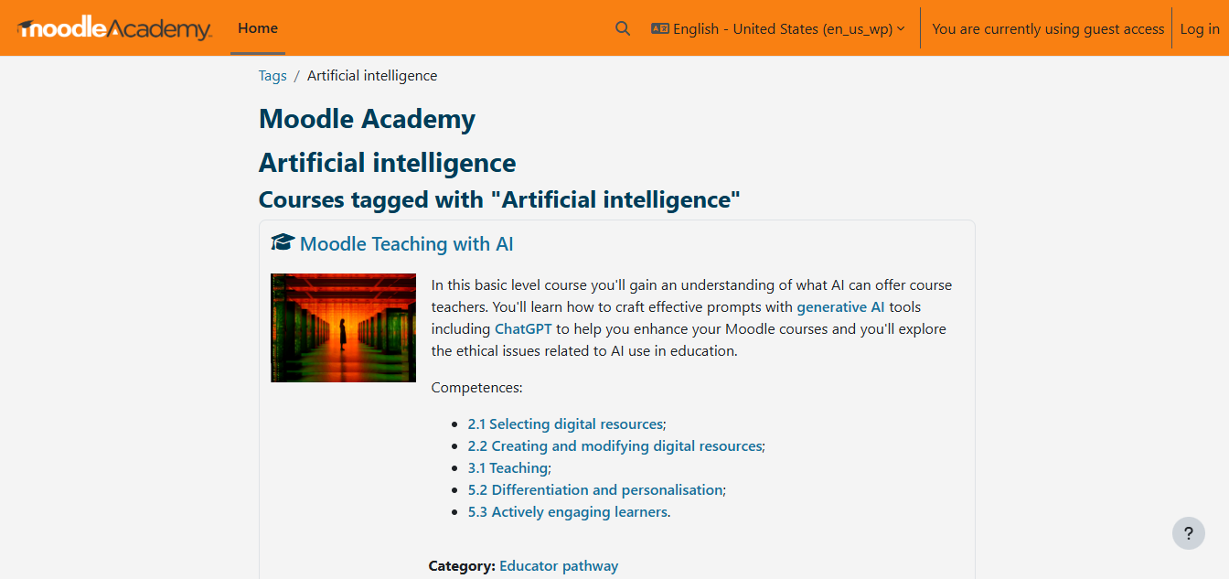

**Figure 2.1 User Interface of Moodle**

Overall, Moodle remains one of the most globally recognized LMS platforms, valued for its flexibility and open-source community. However, institutions with limited technical expertise may find reliance on plugins a challenge.

2.4.1.2 Google Classroom

Google Classrooms is a free cloud based platforms used to manage digital classrooms. It is often used in educational institutions to create classrooms where information can be passed easily.

Features

1. It has a stream where teachers can post announcements and students can participate in question-driven discussion.
2. Teachers can create assignments, grade tasks and share academic material.
3. Students can view materials, turn in assignments, and collaborate with peers.
4. Teachers can invite students into their digital class.
5. Messaging feature allows teachers to leave comments on students assignments.

Strengths

1. It is very user friendly.
2. Seamless with other Google tools like Google Drive, Google Docs, Google Sheets and Google Meet.
3. Push notifications and integration with Gmail keeps users updated on whats happening in the classroom.
4. Available on web browsers and mobile applications.

Limitations

1. Requires stable and consistent internet connection to use it.
2. It does not offer robust analytics or rubrics for monitoring a students engagement and progress.
3. Limited integration with non-google platforms.
4. Does not include inbuilt gamification tools.

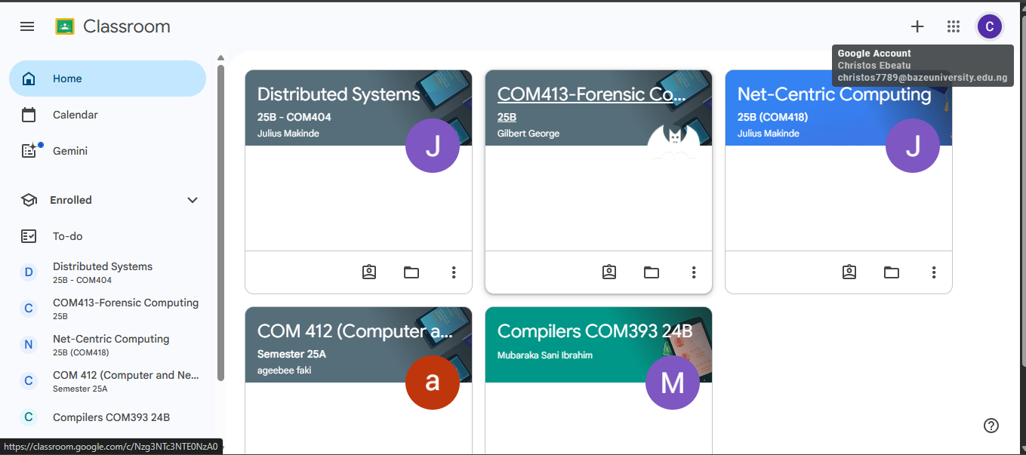

**Figure 2.2 User Interface of Google Classroom**

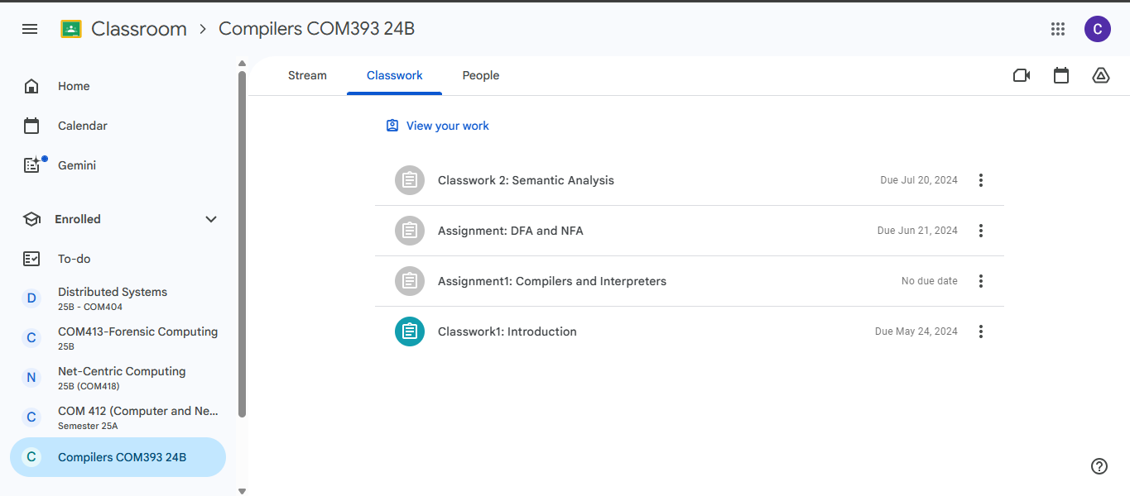

**Figure 2.3 User Interface of Google Classroom**

Google Classroom is highly effective for organizing and managing coursework in institutions already using Google’s ecosystem. However, its lack of advanced analytics and gamification limits its adaptability in more interactive learning contexts.

2.4.1.3 Kahoot!

Kahoot! is an online platform for hosting interactive trivia quizzes and knowledge based competitions. The games are known as “*kahoots*”, which are user-generated multiple-choice quizzes.

Features

1. Users create games (kahoots).
2. Host interactive sessions where users can answer questions on their own devices and the questions and answers are displayed on a shared screen.
3. Quizzes can be assigned to students to answer and they can be answered at their pace rather than having a set time.
4. Students can work in teams to complete challenges.
5. Quizzes are in various forms: multiple choice, true or false, puzzle, open-ended questions.
6. Instant feedback on polls and quizzes.

Strengths

1. Using gaming elements such as leaderboards, scoring systems, and timed answering to motivate students.
2. Accessible across various devices through web browsers or mobile applications.
3. Provides student progress tracking for teachers.

Limitations

1. Advanced features like detailed reports and integration require a paid subscription.
2. It focuses on short, quiz-based activities which may not be comprehensive enough for certain courses.
3. Content on the platform is user-generated bringing up concerns of quality, accuracy, and appropriateness.
4. Requires stable and consistent internet connection to use it.
5. Competitions can create a high pressure environment for students to perform exceptionally.

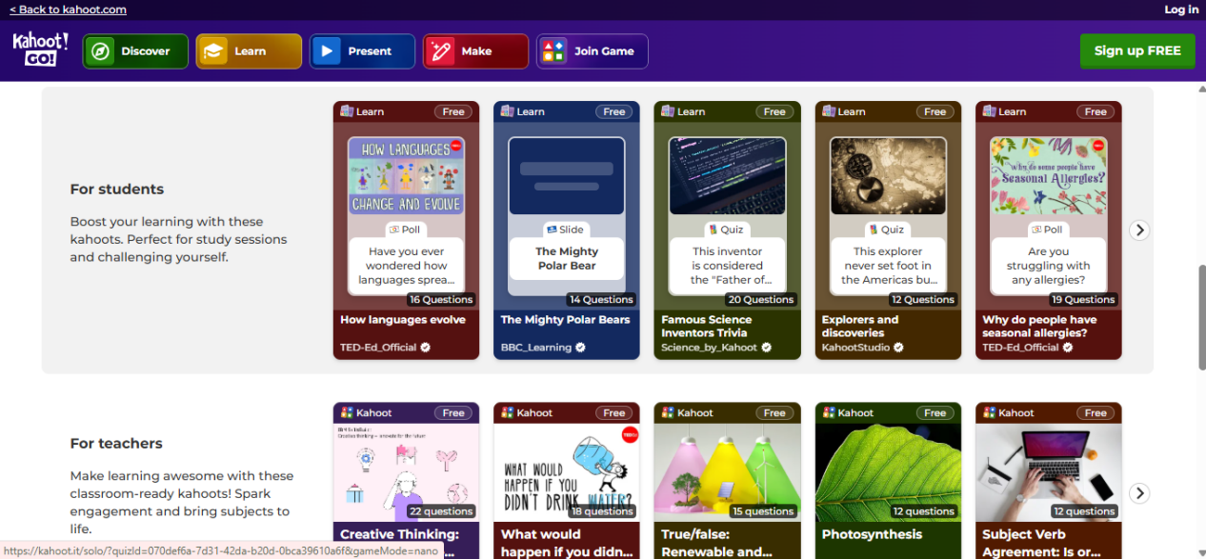

**Figure 2.4 User Interface of Kahoot!**

Kahoot! is excellent for gamified learning and fostering engagement in classrooms but is limited in scope as a full learning platform.

2.4.2 Evaluation of Nigerian Based Online Learning Systems

2.4.2.1 Myschool.ng

Myschool.ng is an online platform that provides examination preparation tools like past questions and CBT simulations for JAMB and WAEC. Also, users can get information from other users or educators.

Features

1. Large database of past questions and examination preparation material (JAMB, WAEC etc.)
2. Offers video lessons and tutorials for core subjects.
3. Users can download content to access offline.
4. Users can replicate exmination conditions with the customizable CBT simulations.
5. Users can ask questions and get replies teachers and other users.
6. Users receive updates on school or examination related information.

Strengths

1. Intutive user interface.
2. Implements leaderboard ranking which will motivate students and promote healthy competition.

Limitations

1. Recurrent errors and bugs causing crashes and loss of progress.
2. Users can stay active across multiple devices leading to repeated activation requests.
3. Limited to secondary school students.
4. Poor customer support.



**Figure 2.5 User Interface of Myschool.ng**



**Figure 2.6 User Interface of Myschool.ng**

2.4.2.2 ULesson

ULesson is an African edtech company that provides a platfrom where primary and secindary school students can watch high quality video lessons, engage in interactive quizzes, and get help with their homework.

Features

1. Utilizing video lessons and animations to teach students.
2. Quizzes and assessments that students can answer individually or as a group.
3. Mock examinations to help students adequately prepare for their main examinations.
4. Real time access to learners progress report.
5. Chat to ask questions and get answers from tutors.

Strengths

1. Allows students to learn at their own pace.
2. Offers personalized video lessons that are also in line with the curriculum.
3. Available across multiple devices (web browsers and mobile applications).
4. Reduces educational inequality by providing access to quality teachers remotely.

Limitations

1. Subscription fees are a barrier for many especially with the current state of Nigeria's economy.
2. Dependent on internet access to stream video lessons which may not be accessible to students in remote areas.
3. Limited to primary and secondary school students.

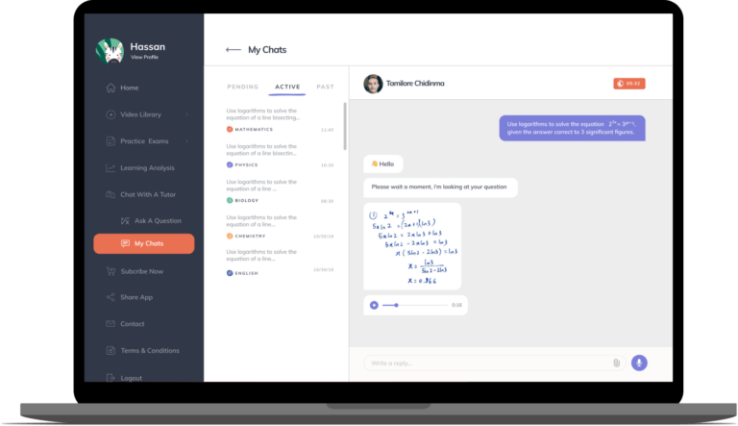

**Figure 2.7 User Interface of ULesson**

**(Ore Badmus, 2021)**

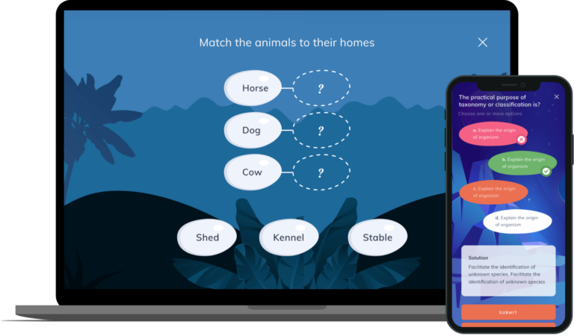

**Figure 2.8 User Interface of ULesson**

**(Badmus, 2021)**

2.5 Summary

This chapter showed the review process of the literature regarding the numerous technologies and resources used through the development process. The Historical overview shows how education evolved over the years to implementing technology in teaching and learning.

The platform being developed recognizes these gaps and strives to provide solutions tailored to the needs of university students in various Nigerian universities.

Chapter 3 will discuss the requirements and the methodology that has been used to solve the stated issue, including the provision of diagrams like the Use case, Activity. ERD etc.

**Table 2.1 Related works summary**

|  |  |  |
| --- | --- | --- |
| Application Name | Features | Limitations |
| Moodle | Course creation and management (admins, educators)  Assessment creation and management  Learner progress tracking (activity, course completion, reports)  Badges and certificates for achievements  Drag-and-drop course building  Plugins for extra functionality  Integration with Microsoft Teams, Zoom, etc.  Mobile and tablet compatibility  Offline access for downloaded courses | No built-in gamification (needs plugins)  Limited support for some content types and sizes  Key tools (e.g., video conferencing) depend on plugins/extensions |
| Google Classroom | Stream for announcements and discussions  Assignment creation, grading, and sharing of academic material  Student collaboration (viewing, turning in, peer work)  Teacher invitation to join class  Messaging and feedback on assignments  Integration with Google Drive, Docs, Sheets, Meet  Push notifications via Gmail  Browser and mobile app access | Requires stable internet connection  Limited analytics and progress monitoring tools  Weak integration with non-Google platforms  Lacks in-built gamification features |
| Kahoot! | User-created games (“kahoots”)  Interactive sessions with shared screens  Self-paced quiz assignments  Team-based challenges  Multiple quiz formats (MCQs, true/false, puzzles, open-ended)  Instant polls and feedback  Leaderboards and scoring systems  Student progress tracking  Accessible on browsers and apps | Advanced features locked behind paid plan  Focused only on quiz-based activities  User-generated content may lack quality or accuracy  Needs strong internet connectivity  Competitive style can cause student anxiety |
| Myschool.ng | Large database of past JAMB/WAEC questions  CBT simulation with customizable exam settings  Video lessons and tutorials for core subjects  Offline download of materials  Peer and teacher Q&A forums  Updates on school/exam information  Leaderboard ranking for users | Frequent app/site errors and crashes  Multiple device login issues (activation requests)  Focused mainly on secondary school level  Weak customer |
| uLesson | Video lessons and animations aligned with curriculum  Quizzes and assessments (individual and group)  Mock examinations for practice  Real-time learner progress reporting  Tutor chat/help support  Multi-device support (browser + mobile apps) | Subscription fees restrict access for many  Internet dependence for video streaming  Limited to primary and secondary school students |