📈 Survival Analysis of Chlorhexidine Trial Outcomes Using Python

This project is based on a real clinical trial case study titled:
“Effectiveness of Oral Hygiene with Chlorhexidine Mouthwash with 0.12% and 0.2% Concentration on Incidence of VAP”
Published in Annuals of International Medical and Dental Research (2021).
1.Project Summary
This project analyses clinical trial data comparing the effectiveness of 0.12% vs 0.20% chlorhexidine oral hygiene in preventing Ventilator-Associated Pneumonia (VAP) among ICU patients. Using survival analysis techniques—including Kaplan–Meier curves, log-rank tests, Cox Proportional Hazards modelling, Schoenfeld residual diagnostics, and hazard ratio forest plots—the study evaluates time to VAP, risk factors, and model validity. The results show overall high VAP-free survival with very few events (n = 7), limiting statistical significance. While the 0.20% concentration demonstrates a slightly better survival trend, the difference between groups is not statistically significant. All predictors satisfied the proportional hazards assumption, and the Cox model was valid but underpowered due to the low event count.
2.Dataset Description

Variable Name | Description | Type | Values or Units
time | Days until VAP event or censoring | Continuous | Based on follow up duration of CPIS
event | Outcome event status | Binary | 1 = VAP occurred, 0 = censored
Age | Patient age in years | Continuous | Years
Gender | Biological sex of patient | Categorical | Male or Female
chest_xray | Chest X ray findings for VAP | Binary | 1 = infiltrate present, 0 = normal
cpis | Clinical Pulmonary Infection Score | Continuous | 1=Score >6
culture | Culture growth | Binary | 1 = positive culture, 0 = negative
ulcer | Oral ulcer | Binary | 1=Present, 0=Absent
apache_score | APACHE II severity score | Continuous | Score
tlc_score | Total leukocyte count | Continuous | cells per microlitre
microbial_load | Microbial count in oral sample | Continuous | CFU
treatment_arm | Treatment group allocation | Categorical | 1 = 0.12% chlorhexidine, 2 = 0.20% chlorhexidine
cpap | Clinical Pulmonary Infection Score | Categorical | 1=Score >6

3.Problem Statement
To determine whether 0.20% chlorhexidine mouthwash is more effective than 0.12% in reducing the incidence and hazard of VAP in mechanically ventilated ICU patients, and to identify baseline clinical predictors associated with time to VAP.

4.Objectives
Primary Objectives
- To compare VAP-free survival between the two treatment groups (0.12% vs 0.20%).
- To determine whether chlorhexidine concentration significantly reduces VAP risk using log-rank testing.
Secondary Objectives
- To evaluate the effect of age, APACHE score, TLC, microbial load, culture status, and X-ray findings on hazard of developing VAP using the Cox PH model.
- To verify the proportional hazards assumption using Schoenfeld residuals.
- To visualize relative risks using a forest plot of hazard ratios.
- To summarize model behaviours via residual checks, variance filtering, and correlation heatmaps.
5.Methodology
1. Data Import & Cleaning
- Load the raw Excel dataset
- Select required clinical variables
- Create survival columns (time & event)
- Encode categorical variables correctly

2. Descriptive Statistics & Filtering
- Remove low-variance predictors
- Check correlations using a heatmap
- Interpret initial survival patterns & distributions

3. Kaplan–Meier Survival Curves
- Plot the overall KM survival curve
- Plot KM curves by treatment arm (0.12% vs 0.20%)
- Interpret survival differences visually

4. Cox-Rank (Log-Rank) Significance
- Compare survival curves statistically
- Test result: χ² = 1.94, p = 0.16 → not statistically significant
- Conclude no strong difference between the two concentrations

5. Cox Proportional Hazards Model
- Fit the Cox PH model using selected predictors
- Calculate hazard ratios and confidence intervals
- Visualize results using a forest plot

6. Schoenfeld Residual Diagnostics
- Check proportional hazards (PH) assumption for each variable
- All p-values > 0.05, meaning PH assumption is satisfied
- Validate model stability

7. Final Interpretation & Report
- Summarize overall survival findings
- Present hazard ratios, significance, and clinical meaning
- Provide final conclusions and recommendations

6.CRITERIA USED TO CONVERT RAW DATA → “Chlorhexidine Trials.xlsx”
1. Standardised and renamed columns
Raw column names were cleaned to consistent, analysis-friendly names.
• “APACHE II Score” → apache_score
• “Average of 10 Day TLC Score” → tlc_score
2. Converted time variable
Raw duration column was coerced to numeric:
• Ensured the final variable is numeric (required for survival time)
3. Converted event variable
Raw event indicator was converted into integer:
• event = 1 if VAP occurred
• event = 0 if No VAP
• All entries were forced into Int64 numeric type
4. Converted TrialArm to numeric coding
Raw text values like:
• “Group 1” → 1 (0.12%)
• “Group 2” → 2 (0.20)
If raw values were already numeric strings, they were directly converted to integers.
5. Ensured essential predictors were present
After cleaning, the dataset was required to contain:
6. Imputed missing numeric values
For variables entering Cox or KM analysis, missing values were filled using:
• median imputation
7.Kaplan Meier estimation overall
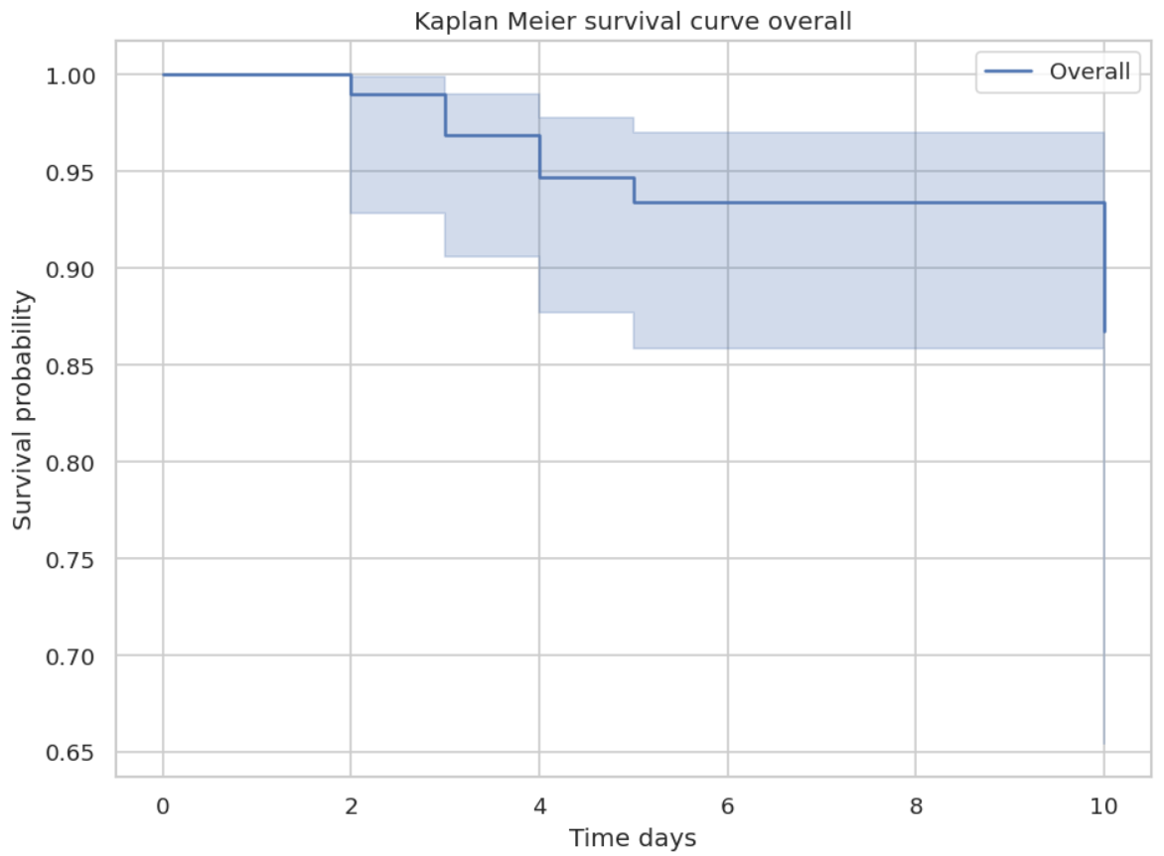
- Initial survival begins at 1.0, meaning all patients were VAP-free at Day 0.
- Gradual decline in survival probability is seen between Days 2 and 6, indicating a small number of VAP events during this timeframe.
- Overall VAP-free survival remains high, staying above 0.90 throughout most of the follow-up period.
- By Day 10, the survival probability stabilizes around 0.92–0.93, suggesting only limited events occurred.
- Confidence intervals are moderately narrow, showing relatively good precision in the estimate despite the small sample size.
- No steep drops are seen, meaning events did not cluster at any specific time point.
- The curve overall reflects a favourable clinical outcome, with most patients maintaining VAP-free status during the 10-day observation period.

8.Kaplan Meier estimation- trial arm
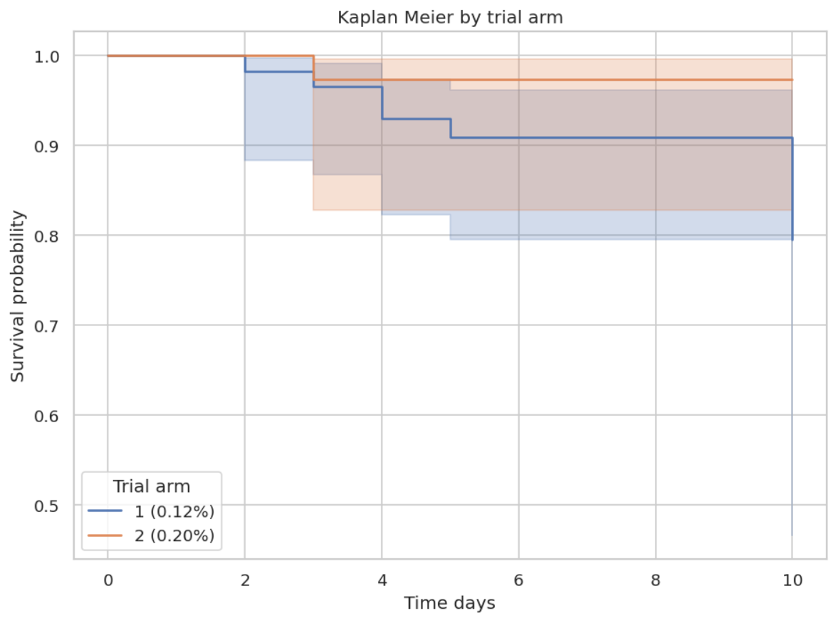
- Both groups start with a survival probability of 1.0, meaning no VAP at baseline.
- The 0.12% group shows earlier drops, indicating earlier VAP events.
- The 0.20% group maintains a higher survival probability for most of the follow-up period.
- By Day 10, the 0.20% arm ends with slightly better VAP-free survival than the 0.12% arm.
- Confidence intervals overlap, suggesting the difference may not be statistically significant without formal testing.
- No sharp falls in either curve, meaning VAP cases were gradually distributed over time.
- Overall, the trend favours the 0.20% chlorhexidine concentration in reducing VAP incidence.
9.Log-Rank Test Interpretation (Trial Arm Comparison)
- The log-rank test shows a chi-square value of 1.94 with a p-value of 0.16, indicating no statistically significant difference in VAP-free survival between the 0.12% and 0.20% chlorhexidine groups.
- Although the 0.20% arm trends better visually, this test confirms that the difference is not strong enough to be considered significant at the 0.05 level.
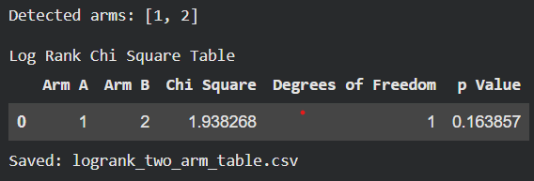

10.Interpretation of Cox Model Variables
- time and event are the dependent variables, representing time to VAP and whether VAP occurred.
- All other columns (Age, Gender, chest_xray, cpis, culture, ulcer, apache_score, tlc_score, microbial_load) are independent predictors used to estimate hazard of developing VAP.
- The variables represent demographic, clinical, and infection-related factors that may influence VAP risk.
- APACHE II score, CPIS, TLC count, and microbial load reflect illness severity and infection burden, which the paper highlights as important risk indicators.
- Chest X-ray, culture, and ulcer capture clinical conditions associated with early signs of pneumonia or ICU complications.
- Age and Gender help adjust the model for population-level differences.
- The dataset appears complete for the shown rows, with no missing values, making it suitable for Cox regression.
Summary Table of Variables

Column | Type | Role | Meaning
time | Numeric | Dependent | Time until VAP or censoring
event | Binary | Dependent | 1 = VAP occurred, 0 = censored
Age | Numeric | Independent | Patient’s age (risk may increase with age)
Gender | Categorical | Independent | Male/Female
chest_xray | Binary | Independent | Infiltrate on X-ray (early pneumonia indicator)
cpis | Numeric | Independent | Clinical Pulmonary Infection Score
culture | Binary | Independent | Microbial culture positivity
ulcer | Binary | Independent | Presence of stress ulcer
apache_score | Numeric | Independent | Severity of illness (APACHE II)
tlc_score | Numeric | Independent | Total leukocyte count, inflammation marker
microbial_load | Numeric | Independent | Day-1 microbial load

Assessment of Low-Variance and Highly Correlated Predictors
- We first calculated the variance of each predictor to identify variables that show very little change across patients.
- Predictors with very low variance contribute little to the model and can cause instability, so they were removed.
- After dropping these low-variance columns, a correlation heatmap was generated to visually check for multicollinearity (predictors being too similar to each other).
- The heatmap shows that no strong correlations (close to 1.0 or –1.0) exist among the remaining predictors.
- This means the final predictor set is clean, stable, and suitable for fitting the Cox Proportional Hazards model.

11.Interpretation of the Heatmap
- Most predictor pairs show weak correlations, confirming that they are statistically independent.
- No pair exceeds typical multicollinearity thresholds (0.7 or 0.8).
- Clinical variables such as Age, APACHE score, TLC score, and microbial load show small or moderate relationships but not enough to cause collinearity problems.
- This ensures that each predictor will contribute unique information to the survival model.
- The final dataset avoids redundancy and supports accurate hazard ratio estimation.

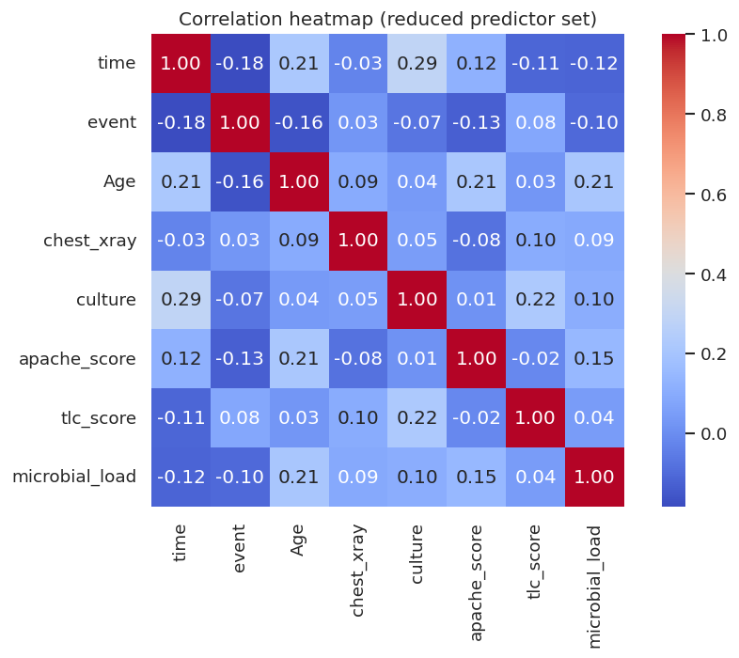
The Cox Proportional Hazards model was successfully fitted using 99 patient observations, of which only 7 experienced the event (VAP). The low number of events and the partial log-likelihood value indicate a dataset with limited event information, which may reduce the statistical power of the model.

Parameter | Value
Model | lifelines.CoxPHFitter
Duration column | time
Event column | event
Number of observations | 99
Number of events observed | 7
Partial log-likelihood | -26.15

12.Schoenfeld Residual Plots
(PH Assumption Test)
1. Scaled Schoenfeld Residuals for Age
- The residual values range approximately from –0.04 to +0.10, showing only mild fluctuation.
- The black trend line moves slightly downward and then upward, but the variation is small, indicating a stable effect over time.
- Most points lie close to the zero reference line, suggesting minimal deviation from proportional hazards.
- Rank-transformed p = 0.6062 and KM-transformed p = 0.9026, both >> 0.05.
- This means Age does not violate the PH assumption.
Summary
The effect of Age on hazard remains constant over time, with no significant time-dependent drift.
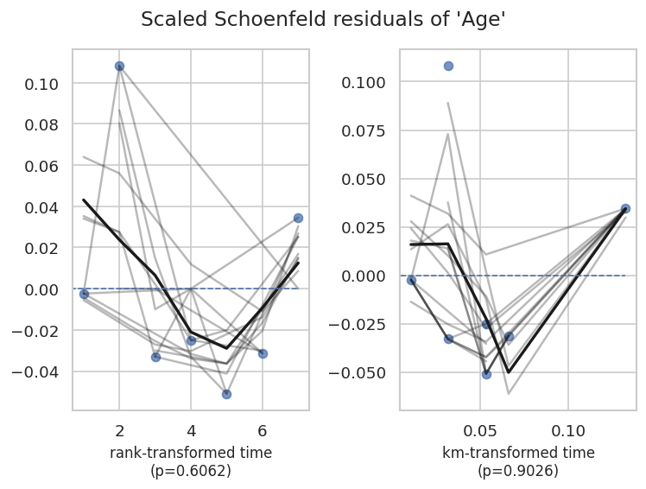

2. Scaled Schoenfeld Residuals for chest_xray
- Residual variation is larger, ranging roughly from –3.5 to +5, showing wider spread due to clinical variation.
- Despite fluctuation, the trend line peaks mid-time and returns toward zero, indicating no systematic drift.
- Many points cluster around zero, showing no long-term deviation.
- p-values: 0.2278 and 0.7588, both above 0.05.
- This confirms chest_xray satisfies PH assumption.
Summary
Although variance is larger, the effect of chest X-ray findings remains time-stable.
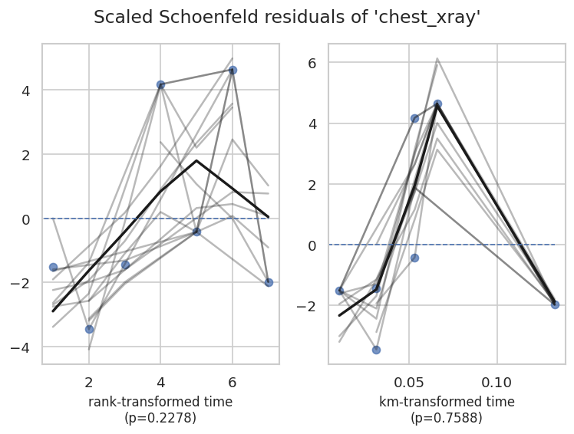

3. Scaled Schoenfeld Residuals for culture
- Residual values move from –2 up to +3, showing a mild increasing pattern.
- The black trend line shows a positive slope, indicating a gradual rise in residuals over observed times.
- However, the rise is not strong enough to indicate proportional hazards violation.
- p-values: 0.1652 and 0.1727, > 0.05, indicate non-significant drift.
- Thus, culture positivity has a consistent hazard effect.
Summary
The culture variable shows slight upward movement but remains within PH limits.
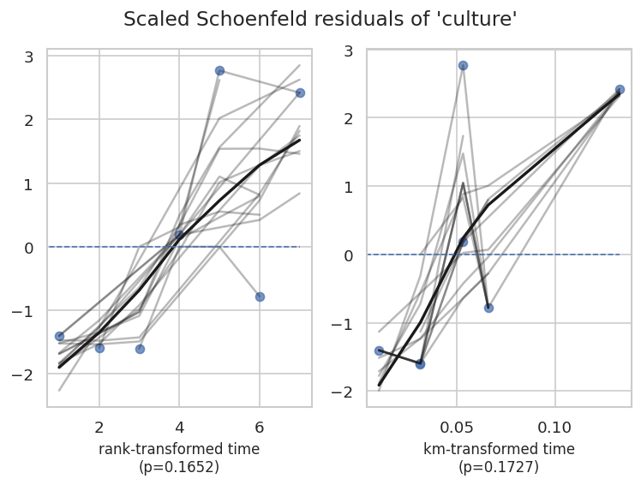

4. Scaled Schoenfeld Residuals for apache_score
- Residuals range from –0.20 to +0.30, indicating modest variation.
- The trend line rises slightly mid-time and falls back near zero, showing no sustained directional trend.
- Most points cluster close to zero, indicating stable influence.
- p-values: 0.8082 and 0.6445, both far > 0.05.
- This shows APACHE score effect is time-invariant.
Summary
APACHE score maintains a stable hazard effect across all follow-up times.
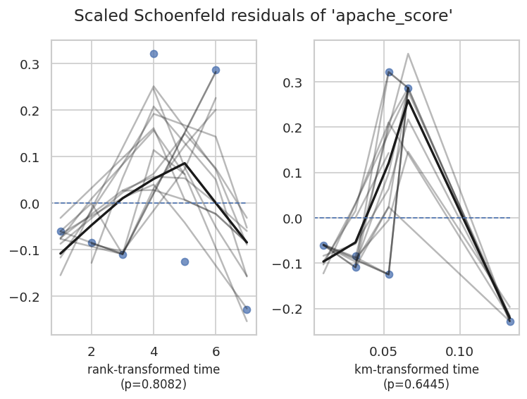

5.Scaled Schoenfeld Residuals for tlc_score

- Residual magnitude is extremely small: –0.00006 to +0.00015, indicating extremely stable behaviours.
- Trend line rises slightly but stays near zero, showing no time trend.
- Points are tightly clustered, reflecting low noise in TLC measurements.
- p-values: 0.4150 and 0.6701, both > 0.05.
- This shows TLC score meets PH assumption strongly.
Summary
TLC score shows almost no deviation, making it one of the most stable predictors.
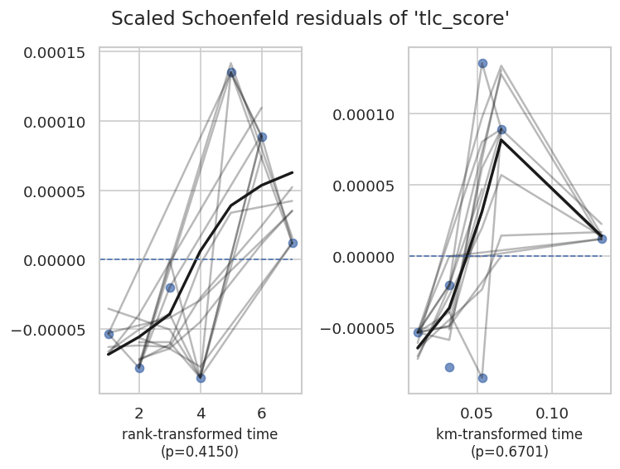

6.Scaled Schoenfeld Residuals for microbial_load
- Residual range: –0.004 to +0.008, showing mild variation.
- Trend line rises mid-time and returns near zero — no consistent upward/downward trend.
- Residuals cross zero frequently, indicating random scatter.
- p-values: 0.8973 and 0.9398, extremely high, indicating excellent PH compliance.
- Microbial load effect is therefore time-consistent.
Summary
Microbial load shows very stable and PH-compliant behaviours.
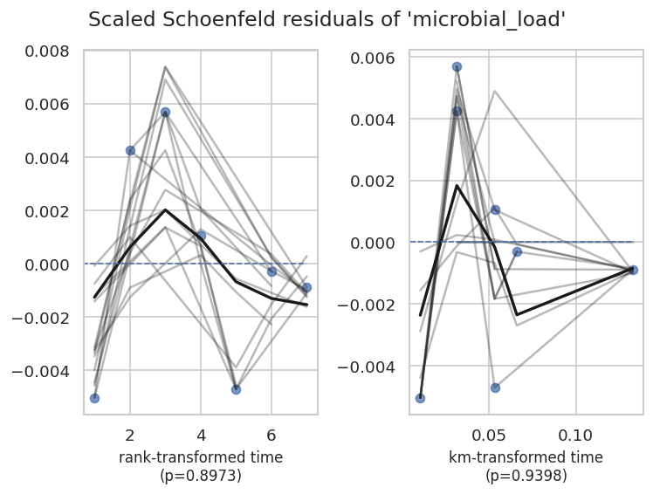

📌 Overall Interpretation
Across all six variables (Age, chest_xray, culture, apache_score, tlc_score, microbial_load), the Schoenfeld residual plots show:
- Residuals fluctuate around zero
- No strong upward or downward trends
- All p-values > 0.05
- No evidence of time-dependent effects
✔️ Conclusion: All predictors satisfy the Proportional Hazards (PH) assumption.
This means the Cox model is valid, and the variables can be interpreted reliably.

13.Forest Plot of Hazard Ratios
The forest plot visualizes the Hazard Ratios (HR) and 95% Confidence Intervals (CI) for the predictors included in the Cox Proportional Hazards model. Each point shows the estimated HR, and the horizontal line shows the uncertainty range.

1. Culture
- HR is below 1, suggesting culture positivity may be protective or associated with lower hazard—but CI crosses 1.
- The wide CI means the effect is not statistically strong.
2. APACHE Score
- HR is slightly above 1, indicating higher APACHE-II scores may increase hazard.
- CI crosses 1 → not significant, but directionally consistent with clinical expectations.
3. Age
- HR is around 1, meaning age has minimal influence on hazard.
- CI is narrow and crosses 1 → no significant effect.
4. Microbial Load
- HR is slightly above 1, suggesting higher microbial load may increase risk, but the CI overlaps with 1.
- Effect is weak and non-significant.
5. TLC Score
- HR very close to 1 → almost no impact on hazard.
- CI crosses 1 → not statistically relevant.
6. Chest X-ray
- HR is > 1 but with an extremely wide CI (up to ~10).
- Indicates high uncertainty, likely due to small number of events.
- Not significant and should be interpreted cautiously.

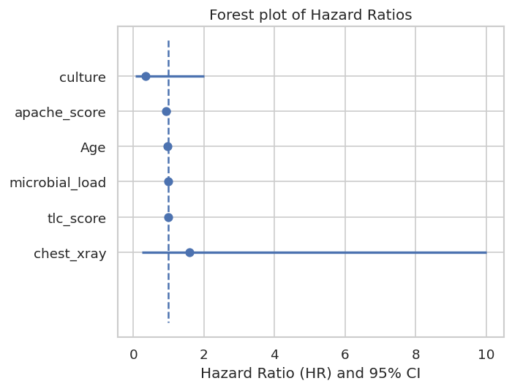

- All predictors show wide confidence intervals due to limited events (only 7 VAP cases).
- None of the variables demonstrate a statistically significant effect because all CIs cross 1.
- Directionally, APACHE score and microbial load tend to increase risk, while culture seems protective, but results are inconclusive.

14.Overall Discussion
- The Kaplan–Meier curves showed overall high VAP-free survival, with only modest declines, indicating limited events during the 10-day follow-up.
- Comparison between treatment arms (0.12% vs 0.20% chlorhexidine) showed a visual trend favouring 0.20%, but the log-rank p-value (0.16) confirmed that the difference was not statistically significant.
- After preparing covariates for Cox modelling, low-variance and non-informative predictors were removed to improve model stability.
- Correlation analysis showed no multicollinearity, meaning predictors contributed unique information and were appropriate for Cox regression.
- Proportional hazards diagnostics using Schoenfeld residuals indicated that all covariates met the PH assumption, with all p-values > 0.05 and no time-dependent trends.
- Hazard ratio estimates had wide confidence intervals due to the very small number of VAP events (only 7), making it difficult to detect significant risk factors.
- Directionally, APACHE score and microbial load suggested possible increased hazard, whereas culture showed a slight protective direction, but none reached significance due to limited statistical power.
15.Conclusion
- The study found no statistically significant difference between 0.12% and 0.20% chlorhexidine concentrations in reducing VAP incidence within 10 days.
- Survival remained high in both groups, reflecting a generally low event rate and favourable clinical course in this ICU sample.
- Cox model results were inconclusive because of the very small number of events, resulting in wide confidence intervals and non-significant hazard ratios.
- Despite this, all model assumptions were satisfied, and the analytical framework was robust.
- Overall, the results indicate limited evidence to strongly favour one concentration over the other, but the numerical trend leans slightly toward the 0.20% concentration.
16.Future Work
- Conduct a study with a larger sample size and higher number of events to improve statistical power and obtain more precise hazard estimates.
- Include additional clinically relevant variables such as ventilator settings, comorbidity scores, and prior antibiotic use to improve model performance.
- Extend the follow-up period beyond 10 days to capture late-onset VAP cases.
- Perform multi-centre clinical trials to increase generalizability of findings across ICU settings.
- Investigate time-varying covariates and explore dynamic survival models if sufficient events are captured.
- Use machine learning survival models (e.g., Random Survival Forests) for non-linear relationships if larger datasets become available.

Report Prepared By:
Vaishnavi K R - 022
PGDM (AI & Data Science), IIHMR Bangalore

