Teaching stills — contact sheet
Hormones and Peptides for Skin · stage 60 media · 48 draft stills · gemini-3.1-flash-image (Nano Banana 2), final tier, 16:9 · style anchor m1-p03. Drafts until Omar Saleem (design) and Dr. Fady Hannah-Shmouni (scientific accuracy) sign off. The pictures carry no text, numbers, doses, products or faces; all words stay in the app.
How to reply: give the moment id and “keep”, “redraw: …” or “drop”.

Module opening films (7)

Module 01 · The skin as an endocrine organ, and how it ages

Watch: https://storage.googleapis.com/perceptors-academy-hormonaly-media/assets/hormones-peptides-skin/video/m01-opener.mp4 (70 s)
Narration: approved text, verbatim (m1-p01 body, sentences 1–2; m1-p03 audioScript, sentences 1–8)
Presenter: HeyGen digital avatar; under the player: “Presented by a digital avatar (AI-generated presenter and voice).”

Module 02 · Systemic hormones and the skin

Watch: https://storage.googleapis.com/perceptors-academy-hormonaly-media/assets/hormones-peptides-skin/video/m02-opener.mp4 (76 s)
Narration: approved text, verbatim (m2-p01 body, sentences 1, 2, 3; m2-p02 audioScript, sentences 1, 2, 3, 4, 5, 6, 7)
Presenter: HeyGen digital avatar; under the player: “Presented by a digital avatar (AI-generated presenter and voice).”

Module 03 · Fat, incretins and the ageing face

Watch: https://storage.googleapis.com/perceptors-academy-hormonaly-media/assets/hormones-peptides-skin/video/m03-opener.mp4 (72 s)
Narration: approved text, verbatim (m3-p01 body, sentences 1, 2; m3-p02 audioScript, sentences 1, 2, 3, 4, 5, 6, 7, 8, 9)
Presenter: HeyGen digital avatar; under the player: “Presented by a digital avatar (AI-generated presenter and voice).”

Module 04 · Matrix peptides and wound healing

Watch: https://storage.googleapis.com/perceptors-academy-hormonaly-media/assets/hormones-peptides-skin/video/m04-opener.mp4 (67 s)
Narration: approved text, verbatim (m4-p01 body, sentences 1, 2; m4-p03 audioScript, sentences 1, 2, 3, 4, 5, 6, 7, 8)
Presenter: HeyGen digital avatar; under the player: “Presented by a digital avatar (AI-generated presenter and voice).”

Module 05 · Follicle, pigment and melanocortins

Watch: https://storage.googleapis.com/perceptors-academy-hormonaly-media/assets/hormones-peptides-skin/video/m05-opener.mp4 (71 s)
Narration: approved text, verbatim (m5-p01 body, sentences 1, 2; m5-p02 audioScript, sentences 1, 2, 3, 5, 8)
Presenter: HeyGen digital avatar; under the player: “Presented by a digital avatar (AI-generated presenter and voice).”

Module 06 · The growth-hormone axis and the skin

Watch: https://storage.googleapis.com/perceptors-academy-hormonaly-media/assets/hormones-peptides-skin/video/m06-opener.mp4 (84 s)
Narration: approved text, verbatim (m6-p01 body, sentences 1, 2, 3; m6-p02 audioScript, sentences 1, 2, 3, 4, 5, 7, 8, 9, 10)
Presenter: HeyGen digital avatar; under the player: “Presented by a digital avatar (AI-generated presenter and voice).”

Module 07 · Evidence, regulation and compliance

Watch: https://storage.googleapis.com/perceptors-academy-hormonaly-media/assets/hormones-peptides-skin/video/m07-opener.mp4 (75 s)
Narration: approved text, verbatim (m7-p01 body, sentences 1, 2; m7-p02 audioScript, sentences 1, 2, 3, 4, 5, 6, 8, 9, 10)
Presenter: HeyGen digital avatar; under the player: “Presented by a digital avatar (AI-generated presenter and voice).”

Look at these first
- m5-p14 A Wnt switch and a zinc question. — Most complex mechanism in the set: a cell-penetrating decoy peptide sits in the docking site so the grey ‘brake’ protein (CXXC5) cannot bind Dishevelled, and β-catenin tokens move into the nucleus. Confirm this reading of PTD-DBM (Lee 2017).
- m3-p08 Two gut hormones, re-engineered. — DPP-4 drawn clipping the two N-terminal residues off native GLP-1; the drug drawn with a substituted second residue and a fatty side chain. Confirm this is acceptable for semaglutide and tirzepatide at this level of detail.
- m2-p17 Freckles before the wedding. — Pedigree shows an affected father and daughter (mother unaffected). Redrawn at review: the myxoma now sits in the left atrium (the upper chamber on the viewer’s right of a textbook four-chamber cutaway, beside the pulmonary-vein openings), the commoner site; it is drawn as a small stalked mass by the septum reaching toward the mitral valve.
- m4-p03 A plasma tripeptide with a copper habit. — GHK-Cu drawn as three beads with the copper ion against the first two (Gly-His). Schematic only; confirm.
- m5-p07 Five receptors, one family of hormones. — Five receptor tiles: MC1R pigment cell, MC2R adrenal, MC3R and MC4R brain (drawn twice), MC5R sebaceous gland — the tidy map the moment itself qualifies.
- m7-p02 GRADE rates certainty in an effect, one outcome at a time. — GRADE: randomized trials on the top shelf, observational studies on the third; the model also put a small cluster on the lowest shelf (very low). Keep, or redraw with the lowest shelf empty?
- m6-p05 Deficiency is a diagnosis. Decline is ageing. — Deficiency drawn as a pituitary mass (one cause among several); normal ageing drawn as an intact gland releasing less.
- m3-p13 Ten months in, and unhappy with the mirror. — Facial fat drawn as one pad over bone; real anatomy has separate superficial and deep compartments.
- m1-p06 Read the skin before the serum. — Skin sign paired with gland: thin skin with bruising and the adrenal (cortisol excess); coarse dry skin and the thyroid; acanthosis nigricans and the pancreas (hyperinsulinaemia).
- m6-p17 Tight rings, eight months into ‘CJC/ipa’. — Tingling drawn along the thumb, index and middle fingers (median nerve) to match carpal tunnel symptoms.
- m4-p13 Rodents, a fragment, and a tripeptide. — TB-500 drawn as a seven-bead fragment lifted from the first half of a long chain (residues 17–23 of thymosin β4); KPV as the last three beads of α-MSH.
- m5-p05 Work up the hair loss before anyone mentions a peptide. — Four hair-loss patterns seen from above: male pattern, diffuse shedding, an alopecia areata patch, female-pattern widened parting. The front of three ovals is bare (forehead).
- m2-p13 Some syndromes show on the skin first. — Only the MEN2A example is drawn: interscapular cutaneous lichen amyloidosis linked to the thyroid.
- m2-p11 Symptoms and bone. Skin is a bystander. — Two of the approved uses drawn (vasomotor symptoms, bone); vulvovaginal symptoms are left to the text.
- m2-p15 The everyday endocrine signs. — Three of the named signs drawn: palm creases (adrenal), acanthosis nigricans at the back of the neck, a pretibial plaque; hirsutism and hypothyroid skin are left to the text.

Module 01 · The skin as an endocrine organ, and how it ages

m1-p03 · Four units, one circuit.
03 / 19 · Lesson 1.1 · Concept · Lesson 1.1 · The skin as a steroidogenic, endocrine organ
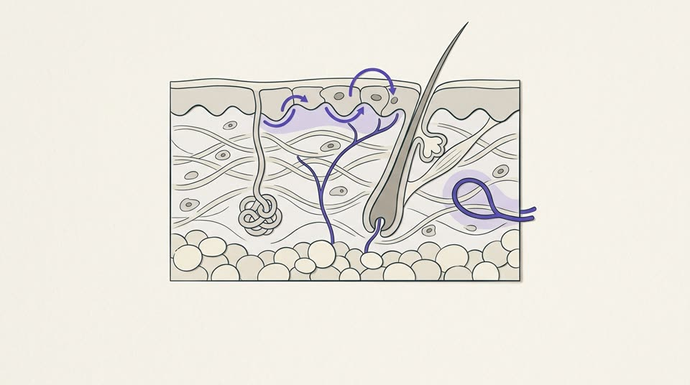
Teaches: Skin as a neuro-immuno-endocrine organ: four units, three signalling routes (neighbouring cells, nerves, blood); mostly cell, tissue and animal evidence.
Alt text: A cross-section of skin showing the epidermis, dermis, fat layer and a hair follicle with its glands, with signals passing between cells, along a nerve and into a blood vessel.
assets/hormones-peptides-skin/images/m1-p03-img.jpg · draft

m1-p06 · Read the skin before the serum.
06 / 19 · What changes in practice · Lesson 1.1 · The skin as a steroidogenic, endocrine organ
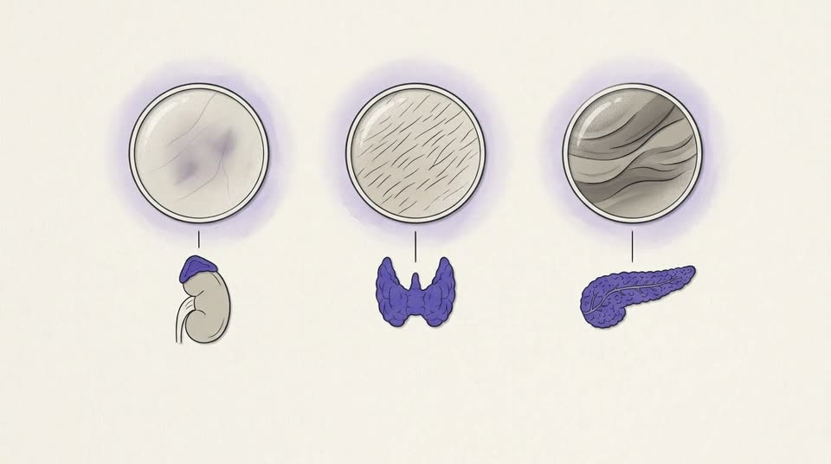
Teaches: The aesthetic exam as a systemic screen: thinning and bruising, coarse dry skin and acanthosis nigricans point to cortisol, thyroid and insulin; some signs mean prompt referral.
Alt text: Three magnified patches of skin — thin with a bruise, coarse and dry, velvety and dark — each linked to the gland it points to: an adrenal gland, the thyroid and the pancreas.
Check first: Skin sign paired with gland: thin skin with bruising and the adrenal (cortisol excess); coarse dry skin and the thyroid; acanthosis nigricans and the pancreas (hyperinsulinaemia).
assets/hormones-peptides-skin/images/m1-p06-img.jpg · draft

m1-p08 · A map of fourteen million cells.
08 / 19 · Lesson 1.2 · Concept · Lesson 1.2 · The Hormone Cell Atlas: receptor maps and what they prove
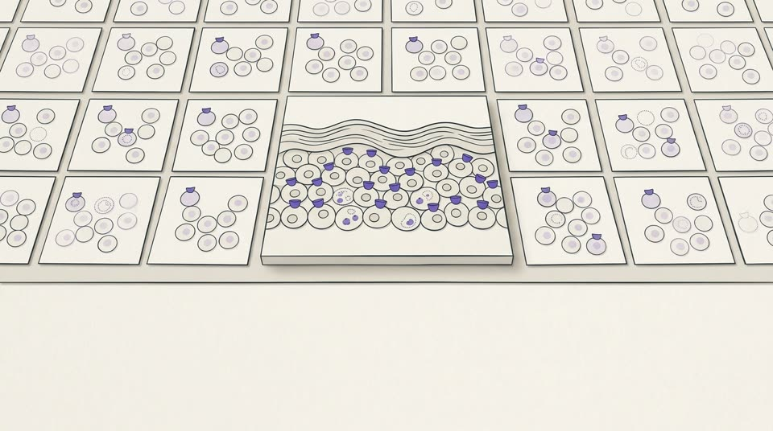
Teaches: The Hormone Cell Atlas read hormone and receptor RNA cell by cell across human tissues: a map of predicted capacity, not measured hormone release.
Alt text: A grid of small tissue tiles with a skin tile at the centre, where some cells carry receptor cups and a few hold outlined granules, marking cells predicted to respond to or make a hormone.
assets/hormones-peptides-skin/images/m1-p08-img.jpg · draft

m1-p11 · A map to confirm, then a trial.
11 / 19 · What changes in practice · Lesson 1.2 · The Hormone Cell Atlas: receptor maps and what they prove
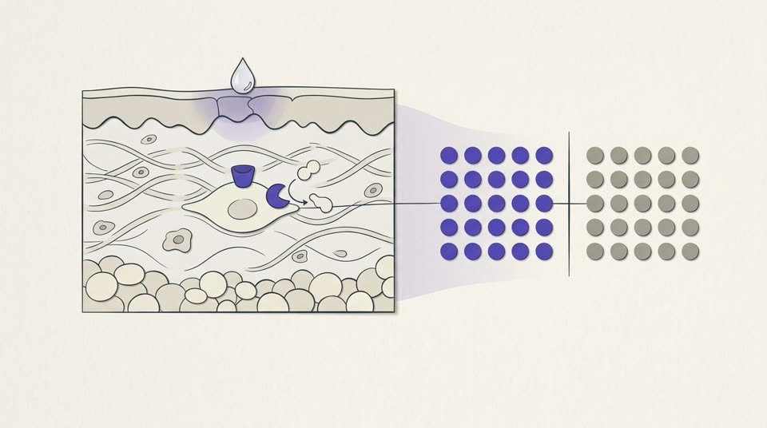
Teaches: A receptor on a map is where an efficacy question starts; skin enzymes change potency; only a human trial answers it (sunscreen and vitamin D as the example).
Alt text: A droplet on the skin reaches a cell’s receptor while an enzyme reshapes a passing molecule, and a line leads to two matched groups of dots standing for a randomized trial.
assets/hormones-peptides-skin/images/m1-p11-img.jpg · draft

m1-p13 · Cells that stop dividing and keep talking.
13 / 19 · Lesson 1.3 · Concept · Lesson 1.3 · Senescence, the SASP and the ageing dermis
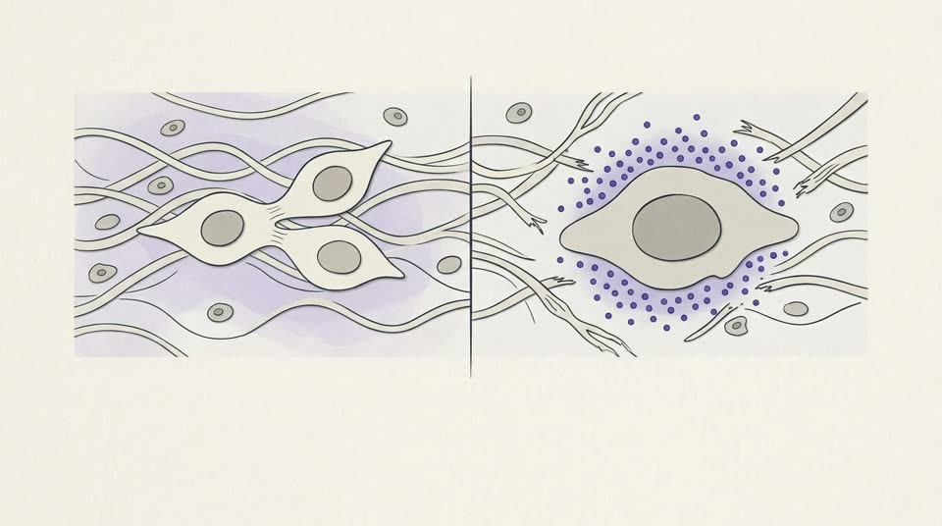
Teaches: Senescent cells stop dividing but keep secreting cytokines, enzymes and growth factors (the SASP); p16-positive cells become more common with age in human skin.
Alt text: On the left a cell divides into two; on the right a larger, flattened cell has stopped dividing and releases a cloud of small particles into the frayed fibres around it.
assets/hormones-peptides-skin/images/m1-p13-img.jpg · draft

m1-p16 · The levers with trials behind them.
16 / 19 · Where the evidence is strongest · Lesson 1.3 · Senescence, the SASP and the ageing dermis
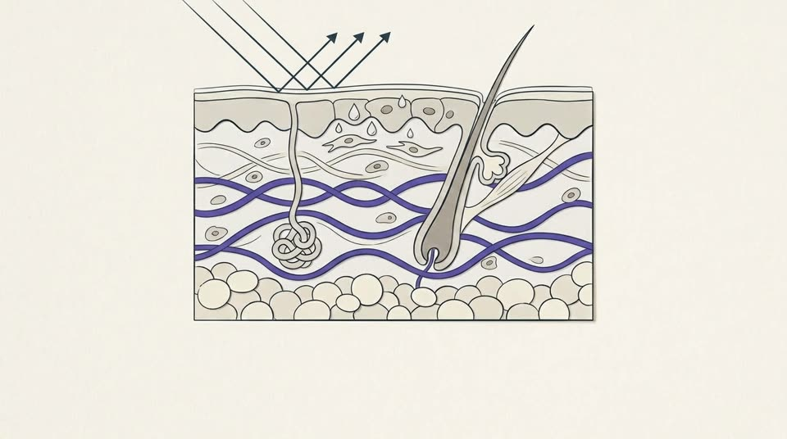
Teaches: The levers with randomized trials: daily sunscreen (B) and topical retinoids (tretinoin, guide A; retinol C); senotherapies are biomarker pilots.
Alt text: A skin cross-section with a thin protective film turning back sun rays and a few drops soaking in, above dense, orderly collagen in the dermis.
assets/hormones-peptides-skin/images/m1-p16-img.jpg · draft

m1-p17 · ‘Can a senolytic fix my skin?’
17 / 19 · Fictional case · Lesson 1.3 · Senescence, the SASP and the ageing dermis
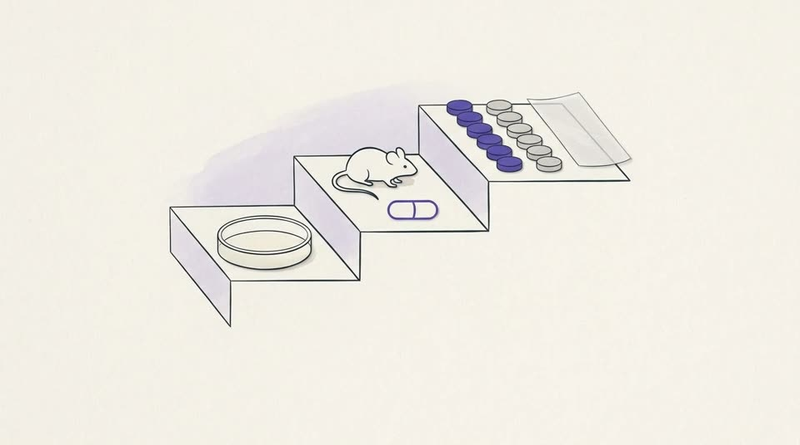
Teaches: Fictional case: senolytic supplements rest on mouse data and small human pilots; daily sunscreen and topical retinoids have randomized trials with visible outcomes.
Alt text: Three steps of evidence, from a culture dish to a mouse to a human trial; an unmarked capsule sits on the mouse step, while a sun-protection film sits on the top step.
assets/hormones-peptides-skin/images/m1-p17-img.jpg · draft

Module 02 · Systemic hormones and the skin

m2-p02 · The skin regenerates its own cortisol.
02 / 19 · Mechanism · Lesson 2.1 · Cortisol signatures: local 11β-HSD1 and Cushing’s syndrome
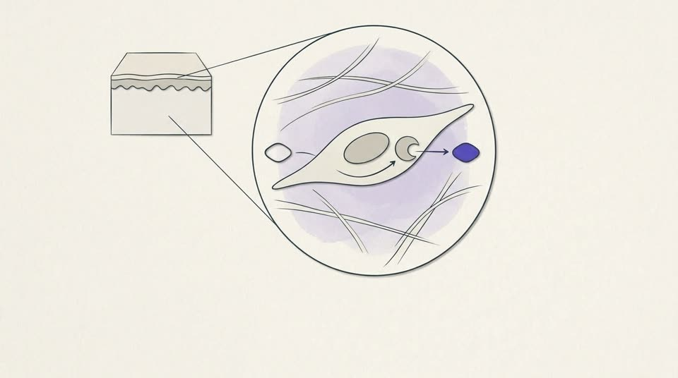
Teaches: Skin regenerates cortisol from cortisone with 11β-HSD1, more with age and sun exposure; cortisol slows collagen synthesis; visible ageing in people is untested.
Alt text: A magnified skin cell in which an enzyme turns an inactive hormone into its active form, surrounded by thin, sparse collagen fibres.
assets/hormones-peptides-skin/images/m2-p02-img.jpg · draft

m2-p06 · Reassure the many, refer the few.
06 / 19 · What changes in practice · Lesson 2.1 · Cortisol signatures: local 11β-HSD1 and Cushing’s syndrome
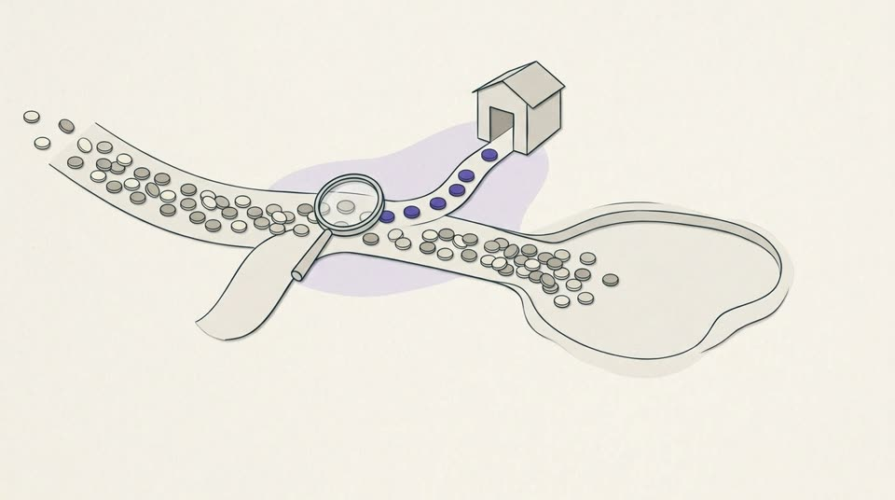
Teaches: ‘Cortisol face’: take the glucocorticoid history, look for discriminating features, reassure most, and route the few to formal testing and an endocrinologist.
Alt text: A stream of tokens passes under a lens; most continue into a calm pool, while a few violet tokens turn onto a path toward a small building.
assets/hormones-peptides-skin/images/m2-p06-img.jpg · draft

m2-p08 · Estrogen and the dermis.
08 / 19 · Lesson 2.2 · Concept · Lesson 2.2 · Estrogen, menopause and dermal collagen
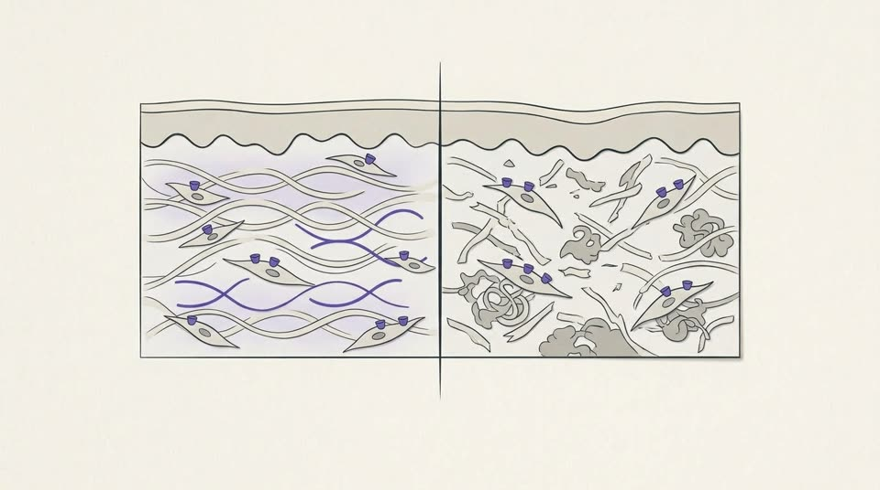
Teaches: Estrogen receptors sit in all skin; topical estradiol raised collagen in sun-protected but not photoaged skin; skin collagen falls with years since menopause.
Alt text: Two panels of dermis: in sun-protected skin, receptor-bearing cells lay down new collagen; in sun-damaged skin, the same cells sit among fragmented, clumped fibres with no new collagen.
assets/hormones-peptides-skin/images/m2-p08-img.jpg · draft

m2-p11 · Symptoms and bone. Skin is a bystander.
11 / 19 · Regulatory status and indications · Lesson 2.2 · Estrogen, menopause and dermal collagen
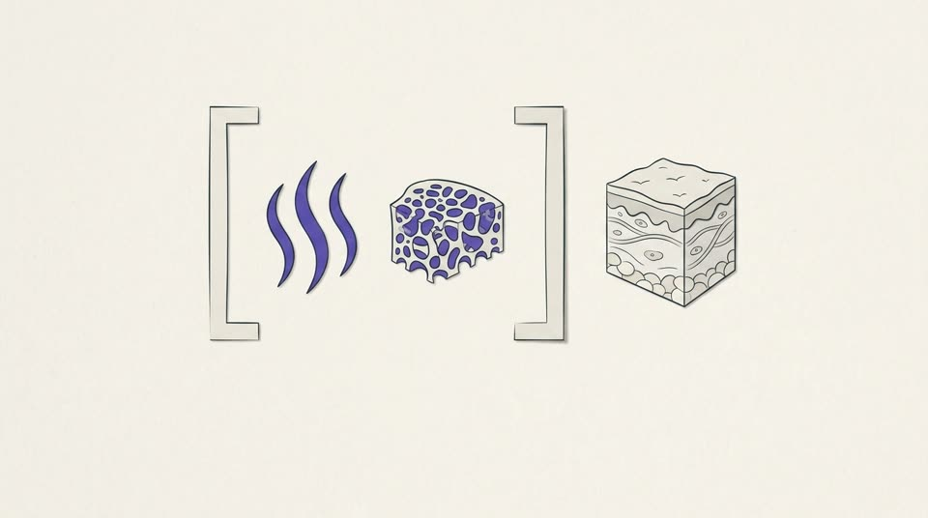
Teaches: US and UK menopausal hormone therapy is approved for symptoms and bone protection; the 2025–26 US label changes did not add skin; compounded ‘bioidentical’ products lack data.
Alt text: An open frame holds rising heat lines and a piece of spongy bone, while a small block of skin sits outside it, drawn in grey.
Check first: Two of the approved uses drawn (vasomotor symptoms, bone); vulvovaginal symptoms are left to the text.
assets/hormones-peptides-skin/images/m2-p11-img.jpg · draft

m2-p13 · Some syndromes show on the skin first.
13 / 19 · Lesson 2.3 · Concept · Lesson 2.3 · Skin hallmarks of inherited and systemic endocrinopathies
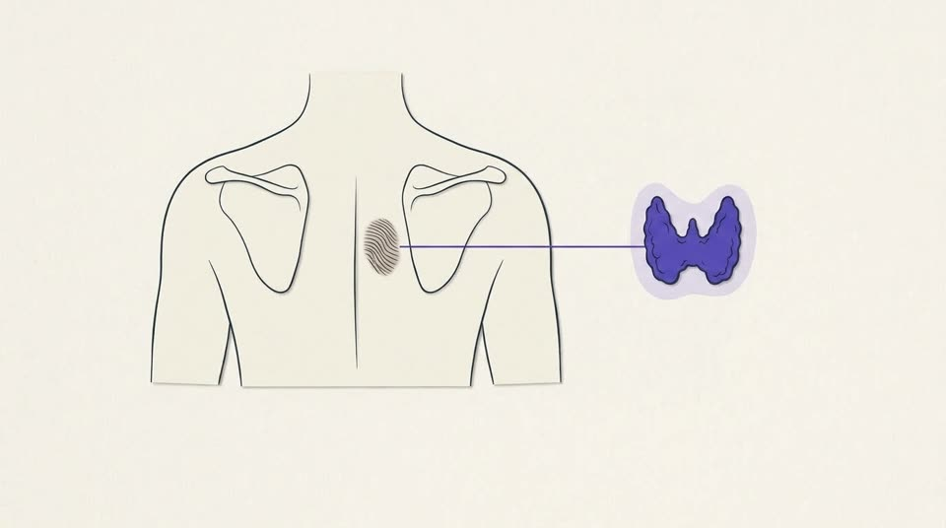
Teaches: Some inherited endocrine syndromes show on the skin first: MEN1 angiofibromas, Carney complex lentigines and myxomas, MEN2A lichen amyloidosis before thyroid cancer.
Alt text: An upper back seen from behind with a rippled, pigmented patch between the shoulder blades, linked by a fine line to a drawing of the thyroid gland.
Check first: Only the MEN2A example is drawn: interscapular cutaneous lichen amyloidosis linked to the thyroid.
assets/hormones-peptides-skin/images/m2-p13-img.jpg · draft

m2-p15 · The everyday endocrine signs.
15 / 19 · Concept · Lesson 2.3 · Skin hallmarks of inherited and systemic endocrinopathies
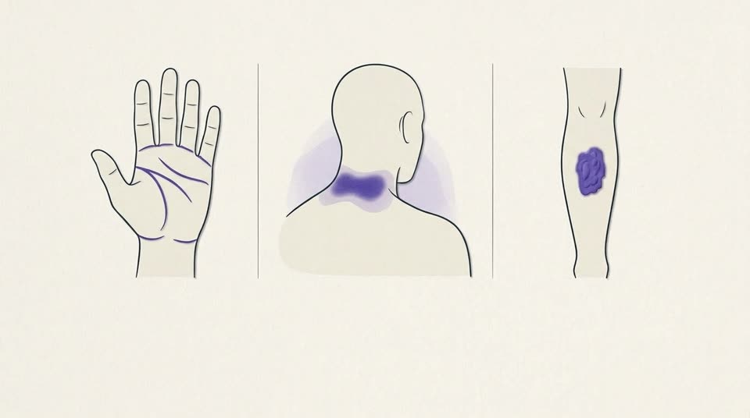
Teaches: Everyday endocrine signs: adrenal darkening in creases, fast or virilising hirsutism, acanthosis nigricans, pretibial myxoedema, cold dry hypothyroid skin.
Alt text: Three body-part outlines with typical sites marked: the palm creases, a velvety patch at the back of the neck, and a raised plaque on the front of the shin.
Check first: Three of the named signs drawn: palm creases (adrenal), acanthosis nigricans at the back of the neck, a pretibial plaque; hirsutism and hypothyroid skin are left to the text.
assets/hormones-peptides-skin/images/m2-p15-img.jpg · draft

m2-p17 · Freckles before the wedding.
17 / 19 · Fictional case · Lesson 2.3 · Skin hallmarks of inherited and systemic endocrinopathies
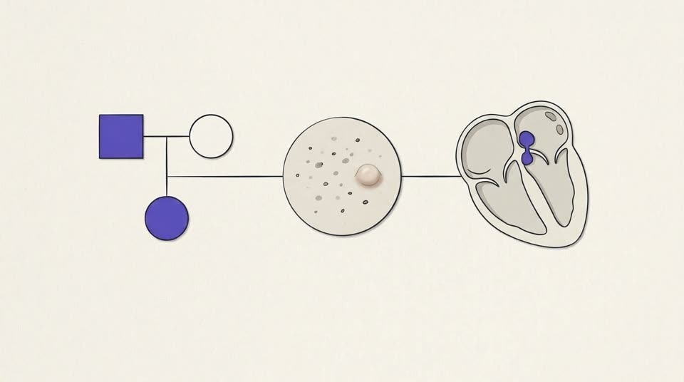
Teaches: Fictional case: lip and canthal lentigines, an eyelid papule and a father’s heart tumour suggest Carney complex; specialist assessment before any laser.
Alt text: A pedigree with an affected father and daughter, a patch of skin with small dark spots and a soft bump, and a heart with a small mass in its left upper chamber, linked by one line.
Check first: Pedigree shows an affected father and daughter (mother unaffected). Redrawn at review: the myxoma now sits in the left atrium (the upper chamber on the viewer’s right of a textbook four-chamber cutaway, beside the pulmonary-vein openings), the commoner site; it is drawn as a small stalked mass by the septum reaching toward the mitral valve.
assets/hormones-peptides-skin/images/m2-p17-img.jpg · draft

Module 03 · Fat, incretins and the ageing face

m3-p02 · The skin keeps its own fat.
02 / 20 · Mechanism · Lesson 3.1 · Dermal fat and matrix glycation
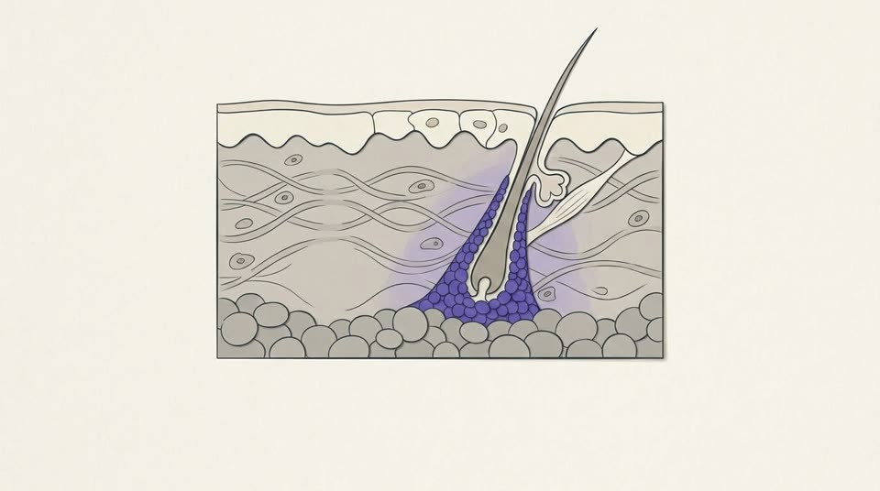
Teaches: Dermal white adipose tissue: a fat layer inside the dermis, in cones around follicles in humans; antimicrobial in mice; its part in human skin ageing is unmeasured.
Alt text: A skin cross-section in which a cone of small fat cells surrounds the lower hair follicle inside the dermis, separate from the fat layer beneath.
assets/hormones-peptides-skin/images/m3-p02-img.jpg · draft

m3-p04 · Sugar that sticks to collagen.
04 / 20 · Mechanism · Lesson 3.1 · Dermal fat and matrix glycation
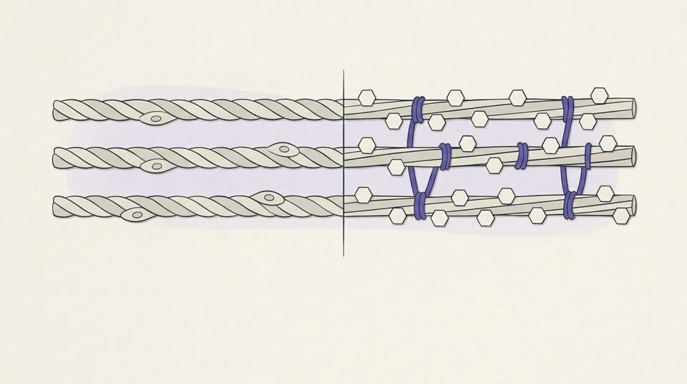
Teaches: Glycation: sugars bind collagen and end as AGEs that cross-link and stiffen the matrix; RAGE signalling in lab studies; the causal link to visible ageing is graded D.
Alt text: On the left, parallel collagen fibres lie free; on the right, the same fibres carry small sugar rings and are tied together by short cross-links.
assets/hormones-peptides-skin/images/m3-p04-img.jpg · draft

m3-p08 · Two gut hormones, re-engineered.
08 / 20 · Lesson 3.2 · Concept · Lesson 3.2 · Incretin therapy and the changing face
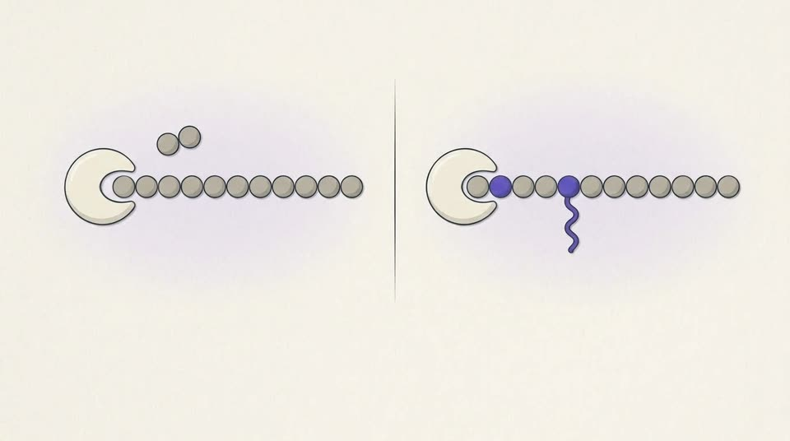
Teaches: GLP-1 and GIP are incretins; native GLP-1 is cleared within minutes by DPP-4; semaglutide and tirzepatide are engineered to last, for approved indications.
Alt text: On the left an enzyme clips a pair of units off the end of a natural hormone chain; on the right a modified chain with an altered unit and a fatty tail resists the enzyme and stays whole.
Check first: DPP-4 drawn clipping the two N-terminal residues off native GLP-1; the drug drawn with a substituted second residue and a fatty side chain. Confirm this is acceptable for semaglutide and tirzepatide at this level of detail.
assets/hormones-peptides-skin/images/m3-p08-img.jpg · draft

m3-p12 · Counsel before, record during, refer when asked.
12 / 20 · What changes in practice · Lesson 3.2 · Incretin therapy and the changing face

Teaches: On GLP-1 drugs: counsel before treatment, photograph with consent during, refer restoration requests; restoration advice is expert opinion.
Alt text: A path passes two blank conversation cards, a camera pointed at a blank frame, and an open door into another room.
assets/hormones-peptides-skin/images/m3-p12-img.jpg · draft

m3-p13 · Ten months in, and unhappy with the mirror.
13 / 20 · Fictional case · Lesson 3.2 · Incretin therapy and the changing face
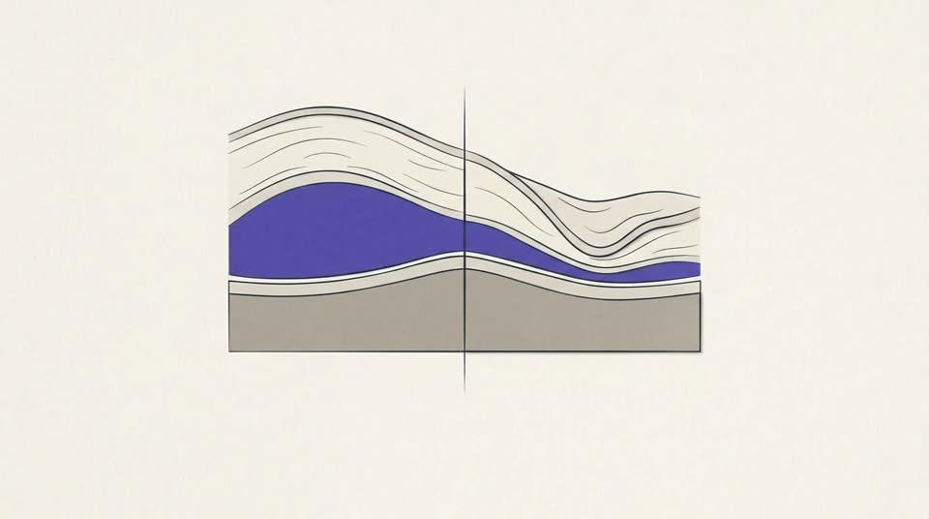
Teaches: Fictional case: facial volume loss and shedding on an effective, approved GLP-1 drug — counsel, record and refer; whether to stop belongs with her prescriber.
Alt text: Two cross-sections of cheek tissue over bone: one with a full fat pad under the skin, the other with a thinner pad and looser skin above it.
Check first: Facial fat drawn as one pad over bone; real anatomy has separate superficial and deep compartments.
assets/hormones-peptides-skin/images/m3-p13-img.jpg · draft

m3-p15 · Inflammation that comes with age.
15 / 20 · Lesson 3.3 · Concept · Lesson 3.3 · Gut barrier, endotoxaemia and inflammaging
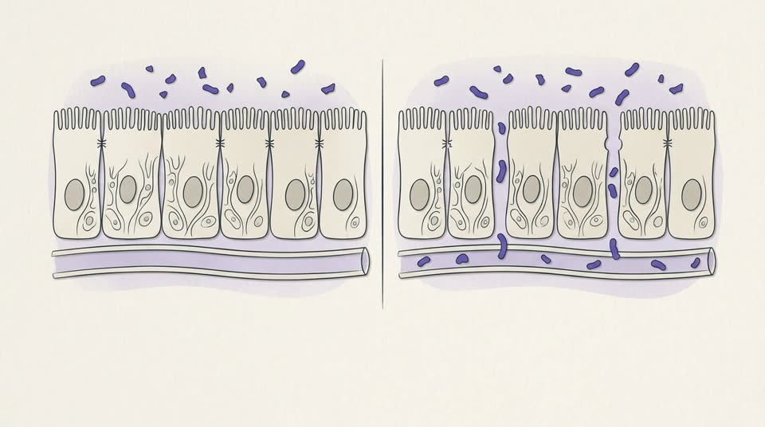
Teaches: Inflammaging and the gut hypothesis: bacterial LPS crossing a leaky barrier, shown in mice and briefly after a fatty meal; not shown to drive skin disease.
Alt text: Two views of the gut lining: one with closed junctions keeping small bacterial fragments out, the other with loosened junctions letting them pass into a blood vessel.
assets/hormones-peptides-skin/images/m3-p15-img.jpg · draft

m3-p18 · Diet first, a bottle last.
18 / 20 · What changes in practice · Lesson 3.3 · Gut barrier, endotoxaemia and inflammaging
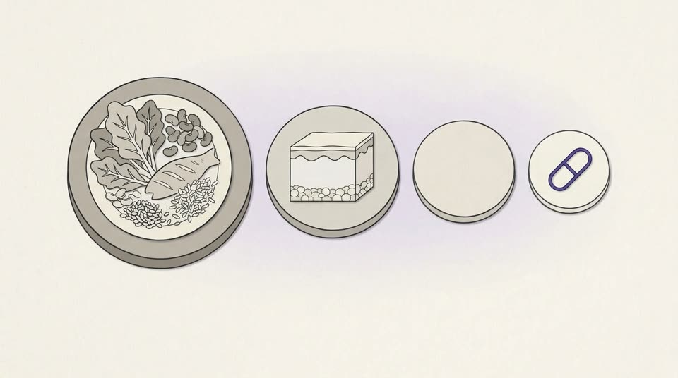
Teaches: Gut and skin: diet quality, metabolic care and established skin treatment come first; a zonulin test cannot show a leaky gut; gut-repair peptides last, if at all.
Alt text: A row of stepping stones leads from a plate of whole foods, past a small block of skin, to a single unmarked capsule on the last, smallest stone.
assets/hormones-peptides-skin/images/m3-p18-img.jpg · draft

Module 04 · Matrix peptides and wound healing

m4-p03 · A plasma tripeptide with a copper habit.
03 / 19 · Mechanism · Lesson 4.1 · Copper peptides: GHK and GHK-Cu
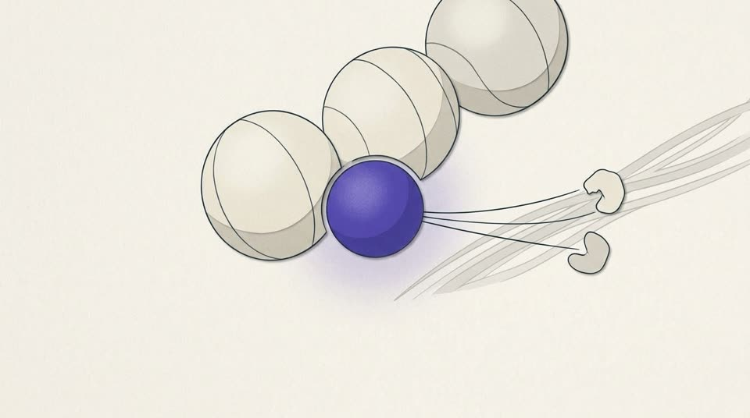
Teaches: GHK-Cu: a plasma tripeptide that binds copper; the proposed copper-delivery and gene-expression mechanism comes largely from its discoverer’s group.
Alt text: A three-bead peptide holds a copper ion, with fine lines toward the collagen fibres and enzymes it is proposed to supply.
Check first: GHK-Cu drawn as three beads with the copper ion against the first two (Gly-His). Schematic only; confirm.
assets/hormones-peptides-skin/images/m4-p03-img.jpg · draft

m4-p06 · Serum yes, syringe no.
06 / 19 · What changes in practice · Lesson 4.1 · Copper peptides: GHK and GHK-Cu
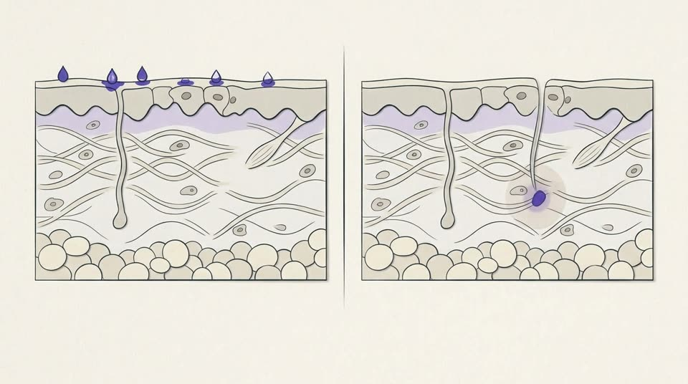
Teaches: Topical GHK-Cu is a reasonable cosmetic conversation (C); injected GHK-Cu has no trials, irritates tissue, and in the US sits outside the Category 1 listing.
Alt text: Two skin cross-sections: drops resting on the surface on the left, and a deposit deep in the dermis with a ring of irritated tissue on the right.
assets/hormones-peptides-skin/images/m4-p06-img.jpg · draft

m4-p08 · Three families, one question: who ran the trial?
08 / 19 · Lesson 4.2 · Concept · Lesson 4.2 · Signal peptides, oral collagen and SNAP-25 mimics
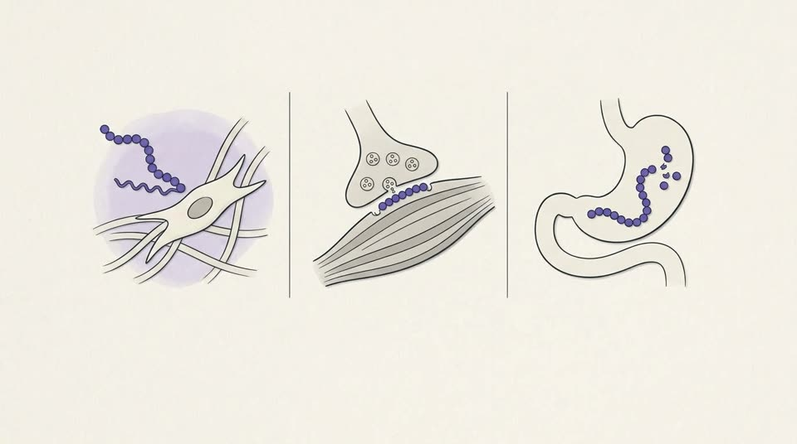
Teaches: Three families — signal peptides, SNAP-25 mimics, oral collagen — all have trial records; the question that matters most is who funded them.
Alt text: Three vignettes: a fatty-tailed peptide near a skin fibroblast, a peptide at a nerve-muscle junction, and a collagen chain breaking into small pieces in the gut.
assets/hormones-peptides-skin/images/m4-p08-img.jpg · draft

m4-p11 · Cosmetic, supplement, drug: three rulebooks.
11 / 19 · What changes in practice · Lesson 4.2 · Signal peptides, oral collagen and SNAP-25 mimics
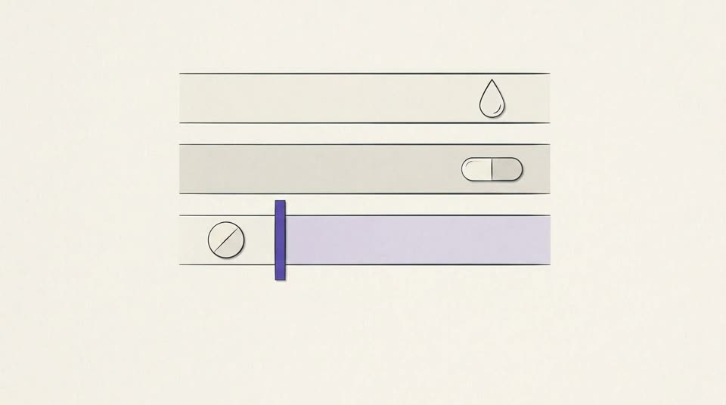
Teaches: Cosmetic, supplement, drug: in the US and UK, cosmetic peptides and oral collagen reach sale without proving efficacy; only drugs pass an approval gate.
Alt text: Three lanes: a droplet and a capsule pass freely, while a tablet waits at a violet barrier across the third lane.
assets/hormones-peptides-skin/images/m4-p11-img.jpg · draft

m4-p13 · Rodents, a fragment, and a tripeptide.
13 / 19 · Lesson 4.3 · Concept · Lesson 4.3 · Repair peptides and the compounding line
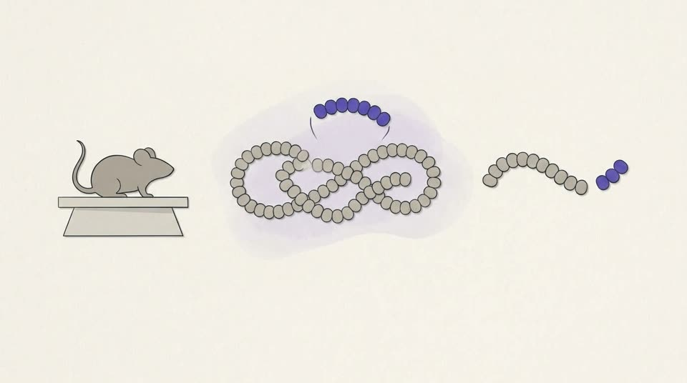
Teaches: BPC-157 rests on rodent studies and case series; TB-500 is a seven-residue fragment of thymosin β4, never trialled; KPV is α-MSH’s end tripeptide with no human RCT.
Alt text: A mouse on a lab plinth, a long peptide chain with a short fragment lifted out, and a shorter chain with its last three beads set apart.
Check first: TB-500 drawn as a seven-bead fragment lifted from the first half of a long chain (residues 17–23 of thymosin β4); KPV as the last three beads of α-MSH.
assets/hormones-peptides-skin/images/m4-p13-img.jpg · draft

m4-p17 · New dark patches, three months into ‘GLOW’.
17 / 19 · Fictional case · Lesson 4.3 · Repair peptides and the compounding line
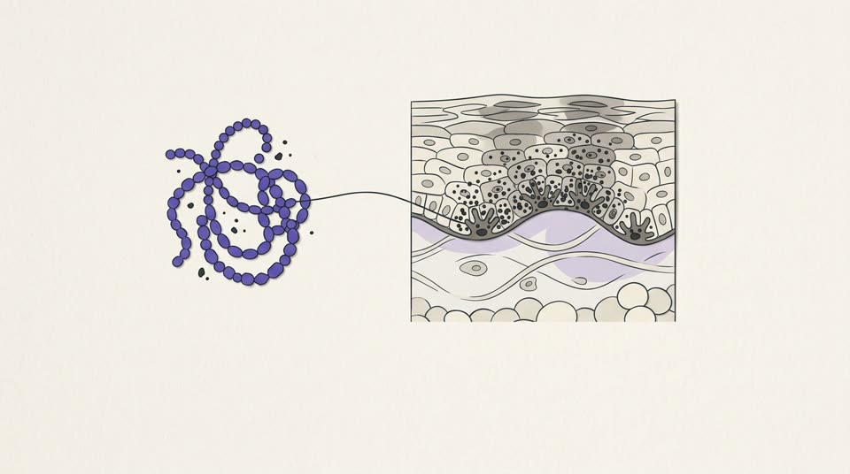
Teaches: Fictional case: a research-use-only three-peptide blend and new patchy pigmentation; no trial tests the blend; impurity and mislabelling are documented.
Alt text: A tangle of three different peptides with stray specks among them, linked to a skin cross-section where pigment cells at the base of the epidermis are crowded with dark granules.
assets/hormones-peptides-skin/images/m4-p17-img.jpg · draft

Module 05 · Follicle, pigment and melanocortins

m5-p02 · A follicle that runs its own hormones.
02 / 19 · Mechanism · Lesson 5.1 · The hair follicle as an endocrine mini-organ
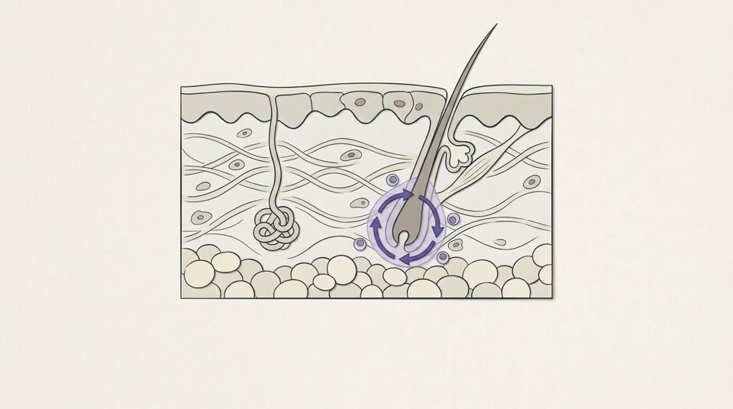
Teaches: The follicle runs its own stress axis and GH/IGF-1 loop; local DHT drives pattern hair loss; alopecia areata follows the collapse of immune privilege.
Alt text: A hair follicle with a closed feedback loop drawn around its bulb, which sits inside a faint protective shell that keeps nearby immune cells out.
assets/hormones-peptides-skin/images/m5-p02-img.jpg · draft

m5-p05 · Work up the hair loss before anyone mentions a peptide.
05 / 19 · What changes in practice · Lesson 5.1 · The hair follicle as an endocrine mini-organ
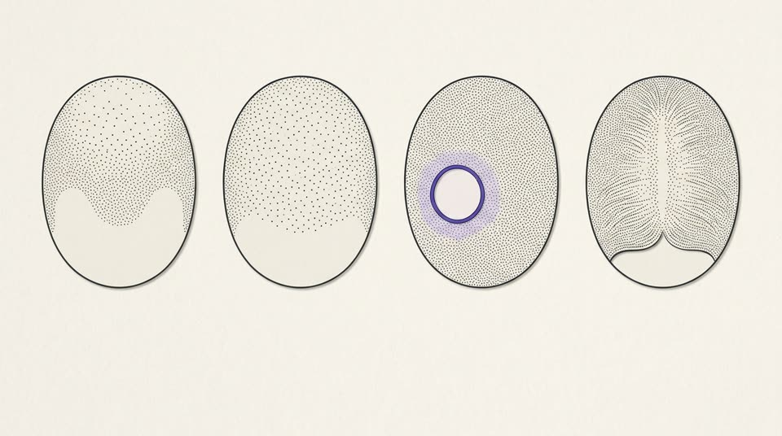
Teaches: Work up hair loss first — pattern, trigger, patches, androgens; minoxidil (men and women) and finasteride (men) have pooled trial support; refer severe alopecia areata.
Alt text: Four views of the scalp from above: thinning at the crown and front, even thinning everywhere, one round bare patch, and a widened central parting.
Check first: Four hair-loss patterns seen from above: male pattern, diffuse shedding, an alopecia areata patch, female-pattern widened parting. The front of three ovals is bare (forehead).
assets/hormones-peptides-skin/images/m5-p05-img.jpg · draft

m5-p07 · Five receptors, one family of hormones.
07 / 19 · Lesson 5.2 · Concept · Lesson 5.2 · Melanocortins: approved afamelanotide and gray-market Melanotan II
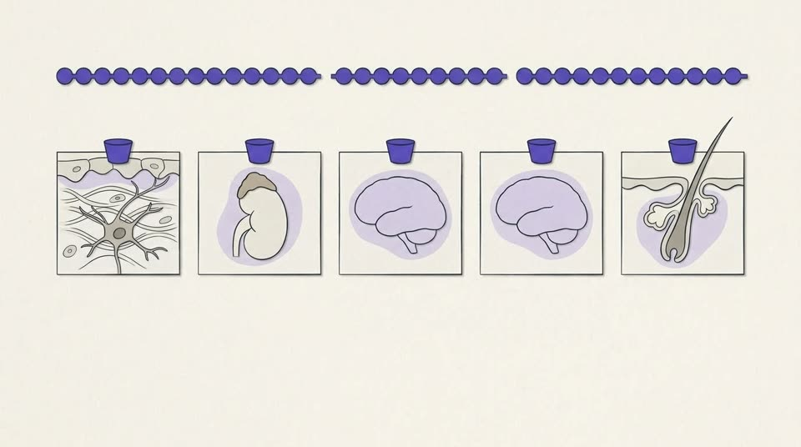
Teaches: POMC yields ACTH, α-MSH and β-endorphin; five melanocortin receptors (pigment, adrenal, two in the brain, sebum); which receptors a drug reaches decides its effects.
Alt text: A precursor peptide cut into three pieces above a row of five receptor tiles: a pigment cell, an adrenal gland, the brain twice, and a sebaceous gland.
Check first: Five receptor tiles: MC1R pigment cell, MC2R adrenal, MC3R and MC4R brain (drawn twice), MC5R sebaceous gland — the tidy map the moment itself qualifies.
assets/hormones-peptides-skin/images/m5-p07-img.jpg · draft

m5-p10 · What the case reports show.
10 / 19 · Safety signals · Lesson 5.2 · Melanocortins: approved afamelanotide and gray-market Melanotan II
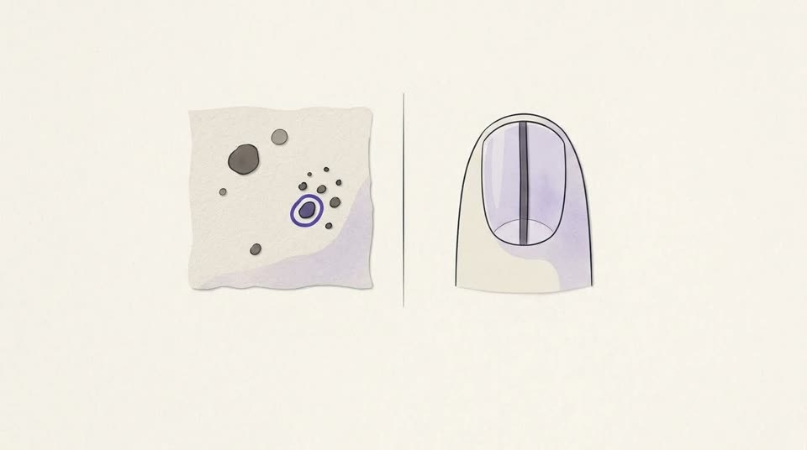
Teaches: Melanotan II harms come from case reports: darkening and new naevi, nail bands, melanomas without proven causation, and systemic emergencies.
Alt text: A patch of skin with darkened, varied moles and a crop of new small ones, beside a fingernail with a dark band running along its length.
assets/hormones-peptides-skin/images/m5-p10-img.jpg · draft

m5-p11 · New moles after a summer of tanning shots.
11 / 19 · Fictional case · Lesson 5.2 · Melanocortins: approved afamelanotide and gray-market Melanotan II
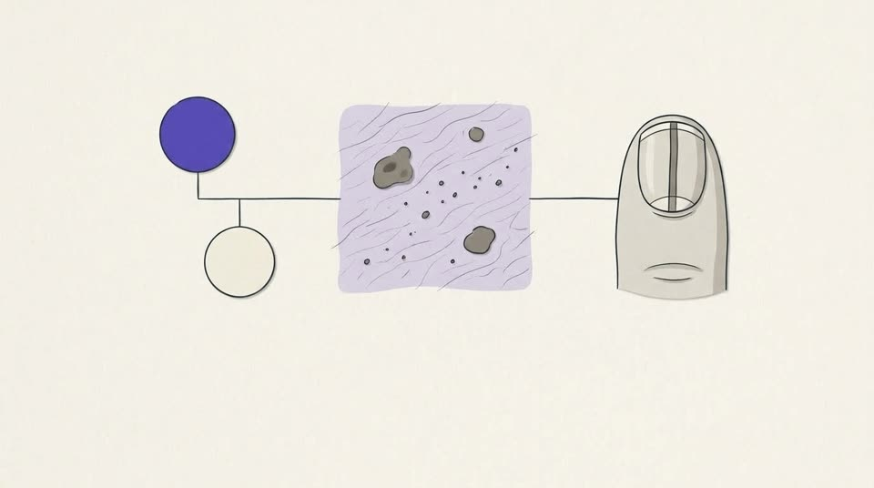
Teaches: Fictional case: tanning-peptide injections, new and darker naevi, a nail band and a mother with melanoma — an absolute contraindication in the guide.
Alt text: A mother-and-daughter pedigree with the mother marked, a patch of skin with darker and new moles, and a fingernail with a dark band.
assets/hormones-peptides-skin/images/m5-p11-img.jpg · draft

m5-p14 · A Wnt switch and a zinc question.
14 / 19 · Lesson 5.3 · Concept · Lesson 5.3 · Investigational hair peptides and how to grade them
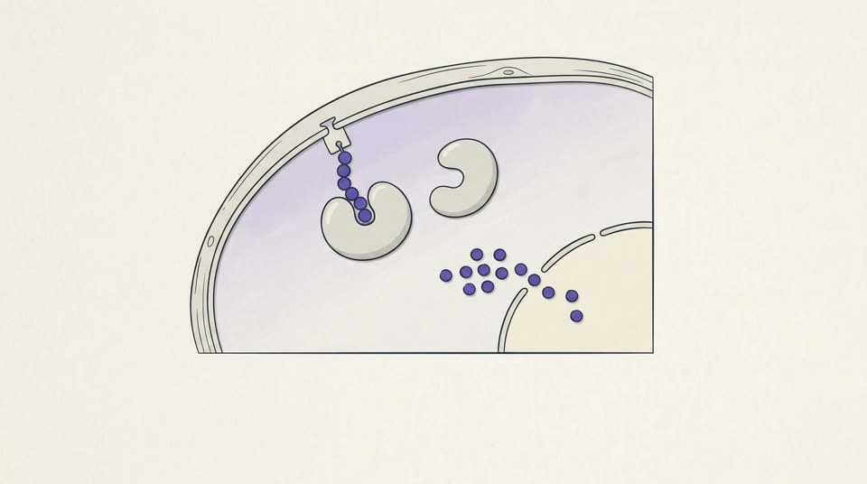
Teaches: PTD-DBM keeps CXXC5 off Dishevelled so Wnt/β-catenin signalling rises; hair regrew in mice (developer’s group); zinc thymulin has no defined mechanism.
Alt text: Inside a cell, a small decoy peptide keeps a brake protein from docking on a signalling protein, and small signal tokens move into the nucleus.
Check first: Most complex mechanism in the set: a cell-penetrating decoy peptide sits in the docking site so the grey ‘brake’ protein (CXXC5) cannot bind Dishevelled, and β-catenin tokens move into the nucleus. Confirm this reading of PTD-DBM (Lee 2017).
assets/hormones-peptides-skin/images/m5-p14-img.jpg · draft

m5-p17 · When the request is a compounded hair spray.
17 / 19 · What changes in practice · Lesson 5.3 · Investigational hair peptides and how to grade them
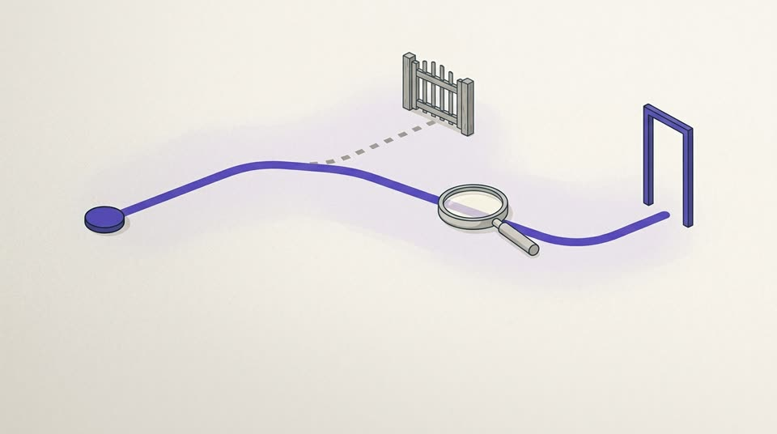
Teaches: A compounded hair spray: thymulin is in US Category 3, PTD-DBM on no list, both grade D; in the UK an unlicensed special; return to diagnosis and approved options.
Alt text: A violet path passes under a magnifying lens to an open doorway, while a dashed side branch stops at a closed gate.
assets/hormones-peptides-skin/images/m5-p17-img.jpg · draft

Module 06 · The growth-hormone axis and the skin

m6-p02 · Two hormones, two layers of skin.
02 / 19 · Lesson 6.1 · Mechanism · Lesson 6.1 · Growth hormone and IGF-1 in skin homeostasis
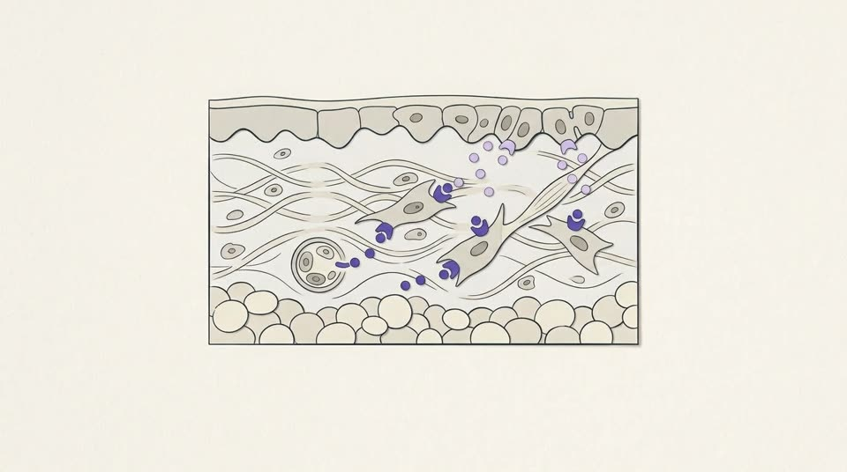
Teaches: GH acts mainly on dermal fibroblasts; fibroblast-made IGF-1 drives keratinocytes to divide; GH and IGF-1 fall steadily with age (the somatopause).
Alt text: A skin cross-section where growth hormone from a capillary reaches fibroblasts in the dermis, which send smaller signals up to dividing cells at the base of the epidermis.
assets/hormones-peptides-skin/images/m6-p02-img.jpg · draft

m6-p05 · Deficiency is a diagnosis. Decline is ageing.
05 / 19 · What changes in practice · Lesson 6.1 · Growth hormone and IGF-1 in skin homeostasis
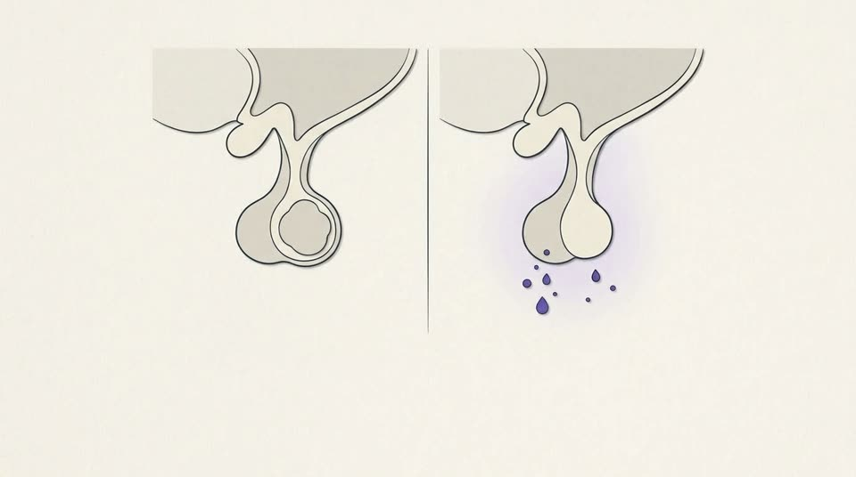
Teaches: GH deficiency is a diagnosis; the fall with age is not. In healthy older adults GH brings small body-composition shifts and more side effects; distributing it for anti-ageing is a US federal offence.
Alt text: Two views of the pituitary: one pressed by a mass and releasing nothing, the other intact but releasing only a few small droplets.
Check first: Deficiency drawn as a pituitary mass (one cause among several); normal ageing drawn as an intact gland releasing less.
assets/hormones-peptides-skin/images/m6-p05-img.jpg · draft

m6-p07 · One axis, four ways in.
07 / 19 · Lesson 6.2 · Concept · Lesson 6.2 · GHRH analogues and secretagogues: clinical pharmacology
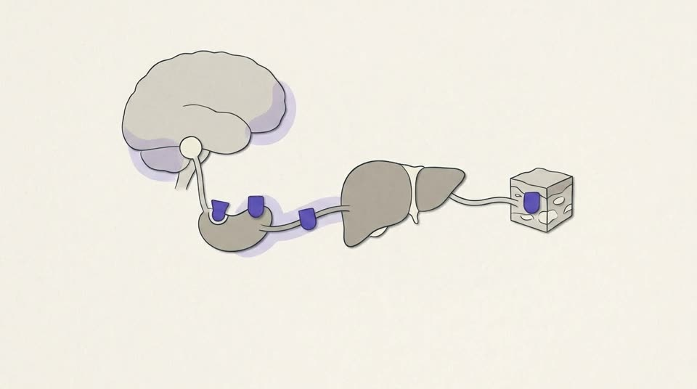
Teaches: One axis, four ways in: replace (somatropin), stimulate through the GHRH or ghrelin receptor, or bypass the pituitary with an IGF-1 analogue.
Alt text: A hormone axis from the brain to the pituitary, liver and tissue, with four violet entry points: two on the pituitary, one in the bloodstream and one at the tissue itself.
assets/hormones-peptides-skin/images/m6-p07-img.jpg · draft

m6-p12 · Name the indication before the molecule.
12 / 19 · What changes in practice · Lesson 6.2 · GHRH analogues and secretagogues: clinical pharmacology
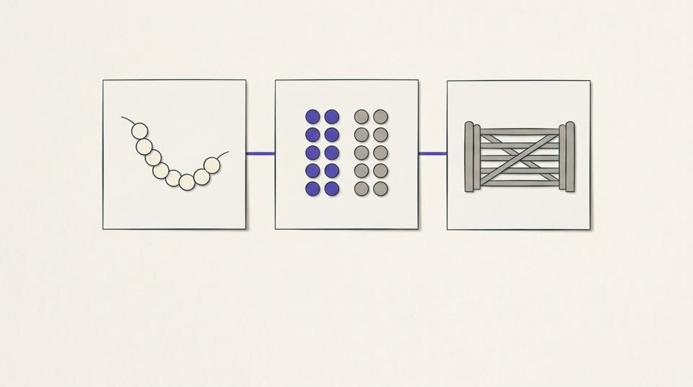
Teaches: Name the molecule (CJC-1295 with or without DAC), what evidence stands behind it, and where it stands legally; tesamorelin’s A is for one HIV indication.
Alt text: Three cards in order: a bead-chain molecule, two columns of tokens standing for trial evidence, and a closed gate for regulatory status.
assets/hormones-peptides-skin/images/m6-p12-img.jpg · draft

m6-p14 · What too much growth hormone looks like.
14 / 19 · Lesson 6.3 · Recognition · Lesson 6.3 · GH excess, oedema and mitogenic risk
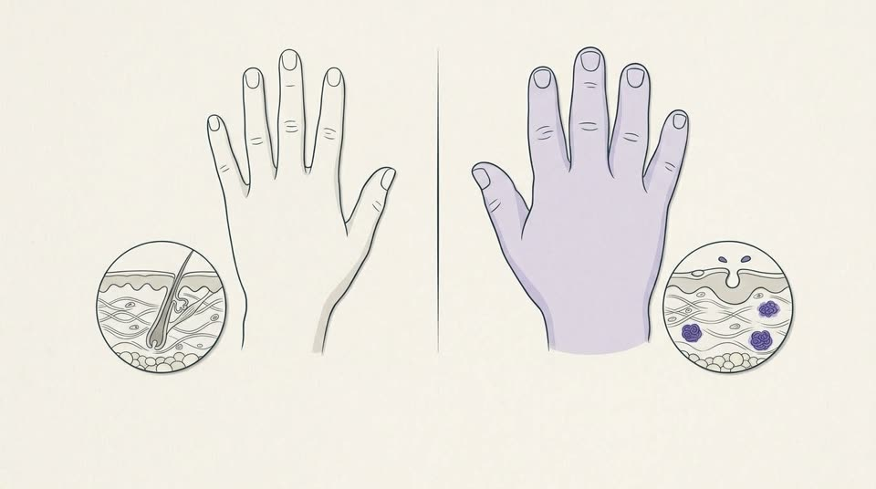
Teaches: Sustained GH excess: thick, oily, sweaty skin, skin tags, acanthosis nigricans, enlarging hands and feet; the Endocrine Society advises IGF-1 when typical features appear.
Alt text: Two hands seen from the back, one of ordinary size and one broad and thick-fingered, each above a small skin section — the second thicker, with a swollen dermis and large pores.
assets/hormones-peptides-skin/images/m6-p14-img.jpg · draft

m6-p17 · Tight rings, eight months into ‘CJC/ipa’.
17 / 19 · Fictional case · Lesson 6.3 · GH excess, oedema and mitogenic risk
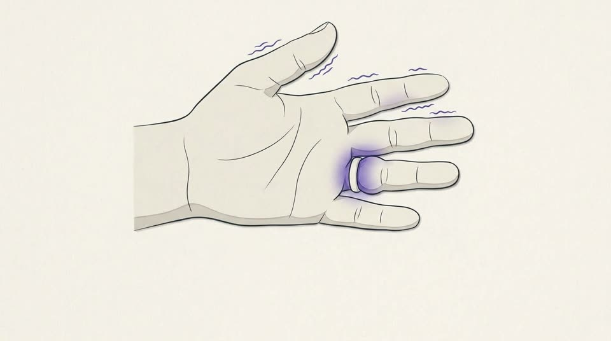
Teaches: Fictional case: tight rings, puffiness, night-time tingling, sweating and skin tags on a clinic ‘CJC/ipamorelin’ product — the soft-tissue pattern of GH excess.
Alt text: An open, puffy hand with a ring pressing into a swollen finger and fine wavy lines along the thumb, index and middle fingers suggesting tingling.
Check first: Tingling drawn along the thumb, index and middle fingers (median nerve) to match carpal tunnel symptoms.
assets/hormones-peptides-skin/images/m6-p17-img.jpg · draft

Module 07 · Evidence, regulation and compliance

m7-p02 · GRADE rates certainty in an effect, one outcome at a time.
02 / 22 · Lesson 7.1 · Concept · Lesson 7.1 · Grading the evidence behind an aesthetic claim
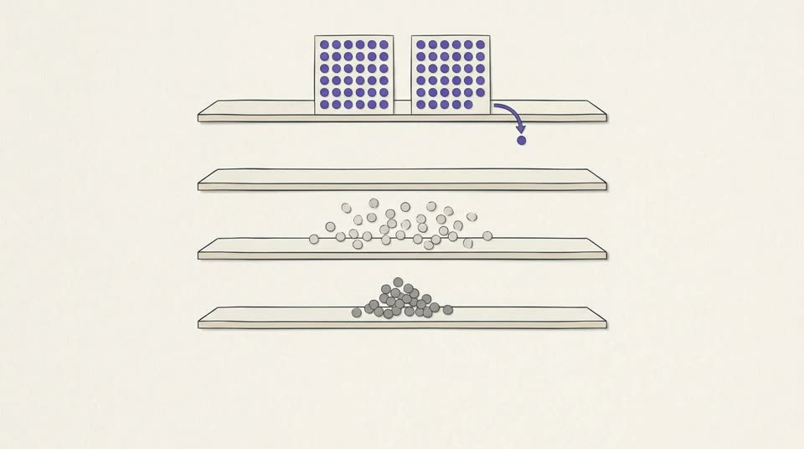
Teaches: GRADE rates certainty for one outcome across the evidence: four levels; randomized trials start high, observational studies low; ratings move for named reasons.
Alt text: Four shelves of certainty: randomized trials start on the top shelf with one dot stepping down, observational studies lie on the third shelf, and a small cluster rests on the lowest.
Check first: GRADE: randomized trials on the top shelf, observational studies on the third; the model also put a small cluster on the lowest shelf (very low). Keep, or redraw with the lowest shelf empty?
assets/hormones-peptides-skin/images/m7-p02-img.jpg · draft

m7-p05 · Two checks, never one.
05 / 22 · What changes in practice · Lesson 7.1 · Grading the evidence behind an aesthetic claim
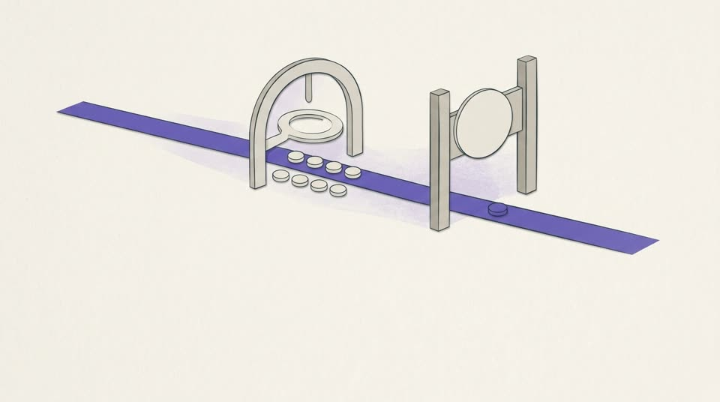
Teaches: Evidence grade and regulatory status are separate checks: an approval says nothing about the grade for an unapproved use, and a mechanism never raises a grade.
Alt text: A token travels a path through two different checkpoints in turn: a lens over trial evidence, then a gate bearing a blank seal.
assets/hormones-peptides-skin/images/m7-p05-img.jpg · draft

m7-p07 · Two compounding routes, one strict order.
07 / 22 · Lesson 7.2 · Concept · Lesson 7.2 · Compounding law, the 40-amino-acid line and certificates of analysis
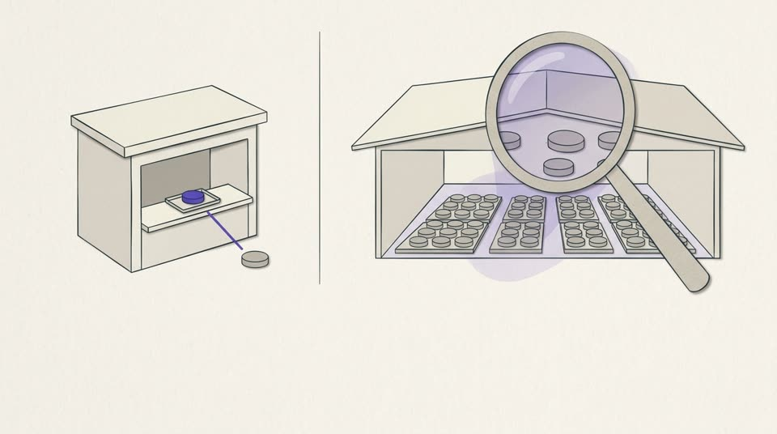
Teaches: US compounding: 503A is patient-specific, with a strict order for bulk substances (monograph, approved-drug component, bulks list); 503B facilities are GMP-inspected; both stay unapproved.
Alt text: A small counter preparing one item for one waiting person, beside a larger facility producing trays of identical items under an inspecting lens.
assets/hormones-peptides-skin/images/m7-p07-img.jpg · draft

m7-p10 · What a certificate can and cannot prove.
11 / 22 · Concept · Lesson 7.2 · Compounding law, the 40-amino-acid line and certificates of analysis
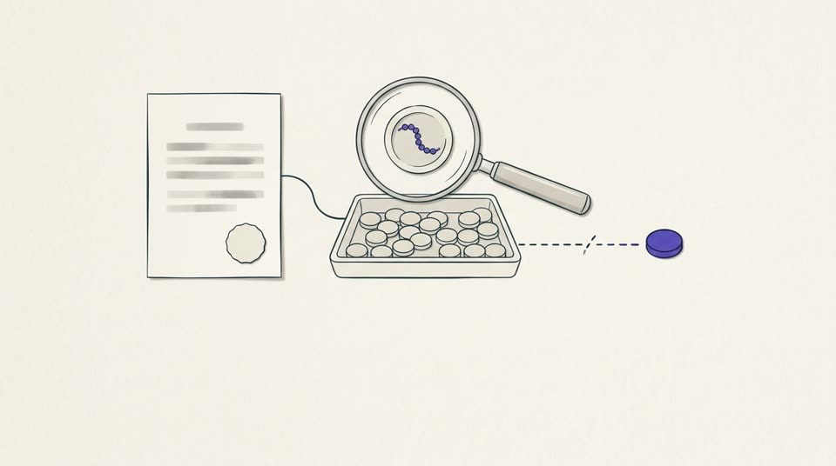
Teaches: A certificate of analysis is the supplier’s report on one lot — identity by mass spectrometry, purity by HPLC — and cannot prove origin, storage or sterility.
Alt text: A blank certificate linked to one tray of identical items, a lens revealing the molecule inside one of them, and a loose item whose link back to the tray is broken.
assets/hormones-peptides-skin/images/m7-p10-img.jpg · draft

m7-p13 · Research use only is a label, and never a route.
14 / 22 · What changes in practice · Lesson 7.2 · Compounding law, the 40-amino-acid line and certificates of analysis
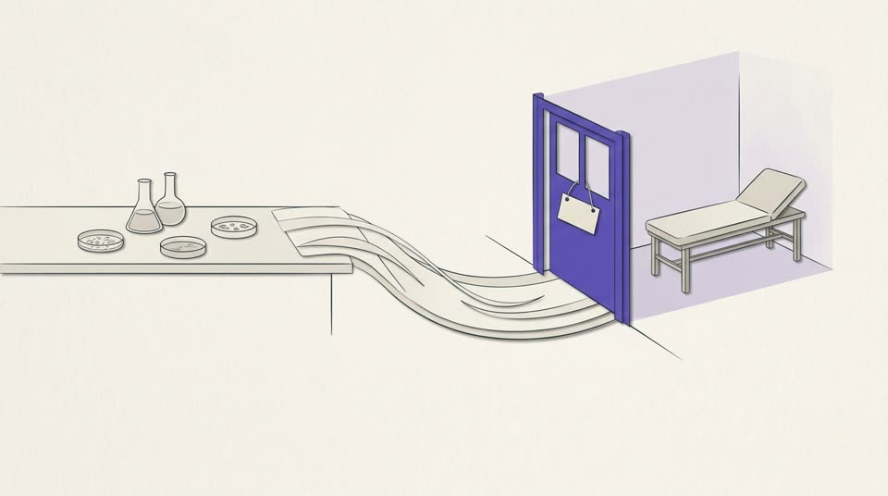
Teaches: ‘Research use only’ is a US shipping permission for laboratory research; FDA reads intended use from claims and sale; it never makes a route to patients.
Alt text: A path from a laboratory bench ends at a closed gate with a blank tag hanging on it, before a clinic room with an empty couch.
assets/hormones-peptides-skin/images/m7-p13-img.jpg · draft

m7-p22 · Selling and advertising peptides outside the US.
15 / 22 · Regulatory status (outside the US) · Lesson 7.2 · Compounding law, the 40-amino-acid line and certificates of analysis
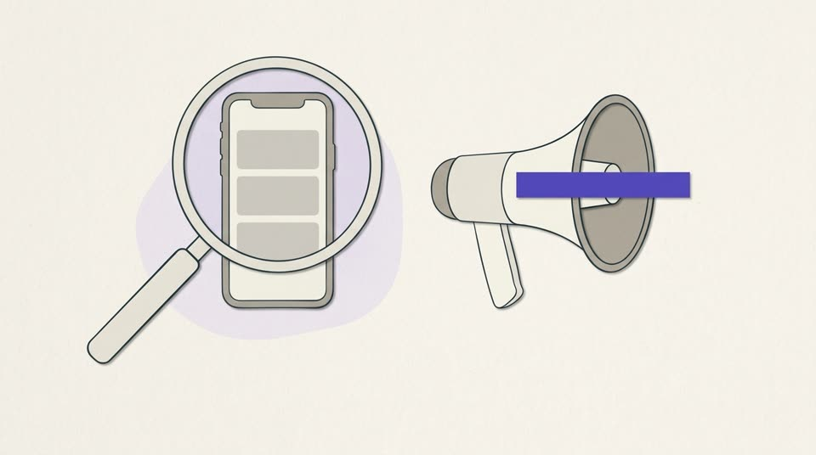
Teaches: In the UK, MHRA judges medicine status from claims, form and use; an unlicensed medicine may not be sold or advertised, and prescription-only medicines are never advertised to the public.
Alt text: A magnifying lens examines a plain phone screen showing a generic post, beside a megaphone blocked by a bar.
assets/hormones-peptides-skin/images/m7-p22-img.jpg · draft

m7-p15 · Off-label needs a label.
17 / 22 · Lesson 7.3 · Concept · Lesson 7.3 · Cosmetic, compounded or investigational: consent and the chart

Teaches: Off-label means an approved drug used outside its labelling; a never-approved peptide has no label to depart from; compounded products are also unapproved.
Alt text: On the left, a tablet with its leaflet steps just outside the leaflet’s boundary; on the right, a tablet stands alone with no leaflet and no boundary.
assets/hormones-peptides-skin/images/m7-p15-img.jpg · draft

m7-p17 · ‘Just prescribe it off-label.’
19 / 22 · Fictional case · Lesson 7.3 · Cosmetic, compounded or investigational: consent and the chart
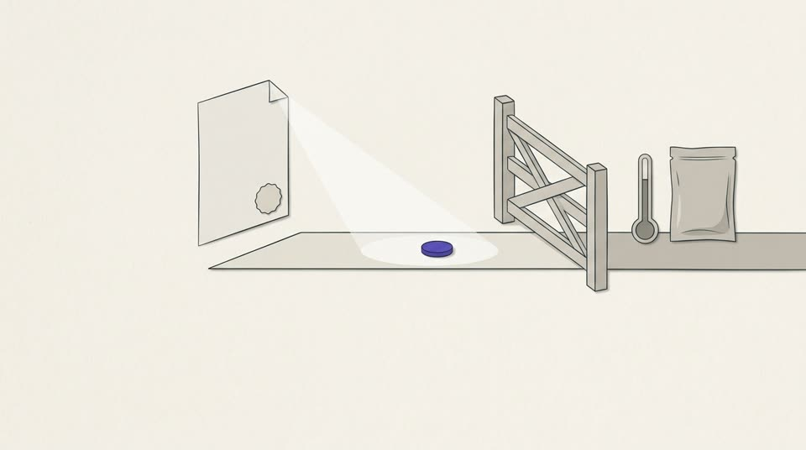
Teaches: Fictional case: ‘off-label’ BPC-157 — never approved, no 503A route; a certificate covers one lot’s identity and purity, never sterility, storage or legality.
Alt text: A single item waits before a closed gate; a blank certificate lights only the item itself, leaving a thermometer and a sealed pouch outside its light.
assets/hormones-peptides-skin/images/m7-p17-img.jpg · draft

