Module 1, re-cut in the sitting design
Hormones and Peptides for Skin · package 1.2.0-rc.1 · DRAFT · awaiting Dr. Fady Hannah-Shmouni and Omar Saleem. The live course (1.1.0) is unchanged; nothing reaches learners before both sign-offs. The films are unchanged.
Omar, 2026-09-28: “yes to all 4 and i agree, the films are great, dont want to change them, rather its more what is around them and the journey that we are focused on here” / “also for the audio, lets improve the quality of the narration, use gemini 3.8 tts across, even if it means redoing them”
How to reply: the moment id and “confirm” or “change: …”.

The dose, before and after (Module 1)
 | 1.1.0 | 1.2.0-rc.1
First decision per lesson | 1:42 · 1:44 · 1:13 | 0:23 · 0:48 · 0:55
Longest passive run | 3 | 2
Cards over their cap (100; a case card 150) | 5 | 1
Failures | 9 | 1
1.1.0: 1.1: p01 › opener › p02 › p03 › p04 › p05 › x01 › p06 › x02 › p07 / 1.2: p08 › p09 › p10 › p11 › x03 › p12 / 1.3: p13 › x04 › p14 › p15 › p16 › x05 › p17 › p18 › p19 (bold = decision)
1.2.0-rc.1: 1.1: p01 › p02 › opener › p03 › p04 › p05 › x01 › p06 › x02 › p07 / 1.2: p08 › p10 › p09 › p11 › x03 › p12 / 1.3: p13 › x04 › p14 › p15 › p16 › x05 › p17 › p18 › p19 (bold = decision)

For your decision (13)
- m1-p03: the term ‘neuro-immuno-endocrine organ’ (body, sentence 1) is no longer on the learner’s screen; it stays in the moment’s body and narration script (the Guide reads both) and in claim c-m01-01
- m1-p08: the atlas’s ‘unexpected sites’ (RNA for the gut hormone secretin in a type of immune cell; the old beat’s ‘outside the classic glands’) is no longer on the learner’s screen and is not taught elsewhere in Module 1 (it stays in the narration script the Guide reads)
- m1-p08: ‘Cambridge-led’ and the guide’s premise ‘built from every major cell lineage’ (claim c-m01-11) leave the screen; the inference itself (‘plausibly one of the body’s largest distributed signalling networks’) stays
- m1-p11: ‘moderate’ (the sunscreens tested in the field trials were moderate) leaves the screen; the high-protection caveat stays
- m1-p16: the retinol biopsy finding (within a week retinol raised collagen synthesis and lowered MMPs in biopsies of aged human skin; claim c-m01-20) leaves the screen and is not taught elsewhere in Module 1
- m1-p16: ‘publicly funded’ (the Nambour sunscreen trial) leaves the screen; it stays in the narration script
- m1-p16: beat 2 writes retinol’s grade as ‘(GRADE C)’ where the body writes ‘(C)’: same grade, the course’s own notation, so the voice says it (a bare ‘(C)’ was dropped or garbled by the TTS in two takes)
- m1-p04: row 6 (Melanocortins: POMC → α-MSH, ACTH, β-endorphin; pigment, barrier and local immune restraint) states no evidence type, so it is not on the ladder and leaves the learner’s screen in Module 1 (Module 05 teaches it)
- m1-p04: the rung names are new labels in the course’s own registers (cell & tissue studies · animal models · human tissue, ex vivo · people (clinical)); the prompt and title are instructions, not claims
- m1-p15: the Mechanism row names two kinds of evidence (aged human dermis; the feedback loop in culture). It is keyed to ‘Human tissue, ex vivo’, the highest rung its evidence reaches; the loop’s feedback step itself rests on culture. Please confirm the key, or move it to ‘Cell & tissue studies’
- m1-p15: the Human evidence row has no evidence sentence of its own; its why is m1-p14’s approved ‘One observational cohort shows an association.’
- m1-p07: the right move’s feedback changes from the quiz’s ‘Correct. Striae, bruising and new hypertension…’ (now the right reason) to ‘A serum cannot answer a systemic question.’ (approved on m1-p06 for advisors and in m1-x02)
- m1-x03: the audit also counts the exercise’s own title (‘Where the page overreaches’), which the inspect card does not draw; without it the card counts 96

Every change (15)

m1-p02, m1-opener · Moved: the role question now comes before the opening film (moments 02 and 03 swap), so lesson 1.1 asks for a decision in its first minute. Both moments are unchanged.
For Fady Hannah-Shmouni; Omar Saleem · awaiting confirmation · 2026-09-28
Why. Sitting design pilot on Module 1 (Omar, 2026-09-28: “yes to all 4”; perceptor-foundry templates/microlearning/SITTING-DESIGN.md). Omar: films stay unchanged; “its more what is around them and the journey”. Dosage rule: a decision within 60 s; the role question landed at 1:42.
Before:
{
"order": "m1-p01 › m1-opener › m1-p02",
"time": {
"m1-opener": "02 / 25",
"m1-p02": "03 / 25"
}
}
After:
{
"order": "m1-p01 › m1-p02 › m1-opener",
"time": {
"m1-p02": "02 / 25",
"m1-opener": "03 / 25"
}
}
☐ Correct as written ☐ Change: ______________________

m1-p10, m1-p09 · Moved: the sort ‘Transcript, tissue or person?’ now comes before the stat ‘Prediction, in the authors’ own words.’, so lesson 1.2 asks for a decision in its first minute; the stat then confirms the authors’ own word, ‘putative’. Both moments are unchanged.
For Fady Hannah-Shmouni; Omar Saleem · awaiting confirmation · 2026-09-28
Why. Sitting design pilot on Module 1 (Omar, 2026-09-28: “yes to all 4”; perceptor-foundry templates/microlearning/SITTING-DESIGN.md). Dosage rule: a decision within 60 s; the sort landed at 1:44 after the narrated card and the stat.
Before:
{
"order": "m1-p08 › m1-p09 › m1-p10",
"time": {
"m1-p09": "12 / 25",
"m1-p10": "13 / 25"
}
}
After:
{
"order": "m1-p08 › m1-p10 › m1-p09",
"time": {
"m1-p10": "12 / 25",
"m1-p09": "13 / 25"
}
}
☐ Correct as written ☐ Change: ______________________

m1-p01 · Trimmed: the cover’s first sentence (‘This course starts with physiology…’) is removed; the opening film, two moments later, speaks it verbatim. Nothing is added.
For Fady Hannah-Shmouni; Omar Saleem · awaiting confirmation · 2026-09-28
Why. Sitting design pilot on Module 1 (Omar, 2026-09-28: “yes to all 4”; perceptor-foundry templates/microlearning/SITTING-DESIGN.md). Dosage rule: at most 100 words before the first tap (the cover had 110; now 91). Say it once: the cover and the film repeated the same two sentences.
Before:
This course starts with physiology, because every later question about a hormone or peptide for skin rests on it. Skin senses hormones from the blood, makes several of its own, and ages in ways that change both. In three lessons you will separate what happens locally in the skin from what the rest of the body sends in, and label each finding by the kind of evidence behind it.
After:
Skin senses hormones from the blood, makes several of its own, and ages in ways that change both. In three lessons you will separate what happens locally in the skin from what the rest of the body sends in, and label each finding by the kind of evidence behind it.
What left this card, and where the module still teaches it:
- m1-opener videoTranscript, sentence 1 (verbatim)
☐ Correct as written ☐ Change: ______________________

m1-x03 · Trimmed: the exercise prompt no longer repeats ‘A fictional product page.’; the moment’s own line above it (‘A fictional product page that leans on the cell atlas.’) keeps the fictional label on screen.
For Fady Hannah-Shmouni; Omar Saleem · awaiting confirmation · 2026-09-28
Why. Sitting design pilot on Module 1 (Omar, 2026-09-28: “yes to all 4”; perceptor-foundry templates/microlearning/SITTING-DESIGN.md). Dosage rule: at most 100 words before the first tap (102; now 98).
Before:
A fictional product page. Find the lines this lesson’s evidence does not support.
After:
Find the lines this lesson’s evidence does not support.
What left this card, and where the module still teaches it:
- m1-x03 body (shown above the exercise)
☐ Correct as written ☐ Change: ______________________

m1-p03 · Read-along beats from approved sentences (audioBeats): the flip-card audio story becomes a read-along card of 3 beats, each with 2–4 key terms quoted from it and focus regions on the approved still. The body, points and narration script stay in the package for the Guide; the beats are what the learner reads and hears.
For Fady Hannah-Shmouni · awaiting confirmation · 2026-09-28
Why. Sitting design pilot on Module 1 (Omar, 2026-09-28: “yes to all 4”; perceptor-foundry templates/microlearning/SITTING-DESIGN.md). Approved by Omar (2026-09-28): the read-along explain card replaces the flip-card audio story, piloted on Skin Module 1. Beats are the narration and the reading text at once: ≤ 35 words each, ≤ 100 words on the card.
Before (flip-card chapters):
- Four units — Epidermis, dermis, subcutis and the adnexa each hold cells that make hormones and cells that react to them, from keratinocytes and fibroblasts to fat cells and mast cells.
- Three routes — Signals pass between neighbouring cells, along sensory nerves, and into the blood, where they can reach distant organs.
- What kind of evidence — The framework is drawn from cell, tissue and animal work. It explains how skin behaves; each finding in this module is labelled by the evidence behind it.
After (read-along beats):
- Four units — Epidermis, dermis, subcutis and the adnexa each hold cells that make hormones and cells that react to them, from keratinocytes and fibroblasts to fat cells and mast cells.
Key terms: Epidermis · dermis · subcutis · adnexa
- Three routes — Signals pass between neighbouring cells, along sensory nerves, and into the blood, where they can reach distant organs.
Key terms: neighbouring cells · sensory nerves · the blood
- What kind of evidence — The framework is drawn from cell, tissue and animal work. It explains how skin behaves; each finding in this module is labelled by the evidence behind it.
Key terms: cell, tissue and animal work · labelled by the evidence behind it
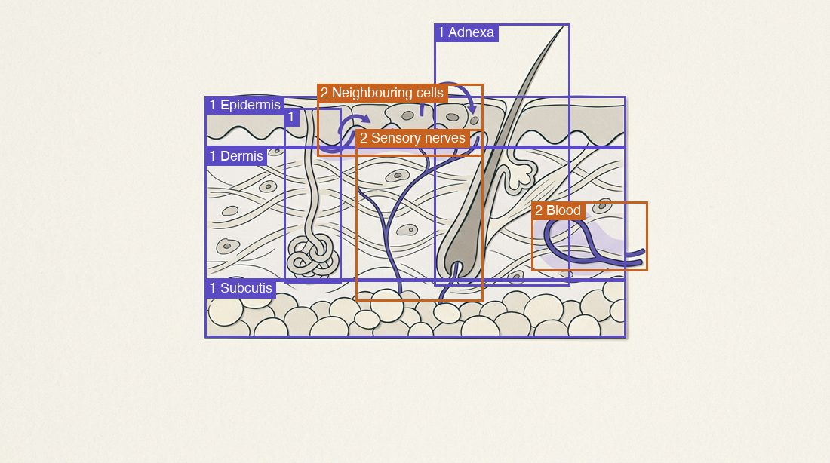
Narration: beat 1 14.6 s (public/assets/hormones-peptides-skin/narration/readalong/m1-p03/b1.en.586b3ab3.mp3); beat 2 8.6 s (public/assets/hormones-peptides-skin/narration/readalong/m1-p03/b2.en.b9b350d7.mp3); beat 3 11.0 s (public/assets/hormones-peptides-skin/narration/readalong/m1-p03/b3.en.caa1800a.mp3)
Built from:
- beat 1: audioBeats 1 (unchanged)
- beat 2: audioBeats 2 (unchanged)
- beat 3: audioBeats 3 (unchanged)
What left this card, and where the module still teaches it:
- audioScript sentences 1–8 (the four units, the adnexa as hair follicles and glands, sebocytes, the three routes, local loop versus systemic signalling): spoken verbatim by the opening film, the moment before this card (m1-opener videoTranscript)
- the local-loop versus systemic distinction: m1-p05 (tool rows and quick-fire)
For your decision:
- the term ‘neuro-immuno-endocrine organ’ (body, sentence 1) is no longer on the learner’s screen; it stays in the moment’s body and narration script (the Guide reads both) and in claim c-m01-01
☐ Correct as written ☐ Change: ______________________

m1-p06 · Read-along beats from approved sentences (body, audioScript): the flip-card audio story becomes a read-along card of 3 beats, each with 2–4 key terms quoted from it and focus regions on the approved still. The body, points and narration script stay in the package for the Guide; the beats are what the learner reads and hears.
For Fady Hannah-Shmouni · awaiting confirmation · 2026-09-28
Why. Sitting design pilot on Module 1 (Omar, 2026-09-28: “yes to all 4”; perceptor-foundry templates/microlearning/SITTING-DESIGN.md). Approved by Omar (2026-09-28): the read-along explain card replaces the flip-card audio story, piloted on Skin Module 1. Beats are the narration and the reading text at once: ≤ 35 words each, ≤ 100 words on the card.
Before (flip-card chapters):
- The exam as a screen — Thinning and bruising, coarse dry skin, new acanthosis nigricans: each points to a systemic axis before it points to a serum.
- When to refer — The guide lists violaceous striae with new hypertension or diabetes, rapid virilisation and signs of an endocrine tumour as reasons to refer promptly.
- Where local biology fits — Local loops explain how skin behaves day to day. The guide calls them foundation, never a reason to dose anyone with a hormone.
After (read-along beats):
- The exam as a screen — The Aesthetic & Regenerative Endocrinology guide treats the aesthetic exam as a systemic screen. Sudden thinning and easy bruising suggest cortisol excess; coarse, dry, cool skin suggests hypothyroidism; new acanthosis nigricans flags insulin resistance.
Key terms: systemic screen · cortisol excess · hypothyroidism · insulin resistance
- When to refer — The guide lists violaceous striae with new hypertension or diabetes, rapidly progressive virilisation, and signs of an endocrine tumour as reasons to refer promptly to endocrinology.
Key terms: violaceous striae · rapidly progressive virilisation · refer promptly to endocrinology
- Where local biology fits — Local skin biology explains how skin behaves; it does not justify prescribing a hormone.
Key terms: Local skin biology · does not justify prescribing a hormone
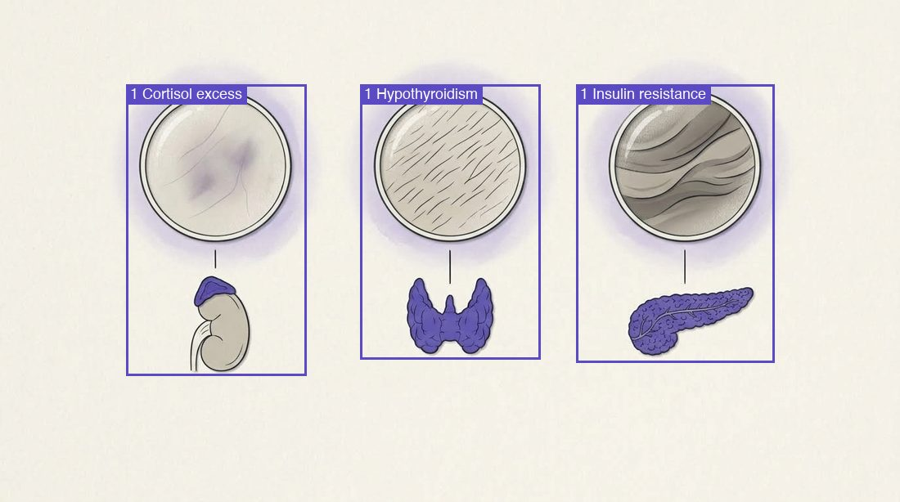
Narration: beat 1 20.2 s (public/assets/hormones-peptides-skin/narration/readalong/m1-p06/b1.en.6dc050b9.mp3); beat 2 14.2 s (public/assets/hormones-peptides-skin/narration/readalong/m1-p06/b2.en.32387b8b.mp3); beat 3 6.7 s (public/assets/hormones-peptides-skin/narration/readalong/m1-p06/b3.en.2d166489.mp3)
Built from:
- beat 1: body, sentences 1–2
- beat 2: audioScript, sentence 6
- beat 3: body, sentence 4
What left this card, and where the module still teaches it:
- audioScript s2 (read the skin as a window on the whole endocrine system before reaching for a serum): m1-x02 decision 1, option ‘richer-serum’ why (verbatim)
- audioScript s8 and the old beat 3 (local loops are foundation biology, no rationale for dosing anyone with a hormone): m1-p04 ladder closing lines (the moment’s callout) and m1-x02 decision 3
- audioScript s9 (whatever your role, a systemic pattern in the skin gets a systemic answer): m1-x02 decision 2, option ‘systemic-answer’ why (verbatim)
- the role versions (metadata.variants.audienceLevel) are unchanged and still show under the card
☐ Correct as written ☐ Change: ______________________

m1-p08 · Read-along beats from approved sentences (body, audioScript): the flip-card audio story becomes a read-along card of 3 beats, each with 2–4 key terms quoted from it and focus regions on the approved still. The body, points and narration script stay in the package for the Guide; the beats are what the learner reads and hears.
For Fady Hannah-Shmouni · awaiting confirmation · 2026-09-28
Why. Sitting design pilot on Module 1 (Omar, 2026-09-28: “yes to all 4”; perceptor-foundry templates/microlearning/SITTING-DESIGN.md). Approved by Omar (2026-09-28): the read-along explain card replaces the flip-card audio story, piloted on Skin Module 1. Beats are the narration and the reading text at once: ≤ 35 words each, ≤ 100 words on the card.
Before (flip-card chapters):
- What it measured — RNA for 379 hormone and receptor genes, cell by cell, across 47 human tissues including skin.
- What it predicted — Which cell types could make a hormone and which could respond, including unexpected sites outside the classic glands.
- What it leaves open — Whether a cell actually makes and releases the hormone, and whether that hormone does anything there.
After (read-along beats):
- What it measured — The Hormone Cell Atlas, published in Science in 2026, read the RNA for 379 hormone and receptor genes in about 14 million single cells and nuclei from 47 human tissues, skin among them.
Key terms: 379 hormone and receptor genes · 14 million single cells and nuclei · 47 human tissues
- What it predicted — From that RNA it predicted which cell types could make a hormone and which could respond to one.
Key terms: make a hormone · respond to one
- What it leaves open — The guide uses the atlas to argue that the skin is plausibly one of the body’s largest distributed signalling networks. RNA tells you what a cell could make.
Key terms: plausibly · largest distributed signalling networks · what a cell could make
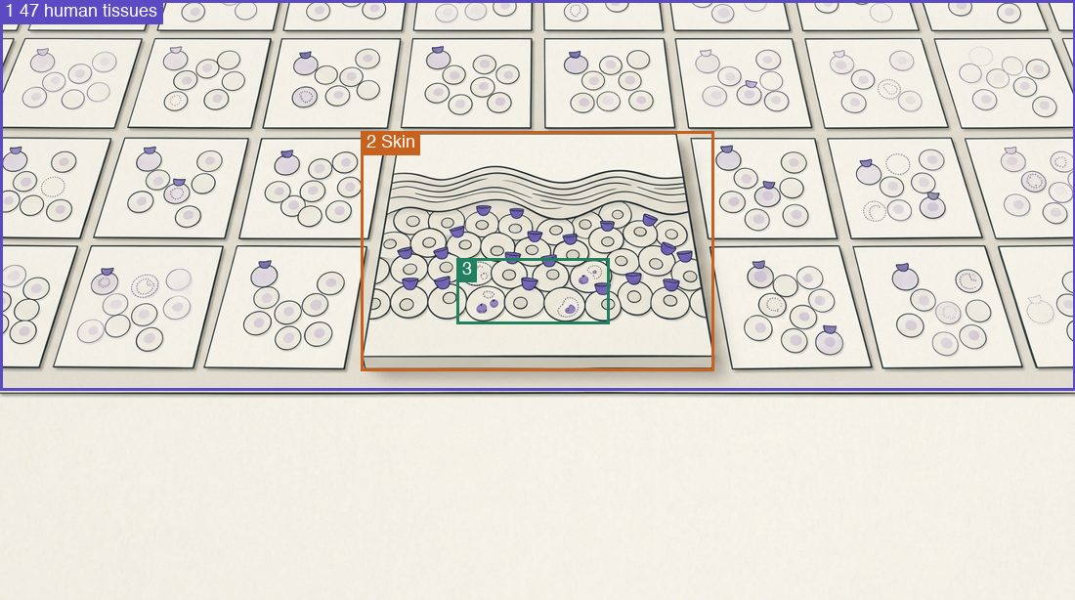
Narration: beat 1 16.4 s (public/assets/hormones-peptides-skin/narration/readalong/m1-p08/b1.en.7a683187.mp3); beat 2 6.8 s (public/assets/hormones-peptides-skin/narration/readalong/m1-p08/b2.en.0976c332.mp3); beat 3 12.0 s (public/assets/hormones-peptides-skin/narration/readalong/m1-p08/b3.en.ad535fe7.mp3)
Built from:
- beat 1: body, sentence 1
- beat 2: body, sentence 2
- beat 3: audioScript, sentence 4 (trimmed: ‘Aesthetic and Regenerative Endocrinology’, ‘built from every major cell lineage’) and sentence 6 (trimmed: ‘Everything in the atlas starts from RNA, and’)
What left this card, and where the module still teaches it:
- body s3 (a map of predicted capacity; it did not measure hormone release): m1-p09 stat (means / does not mean) and m1-p10 whys
- audioScript s7 (whether the cell actually makes and releases the hormone): m1-p09 stat.doesNot and the rest of lesson 1.2
For your decision:
- the atlas’s ‘unexpected sites’ (RNA for the gut hormone secretin in a type of immune cell; the old beat’s ‘outside the classic glands’) is no longer on the learner’s screen and is not taught elsewhere in Module 1 (it stays in the narration script the Guide reads)
- ‘Cambridge-led’ and the guide’s premise ‘built from every major cell lineage’ (claim c-m01-11) leave the screen; the inference itself (‘plausibly one of the body’s largest distributed signalling networks’) stays
☐ Correct as written ☐ Change: ______________________

m1-p11 · Read-along beats from approved sentences (body, audioBeats): the flip-card audio story becomes a read-along card of 3 beats, each with 2–4 key terms quoted from it and focus regions on the approved still. The body, points and narration script stay in the package for the Guide; the beats are what the learner reads and hears.
For Fady Hannah-Shmouni · awaiting confirmation · 2026-09-28
Why. Sitting design pilot on Module 1 (Omar, 2026-09-28: “yes to all 4”; perceptor-foundry templates/microlearning/SITTING-DESIGN.md). Approved by Omar (2026-09-28): the read-along explain card replaces the flip-card audio story, piloted on Skin Module 1. Beats are the narration and the reading text at once: ≤ 35 words each, ≤ 100 words on the card.
Before (flip-card chapters):
- Claims built on receptors — Receptors explain how a topical could act. Whether it does is a question for a human trial.
- Local enzymes — Steroid-metabolising enzymes in skin change potency, so the response in skin can differ from what the dose predicts.
- Sunscreen and vitamin D — Artificial-UV experiments show sunscreen blocks vitamin D synthesis; field trials of daily use did not lower blood levels. High-protection products have not been trialled.
After (read-along beats):
- Claims built on receptors — Receptors explain how a topical could act. Whether it does is a question for a human trial.
Key terms: how a topical could act · a human trial
- Local enzymes — Steroid-metabolising enzymes in skin change potency, so the response in skin can differ from what the dose predicts.
Key terms: Steroid-metabolising enzymes · change potency · what the dose predicts
- Sunscreen and vitamin D — The guide says serum vitamin D falls with sunscreen use, yet field trials of daily sunscreen did not lower it. High-protection products have not been trialled.
Key terms: serum vitamin D falls with sunscreen use · field trials of daily sunscreen · High-protection products
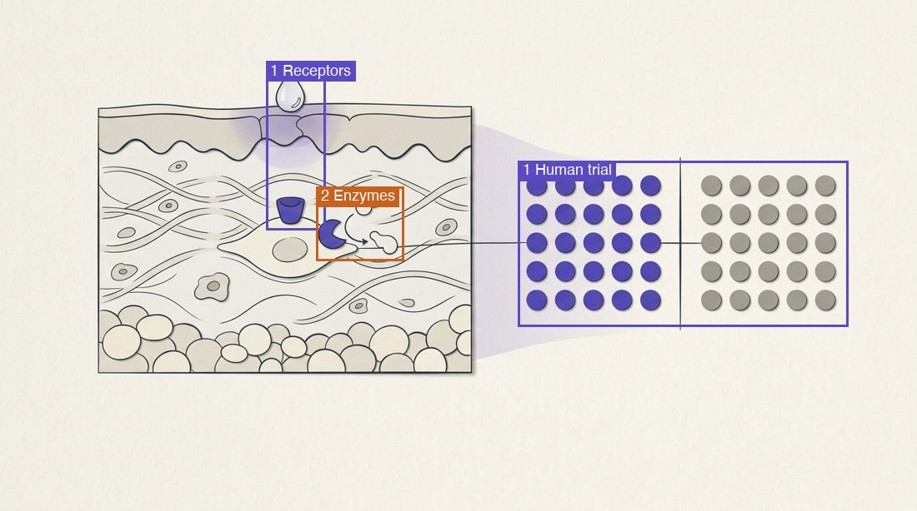
Narration: beat 1 7.2 s (public/assets/hormones-peptides-skin/narration/readalong/m1-p11/b1.en.9daeeb9e.mp3); beat 2 8.8 s (public/assets/hormones-peptides-skin/narration/readalong/m1-p11/b2.en.a88593f9.mp3); beat 3 12.3 s (public/assets/hormones-peptides-skin/narration/readalong/m1-p11/b3.en.24644415.mp3)
Built from:
- beat 1: audioBeats 1 (unchanged)
- beat 2: audioBeats 2 (unchanged)
- beat 3: body, sentence 3 (trimmed: ‘The same caution applies to physiology you think you know:’) and audioBeats 3, sentence 2
What left this card, and where the module still teaches it:
- body s2 and audioScript s4 (a receptor on a map is where an efficacy question starts, and the answer still needs a trial): beat 1 and m1-x03 segment ‘results’ why (verbatim)
- the old beat 3, sentence 1 (sunscreen blocks vitamin D synthesis under artificial UV): m1-x03 segment ‘sunscreen’ why
- audioScript s8 (keep recommending sun protection, and treat vitamin D as its own question): m1-x03 segment ‘sunscreen’ why (verbatim) and the role versions under the card
For your decision:
- ‘moderate’ (the sunscreens tested in the field trials were moderate) leaves the screen; the high-protection caveat stays
☐ Correct as written ☐ Change: ______________________

m1-p13 · Read-along beats from approved sentences (body, audioScript, audioBeats): the flip-card audio story becomes a read-along card of 3 beats, each with 2–4 key terms quoted from it and focus regions on the approved still. The body, points and narration script stay in the package for the Guide; the beats are what the learner reads and hears.
For Fady Hannah-Shmouni · awaiting confirmation · 2026-09-28
Why. Sitting design pilot on Module 1 (Omar, 2026-09-28: “yes to all 4”; perceptor-foundry templates/microlearning/SITTING-DESIGN.md). Approved by Omar (2026-09-28): the read-along explain card replaces the flip-card audio story, piloted on Skin Module 1. Beats are the narration and the reading text at once: ≤ 35 words each, ≤ 100 words on the card.
Before (flip-card chapters):
- A safety mechanism — A damaged cell stops dividing for good, which guards against cancer and helps wound repair.
- The secretory phase — It stays active and releases inflammatory cytokines, matrix-degrading enzymes and growth factors, first catalogued in cultured human cells.
- What we see in human skin — Older skin holds more cells carrying the marker p16 in epidermis and dermis. No single marker is definitive.
After (read-along beats):
- A safety mechanism — A damaged cell stops dividing for good, which guards against cancer and helps wound repair.
Key terms: stops dividing for good · guards against cancer · wound repair
- The secretory phase — A senescent cell has stopped dividing for good but stays metabolically active, releasing cytokines, matrix-degrading enzymes and growth factors: the senescence-associated secretory phenotype, or SASP. The SASP was characterised in cultured cells.
Key terms: metabolically active · cytokines, matrix-degrading enzymes and growth factors · SASP · cultured cells
- In human skin — Older skin holds more cells carrying the marker p16 in epidermis and dermis. Researchers also caution that no single marker identifies a senescent cell with certainty, so counts depend on the marker chosen.
Key terms: marker p16 · no single marker · counts depend on the marker chosen
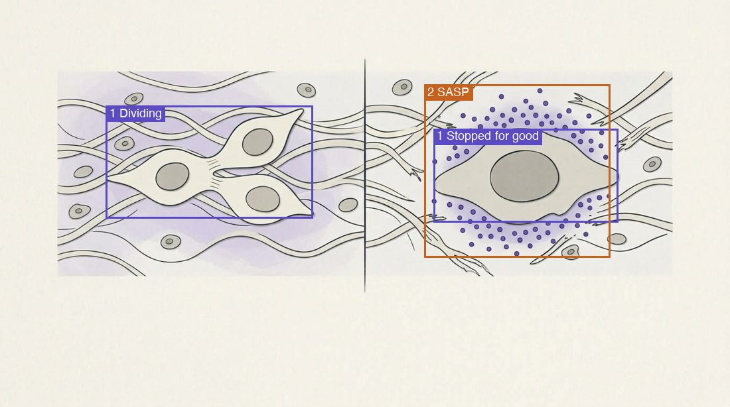
Narration: beat 1 6.4 s (public/assets/hormones-peptides-skin/narration/readalong/m1-p13/b1.en.73a1d145.mp3); beat 2 20.0 s (public/assets/hormones-peptides-skin/narration/readalong/m1-p13/b2.en.6dd9f978.mp3); beat 3 15.6 s (public/assets/hormones-peptides-skin/narration/readalong/m1-p13/b3.en.ef8d41de.mp3)
Built from:
- beat 1: audioBeats 1 (unchanged)
- beat 2: body, sentences 1–2 (sentence 1 is the Today line’s detail)
- beat 3: audioBeats 3, sentence 1 and audioScript, sentence 8 (replaces ‘No single marker is definitive.’); title trimmed from ‘What we see in human skin’
What left this card, and where the module still teaches it:
- audioScript s4 (IL-6 and IL-8 named): m1-x04 hotspot ‘sasp’ why and m1-x05 item ‘sasp-culture’
- audioScript s5 (‘after DNA damage’): m1-x05 item ‘sasp-culture’ why (verbatim)
- audioScript s6 (in living human skin the evidence is observational): m1-p14 stat.doesNot (‘One observational cohort shows an association.’)
- audioScript s7, second half (fibroblasts, keratinocytes and melanocytes can all become senescent): m1-x04 hotspot ‘senescent’ why (verbatim)
☐ Correct as written ☐ Change: ______________________

m1-p16 · Read-along beats from approved sentences (body, audioScript): the flip-card audio story becomes a read-along card of 3 beats, each with 2–4 key terms quoted from it and focus regions on the approved still. The body, points and narration script stay in the package for the Guide; the beats are what the learner reads and hears.
For Fady Hannah-Shmouni · awaiting confirmation · 2026-09-28
Why. Sitting design pilot on Module 1 (Omar, 2026-09-28: “yes to all 4”; perceptor-foundry templates/microlearning/SITTING-DESIGN.md). Approved by Omar (2026-09-28): the read-along explain card replaces the flip-card audio story, piloted on Skin Module 1. Beats are the narration and the reading text at once: ≤ 35 words each, ≤ 100 words on the card.
Before (flip-card chapters):
- Sun protection — A publicly funded Australian trial of 903 adults: daily sunscreen meant about a quarter less skin ageing over four and a half years.
- Retinoids — Consistent randomized trials for tretinoin in photoaged skin; the guide’s GRADE A. Retinol has smaller trials, including one in very old skin.
- Senotherapies — Biomarker pilots only, so far. They sit below the levers that already have outcome data.
After (read-along beats):
- Sun protection — In a community trial of 903 adults, daily sunscreen for four and a half years slowed photoageing compared with discretionary use (GRADE B).
Key terms: 903 adults · daily sunscreen · GRADE B
- Retinoids — Topical tretinoin improves photoageing consistently across randomized trials, and the Aesthetic & Regenerative Endocrinology guide rates topical retinoids first-line, GRADE A. Retinol improved fine wrinkles in very old skin in a small trial (GRADE C).
Key terms: Topical tretinoin · GRADE A · Retinol · a small trial
- Senotherapies — Both levers protect or rebuild the dermal matrix, and both have human outcome data. Senolytics for skin have no such data yet.
Key terms: dermal matrix · human outcome data · Senolytics for skin
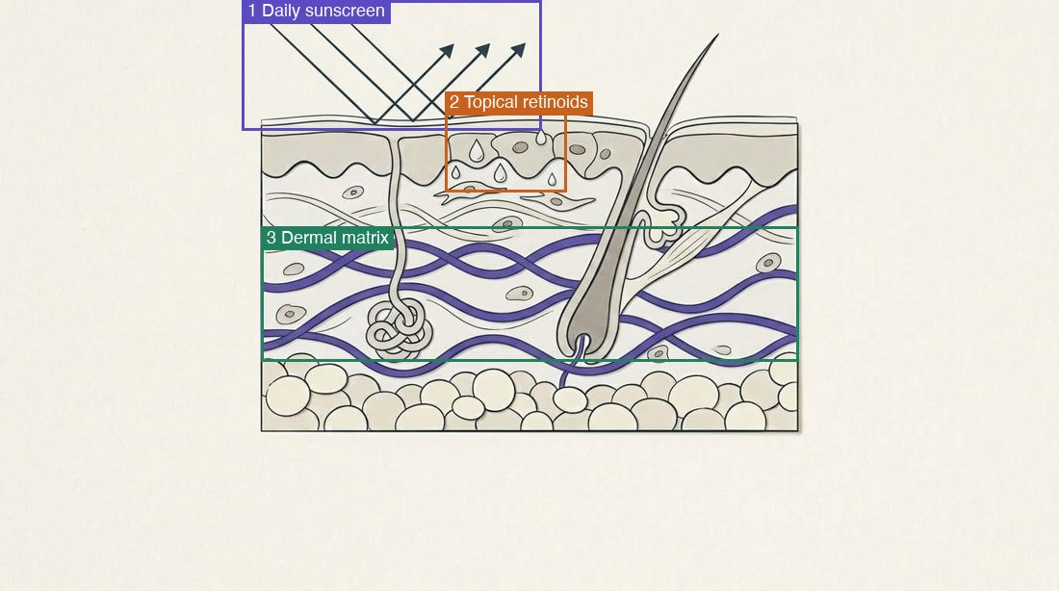
Narration: beat 1 10.8 s (public/assets/hormones-peptides-skin/narration/readalong/m1-p16/b1.en.e25e91d3.mp3); beat 2 18.7 s (public/assets/hormones-peptides-skin/narration/readalong/m1-p16/b2.en.f9891d1a.mp3); beat 3 10.7 s (public/assets/hormones-peptides-skin/narration/readalong/m1-p16/b3.en.35ac90b7.mp3)
Built from:
- beat 1: body, sentence 2
- beat 2: body, sentence 3 and sentence 4 (trimmed after ‘(C)’; the grade written ‘(GRADE C)’, the notation this beat uses for GRADE A and beat 1 for GRADE B, because the voice skipped or garbled a bare ‘(C)’)
- beat 3: audioScript, sentence 5 (trimmed: ‘that ultraviolet light and, it is thought, the SASP erode’) and sentence 6
What left this card, and where the module still teaches it:
- audioScript s2 (‘about a quarter lower with daily use’, 903 adults, daily or discretionary): m1-x05 item ‘daily-sunscreen’ why (verbatim)
- audioScript s5, the trimmed clause (that the SASP erodes the matrix is thought, not shown): m1-p15 ladder item ‘Mechanism’ (‘That senescent cells drive this in living skin is plausible, not shown.’)
- audioScript s7 (keep that order in mind when a patient asks what works): m1-p17 case and m1-p19 chip ‘start ageing conversations with sunscreen and retinoid evidence’
For your decision:
- the retinol biopsy finding (within a week retinol raised collagen synthesis and lowered MMPs in biopsies of aged human skin; claim c-m01-20) leaves the screen and is not taught elsewhere in Module 1
- ‘publicly funded’ (the Nambour sunscreen trial) leaves the screen; it stays in the narration script
- beat 2 writes retinol’s grade as ‘(GRADE C)’ where the body writes ‘(C)’: same grade, the course’s own notation, so the voice says it (a bare ‘(C)’ was dropped or garbled by the TTS in two takes)
☐ Correct as written ☐ Change: ______________________

m1-p17 · Read-along beats from approved sentences (audioScript, audioBeats): the flip-card audio story becomes a read-along card of 3 beats, each with 2–4 key terms quoted from it and focus regions on the approved still. The body, points and narration script stay in the package for the Guide; the beats are what the learner reads and hears.
For Fady Hannah-Shmouni · awaiting confirmation · 2026-09-28
Why. Sitting design pilot on Module 1 (Omar, 2026-09-28: “yes to all 4”; perceptor-foundry templates/microlearning/SITTING-DESIGN.md). Approved by Omar (2026-09-28): the read-along explain card replaces the flip-card audio story, piloted on Skin Module 1. Beats are the narration and the reading text at once: ≤ 35 words each, ≤ 100 words on the card.
Before (flip-card chapters):
- What she read — That senolytic supplements clear senescent cells and reverse skin ageing.
- What is known — Senescent cells track with visible ageing in human skin; clearing them helps in mice; human data are small biomarker pilots.
- What has trials — Daily sunscreen and topical retinoids have randomized trials with visible skin outcomes.
After (read-along beats):
- What she read — Consider a fifty-eight-year-old patient, fictional and built from this lesson’s evidence. She has read that senolytic supplements clear so-called zombie cells and reverse skin ageing, and she asks whether to start one she found online.
Key terms: fictional · senolytic supplements · reverse skin ageing
- What is known — Senescent cells track with visible ageing in human skin; clearing them helps in mice; human data are small biomarker pilots.
Key terms: visible ageing in human skin · helps in mice · small biomarker pilots
- What has trials — Daily sunscreen and topical retinoids, by contrast, have randomised trials with visible skin outcomes. The Aesthetic and Regenerative Endocrinology guide advises keeping senolytics within clinical trials.
Key terms: Daily sunscreen and topical retinoids · randomised trials · within clinical trials
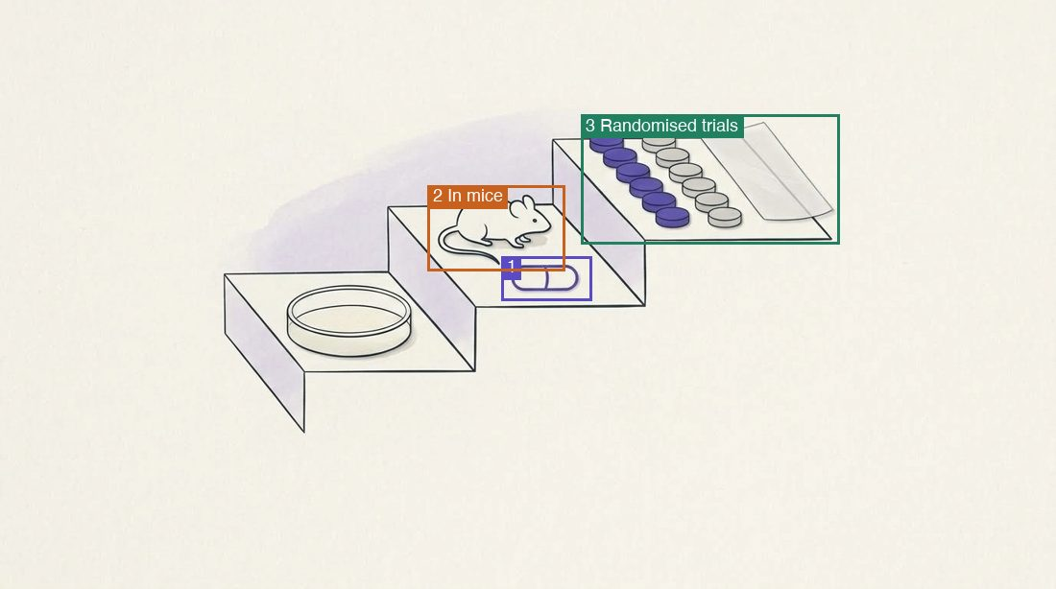
Narration: beat 1 16.7 s (public/assets/hormones-peptides-skin/narration/readalong/m1-p17/b1.en.0d0cd72c.mp3); beat 2 10.6 s (public/assets/hormones-peptides-skin/narration/readalong/m1-p17/b2.en.cba1a1e5.mp3); beat 3 15.5 s (public/assets/hormones-peptides-skin/narration/readalong/m1-p17/b3.en.9adb1711.mp3)
Built from:
- beat 1: audioScript, sentences 1–2
- beat 2: audioBeats 2 (unchanged)
- beat 3: audioScript, sentences 7–8
What left this card, and where the module still teaches it:
- body s2 and audioScript s3 (she does not use sunscreen daily): the case setup of the exercise on this card (m1-p17 interaction.setup, verbatim)
- audioScript s4–6 (three facts frame the conversation): the exercise’s ‘what you notice’ list on this card
- audioScript s9 (decide what you say first): the exercise title ‘What do you do first?’
☐ Correct as written ☐ Change: ______________________

m1-p04 · New exercise (evidence ladder) on the model grid: the five loops whose rows name their evidence are placed on four rungs (cell & tissue studies · animal models · human tissue, ex vivo · people); each item’s note is the row’s evidence text and its why the row’s evidence sentence, verbatim. The callout closes the ladder. The grid stays in the package; a ladder pane draws its rows instead of the table.
For Fady Hannah-Shmouni · awaiting confirmation · 2026-09-28
Why. Sitting design pilot on Module 1 (Omar, 2026-09-28: “yes to all 4”; perceptor-foundry templates/microlearning/SITTING-DESIGN.md). Approved by Omar (2026-09-28): build the evidence ladder first. Dosage rule: at most 100 words before the first tap (the grid had 174; the ladder has 94) and it turns a passive grid into a decision.
Before:
{
"tool.items": [
{
"label": "Steroid synthesis",
"value": "Cholesterol to cortisol, androgens and estrogens",
"note": "CYP11A1 starts the chain; 11β-HSD1, 5α-reductase and aromatase activate precursors from the blood. Cell and tissue studies."
},
{
"label": "HPA-like loop",
"value": "CRH → ACTH → cortisol, with feedback",
"note": "Human scalp follicles kept alive in culture. Ex vivo, human tissue."
},
{
"label": "Keratinocyte glucocorticoids",
"value": "Set local immune tone",
"note": "Genetic deletion in mouse keratinocytes. Animal evidence."
},
{
"label": "Thyroid-like loop",
"value": "TRH, TSH and deiodinases → T3",
"note": "Keratinocyte growth and the hair cycle. Mostly mouse models."
},
{
"label": "Somatotropic loop",
"value": "GH and IGF-1",
"note": "Human hair follicles, ex vivo."
},
{
"label": "Melanocortins",
"value": "POMC → α-MSH, ACTH, β-endorphin",
"note": "Pigment, barrier and local immune restraint. Module 05 returns to this."
}
],
"callout": "A local axis explains biology. The Aesthetic & Regenerative Endocrinology guide calls it foundation, not a dosing rationale."
}
After:
{
"rungs": [
"Cell & tissue studies",
"Animal models",
"Human tissue, ex vivo",
"People (clinical)"
],
"items": [
{
"label": "Steroid synthesis",
"note": "CYP11A1 starts the chain; 11β-HSD1, 5α-reductase and aromatase activate precursors from the blood. Cell and tissue studies.",
"rung": "Cell & tissue studies",
"why": "Cell and tissue studies."
},
{
"label": "HPA-like loop",
"note": "Human scalp follicles kept alive in culture. Ex vivo, human tissue.",
"rung": "Human tissue, ex vivo",
"why": "Ex vivo, human tissue."
},
{
"label": "Keratinocyte glucocorticoids",
"note": "Genetic deletion in mouse keratinocytes. Animal evidence.",
"rung": "Animal models",
"why": "Animal evidence."
},
{
"label": "Thyroid-like loop",
"detail": "TRH, TSH and deiodinases → T3",
"note": "Keratinocyte growth and the hair cycle. Mostly mouse models.",
"rung": "Animal models",
"why": "Mostly mouse models."
},
{
"label": "Somatotropic loop",
"detail": "GH and IGF-1",
"note": "Human hair follicles, ex vivo.",
"rung": "Human tissue, ex vivo",
"why": "Human hair follicles, ex vivo."
}
],
"summary": "A local axis explains biology.",
"done": "The Aesthetic & Regenerative Endocrinology guide calls it foundation, not a dosing rationale.",
"title": "Which rung?",
"prompt": "Tap the rung each loop rests on."
}
Built from:
- tool rows 1–5: label, note (verbatim); rows 4–5 also their value as the detail
- why: each row’s evidence sentence (the last sentence of its note, or the whole note on row 5)
- summary and closing line: the tool callout, sentences 1 and 2
What left this card, and where the module still teaches it:
- row 1 value (cholesterol to cortisol, androgens and estrogens): the moment’s own line above the ladder (‘build steroids from cholesterol or to activate precursors arriving in the blood’) and m1-p05 quick-fire items ‘keratinocyte-cortisol’ and ‘sex-steroid-supply’
- row 2 value (CRH → ACTH → cortisol, with feedback): m1-x01 sequence, two moments later
- row 3 value (set local immune tone): m1-p05 quick-fire item ‘keratinocyte-cortisol’
For your decision:
- row 6 (Melanocortins: POMC → α-MSH, ACTH, β-endorphin; pigment, barrier and local immune restraint) states no evidence type, so it is not on the ladder and leaves the learner’s screen in Module 1 (Module 05 teaches it)
- the rung names are new labels in the course’s own registers (cell & tissue studies · animal models · human tissue, ex vivo · people (clinical)); the prompt and title are instructions, not claims
☐ Correct as written ☐ Change: ______________________

m1-p15 · New exercise (evidence ladder) on the model grid: the four registers (mechanism, human evidence, animal evidence, open question) are placed on the same four rungs. Each note quotes the row’s evidence sentences and each why the row’s own limit sentence, verbatim; the callout is the summary. The grid stays in the package; a ladder pane draws its rows instead of the table.
For Fady Hannah-Shmouni · awaiting confirmation · 2026-09-28
Why. Sitting design pilot on Module 1 (Omar, 2026-09-28: “yes to all 4”; perceptor-foundry templates/microlearning/SITTING-DESIGN.md). Approved by Omar (2026-09-28): build the evidence ladder first. Dosage rules: at most 100 words before the first tap (the grid had 172; the ladder has 99) and never more than two passive cards in a row (the stat, the grid and the narrated card made three).
Before:
{
"tool.items": [
{
"label": "Mechanism",
"value": "A collagen-fragmentation loop",
"note": "Skin collagen falls with age. Aged human dermis shows more fibroblast MMP-1 and fragmented collagen; in culture, fragmentation raises MMP-1 further. That senescent cells drive this in living skin is plausible, not shown."
},
{
"label": "Human evidence",
"value": "Association",
"note": "p16-positive cells rise with age and track with wrinkles and perceived age"
},
{
"label": "Animal evidence",
"value": "Causation, in mice",
"note": "Clearing p16-positive cells, or giving senolytic drugs, extends healthy lifespan in mice. Skin was checked only for safety, and clearing these cells during healing slowed wound closure."
},
{
"label": "Open question",
"value": "Do senotherapies change human skin?",
"note": "Small pilots measuring tissue markers. One exploratory randomized trial of topical rapamycin (36 enrolled, 19 dropped out) lowered skin p16, and clinical change was only described. No adequately sized trial with clinical skin-ageing outcomes was found (September 2026)."
}
],
"callout": "A mouse lifespan result is not a skin treatment."
}
After:
{
"rungs": [
"Cell & tissue studies",
"Animal models",
"Human tissue, ex vivo",
"People (clinical)"
],
"items": [
{
"label": "Mechanism",
"note": "Skin collagen falls with age. Aged human dermis shows more fibroblast MMP-1 and fragmented collagen; in culture, fragmentation raises MMP-1 further.",
"rung": "Human tissue, ex vivo",
"why": "That senescent cells drive this in living skin is plausible, not shown."
},
{
"label": "Human evidence",
"note": "p16-positive cells rise with age and track with wrinkles and perceived age",
"rung": "People (clinical)",
"why": "One observational cohort shows an association."
},
{
"label": "Animal evidence",
"note": "Clearing p16-positive cells, or giving senolytic drugs, extends healthy lifespan in mice.",
"rung": "Animal models",
"why": "Skin was checked only for safety, and clearing these cells during healing slowed wound closure."
},
{
"label": "Open question",
"note": "One exploratory randomized trial of topical rapamycin (36 enrolled, 19 dropped out) lowered skin p16, and clinical change was only described.",
"rung": "People (clinical)",
"why": "No adequately sized trial with clinical skin-ageing outcomes was found (September 2026)."
}
],
"summary": "A mouse lifespan result is not a skin treatment.",
"done": "Name the species before you weigh the finding.",
"title": "Which rung?",
"prompt": "Tap the rung each finding rests on."
}
Built from:
- Mechanism: note = row note sentences 1–2, why = sentence 3
- Human evidence: note = row note; why = m1-p14 stat.doesNot, sentence 2
- Animal evidence: note = row note sentence 1, why = sentence 2
- Open question: note = row note sentence 2, why = sentence 3
- summary: the tool callout; closing line: m1-p18 quiz feedback
What left this card, and where the module still teaches it:
- Open question, sentence 1 (‘Small pilots measuring tissue markers.’): m1-p17 beat 2 (‘human data are small biomarker pilots’), m1-x05 label ‘Human association or biomarker pilots’ and m1-p18 option 1 why
- the row values (‘A collagen-fragmentation loop’, ‘Association’, ‘Causation, in mice’, ‘Do senotherapies change human skin?’) leave the screen; each row’s note carries its content
For your decision:
- the Mechanism row names two kinds of evidence (aged human dermis; the feedback loop in culture). It is keyed to ‘Human tissue, ex vivo’, the highest rung its evidence reaches; the loop’s feedback step itself rests on culture. Please confirm the key, or move it to ‘Cell & tissue studies’
- the Human evidence row has no evidence sentence of its own; its why is m1-p14’s approved ‘One observational cohort shows an association.’
☐ Correct as written ☐ Change: ______________________

m1-p07 · Quiz becomes move and reason (twotier): the three readings are the moves, with their approved whys; the reason step offers the right reason (the right option’s own why), the misconception ‘skin has no hormone loops of its own’ (from m1-x02) and the belief behind the third option. An optional reason in the learner’s own words is never graded. Closing line: the quiz’s own feedback.
For Fady Hannah-Shmouni · awaiting confirmation · 2026-09-28
Why. Sitting design pilot on Module 1 (Omar, 2026-09-28: “yes to all 4”; perceptor-foundry templates/microlearning/SITTING-DESIGN.md). Approved by Omar (2026-09-28): build move and reason first. p07 is the case with a clinical move (refer before any skin treatment) and a reason that can be right or wrong on its own; it also gives lesson 1.1 its constructive step (own words).
Before:
{
"type": "quiz",
"prompt": "Fictional case. A 52-year-old has new thin, easily bruised skin on her forearms, new violaceous striae and newly raised blood pressure. She has read that skin makes its own cortisol and asks whether a cream could calm it. Which reading is right?",
"options": [
{
"text": "Her skin's own cortisol explains the picture, so the answer is local.",
"why": "Local skin cortisol tunes immune activity where it is made. It does not explain new striae together with new hypertension.",
"correct": false
},
{
"text": "The combination is a systemic pattern; the guide lists it as a reason for prompt endocrine referral before any skin treatment.",
"why": "Correct. Striae, bruising and new hypertension together point to possible systemic cortisol excess: a body-to-skin signal.",
"correct": true
},
{
"text": "Local and systemic cortisol are interchangeable, so either explanation fits.",
"why": "Local synthesis acts within the skin and runs its own feedback; a systemic syndrome needs a systemic assessment.",
"correct": false
}
],
"feedback": "Decide which direction the signal runs before you decide what to treat."
}
After:
{
"type": "tool + twotier",
"title": "Local or systemic",
"setup": "Fictional case. A 52-year-old has new thin, easily bruised skin on her forearms, new violaceous striae and newly raised blood pressure. She has read that skin makes its own cortisol and asks whether a cream could calm it.",
"prompt": "Which reading is right?",
"moves": [
{
"label": "Her skin's own cortisol explains the picture, so the answer is local.",
"why": "Local skin cortisol tunes immune activity where it is made. It does not explain new striae together with new hypertension.",
"correct": false
},
{
"label": "Local and systemic cortisol are interchangeable, so either explanation fits.",
"why": "Local synthesis acts within the skin and runs its own feedback; a systemic syndrome needs a systemic assessment.",
"correct": false
},
{
"label": "The combination is a systemic pattern; the guide lists it as a reason for prompt endocrine referral before any skin treatment.",
"why": "A serum cannot answer a systemic question.",
"correct": true
}
],
"reasonPrompt": "Why is that reading right?",
"reasons": [
{
"label": "Striae, bruising and new hypertension together point to possible systemic cortisol excess: a body-to-skin signal.",
"why": "Body to skin. Systemic cortisol excess acting on the dermis. The Aesthetic & Regenerative Endocrinology guide lists suspected Cushing syndrome as a reason to refer promptly.",
"correct": true
},
{
"label": "Skin has no hormone loops of its own.",
"why": "Skin does run shortened copies of the body's central hormone axes. They explain how skin behaves; they do not justify prescribing a hormone.",
"correct": false
},
{
"label": "Local and systemic cortisol are interchangeable.",
"why": "Local synthesis acts within the skin and runs its own feedback; a systemic syndrome needs a systemic assessment.",
"correct": false
}
],
"ownWords": true,
"done": "Decide which direction the signal runs before you decide what to treat."
}
Built from:
- moves: m1-p07 quiz options with their whys (reordered so the keyed move is third; the runtime shuffles)
- right move’s feedback: m1-p06 variants.audienceLevel.advisor, sentence 2 (‘A serum cannot answer a systemic question.’). The right option’s approved why (‘Striae, bruising and new hypertension…’) became the right REASON, so step 1 does not give step 2 away
- right reason: m1-p07 option 2 why (without ‘Correct.’); its why: m1-p05 quick-fire item ‘cushing-skin’ why
- wrong reason 1: m1-x02 decision 3 option ‘no-loops’ label (‘That skin has no hormone loops of its own.’, trimmed) and its why
- wrong reason 2: m1-p07 option 3, the belief behind it (trimmed) and its why
- closing line: m1-p07 quiz feedback; title ‘Local or systemic’: m1-p05 lead
For your decision:
- the right move’s feedback changes from the quiz’s ‘Correct. Striae, bruising and new hypertension…’ (now the right reason) to ‘A serum cannot answer a systemic question.’ (approved on m1-p06 for advisors and in m1-x02)
☐ Correct as written ☐ Change: ______________________

m1-x03 · Trimmed: the line above the exercise keeps its fictional label and drops the rest: ‘A fictional product page that leans on the cell atlas.’ becomes ‘Fictional product page.’ Nothing is added; the page’s six lines do not change.
For Fady Hannah-Shmouni; Omar Saleem · awaiting confirmation · 2026-09-28 · round 2
Why. Round 2. The dosage audit now counts what the app shows (perceptor-foundry 8a8f8ee, perceptor-runtime dc4da71). That includes this line, which the app draws above an exercise with no model table. The card counted 107 words before the first tap; it now counts 100 (the rule is ≤ 100). The page’s first line names the cell atlas itself.
Before:
A fictional product page that leans on the cell atlas.
After:
Fictional product page.
What left this card, and where the module still teaches it:
- the page’s link to the atlas: its first line, ‘The Hormone Cell Atlas (Science, 2026) read the RNA for 379 hormone and receptor genes…’
For your decision:
- the audit also counts the exercise’s own title (‘Where the page overreaches’), which the inspect card does not draw; without it the card counts 96
☐ Correct as written ☐ Change: ______________________

Media preview: the new narration (21 beats, 264 s)
Gemini 3.8 Flash TTS, voice en-gb-tutor-1 (the films’ voice and delivery), −16 LUFS as heard, word timings per beat. Drafts until the media preview; the films keep their audio.
- m1-p03 beat 1 · 14.6 s · public/assets/hormones-peptides-skin/narration/readalong/m1-p03/b1.en.586b3ab3.mp3
- m1-p03 beat 2 · 8.6 s · public/assets/hormones-peptides-skin/narration/readalong/m1-p03/b2.en.b9b350d7.mp3
- m1-p03 beat 3 · 11.0 s · public/assets/hormones-peptides-skin/narration/readalong/m1-p03/b3.en.caa1800a.mp3
- m1-p06 beat 1 · 20.2 s · public/assets/hormones-peptides-skin/narration/readalong/m1-p06/b1.en.6dc050b9.mp3
- m1-p06 beat 2 · 14.2 s · public/assets/hormones-peptides-skin/narration/readalong/m1-p06/b2.en.32387b8b.mp3
- m1-p06 beat 3 · 6.7 s · public/assets/hormones-peptides-skin/narration/readalong/m1-p06/b3.en.2d166489.mp3
- m1-p08 beat 1 · 16.4 s · public/assets/hormones-peptides-skin/narration/readalong/m1-p08/b1.en.7a683187.mp3
- m1-p08 beat 2 · 6.8 s · public/assets/hormones-peptides-skin/narration/readalong/m1-p08/b2.en.0976c332.mp3
- m1-p08 beat 3 · 12.0 s · public/assets/hormones-peptides-skin/narration/readalong/m1-p08/b3.en.ad535fe7.mp3
- m1-p11 beat 1 · 7.2 s · public/assets/hormones-peptides-skin/narration/readalong/m1-p11/b1.en.9daeeb9e.mp3
- m1-p11 beat 2 · 8.8 s · public/assets/hormones-peptides-skin/narration/readalong/m1-p11/b2.en.a88593f9.mp3
- m1-p11 beat 3 · 12.3 s · public/assets/hormones-peptides-skin/narration/readalong/m1-p11/b3.en.24644415.mp3
- m1-p13 beat 1 · 6.4 s · public/assets/hormones-peptides-skin/narration/readalong/m1-p13/b1.en.73a1d145.mp3
- m1-p13 beat 2 · 20.0 s · public/assets/hormones-peptides-skin/narration/readalong/m1-p13/b2.en.6dd9f978.mp3
- m1-p13 beat 3 · 15.6 s · public/assets/hormones-peptides-skin/narration/readalong/m1-p13/b3.en.ef8d41de.mp3
- m1-p16 beat 1 · 10.8 s · public/assets/hormones-peptides-skin/narration/readalong/m1-p16/b1.en.e25e91d3.mp3
- m1-p16 beat 2 · 18.7 s · public/assets/hormones-peptides-skin/narration/readalong/m1-p16/b2.en.f9891d1a.mp3
- m1-p16 beat 3 · 10.7 s · public/assets/hormones-peptides-skin/narration/readalong/m1-p16/b3.en.35ac90b7.mp3
- m1-p17 beat 1 · 16.7 s · public/assets/hormones-peptides-skin/narration/readalong/m1-p17/b1.en.0d0cd72c.mp3
- m1-p17 beat 2 · 10.6 s · public/assets/hormones-peptides-skin/narration/readalong/m1-p17/b2.en.cba1a1e5.mp3
- m1-p17 beat 3 · 15.5 s · public/assets/hormones-peptides-skin/narration/readalong/m1-p17/b3.en.9adb1711.mp3

Gates
- scripts/validate.mjs: valid · 7 warnings: the read-along cards keep metadata.audioScript (the Guide’s approved-pane index reads it; the opening film’s script sources cite m1-p03’s)
- perceptor check: ✓ check: all gates pass
- dosage audit · Module 1: 9 failures → 1 (m1-p17: card total 240 words (read-along 96 + exercise 144); the rule is ≤ 200) · first decision 1:42 · 1:44 · 1:13 → 0:23 · 0:48 · 0:55 · longest passive run 3 → 2
- dosage audit · course: 70 failures → 62 (modules 2–7 are not in this pilot)
- interaction audit: TOTAL 66 interaction(s) across 7 module(s) · 0 warning(s) · ladder 2 · quickfire 7 · sequence 7 · branching 7 · twotier 1 · classify 14 · inspect 7 · hotspots 7 · scenario 7 · chips 7
- signature audit (with academy.yaml): ✓ signature audit: 0 error(s), 0 warning(s) (the three Module 1 Today lines are still the moments’ own text)
- editorial · tic · citation · dosing audits: ✓ editorial audit: 0 finding(s) · contrastive: 0 meta: 0 colon: 0 dupOpen: 0 dupClose: 0 · ✓ citation audit: 0 finding(s) · ✓ dosing audit: 0 finding(s) for human review (report-only; –strict to enforce)
- claim support (–merge, gemini-3.7-flash): course: 0 blocking / 18 major / 345 minor (1.1.0: 0 / 19 / 345); every changed Module 1 unit supported or nothing checkable; 3 minor not-found in modules 2–7 role versions are pre-existing
- course-final gate: blocks, as it should: [medical review] no change made after an approval awaits the approver; [medical review] every logged change after approval is confirmed (29 open in course-production/*/authored); [framework] academy content merged to origin/factory/intake-hormonaly (reviewed build reproducible)
- narration: 21 of 21 beats voiced, 263.6 s · −16 LUFS as heard · beats.mjs –relink after a rebuild is a no-op

